Table of Contents

List of Abbreviations 2
1. Introduction 3
2. Task Implementation 4
2.1. Practical 1: Conceptual and Logical Design 4
2.1.1. Entity-Relationship (ER) Diagram 4
Normalization 5
2.2. Practical 2: Database Creation 8
2.3. Practical 3: CRUD Operations and Queries 9
2.4. Insert, Update, and Delete 9
2.5. Retrieve Student Details Using JOIN 10
2.6. Search Using LIKE, BETWEEN, IN 11
2.7. Practical 4: Relational Algebra and Transactions 12
2.7.1. Relational Algebra Examples 12
2.7.2. Transaction Management (COMMIT / ROLLBACK) 13
2.8. Practical 5: Database Operations 14
2.8.1. SQL Joins 14
2.8.2. Aggregate Functions, Grouping and Filtering 16
3. Conclusion 17
4. References 18
5. Appendix 19

List of Abbreviations
Abbreviation | Full Form
DMS | Database Management Systems
SIMS | Student Information Management System
ER | Entity-Relationship
ERD | Entity-Relationship Diagram
1NF | First Normal Form
2NF | Second Normal Form
3NF | Third Normal Form
CRUD | Create, Read, Update, Delete
SQL | Structured Query Language
DB | Database
PK | Primary Key
FK | Foreign Key
UQ | Unique Constraint
INT | Integer
AVG | Average
MAX | Maximum

Introduction
This report documents the design and implementation of a Student Information Management System (SIMS), developed as part of the DMS-236 Database Management Systems mini project. The system is built using Microsoft SQL Server and is designed to manage student registration and profiles, course Enrolment and grade storage, faculty feedback and evaluation records, and administrative monitoring of student and faculty data.
The project applies core database concepts covered in the course, including conceptual and logical data modelling through Entity-Relationship (ER) diagrams, normalization up to Third Normal Form (3NF), implementation of relational schema with primary and foreign key constraints, CRUD (Create, Read, Update, Delete) operations, relational algebra, and transaction management using COMMIT and ROLLBACK.
The remainder of this report is organized according to the five practical components of the assignment: (1) Conceptual and Logical Design, (2) Database Creation, (3) CRUD Operations and Queries, (4) Relational Algebra and Transactions, and (5) Database Operations (joins, aggregate functions, grouping and filtering).

Task Implementation

Practical 1: Conceptual and Logical Design

Entity-Relationship (ER) Diagram
The SIMS database consists of five entities: Students, Faculty, Courses, Enrolment, and Feedback. Students and Courses share a many-to-many relationship, which is resolved through the Enrolment junction/associative entity. Each Course is taught by one Faculty member (one-to-many). Feedback records link a specific Enrolment to the Faculty member who gave the evaluation.
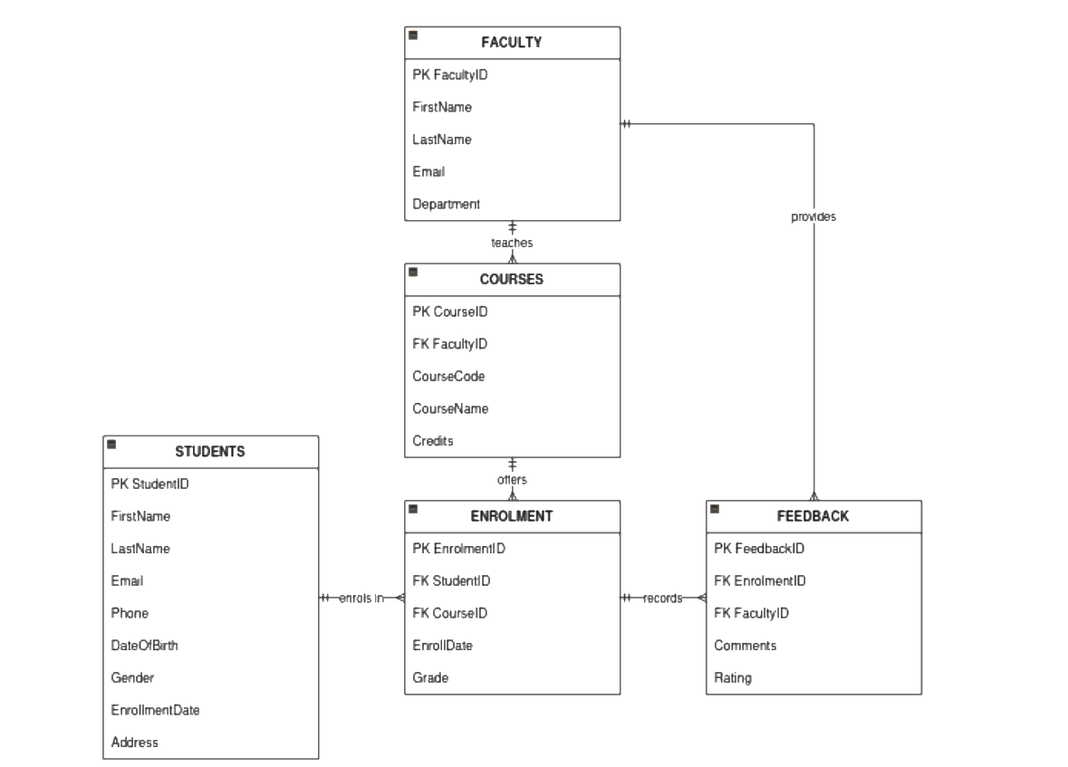
Figure 1: ER Diagram of the Student Information Manageent System
Relationship summary:
- Faculty (1) — (M) Courses: one faculty member can teach many courses.
- Students (1) — (M) Enrolment: one student can have many enrolment records.
- Courses (1) — (M) Enrolment: one course can have many enrolled students.
- Enrolment (1) — (M) Feedback: one Enrolment can receive multiple feedback entries over time.
- Enrolments.

Normalization
First Normal Form (1NF)
A relation is in 1NF if all attributes contain only atomic (indivisible) values and there are no repeating groups. In the initial unnormalized design, a single 'Student' record might store multiple enrolled courses and grades in one repeating field (e.g., Courses = 'DMS-236, NET-210'). To satisfy 1NF, this repeating group is removed and each course enrolment is stored as its own row in a separate Enrolment relation, so that every cell holds a single value.
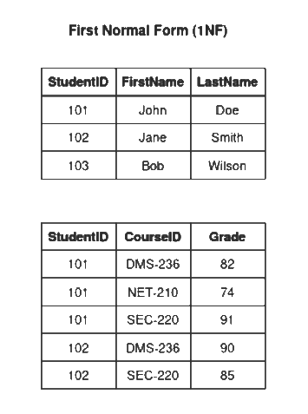
Figure 2. 1 NF

Second Normal Form (2NF)
A relation is in 2NF if it is in 1NF and every non-key attribute is fully functionally dependent on the whole primary key (no partial dependency on part of a composite key). In an early design, the Enrolment table used a composite key (StudentID, CourseID) but also stored CourseName and Credits, which depend only on CourseID and not on the full composite key — a partial dependency. To reach 2NF, CourseName and Credits are moved out into the Courses table, leaving Enrolment with only attributes (EnrollDate, Grade) that depend on the full composite relationship (represented here using a surrogate EnrolmentID key together with the StudentID/CourseID foreign keys).
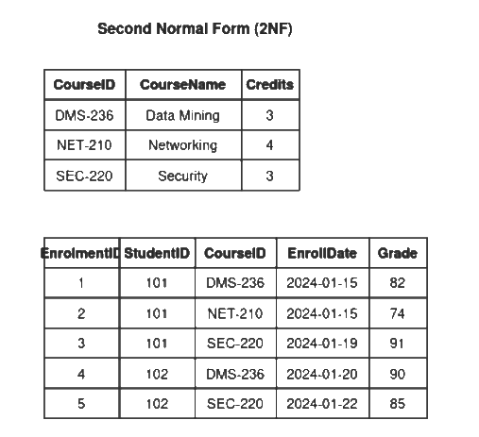
Figure 3. 2 NF
Third Normal Form (3NF)
A relation is in 3NF if it is in 2NF and has no transitive dependencies (non-key attributes must depend only on the primary key, not on another non-key attribute). For example, if the Courses table stored FacultyName and FacultyDepartment directly, these would depend on FacultyID rather than on CourseID directly, creating a transitive dependency. To achieve 3NF, faculty details are separated into their own Faculty table, and Courses only stores a FacultyID foreign key reference. The same principle is applied to Students, Enrolment, and Feedback so that every non-key attribute depends only on "the key, the whole key, and nothing but the key."
The resulting five relations (Students, Faculty, Courses, Enrolment, Feedback), as implemented in Practical 2, are therefore all in 3NF.
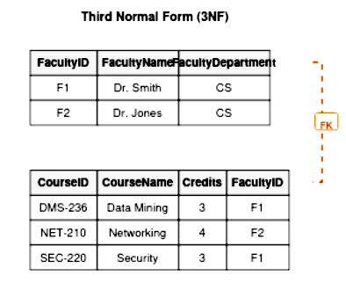
Figure 4. 3NF

Practical 2: Database Creation
The database SIMS_DB was created in Microsoft SQL Server with five tables: Students, Faculty, Courses, Enrolment, and Feedback. Primary keys, foreign keys, and constraints (UNIQUE, CHECK, DEFAULT, NOT NULL) were defined as shown below.
CREATE DATABASE SIMS_DB;
GO
USE SIMS_DB;
GO

CREATE TABLE Students (
StudentID INT IDENTITY(1,1) PRIMARY KEY,
FirstName VARCHAR(50) NOT NULL,
LastName VARCHAR(50) NOT NULL,
Email VARCHAR(100) UNIQUE NOT NULL,
Phone VARCHAR(15),
DateOfBirth DATE NOT NULL,
Gender VARCHAR(10)
CHECK (Gender IN ('Male','Female','Other')),
EnrollmentDate DATE DEFAULT GETDATE(),
Address VARCHAR(150)
);

CREATE TABLE Faculty (
FacultyID INT IDENTITY(1,1) PRIMARY KEY,
FirstName VARCHAR(50) NOT NULL,
LastName VARCHAR(50) NOT NULL,
Email VARCHAR(100) UNIQUE NOT NULL,
Department VARCHAR(100) NOT NULL,
Phone VARCHAR(15)
);

CREATE TABLE Courses (
CourseID INT IDENTITY(1,1) PRIMARY KEY,
CourseCode VARCHAR(10) NOT NULL UNIQUE,
CourseName VARCHAR(100) NOT NULL,
Credits INT NOT NULL CHECK (Credits BETWEEN 1 AND 6),
FacultyID INT NOT NULL,
CONSTRAINT FK_Courses_Faculty
FOREIGN KEY (FacultyID)
REFERENCES Faculty(FacultyID)
);

CREATE TABLE Enrolment (
EnrolmentID INT IDENTITY(1,1) PRIMARY KEY,
StudentID INT NOT NULL,
CourseID INT NOT NULL,
EnrollDate DATE NOT NULL DEFAULT GETDATE(),
Grade DECIMAL(5,2) NULL CHECK (Grade BETWEEN 0 AND 100),
CONSTRAINT FK_Enrolment_Student
FOREIGN KEY (StudentID)
REFERENCES Students(StudentID),
CONSTRAINT FK_Enrolment_Course
FOREIGN KEY (CourseID)
REFERENCES Courses(CourseID),
CONSTRAINT UQ_Student_Course
UNIQUE (StudentID, CourseID)
);

CREATE TABLE Feedback (
FeedbackID INT IDENTITY(1,1) PRIMARY KEY,
EnrolmentID INT NOT NULL,
FacultyID INT NOT NULL,
Comments VARCHAR(255),
Rating INT CHECK (Rating BETWEEN 1 AND 5),
FeedbackDate DATE DEFAULT GETDATE(),

CONSTRAINT FK_Feedback_Enrolment
FOREIGN KEY (EnrolmentID)
REFERENCES Enrolment(EnrolmentID),

CONSTRAINT FK_Feedback_Faculty
FOREIGN KEY (FacultyID)
REFERENCES Faculty(FacultyID)
);

The complete script, including the Faculty and Feedback tables, all foreign key constraints, and sample data inserts is provided in Appendix A (DMS236_Quries.sql).
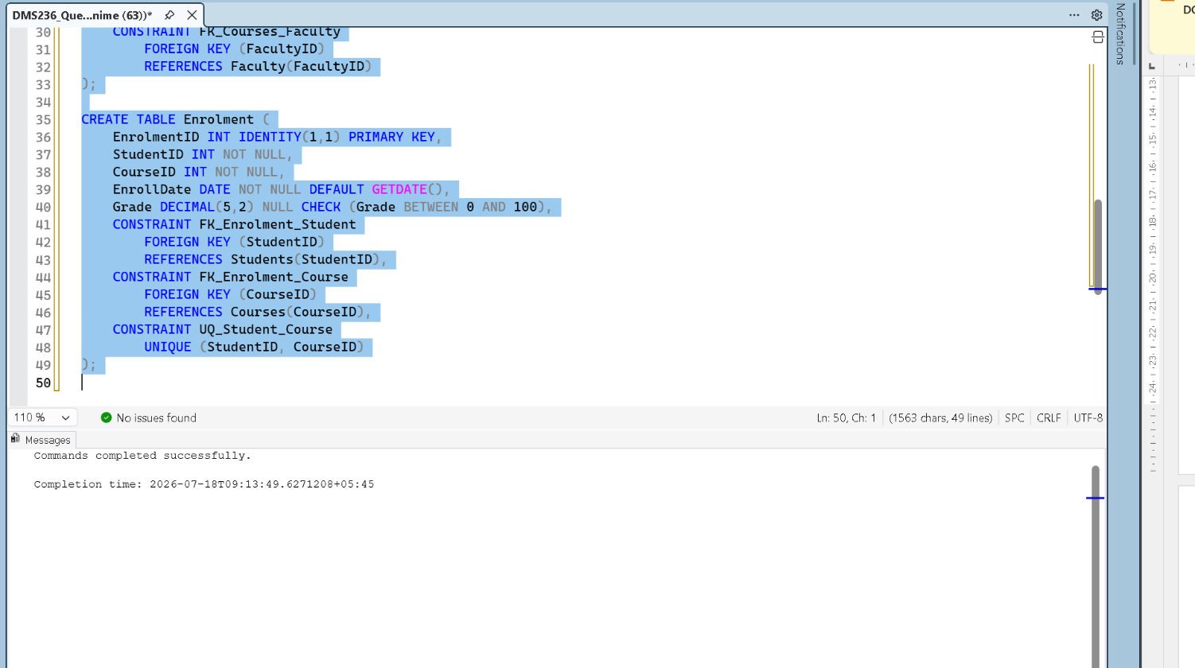
Figure 5. Database and Tables creation

Practical 3: CRUD Operations and Queries

Insert, Update, and Delete
INSERT INTO Students (FirstName, LastName, Email, Phone, DateOfBirth, Gender, Address)
VALUES ('Prakash', 'Adhikari', 'prakash.a@student.edu.np', '9800000006', '2004-03-18', 'Male', 'Kathmandu');

UPDATE Students SET Phone = '9811111111' WHERE Email = 'prakash.a@student.edu.np';

DELETE FROM Students WHERE Email = 'prakash.a@student.edu.np';

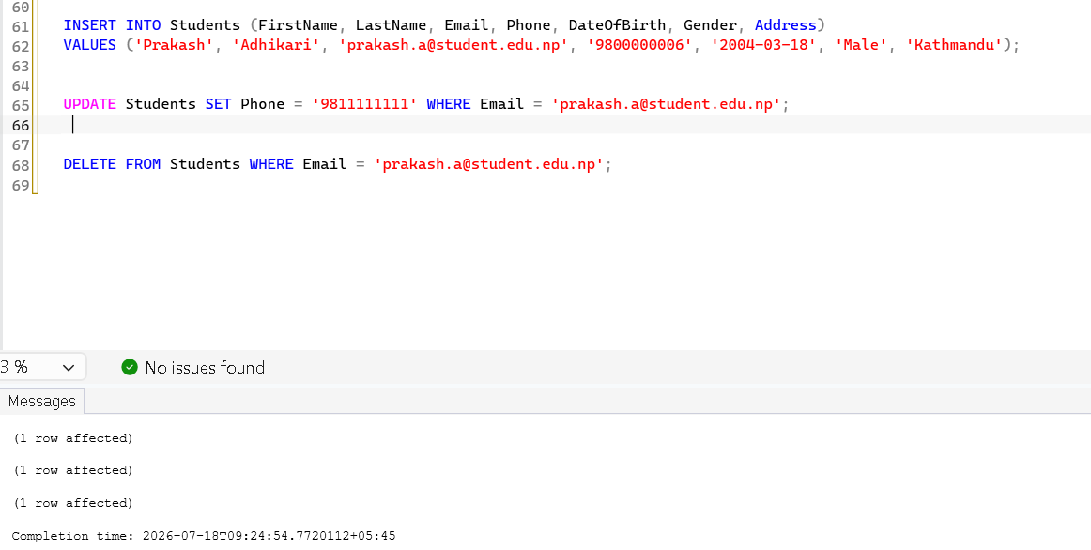
Figure 6. Insert, Update and Delete Queries

Retrieve Student Details Using JOIN
First I added some values in all the tables.
INSERT INTO Faculty (FirstName, LastName, Email, Department, Phone)
VALUES
('Ram', 'Sharma', 'ram.sharma@college.edu.np', 'Computer Science', '9800000001'),
('Sita', 'Thapa', 'sita.thapa@college.edu.np', 'Information Technology', '9800000002'),
('Hari', 'Karki', 'hari.karki@college.edu.np', 'Cyber Security', '9800000003');

INSERT INTO Students
(FirstName, LastName, Email, Phone, DateOfBirth, Gender, Address)
VALUES
('Prakash', 'Adhikari', 'prakash.adhikari@student.edu.np', '9800000006', '2004-03-18', 'Male', 'Kathmandu'),
('Anjali', 'Shrestha', 'anjali.shrestha@student.edu.np', '9800000007', '2003-11-25', 'Female', 'Lalitpur'),
('Rohit', 'Gurung', 'rohit.gurung@student.edu.np', '9800000008', '2004-07-10', 'Male', 'Bhaktapur');

INSERT INTO Courses
(CourseCode, CourseName, Credits, FacultyID)
VALUES
('DMS-236', 'Database Management Systems', 3, 1),
('SEC-220', 'Cyber Security Fundamentals', 3, 3),
('WEB-210', 'Web Development', 4, 2);

INSERT INTO Enrolment (StudentID, CourseID, Grade)
VALUES
(4,1,88),
(4,2,91),
(5,1,84),
(5,3,79),
(6,2,93),
(6,3,87);

INSERT INTO Feedback
(EnrolmentID, FacultyID, Comments, Rating)
VALUES
(1, 1, 'Excellent understanding of SQL.', 5),
(2, 3, 'Strong security concepts demonstrated.', 5),
(3, 1, 'Good progress throughout the semester.', 4),
(4, 2, 'Needs improvement in frontend design.', 3),
(5, 3, 'Very active during practical sessions.', 5),
(6, 2, 'Consistent work and timely submissions.', 4);

SELECT * FROM Students
SELECT s.StudentID, s.FirstName, s.LastName, c.CourseName, e.Grade
FROM Students s
INNER JOIN Enrolment e ON s.StudentID = e.StudentID
INNER JOIN Courses c ON e.CourseID = c.CourseID
ORDER BY s.StudentID;

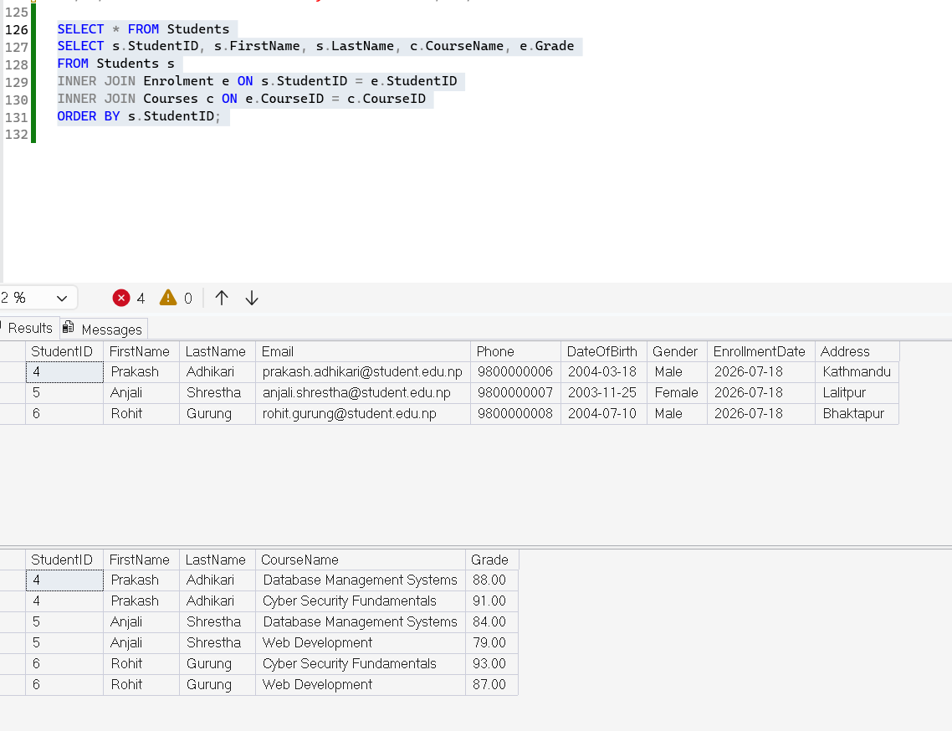
Figure 7. Retrieving Student details with JOIN

Search Using LIKE, BETWEEN, IN
SELECT * FROM Students WHERE FirstName LIKE 'P%';

SELECT StudentID, FirstName, LastName, DateOfBirth FROM Students
WHERE DateOfBirth BETWEEN '2004-01-01' AND '2004-12-31';

SELECT * FROM Courses WHERE CourseCode IN ('DMS-236', 'SEC-220');
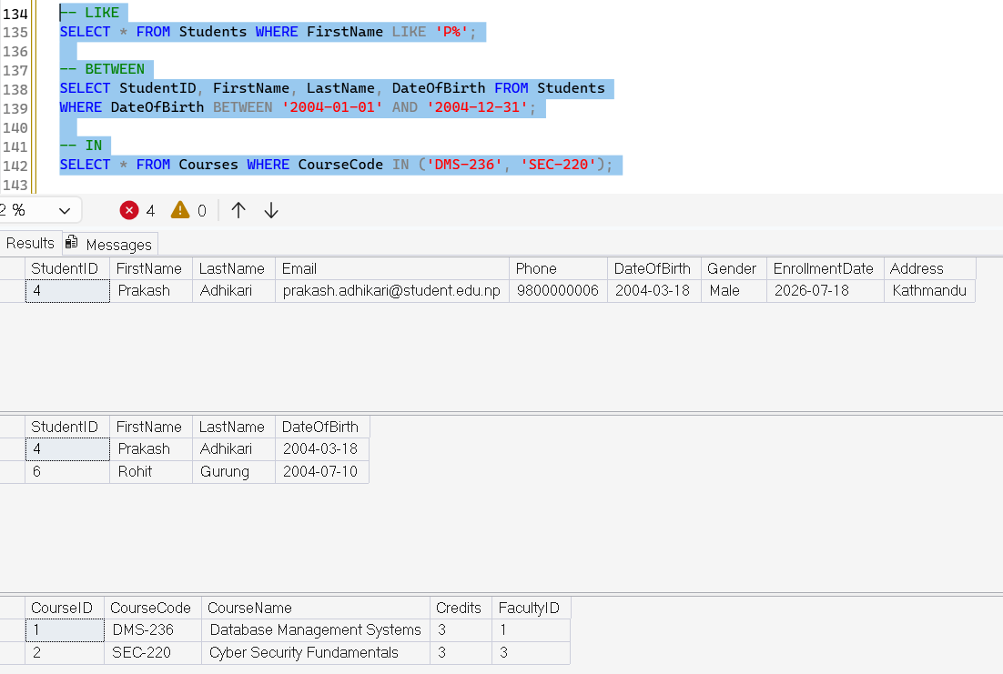
Figure 8. Results of retreiving specifi/ranged values

Practical 4: Relational Algebra and Transactions

Relational Algebra Examples
Operator | Relational Algebra | Equivalent SQL
SELECT (σ) | σ Grade > 80 (Enrolment) | SELECT * FROM Enrolment WHERE Grade > 80;
PROJECT (π) | π FirstName, LastName (Students) | SELECT DISTINCT FirstName, LastName FROM Students;
JOIN (⋈) | Students ⋈ Enrolment | SELECT s.StudentID, e.Grade FROM Students s JOIN Enrolment e ON s.StudentID = e.StudentID;
UNION (∪) | π Email(Students) ∪ π Email(Faculty) | SELECT Email FROM Students UNION SELECT Email FROM Faculty;
INTERSECTION (∩) | π StudentID(σ CourseID=1) ∩ π StudentID(σ CourseID=2) | SELECT StudentID FROM Enrolment WHERE CourseID=1 INTERSECT SELECT StudentID FROM Enrolment WHERE CourseID=2;
Table 1. Relational Algebra Examples

Transaction Management (COMMIT / ROLLBACK)
-- Test Case 1: Successful transaction
BEGIN TRANSACTION;
UPDATE Enrolment
SET Grade = 90
WHERE EnrolmentID = 3;

INSERT INTO Feedback (EnrolmentID, FacultyID, Comments, Rating)
VALUES (1, 1, 'Grade revised after re-evaluation.', 5);

COMMIT TRANSACTION;

-- Test Case 2: Failed transaction (rolled back)
BEGIN TRANSACTION;
UPDATE Students
SET Email = 'sita.gurung@student.edu.np'
WHERE StudentID = 4;

-- violates UNIQUE constraint on Email
IF @@ERROR <> 0
ROLLBACK TRANSACTION;
ELSE
COMMIT TRANSACTION;

Test Case 1 demonstrates a valid grade update and related feedback insert being committed together, so both changes persist. Test Case 2 attempts to duplicate an email address that already exists; because this violates the UNIQUE constraint, the transaction is rolled back and no partial change is saved, preserving the database's consistency.
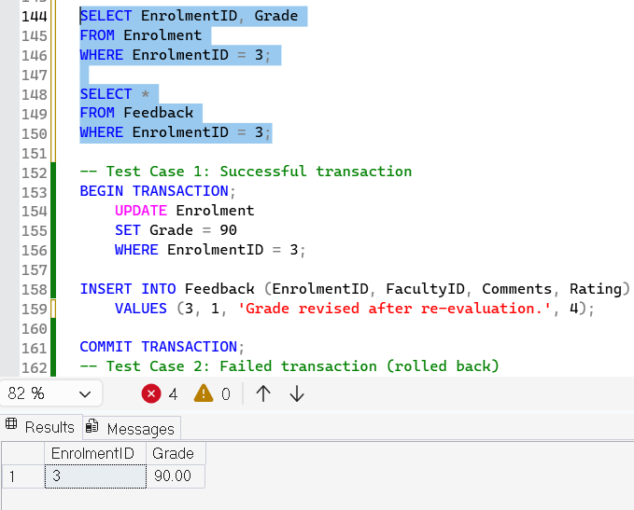
Figure 9. Grade before transaction
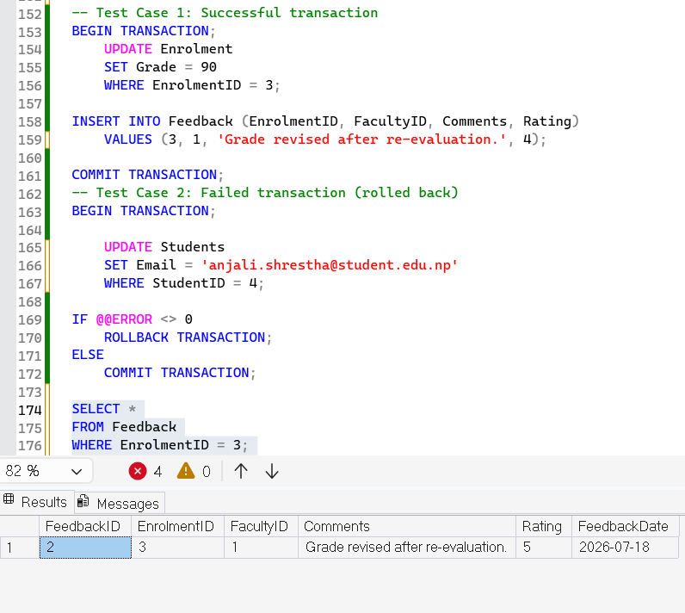
Figure 10. Result of Test Case 1
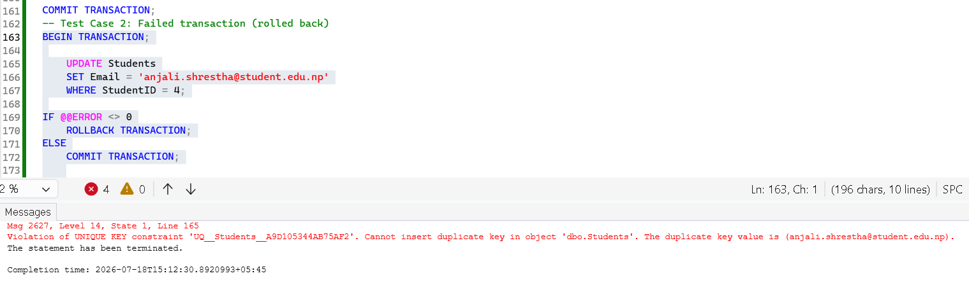
Figure 11. Result of Test Case 2

Practical 5: Database Operations

SQL Joins
-- INNER JOIN
SELECT s.StudentID, s.FirstName, c.CourseName
FROM Students s
INNER JOIN Enrolment e ON s.StudentID = e.StudentID
INNER JOIN Courses c ON e.CourseID = c.CourseID;

-- LEFT JOIN: students not enrolled in any course
SELECT s.StudentID, s.FirstName, s.LastName
FROM Students s
LEFT JOIN Enrolment e ON s.StudentID = e.StudentID
WHERE e.EnrolmentID IS NULL;

-- SELF JOIN: compare grades of students in the same course
SELECT e1.CourseID, s1.FirstName AS Student1, e1.Grade AS Grade1,
s2.FirstName AS Student2, e2.Grade AS Grade2
FROM Enrolment e1
JOIN Enrolment e2 ON e1.CourseID = e2.CourseID AND e1.StudentID < e2.StudentID
JOIN Students s1 ON e1.StudentID = s1.StudentID
JOIN Students s2 ON e2.StudentID = s2.StudentID;

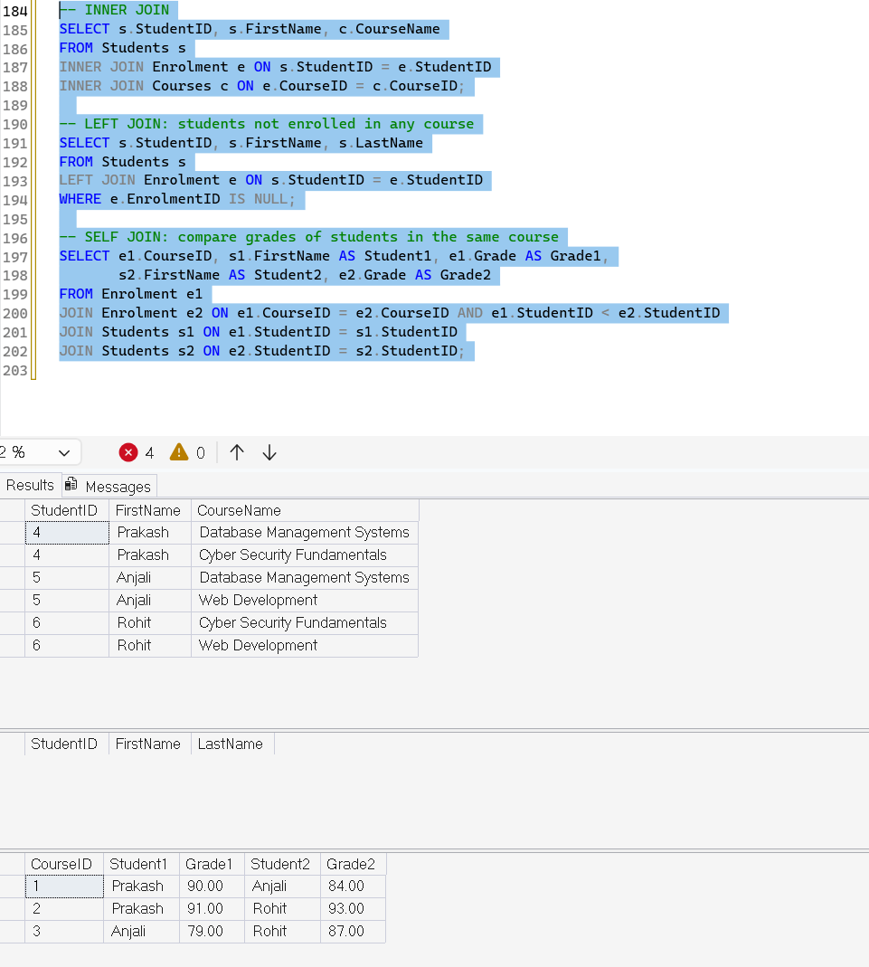
Figure 12. SQL Joins Resutls

Aggregate Functions, Grouping and Filtering
-- COUNT: students enrolled per course
SELECT c.CourseName, COUNT(e.StudentID) AS TotalStudents
FROM Courses c LEFT JOIN Enrolment e ON c.CourseID = e.CourseID
GROUP BY c.CourseName;

-- AVG: average grade per course
SELECT c.CourseName, AVG(e.Grade) AS AverageGrade
FROM Courses c JOIN Enrolment e ON c.CourseID = e.CourseID
GROUP BY c.CourseName;

-- HAVING: courses with average grade below 80
SELECT c.CourseName, AVG(e.Grade) AS AverageGrade
FROM Courses c JOIN Enrolment e ON c.CourseID = e.CourseID
GROUP BY c.CourseName
HAVING AVG(e.Grade) < 80;

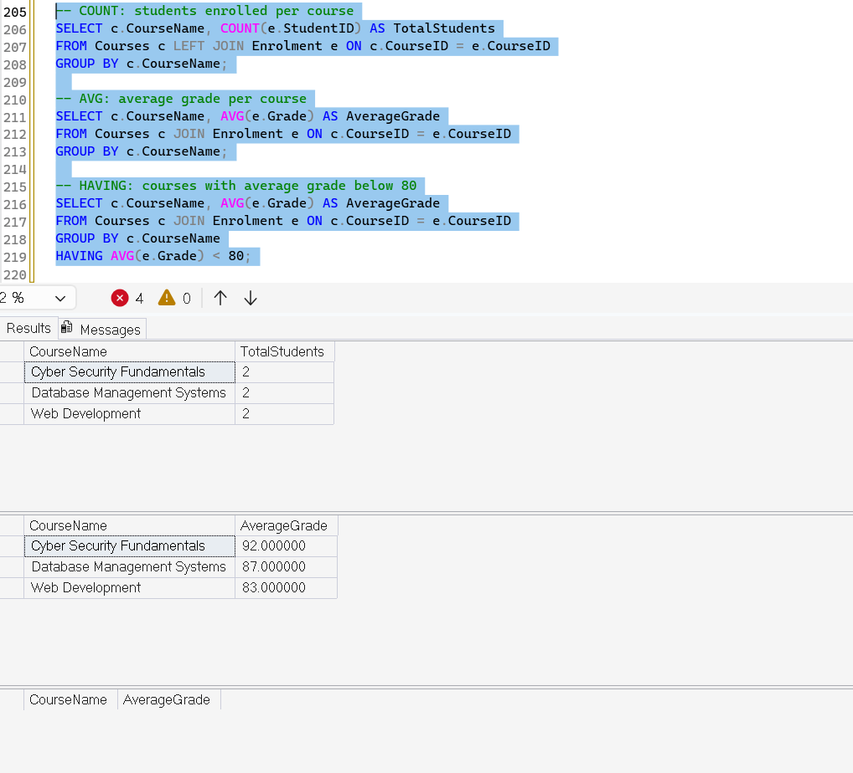
Figure 13. Result of Aggregate Functions (Grouping and Filtering)
The full set of aggregate queries (COUNT, SUM, AVG, MAX/MIN) and the GROUP BY report of students by course are provided in Appendix A.

Conclusion
This mini project involved the complete lifecycle of designing and implementing a relational database for a Student Information Management System, from conceptual ER modelling and normalization through to physical implementation, query development, and transaction management in Microsoft SQL Server. Working through each practical component reinforced how normalization reduces data redundancy and update anomalies, how primary and foreign key constraints enforce referential integrity, and how relational algebra concepts map directly onto SQL joins, projections, and set operations.
The transaction management exercises further demonstrated how COMMIT and ROLLBACK preserve database consistency when constraint violations occur, which is essential in any real-world, multi-user system such as a student records platform. Overall, the project met the stated learning outcomes by combining conceptual design, hands-on SQL implementation, and testing within a single, cohesive database system.

References
Elmasri, R., & Navathe, S. B. (2016). Fundamentals of database systems (7th ed.). Pearson.
Microsoft. (2025). Transact-SQL reference (Database Engine). Microsoft Learn. https://learn.microsoft.com/en-us/sql/t-sql/
Silberschatz, A., Korth, H. F., & Sudarshan, S. (2019). Database system concepts (7th ed.). McGraw-Hill.

Appendix
Appendix A: SQL Scripts
The complete SQL script (DMS236_Quries.sql) — covering database creation, table definitions with constraints, sample data, CRUD operations, relational algebra queries, transactions, joins, and aggregate/grouping queries — is submitted alongside this report.
Appendix B: Screenshots
Insert screenshots of: (1) the database and tables in SQL Server Management Studio, (2) each CRUD query with its result set, (3) transaction test case outputs, and (4) each join/aggregate query with its result set, in the order they appear in Section 2 of this report.
Appendix C: Presentation Slides
A separate presentation slide deck summarising the project scope, ER diagram, and key queries is submitted alongside this report and the SQL script.

