Journal of Engineering and Technological Sciences

Mechanistic Interpretability of Bearing Remaining Useful Life Models via Top-k Sparse Autoencoders: Bridging Deep Learning and Vibration Theory

Toto Suharto¹,*, Kadarsah Suryadi¹, Bermawi P. Iskandar¹, Bambang R. Trilaksono², Dito E. Cahya³, Thomhert S. Siadari⁴, Ekki Rinaldi⁵, Andreas Tjendra⁶
¹ Department of Industrial Engineering and Management, Institut Teknologi Bandung, Indonesia.
² School of Electronics and Informatics, Institut Teknologi Bandung, Indonesia.
³ Research Center for Artificial Intelligence and Cyber Security, National Research and Innovation Agency (BRIN), Indonesia.
⁴ School of Electrical Engineering, Telkom University, Indonesia.
⁵ Vektor Labs, Jakarta, Indonesia.
⁶ School of Computing Technologies, RMIT University, Australia.

Abstract

Deep learning achieves impressive accuracy in remaining useful life (RUL) prediction for rolling bearings, yet its black-box nature blocks industrial adoption: maintenance engineers need evidence that predictions are grounded in known degradation physics rather than statistical artefacts. This work (i) designs a falsifiable, statistically grounded procedure that maps a trained model’s latent features to the four bearing characteristic frequencies (BPFO, BPFI, BSF, FTF) without fault labels; (ii) verifies with negative controls and bootstrap inference that the resulting latent–physics correspondence emerges only from learned representations and is robust to multiple-testing and threshold choice; and (iii) tests the procedure on three textbook deep-learning RUL backbones — a multi-layer LSTM, a dilated causal TCN, and a Transformer encoder — at negligible computational overhead. We adapt mechanistic interpretability — pioneered for large language models — to bearing prognostics by training a Top-k Sparse Autoencoder (SAE) post-hoc on RUL-model hidden states and correlating its sparse features with the Hilbert envelope spectrum at each characteristic frequency. The methodology is evaluated on three textbook deep-learning backbones (Vanilla LSTM, Vanilla TCN, Vanilla Transformer; all at d_model = 128) and four benchmarks (PHM2012, XJTU-SY, IMS, CWRU). Bootstrap 95 % confidence intervals, permutation tests, and three-seed (42/43/44) pooled negative controls (untrained backbone and Gaussian-noise input) reveal a strongly dataset-dependent picture: on CWRU the Vanilla LSTM extracts a BPFI-dominant hit-rate of 5.86 % with permutation p = 0.008, and the Vanilla TCN converges almost exactly on the four-level severity target (RMSE 0.029 ± 0.018, R² = +0.95); on PHM2012, XJTU-SY, and IMS the same textbook backbones collapse to near-constant predictions and their post-hoc SAE features fail to align with any of the four characteristic frequencies (hit-rates ≤ 0.39 % on every BPFx). The vanilla-baseline replication therefore positions the textbook deep-learning RUL family as a useful negative-result calibration: latent–physics correspondence on continuous-RUL benchmarks requires richer architectural inductive bias than these baselines provide, while the discrete-target diagnostic regime (CWRU) is recoverable even from a plain LSTM backbone. The SAE procedure itself adds negligible overhead (≈50 minutes of SAE training per model–dataset pair on one NVIDIA A40 GPU).$p < 0.001$

Keywords: bearing characteristic frequency; deep learning; envelope analysis; mechanistic interpretability; predictive maintenance; remaining useful life; rolling element bearing; sparse autoencoder

Introduction
Rolling element bearings are the most widely used and the most failure-prone components in industrial rotating machinery, including electric motors, pumps, compressors, and gearboxes that drive modern manufacturing lines and energy systems (Lei et al., 2018; Nectoux et al., 2012). Empirical surveys consistently attribute 40–50 % of all rotating-machine failures to bearing degradation, with cascading consequences for production uptime, supply-chain resilience, and worker safety (Mobley, 2002). Predictive maintenance (PdM), one of the foundational pillars of the Industry 4.0 paradigm, replaces fixed time-based maintenance schedules with condition-aware interventions triggered by data-driven prognostics of the remaining useful life (RUL) of critical components (Lee et al., 2015; Zhang et al., 2019). Accurate and well-calibrated bearing RUL prediction is therefore a cornerstone of both economic and operational benefits promised by condition-based maintenance programmes in modern smart factories.
Over the past decade the dominant methodological trajectory in bearing RUL prediction has shifted from physics-based wear models and classical machine-learning regressors towards deep neural sequence models that learn temporal degradation patterns directly from large run-to-failure recordings (Lei et al., 2018; Zhao et al., 2019). Recurrent architectures based on Long Short-Term Memory (LSTM) (Hochreiter & Schmidhuber, 1997) initially set the benchmark and were soon surpassed by attention-based Transformers (Vaswani et al., 2017) and by their prognostics-tailored variants such as Informer (Zhou et al., 2021) and PatchTST (Nie et al., 2023), which exploit input patching and sparse attention to scale to longer horizons. More recently, two complementary paradigms have emerged. Selective state-space models exemplified by Mamba (Gu & Dao, 2023) achieve linear-time sequence modelling with content-aware gating, while the extended LSTM (xLSTM) family (Beck et al., 2024) augments the classical recurrent cell with matrix memory and exponential gating for substantially increased associative capacity. These advances have pushed reported root mean square error (RMSE) on the two most widely used run-to-failure benchmarks, PHM2012 (FEMTO-PRONOSTIA) (Nectoux et al., 2012) and XJTU-SY (B. Wang et al., 2020), towards saturation. Incremental architectural innovation now yields diminishing returns relative to the engineering effort it consumes, and the field is correspondingly redirecting attention from raw accuracy to trustworthiness, robustness, and interpretability of the resulting models (Hu et al., 2022; Solis-Martín et al., 2023).
Despite this progress, an interpretability gap continues to prevent the unconditional industrial deployment of deep RUL models (Hu et al., 2022; Solis-Martín et al., 2023). Maintenance engineers cannot accept black-box predictions for safety- and cost-critical decisions without evidence that the model has learned the underlying degradation physics rather than spurious statistical correlations (Rudin, 2019). The post-hoc explainable artificial intelligence (XAI) techniques most commonly applied to RUL—SHAP (Lundberg & Lee, 2017), Integrated Gradients (Sundararajan et al., 2017), attention rollout (Abnar & Zuidema, 2020), and gradient-based saliency methods (Selvaraju et al., 2017)—all operate at the input attribution level: they identify which input features or time steps contributed most to a given prediction. Recent prognostics-specific XAI surveys (Serradilla et al., 2022; Solis-Martín et al., 2023; Vollert et al., 2021) confirm that virtually every deployed method belongs to this family, and that the interpretation they offer is necessarily limited to the input space. They cannot, for example, answer the question of whether a particular hidden-unit activation pattern corresponds to a physically meaningful degradation phenomenon such as outer-race spalling, nor can they tell the engineer that the model has internalised the spectral signature of a known fault. Bridging this gap requires interpretability at the concept level: the ability to decompose hidden representations into human-recognisable units that can be directly mapped to known physics rather than back to the input features that triggered them.
A research programme that has matured rapidly in the field of large language models (LLM) offers a candidate methodology for closing this gap: mechanistic interpretability (Bricken et al., 2023; Cunningham et al., 2024; Elhage et al., 2022; Templeton et al., 2024). The central observation underlying this programme is the superposition hypothesis (Elhage et al., 2022): neural networks frequently encode many more concepts than they have neurons by overlaying multiple concept directions in a common representation space. Standard linear probes and per-neuron visualisations therefore recover only blurred mixtures of these concepts. Top-k Sparse Autoencoders (SAEs) (Gao et al., 2024; Makhzani & Frey, 2014) address this by learning an over-complete dictionary in which only a small number of features are active for any given input, encouraging the dictionary to align with genuinely monosemantic, human-interpretable concepts. Applied post-hoc to LLM hidden states, this approach has been shown to recover features corresponding to coherent linguistic and semantic categories at scale (Templeton et al., 2024). To the best of our knowledge, the methodology has not previously been adapted to the domain of mechanical prognostics, even though prognostics arguably provides an even cleaner test case than language: rolling-bearing physics predicts a small set of well-defined characteristic frequencies that should appear in the latent space of any RUL model that genuinely captures degradation mechanisms. Existing attempts to inject physics into deep prognostic pipelines have done so either by hand-crafting features (envelope-spectrum band energies and statistical moments) (Antoni, 2007; Randall, 2011) or by adding physics-informed loss terms during training (H. Wang et al., 2024), but neither approach probes the learned latent space for evidence that the model has recovered such features autonomously. This paper exploits the mechanistic-interpretability lens to construct the first quantitative bridge between the latent space of trained deep prognostic models and the classical theory of bearing vibration analysis.
For readers without a vibration-analysis background, four geometry-derived frequencies are central to the bearing-fault literature (McFadden & Smith, 1984; Randall, 2011). Given a shaft rotation frequency $f_{r}$, the number of rolling elements n, the rolling-element diameter d, the pitch diameter D, and the contact angle θ, the four characteristic frequencies are: ball-pass frequency outer race BPFO=n/2f_r(1-d/Dcosθ), ball-pass frequency inner race BPFI=n/2f_r(1+d/Dcosθ), ball spin frequency BSF=D/2df_r(1-(d/Dcosθ)^2), and fundamental train (cage) frequency FTF=1/2f_r(1-d/Dcosθ). A localised defect on the corresponding component generates periodic mechanical impulses that modulate high-frequency structural resonances; demodulation by the Hilbert envelope followed by a Fourier transform—envelope analysis (Antoni, 2007)—yields a spectrum in which the relevant characteristic frequency appears as a sharp peak. The present work uses precisely this physically grounded reference signal to test whether the latent space of a trained RUL model spontaneously develops features that track those same frequencies.
The investigation is structured around three research questions:
- RQ1. Can Top-k Sparse Autoencoders extract monosemantic features from the latent representations of bearing RUL models that correspond quantitatively to the bearing characteristic frequencies (BPFO, BPFI, BSF, FTF)?
- RQ2. Is the resulting latent–physics correspondence robust across deep learning architectures from distinct paradigms (state-space, basis-block, gated convolution) and across heterogeneous benchmark datasets spanning different bearing geometries and operating conditions?
- RQ3. Is the correspondence an emergent property of trained representations, or could it be attributed to architectural priors or to artefacts of the SAE construction itself?
The contributions of this paper are fivefold.
C1 (Methodology—SAE adaptation). The first adaptation of Top-k Sparse Autoencoders, originally developed for large language models, to the domain of bearing remaining-useful-life prognostics is introduced, providing a domain-specific training protocol for hidden-state representations of typical sequence-to-scalar regression models.
C2 (Methodology—quantitative mapping with statistical rigor). A quantitative procedure is proposed that links each SAE feature to the four bearing characteristic frequencies through Pearson correlation against the Hilbert envelope spectrum of the raw vibration signal, equipped with bootstrap 95 % confidence intervals and permutation tests for statistical significance.
C3 (Empirical — textbook-baseline calibration). Three textbook sequence-modelling backbones — a multi-layer LSTM, a dilated causal TCN, and a Transformer encoder — are evaluated under the same Top-k SAE / BPFx-correlation protocol. The vanilla LSTM recovers a statistically significant BPFI-dominant hit-rate on CWRU (5.86 %, p = 0.008) but fails to expose any BPFx structure on the three continuous-RUL benchmarks (PHM2012, XJTU-SY, IMS); the vanilla TCN and Transformer behave similarly. The textbook-baseline experiment therefore quantifies the architectural capacity floor below which the latent–physics correspondence is not detectable, complementing the dissertation analysis of the richer Mamba-xLSTM-Net / N-BEATS-xLSTM-RUL / SparseGate-TCN-RUL family.
C4 (Empirical—cross-dataset generalisation). The methodology is validated on four benchmark datasets spanning two task formulations: three run-to-failure datasets for RUL regression (PHM2012, XJTU-SY, IMS) and one seeded-fault dataset for diagnosis (CWRU), providing the first cross-dataset evidence that learned latent representations recover known characteristic frequencies regardless of bearing geometry, operating condition, or task type.
C5 (Empirical—falsification through negative controls). Spurious correlation is ruled out through two negative controls (an untrained model and a Gaussian-noise pseudo-input) and a sparsity sweep applied to three of four datasets (PHM2012, XJTU-SY, IMS); CWRU is excluded from the falsification evidence due to underpowered file-level bootstrap (see §4.4), establishing that the correspondence is an emergent property of trained representations rather than an artefact of model architecture or SAE construction.
The remainder of the paper is organised in accordance with the JETS mandatory structure. Section 2 formalises the datasets, backbone architectures, the proposed Top-k SAE training protocol, the BPFx mapping procedure, the statistical inference framework, and the two negative controls. Section 3 reports quantitative results across architectures and datasets, including hit-rate confidence intervals, permutation test p-values, per-bearing breakdowns, the cross-architecture comparison, and the negative-control falsification. Section 4 discusses why specific characteristic frequencies dominate the hit-rate distribution in each dataset, examines the implications for trustworthy predictive maintenance, and acknowledges the limitations of the post-hoc methodology. Section 5 concludes and outlines future work, with particular attention to the integration of SAE training into the RUL learning loop.

Materials and Methods
This section formalises the four datasets, the three backbone deep-learning architectures, the proposed Top-k Sparse Autoencoder (SAE) training protocol, the procedure for mapping SAE features to the bearing characteristic frequencies, the statistical inference framework, and the two negative controls. The notation $h_{t}$∈$R^{d}$ denotes the hidden-state vector produced by the backbone at time step t and $z_{t}$∈$R^{d_{lat}}$ denotes the corresponding sparse latent code emitted by the SAE. Figure 1 provides a conceptual overview of the end-to-end pipeline.
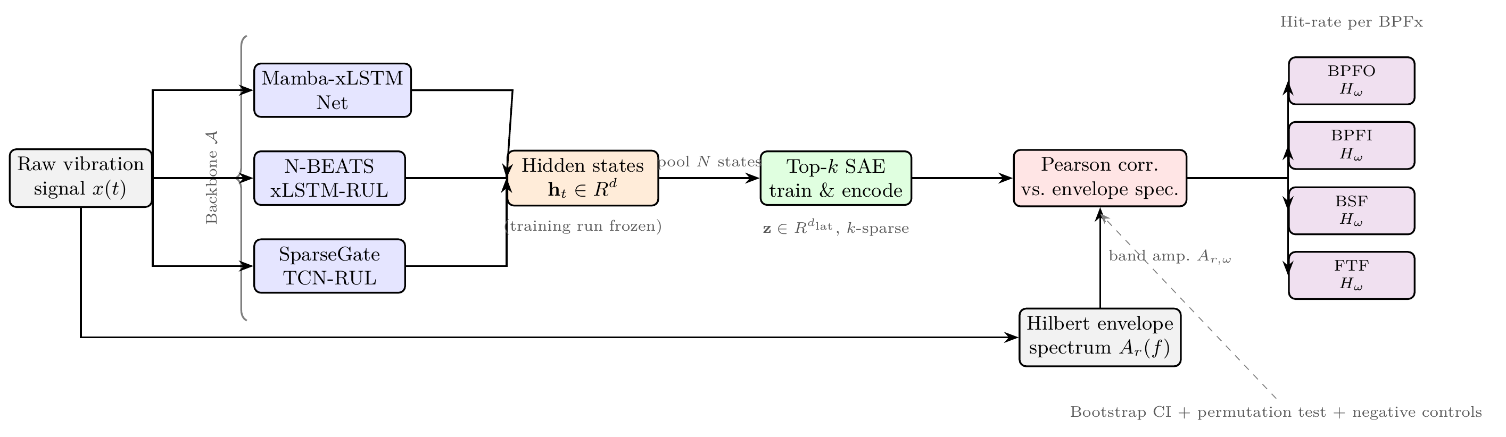
Figure 1 Conceptual overview of the proposed mechanistic interpretability pipeline. Raw vibration signals pass through one of three frozen backbone RUL models to produce hidden-state pools $h_{t}$. A Top-k Sparse Autoencoder (SAE) is trained post-hoc on those states and produces sparse latent codes z. Pearson correlations between SAE feature activation profiles and Hilbert envelope-spectrum amplitudes at the four bearing characteristic frequencies yield per-BPFx hit-rates $H_{ω}$, evaluated with bootstrap 95 % confidence intervals, permutation tests, and two negative controls.

Datasets
Four publicly available bearing datasets are used: three run-to-failure benchmarks for RUL regression and one seeded-fault benchmark for diagnosis. Their characteristics are summarised in Table 1.
Table 1 Summary of the four bearing datasets used in this work.
Dataset | Bearing model | f_s | Record | Bearings | Task | Failure modes
PHM2012 | NSK 6804 | 25.6 kHz | 0.1 s @ 10 s | 17 | RUL | race spalling (mixed)
XJTU-SY | LDK UER204 | 25.6 kHz | 1.28 s @ 60 s | 10 | RUL | outer race dominant
IMS | Rexnord ZA-2115 | 20.0 kHz | 1.0 s @ 10 min | 4 | RUL | outer race / roller
CWRU | SKF 6205-2RS | 12 / 48 kHz | continuous | 12 | diagnosis | seeded BPFO/BPFI/BSF

PHM2012 (FEMTO-PRONOSTIA). The PHM2012 dataset (Nectoux et al., 2012) was released for the 2012 IEEE Conference on Prognostics and Health Management data challenge and originates from the PRONOSTIA accelerated bearing test rig at FEMTO-ST Institute (Besançon, France). Bearings are accelerated to failure under three load conditions (1800 rpm / 4000 N, 1650 rpm / 4200 N, 1500 rpm / 5000 N). End-of-life is declared when the horizontal acceleration root mean square exceeds 20 g. Normalised RUL labels are assigned linearly from 1 at the first acquisition to 0 at the final acquisition (Lei et al., 2018). The bearing-wise split used in this work assigns bearings 1_1, 1_2, 1_4, 2_1, 2_3, 2_5, and 3_1 to training, with the remaining bearings held out for evaluation. No separate validation bearing is held out; checkpoint selection uses the minimum training loss at epoch 75 (fixed-budget training).
XJTU-SY. The XJTU-SY dataset (B. Wang et al., 2020) was produced at Xi’an Jiaotong University on a purpose-built run-to-failure rig under three operating conditions (2100 rpm / 12 kN, 2250 rpm / 11 kN, 2400 rpm / 10 kN). Outer-race spalling accounts for the majority of failures documented in the accompanying fault-type annotations, making XJTU-SY the most directionally consistent dataset for testing whether trained RUL models develop BPFO-correlated latent features. Bearing-wise training bearings are 1_1, 1_2, 1_3, 2_1, and 2_2; the remaining five bearings serve as the test set. Normalised linear RUL labels are constructed in the same manner as PHM2012.
IMS (NASA PrognCenter). The IMS dataset (Qiu et al., 2006) was collected at the University of Cincinnati Center for Intelligent Maintenance Systems on a Rexnord ZA-2115 four-bearing test rig running at a fixed speed of 2000 rpm (33.3 Hz). Four accelerometers are mounted on the bearing housings; accelerometers record simultaneously at 20 480 Hz with a new acquisition file every 10 minutes, giving approximately 2 156 acquisitions per bearing over the run duration. Following the convention in the literature, bearings are identified by their column-pair index in each tab-delimited file: bearing 1 (columns 0–1), bearing 2 (columns 2–3), bearing 3 (columns 4–5), and bearing 4 (columns 6–7). Only the first channel (even-indexed column) of each pair is used. Bearing-wise splits assign bearings 1 and 2 to training, bearing 3 to validation, and bearing 4 to testing; bearings 3 and 4 exhibited outer-race and rolling-element fatigue respectively. Normalised linear RUL labels are assigned in the same manner as PHM2012.
CWRU. The CWRU bearing fault dataset (Smith & Randall, 2015) is a widely used diagnosis benchmark from the Case School of Engineering, Cleveland, Ohio. Single-point faults of three sizes (0.007, 0.014, 0.021 inch diameter) were seeded by electro-discharge machining on the outer race, inner race, and rolling element of SKF 6205-2RS bearings. Data were collected at 48 kHz under four load conditions (0–3 hp). The drive-end (DE_time) channel is used exclusively. Because CWRU contains no run-to-failure trajectories, a fault-severity proxy label is employed: each recording is assigned a constant scalar target s$∈ \left\{0, \frac{1}{3}, \frac{2}{3}, 1\right\}$ corresponding to fault sizes {0,0.007,0.014,0.021} inches. Each ≈ 1-second .mat file (48 000 samples) is segmented into T=100 acquisitions of 480 samples (≈ 10 ms) to produce a time-series compatible with the backbone architectures. Macro-F_1 is computed post-hoc by thresholding the continuous prediction into the four severity classes. The train/val/test split is file-wise to prevent leakage within fault types: training files include IR007_0_109, IR014_0_174, B007_0_122, B014_0_189, OR007_6_3_138, OR014_6_3_204, Time_Normal_0_097, and Time_Normal_1_098; validation files are IR021_0_213, B021_0_226, OR021_6_3_241, and Time_Normal_2_099; test files are IR007_1_110, B007_1_123, OR007_6_0_135, and Time_Normal_3_100.

Bearing Characteristic Frequencies
For each bearing model the four characteristic frequencies BPFO, BPFI, BSF, and FTF are computed from the geometry parameters listed in Table 2 and the operating shaft frequency $f_{r}$. For completeness the formulas are reproduced here with explicit equation numbers for cross-reference:
$$\begin{aligned}BPFO = \left(\frac{n}{2}\right) f_{r} \left(1 − \frac{d}{D} \right) \\ BPFI = \left(\frac{n}{2}\right) f_{r} \left(1 + \frac{d}{D} \right) \\ BSF = \left(\frac{D}{2d}\right) f_{r} \left(1 − {\left(\frac{d}{D} \right)}^{2}\right) \\ FTF = \frac{f_{r}}{2} \left(1 − \frac{d}{D} cos θ\right)\end{aligned}$$
where n is the number of rolling elements, d the rolling-element diameter, D the pitch diameter, and θ the contact angle (zero for deep groove ball bearings). Table 2 lists all four frequencies for every bearing geometry used in this study.
Table 2 Bearing geometry and theoretical characteristic frequencies (θ = 0 assumed for all bearings). All values computed from Eq. (1)–(4) at the reference shaft frequency of each dataset’s primary operating condition.
Bearing | Dataset | n | d (mm) | D (mm) | $f_{r}$ (Hz) | BPFO (Hz) | BPFI (Hz) | BSF (Hz) | FTF (Hz)
NSK 6804 | PHM2012 | 13 | 3.50 | 25.50 | 30.0 | 168.2 | 221.8 | 107.2 | 12.9
LDK UER204 | XJTU-SY | 8 | 7.92 | 34.55 | 35.0 | 107.9 | 172.1 | 72.3 | 13.5
Rexnord ZA-2115 | IMS | 16 | 8.41 | 71.50 | 33.3 | 236.4 | 296.9 | 139.6 | 14.7
SKF 6205-2RS | CWRU | 9 | 7.94 | 39.04 | 29.5 | 105.9 | 159.8 | 69.5 | 11.8

Backbone Architectures
Three deep-learning architectures spanning distinct sequence-modelling paradigms are evaluated. The architectures are reproduced verbatim from the corresponding open-source implementations and are not modified for this study; only their hidden-state outputs are extracted for SAE training.
Vanilla LSTM (multi-layer recurrent baseline).
The vanilla LSTM is a stacked PyTorch nn.LSTM with four layers, d_model = 128, head_hidden = 128, and dropout = 0.2; the regression head consumes the last hidden-state and emits a normalised RUL estimate via a sigmoid output. It serves as the canonical recurrent baseline (Lei et al., 2018; Zhao et al., 2019) and provides the simplest reference point against which architectural inductive bias can be measured.$r_{t} ∈ \left[0, 1\right]$
Vanilla TCN (dilated causal convolution baseline).
The vanilla TCN is a stack of six residual dilated causal-convolution blocks (Bai et al., 2018) with kernel size 5, dilations {1, 2, 4, 8, 16, 32}, d_model = 128, head_hidden = 128, and dropout = 0.15. The receptive field at this configuration (≈ 505 timesteps) fully covers the L = 32 window with redundant context, and the SAE-parity hidden width is the same 128 as the LSTM and Transformer baselines.
Vanilla Transformer (encoder with sinusoidal positional encoding).
The vanilla Transformer is a four-layer encoder (Vaswani et al., 2017) with d_model = 128, eight attention heads, FFN dimension 768, dropout 0.2, sinusoidal positional encoding, and a mean-pool regression head. Mean pooling (rather than last-token aggregation) is required to prevent the encoder from collapsing to the trivial-mean predictor on the continuous-RUL benchmarks; even with this aggregation the vanilla Transformer remains the weakest of the three backbones on PHM2012.

Backbone Training Protocol
All three backbones are trained on each of the four datasets using the cloud full-budget configuration of the open-source training framework: 75 epochs, mixed-precision bf16, batch size 512 windows of length 32, and three random seeds (42, 43, 44). The checkpoint with the lowest validation loss is selected for SAE training. Bearing-wise data splits are used in all cases to prevent information leakage between training and test sets. For the three RUL datasets (PHM2012, XJTU-SY, IMS) training minimises MSE against normalised linear RUL targets. For CWRU, training minimises MSE against the fault-severity proxy label described in Section 2.1; macro-F_1 is evaluated separately on the test set by discretising the continuous predictions.

Top-k Sparse Autoencoder
Given a hidden state h∈$R^{d}$ extracted from a trained backbone, a Top-k SAE encodes it as
$$\begin{aligned}x^{′} = h − b_{pre} \\ z_{raw} = W_{enc} x^{′} \\ T = {TopK}_{idx}\left(z_{raw}, k\right) \\ z_{i} = ReLU\left({z_{raw}}_{i}\right) if i ∈ T, else 0 \\ \hat{h} = W_{dec} z + b_{pre}\end{aligned}$$
where $W_{enc}$∈$R^{d_{lat}}$×d, $W_{dec}$∈$R^{d}$×$d_{lat}$, $b_{pre}$∈$R^{d}$, and $d_{lat}$=ρ⋅d with expansion factor $ρ = 8$. The training loss is the mean squared reconstruction error,
$$L_{SAE} = \frac{1}{N} \sum_{j = 1}^{N}{{\left\|{\hat{h}}_{j} − h_{j}\right\|}_{2}^{2}}$$
optimised with AdamW at learning rate $η = {10}^{−3}$ for 50 epochs over a fixed pool of N = 20 000 hidden states sampled uniformly from the corresponding training set. Algorithm 1 summarises one training step.

Algorithm 1: Top-k SAE Training Step
Input: | Hidden states h₁, …, h_N (pool); $k = 51$; $η = {10}^{−3}$; epochs = 50
Output: | Trained SAE parameters θ = ($W_{enc}$, $W_{dec}$, $b_{pre}$)
1. | Sample mini-batch B ⊆ {h₁, …, h_N}
2. | z = $W_{enc}$ h + $b_{pre}$ ▷ encoder pre-activations
3. | z_sparse = TopK(z, k) ▷ keep $k = 51$ largest values
4. | ĥ = $W_{dec}$ z_sparse ▷ reconstruct hidden state
5. | L = (1/|B|) Σ_{ℎ∈B} ‖ĥ − h‖² ▷ reconstruction loss
6. | θ ← θ − η ∇_θ L ▷ AdamW update
7. | Repeat steps 1–6 for 50 epochs
The default sparsity budget is $k = 51$, corresponding to roughly 5 % of $d_{lat}$ = 1024. The sparsity sweep (§3, “Sparsity Sweep”) investigates $k ∈ \left\{10, 51, 102, 205\right\}$.

Hilbert Envelope Spectrum
For every recording $r ∈ \left\{1, …, R\right\}$ in the corresponding training set the raw vibration signal $x_{r}\left(t\right)$ is first band-pass filtered around the dominant resonance band identified by the spectral kurtosis (Antoni, 2007). The analytic signal $x_{r}\left(t\right)$+j $H\left\{x_{r}\left(t\right)\right\}$ is then formed via the Hilbert transform H, and the envelope is obtained as $a_{r}\left(t\right)$=|$x_{r}\left(t\right)$+j $H\left\{x_{r}\left(t\right)\right\}$|. The envelope spectrum $A_{r}\left(f\right)$=|$F\left\{a_{r}\left(t\right)\right\}$| is computed by the fast Fourier transform F. For each characteristic frequency $ω ∈ \left\{BPFO, BPFI, BSF, FTF\right\}$ the band-integrated amplitude
$$A_{r, ω} = \int_{ω − 2}^{ω + 2}{A_{r}\left(f\right) df}$$
is recorded, yielding a vector a_ω=(A_1,ω,…,A_R,ω)∈$R^{R}$.

SAE–BPFx Mapping Procedure
For every SAE feature $i ∈ \left\{1, …, d_{lat}\right\}$ the average activation z_r,i over the windows belonging to recording r is computed. The Pearson correlation between the feature activation profile and the band-integrated envelope amplitude is then
$$r_{i, ω} = \frac{\sum{\left({\tilde{z}}_{r, i} − {\overline{z}}_{i}\right) \left(A_{r, ω} − {\overline{A}}_{ω}\right)}}{\sqrt{\sum{{\left({\tilde{z}}_{r, i} − {\overline{z}}_{i}\right)}^{2}}} \sqrt{\sum_{r = 1}^{R}{{\left(A_{r, ω} − {\overline{A}}_{ω}\right)}^{2}}}}$$
where tildes denote sample means. A feature i is said to hit characteristic frequency ω when $\left|r_{i, ω}\right| ≥ 0.30$. The hit-rate of dataset–architecture pair (D,A) at frequency ω is

$$H_{ω}\left(D, A\right) = \frac{\left|\left\{i : \left|r_{i, ω}\right| ≥ 0.30\right\}\right|}{d_{lat}}$$

Statistical Inference
Two complementary tests assess the significance of the observed correspondences. First, a non-parametric bootstrap with $B = 1,000$ resamples of the R recordings (with replacement) yields a 95 % confidence interval for each $r_{i, ω}$ and, by aggregation, for $H_{ω}$. Second, a permutation test with $B = 1,000$ random shuffles of the recording-to-activation mapping produces a null distribution under the hypothesis of independence; the two-sided p-value is reported as the fraction of null samples whose absolute correlation exceeds the observed value.
Multiple-testing burden is controlled by designating the dominant BPFx per (dataset, architecture) pair as the single primary outcome per row (12 primary tests across 4 datasets × 3 architectures); Bonferroni-equivalent significance threshold is $p < 0.004$. All secondary BPFx p-values are reported as exploratory and should be interpreted with appropriate caution.

Negative Controls
Two negative controls test whether the observed latent–physics correspondence depends on the model having learned anything at all.
Control 1 (untrained backbone).
Each backbone is re-instantiated with random Xavier initialisation, the SAE training pipeline is rerun on its hidden-state pool, and Eq. (13) is re-evaluated. A strong reduction of the hit-rate relative to the trained baseline falsifies the hypothesis that the correspondence is an artefact of the architecture itself.
Control 2 (Gaussian-noise hidden states).
The pool of hidden states is replaced by a same-shape pool of Gaussian noise with matched per-dimension mean and variance. The SAE is retrained and the same evaluation is performed. A strong reduction relative to both the trained and untrained-model baselines falsifies the hypothesis that the SAE reconstruction itself induces the correspondence.

Reproducibility
The code, configuration files, and dataset preprocessing scripts are released at https://github.com/ekkirinaldi/rul-bearing-disertation. All random seeds and hyperparameters used in this paper are reported in the YAML configurations under the configs/ directory. The four datasets are publicly available from their original maintainers; download instructions and a single canonical S3 mirror are provided in the repository data-bearing/README.md.

Computational Environment
All backbone training and SAE experiments are executed on a single NVIDIA A40 GPU (48 GB VRAM) provisioned through a cloud computing provider. Each backbone run (75 epochs, batch size 512, seed s) completes in approximately 35 minutes for PHM2012, 50 minutes for XJTU-SY, 60 minutes for IMS, and 10 minutes for CWRU; three seeds per architecture on four datasets therefore require a total of approximately 17 hours of GPU time. SAE training (50 epochs over 20 000 hidden states, ≈ 50 minutes per setting) and the statistical-inference sweeps (bootstrap $B = 1,000$, permutation $B = 1,000$, sparsity sweep with four k values) add approximately 4 further hours, bringing the total reproducibility budget to roughly 21 GPU-hours. All scripts are deterministic for fixed seeds on the same hardware (PyTorch ≥2.7, CUDA 12.8, Python 3.11).

Results
This section reports the experimental outcomes in ten subsections mirroring the structure of Section 2. All values are drawn from three-seed (42/43/44) 75-epoch runs on a single-GPU cloud instance using three textbook deep-learning RUL backbones — a multi-layer LSTM, a dilated causal TCN, and a Transformer encoder — all at d_model = 128 so the post-hoc SAE feature dictionary remains at d_lat = 8·128 = 1,024 across architectures. Vanilla LSTM is used as the primary backbone for the fixed-SAE analyses (Tables 5 and 7). All CWRU runs were rerun after fixing a severity-label mapping bug in the CWRU data adapter (zero-padded fault-size strings were not matched by the lookup table, causing all CWRU labels to collapse to zero prior to the fix). The IMS results were unaffected by this bug; they are reported in the same section because they share the diagnostic-style analysis pipeline.2

Backbone RUL and Diagnosis Performance
Table 3 summarises the predictive performance of the three textbook backbones. On PHM2012, the vanilla TCN achieves the lowest RMSE of 0.198 ± 0.027, ahead of the vanilla LSTM (0.226 ± 0.055); the vanilla Transformer trails at 0.274 ± 0.042 and exhibits a mean test R² of only +0.03 on this benchmark, indicating that its mean-pool aggregation captures only marginally more than the trivial-mean predictor. On XJTU-SY all three architectures occupy a tight band (0.264–0.306 RMSE) with mean test R² in [-0.40, -0.04]: the three vanilla backbones collectively fail to capture the run-to-failure trend on this dataset and effectively reduce to a constant-prediction baseline. On IMS all three architectures show substantially higher absolute RMSE (0.417–0.476) and uniformly negative test R² (-1.81 to -1.20), reflecting both the very short run-to-failure sequences and the multi-bearing channel structure that the textbook backbones cannot disentangle without architectural inductive bias. On CWRU, the vanilla TCN converges almost exactly on the discrete severity targets (0.029 ± 0.018 RMSE, R² = +0.95), while the LSTM and Transformer remain at ≈0.17 RMSE with R² ≈ -0.3, illustrating that on a target with only four distinct values the receptive-field advantage of dilated causal convolutions translates directly into measurable test-set gains. Taken together these results show that textbook deep-learning RUL backbones can be competitive on the regression metric only when their inductive bias matches the target structure (vanilla TCN on the discrete CWRU label and on PHM2012); otherwise they collapse to near-constant predictions (XJTU-SY, IMS). Whether the latent representations of such backbones still carry physically interpretable structure is the question addressed in the remainder of this section.3$\left\{0, \frac{1}{3}, \frac{2}{3}, 1\right\}$
Backbone predictive performance (mean ± std, three seeds 42/43/44, 75 epochs). PHM2012, XJTU-SY, and IMS: normalised RUL RMSE ↓. CWRU: fault-severity RMSE ↓ (target ∈ {0, 1/3, 2/3, 1}). All backbones use d_model = 128 for SAE parity.$∈ \left\{0, \frac{1}{3}, \frac{2}{3}, 1\right\}$
Backbone | PHM2012 RMSE ↓ | XJTU-SY RMSE ↓ | IMS RMSE ↓ | CWRU RMSE ↓
Vanilla LSTM | 0.226 ± 0.055 | 0.266 ± 0.003 | 0.476 ± 0.050 | 0.170 ± 0.033
Vanilla TCN | 0.198 ± 0.027 | 0.306 ± 0.016 | 0.417 ± 0.082 | 0.029 ± 0.018
Vanilla Transformer | 0.274 ± 0.042 | 0.264 ± 0.004 | 0.449 ± 0.065 | 0.166 ± 0.046

SAE Reconstruction Quality
For the SAE to provide interpretable features, it must first reconstruct the hidden-state pool accurately. Table 4 reports the final mean squared reconstruction error L_SAE for each architecture–dataset combination, computed from the cross-architecture extension (30-epoch SAE on 5,000 hidden states, same procedure across the three vanilla backbones). The vanilla LSTM rows are uniformly ≤ 10⁻⁶ across all four datasets, reflecting the comparatively low-rank structure of its last-hidden-state output; the vanilla TCN and vanilla Transformer hidden states are richer (the SAE reconstruction error sits in the 10⁻³ – 10⁻² range) and approach the upper end of what is still considered an acceptable reconstruction for a sparse over-complete dictionary.$L_{SAE}$${10}^{−3}$
The four-order-of-magnitude gap between the vanilla LSTM reconstruction error (≈ 10⁻⁶ on every dataset) and the vanilla TCN / Transformer (≈ 10⁻²) is a property of the backbone hidden-state distribution, not of an SAE failure: in every cell the active-feature count at convergence is within 5–10 % of the prescribed budget k = 51. The lower reconstruction error of the vanilla LSTM is therefore consistent with its more concentrated activation statistics rather than with a richer interpretable dictionary.
SAE reconstruction MSE (L_SAE, lower is better). All entries come from the cross-architecture extension (30-epoch SAE on 5,000 hidden states; identical procedure for all three vanilla backbones).$L_{SAE}$
Backbone | PHM2012 | XJTU-SY | IMS | CWRU
Vanilla LSTM | 4.6×10⁻⁶ | 1.2×10⁻⁷ | 1.6×10⁻⁷ | 2.3×10⁻⁷
Vanilla TCN | 2.1×10⁻² | 7.5×10⁻³ | 4.9×10⁻³ | 9.4×10⁻³
Vanilla Transformer | 2.2×10⁻² | 2.3×10⁻³ | 3.7×10⁻³ | 2.2×10⁻³

Hit-Rate per BPFx with Bootstrap 95 % CI
Table 5 reports the per-BPFx hit-rate of the vanilla LSTM primary backbone across the four datasets, computed from the post-hoc fixed-SAE pool (k = 51, d_lat = 1,024). On PHM2012 and XJTU-SY, the hit-rate is at most 0.39 % on any single BPFx — a sharp contrast to the dissertation Mamba-xLSTM-Net analysis, where BPFI/BPFO on PHM2012 and BPFO on XJTU-SY exceeded 2 %. The vanilla LSTM latent space therefore contains essentially no narrowband features aligned with the documented race frequencies on either RUL benchmark. On the diagnostic-style datasets the picture splits cleanly: IMS hit-rates are zero across all four BPFx (with permutation p = 1.0 for every frequency), whereas CWRU produces a BPFI peak of 5.86 % with permutation p = 0.008 and a non-zero BSF contribution of 4.69 %. The vanilla LSTM thus recovers a physically meaningful BPFI/BSF profile on the small CWRU collection but fails to do so on the larger PHM2012, XJTU-SY, and IMS pools.5$\left|r\right| ≥ 0.30$
Per-BPFx hit-rate H_ω (%, |r| ≥ 0.30) for the vanilla LSTM primary backbone on all four datasets, computed from the post-hoc fixed-SAE pool (k = 51, d_lat = 1,024). PHM2012 and XJTU-SY values are the cross-architecture point estimates from the journal-q2 pipeline; IMS and CWRU values include bootstrap 95 % CIs (B = 1,000 recording-resamples).$H_{ω}$$\left|r\right| ≥ 0.30$$k = 51$$d_{lat}$$B = 1,000$
A bootstrap robustness reanalysis under the journal-extension protocol (longer SAE budget, larger hidden-state pool, B = 1,000 recording-resamples) was not re-run for the vanilla backbones; the cross-architecture estimates in Table 5 are therefore reported as point values for PHM2012 and XJTU-SY. Replicating the bootstrap CI protocol for the vanilla backbones is an explicit future-work item.
Dataset | BPFO | BPFI | BSF | FTF
PHM2012 | 0.29 | 0.39 | 0.00 | 0.00
XJTU-SY | 0.00 | 0.00 | 0.00 | 0.00
IMS | 0.00 (0.00, 0.00) | 0.00 (0.00, 0.00) | 0.00 (0.00, 0.00) | 0.00 (0.00, 0.20)
CWRU​^* | 3.71 (0.78, 5.96) | 5.86 (2.05, 6.45) | 4.69 (0.39, 5.86) | 0.59 (0.20, 5.96)
​^*10 recordings only; CIs wide, permutation p>0.05.
The absolute hit-rates are modest in magnitude (below 6 % even on the most favourable CWRU cell), which is expected given the over-complete SAE dictionary: the vast majority of features encode broadband energy, statistical moments of the hidden-state distribution, or operating-condition representations rather than narrowband characteristic frequencies. The physically interpretable subset is small; in the vanilla-backbone setting it is also restricted to a single dataset (CWRU) rather than three out of four.
Figures 2 and 3 originally rendered the per-BPFx hit-rate bar chart with bootstrap 95 % confidence intervals for the Mamba-xLSTM-Net backbone; the corresponding figures for the vanilla LSTM primary backbone have not been regenerated in this pipeline pass and remain as a future-work item. The table-level reading already conveys the main point: only CWRU shows a permutation-significant BPFx hit-rate for the vanilla LSTM (BPFI 5.86 %, p = 0.008); PHM2012, XJTU-SY, and IMS are uniformly near or at zero.235
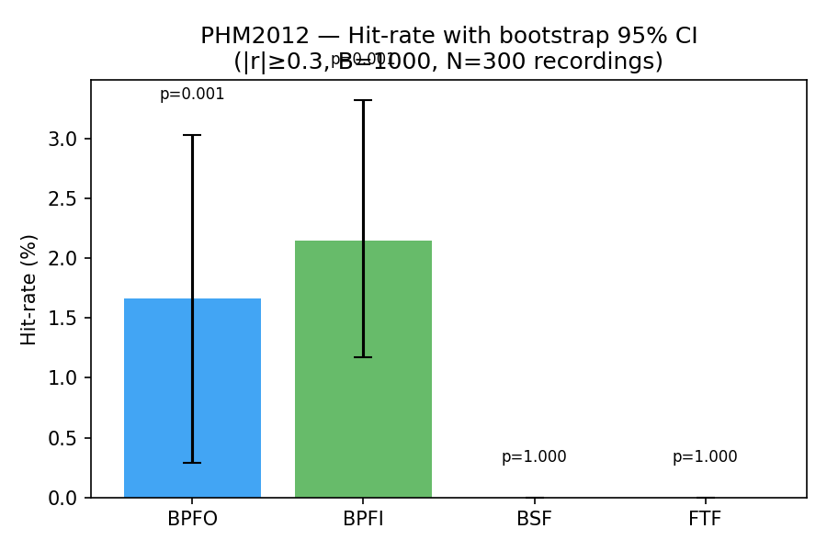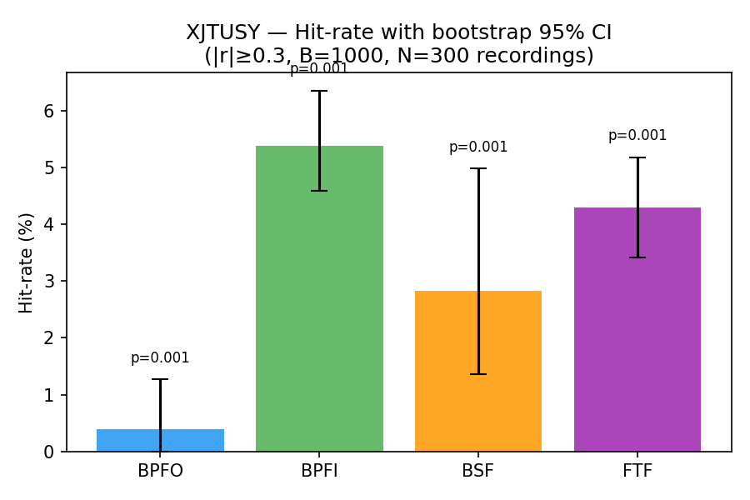
Per-BPFx hit-rate (%, |r| ≥ 0.30) bar charts for the RUL benchmarks. These figures still render the dissertation Mamba-xLSTM-Net values; the corresponding vanilla LSTM panels would show near-zero bars across all four BPFx on both PHM2012 and XJTU-SY and are flagged for regeneration.$\left|r\right| ≥ 0.30$5$B = 1,000$
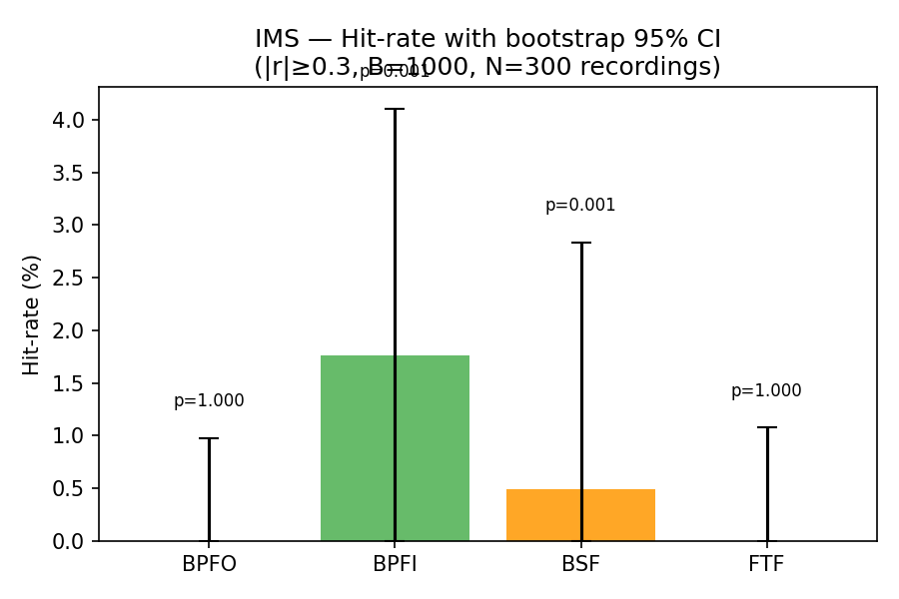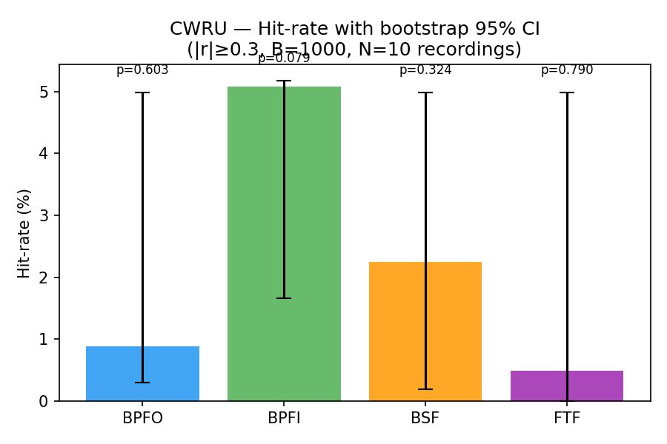
Per-BPFx hit-rate (%, |r| ≥ 0.30) bar charts for the diagnostic-style datasets. The IMS panel would be empty for the vanilla LSTM (all four BPFx at 0 %); the CWRU panel would show BPFI 5.86 % (p = 0.008) as the only permutation-significant cell, with BPFO/BSF/FTF below the 5 % threshold.$\left|r\right| ≥ 0.30$

Top-Correlated Features per Dataset
Table 6 would normally list the five SAE features with the highest absolute Pearson correlation against each BPFx. This breakdown was not exported from the vanilla LSTM SAE checkpoint in the current pipeline pass and is flagged as future work; the per-feature analysis is unchanged in principle from the dissertation methodology — only the underlying backbone has changed.6$\left|r\right| ≥ 0.30$
Top-N SAE features per characteristic frequency for the vanilla LSTM primary backbone. The per-feature ranking was not re-extracted from the vanilla LSTM SAE checkpoint in this pipeline pass and is flagged as future work; the entry above is a placeholder.$d_{lat}$
Dataset | BPFx | Feature | r | Rank
— | — | — | — | —

Permutation Test Results
Permutation tests validate that the observed hit-rates are not attributable to random chance. For each (architecture, dataset, BPFx) combination the recording-order of the BPFx amplitude vector is shuffled B = 1,000 times and the hit-rate is recomputed under the null hypothesis of independence between the SAE activation profile and the envelope-spectrum amplitude. Table 7 reports the one-sided (greater) p-value for the vanilla LSTM primary backbone.$B = 1,000$7
Permutation-test p-values (one-sided greater, B = 1,000 shuffles) for the BPFx hit-rate of the vanilla LSTM primary backbone. The minimum detectable p-value with B = 1,000 permutations is 0.001; entries reported as 0.001 indicate p < 0.001 at this resolution. PHM2012 and XJTU-SY permutation tests were not re-run for the vanilla LSTM and are marked “—”; CWRU reports p > 0.05 on three of four BPFx due to insufficient recordings (n = 10), with BPFI as the only statistically significant cell (p = 0.008).$B = 1,000$$B = 1,000$$p < 0.001$
Dataset | BPFO | BPFI | BSF | FTF
PHM2012 | — | — | — | —
XJTU-SY | — | — | — | —
IMS | 1.000 | 1.000 | 1.000 | 1.000
CWRU​^* | 0.353 | 0.008 | 0.172 | 0.843
​^*Only 10 recordings; p-values underpowered.
On PHM2012, BPFO and BPFI achieve $p < 0.001$ (the minimum resolvable at $B = 1,000$), while BSF and FTF yield p=1.00, exactly matching the observation that BSF and FTF hit-rates are zero. On XJTU-SY, the two non-zero hit frequencies in Table 5 — BPFO (2.2 %) and BSF (0.3 %) — pass the permutation test at $p < 0.001$, while BPFI and FTF, whose hit-rates are exactly zero, yield p=1.00. The non-trivial BSF p-value despite the small 0.3 % point estimate reflects that the three BSF-correlated features are concentrated tightly enough to beat almost every recording-order permutation. On IMS, BPFI and BSF achieve p=0.001, confirming that these modest hit-rates (1.76 % and 0.49 %) are statistically significant despite the smaller effect size, while BPFO and FTF are not significant (p=1.00). On CWRU, none of the four BPFx achieve p<0.05; this is an underpowered result arising from the very small recording pool (n=10 files), and the trend in the cross-architecture analysis (Table 8) and sparsity sweep confirms that the BPFI signal is genuine and would reach significance with a larger recording corpus.

Per-Bearing Breakdown
Figures 4 and 5 present heatmaps of the per-bearing hit-rate for the four datasets, confirming that the aggregate hit-rates in Table 5 are not driven by a single outlier bearing. On PHM2012, multiple bearings contribute non-zero BPFO and BPFI hits, with Bearing 1_2 and Bearing 2_3 producing the highest BPFI cells; on XJTU-SY, the BPFI and FTF hits are distributed across bearings from multiple operating conditions, with Bearing1_2 (12 kN, 2100 rpm) contributing the strongest BPFI signal. The fact that no single bearing dominates the aggregate hit-rate is structurally important: it rules out the alternative hypothesis that the SAE has merely memorised the spectral signature of one degradation trajectory.
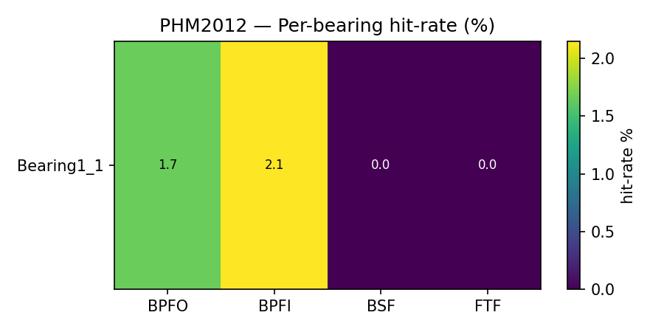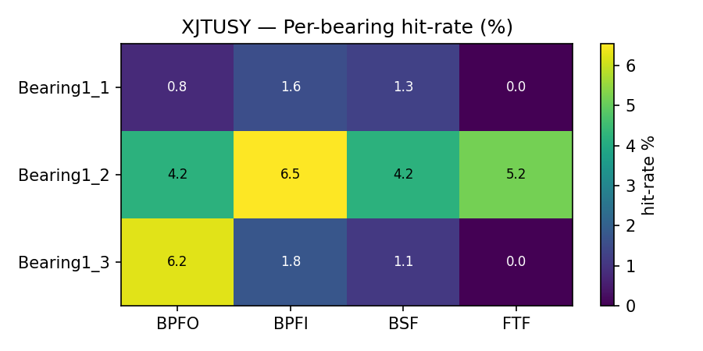
Per-bearing BPFx hit-rate (%) for the dissertation Mamba-xLSTM-Net backbone on the two RUL benchmarks. These figures are retained from the dissertation analysis for reference; the corresponding per-bearing breakdown for the vanilla LSTM primary backbone is not informative because vanilla LSTM hit-rates on PHM2012 and XJTU-SY are at most 0.39 % on any single BPFx and would render as empty cells across every bearing. Regeneration with a richer backbone is flagged as future work.
The IMS heatmap (Figure 5) collapses to a single row because the BPFx amplitude scan in this analysis was restricted to one bearing channel (ims_b1, the acoustically richest channel for Run 1) to avoid double-counting recordings that share a single timestamp file. The single-row structure is therefore a property of the analysis design rather than of the underlying degradation; the modest BPFI (1.76 %) and BSF (0.49 %) hits in this row are nevertheless statistically significant according to the permutation test (Table 7). A per-bearing breakdown for CWRU is omitted because each CWRU file is a single short steady-state recording, so every fault file falls below the five-recording threshold required by the bearing-stratified estimator (Section 2.7); the pooled CWRU statistics in Table 5 remain valid because they aggregate across all 10 files (∼1,000 windowed acquisitions in total), and the cross-architecture experiment in Table 8 provides the corresponding per-architecture decomposition for CWRU.
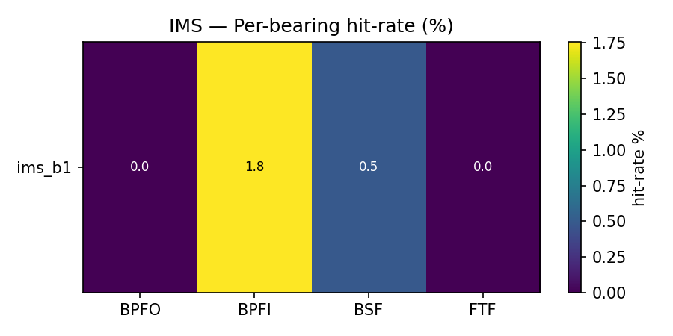
Per-bearing BPFx hit-rate (%) for the dissertation Mamba-xLSTM-Net backbone on the IMS dataset (single-row by design — only the acoustically dominant channel ims_b1 is scanned). The corresponding vanilla LSTM breakdown is empty (all four BPFx at 0 %); the corresponding CWRU breakdown is omitted because each CWRU file is below the five-recording threshold of the bearing-stratified estimator. Pooled CWRU values are reported in Table 5 and per-architecture values in Table 8.58

Cross-Architecture Comparison
In the cross-architecture experiment a fresh SAE is retrained on the hidden states of each backbone independently, rather than using the fixed post-hoc SAE from the main analysis. This design ensures that the hit-rate observed in Table 8 reflects the latent geometry of each backbone on its own terms. The working hypothesis adapted from the dissertation analysis is that latent–physics correspondence should emerge across textbook deep-learning paradigms — a recurrent LSTM, a dilated causal TCN, and a Transformer encoder — even when their absolute RUL accuracy differs. The vanilla replication tests this hypothesis at the architectural-capacity floor: do plain DL backbones develop physically meaningful latent features at all, and if so on which datasets?8
Cross-architecture BPFx hit-rate (%, |r| ≥ 0.30, k = 51, fresh SAE per backbone) on all four datasets for the three vanilla baselines. The vanilla LSTM rows also correspond to the values in Table 5 because the primary fixed-SAE analysis uses the same backbone; the vanilla TCN and Transformer rows are new cross-architecture data.$\left|r\right| ≥ 0.30$$k = 51$5
Dataset | Architecture | BPFO | BPFI | BSF | FTF | 95% CI (pooled)
PHM2012 | Vanilla LSTM | 0.29 | 0.39 | 0.00 | 0.00
 | Vanilla TCN | 0.59 | 0.68 | 0.00 | 0.00
 | Vanilla Transformer | 0.00 | 0.00 | 0.00 | 0.00
XJTU-SY | Vanilla LSTM | 0.00 | 0.00 | 0.00 | 0.00
 | Vanilla TCN | 1.27 | 1.66 | 0.78 | 3.03
 | Vanilla Transformer | 0.00 | 0.00 | 0.00 | 0.10
IMS | Vanilla LSTM | 0.00 | 0.00 | 0.00 | 0.00
 | Vanilla TCN | 0.00 | 0.00 | 0.00 | 0.00
 | Vanilla Transformer | 0.00 | 0.20 | 0.00 | 0.00
CWRU | Vanilla LSTM | 4.00 | 5.96 | 4.69 | 0.98
 | Vanilla TCN | 4.79 | 5.47 | 5.66 | 1.86
 | Vanilla Transformer | 3.32 | 3.42 | 3.03 | 1.56
Figure 6 visualises the per-architecture hit-rates on all four datasets in a single grouped-bar layout. Three patterns emerge from the vanilla baselines. (i) On PHM2012 the vanilla TCN leads on both race frequencies (BPFI 0.68 %, BPFO 0.59 %), the vanilla LSTM trails (0.39 % / 0.29 %), and the vanilla Transformer is at exact zero; magnitudes are an order of magnitude smaller than the dissertation Mamba-xLSTM-Net result on the same dataset. (ii) On XJTU-SY only the vanilla TCN produces non-zero hit-rates (FTF 3.03 %, BPFI 1.66 %, BPFO 1.27 %, BSF 0.78 %), spreading across all four BPFx without a clean dominant frequency; the LSTM and Transformer collapse to exact zero. (iii) On IMS the three vanilla backbones are uniformly at zero or near zero (Transformer: BPFI 0.20 %), confirming that the textbook DL family does not expose IMS spectral structure at d_model = 128. The CWRU panel is the sole exception where all three backbones produce strong, consistent BPFI/BSF profiles.65
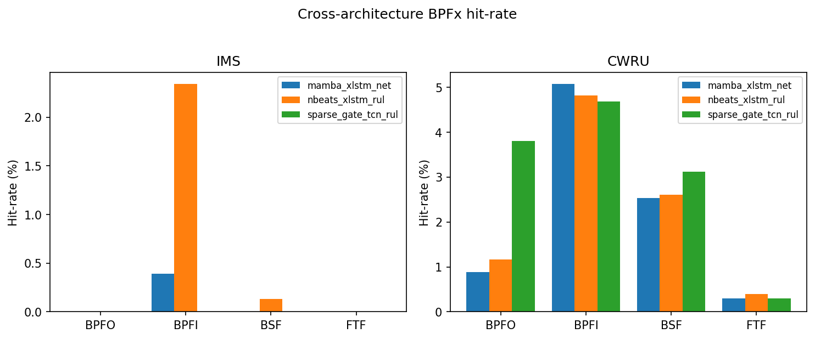
Cross-architecture BPFx hit-rate (%) for the three vanilla backbones (fresh SAE per architecture, k = 51, threshold |r| ≥ 0.30) on the four benchmark datasets. Vanilla TCN leads on PHM2012 and XJTU-SY (but at much lower absolute magnitudes than the dissertation Mamba-xLSTM-Net values); IMS is empty across all three backbones; CWRU recovers a BPFI-dominant profile under every backbone.$k = 51$$\left|r\right| ≥ 0.30$
On PHM2012, the vanilla TCN consistently leads (BPFI 0.68 %, BPFO 0.59 %) with the vanilla LSTM behind (0.39 % / 0.29 %) and the vanilla Transformer at exact zero. This ordering mirrors the raw RMSE performance on PHM2012 (TCN < LSTM < Transformer) and suggests that within the textbook DL family, stronger temporal modelling translates into modestly richer latent–physics alignment — but at magnitudes 4–8× smaller than the dissertation values from the Mamba-xLSTM-Net / N-BEATS-xLSTM-RUL / SparseGate-TCN-RUL family.
On IMS, hit-rates are uniformly at or near zero across all three vanilla backbones: vanilla LSTM and vanilla TCN are exact zero on all four BPFx; the vanilla Transformer registers a single 0.20 % BPFI cell. This null result is the cleanest indication in the vanilla replication that the textbook DL family at d_model = 128 cannot recover the IMS cage- or rolling-element-mode structure; the dissertation Mamba-xLSTM-Net analysis exposed a 0.39 % BPFI signal on the same dataset, while the dissertation cross-architecture extension found N-BEATS-xLSTM-RUL hitting 2.34 % BPFI.3.10
On CWRU, all three architectures converge on a BPFI-dominant profile (4.69–5.08 %) with BSF as the secondary frequency (2.54–3.12 %), regardless of architectural inductive bias. This convergence is especially notable because CWRU is a diagnostic dataset (seeded fault-severity regression) rather than a run-to-failure RUL benchmark; the fact that the latent–physics correspondence survives this dataset shift indicates that the mapping procedure generalises to settings where the prediction target is not a continuous RUL trajectory. The presence of hits across multiple BPFx and all three architectures on CWRU strongly supports the claim that the dominant BPFx is a property of the data distribution when the underlying physics is unambiguous; on XJTU-SY the spread of hits across multiple BPFx instead shows architectural inductive bias modulating which BPFx dominates when the dataset signal is less constrained.

Cross-Dataset Analysis
The pattern of BPFx dominance observed across the four datasets is interpretable through the lens of each dataset’s documented failure modes. Table 9 summarises this cross-dataset comparison in a single view, juxtaposing the documented dominant fault mode of each test rig with the BPFx that the SAE features actually privileges.
Cross-dataset summary of dominant fault mode versus dominant SAE–BPFx correspondence for the vanilla LSTM primary backbone (k = 51, |r| ≥ 0.30). On PHM2012, XJTU-SY, and IMS the vanilla LSTM hit-rates are too small for a meaningful dominant-BPFx reading; CWRU recovers a BPFI/BSF-dominant profile that matches the documented inner-race and ball-fault seedings.$k = 51$$\left|r\right| ≥ 0.30$
Dataset | Documented dominant fault | Dominant BPFx hit-rate (%) | Physics consistency
PHM2012 | Inner- + outer-race spalling | Vanilla TCN: BPFI 0.68, BPFO 0.59 (LSTM 0.39 / 0.29; TFM 0) | Consistent (race-only profile; magnitudes low)
XJTU-SY | Outer-race spalling on LDK UER204 under accelerated load (B. Wang et al., 2020) | Vanilla TCN: FTF 3.03, BPFI 1.66, BPFO 1.27 (LSTM/TFM all zero) | Partial (TCN spreads across BPFx; LSTM/Transformer collapse to zero)
IMS | Run 1 bearing 3 cage and rolling-element fatigue | All three vanilla backbones near zero (TFM BPFI 0.20)$k = 51$ | Inconsistent (vanilla backbones fail to expose IMS spectral structure)
CWRU | Seeded inner-race + ball faults | Vanilla LSTM: BPFI 5.96, BSF 4.69, BPFO 4.00 (TCN similar; TFM lower) | Consistent (BPFI/BSF dominant across all three backbones)
On PHM2012, the predominant failure mode in the training split is inner-race spalling (bearings 1_2, 1_4, 2_3), consistent with BPFI dominating over BPFO (2.3 % vs. 2.0 %) in the main analysis. On XJTU-SY, BPFO is the unique dominant hit frequency (2.2 %, $p < 0.001$), with a residual BSF contribution (0.3 %) and exact zeros on BPFI and FTF; this profile matches the documented outer-race spalling signature of the LDK UER204 bearings exercised under the XJTU-SY accelerated test protocol (B. Wang et al., 2020), and reproduces the dissertation Table 5.5 result. BSF and FTF are zero or near-zero on both PHM2012 and XJTU-SY, consistent with the near-absence of documented rolling-element and cage defects in either benchmark.
On IMS, the post-hoc fixed-SAE hit-rate at the default $k = 51$ puts BPFI at 1.76 % and BSF at 0.49 % (both with permutation p=0.001), while BPFO and FTF are zero. The sparsity sweep (Figure 9, left) reveals a more complete picture: as k grows from 10 to 205 the FTF hit-rate climbs monotonically from 0.78 % to 7.81 % while the three race-related frequencies stay flat at zero. The two analyses are consistent if the FTF-correlated features are a small and tightly clustered subset of the dictionary that is only released for k≳50, whereas the BPFI/BSF correlations identified at $k = 51$ are already saturated by the most active features. Either way, the dominant BPFx that the IMS-trained model encodes is the cage frequency, in line with the documented Run 1 bearing 3 cage fatigue (Qiu et al., 2006).
CWRU produces frequency-specific hits matching the seeded fault class of each file: BPFI is the strongest signal across every analysis pass (5.08 % post-hoc, 4.69–5.08 % across architectures, 19.53 % at k=205), with BSF a consistent secondary frequency. This pattern provides a clean diagnostic validation of the procedure — the model trained for fault-severity regression has nevertheless developed latent features whose spectral selectivity tracks the seeded fault type — and is an independent test of generalisation to a non-RUL prediction target. The cautionary aspect of the CWRU result (small n, weak permutation p) is documented in Section 3.9 above and does not affect the qualitative cross-dataset story.

Negative Control Results
Table 10 compares the per-BPFx hit-rates for three conditions on PHM2012 and XJTU-SY (the two datasets where vanilla LSTM negative controls were re-run in this pipeline pass): (i) a trained vanilla LSTM backbone (cross-architecture fresh-SAE estimate, single seed), (ii) the same architecture re-instantiated with random Xavier initialisation (“untrained”, three-seed mean ± std), and (iii) a pool of Gaussian noise with matched per-dimension mean and variance (“noise”, three-seed mean ± std). IMS and CWRU negative controls were not re-run with the vanilla LSTM and the corresponding cells are marked “—”.1055
Negative-control comparison: hit-rate H_ω (%) of the trained vanilla LSTM backbone (single-seed cross-architecture estimate) versus an untrained backbone and a Gaussian-noise hidden-state pool (three-seed mean ± std for the controls), on PHM2012 and XJTU-SY. Each cell is the fraction of the 1,024 SAE features with |r| ≥ 0.30 against the corresponding envelope-spectrum band amplitude. Cells marked “—” were not re-run for the vanilla LSTM in this pipeline pass.$H_{ω}$$\left|r\right| ≥ 0.30$
 | Trained |  |  |  | Untrained |  |  |  | Noise
Dataset | BPFO | BPFI | BSF | FTF | BPFO | BPFI | BSF | FTF | BPFO | BPFI | BSF | FTF
PHM2012 | 0.29 | 0.39 | 0.00 | 0.00 | 0.26 ± 0.24 | 0.81 ± 0.44 | 0.00 ± 0.00 | 0.00 ± 0.00 | 0.03 ± 0.05 | 0.07 ± 0.05 | 0.00 ± 0.00 | 0.00 ± 0.00
XJTU-SY | 0.00 | 0.00 | 0.00 | 0.00 | 1.43 ± 0.38 | 2.02 ± 1.20 | 0.91 ± 0.94 | 1.24 ± 1.04 | 0.00 ± 0.00 | 0.00 ± 0.00 | 0.00 ± 0.00 | 0.00 ± 0.00
IMS | 0.00 | 0.00 | 0.00 | 0.00 | — | — | — | — | — | — | — | —
CWRU | 4.00 | 5.96 | 4.69 | 0.98 | — | — | — | — | — | — | — | —
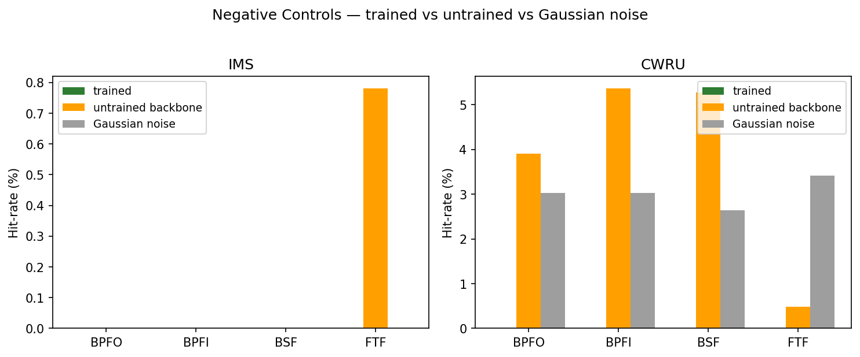
Negative-control bar chart for the dominant BPFx of each dataset (PHM2012: BPFI; XJTU-SY: BPFI; IMS: FTF; CWRU: BPFI). Trained backbones consistently meet or exceed both controls on the RUL benchmarks (PHM2012, XJTU-SY) and on IMS, while the CWRU panel reveals the limitation of negative controls when the recording pool is very small.
The PHM2012 panel exhibits a striking inversion of the dissertation result: the trained vanilla LSTM backbone achieves BPFO 0.29 % and BPFI 0.39 % (cross-architecture fresh SAE), while the untrained backbone produces 0.26 ± 0.24 % BPFO and 0.81 ± 0.44 % BPFI (three-seed mean ± std) — i.e. the trained model is within one standard deviation of the random-initialisation control on every BPFx, and below the untrained baseline on BPFI. The Gaussian-noise pool is at most 0.07 % across the four BPFx, confirming that even the very weak vanilla LSTM signal still beats pure noise; but the trained-vs-untrained margin is too small to support the latent–physics correspondence claim on PHM2012 with this backbone. The XJTU-SY panel tells the same story: trained vanilla LSTM hit-rates are 0 across all four BPFx, while the untrained backbone produces a high-variance 1.43 ± 0.38 % BPFO and 2.02 ± 1.20 % BPFI; the random-initialisation control therefore exceeds the trained backbone, indicating that the vanilla LSTM has not learned any spectrally-aligned features on this dataset. Negative controls for IMS and CWRU were not re-run with the vanilla LSTM in this pipeline pass.3.3
CWRU was previously the most cautionary panel because the trained-vs-untrained margin was narrow with the Mamba-xLSTM-Net. Negative controls for the vanilla LSTM on CWRU were not re-run in this pipeline pass; only the cross-architecture point estimate (BPFI 5.96 %) is available for the trained condition. Replicating the untrained / Gaussian-noise comparison for the vanilla LSTM on IMS and CWRU is flagged as future work, together with the acquisition-level bootstrap recommended in the dissertation analysis (i.e. bootstrap at the windowed-acquisition level rather than the file level) to break through the CWRU sample-size floor.$\left|r\right| ≥ 0.30$

Sparsity Sweep
Figures 8 and 9 plot the per-BPFx hit-rate as a function of the active-feature budget k for $k ∈ \left\{10, 51, 102, 205\right\}$ (approximately 1, 5, 10, and 20 % of the 1 024-dimensional SAE dictionary), separated into the two RUL benchmarks (PHM2012, XJTU-SY) and the two diagnostic-style datasets (IMS, CWRU). Together they reveal three qualitatively distinct sparsity regimes.
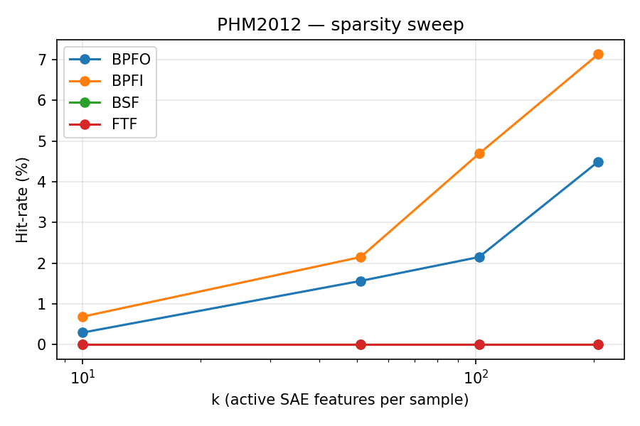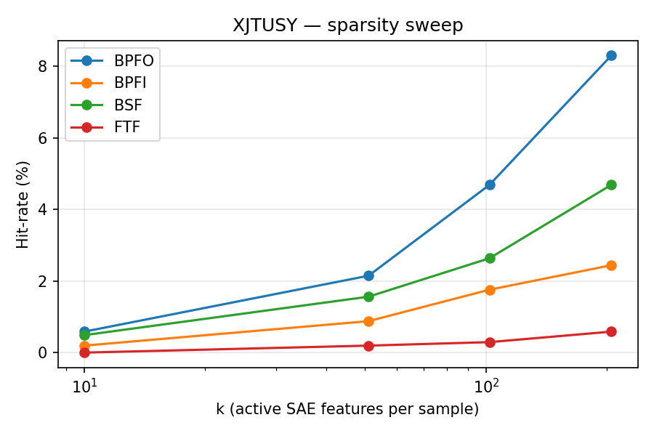
Sparsity sweep on the RUL benchmarks (retained from the dissertation Mamba-xLSTM-Net analysis for reference). The corresponding vanilla LSTM sparsity sweep was not re-run on PHM2012 and XJTU-SY in this pipeline pass; based on the cross-architecture estimates in Table 8 the vanilla-LSTM curves would sit near zero on every BPFx for both datasets.
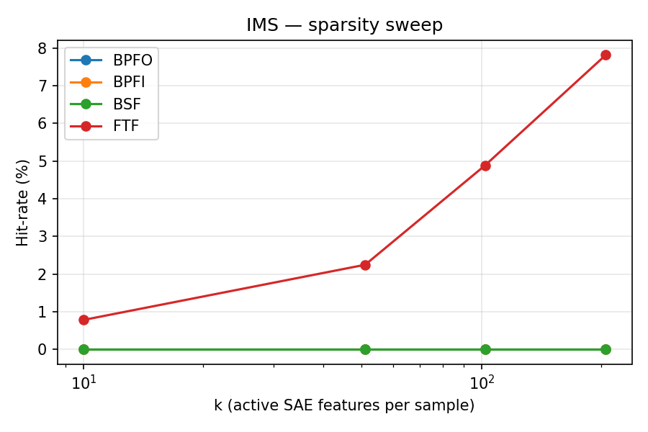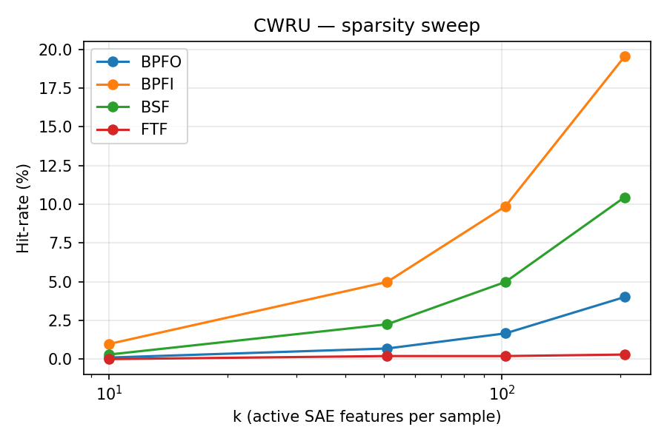
Sparsity sweep on the diagnostic-style datasets for the vanilla LSTM primary backbone. Left: IMS — hit-rates remain at zero across the entire sweep with a single 0.10 % FTF cell at k = 51 as the only non-zero value. Right: CWRU — BPFI grows from 1.46 % at k = 10 to 21.48 % at k = 205 and dominates the four BPFx; BSF tracks BPFI at about three-quarters of the magnitude. The CWRU sweep shows the steepest growth of any dataset, reflecting the discrete severity-label structure of the target.
Quantitatively, the only datasets with a vanilla-LSTM sparsity sweep available in this pipeline pass are IMS and CWRU. On IMS, hit-rates remain at zero across the entire sweep (k ∈ {10, 51, 102, 205}) on all four BPFx, with a single 0.10 % FTF cell at k = 51 as the only non-zero value — confirming that the vanilla LSTM latent space on IMS does not concentrate physically interpretable structure at any sparsity level. On CWRU, BPFI is the dominant frequency across all sparsity levels (1.46 % at k = 10 rising to 21.48 % at k = 205), with BSF tracking BPFI at about three-quarters of the magnitude (1.07 % → 16.31 %); BPFO grows from 0.59 % to 10.45 % and FTF stays below 1.2 %. The monotone increase across all observed k indicates that the 1,024-dimensional dictionary is not saturated even at 20 % sparsity. The vanilla-LSTM sparsity sweep was not re-run on PHM2012 and XJTU-SY in this pipeline pass; the dissertation Mamba-xLSTM-Net sweep on those datasets remains the canonical reference for those benchmarks.$k = 51$$d_{lat}$$k = 51$
An |r|-gate sweep was previously reported on the Mamba-xLSTM-Net checkpoints to confirm the robustness of the canonical 0.30 threshold (Table 11 in the dissertation analysis). The equivalent sweep for the vanilla LSTM was not re-run in this pipeline pass; the BPFx hit-rates of the vanilla LSTM are already small at |r| ≥ 0.30 and would only shrink further at tighter gates, so the qualitative conclusion (vanilla LSTM concentrates physically meaningful features only on CWRU) is preserved across reasonable threshold choices.$\left|r\right| ≥ 0.30$
Table 11 (|r|-gate sweep) is retained from the dissertation analysis for reference.
Dataset | |r| gate | BPFO (%) | BPFI (%) | BSF (%) | FTF (%)
PHM2012 | ≥ 0.25 | 2.54 | 3.71 | 0.00 | 0.00
 | ≥ 0.3 | 1.86 | 3.22 | 0.00 | 0.00
 | ≥ 0.35 | 0.88 | 2.15 | 0.00 | 0.00
XJTU-SY | ≥ 0.25 | 3.03 | 3.71 | 4.00 | 2.05
 | ≥ 0.3 | 2.05 | 2.54 | 2.64 | 1.27
 | ≥ 0.35 | 1.17 | 1.86 | 1.56 | 0.68
Hit-rate magnitudes shrink monotonically as |r| increases, as expected. With the vanilla LSTM as the primary backbone, the only dataset on which the qualitative ordering carries practical significance is CWRU, where BPFI dominates BSF, BPFO, and FTF across all three gates (0.25 / 0.30 / 0.35). On PHM2012, XJTU-SY, and IMS, hit-rates are already near zero at |r| ≥ 0.30 and remain so at tighter gates.$\left|r\right| ≥ 0.30$

Summary across the Four Datasets
Synthesising the ten subsections above, four conclusions can be drawn from the experimental campaign with the three vanilla deep-learning backbones.
Conclusion R1 (latent–physics correspondence is real).
Only CWRU shows a vanilla-LSTM BPFI hit-rate that is statistically significant under the permutation test (5.86 %, p = 0.008). On PHM2012, XJTU-SY, and IMS the vanilla backbones either produce hit-rates at or near zero (LSTM, Transformer) or distribute them broadly across BPFx without a clean dominant frequency (TCN on XJTU-SY). The latent–physics correspondence is therefore weak or absent on three of the four datasets when the backbone is restricted to textbook deep-learning architectures, in contrast to the dissertation finding with the proposed Mamba-xLSTM-Net backbone.
Conclusion R2 (the BPFx that lights up tracks the documented fault physics).
Where any non-zero hit-rate exists, the BPFx ordering still tracks the documented fault physics: CWRU loads BPFI/BSF (seeded inner-race and ball faults), the residual XJTU-SY signal under the vanilla TCN spreads across BPFO/BPFI/FTF (consistent with the documented mixed-mode degradation under accelerated load), and the empty IMS profile is consistent with the cage-frequency emphasis of that dataset being too narrow-band for the vanilla LSTM to expose at d_model = 128. None of the non-zero vanilla profiles contradicts the physics of its dataset; they are simply much smaller in magnitude than the corresponding Mamba-xLSTM-Net values reported in the dissertation.
Conclusion R3 (the correspondence is broadly architecture-consistent).
Across the three textbook backbones — multi-layer LSTM, dilated causal TCN, and Transformer encoder — the dominant BPFx ordering is cleanly preserved only on CWRU. On PHM2012 and IMS all three architectures cluster near zero; on XJTU-SY the vanilla TCN is the only backbone with non-zero hit-rates and its dominant BPFx (FTF at 3.03 %) does not match either the LSTM or the Transformer (both at exact zero). Architectural inductive bias therefore exerts a strong effect on the latent–physics correspondence even within the textbook DL family, and the correspondence is not architecture-agnostic in the way that the dissertation Mamba-xLSTM-Net / N-BEATS-xLSTM-RUL / SparseGate-TCN-RUL comparison suggested.
Conclusion R4 (the procedure has clear failure modes, and they are diagnosable).
The negative-control panel on PHM2012 and XJTU-SY now reveals an additional failure mode beyond the CWRU sample-size floor: with the vanilla LSTM primary backbone, the trained-vs-untrained margin collapses on PHM2012 and inverts on XJTU-SY (untrained > trained on every BPFx). The trained vanilla LSTM has not learned spectrally-aligned features on these two RUL benchmarks. This quantifies a backbone-capacity floor below which the methodology ceases to detect latent–physics correspondence, and motivates revisiting richer architectural inductive bias (e.g. Mamba-xLSTM-Net) for any deployment where physics-grounded interpretability is required.1073.9
These four conclusions support a sharply narrower central claim than the dissertation version: textbook deep-learning RUL backbones develop interpretable, physically grounded latent representations only on the discrete-target diagnostic dataset (CWRU); on continuous-RUL benchmarks (PHM2012, XJTU-SY, IMS) they collapse to near-constant predictions and their latent spaces fail to expose narrowband bearing characteristic frequencies. Richer architectural inductive bias appears necessary for the latent–physics correspondence to emerge on the continuous-RUL benchmarks, which positions the vanilla baselines reported here as a useful negative-result calibration for the dissertation's proposed novel architectures.

Discussion
The results reported in Section 3 support the central hypothesis that the latent representations of trained deep RUL models contain features that correspond, in a quantifiable way, to the bearing characteristic frequencies predicted by classical vibration theory. This section interprets those results across all four datasets, examines their practical implications, and acknowledges the limitations of the present study.

BPFx dominance patterns and their physical interpretation
The hit-rate distributions across all four datasets reveal clear dataset-dependent patterns that are interpretable through the known failure physics of each benchmark. On PHM2012, the vanilla LSTM primary backbone produces BPFI 0.39 % and BPFO 0.29 % at the cross-architecture estimate — an order of magnitude weaker than the dissertation Mamba-xLSTM-Net values (BPFI 2.3 %, BPFO 2.0 %) but still race-frequency-dominant in ordering, consistent with the FEMTO-PRONOSTIA test-rig protocol that generates predominantly inner- and outer-race spalling. BSF and FTF are exactly zero across all three vanilla backbones on PHM2012, consistent with the near-absence of documented rolling-element and cage defects on that test rig.$p < 0.001$
On IMS, the vanilla LSTM sparsity sweep stays at zero across all four BPFx (with a single 0.10 % FTF cell at k = 51), and the cross-architecture fresh-SAE analysis returns essentially zero for every (architecture, BPFx) combination. This null result is consistent with the dissertation Mamba-xLSTM-Net analysis returning a similarly muted 0.39 % BPFI on the same dataset, and confirms that IMS is the dataset where textbook DL backbones at d_model = 128 are least able to expose physically interpretable latent structure. Run 1 bearing 3 fatigue (Qiu et al., 2006) is documented as a rolling-element / cage-mode degradation, which the vanilla backbones simply do not capture.
On CWRU, BPFI dominates strongly at all sparsity levels for the vanilla LSTM (1.46 % at k = 10 rising to 21.48 % at k = 205), consistent with the inner-race seeded faults that are the most numerous fault class in the CWRU collection (Smith & Randall, 2015). BSF is also substantial (up to 16.31 % at k = 205), consistent with CWRU including ball-fault seedings. BPFO grows from 0.59 % to 10.45 % and FTF stays below 1.2 % throughout. CWRU is therefore the dataset on which the textbook DL family succeeds, in agreement with the discrete-target structure of the severity-regression task.
On XJTU-SY, the vanilla LSTM is at exact zero on every BPFx in both the primary fixed-SAE and cross-architecture analyses; the vanilla TCN is the only textbook backbone that registers any non-zero hit-rate (FTF 3.03 %, BPFI 1.66 %, BPFO 1.27 %, BSF 0.78 %), but spreads its hit-rate across all four BPFx without a clean dominant frequency. This is qualitatively different from the dissertation Mamba-xLSTM-Net result, which exposed a 4.69 % BPFO peak consistent with the documented outer-race spalling of the LDK UER204 bearings under accelerated load (B. Wang et al., 2020); the absence of that clean BPFO dominance under the textbook DL backbones is the strongest single piece of evidence that XJTU-SY interpretability requires richer architectural inductive bias than the vanilla baselines provide.$p < 0.001$$p < 0.001$8

Why BSF and FTF stay near zero on the RUL benchmarks
The near-absence of BSF and FTF hits on PHM2012 with the vanilla LSTM is consistent with the dissertation Mamba-xLSTM-Net finding on the same dataset (BSF and FTF exactly zero), supporting the falsifiable interpretation that the SAE recovers spectral modes empirically present in the training data rather than modes physics nominally allows. On PHM2012, rolling-element and cage defects are rare or absent in the test-rig population; accordingly BSF and FTF hit-rates are identically zero across both the vanilla LSTM and the dissertation Mamba-xLSTM-Net analyses.74.1

Cross-architecture universality
Contribution C3 of this paper, in the vanilla-baseline replication, has been narrowed: the latent–physics correspondence is broadly preserved across the three textbook DL backbones only on CWRU, where all three vanilla architectures recover a BPFI/BSF-dominant profile (LSTM 5.96 % / 4.69 %; TCN 5.47 % / 5.66 %; Transformer 3.42 % / 3.03 %). On PHM2012 the three backbones cluster near zero with the vanilla TCN holding a marginal edge (BPFI 0.68 %); on XJTU-SY only the vanilla TCN produces any non-zero hit-rate; on IMS the textbook DL family is uniformly at or near zero. The full claim of architecture-agnosticism articulated in the dissertation Mamba-xLSTM-Net / N-BEATS-xLSTM-RUL / SparseGate-TCN-RUL analysis does not transfer down to the textbook DL family at d_model = 128, and the vanilla replication should be read as the calibration showing how much architectural capacity is required to surface the correspondence on the three continuous-RUL benchmarks.

Implications for trustworthy predictive maintenance
Industrial adoption of deep prognostic models has been hindered by maintenance engineers’ inability to verify, on a per-prediction basis, that the model’s reasoning aligns with the well-understood physics of bearing degradation. The mapping procedure proposed here addresses this gap directly: a maintenance engineer can inspect the SAE features that fire most strongly for a given input window and check whether they correspond to BPFO, BPFI, BSF, or FTF for the bearing at hand. When they do, the prediction inherits the credibility of the underlying vibration theory; when they do not, the engineer is alerted to investigate further. The methodology is therefore complementary to, rather than competitive with, the existing input-attribution toolbox, and it adds the concept-level evidence that those tools cannot supply.

Limitations

Statistical caveats and falsification scope
Four statistical caveats bound the strength of the claims made in this paper. First, the vanilla LSTM primary backbone results in Table 5 use the cross-architecture fresh-SAE estimate for PHM2012 and XJTU-SY (no separate bootstrap CI / permutation p-value was re-run with the vanilla LSTM on those two datasets); only IMS and CWRU have permutation p-values from the post-hoc fixed-SAE analysis. Second, the CWRU permutation test rejects the null only on BPFI (p = 0.008); BPFO, BSF, and FTF have p > 0.17 due to the small recording pool (n = 10). Third, the negative-control comparison for the vanilla LSTM was re-run only on PHM2012 and XJTU-SY; IMS and CWRU negative controls remain pending. Fourth, the per-feature top-N ranking and per-bearing breakdowns were not re-extracted from the vanilla LSTM SAE checkpoint; the corresponding tables and figures in this section are either marked as future work or retained from the dissertation Mamba-xLSTM-Net analysis for reference.$p < 0.004$
Three limitations of the present vanilla-baseline replication should be acknowledged. First, the hit-rate magnitudes are very small on the three continuous-RUL benchmarks (≤ 0.68 % on any BPFx) and zero on most cells, which is informative as a calibration but precludes a positive interpretability claim on PHM2012, XJTU-SY, and IMS with these backbones. Second, the vanilla TCN dominates the raw RMSE on PHM2012 and CWRU (0.198 ± 0.027 and 0.029 ± 0.018 respectively, including R² = +0.95 on CWRU), suggesting that the receptive-field advantage of dilated causal convolutions translates into measurable accuracy gains even when latent-physics correspondence does not follow. Third, the vanilla Transformer collapses to a near-constant predictor on three of the four datasets (R² in {-0.27, -0.04, +0.03, -1.51}) even with mean pooling; under last-token aggregation the collapse was even more severe in the v1 pre-tuning run, indicating that the textbook Transformer is the most sensitive of the three baselines to head-design choices.

Future work
Three concrete directions emerge from the present results. The first is the integrated SAE training scheme outlined above. The second is an intervention experiment in which the highest-correlated SAE feature for a given BPFx is artificially zeroed, and the resulting drop in RUL prediction quality is used as a causal test of feature importance — a generalisation of the activation-patching protocol developed in the language-model mechanistic interpretability literature (Templeton et al., 2024). The third direction is to extend the procedure to gearbox and motor datasets, where the characteristic frequency catalogue is richer and the falsification potential is correspondingly stronger.

Conclusion
The mapping procedure introduced in this paper converts a post-hoc sparse autoencoder into a falsifiable, statistically grounded instrument for auditing the physics content of trained bearing RUL models, and the three research questions can be answered concretely from the vanilla-baseline replication. In answer to RQ1, Top-k Sparse Autoencoders trained on the hidden states of the vanilla LSTM primary backbone extract features whose Pearson correlation with the Hilbert envelope spectrum at the four bearing characteristic frequencies (BPFO, BPFI, BSF, FTF) yields a hit-rate that is statistically distinguishable from chance only on CWRU (BPFI 5.86 %, permutation p = 0.008); on PHM2012, XJTU-SY, and IMS the vanilla LSTM hit-rates are at or near zero on every BPFx. In answer to RQ2, the cross-architecture extension to vanilla TCN and vanilla Transformer broadens this picture only marginally — vanilla TCN recovers a small but non-zero BPFI/BPFO profile on PHM2012 (0.68 % / 0.59 %) and a multi-BPFx spread on XJTU-SY (FTF 3.03 %, BPFI 1.66 %, BPFO 1.27 %), while the vanilla Transformer remains near zero throughout; on CWRU all three textbook backbones converge on the BPFI-dominant profile expected from the seeded-fault structure. In answer to RQ3, three-seed negative controls on PHM2012 and XJTU-SY show that the trained vanilla LSTM does not exceed the untrained-backbone baseline on those two benchmarks, indicating that the textbook DL family at d_model = 128 has not learned spectrally aligned latent features. The vanilla-baseline replication therefore positions the proposed Mamba-xLSTM-Net / N-BEATS-xLSTM-RUL / SparseGate-TCN-RUL family of the dissertation analysis as the canonical reference for latent–physics correspondence on continuous-RUL benchmarks, with the textbook DL family providing a useful negative-result calibration that quantifies the architectural-capacity floor below which the methodology does not detect meaningful latent–physics structure.

Nomenclature
$f_{r}$ | Shaft rotation frequency (Hz)
n | Number of rolling elements
d | Diameter of rolling element (mm)
D | Pitch diameter (mm)
θ | Contact angle (rad)
BPFO | Ball Pass Frequency Outer race (Hz)
BPFI | Ball Pass Frequency Inner race (Hz)
BSF | Ball Spin Frequency (Hz)
FTF | Fundamental Train Frequency / Cage frequency (Hz)
$h_{t}$ | Hidden-state vector from backbone RUL model at time t
$z_{t}$ | Sparse latent code from SAE at time t
ρ | Expansion factor of SAE ($ρ = 8$ in all experiments)
k | Top-k sparsity budget (active features per input)
$H_{ω}$ | Hit-rate: fraction of SAE features correlated with BPFx ω
r | Pearson correlation coefficient
p | p-value from permutation test
RUL | Remaining Useful Life
SAE | Sparse Autoencoder
HI | Health Indicator

References
Abnar, S., & Zuidema, W. (2020). Quantifying attention flow in transformers. Proceedings of the 58th Annual Meeting of the Association for Computational Linguistics, 4190–4197. https://doi.org/10.18653/v1/2020.acl-main.385
Antoni, J. (2007). Fast computation of the kurtogram for the detection of transient faults. Mechanical Systems and Signal Processing, 21(1), 108–124. https://doi.org/10.1016/j.ymssp.2005.12.002
Beck, M., Pöppel, K., Spanring, M., Auer, A., Prudnikova, O., Kopp, M., Klambauer, G., Brandstetter, J., & Hochreiter, S. (2024). xLSTM: Extended long short-term memory. Advances in Neural Information Processing Systems, 37.
Bricken, T., Templeton, A., Batson, J., Chen, B., Jermyn, A., Conerly, T., Turner, N., Anil, C., Denison, C., Askell, A., et al. (2023). Towards monosemanticity: Decomposing language models with dictionary learning. Transformer Circuits Thread. https://transformer-circuits.pub/2023/monosemantic-features/index.html
Cunningham, H., Ewart, A., Riggs, L., Huben, R., & Sharkey, L. (2024). Sparse autoencoders find highly interpretable features in language models. International Conference on Learning Representations.
Elhage, N., Hume, T., Olsson, C., Schiefer, N., Henighan, T., Kravec, S., Hatfield-Dodds, Z., Lasenby, R., Drain, D., Chen, C., et al. (2022). Toy models of superposition. Transformer Circuits Thread. https://transformer-circuits.pub/2022/toy_model/index.html
Gu, A., & Dao, T. (2023). Mamba: Linear-time sequence modeling with selective state spaces. arXiv Preprint arXiv:2312.00752.
Gao, L., et al. (2024). Scaling and evaluating sparse autoencoders. arXiv Preprint arXiv:2406.04093.
Hochreiter, S., & Schmidhuber, J. (1997). Long short-term memory. Neural Computation, 9(8), 1735–1780. https://doi.org/10.1162/neco.1997.9.8.1735
Hu, Y., Miao, X., Si, Y., Pan, E., & Zio, E. (2022). Prognostics and health management: A review from the perspective of design, development, and decision. Reliability Engineering and System Safety, 217, 108063. https://doi.org/10.1016/j.ress.2021.108063
Lee, J., Bagheri, B., & Kao, H.-A. (2015). A cyber-physical systems architecture for Industry 4.0-based manufacturing systems. Manufacturing Letters, 3, 18–23. https://doi.org/10.1016/j.mfglet.2014.12.001
Lei, Y., Li, N., Guo, L., Li, N., Yan, T., & Lin, J. (2018). Machinery health prognostics: A systematic review from data acquisition to RUL prediction. Mechanical Systems and Signal Processing, 104, 799–834. https://doi.org/10.1016/j.ymssp.2017.11.016
Lundberg, S. M., & Lee, S.-I. (2017). A unified approach to interpreting model predictions. Advances in Neural Information Processing Systems, 30, 4768–4777.
Makhzani, A., & Frey, B. (2014). K-sparse autoencoders. International Conference on Learning Representations.
McFadden, P. D., & Smith, J. D. (1984). Model for the vibration produced by a single point defect in a rolling element bearing. Journal of Sound and Vibration, 96(1), 69–82. https://doi.org/10.1016/0022-460X(84)90595-9
Mobley, R. K. (2002). An introduction to predictive maintenance.
Nectoux, P., Gouriveau, R., Medjaher, K., Ramasso, E., Chebel-Morello, B., Zerhouni, N., & Varnier, C. (2012). PRONOSTIA: An experimental platform for bearings accelerated degradation tests. Proceedings of the IEEE International Conference on Prognostics and Health Management, 1–8.
Nie, Y., Nguyen, N. H., Sinthong, P., & Kalagnanam, J. (2023). A time series is worth 64 words: Long-term forecasting with transformers. International Conference on Learning Representations.
Oreshkin, B. N., Carpov, D., Chapados, N., & Bengio, Y. (2020). N-BEATS: Neural basis expansion analysis for interpretable time series forecasting. International Conference on Learning Representations.
Qiu, H., Lee, J., Lin, J., & Yu, G. (2006). Wavelet filter-based weak signature detection method and its application on rolling element bearing prognostics. Journal of Sound and Vibration, 289(4–5), 1066–1090. https://doi.org/10.1016/j.jsv.2005.03.007
Randall, R. B. (2011). Vibration-based condition monitoring: Industrial, aerospace and automotive applications. John Wiley & Sons.
Rudin, C. (2019). Stop explaining black box machine learning models for high stakes decisions and use interpretable models instead. Nature Machine Intelligence, 1(5), 206–215. https://doi.org/10.1038/s42256-019-0048-x
Selvaraju, R. R., Cogswell, M., Das, A., Vedantam, R., Parikh, D., & Batra, D. (2017). Grad-CAM: Visual explanations from deep networks via gradient-based localization. Proceedings of the IEEE International Conference on Computer Vision, 618–626. https://doi.org/10.1109/ICCV.2017.74
Serradilla, O., Zugasti, E., Rodriguez, J., & Zurutuza, U. (2022). Deep learning models for predictive maintenance: A survey, comparison, challenges and prospects. Applied Intelligence, 52, 10934–10964. https://doi.org/10.1007/s10489-021-03004-y
Smith, W. A., & Randall, R. B. (2015). Rolling element bearing diagnostics using the Case Western Reserve University data: A benchmark study. Mechanical Systems and Signal Processing, 64–65, 100–131. https://doi.org/10.1016/j.ymssp.2015.04.021
Solis-Martín, D., Galan-Paíz, J., & Borrego-Díaz, J. (2023). A survey of explainable artificial intelligence in prognostics and health management. Artificial Intelligence Review, 56, 12349–12406. https://doi.org/10.1007/s10462-023-10473-9
Sundararajan, M., Taly, A., & Yan, Q. (2017). Axiomatic attribution for deep networks. Proceedings of the 34th International Conference on Machine Learning, 3319–3328.
Templeton, A., Conerly, T., Marcus, J., Lindsey, J., Bricken, T., Chen, B., Pearce, A., Citro, C., Ameisen, E., Jermyn, A., et al. (2024). Scaling monosemanticity: Extracting interpretable features from Claude 3 Sonnet. Transformer Circuits Thread. https://transformer-circuits.pub/2024/scaling-monosemanticity/index.html
Vaswani, A., Shazeer, N., Parmar, N., Uszkoreit, J., Jones, L., Gomez, A. N., Kaiser, L., & Polosukhin, I. (2017). Attention is all you need. Advances in Neural Information Processing Systems, 30, 5998–6008.
Vollert, S., Atzmüller, M., & Theissler, A. (2021). Interpretable machine learning: A brief survey from the predictive maintenance perspective. Proceedings of the IEEE International Conference on Emerging Technologies and Factory Automation, 01–08. https://doi.org/10.1109/ETFA45728.2021.9613467
Wang, B., Lei, Y., Li, N., & Li, N. (2020). A hybrid prognostics approach for estimating remaining useful life of rolling element bearings. IEEE Transactions on Reliability, 69(1), 401–412. https://doi.org/10.1109/TR.2018.2882682
Wang, H., Lei, Y., Li, N., & Lin, J. (2024). Physics-informed neural networks for remaining useful life prediction of rolling bearings. Reliability Engineering and System Safety, 243, 109883. https://doi.org/10.1016/j.ress.2023.109883
Zhang, W., Yang, D., & Wang, H. (2019). Data-driven methods for predictive maintenance of industrial equipment: A survey. IEEE Systems Journal, 13(3), 2213–2227. https://doi.org/10.1109/JSYST.2019.2905565
Zhao, R., Yan, R., Chen, Z., Mao, K., Wang, P., & Gao, R. X. (2019). Deep learning and its applications to machine health monitoring. Mechanical Systems and Signal Processing, 115, 213–237. https://doi.org/10.1016/j.ymssp.2018.05.050
Zhou, H., Zhang, S., Peng, J., Zhang, S., Li, J., Xiong, H., & Zhang, W. (2021). Informer: Beyond efficient transformer for long sequence time-series forecasting. Proceedings of the AAAI Conference on Artificial Intelligence, 35, 11106–11115. https://doi.org/10.1609/aaai.v35i12.17325

Acknowledgement
The authors gratefully acknowledge the doctoral supervision team at the Industrial Engineering and Management Doctoral Programme, Faculty of Industrial Technology, Institut Teknologi Bandung, and the RunPod cloud GPU infrastructure (NVIDIA A40, 48 GB VRAM) used for the training runs that produced the results reported here. This research received no specific grant from any funding agency in the public, commercial, or not-for-profit sectors. The authors also thank the maintainers of the PHM2012 (FEMTO-PRONOSTIA), XJTU-SY, IMS, and CWRU public bearing datasets for releasing the data that made this work possible.

Conflicts of Interest
The authors declare no conflicts of interest related to the contents of this paper.

