I. GitHub

Link: <https://github.com/ekkrug/CPSC224_02_Group1>

Below is a screenshot from the main page of our GitHub repository.





II. JUnit

A. DieTest.java

package yahtzee;

import static org.junit.jupiter.api.Assertions.\*;

import org.junit.jupiter.api.AfterAll;

import org.junit.jupiter.api.AfterEach;

import org.junit.jupiter.api.BeforeAll;

import org.junit.jupiter.api.BeforeEach;

import org.junit.jupiter.api.Test;

class DieTest {

@Test

void test() {

Die testDie = new Die();

testDie.roll();

assertEquals(8,testDie.getValue(), 7);

if(testDie.getValue() == 3 || testDie.getValue() == 4 || testDie.getValue() == 5 ||

testDie.getValue() == 7 || testDie.getValue() == 13 || testDie.getValue() == 15)

assertTrue(testDie.getPosition() == "FORWARD");

else

assertTrue(testDie.getPosition() == "GUARD");

if(testDie.getValue() == 9 || testDie.getValue() == 10 || testDie.getValue() == 11 ||

testDie.getValue() == 13 || testDie.getValue() == 15)

assertTrue(testDie.getStatus() == "STARTER");

else

assertTrue(testDie.getStatus() == "BENCH");

if(testDie.getValue() ==1)

assertTrue("Joel Ayayi" == testDie.getName());

else if(testDie.getValue() == 2)

assertTrue("Jack Beach" == testDie.getName());

else if(testDie.getValue() == 3)

assertTrue("Brandon Clarke" == testDie.getName());

else if(testDie.getValue() == 4)

assertTrue("Rui Hachimura" == testDie.getName());

else if(testDie.getValue() == 5)

assertTrue("Jeremy Jones" == testDie.getName());

else if(testDie.getValue() == 6)

assertTrue("Corey Kispert" == testDie.getName());

else if(testDie.getValue() == 7)

assertTrue("Jacob Larson" == testDie.getName());

else if(testDie.getValue() == 8)

assertTrue("Alex Martin" == testDie.getName());

else if(testDie.getValue() == 9)

assertTrue("Silas Melson" == testDie.getName());

else if(testDie.getValue() == 10)

assertTrue("Zach Norvell Jr." == testDie.getName());

else if(testDie.getValue() == 11)

assertTrue("Josh Perkins" == testDie.getName());

else if(testDie.getValue() == 12)

assertTrue("Brian Pete" == testDie.getName());

else if(testDie.getValue() == 13)

assertTrue("Killian Tillie" == testDie.getName());

else if(testDie.getValue() == 14)

assertTrue("Jesse Wade" == testDie.getName());

else if(testDie.getValue() == 15)

assertTrue("Jonathan Williams" == testDie.getName());

}

}

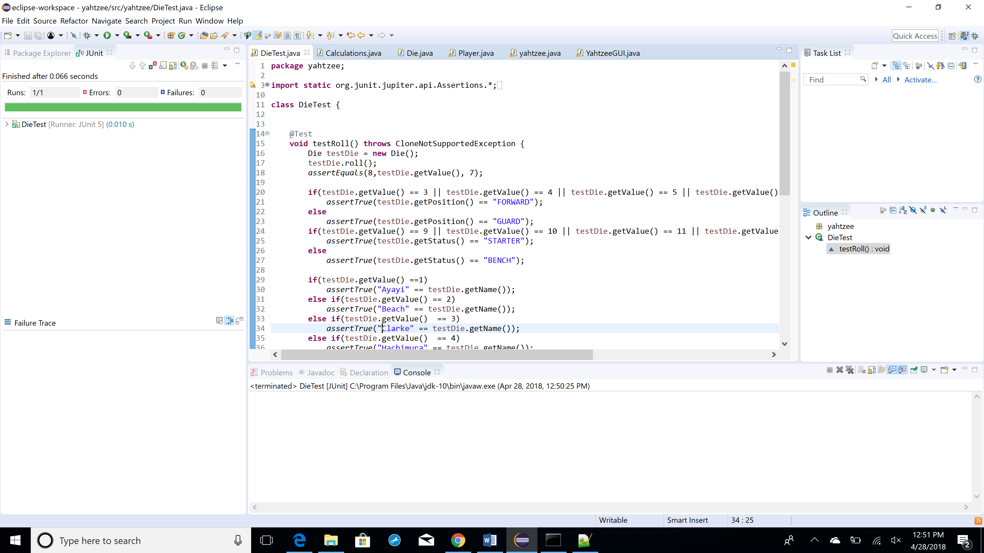

B. PlayerTest.java

(Code is on three pages.)

package yahtzee;

import static org.junit.jupiter.api.Assertions.\*;

import org.junit.Assert;

import org.junit.Test;

public class PlayerTest {

@Test

public void testPlayersetup() {

Player testPlayer = new Player();

Assert.assertNotNull(testPlayer.hand);

assertEquals(testPlayer.numberRows, 22);

assertEquals(testPlayer.bonusLine, 22);

assertEquals(testPlayer.scoringCard.length, testPlayer.numberRows);

assertEquals(testPlayer.canPlaceScoreCard.length, testPlayer.numberRows);

assertEquals(testPlayer.athleteNames.length, Die.numberOfSides);

for(int i = 0; i < testPlayer.numberRows; i++)

{

assert(testPlayer.scoringCard[i] == 0);

assert(testPlayer.canPlaceScoreCard[i] == true);

}

assert(testPlayer.athleteNames[0] == "Joel Ayayi");

assert(testPlayer.athleteNames[1] == "Jack Beach");

assert(testPlayer.athleteNames[2] == "Brandon Clarke");

assert(testPlayer.athleteNames[3] == "Rui Hachimura");

assert(testPlayer.athleteNames[4] == "Jeremy Jones");

assert(testPlayer.athleteNames[5] == "Corey Kispert");

assert(testPlayer.athleteNames[6] == "Jacob Larson");

assert(testPlayer.athleteNames[7] == "Alex Martin");

assert(testPlayer.athleteNames[8] == "Silas Melson");

assert(testPlayer.athleteNames[9] == "Zach Norvell Jr.");

assert(testPlayer.athleteNames[10] == "Josh Perkins");

assert(testPlayer.athleteNames[11] == "Brian Pete");

assert(testPlayer.athleteNames[12] == "Killian Tillie");

assert(testPlayer.athleteNames[13] == "Jesse Wade");

assert(testPlayer.athleteNames[14] == "Jonathan Williams");

}

assert(testPlayer.athleteNames[13] == "Jesse Wade");

assert(testPlayer.athleteNames[14] == "Jonathan Williams");

}

@Test

public void testPlayerName() {

Player testPlayer = new Player();

testPlayer.setName("bob");

assert("bob" == testPlayer.getName());

}

@Test

public void canPrintTest() {

Player testPlayer = new Player();

assert(testPlayer.canPrint(5) == true);

testPlayer.scoringCard[5] = 50;

testPlayer.canPlaceScoreCard[5] = false;

assert(testPlayer.canPrint(5) == false);

}

@Test

public void totalValueTest() {

Player testPlayer = new Player();

assert(testPlayer.totalValue() == 0);

testPlayer.scoringCard[0] = 10;

testPlayer.canPlaceScoreCard[0] = false;

assert(testPlayer.totalValue() == 10);

testPlayer.scoringCard[1] = 10;

testPlayer.canPlaceScoreCard[1] = false;

assert(testPlayer.totalValue() == 20);

testPlayer.scoringCard[2] = 10;

testPlayer.canPlaceScoreCard[2] = false;

assert(testPlayer.totalValue() == 30);

testPlayer.scoringCard[3] = 10;

testPlayer.canPlaceScoreCard[3] = false;

assert(testPlayer.totalValue() == 40);

testPlayer.scoringCard[4] = 10;

testPlayer.canPlaceScoreCard[4] = false;

assert(testPlayer.totalValue() == 50);

testPlayer.scoringCard[5] = 10;

testPlayer.canPlaceScoreCard[5] = false;

assert(testPlayer.totalValue() == 60);

testPlayer.scoringCard[6] = 10;

testPlayer.canPlaceScoreCard[6] = false;

assert(testPlayer.totalValue() == 70);

testPlayer.scoringCard[7] = 10;

testPlayer.canPlaceScoreCard[7] = false;

assert(testPlayer.totalValue() == 80);

testPlayer.scoringCard[8] = 10;

testPlayer.canPlaceScoreCard[8] = false;

assert(testPlayer.totalValue() == 90);

testPlayer.scoringCard[9] = 10;

testPlayer.canPlaceScoreCard[9] = false;

assert(testPlayer.sumBonus() == 35);

assert(testPlayer.totalValue() == 135);

}

@Test

public void getCurrentScoreTest() {

Player testPlayer = new Player();

assert(testPlayer.getCurrentScore() == 0);

testPlayer.scoringCard[0] = 10;

testPlayer.canPlaceScoreCard[0] = false;

assert(testPlayer.getCurrentScore() == 10);

testPlayer.scoringCard[1] = 10;

testPlayer.canPlaceScoreCard[1] = false;

assert(testPlayer.getCurrentScore() == 20);

testPlayer.scoringCard[2] = 10;

testPlayer.canPlaceScoreCard[2] = false;

assert(testPlayer.getCurrentScore() == 30);

testPlayer.scoringCard[3] = 10;

testPlayer.canPlaceScoreCard[3] = false;

assert(testPlayer.getCurrentScore() == 40);

testPlayer.scoringCard[4] = 10;

testPlayer.canPlaceScoreCard[4] = false;

assert(testPlayer.getCurrentScore() == 50);

testPlayer.scoringCard[5] = 10;

testPlayer.canPlaceScoreCard[5] = false;

assert(testPlayer.getCurrentScore() == 60);

testPlayer.scoringCard[6] = 10;

testPlayer.canPlaceScoreCard[6] = false;

assert(testPlayer.getCurrentScore() == 70);

testPlayer.scoringCard[7] = 10;

testPlayer.canPlaceScoreCard[7] = false;

assert(testPlayer.getCurrentScore() == 80);

testPlayer.scoringCard[8] = 10;

testPlayer.canPlaceScoreCard[8] = false;

assert(testPlayer.getCurrentScore() == 90);

testPlayer.scoringCard[9] = 10;

testPlayer.canPlaceScoreCard[9] = false;

//Bonus not included until the very end

assert(testPlayer.getCurrentScore() == 100);

}

}

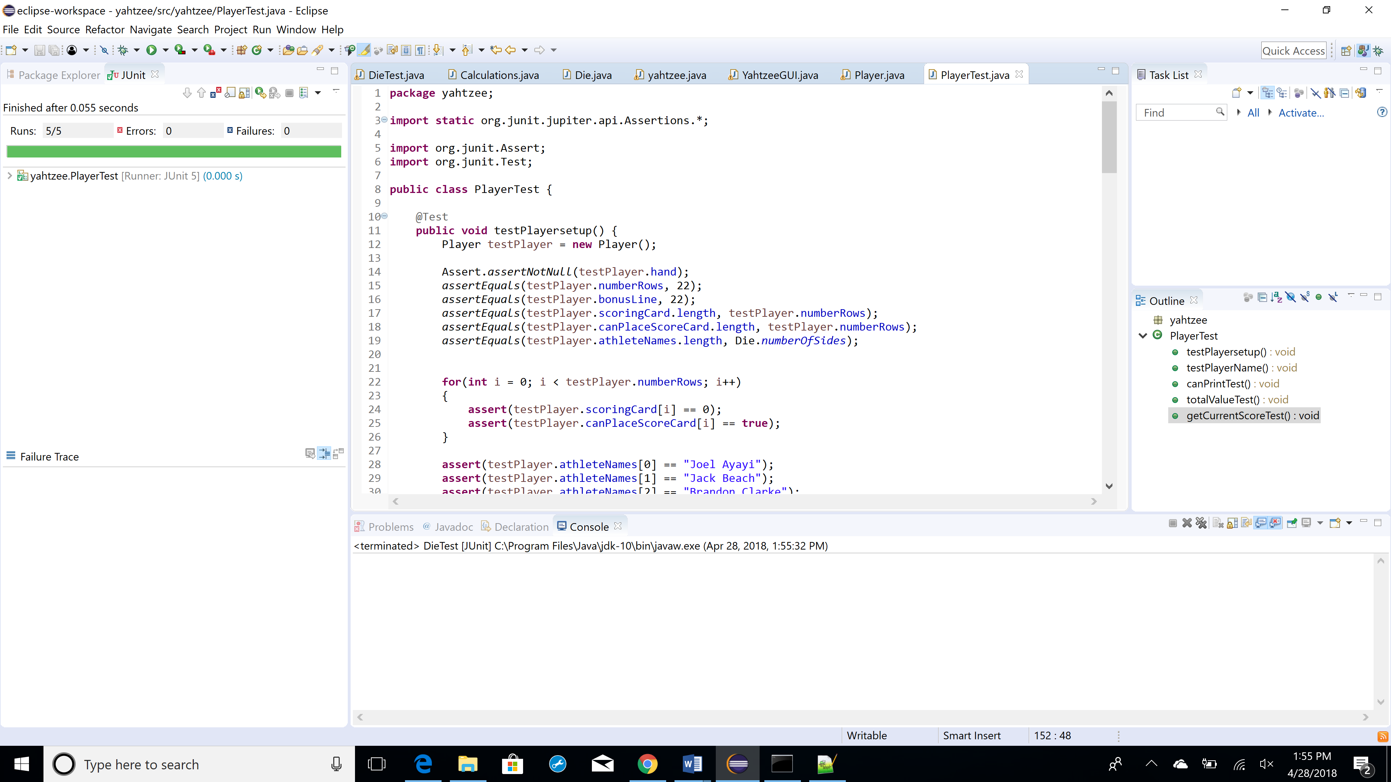

C. CalculationsTest.java

(Code is on four pages.)

package yahtzee;

import static org.junit.jupiter.api.Assertions.\*;

import java.util.ArrayList;

import org.junit.Assert;

import org.junit.Test;

public class CalculationsTest {

@Test

public void maxOfAZagFoundTest()

{

ArrayList<Die> hand = new ArrayList<Die>();

assert(Calculations.maxOfAZagFound(hand) == 0);

Die die0 = new Die();

die0.jerseyNumber = 1;

hand.add(0, die0);

assert(Calculations.maxOfAZagFound(hand) == 1);

Die die1 = new Die();

die1.jerseyNumber = 1;

hand.add(1, die1);

assert(Calculations.maxOfAZagFound(hand) == 2);

Die die2 = new Die();

die2.jerseyNumber = 1;

hand.add(2, die2);

assert(Calculations.maxOfAZagFound(hand) == 3);

Die die3 = new Die();

die3.jerseyNumber = 1;

hand.add(3, die3);

assert(Calculations.maxOfAZagFound(hand) == 4);

Die die4 = new Die();

die4.jerseyNumber = 1;

hand.add(4, die4);

assert(Calculations.maxOfAZagFound(hand) == 5);

}

@Test

public void totalAllDiceTest()

{

ArrayList<Die> hand = new ArrayList<Die>();

assert(Calculations.totalAllDice(hand) == 0);

Die die0 = new Die();

die0.jerseyNumber = 1;

hand.add(0, die0);

assert(Calculations.totalAllDice(hand) == 1);

Die die1 = new Die();

die1.jerseyNumber = 5;

hand.add(1, die1);

assert(Calculations.totalAllDice(hand) == 6);

Die die2 = new Die();

die2.jerseyNumber = 10;

hand.add(2, die2);

assert(Calculations.totalAllDice(hand) == 16);

Die die3 = new Die();

die3.jerseyNumber = 14;

hand.add(3, die3);

assert(Calculations.totalAllDice(hand) == 30);

Die die4 = new Die();

die4.jerseyNumber = 1;

hand.add(4, die4);

assert(Calculations.totalAllDice(hand) == 31);

}

@Test

public void fullTeamFoundTest()

{

ArrayList<Die> hand = new ArrayList<Die>();

assert(Calculations.fullTeamFound(hand) == false);

Die die0 = new Die();

die0.jerseyNumber = 3;

rollDie(die0);

hand.add(0, die0);

assert(Calculations.fullTeamFound(hand) == false);

Die die1 = new Die();

die1.jerseyNumber = 4;

rollDie(die1);

hand.add(1, die1);

assert(Calculations.fullTeamFound(hand) == false);

Die die2 = new Die();

die2.jerseyNumber = 10;

rollDie(die2);

hand.add(2, die2);

assert(Calculations.fullTeamFound(hand) == false);

Die die3 = new Die();

die3.jerseyNumber = 9;

rollDie(die3);

hand.add(3, die3);

assert(Calculations.fullTeamFound(hand) == false);

Die die4 = new Die();

die4.jerseyNumber = 5;

rollDie(die4);

hand.add(4, die4);

assert(Calculations.fullTeamFound(hand) == false);

die4.jerseyNumber = 11;

rollDie(die4);

hand.set(4, die4);

assert(Calculations.fullTeamFound(hand) == true);

}

public void benchBrigadeFoundTest()

{

ArrayList<Die> hand = new ArrayList<Die>();

assert(Calculations.benchBrigadeFound(hand) == false);

Die die0 = new Die();

die0.jerseyNumber = 1;

rollDie(die0);

hand.add(0, die0);

assert(Calculations.benchBrigadeFound(hand) == false);

Die die1 = new Die();

die1.jerseyNumber = 2;

rollDie(die1);

hand.add(1, die1);

assert(Calculations.benchBrigadeFound(hand) == false);

Die die2 = new Die();

die2.jerseyNumber = 3;

rollDie(die2);

hand.add(2, die2);

assert(Calculations.benchBrigadeFound(hand) == false);

Die die3 = new Die();

die3.jerseyNumber = 4;

rollDie(die3);

hand.add(3, die3);

assert(Calculations.benchBrigadeFound(hand) == false);

Die die4 = new Die();

die4.jerseyNumber = 10;

rollDie(die4);

hand.add(4, die4);

assert(Calculations.benchBrigadeFound(hand) == false);

die4.jerseyNumber = 5;

rollDie(die4);

hand.set(4, die4);

assert(Calculations.benchBrigadeFound(hand) == true);

}

public void startingLineupFoundTest()

{

ArrayList<Die> hand = new ArrayList<Die>();

assert(Calculations.benchBrigadeFound(hand) == false);

Die die0 = new Die();

die0.jerseyNumber = 9;

rollDie(die0);

hand.add(0, die0);

assert(Calculations.startingLineupFound(hand) == false);

Die die1 = new Die();

die1.jerseyNumber = 10;

rollDie(die1);

hand.add(1, die1);

assert(Calculations.startingLineupFound(hand) == false);

Die die2 = new Die();

die2.jerseyNumber = 11;

rollDie(die2);

hand.add(2, die2);

assert(Calculations.startingLineupFound(hand) == false);

Die die3 = new Die();

die3.jerseyNumber = 13;

rollDie(die3);

hand.add(3, die3);

assert(Calculations.startingLineupFound(hand) == false);

Die die4 = new Die();

die4.jerseyNumber = 8;

rollDie(die4);

hand.add(4, die4);

assert(Calculations.startingLineupFound(hand) == false);

die4.jerseyNumber = 15;

rollDie(die4);

hand.set(4, die4);

assert(Calculations.startingLineupFound(hand) == true);

}

public static Die rollDie()

{

Die newDie = new Die();

newDie.roll();

return newDie;

}

public void rollDie(Die die){

if(die.jerseyNumber == 3 || die.jerseyNumber == 4 || die.jerseyNumber == 5 ||

die.jerseyNumber == 7 || die.jerseyNumber == 13 || die.jerseyNumber == 15)

die.position = "FORWARD";

else

die.position = "GUARD";

if(die.jerseyNumber == 9 || die.jerseyNumber == 10 || die.jerseyNumber == 11 ||

die.jerseyNumber == 13 || die.jerseyNumber == 15)

die.status = "STARTER";

else

die.status = "BENCH";

if(die.jerseyNumber == 1)

die.name = "Ayayi";

else if(die.jerseyNumber == 2)

die.name = "Beach";

else if(die.jerseyNumber == 3)

die.name = "Clarke";

else if(die.jerseyNumber == 4)

die.name = "Hachimura";

else if(die.jerseyNumber == 5)

die.name = "Jones";

else if(die.jerseyNumber == 6)

die.name = "Kispert";

else if(die.jerseyNumber == 7)

die.name = "Larsen";

else if(die.jerseyNumber == 8)

die.name = "Martin";

else if(die.jerseyNumber == 9)

die.name = "Melson";

else if(die.jerseyNumber == 10)

die.name = "Norvell";

else if(die.jerseyNumber == 11)

die.name = "Perkins";

else if(die.jerseyNumber == 12)

die.name = "Pete";

else if(die.jerseyNumber == 13)

die.name = "Tillie";

else if(die.jerseyNumber == 14)

die.name = "Wade";

else

die.name = "Williams";

}

}

