Background Theory
The model used was a digital reconstruction of the microcircuitry of somatosensory cortex of a juvenile rat. The reconstruction uses cellular and synaptic organizing principles to algorithmically reconstruct detailed anatomy and physiology from sparse experimental data [1].
Properties of the Cortical circuit are available in Table I. These properties apply to the entire cortical circuit model. However, separate models are provided [2] and they will be investigated later.
Layer Thickness | L6: 700, L5: 525, L4: 190, L3: 353, L2: 149, L1: 165
No. of electrical types | 11
Microcircuit Volume | 0.29
Neuron Densities | L6: 131500, L5: 83900, L4: 177300, L3: 83800, L2: 164600, L1: 14200
No. of neurons per layer | L6: 12651, L5: 6114, L4: 4656, L23: 7524, L1: 338
No. of morphological types | 55
No. of intrinsic synapses | ~37 million
No. of intrinsic connections | ~8.1 million
No. of extrinsic synapses | ~147 million
No. of extrinsic connections | ~40 million
No. of neurons | 31346
Table 1
Some detail about the Neucortical Neuronal Morphologies are provided in Fig.1 [1].
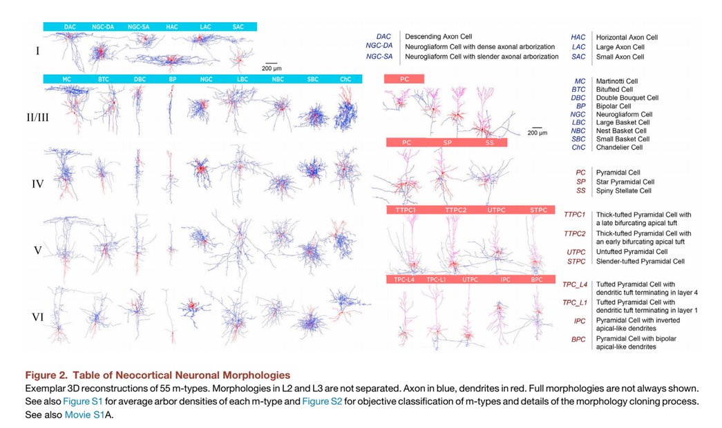

Fig. 1
Features that could be extracted from the above figure, which were investigated by [1]:
- Inhibitory types can be distinguished by axonal features and excitatory types by dendritic features.
- Those inhibitory types were present in all layers except for layer 1, which contained a unique set.
- Cell morphologies that were pyramidal in nature varied across layers.
- The number of pyramidal cell types, as defined by their local morphology, increased from upper to lower layers.

Aims/Objectives
The project aims to develop an efficient and robust Machine Learning model. Robust in
terms of functionality, for example to capture the topology of the cortex of a certain
individual. This can be achieved by having a limited number of electrodes in a brain machine
interface.
Why? Well the next generation of brain machine interfaces or even brain simulation devices
require a feedback loop. Why Machine Learning? Machine Learning would be important to
infer the state of the tissue or what is the topology of the tissue. To achieve this, we need a
general model – a Machine Learning model to predict as much information as possible.
Part of the problem is designing a training set for the machine learning model. NEURON
simulator plays an important role in designing this training set. There exist many adjustable
variables in a system. However, in machine learning the size and order of the training set are
key pieces in getting the correct outcome.
Summary of Project Aims:
- Create a training set using NEURON simulator. The variables can be adjusted to
observe the difference when applying different criteria.
- Test and validate this training set using RapidMiner, a Machine Learning tool. The outcome will be a misclassification error – whether RapidMiner could correctly infer some properties such as the network topology and the condition of the tissue.

Methodology
The proposed methodology involves using two tools: NEURON simulator and RapidMiner.
Details about the functionality of these tools are described below:
NEURON simulator
NEURON simulator provides the label set. The label set consists of simulated neurons and
their generated outputs. A neuron sends a lot of spikes and a spike train is created. The
location of the spikes would be known as they would be the interface to the device. Other
variables include:
- Morphology of the neuron.
- Number of terminals.
- The size and volume of the terminals.
The generated data through the simulated neuron gives us the label set which is then fed to
RapidMiner.
RapidMiner
The label set is obtained from the NEURON simulator. To estimate the statistical
performance of a learning model and to estimate how accurately a model will perform in
practice, a Cross Validation technique will be used. RapidMiner divides this into two sub-
processes:
- Training: Create a synthetic set of neurons model where the topology is known.
Parameters include: Hidden Layers, Training Cycles, Learning rate, Momentum and
Decay. These parameters are not fixed and their values can be adjusted.
- Testing: Random models could be created to generate real measures. These generated measures can be used to check whether the training model can correctly
infer them.

Prelimenary Results
Layer 4 and Layer 2-3 were used to obtain some prelimenary results. The connection properties are summarised in Table 1 below:
number_of_convergent_neuron_std | 3.3
connection_probability | 0.35
number_of_divergent_neuron_std | 9.4
total_synapse_count | 53367
mean_number_of_synapse_per_connection | 2.3
common_neighbor_bias | 2.1
number_of_convergent_neuron_mean" | 1.7
number_of_synapse_per_connection_std | 0.71
number_of_divergent_neuron_mean | 8.8
Table 1
Fig. 2 and Fig. 3 represent the NEURON simulator output:
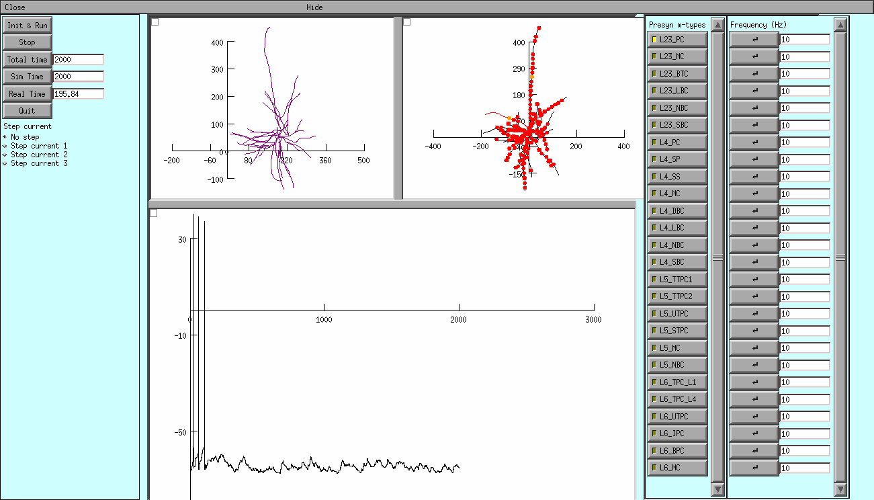
Fig. 2 - L4_SP:L23_PC for duration 2000ms @ 10Hz
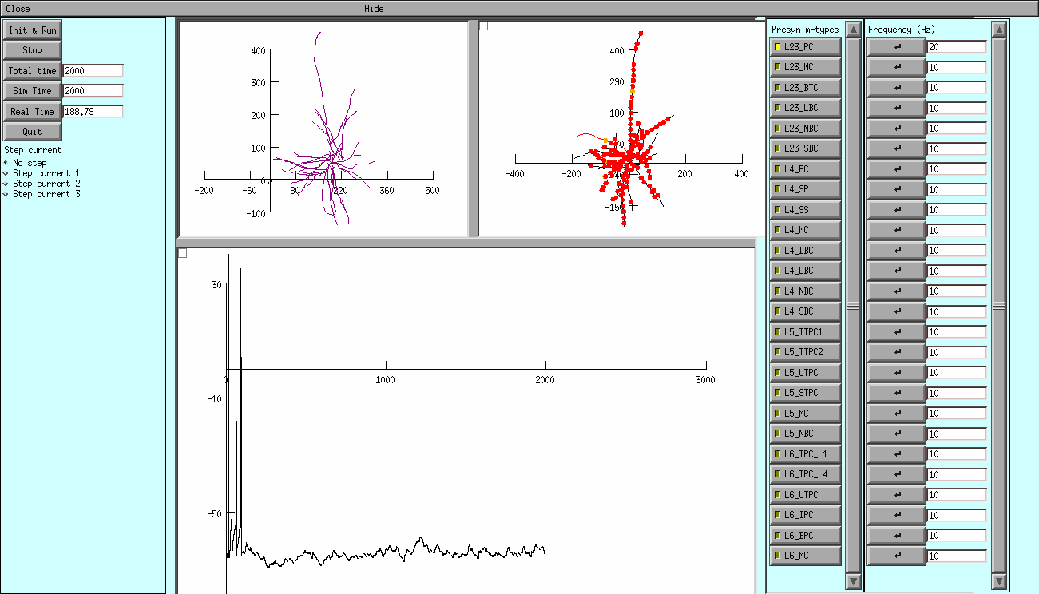
Fig. 3 - L4_SP:L23_PC for duration 2000ms @ 20Hz

- The graph represents the membrane voltage recorded in the soma. Units are ms (x-axis) and mV (y-axis). Every presynaptic cell will be represented by a Poisson Spike Train and the default firing rate is 10Hz; the two other parts have a representation of the cells morphology.
- The sections in the first morphology change colour depending on their membrane voltage during the simulation. When synaptic input is presenr, the second morphology will show the location of the activated synapses.
- The neuron can be stimulaed in two ways:
- Step currents can be selected from the first tab.
- Synaptic inputs can be enabled by choosing from the list of presynaptic m-types. When a certain m-type is selected, all the synapses that cells from the specified m-type make on the stimulated cell (in the neocortical microcircuit model) will become active.

Next Steps
The next phase of the project is described below:
1) Based on the NEURON simulator, I’ll learn the signalling characteristics of different types of neurons. In the cortical circuit there is about 6 layers and each of those layers have different neurons. The NEURON simulator has packages of neuron models for different types of neurons.
2) Pick a few representative neurons, run through them and observe the signalling behaviour. Signalling behaviour was chosen as the signal propagation along the neurons is different from one neuron to the next.
3) Variability in the types of neurons and types of stimulus exists – the pulses that travel through the neuron will be quite different also, not only for different neurons but for different stimulation effects.

I) Look at the cortical model which joins the different neurons into a line topology. Connect the neurons together and simulate a pulse that is sent from the top neuron and observe how the pulse propagates down the neuron.
II) Observe the delay and the pulse behaviour as it travels from one neuron to the next. Change the topology or structure from case to case as sometimes they branch out into multiple neurons as you go down and then branch back into one neuron.

A) Look at specific features which include the pulse delay and the signalling capacity.
B) Train a machine learning tool like RapidMiner to infer the topology or the types of neuron that are present in the topology.

The deadline for each task is represented in Fig. 4:
- Steps 1-3 by end of November.
- Steps I-II by mid January.
- Steps A-B by mid March.
- Final step is to write the report by mid April.

Fig .4 - Gantt Chart

References

