Title: Communication Theoretic Analysis of Brain Cortical Circuits
Alaa Ekky 13317728

Introduction
The emerging area of “Internet of Nano Things” as well as “Internet of Bio-Nano Things” aims to interconnect nanoscale devices to the internet, where information from molecular systems can be collected at fine granularity. There exists a number of works proposed for implanting nanoscale devices (or devices that are built from nanoscale components), such as the Berkely Neural Dust as well as the Wireless Ontogenetic Nanonetworks from The Telecommunications Software & Systems Group (TSSG). These devices can be used to understand the functionalities of the brain at a single-cell level. The objective of this thesis is to use approaches in conventional communication networks, such as network tomography, where inference of network topology can be established through data mining of packet information and to use this to infer the cortical network topology. The end result could lead to new approaches of diagnosing network connectivity of the cortical column, as well as the brain, and also to understand how certain diseases may lead to changes in the network connectivity.

Aims/Objectives
The project aims to develop an efficient and robust Machine Learning model. Robust in
terms of functionality, for example to capture the topology of the cortex of a certain
individual. The Machine Learning model will produce information on the topology of the cortex of an individual given the readings from a limited number of electrodes in a brain machine interface.
Why? Well the next generation of brain machine interfaces or even brain simulation devices
require a feedback loop. Why Machine Learning? Machine Learning would be important to
infer the state of the tissue or what is the topology of the tissue. To achieve this, we need a
general model – a Machine Learning model to predict as much information as possible.
Part of the problem is designing a training set for the machine learning model. NEURON
Simulator – a flexible and powerful simulator of neurons and networks [1], plays an important role in designing this training set. There exist many adjustable variables in a system. However, in machine learning the size and order of the training set are key pieces in getting the correct outcome [2].

Summary of Project Aims:
- Create a training set using NEURON simulator. The variables can be adjusted to
observe the difference when applying different criteria such as varying stimulation and delay.
- NEURON simulator will be used to generate both the training set and the validation set. The output will be a machine learning model, which will be tested using RapidMiner - a software platform that unifies data prep, machine learning and predictive development [3]. The outcome will be a misclassification error – whether RapidMiner could correctly infer some properties such as the network topology and the condition of the tissue.

Background Theory
The model used was a digital reconstruction of the microcircuitry of somatosensory cortex of a juvenile rat. The reconstruction uses cellular and synaptic organizing principles to algorithmically reconstruct detailed anatomy and physiology from sparse experimental data [4].
Properties of the Cortical circuit are available in Table I. L in Table 1 stands for Layer so L6 is Layer 6. These properties apply to the entire cortical circuit model. However, separate models are provided [5] and they will be investigated later.

Layer Thickness (µm) | L6: 700, L5: 525, L4: 190, L3: 353, L2: 149, L1: 165
No. of electrical types | 11
Microcircuit Volume (mm³) | 0.29
Neuron Densities (neurons/mm³) | L6: 131500, L5: 83900, L4: 177300, L3: 83800, L2: 164600, L1: 14200
No. of neurons per layer | L6: 12651, L5: 6114, L4: 4656, L23: 7524, L1: 338
No. of morphological types | 55
No. of intrinsic synapses | ~37 million
No. of intrinsic connections | ~8.1 million
No. of extrinsic synapses | ~147 million
No. of extrinsic connections | ~40 million
No. of neurons | 31346
Table 1
Some detail about the Neucortical Neuronal Morphologies are provided in Fig.1 [2].
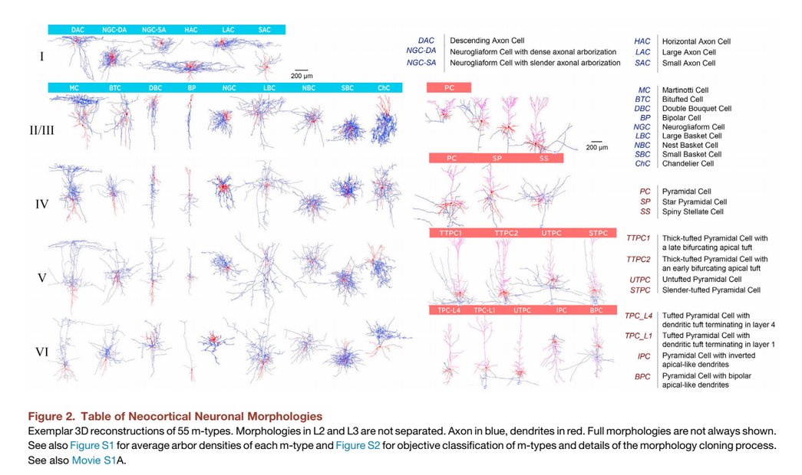

Fig. 1
Features that could be extracted from the above figure, which were investigated by [2]:
- Inhibitory types can be distinguished by axonal features and excitatory types by dendritic features.
- Those inhibitory types were present in all layers except for layer 1, which contained a unique set of inhibitory neuron types.
- Cell morphologies that were pyramidal in nature varied across layers.
- The number of pyramidal cell types, as defined by their local morphology, increased from upper to lower layers.

Methodology
The proposed methodology involves using two tools: NEURON simulator and RapidMiner.
Details about the functionality of these tools are described below:
NEURON Simulator
NEURON simulator provides the label set. The label set consists of simulated neurons and
their generated outputs. A neuron sends a lot of spikes and a spike train is created. The
location of the spikes would be known as they would be the interface to a brain interface device. Other variables include:
- Morphology of the neuron.
- Number of axon terminals – to transmit information to different neurons, muscles and glands.
- The size and volume of the terminals.
The generated data through the simulated neuron gives us the label set which is then fed to
RapidMiner.
RapidMiner
The label set is obtained from the NEURON simulator. To estimate the statistical
performance of a learning model and to estimate how accurately a model will perform in
practice, a Cross Validation technique will be used. RapidMiner divides this into two sub-
processes:
- Training: Create a synthetic set of neurons model where the topology is known.
Parameters include: Hidden Layers, Training Cycles, Learning rate, Momentum and
Decay. These parameters are not fixed and their values can be adjusted.
- Testing: Random models could be created to generate real measures. These generated measures can be used to check whether the training model can correctly
infer them.

Preliminary Results
Layer 4 and Layer 2-3 were used to obtain some preliminary results. The connection properties between layers 4 and 2-3 are summarised in Table 2 below:

number_of_convergent_neuron_std | 3.3
connection_probability | 0.35
number_of_divergent_neuron_std | 9.4
total_synapse_count | 53367
mean_number_of_synapse_per_connection | 2.3
common_neighbor_bias | 2.1
number_of_convergent_neuron_mean" | 1.7
number_of_synapse_per_connection_std | 0.71
number_of_divergent_neuron_mean | 8.8
Table 2
Fig. 2 and Fig. 3 represent the NEURON simulator output:
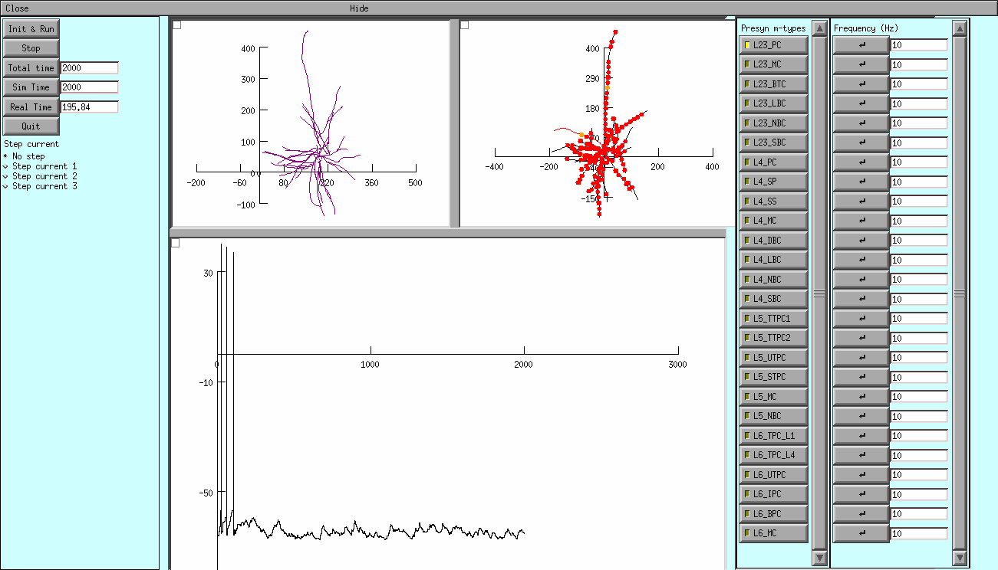
Fig. 2 - L4_SP:L23_PC
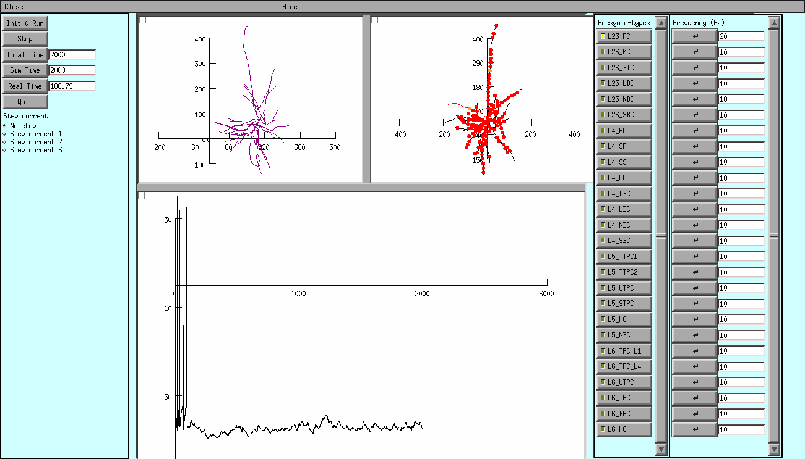
Fig. 3 - L4_SP:L23_PC

- The graph represents the membrane voltage recorded in the soma. Units are ms (x-axis) and mV (y-axis). Every presynaptic cell will be represented by a Poisson Spike Train and the default firing rate is 10Hz; the two other parts have a representation of the cells morphology.
- The sections in the first morphology change colour depending on their membrane voltage during the simulation. When synaptic input is presenr, the second morphology will show the location of the activated synapses.
- The neuron can be stimulated in two ways:
- Step currents can be selected from the first tab.
- Synaptic inputs can be enabled by choosing from the list of presynaptic m-types. When a certain m-type is selected, all the synapses that cells from the specified m-type make on the stimulated cell (in the neocortical microcircuit model) will become active.

Update on Results
Neuron Model used was the L5_DBC_cAC which can be downloaded from the Blue Brain Project website [6]. A combination of Presynaptic m-types were applied from different layers. The following presynaptic m-types were connected together:
- L23PC_L4PC_L5LBC_L6IPC: A Pyramidal Cell (PC) from layer 23 is connected to a Pyramidal Cell (PC) from layer 4, which is connected to Large Basket Cell (LBC) from layer 5. LBC from layer 5 is connected to a Pyramidal cell with Inverted apical dendrites (IPC) from layer 6.
- L23MC_L4SP_L5STPC_L6BP: A Martinotti Cell (MC) from layer 23 is connected to a Star Pyramidal Cell (SP) from layer 4, which is connected to Thick Tufted Pyramidal Cell (TPC) from layer 5. TPC from layer 5 is connected to a Bipolar Cell (BP) from layer 6.
- L23PC_L4NBC_L5UTPC_L6UTPC:A Pyramidal Cell (PC) from layer 23 is connected to a Nest Basket Cell (NBC) from layer 4, which is connected to Untufted Pyramidal Cell (UTPC) from layer 5. UTPC from layer 5 is connected to its corresponding presynaptic m-type UTPC from layer 6.
- L23PC_L4PC_L5STPC_L6IPC: A Pyramidal Cell (PC) from layer 23 is connected to a Pyramidal Cell (PC) from layer 4, which is connected to Slender Tufted Pyramidal Cell (STPC) from layer 5. STPC from layer 5 is connected to a Pyramidal cell with Inverted apical dendrites (IPC) from layer 6.
The simulation was run for 3000ms and the results were recorded for each train spike. For each train spike, the time of occurrence and the voltage were measured. Frequency, number of spikes and delay between spikes were measured also. These were measured for each connection of presynaptic input and the results were passed into RapidMiner.

Results from RapidMiner
Accuracy: 83.35% +/- 3.71%
A Confusion Matrix is provided below:

 | true PC_PC_LBC_IPC | true MC_SP_STPC_BP | true PC_NBC_UTPC_UTPC | true PC_PC_STPC_IPC | class precision
pred. PC_PC_LBC_IPC | 127 | 0 | 2 | 32 | 78.88%
pred. MC_SP_STPC_BP | 0 | 237 | 0 | 0 | 100.00%
pred. PC_NBC_UTPC_UTPC | 81 | 1 | 258 | 0 | 75.88%
pred. PC_PC_STPC_IPC | 53 | 0 | 1 | 229 | 80.92%
class recall | 48.66% | 99.58% | 98.85% | 87.74%
Table 3

Table 3 describes the performance in classifying the presynaptic m-types:
- Precision - is the ratio of true positives over the sum of true positives and false positives. The precision values for predicting the difference between the connections of layer 23 and layer 4 are low and need to be improved as can be seen at the end of row 1. This may be due to the algorithm mis-classifying based on the data provided to the machine learning algorithm.
- Recall – is the ratio of true positives over the sum of true positives and false negatives. Again this value is low especially in column 1 as the machine learning algorithm found it difficult to distinguish between the connections from layer 23 to layer 4. Parameters in the machine learning algorithm need to be tuned and other variables to be measured.
The Accuracy of predicting the presynaptic m-type input was 83.35%. This accuracy needed to improve as the next stage involves connecting multiple neuron models together. Improving the accuracy was the next target as the model becomes increasingly complex.

Increasing Accuracy
To improve the accuracy, parameters involved in the machine learning algorithm were tweaked and other measurement variables were investigated. Parameters include:
- Learning Rate – weight change according to the neural network error. The learning rate was increased from 0.1 to 0.3.
- Momentum – proportion of weight change from the last training step used in the next step. The momentum was increased from 0.1 to 0.2.
Alternative measurement variable investigated was the Power Spectral Density (PSD) for each presynaptic input. PSD is the frequency response of a random or periodic signal. It tells us where the average power is distributed as a function of frequency. With a combination of frequency, number of spikes, delay between spikes and PSD, precision and recall values increase. Overall accuracy increased from 83.35% to 96.95% which is represented by the updated Confusion Matrix below:
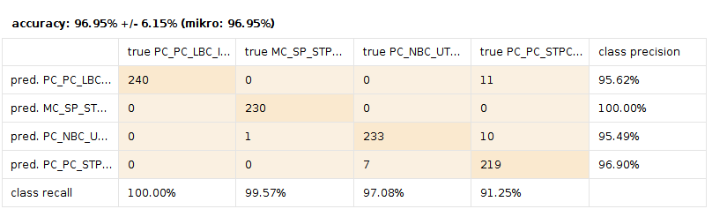
Next Steps
The next phase of the project is described below:
1) Based on the NEURON simulator, I’ll learn the signalling characteristics of different types of neurons. In the cortical circuit there are about 6 layers and each of those layers have different neurons. The NEURON simulator has packages of neuron models for different types of neurons.
2) Pick a few representative neurons, run through them and observe the signalling behaviour. Signalling behaviour was chosen as the signal propagation along the neurons is different from one neuron to the next.
3) Variability in the types of neurons and types of stimulus exists – the pulses that travel through the neuron will be quite different also, not only for different neurons but for different stimulation effects.

4) Look at the cortical model which joins the different neurons into a line topology. Connect the neurons together and simulate a pulse that is sent from the top neuron and observe how the pulse propagates down the neuron.
5) Observe the delay and the pulse behaviour as it travels from one neuron to the next. Change the topology or structure from case to case as sometimes they branch out into multiple neurons as you go down and then branch back into one neuron.

6) Look at specific features which include the pulse delay and the signalling capacity.
7) Train a machine learning tool like RapidMiner to infer the topology or the types of neuron that are present in the topology.

The deadline for each task is represented in Fig. 4:
- Steps 1-3 by end of November – Completed.
- Steps 4-5 by mid January – Completed.
- Steps 6-7 by mid March.
- Final step is to write the report by mid April.
- Submission of an IEEE letter to a Conference or Journal paper is planned by the end of the project.

Fig .4 - Gantt Chart

References
[1] Neuron.yale.edu. (2017). NEURON | for empirically-based simulations of neurons and networks of neurons. [online] Available at: https://www.neuron.yale.edu/neuron
[2] Kim, H., Claffy. K.C., Fomenkov, M., Barman, D., Faloutsos, M. and Lee, K., 2008, December. Internet traffic classification demystified: myths, caveats, and the best practices. In Proceedings of the 2008 ACM CoNEXT conference (p. 11). ACM.
[3] RapidMiner. (2017). Data Science Platform | RapidMiner. [online] Available at: https://rapidminer.com
[4] Gal, E., London, M., Globerson, A., Ramaswamy, S., Reimann, M., Muller, E., Markram, H. and Segev, I. (2017). Rich cell-type-specific network topology in neocortical microcircuitry. Nature Neuroscience, 20(7), pp.1004-1013.
[5] Srikanth, R. (2016). Reconstructing and Simulating Neocortical Microcircuitry. Frontiers in Neuroinformatics, 10.
[6] Bbp.epfl.ch.(2018).Home-nmc-portal.[online] Available at: https://bbp.epfl.ch/nmc-portal

