**Discrete Probability Distributions:**

1. **Bernoulli Distribution:**

**Mean: E[X] = p**

**Variance: Var[X] = p(1-p)**

1. **Binomial distribution:**

**It is an extension of Bernoulli distribution, where we can have n trials and calculate the probability of r successes.**

**In P(x) X represents the number of successes in n trials/events**

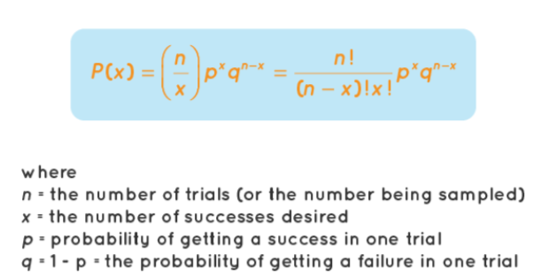

1. **Geometric Distribution:**

**The geometric distribution is the probability of the number of Bernoulli trials we need before we get a success. In P(X = x) the X is the number of trials when very first success is obtained.**

1. **Negative Binomial distribution:**

**Negative binomial distribution is the distribution of the number of trials needed to get rth successes. In P(x) X represents the number of trials required to get rth success.**

**So for the rth success to occur at xth trial, first (x-1) trials must have (r-1) success, xth trial must be a success**

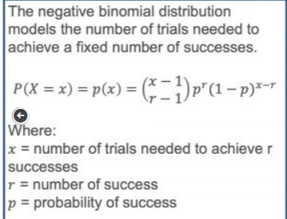

1. **Hypergeometric distribution: In hypergeometric distribution we  randomly sample n objects without replacement from population that contains ‘a’ successes and ‘N-a’ failure. And P(X = x) represents x successes present in the sample**

1. **Poisson distribution:**

**Poisson distribution holds if 1. events occur independently and 2. ‘probability of occurrence of a event in a given length of time’ does not change with time. In other words the rate (lambda) with which events are occurring is constant with time.**

**P(X = x) here x is the number of events occurring in 1 second.**

**Continuous Probability Distributions:**

1. **Normal distribution or gaussian distribution:**

**Standard normal distribution:**



1. **Exponential distribution:**

**If events occur continuously with constant rate (lambda) and independently.**

**In P(X = x) X represents the time it will take for the successive event to occur. Of probability that time between two consecutive events is X**



1. **Gamma distribution:**

**Mean and variance:**

**A special form of gamma distribution is chi – square distribution:**

