Test Engine Step Types
This section describes the syntax for the Test Engine Steps in detail.
Test Engine Step Types 1
Change Alarm 2
Component 8
End Time 10
Ramp 11
Update 15
Wait til GT 17
Wait til LT 20
GC Configuration 23
Pull GC Sample 24
Timed GC Pull 25
Wait for All Alarms 27
View 29
Prompt 31
Wait til 33
Conditional 38
Error filter 40
Edit 42
For / Next 44
DoWhile / Loop 46
Wait Til Settled 47

Change Alarm
This step type can be used to change alarm levels or disable alarming for alarm tags. In order to specify alarm levels for a tag, that tag must have been defined as an Alarm Tag in the Alarms definition section.
As shown in the parameters syntax table below, included in the alarm change command is the provision to set the delay for implementing the new alarm levels. It is common for the state of the system to change over a period of time such that an alarm would be generated during the system’s transition. A delay in the alarm level change can be used to allow the system to move to an acceptable range before implementing the new alarm levels. During the transition, the widest alarm range is used to minimize unnecessary alarm generation.

Parameter | Value
Step Type | "Change Alarm" – REQUIRED
Alarm Tag | Name of tag to be alarmed - REQUIRED, several allowed
Delay | Delay to allow system to react, secs ("5.0")
Duration | Pause after setting alarms, secs ("2.1")
HiHi | Numeric value of HiHi Limit ("20.1") or "Disable"
Hi | Numeric value of Hi Limit ("20.1") or "Disable"
Lo | Numeric value of Lo Limit ("20.1") or "Disable"
Lolo | Numeric value of Lolo Limit ("20.1") or "Disable"
HiHiRel | Numeric value of HiHiRel Limit ("20.1") or "Disable"
HiRel | Numeric value of HiRel Limit ("20.1") or "Disable"
LoRel | Numeric value of LoRel Limit ("20.1") or "Disable"
LoLoRel | Numeric value of LoLoRel Limit ("20.1") or "Disable"
In the case below, if the Lo and Hi Alarm Levels for DummyInT were 25 and 500 respectively, then for the specified duration of 20 seconds, the low alarm level will be the lower value of the new (50) and old (25), which is 25. Similarly, the high alarm level will be the higher value of the new (1000) and old (500), which is 1000. Therefore the chances of generating an alarm error may be minimized for the duration of 20 seconds after which the new alarm levels are set to 50 and 1000 for Lo and Hi respectively.

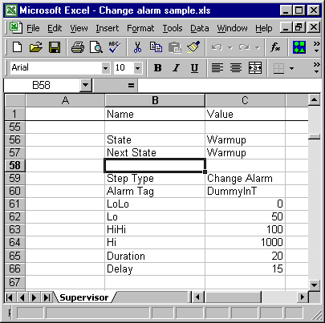
Multiple alarms can be changed in one step. In the example shown below, DummyInT and DummyInP will experience alarm level changes simultaneously for the same duration. The system will wait for 20 seconds after both alarm levels have been changed, before continuing to the next step.

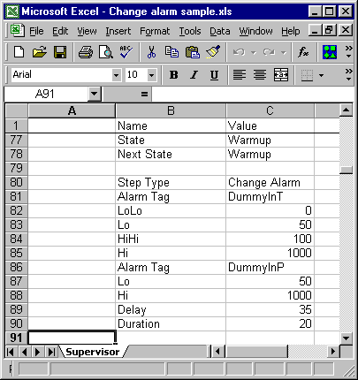
Alternatively, individual alarms can be changed in separate steps. The latter option allows the specification of different delays for each individual step. In the script illustrated below, the Change Alarm command for DummyInT and DummyInP have been split into 2 separate steps. The Alarm level change for DummyInT will take 20 seconds, after which the system will pause for 15 seconds before proceeding to instantaneously modify the Alarm level for DummyInP, wait for 35 seconds and then proceed to the next step.

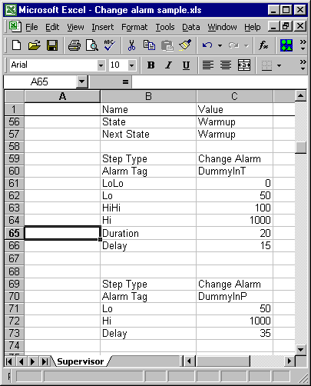
Absolute, relative or a combination of both kinds of alarm levels may be specified provided that a Setpoint tag was specified, earlier in the Alarms Definition section, for relative alarms.

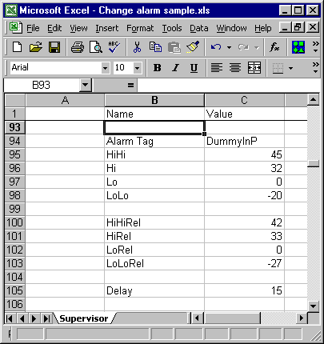
As shown in the figure above, the criteria for triggering a HiHi Alarm level is activated when the DummyInP value reaches or exceeds 45. Similarly, the criterion for triggering a HiHiRel Alarm is activated when the DummyInP value reaches or exceeds the set point by 42.
The change alarm command can also be used to Disable alarm levels.
As shown in the figure below, the DummyInT HiHi alarm will be activated when the value of DummyInT exceeds 1000. The Hi Alarm has been disabled and will not be triggered at all irrespective of the value of DummyInT and whether or not the Alarm Tag is enabled in BridgeVIEW.
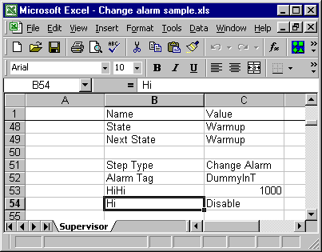

Component
This step type will call the component named, execute the script specified for that component and then pause for the duration specified before moving to the next step.
Add Wait on/off to this discussion
Parameter | Value
Step Type | "Component" – REQUIRED
Component | Name of script to be run - REQUIRED, several allowed.
Name of component to be called | Name of state already defined in component ‘s script
Component itself must be already defined
Duration | Pause after running component script, secs ("2.1")
On Failure | "Error" or "Anything Else can go here, if no error"
On Failure | Action to take if component is not ready when duration expires.
On Failure | If the value entered is “Error”, then an error is generated.
On Failure | If the value entered is not “Error” then a simple warning is generated.

As shown in the parameters syntax table above, included in the component command is the provision to set the Duration. After the component script has been executed, the system will pause for the number of seconds specified in duration before moving to the next step. If the component is not ready when the duration expires, then notification is sent to the main program based on the specified value. If “Error” is specified in the On Failure field, an error is logged to Warning file and the component runs the Estop Script. If anything else is found in the On Failure field, or if there is no On Failure field, a warning is logged to the Warning file.
The component step permits the execution either of individual components or multiple components simultaneously. The script below shows the Reactor component called twice to execute individual components. The Estop script for reactor will occur only after the Warmup script for the reactor is has executed, and a pause of 100 seconds elapses. Another pause of 221 seconds is observed after the Estop script is executed before moving to subsequent steps.
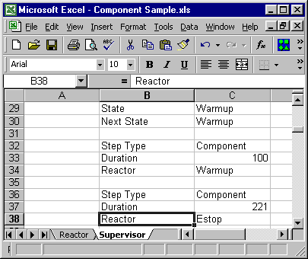
The script below shows the Reactor component called once, with multiple component scripts. The Run and Home scripts for Reactor will be executed simultaneously, followed by a pause
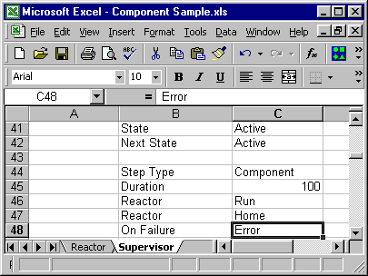
of 100 seconds.

End Time
This step type will cause the component to pause until the specified time of day is reached.
Parameter | Value
Step Type | "End Time" – REQUIRED
End time ("HH:MM") | Time at which script execution continues - REQUIRED, only one allowed.

As shown in the parameters syntax table above, there is only one option included in the End Time command and that is the End Time value itself. Only one End Time value is processed within each End Time step. If more than one End Time value is specified, only the first one is used. All subsequent values are discarded. In the unlikely event that there is any need to specify a continuous series of End Times, multiple End Time steps must be called separately.
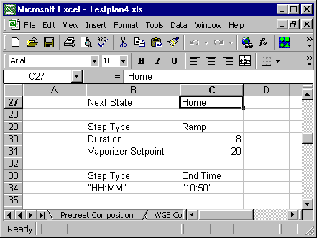
For instance if 10:50 is specified as in the figure above, the program will only move to the next step when the time becomes 10:50. Since there is no indication about which of half of the day the time should fall in, this step behaves the same way at 10:50am or 10:50pm. The step exits whenever the first one occurs.

Ramp
This step type will change the output from the current value to the specified value for each tag in equal increments over the specified duration. As it is meaningless to gradually increment Strings and Booleans, the only category of tags that this step can act on is the Analog Data Type.
Parameter | Value | Comment
Step Type | "Ramp" | REQUIRED
Duration | Ramp Time, secs ("2.1") | Optional
Tag1 | Value1 | Ramp Tag1 to value1, Analog Tags only
Tag2 | Value2 | Ramp Tag2 to value2, Analog Tags only

The only Data types permissible with the Ramp command are Analog Values, samples of which are shown below

Data Type | Value Strings
Analog | "0", "1.13e5"

As shown in the parameters syntax table above, there is an option included in the Ramp command to specify the length of time over which to change the value of an output.

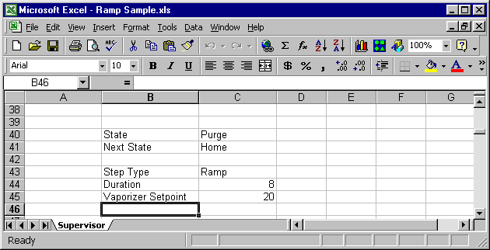
For instance if Vaporizer Setpoint is configured as in the figure above, the program will gradually move the output value of Vaporizer Setpoint to 20 within 8 seconds. At the end of the 8th second, the Vaporizer Setpoint will be exactly 20 and the component moves on to the next step. If the specified duration were zero (0), or if the duration field is not defined, the ramp step acts like the Update step type (see below) and the output value would immediately be set to 20 without any iteration or intermediate increments.
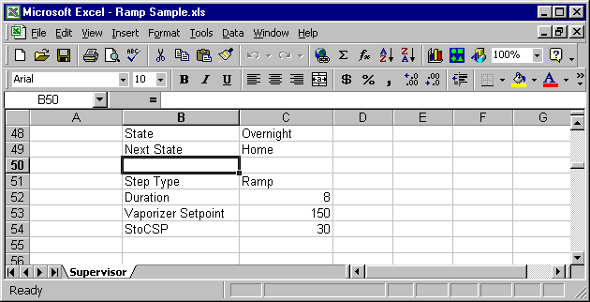
The Ramp step permits the Ramping either of individual tags separately or multiple tags simultaneously. With Individual Ramp Steps, different durations can be specified for each tag. However, multiple tags in one ramp step must share the same duration. The script below shows the Ramp step called twice to alter individual tag values. The ramp script for PreheatCSp will occur only after the Ramp script for Vaporizer Setpoint is complete. Hence, an interval of 81 seconds exists between the two scripts.
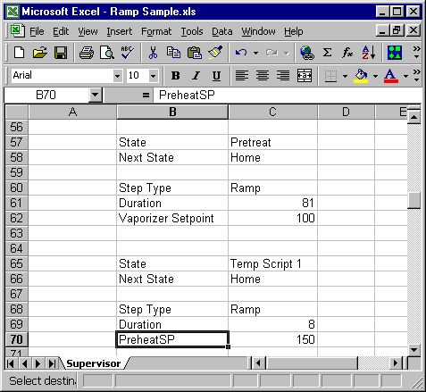
The script below shows the Ramp Script called once, with multiple Tag Modifications. Unlike the previous example, the same duration must be used for all Tag Modifications, as the Ramping is done simultaneously.
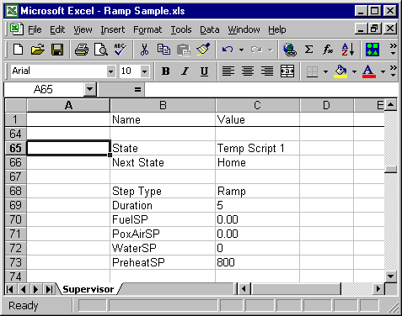

Update
This step type will change the output to the specified value for each tag immediately and pause the program for the number of seconds specified in duration.
Parameter | Value | Comment
"Step Type" | "Update" | REQUIRED
"Duration" | Pause after setting tags, secs ("2.1") | Optional
Tag1 | Value1 | Set Tag1 to value1, Any Tag data type Valid
Tag2 | Value2 | Set Tag2 to value2, Any Tag data type Valid

Data Type | Value Strings
Analog | "0", "1.13e5"
String | Empty, "Hello"
Discrete | "On", "Off"
Discrete Array | "TTFT"

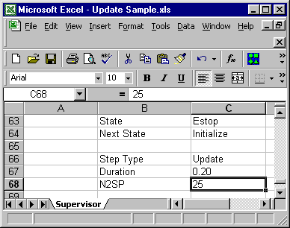
The figure above shows a case where the Update step updates a single tag. This configuration causes the program to immediately change the output value of N2SP to 25, pause for 0.2 seconds and then move to the next step.

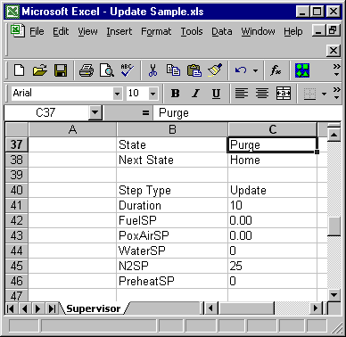
The figure above shows a case where the Update step updates multiple tags. This configuration causes the program to simultaneously change the output value of FuelSP PoxAirSP, WaterSP, N2SP and PreheatSP to 0, 0, 0, 25, and 0 respectively, pause for 0.2 seconds and then move to the next step.

Wait til GT
This step type will cause the component to pause until tag values exceed the specified limits. The maximum time to wait is specified using the duration field. Individual or multiple tags may be tested. If the specified limits are not reached for all tags before the maximum time expires, the step exits and the On Failure action is implemented.
Parameter | Value | Comment
"Step Type" | "Wait til GT" | REQUIRED
"Duration" | Timeout, secs ("2.1") | Optional
"On Failure" | "Error" or "Warn" | Optional, defaults to Warning
Tag1 | Value1 | Wait til Tag1 > value1, Analog Values Only
Tag2 | Value2 | Wait til Tag2 > value2, Analog Values Only

The only Data types permissible with the Wait til GT command are Analog Values, samples of which are shown below
Data Type | Value Strings
Analog | "0", "1.13e5"

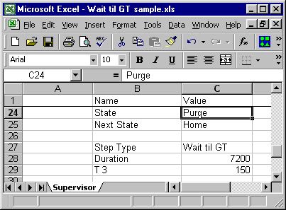
For instance if T3 is configured as in the figure above, the program will remain in the Wait Til GT step until the value of T3 exceeds to 150. However, if 7200 seconds elapse before T3 exceeds 210, the step exits.
Just as it is possible to use the Wait til GT step to test one tag, it is also possible to use the Wait til GT step to test multiple tags simultaneously.
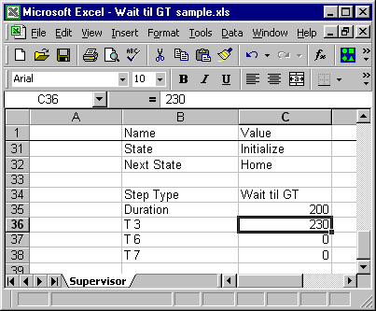The figure shown above demonstrates a script in which the component remains in the Initialize state until all of the following conditions are met;
  - T3 exceeds 230
  - T6 exceeds 0
  - T7 exceeds 0
The case where the Duration expires is one exception to the above rule. If 200 seconds have elapsed since the time that the step began, the step exits. If it happens that at least one of the above conditions is not met, the program is notified according to the action specified in “On Failure”. In this particular case, the “On Failure” field is empty and a warning is logged to the warning file.

If the Duration is not present, is empty or set equal to zero, the timeout is infinite. In this case, the component will not move to the next step until all listed tags exceed the specified values.
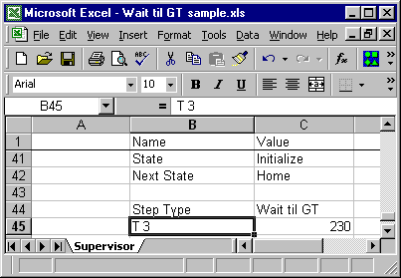

In the figure shown above, the component will not do anything at all until T3 exceeds 230.

Wait til LT
This step type will cause the component to pause until tag values fall beneath the specified limits. The maximum time to wait is specified using the duration field. Individual or multiple tags may be tested. If the specified limits are not reached for all tags before the maximum time expires, the step exits and the On Failure action is implemented.
Parameter | Value | Comment
"Step Type" | "Wait til LT" | REQUIRED
"Duration" | Timeout, secs ("2.1") | Optional
"On Failure" | "Error" or "Warn" | Optional, defaults to Warning
Tag1 | Value1 | Wait til Tag1 < value1, Analog Values Only
Tag2 | Value2 | Wait til Tag2 < value2, Analog Values Only

The only Data types permissible with the Wait til LT command are Analog Values, samples of which are shown below
Data Type | Value Strings
Analog | "0", "1.13e5"

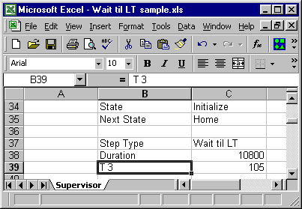
As shown in the figure above the Wait til LT step will keep running until T3 falls beneath 105 or 10800 seconds expire from the start of the step. When either condition is met, then the step is completed.
Just as it is possible to use the Wait til LT step to test one tag, it is also possible to use the Wait til LT step to test multiple tags simultaneously.
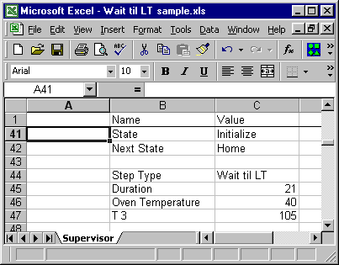The figure shown above demonstrates a script in which the component remains in the Initialize state until both of the following conditions are met;
- Oven Temperature falls beneath 40
- T3 falls beneath 105
The case where the Duration expires is one exception to the above rule. If 21 seconds have elapsed since the time that the step began, the step exits. If it happens that at least one of the above conditions is not met, the program is notified according to the action specified in “On Failure”. In this particular case, the “On Failure” field is empty and a warning is logged to the warning file.

If the Duration is not present, is empty or set equal to zero, the timeout is infinite. In this case, the component will not move to the next step until all listed tags fall beneath the specified values.
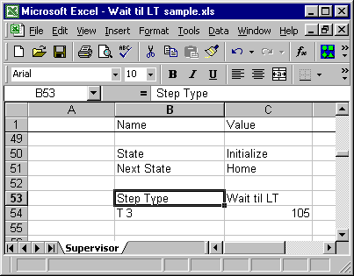

In the figure shown above, the component will not do anything at all until T3 falls beneath 105.

GC Configuration
The “GC Configuration” step is used by the “Pull GC Sample” step and the “Timed GC Pull” step to determine where and which tag values to save to an Excel spreadsheet.
Note: The “GC Configuration” step must be loaded before the “Pull GC Sample” step and the “Timed GC Pull” step or data will not be saved to the spreadsheet.
Parameter | Value | Comment
"Step Type" | "GC Configuration" | REQUIRED
"File" | File Path & Name | REQUIRED
Tag Name | "ON" or "OFF" | REQUIRED

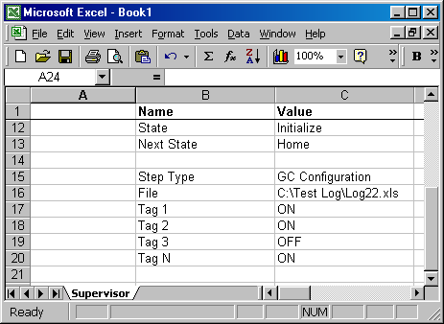
An example of a GC Configuration Step script is shown above. When the “SAVE” parameter in the “Pull GC Sample” or the “Timed GC Pull” step is “ON” the value of the tags that are “ON” will be saved to the spreadsheet file specified in the “File” field. In this case, the value of Tag 1, Tag 2, and Tag N will be saved to file “C:\Test Log\Log22.xls” when a GC Sample is taken in the “Pull GC Sample” step or the “Timed GC Pull” step.

Pull GC Sample
This step type will open up a TCP/IP connection on the Gas Chromatograph (GC) computer. An independent application (GC App) is typically already running on the GC computer. Whenever, the TCP/IP connection is opened, the GC App plays the F5 key on the GC computer, which causes a GC sample to be read. In effect, execution of the Pull GC Sample step triggers GC sample reading. Subsequently the Pull GC Sample step closes the TCP/IP connection previously opened.
Parameter | Value | Comment
"Step Type" | "Pull GC sample" | REQUIRED
"SAVE" | "ON" or "OFF" | Optional

The parameters syntax table above shows that there is one option for the Pull GC Sample step, namely “SAVE”. Immediately, the step begins, the GC sample is read once and depending of the parameter value of “SAVE” (ON or OFF) the step will log the instantaneous values of the tags specified in the GC Configuration step to the Excel spreadsheet specified in the GC Configuration step. After which the component moves on to the next step. If the SAVE Field is absent or contains an invalid entry, the value will be interpreted as OFF and the data will not be saved.
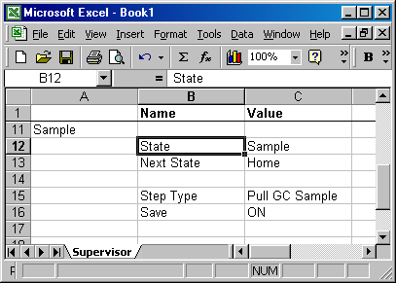
An example of a Pull GC Sample Step script is shown above. From the Sample State, the Supervisor component opens a TCP/IP connection on the GC computer, which activates reading of the GC sample, then closes the TCP/IP connection. Opening the TCP/IP connection, reading the GC sample and then closing the TCP/IP connection happens only once and then the Supervisor component moves to the next step.

Timed GC Pull
This step type will periodically open up a TCP/IP connection on the Gas Chromatograph (GC) computer. An independent application (GC App) is typically already running on the GC computer. Whenever, the TCP/IP connection is opened, the GC App plays the F5 key on the GC computer, which causes a GC sample to be read. In effect, execution of the Timed GC Pull step periodically triggers GC sample reading. At the end of each cycle, the Timed GC Pull step closes the TCP/IP connection previously opened.
Parameter | Value | Comment
"Step Type" | "Timed GC pull" | REQUIRED
"Duration" | Interval between GC Sample Pulls (secs) | Optional
"Cycles" | Number of GC Samples to be read | Optional
"SAVE" | "ON" or "OFF" | Optional

The parameters syntax table above shows that there are 3 options for the Timed GC Pull step, namely “Duration”, “Cycles”, and “SAVE”. The Duration will be used to govern the rate at which the GC sample reading(s) is taken. The first GC sample is read instantaneously, irrespective of the duration specified. The timing of subsequent readings however is dependent on the specified duration. Each reading is taken after the number of minutes, specified in duration, has elapsed since the previous reading. If the Duration Field is absent or contains an invalid number, the value is interpreted as zero. In such cases, there will be no interval between readings.
The total number or readings is equal to the value specified in cycles in the “Cycles” field. This value is interpreted as 0 (no readings are taken) if the “Cycles” field is absent or, as 1 if the value entered is 0 or an invalid number.
After the GC sample is read and depending of the parameter value of “SAVE” (ON or OFF) the step will log the instantaneous values of the tags specified in the GC Configuration step to the Excel spreadsheet specified in the GC Configuration step. This will happen for the number of cycles specified in the “Cycles” field. If the SAVE Field is absent or contains an invalid entry, the value will be interpreted as OFF and the data will not be saved.
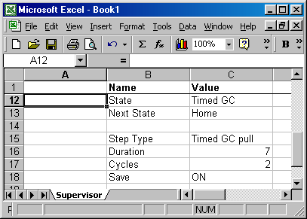

A sample Timed GC Pull Step script is shown above, such that from the Timed GC State, the Supervisor component activates reading of two GC samples at intervals of seven minutes. The first reading is taken at the zeroth Minute. The second and last reading taken at the seventh minute follows a pause of seven minutes. The Supervisor component then moves to the next step.

Wait for All Alarms
This step type will cause execution of the component to pause until all alarms return to the inactivated state or until the specified Duration expires, whichever occurs first.
Parameter | Value | Comment
"Step Type" | "Wait for All Alarms" | REQUIRED
"Duration" | Timeout, secs ("2.1") | Optional
On Failure | "Error" or "Anything Else can go here, if no error" | Action to take if any alarm is still in an  activated state when duration expires.  If the value entered is “Error”, then an  error is generated. If the value entered  is not “Error” then a simple warning is generated.

As can be seen from the above table, it is possible to specify how long to wait for all alarms errors to end. The component will wait for the cessation of all alarms. If the duration field is empty or is set to zero, the timeout is infinite. The component will not execute any other steps until all alarm errors are eliminated. If the duration is not zero, and if the time from the start of the step exceeds the number of seconds specified in duration, the step exits, but generates an error or warning, depending on the action specified in the “On Failure” field. If the Value of the “On Failure” field is "Error'", the component runs the Estop script and logs a message to the warning file. However if the value of the “On Failure” field is not error, is empty or the field is entirely absent, a simple warning is logged to the warning file.
The first script shown below is a case where none of the options of “Duration” or “On Failure” are used. This step does not time out, but will actually remain at this junction until all alarm errors cease. It would make no difference if the “On Failure” field were used, as the step does not timeout and hence does not generate any failure.
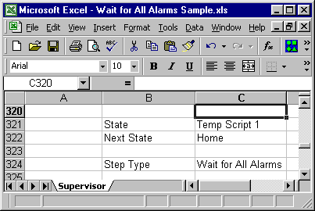

The script shown below is a case where the component has a maximum of 8 seconds to wait for the eradication of all alarm errors. If 8 seconds elapse from the start of the test and at least one alarm still has an error, a warning is sent to the warning file and the component tries to execute subsequent steps. This may not be possible since alarm errors may cause the component to enter the Estop state.

.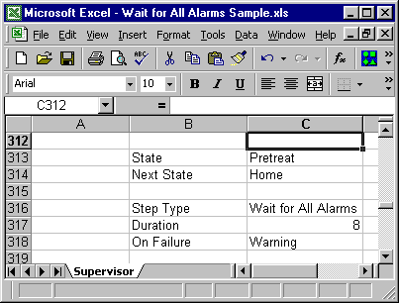
It is actually possible to force a component into an Estop state, if alarm errors are still present after a specified time. The script below shows a case where the component has a maximum of 20 seconds to wait for alarms to return to the untriggered state. Before the 20 seconds expire, the component continues normal execution at any time that these alarms become OK. However, if the 20 seconds expire and at least one alarm is not OK, the component goes into and Estop script, and a message is logged to the warning file.
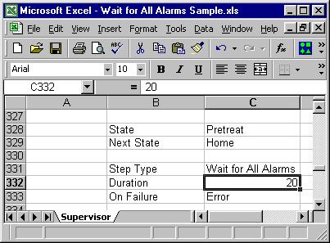

View
This step type can be used to manipulate screen management of a component’s view. A View is a graphical user interface for a component, which allows manual control and monitoring of tags. Views execute independently from component and execute in parallel with the components. Multiple views per component are allowed. However, View Steps can contain only one call to a view. Multiple views can only be called with separate steps. If a View Step contains more than one View call, only the first one is used, the others are discarded.

Parameter | Value | Comment
"Step Type" | "View" | REQUIRED
"View Name" | "On" or "Off" | REQUIRED, only one allowed
"Duration" | Pause after opening or closing view, secs ("2.1") | Optional

The script shows below an instance where Tubular Main View is opened from the Demowgs state. If the view is already open, the step makes the Tubular Main View Panel front most.
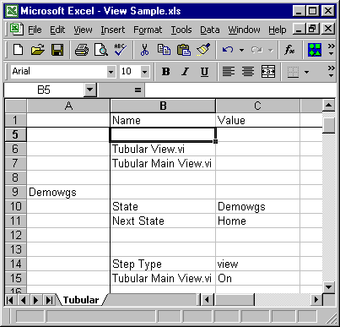

The script shows below an instance where Air Cooled Process View is closed from the Initialize state. If the view is already closed, the step does nothing. In either cause the component pauses for 10 seconds before moving to the next step.
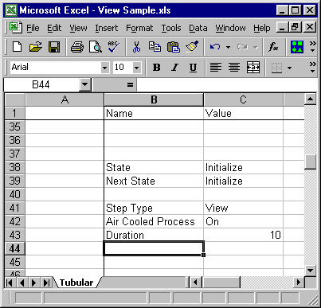

Prompt
This step type will cause a one button dialog box to pop-up with some message and wait for user acknowledgement. If the step is set up as synchronous, the script will wait until the dialog box is acknowledged before continuing through the rest of the script.
However, if the step is set up as asynchronous, the script will continue down through the script as normal. If it happens that the dialog box wasn’t acknowledged by the user before encountering another prompt step, the previous dialog box will be closed and replaced with the new dialog box.
Parameter | Value | Comment
"Step Type" | "Prompt" | REQUIRED
"sync" or ”async” | Message, (“Press OK to continue”) | REQUIRED

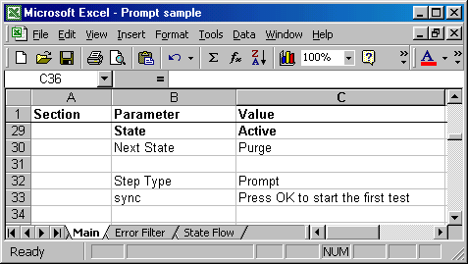
For instance if the prompt step is configured as in the figure above, the program will remain in a wait state until user acknowledgement, (until the user presses the “OK” button on the dialog box).
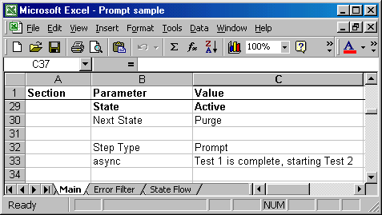
If the prompt step is configured as in the figure above, the program will pop-up the dialog box, displaying the above message and continue on down through the script. Remember that if the program encounters another prompt step before the user acknowledges this prompt step the more recent prompt will replace the original.

Wait til
This step type will cause the component to pause until all the tag values (AND) or one of the tag values (OR) satisfy the specified limits. The maximum time to wait is specified using the duration field. Individual or multiple tags may be tested. If the specified limits are not reached for all tags before the maximum time expires, the step exits and the On Failure action is implemented.
Parameter | Value | Comment
"Step Type" | "Wait til" | REQUIRED
"Duration" | Timeout, secs ("2.1") | Optional
"On Failure" | "Error" or "Warn" | Optional, defaults to Warning
“Mode” | “AND” or “OR” | Optional, defaults to AND
“Condition” | ** “EQ” | REQUIRED
Tag1 | Value1 | Wait til Tag1 = value1, Analog Values Only

The Data types that are permissible with the Wait til command are shown below with sample data:
Data Type | Value Strings
Analog | "0", "1.13e5"
String | Empty, "Hello"
Discrete | "On", "Off"

** Note: The “EQ” parameter may be replace by the following parameters:
Parameter | Description
EQ | Equal
NE | Not Equal
GT | Greater Than
LT | Less Than
GE | Greater Than or Equal
LE | Less Than or Equal

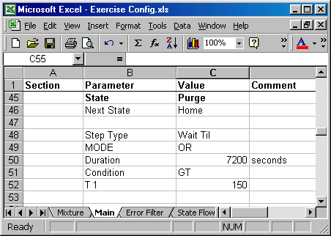
For instance if T1 is configured as in the figure above, the program will remain in the Wait Til step until the value of T1 exceeds to 150. However, if 7200 seconds elapse before T1 exceeds 150, the step exits.
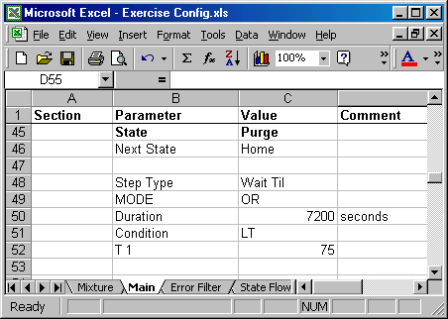
If T1 is configured as in the figure above, the program will remain in the Wait Til step until the value of T1 falls beneath 75 or 7200 seconds expire from the start of the step. When either condition is met, then the step is completed.
Just as it is possible to use the Wait til step to test one tag, it is also possible to use the Wait til step to test multiple tags simultaneously.
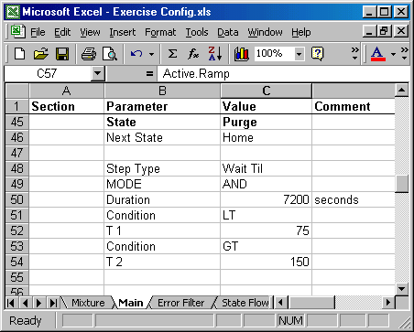
The figure shown above demonstrates a script in which the component remains in the Purge state until both of the following conditions are met;
- T1 falls beneath 75
- T2 exceeds 150
The case where the Duration expires is one exception to the above rule. If 7200 seconds have elapsed since the time that the step began, the step exits. If it happens that at least one of the above conditions is not met, the program is notified according to the action specified in “On Failure”. In this particular case, the “On Failure” field is empty and a warning is logged to the warning file.
If the Duration is not present, is empty or set equal to zero, the timeout is infinite. In this case, the component will not move to the next step until all listed tags fall beneath the specified values.

It is also possible to use the Wait til step another way to test multiple tags simultaneously.
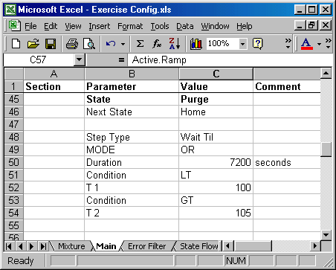
The figure shown above demonstrates a script in which the component remains in the Purge state until one of the following conditions are met;
- T1 falls beneath 100, or
- T2 exceeds 105
As before, the case where the Duration expires is one exception to the above rule. If 120 seconds have elapsed since the time that the step began, the step exits. If it happens that none of the above conditions are met, the program is notified according to the action specified in “On Failure”. In this particular case, the “On Failure” field is empty and a warning is logged to the warning file.
Again, if the Duration is not present, is empty or set equal to zero, the timeout is infinite. In this case, the component will not move to the next step until one of the conditions are satisfied.

Conditional
Mode: AND or OR all conditions.
If conditions are met, THEN will be executed.
If conditions are not met, ELSE will be executed.
Note: The IF/THEN/ELSE occurs immediately, then the step waits the Duration.

Step Type | Conditional
Duration | 3
MODE | AND
IF | compare_bool_1
EQ | ON
IF | compare_bool_2
EQ | ON
IF | start_val
GE | $compare_dbl_lo
IF | start_val
LT | $compare_dbl_hi
THEN
end_val | $compare_dbl_hi
ELSE
end_val | $compare_dbl_lo
compare_bool_1 | OFF
compare_bool_2 | OFF

Error filter
This step type will cause a tag error to be ignored (not recognized) for the amount of time specified by the delay time. Multiple tag error may be ignored. Once a tag error is marked to be ignored by the program, it will be ignored for the specified delay time, each time the error presents itself until the error is re-activated elsewhere in the script.
Parameter | Value | Comment
"Step Type" | "Error Filter" | REQUIRED
"Delay" | Wait Time before Error, secs ("2.1") | Optional
"Ignore" | Error Number | Optional
“Activate” | Error Number | Optional
“Activate” | “ALL” | Optional

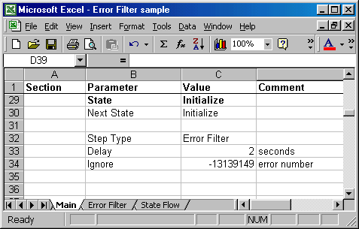
For instance, in the above example the error filter step is configured so that tag error
number of -13139149 is ignored by the program for two seconds before reporting the tag error as an actual error. If the “Delay” is not present, the delay time will default to the current delay time value.

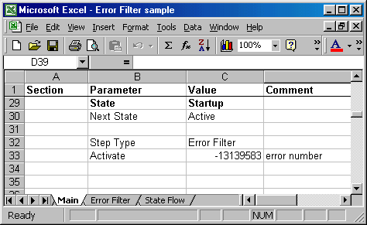
It is also possible, as the above example displays, that a tag error that was previously being ignored can be activated through the error filter step.
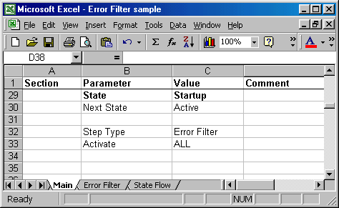
It is also possible to activate ALL the previously ignored tag errors through the use of the key word “ALL”, as is displayed in the above example.
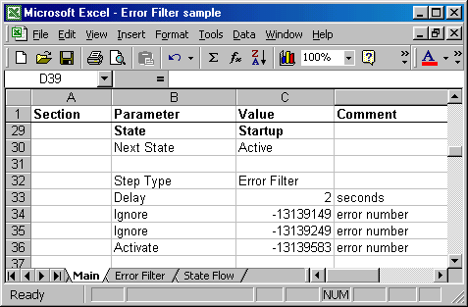
Not only is it possible to activate or ignore only one tag error at a time, the error filter step has the capability of activating or ignoring more than one tag error in a given step. The above example displays this by ignoring two tag errors and activating a third that was previously being ignored.

Edit
The edit step is used to edit tags. Edit causes a dialog box to open that permits the operator to see and modify the values of up to 10 tags. Analog, Discrete, and String tags are supported.
Parameter | Value | Comment
"Step Type" | "Edit" | REQUIRED
"Prompt" | Message to display at the top of the dialog box | Optional
Tag 1 | Optional Caption | Required
Tag 2 | Optional Caption | Optional
…
Tag 10 | Optional Caption | Optional

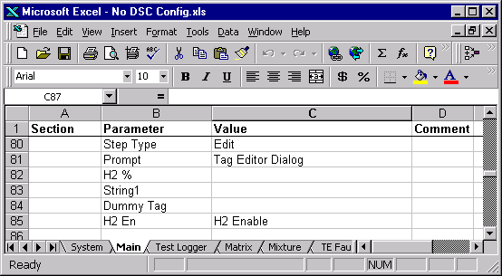
The above example shows Prompt being used to set the text visible at the top of the dialog box. Four tags are being edited: H2 %, String1, Dummy Tag, H2 En. The values to the right of the tag names in the spreadsheet are captions displayed in the dialog. Notice how the dialog displays “H2 Enable” for the “H2 En” tag. If no caption is specified the tag name is used for the caption.
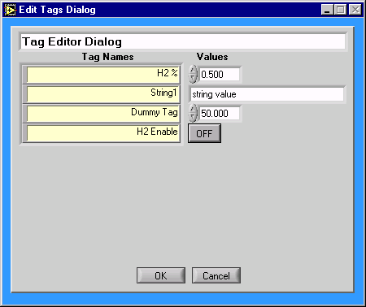

For / Next
The for/ next pair of steps repeats a steps between them a specified number of times. The code between the steps always executes at least one time.
FOR step parameters:
Parameter | Value | Comment
"For" | Tag | An existing analog tag to be indexed as the loop runs.
"=" | Value or $tag | Initial value. The first time thru the loop, Tag is set to this value and the following steps are executed.
"To" | Value or $tag | End value. When Tag exceeds this value, execution passes to the statement after the Next step.
“Step” | Value or $tag | Increment. Optional, default is one. Tag is incremented by this amount each time thru the loop.

NEXT step parameters
Parameter | Value | Comment
"Next" | Tag | SAME tag as the corresponding FOR step. If tags are not properly nested, an error occurs.
“While” | Tag | An existing analog or discrete tag to be tested as the loop runs. Optional field
"=", “!=”, ”>”, , ”<”, ”>=”, ”<=” | Value or $tag | Condition. Loop runs as long the condition is true. See example below. Optional

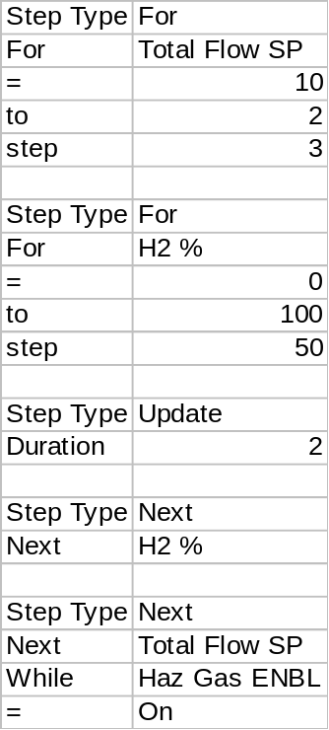This example shows nested For loops. The outer loop increments Total Flow from 10 to 2 in steps of 3 as long as Haz Gas ENBL is On. The inner loop will run values of 10, 7, 4, and 2.

DoWhile / Loop
The DoWhile / Loop pair of steps repeats a steps between them as long as the “while” condition is true.
DoWhile step parameters:
Parameter | Value | Comment
"DoWhile" | Tag | An existing analog or discrete tag to be tested as the loop runs.
"=", “!=”, ”>”, , ”<”, ”>=”, ”<=” | Value or $tag | Condition. Loop runs as long the condition is true. See example below.

Loop step parameters
Parameter | Value | Comment
"Loop" | Tag | SAME tag as the corresponding DoWhile step. If tags are not properly nested, an error occurs.
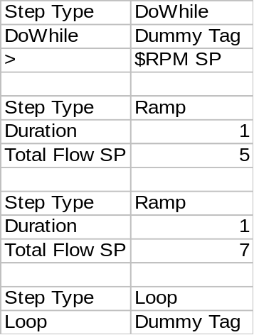
This example shows a DoWhile / Loop pair. The tow Ramp steps will repeat as long as the value of “Dummy Tag” is greater than the value of “RPM SP”.

Wait Til Settled
This step waits until a feedback is close to a setpoint for some time.
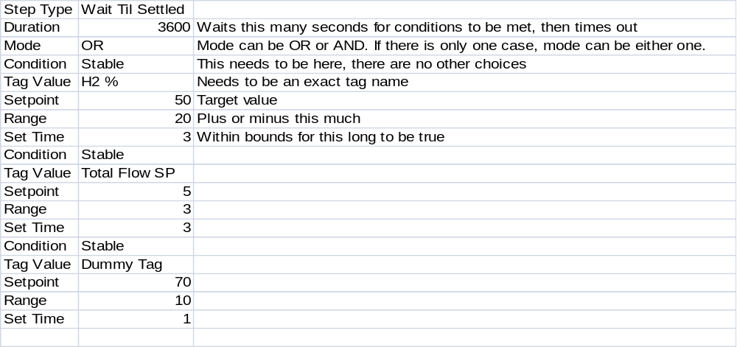

skip if not bool

skip if gt

skip if gt eq

These step types skip forward a certain number of steps if criteria are met.

Skip if not bool:
- If any of the tags are NOT equal to the values specified then a skip will occur.
- In other words, if all tags are equal to the values specified, then NO skip will occur.

Example:

If “Fake Bool” is != ON OR “Fake Bool 2” != OFF, then will skip forward 2 steps, to the Step Type commented as “2” (values in comment lines are meaningless).

If “Fake Bool” is = ON AND “Fake Bool 2” = OFF, then no skips will occur.

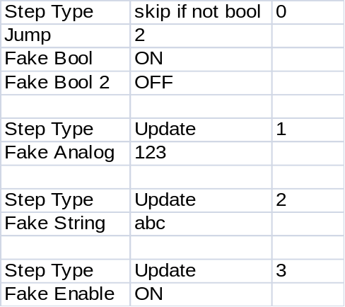

Skip if gt eq:

- If any of the tags are NOT >= to the values specified then a skip will occur.
- In other words, if all tags are >= to the values specified, then NO skip will occur.

Example:

If “Fake Count” is < 1 OR “Fake Count 2” < 4, then will skip forward 2 steps, to the Step Type commented as “2” (values in comment lines are meaningless).

If “Fake Count” is >= 1 AND “Fake Count 2” >= 4, then no skips will occur.

