CLASSIFICATION: CONFIDENTIAL



Information Technology and Innovation Department

CUSTOMS TAXPAYER RISK PROFILING MODEL
Model Development Decision Record: Release 1

VERSION 0.3, OCTOBER 2026 (DRAFT)

Document Control & Authority
Table 1: Document Information
Field | Details
Document Title | Customs Taxpayer Risk Profiling Model: Model Development Decision Record
Version | 0.3 (draft for review)
Classification | Confidential
Owner | Data Science Section, Data, Innovations and Projects Division, ITID
Model version recorded | 1.0.0-dev5 (settings fingerprint printed on every output)

Table 2: Document Version History
Version | Date | Author(s) | Role | Changes
0.1 | October 2026 | Ethan Mugire | Officer, Data Science | First draft: decisions and evidence for Stages 1 to 6 of release 1, the first challenger comparison, and the open questions for Stage 7.
0.2 | October 2026 | Ethan Mugire | Officer, Data Science | Lift worked through with real numbers; ensembles tested (decisions 52 to 54); project reorganised into the standard src layout with automatic tests (decision 55).
0.3 | October 2026 | Ethan Mugire | Officer, Data Science | Round 2 (Part 7): the two-track design, data since 2014 through the long run, performance measured per check, nine years of validation, three years of history with recent years counting more, Track B results and the blind review. Open questions moved to Part 8 and updated (decisions 57 to 95).

Table 3: Document Reviewers
Name | Role | Signature | Date
Stella Kwera Kisuze | Supervisor, Data Science
Judith Phionah Kembabazi | Supervisor, National Targeting Centre
Denis Lutaaya | Manager, National Targeting Centre

Table 4: Document Approvals
Name | Role | Signature | Date
Kevin Mugumya | Manager, Data Science
Nelson Keikara | Assistant Commissioner, Data, Innovations and Projects
James Malinzi | Assistant Commissioner, Customs Risk Management

Distribution
This record was prepared by the Data Science Section under the Data, Innovations and Projects (DIP) Division of the Information Technology and Innovation Department (ITID). It is the reference for why the Customs Taxpayer Risk Profiling Model is built the way it is: every decision taken during release 1, the reason for it, and the evidence behind it. It is meant to be read with the model code, the working notebook and the decision log kept beside the code.
Table 5: Audience for Internal Distribution
Audience | Primary Use
Data Science | Reference for the design, the evidence behind each setting, and how to change it safely.
Customs Risk Management and the National Targeting Centre | Review of the parameters, thresholds, bands and reason wording; the open questions in Part 8 need their answers.
Data Engineering | The source view, the cleaning rules and the extract query the model depends on.
Data Governance and Internal Audit | Traceability: every score carries a model version and a settings fingerprint that this record explains.

Table of Contents
Right-click here and choose Update Field to build the contents.

List of Tables
Right-click here and choose Update Field to list the tables.

List of Figures
Right-click here and choose Update Field to list the figures.

List of Acronyms
Table 6: Acronyms and Terms
Term | Meaning
APC | Additional Procedure Code: the last 3 digits of the CPC; claims a rebate or exemption
ASYCUDA | Automated System for Customs Data
Back-test | Scoring taxpayers as they stood at a past date and checking what happened next
CPC | Customs Procedure Code (EPC + APC)
EPC | Extended Procedure Code: the first 4 digits of the CPC
HDBSCAN | Hierarchical Density-Based Spatial Clustering of Applications with Noise
Hit | A red or yellow lane declaration that ended in a top-up
Hit rate | Hits divided by checked (red or yellow) declarations
HS | Harmonized System of commodity classification
IM4, IM7 | Import for home use; import into a warehouse
ITID | Information Technology and Innovation Department
L x I | Likelihood times impact: the rating behind each parameter's weight
Lift | Hit rate of the model's top group divided by everyone's hit rate
NTC | National Targeting Centre
PCA | Principal Component Analysis
Snapshot | The date at which taxpayers are scored; features come from the 24 months before it
TIN | Taxpayer Identification Number
Top-up | Tax raised after assessment: flag Y and final tax above original tax
UGX | Uganda Shillings
URA | Uganda Revenue Authority
WCO | World Customs Organization

PART 1: PURPOSE AND CONTEXT
This part sets out what this record is for, what the model does in one page, the data it was built on, and the standard of evidence every decision in the later parts was held to.

1.1 Purpose of this Record
Release 1 of the Customs Taxpayer Risk Profiling Model was built in stages, and at each stage a choice was made between alternatives. This record keeps those choices in one place so that a reviewer can see, for each one, what was decided, why, and what evidence supported it. Decisions are numbered as in the decision log kept with the code (DECISIONS.md); Annex A lists all of them.

1.2 The Model in Brief
The model ranks every importer (IM4 and IM7) by compliance risk, using the last 24 months of their declarations. Each taxpayer receives a score from 0 to 100, a band from VERY LOW to VERY HIGH, up to three reasons in fixed wording, and notes on how much weight the score can bear. It has four layers.
Table 7: The Four Layers of the Model
Layer | What it does | Status
L1 Peer groups | Places each regular taxpayer (10 or more declarations) in a group of similar traders: main goods (HS section) x size tier | Adopted (decisions 44, 45)
L2 Scorecard | Turns 8 agreed risk parameters into points that add up to at most 100 | Adopted (decision 41)
L3 Pattern check | Flags taxpayers whose overall trading pattern is unusual for their peer group | A note, no points (decision 46)
L4 Score and band | Rounds the points and assigns a band; writes reasons and notes | Bands provisional (Stage 7)

1.3 Data
The model reads one view prepared by Data Engineering in the dm_modeled_ura_datascience schema (its name is in the query template), with one row per declaration item. A single SQL query (one per snapshot date) turns it into one row per taxpayer: features from the 24 months before the snapshot and outcomes from the 6 months after it.
Table 8: Extracts Used in Release 1
Snapshot | Taxpayers | Declarations (24 months) | Share topped up | Hit rate in the 6 months after
30 Sep 2023 | 49,699 | 967,757 | 8.5% | 12.8%
31 Mar 2024 | 51,138 | 996,507 | 9.1% | 11.4%
30 Sep 2024 | 53,927 | 1,032,038 | 9.4% | 7.5%
31 Mar 2025 | 55,110 | 1,076,894 | 8.6% | 7.2%
30 Sep 2025 | 56,691 | 1,120,008 | 7.7% | 7.2%
31 Mar 2026 | 58,161 | 1,198,776 | 6.5% | 7.0%
30 Sep 2026 (live) | 57,501 | 1,291,508 | 5.4% | not yet known

1.4 Standard of Evidence
Every setting was judged in a back-test on each of the six past snapshots, not on the average alone. The measure is lift: the hit rate, in the 6 months after the snapshot, of the taxpayers the model ranks in its top 1%, 5% and 10%, divided by the hit rate of all taxpayers. A lift of 4 means the top group was topped up four times as often as the average taxpayer. Every result is compared with a simple baseline, ranking on past top-up ratio alone. From decision 48, lift is reported together with the number of hits caught, the share of top-up revenue caught, the top-up revenue per check and the share of small traders in the top group, because lift alone can be raised by moving the top of the list onto small one-off importers.
Table 9: Lift Worked Through (31 March 2026, release 1 model)
Group | Taxpayers | Checked declarations | Hits | Hit rate | Lift | Share of all hits
Top 1% | 582 | 2,469 | 794 | 32.2% | 4.6 | 6%
Top 5% | 2,908 | 19,134 | 7,162 | 37.4% | 5.4 | 56%
Top 10% | 5,816 | 26,471 | 7,774 | 29.4% | 4.2 | 61%
All taxpayers | 58,161 | 182,868 | 12,726 | 7.0% | 1.0 | 100%

Lift is used rather than accuracy because only about 7% of checks end in a top-up: a model that predicted "no top-up" for everything would be 93% accurate and useless. What matters with limited inspection capacity is how much more each check finds when officers follow the top of the list.
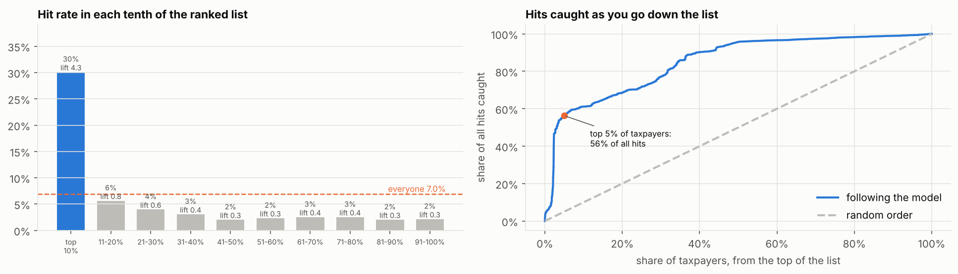
Figure 1: Hit rate in each tenth of the ranked list, and the share of all hits caught down the list

PART 2: DATA DECISIONS
This part records how the source view was checked and cleaned (Stage 1) and how the extracts were designed and accepted (Stage 2). Each cleaning rule exists because a specific check found a specific problem.

2.1 Cleaning Rules (Stage 1)
Table 10: Cleaning Rules and Their Evidence
# | Rule | Evidence (query)
1 | Score IM4 and IM7 only | Transit and export regimes carry guarantees or suspended amounts, not duty paid (D2)
2, 3 | Valid 10-digit TIN only | All valid TINs have 10 digits; the 479,719 declarations without a TIN are all in IM8, PB4, PP4 and SE1 (C1, H3)
4 | Exclude cancelled declarations | About 14,065 cancelled declarations (D1)
5 | One row per item | 14,215 items stored more than once, adding 1,478,314 identical rows (B1, H1)
6 | Tax amounts once per declaration | Tax is repeated on every item row (B2)
7, 17 | Top-up = flag Y and final tax above original; amount = final minus original | On unflagged declarations top_up_amt equals the final tax 99.8% of the time (H2)
8 | Negative top-up = final tax below original | H2
9 | Blank original tax filled with the final tax | Blank on about 37% of unflagged declarations; blank means unchanged
16 | Prices judged within each HS code; below 1% of the HS median is an entry error | Price per kg runs from UGX 69 to 17 million across all goods (F3)
43 | APC 483 excluded | Destroyed or abandoned goods and dummy reconciliation entries (procedure code guidance of 19 Nov 2025)

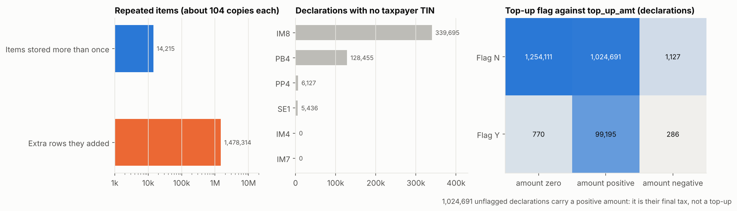
Figure 2: The three data problems behind the cleaning rules

2.2 Extract Design (Stage 2)
- Six back-test snapshots, six months apart (Sep 2023 to Mar 2026), plus the live snapshot of Sep 2026. Every month in the view is complete to September 2026 (A2).
- Features from the 24 months before the snapshot; outcomes from the 6 months after. The model never sees the period it is judged on.
- Lift is measured against each snapshot's own hit rate (decision 22), because the hit rate fell from about 12% to about 7% after March 2024 (decision 21). The cause is a question for the Risk team.
- All extracts passed the automatic checks (decisions 19 and 25): one row per TIN, valid TINs, rates between 0 and 1, hits never above checks.
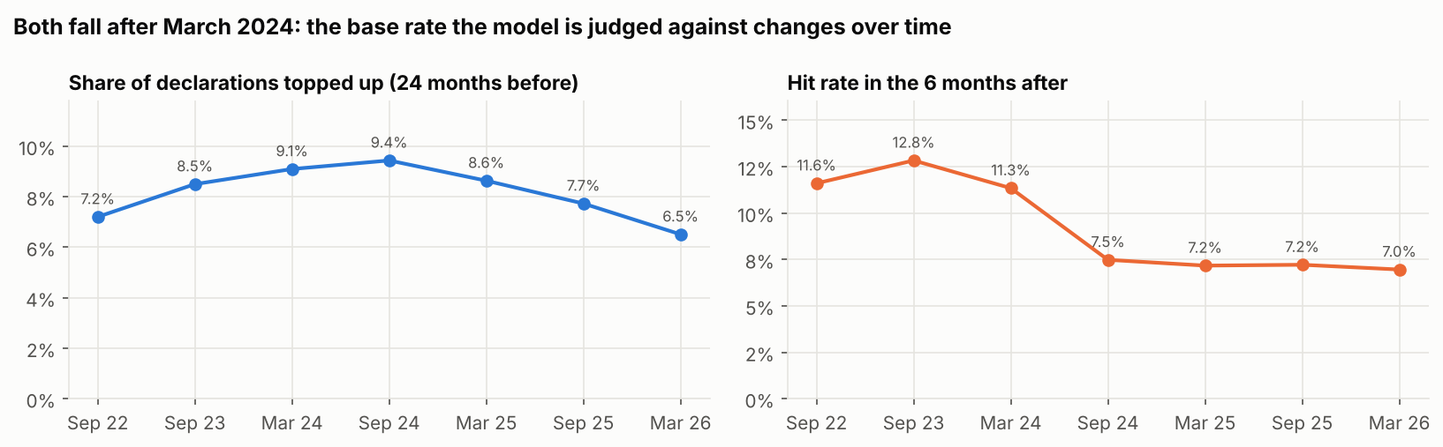
Figure 3: Share topped up and later hit rate by snapshot

PART 3: SCORECARD DECISIONS
This part records how the risk parameters were chosen, measured, protected against small counts, thresholded and weighted (Stages 3 and 4). The scorecard produces every point of the score.

3.1 The Small-Count Problem and Credibility Weighting
Most taxpayers declare very little: 87% of IM4 and IM7 taxpayers have fewer than 10 declarations in 24 months, and 28,626 have exactly one. A rate built on one or two declarations can only be 0%, 50% or 100%. Left alone, these taxpayers filled 84% of the HIGH band. Each rate is therefore blended with the population average by the weight n / (n + 10), where n is the number of declarations (decision 31), and the blend may only lower a rate, never raise it (decision 35).
Table 11: Effect of the Weighting Strength K (March 2026, one-way weighting)
K | Small traders in HIGH and VERY HIGH | Lift top 1% / 5% / 10%
None | 5,254 | 4.10 / 3.69 / 3.46
5 | 1,540 | 4.05 / 3.52 / 3.19
10 (adopted) | 538 | 3.90 / 3.33 / 2.96

Two-way weighting was rejected because it gave clean small traders points for other people's behaviour. A data-estimated strength was tested in the challenger round (decision 49): the data put K near 3, and two-way shrinkage moved small traders to the top of the list and caught fewer hits.
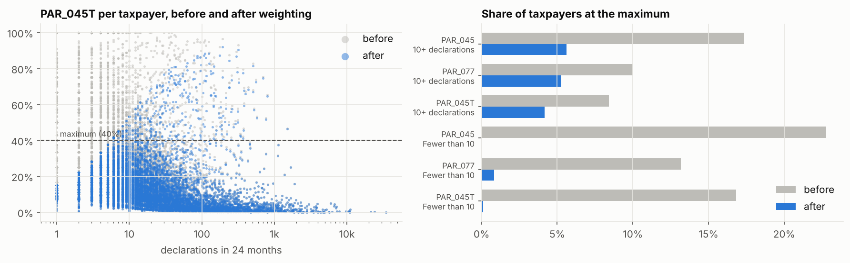
Figure 4: Share topped up per taxpayer before and after weighting

3.2 How Each Parameter is Measured
- PAR_048 is measured over final tax, not original tax (decision 32). Over original tax, a declared tax of UGX 29 produced a ratio of 4,399; 2,318 taxpayers were above 1. Over final tax the measure stays between 0 and 1, keeps the same order, and the officers' thresholds convert exactly (6% becomes 5.7%, 33% becomes 24.8%).
- PAR_045T is the officers' business rule "entries with top-up / total entries" (decision 42). Its maximum is 40%, not the officers' 10%: at 10%, 35% of regular traders scored full points and the scale stopped ranking.
- PAR_045 stays as amendments (decision 37).
- Consignee measures were dropped (decision 30): in IM4 and IM7 the consignee is always the taxpayer.
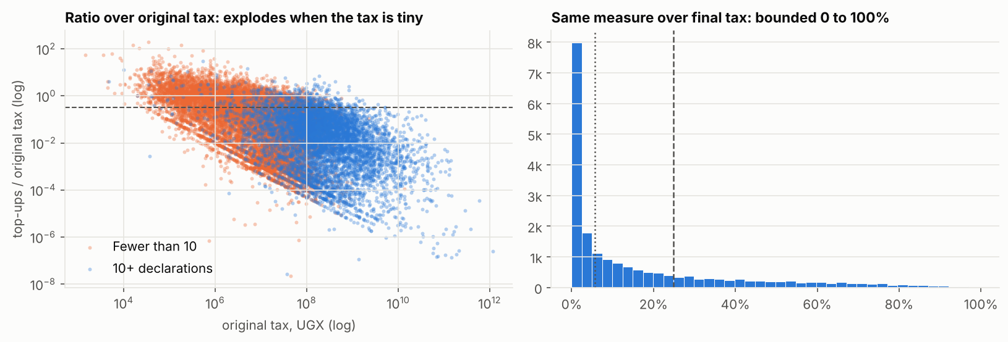
Figure 5: The top-up ratio over original tax and over final tax

3.3 The Adopted Scorecard
Table 12: Scored Parameters, Thresholds and Weights
Code | Parameter | Minimum risk level | Maximum at | L x I | Weight
PAR_045T | Declarations topped up | 3% | 40% | 5 x 5 | 33%
PAR_077 | Severe top-ups (30% or more of final tax) | 2% | 20% | 4 x 5 | 26%
PAR_045 | Declarations amended | 10% | 50% | 4 x 4 | 21%
PAR_048 | Top-ups as a share of final tax | 5% | 25% | 3 x 1 | 4%
PAR_076 | Value below HS benchmark | 2% | 20% | 3 x 1 | 4%
PAR_066 | Tax reduced after assessment | 2% | 20% | 3 x 1 | 4%
PAR_105 | Top-up within 180 days | no | yes | 3 x 1 | 4%
PAR_023 | Clearance away from main station | 30% | 70% | 3 x 1 | 4%

Each parameter scores 0 at its minimum risk level, full weight at its maximum, and a straight line between. If a parameter cannot be computed for a taxpayer, the others are reweighted to still total 100. The likelihood and impact ratings are Data Science working ratings set from the back-test, to be confirmed with the Risk Officers.
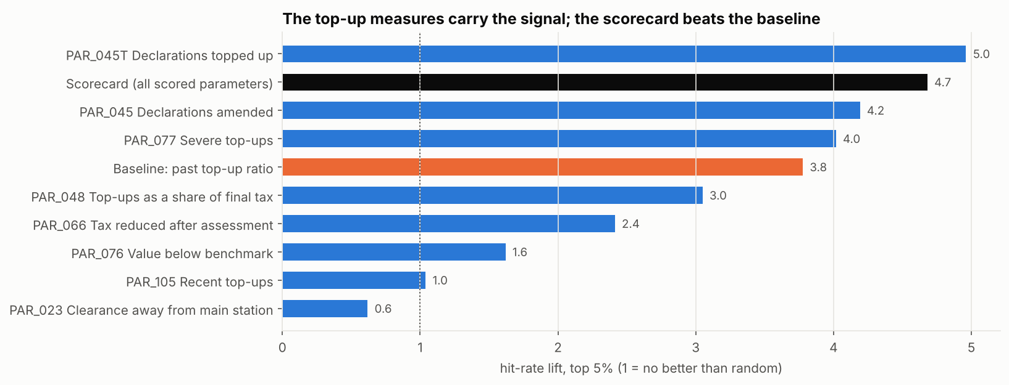
Figure 6: Lift at the top 5% for each parameter alone, the baseline and the scorecard
Table 13: Scorecard Options Tested (average of 6 snapshots)
Scorecard | Lift top 1% / 5% / 10% | Snapshots beating the baseline
Lean: PAR_045T + PAR_077 + PAR_045 | 4.87 / 4.26 / 4.19 | 6 / 4 / 3
All 8, evidence weights (adopted, decision 41) | 4.62 / 4.49 / 4.05 | 6 / 4 / 4
Earlier 7-parameter card | 4.00 / 3.39 / 2.94 | 6 / 2 / 1
Baseline: past top-up ratio | 2.87 / 3.60 / 3.55

All eight were kept because scoring them costs almost nothing in ranking and keeps every agreed parameter with data in the score and in the reasons officers read.

3.4 Officers' Thresholds Compared
Table 14: Threshold Profiles Compared (one-way weighting, K = 10)
Profile | Lift top 1% / 5% / 10% | Regular / small traders in HIGH and VERY HIGH
Data Science provisional | 3.90 / 3.33 / 2.96 | 740 / 538
Officers (profile 1) | 3.76 / 3.29 / 2.99 | 1,466 / 3,205
Officers (profile 2) | 3.77 / 3.26 / 2.88 | 1,002 / 1,149

Both officer profiles are kept in the code for continued testing (decision 34). PAR_048 uses the band of 5% to 25% of final tax and PAR_105 the officers' yes or no rule (decision 40).

3.5 Coverage of the 20 Agreed Parameters
Table 15: Status of the 20 Agreed Parameters
Status | Parameters | Reason
Scored (8) | PAR_045, PAR_045T, PAR_077, PAR_048, PAR_076, PAR_066, PAR_105, PAR_023 | Data available in the view
Built, awaiting the next extract (2) | PAR_067 (price against own history), PAR_053 (exemption and watch-list APC use) | Query written; the source platform was unavailable
Data not available (11) | PAR_012, PAR_016, PAR_051, PAR_054, PAR_096 | Need earlier versions of each declaration
 | PAR_015, PAR_075 | Boxes 45 and 46 not in the view
 | PAR_039, PAR_040 | Penalties not in the view
 | PAR_078, PAR_173 | Agent TIN not in the view

PART 4: PEER GROUPS AND THE PATTERN CHECK
This part records why HDBSCAN was dropped in favour of named peer groups (main goods x size), and why the pattern check became a note with no points (Stages 5 and 6).

4.1 Peer Groups: Main Goods x Size (decision 44)
A peer group answers one question: who is this taxpayer compared with? It is used only by the pattern check; it never changes scorecard points. Only regular taxpayers (10 or more declarations) are grouped.
- Main goods: the WCO HS section of the chapter where most of the taxpayer's customs value sits over the 24 months (for example HS 87 is Vehicles).
- Size: the taxpayer's total customs value over 24 months, ranked among regular taxpayers in the same section and cut into thirds: small, medium, large. The cut-offs are recalculated each run.
- Pooling: a group with fewer than 30 taxpayers is merged into "Other goods, <size>" and its members carry the "no close peers" note.
Table 16: Size Cut-offs for the Largest Sections (March 2026, customs value over 24 months)
Section | Small | Medium | Large
Vehicles | under UGX 380M | 380M to 1.39B | 1.39B and above
Machinery, electrical | under 845M | 845M to 3.65B | 3.65B and above
Textiles | under 735M | 735M to 3.13B | 3.13B and above
Minerals and fuel | under 3.3B | 3.3B to 50B | 50B and above

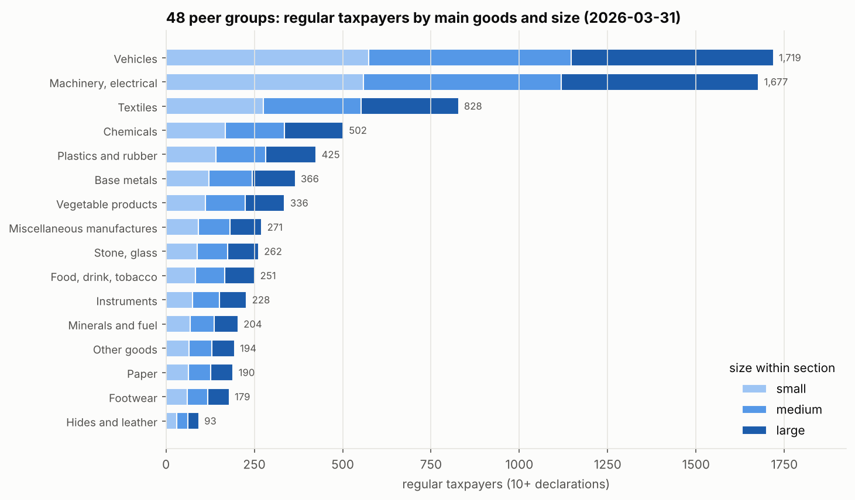
Figure 7: Regular taxpayers by main goods and size (48 peer groups)

4.2 HDBSCAN Tested and Dropped (decision 45)
HDBSCAN groups points that sit in crowded neighbourhoods and labels every point in a thin area as noise. On the nine trading-structure measures it left 77.1% of regular taxpayers unclustered. The six groups it found were piles of single-product traders sharing identical counts (one HS heading, one origin, one item per declaration), mostly vehicle importers and one group of fuel importers. Loosening the settings only reduced noise to about 70%. Trade is a continuum, not a set of separate types, so a density method has no gap to cut along.
Table 17: Peer Group Methods Compared (March 2026)
 | HDBSCAN | Main goods x size (adopted)
Groups | 6 | 48
Regular taxpayers without a real group | 77% (sent to the nearest group) | 2.5% (pooled)
What a group means | A pile of single-product traders | A named trade and size, e.g. Textiles, large
Pattern check lift, top 1% / 5% / 10% | 4.41 / 4.44 / 3.96 | 4.09 / 4.34 / 3.88
Without pattern points | 4.62 / 4.49 / 4.05 | 4.62 / 4.49 / 4.05

HDBSCAN was removed from the model code. The test remains in the notebook as the record of why.
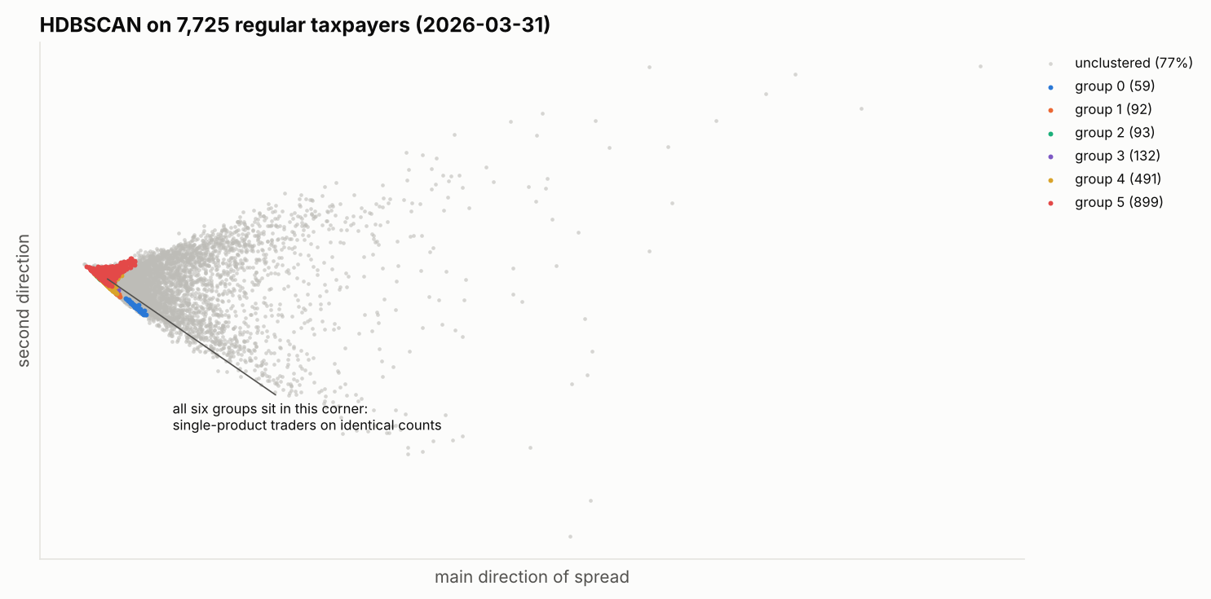
Figure 8: HDBSCAN on regular taxpayers: the six groups sit in one corner, the rest is noise

4.3 Pattern Check: a Note, Not Points (decision 46)
The pattern check runs an Isolation Forest within each peer group. It measures how few random cuts are needed to isolate a taxpayer from their peers: the fewer, the more unusual. It never sees outcomes, so it finds what is rare, not what is risky. It was tested as up to 15 extra points for the most unusual 20% of each group.
Table 18: Lift by Points Allowed to the Pattern Check (average of 6 snapshots)
Pattern points | Top 1% | Top 5% | Top 10%
0 (note only, adopted) | 4.62 | 4.49 | 4.05
Up to 5 | 4.44 | 4.45 | 3.99
Up to 10 | 4.32 | 4.41 | 3.92
Up to 15 (as tested) | 4.09 | 4.34 | 3.88

Table 19: Later Hit Rate of Regular Taxpayers by Scorecard and Pattern (average of 6 snapshots)
Group | Hit rate in the 6 months after
Scorecard under 15 points, usual pattern | 2.8%
Scorecard under 15 points, unusual pattern (top 20%) | 2.4%
Scorecard 15 points or more, usual pattern | 23.0%
Scorecard 15 points or more, unusual pattern | 24.7%
All taxpayers | 8.8%

Among taxpayers the scorecard sees as low risk, the unusual ones were hit no more often than the usual ones. The most unusual 10% use 7.7 times as many HS headings, 3.7 times as many items per declaration and twice the origins of the usual half: general merchants and consolidators. Pattern points therefore pushed varied but clean traders above taxpayers with real top-up records. The check is kept as a note (code PAT) for taxpayers more unusual than 95% of their peer group (413 taxpayers in March 2026), because officers asked to be made aware of such cases. The outcome used here only sees top-ups on checked declarations; risks it cannot see remain possible, and the decision can be revisited if audit outcomes show otherwise.
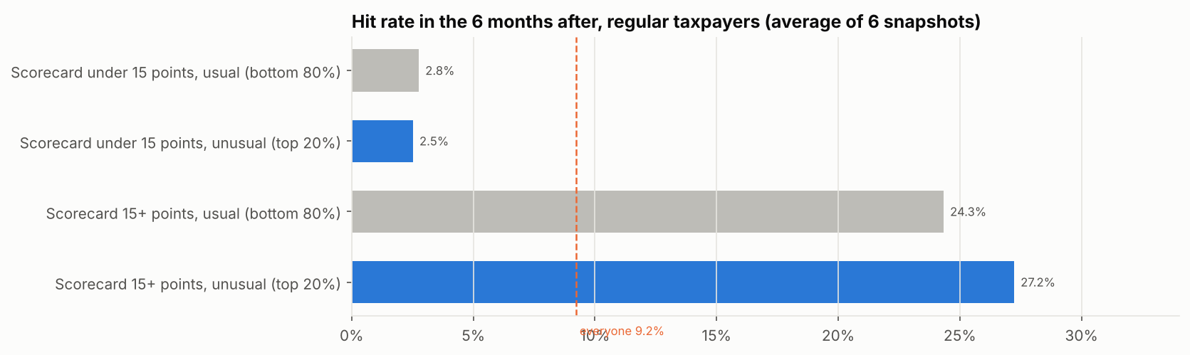
Figure 9: Later hit rate by scorecard level and pattern

PART 5: SCORES, BANDS AND OUTPUTS
This part records the output contract officers receive and the current state of the bands, which remain provisional until Stage 7.

5.1 Output Contract (decisions 26 to 29)
- One model (src/ctrp/core.py, in the ctrp package) is used by the notebook, the command line (main.py) and production, so the same input always gives the same scores. Automatic tests check its promises (decision 55).
- Officers receive an Excel workbook with fixed sheets: Read me, Scores, Reasons, Parameter values, Band summary, Reason codes, Run info.
- Every reason is a fixed sentence per code, ordered by points then code. Notes (PAT, LIM, NPE, LAG, MIS) carry no points.
- Every output carries the model version and a fingerprint of all settings.

5.2 Bands (provisional)
Table 20: Bands and Results for March 2026 (model 1.0.0-dev4)
Band | Score | Taxpayers | Hit rate in the 6 months after
VERY LOW | 0 to 15 | 44,245 | 2.8%
LOW | 16 to 35 | 9,888 | 5.8%
MEDIUM | 36 to 50 | 1,897 | 10.7%
HIGH | 51 to 80 | 1,785 | 43.0%
VERY HIGH | 81 to 100 | 346 | 38.4%
All |  | 58,161 | 7.0%

The hit rate rises band by band to HIGH. VERY HIGH sits above HIGH in the four earlier snapshots but below it in September 2025 and March 2026; the dip is concentrated in scores of 71 to 90. Stage 7 will set the cut-offs against this evidence and against inspection capacity.
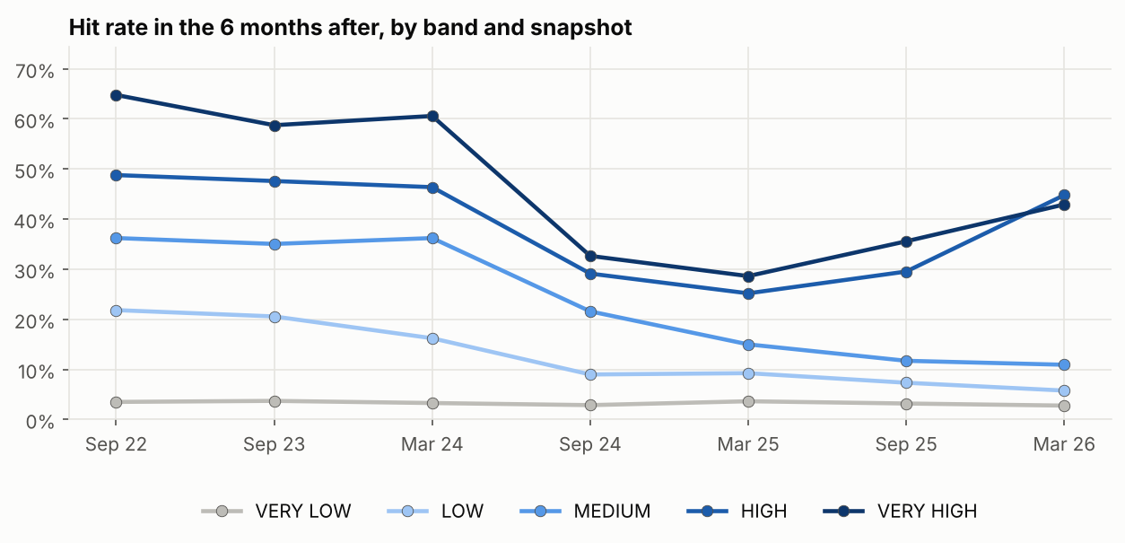
Figure 10: Hit rate by band in every snapshot

PART 6: CHALLENGER COMPARISON, ROUND 1
This part records the first comparison of the scorecard against alternative models: the candidates of the June 2026 Scope, Architecture and Design document and the challengers identified by desk research.

6.1 How the Comparison was Run
- Every challenger scores the same taxpayers and is measured the same way (code: src/ctrp/models/challengers.py).
- Models that learn from outcomes train only on earlier snapshots whose outcome window had closed. Tests run on September 2024, March 2025, September 2025 and March 2026.
- A challenger is called better or worse than the scorecard only where a 90% paired bootstrap interval of the top-5% lift difference excludes zero.
- Unsupervised candidates were given one-sided features (how far above the HS-section median each parameter sits, floored at zero), so they could only react to worse-than-peer behaviour.

6.2 Results
Table 21: Challenger Results (average of 4 test snapshots)
Model | Lift 1% / 5% / 10% | Hits in top 5% | Revenue in top 5% | Revenue per check (UGX M) | Small traders in top 5% | vs scorecard (top 5%)
Scorecard (release 1) | 4.30 / 4.37 / 3.86 | 5,522 | 45% | 1.18 | 53%
Baseline: past top-up ratio | 1.93 / 2.58 / 2.71 | 807 | 13% | 1.39 | 94% | 0 better, 2 worse
Largest importers by value (reference) | 0.39 / 0.52 / 0.71 | 5,099 | 53% | 0.17 | 2% | 0 better, 4 worse
Learned weights (logistic) | 4.11 / 5.00 / 4.49 | 5,070 | 38% | 1.27 | 59% | 3 better, 0 worse
Data-estimated shrinkage | 4.88 / 3.97 / 3.50 | 2,238 | 35% | 1.93 | 78% | 0 better, 1 worse
Monotone boosting (same 8 inputs) | 5.71 / 4.75 / 4.13 | 5,809 | 43% | 1.16 | 53% | 3 better, 1 worse
Monotone boosting with size | 7.33 / 6.30 / 5.85 | 3,508 | 19% | 1.41 | 83% | 4 better, 0 worse
Peer percentile (one-sided) | 3.65 / 3.48 / 2.62 | 4,228 | 45% | 1.16 | 53% | 0 better, 4 worse
Ensemble: Isolation Forest + PCA | 3.49 / 2.13 / 1.26 | 6,678 | 50% | 0.51 | 42% | 0 better, 4 worse
K-Means distance | 3.41 / 2.49 / 1.46 | 6,424 | 45% | 0.59 | 37% | 0 better, 4 worse
Gaussian mixture | 3.38 / 1.20 / 1.15 | 8,414 | 57% | 0.25 | 28% | 0 better, 4 worse

How to read the revenue columns. "Revenue in top 5%" adds up the top-up money customs actually raised on the declarations of the taxpayers a model ranks in its top 5%, over the 6 months after the snapshot, as a share of all top-up money raised in that period. It is not money the model creates. Because top-up money grows with how much a taxpayer imports and how often they are checked, this share rises whenever a model puts big importers at the top. The reference row shows it: ranking on customs value alone, with no risk information, reaches 53% of top-up revenue with a lift of 0.52 (half the average hit rate). Revenue per check (top-up money divided by the checks it took) removes the size effect; on that measure the scorecard yields UGX 1.18 million per check, the Gaussian mixture UGX 0.25 million. Revenue per check on very few checks is noisy (the data-estimated shrinkage figure rests on about 7,600 checks), so it is read with hits caught.
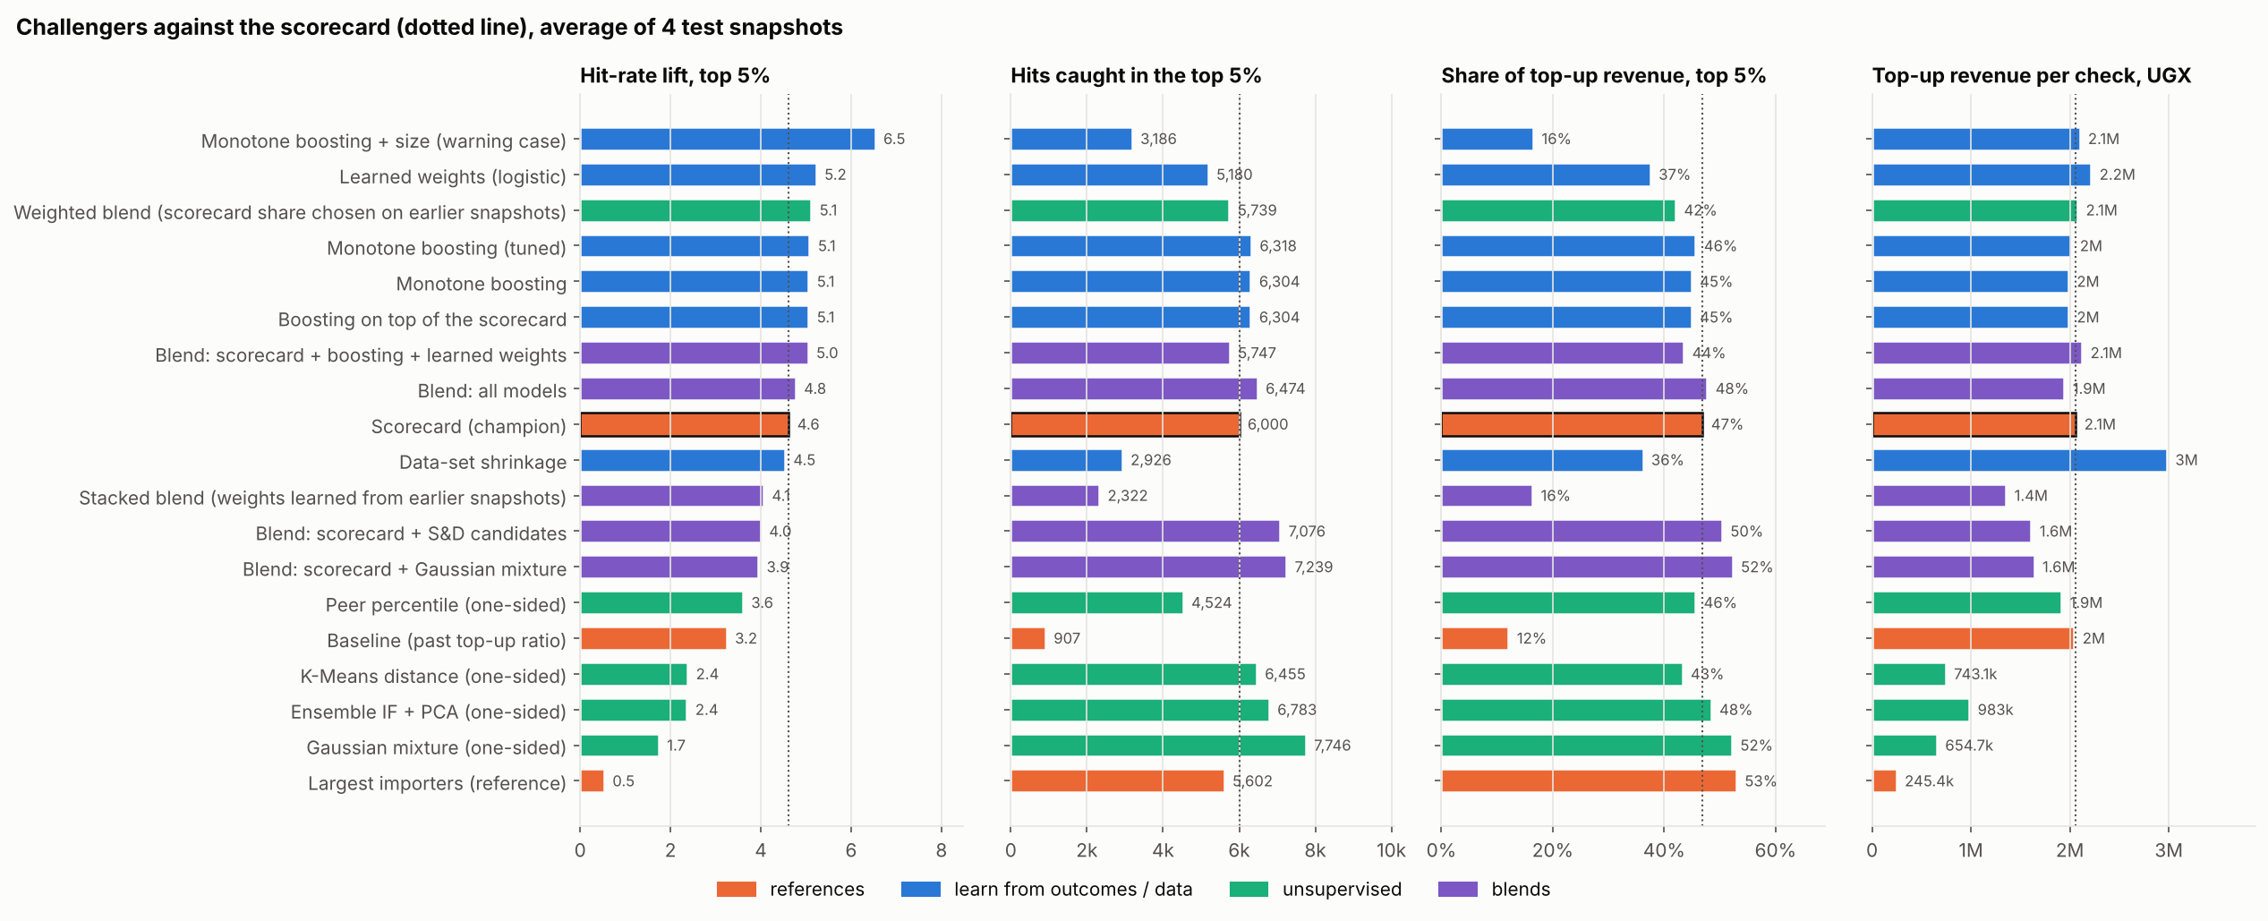
Figure 11: Challengers and blends against the scorecard: lift, hits and revenue in the top 5%

6.3 Decisions from the Comparison
Table 22: Decisions from Challenger Round 1
# | Decision | Reason
47 | The scorecard stays the release 1 model. Monotone boosting on the same 8 inputs and the learned-weight logistic scorecard go forward to round 2 | Boosting gains about 0.4 lift and 5% more hits at the top 5% with the same revenue and trader mix, but is worse in 1 of 4 tests and learns from selectivity-driven outcomes; the scorecard is explainable in officers' own thresholds
48 | Lift is always reported with hits caught, revenue caught and the small-trader share | Boosting with size reaches lift 6.3 by filling the top 5% with one-off importers, catching fewer hits and 19% of revenue
49 | One-way weighting at K = 10 stays | The data-estimated K (about 3) with two-way shrinkage pushed small traders up and caught 60% fewer hits
50 | The four Scope and Design candidates are not pursued as scorers | All lose on lift in 4 of 4 tests even with one-sided features. Their higher revenue share is a size effect: their top 5% needs 2.5 to 5.5 times the checks for UGX 0.25 to 0.59 million per check, against 1.18 million for the scorecard (decision 56)
56 | Revenue share is only read together with revenue per check | Largest importers by value (no risk information): 53% of revenue, lift 0.52, UGX 0.17 million per check. A high revenue share on its own shows size, not targeting
51 | Learned weights are taken to the ratings session as evidence | Outcomes put about 76% of the weight on PAR_045T, 14% on PAR_066, 6% on PAR_077 and none on amendments once top-ups are known

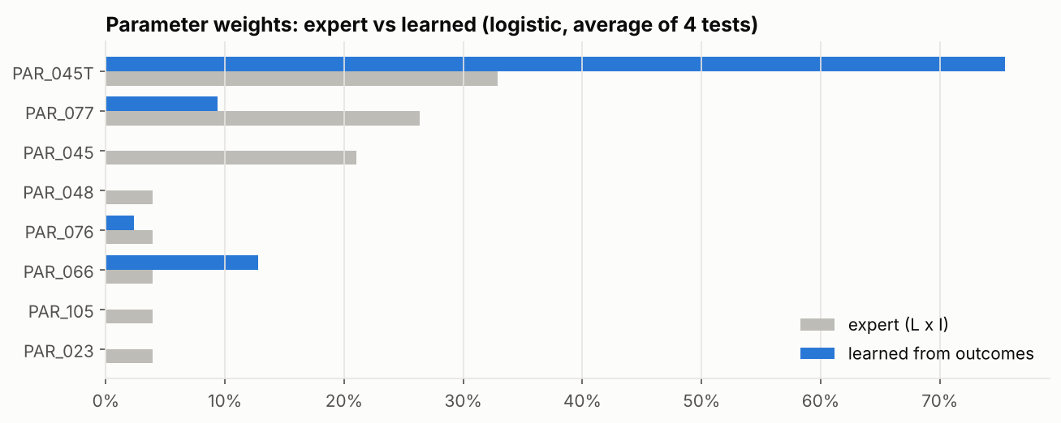
Figure 12: Parameter weights: expert ratings against weights learned from outcomes

6.4 Ensembles
A blend gives each taxpayer the average of their rank positions in its member models, so a taxpayer stays at the top only if several models agree. The stacked blend learns how much each member counts from earlier test snapshots (three tests only). The same protocol applies.
Table 23: Blends Against the Scorecard (average of 4 test snapshots)
Model | Lift 1% / 5% / 10% | Hits in top 5% | Revenue in top 5% | Revenue per check (UGX M) | Small traders in top 5% | vs scorecard (top 5%)
Scorecard (release 1) | 4.30 / 4.37 / 3.86 | 5,522 | 45% | 1.18 | 53%
Blend: all models | 4.53 / 4.57 / 3.94 | 6,119 | 46% | 1.11 | 52% | 2 better, 0 worse
Blend: scorecard + boosting + learned weights | 5.24 / 4.80 / 4.32 | 5,393 | 42% | 1.25 | 55% | 3 better, 0 worse
Blend: scorecard + Scope and Design candidates | 4.83 / 3.90 / 2.40 | 6,680 | 49% | 0.93 | 43% | 0 better, 2 worse
Blend: scorecard + Gaussian mixture | 5.30 / 3.92 / 3.14 | 6,673 | 49% | 0.95 | 44% | 0 better, 2 worse
Stacked blend (3 tests) | 2.17 / 3.95 / 3.92 | 2,919 | 21% | 1.05 | 72% | 1 better, 1 worse

Table 24: Decisions on Ensembles
# | Decision | Reason
52 | The blend of all models is the leading round 2 challenger; not adopted for release 1 | It improves lift, hits and revenue share together (better in 2 of 4 tests, worse in none), with revenue per check about the same (UGX 1.11 against 1.18 million). Everyone in its top 5% has 15+ scorecard points (median 57) and 85% overlap the scorecard's top 5%, so the reasons still apply. Not adopted yet: significant in only half the tests, the rank would no longer follow the points officers see, and eight models would run in production. Next: shadow run and blind officer review
53 | Stacked blend rejected for now | With three earlier windows to learn from, member weights swing between snapshots and lift at the top 1% falls to 2.2
54 | Blends with the Scope and Design candidates are not pursued | More hits and revenue share come from more checks on bigger traders: lift falls at 5% and 10% and revenue per check falls to about UGX 0.94 million (decision 56)

PART 7: ROUND 2: TWO TRACKS, NINE YEARS OF EVIDENCE AND HOW PERFORMANCE IS MEASURED
The decisions taken after release 1: a second view of risk for taxpayers with no record, the way the history since 2014 was obtained and checked, the measure performance is judged by, the evidence over nine years, the weighting of recent years, and how Track B is being proven.

7.1 Two Tracks (decisions 69, 70, 74 to 81)
The scope widened from identifying low-risk taxpayers to profiling every IM4 and IM7 taxpayer. Track A, the scorecard, scores the compliance record and cannot see risk that has not yet been found: 69% of taxpayers have no top-up history. Track B scores trading behaviour against similar importers, using nothing customs did to the taxpayer, for regular and small traders separately. The Overall Risk Band is the higher of the two tracks; a Risky Behaviour Flag raises a taxpayer to HIGH at most until the flags are proven. Flagged taxpayers carry entry-level evidence (entries priced below peers for the same line and origin), with fuel excluded and very low prices marked for a unit check.

7.2 Data Since 2014: the Long Run (decisions 85, 87, 90, 91)
Hue stops a query after about 30 minutes and a download at 100,000 rows. A one-pass query giving each taxpayer's additive counts per half-year was run as 12 one-year pieces (29,897 to 48,605 rows each). Checked against the six dates also pulled in full: the same taxpayers, and 99.5% to 100% of taxpayers matching on every measure, the small differences coming from top-ups recorded after the earlier pull. It cannot give the price benchmark or station spread, so it scores on six parameters (92% of the weight); on the six full dates this keeps 95% to 97% of the same top 5% and per-check AUC within 0.003.

7.3 How Performance is Measured (decisions 83, 84, 88)
Table 25: Measures Adopted
Measure | Role | Reason
AUC per check | Main measure | Each red or yellow check is one case; fair to big and small traders; matches how officers judge checks
Share of top-up money above the line | Beside it | Matches "additional revenue" in the officers' own measures
Precision and recall at HIGH and above (and other lines) | Read at the line officers use | Only meaningful once a line is drawn
Per taxpayer, at least one top-up | Dropped | Rewards being checked often
Accuracy | Not used | A model that says "nothing found" for everything is about 93% accurate

7.4 Nine Years of Validation (decision 91)
Track A scored at 18 dates, September 2017 to March 2026, each judged on the six months after it. AUC per check ranged from 0.74 to 0.86 with the adopted settings, at or above 0.80 on most dates. The one clear dip (September 2024 to September 2025, low point 0.74) coincides with the hit rate of all checks falling from 11-13% to 7% after March 2024, and is recovering (0.80 in March 2026).
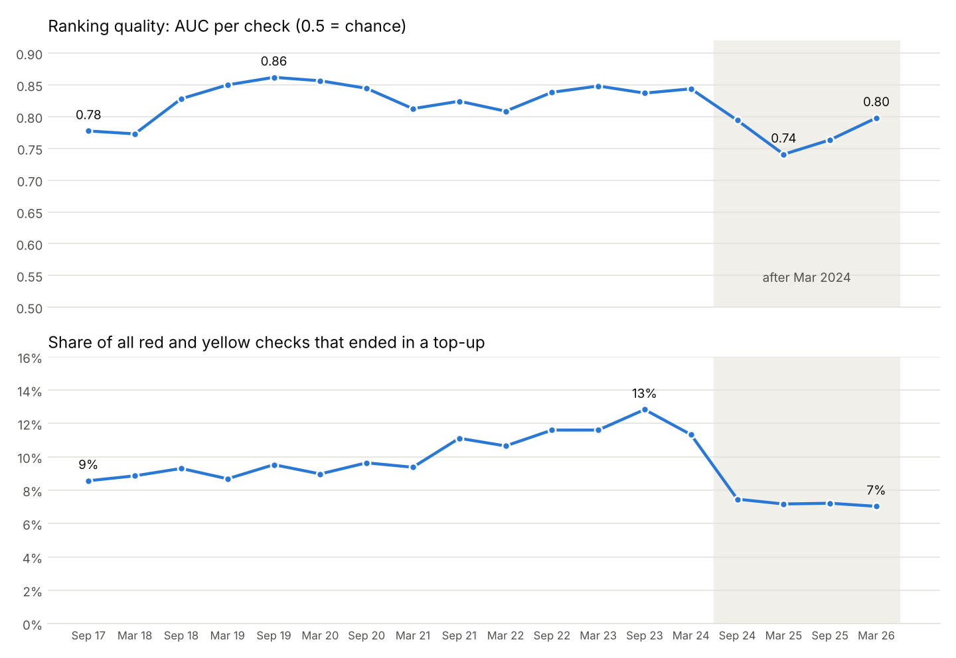
Figure 13: AUC per check and the hit rate of all checks, Sep 2017 to Mar 2026

7.5 Three Years of History, Recent Years Counting More (decisions 92 to 94)
Table 26: Weightings Tested
Option | AUC per check | Better than the old rule on
Old rule: last 2 years, equal | 0.813 | reference (18 dates)
Last year only | 0.804 | worse on 16 of 18
3 years: equal / gentle / halving / steep | 0.816 / 0.817 / 0.817 / 0.816 | 14 / 16 / 18 / 14 of 18
5 years: equal / halving / gentle (14 dates) | 0.821 / 0.821 / 0.822 (3 years halving: 0.820) | 13 / 14 / 14 of 14

Adopted: three years weighted 1, 0.5 and 0.25, the only option better on every date. Five years adds nothing measurable and needs heavier queries; equal or gentle weights let old top-ups count too much. Model version 1.0.0-dev5.

7.6 Track B Evidence and the Blind Review (decisions 86, 89, 95)
Against top-ups, within the taxpayers it is for, Track B ranks checks better than chance and better than Track A on every test date: AUC per check 0.62 for regular traders and 0.57 for small traders, against 0.55 and 0.52 for Track A. Top-ups cannot show undervaluation that was never found, so the decisive test is a blind review: 25 flagged and 25 comparison taxpayers, mixed under codes, judged by officers without knowing which is which.

PART 8: OPEN QUESTIONS AND NEXT STEPS
This part lists what remains to be decided, who must decide it, and the work planned for the next round.

8.1 Open Questions
Table 27: Open Questions
Ref | Question | Who decides
OQ-1 | Confirm that the list should maximise what each check finds (hit rate and revenue per check). Ranking big traders first reaches more total revenue only by spending many more checks, each finding less | Customs Risk Management with Data Science
OQ-2 | Confirm the likelihood and impact ratings, using the learned weights (decision 51) as evidence | Risk Officers (ratings session)
OQ-3 | PAR_045T maximum at 40% instead of 10% | Risk Officers
OQ-4 | APC 483 exclusion | Risk Officers
OQ-5 | What changed around March 2024: the hit rate of all checks fell from 11-13% to 7% and has stayed there (Part 7.4) | Risk Officers
OQ-6 | Band cut-offs, including the VERY HIGH dip, against inspection capacity (Stage 7) | Data Science with NTC
OQ-7 | Does the selectivity system keep a random inspection share, and are post-clearance audit results available? Either would give an unbiased test set | Customs Risk Management
OQ-8 | Inspection capacity: how many taxpayers can officers act on from each list (sets the line for the bands and the Risky Behaviour Flag) | Risk Officers
OQ-9 | Blind review verdicts on the 50 coded taxpayers (proves or disproves Track B) | Risk Officers
OQ-10 | What the S-series entry numbers are (the same goods often appear on an S- and a C-series entry) | Data Engineering or Risk Officers

8.2 Next Steps
- Score the blind review verdicts and decide whether Track B goes live as a list for officers.
- Pull full extracts for older dates (September 2019 to September 2022) to test Track B over more years.
- Re-run the seven extracts with the version 2 query and score PAR_067 and PAR_053 once tested (Stage 4 method).
- Stage 7: set band cut-offs against the score distribution, the VERY HIGH dip and capacity.
- Challenger round 2: a shadow run of the all-models blend; monotone boosting and the learned-weight scorecard with an expert-anchored variant; an expected-revenue model; network features once agent TINs are available. Officers review the top taxpayers of each list without knowing which model produced them.
- Stage 8: review the top 50 taxpayers with the Risk Officers.

Annex A: Decision Register
Every numbered decision in the decision log, with its evidence, as recorded at the time.
Table 28: Decision Register
# | Decision | Evidence
1 | Score regimes IM4 and IM7 only | D2: transit and export regimes carry guarantee or suspended amounts, not duty paid
2 | Valid 10-digit TIN only | C2: all valid TINs are 10 digits; one 3-character TIN on 373 declarations
3 | The missing-TIN gap does not affect the scored population | H3: IM4 and IM7 have no declarations without a TIN; the 480,000 are in IM8, PB4, PP4, SE1
4 | Exclude cancelled declarations | D1: 14,065 cancelled
5 | Keep one row per item | B1, H1: 14,219 items repeated up to 522 times, copies identical
6 | Tax amounts once per declaration | B2: identical on every item of a declaration
7 | Top-up = flag Y and final > original; amount = final minus original | H2: top_up_amt equals the final tax on 99.5% of unflagged declarations
8 | Negative top-up = final below original | H2
9 | Blank original tax treated as unchanged (filled with final) | H2: blank on about 37% of unflagged declarations; an inference, not stated in the data
10 | Back-test snapshots Sep 2023 to Mar 2026; live Sep 2026 | A2: every month complete to Sep 2026; Oct 2026 partial
11 | Lane flags tested with = 1 | E1: coded 1 or blank; one declaration can carry several lanes
12 | Taxpayer names not used | C3, I1: addresses mixed in, typos, one name is a backtick
13 | Preferential flag read as Y/N; the inf column dropped | E2: flag is Y or N (4% Y); inf is always blank
14 | No currency conversion needed | F2: customs_value equals CIF in UGX for every currency
15 | Fields complete enough to use as they are | F1: value, HS, origin and station never missing; weight and supplementary quantity missing on 0.01%
16 | Price outliers judged within each HS code, not across all goods: below 1% of the HS median = entry error, kept out of PAR_076 | F3: UGX per kg runs from 69 to 17 million across all goods, mostly because commodities differ; a single cut would remove cheap bulk goods wrongly
17 | top_up_amt confirmed as the final tax, not rounding | H2: on unflagged, unamended declarations it equals the final tax 99.8% of the time, median UGX 11.7 million; G1's top-up columns are therefore not used
18 | Amended declarations whose tax rose without the top-up flag (about 3,000) are not counted as top-ups | H2: the flag is customs' own marking; to be tested as an alternative in stage 3
19 | Six back-test extracts accepted: one row per TIN, valid TINs, rates in range, hits never above checks | check_extract.py: all tests PASS except the top-up ratio (below)
20 | Population grows steadily: 49,699 to 58,161 taxpayers, 968,000 to 1.2 million declarations per 24-month window | check_extract.py summary
21 | The top-up share and the hit rate fall over time, with a step down after March 2024: hit rate 12.8% and 11.4% in the first two outcome windows, then 7.0% to 7.5% in the last four | check_extract.py; to be raised with the Risk team (what changed around October 2024?)
22 | Lift is measured against each snapshot's own hit rate, not a fixed one, so the fall in base rate does not distort the comparison | follows from 21; score_v2.py already does this
23 | 86% to 87% of IM4 and IM7 taxpayers have fewer than 10 declarations | carried to stage 3
24 | Extreme top-up ratios are real, not errors: they come from a tiny original tax (UGX 29 behind the 4,399) on taxpayers with 1 to 3 declarations | look_top_up_ratio.py: 2,318 taxpayers above 1, 117 above 10 (Mar 2026); one regular importer (171 declarations) mostly zero-rated
25 | Live extract accepted: 57,501 taxpayers, 1.29 million declarations, 5.4% topped up, no outcome window | check_extract.py
26 | One model file (ctrp_model.py) used by the notebook, the command line and production | The same input always gives the same scores, whichever way it is run
27 | Officers' output is an Excel workbook with fixed sheets: Read me, Scores, Reasons, Parameter values, Band summary, Reason codes, Run info | Officers learn it once; any two runs can be compared
28 | Every reason comes from a fixed sentence per code, ordered by points then code; notes (LIM, NPE, LAG, MIS) carry no points | Two taxpayers with the same facts get the same words
29 | Each output carries the model version and a fingerprint of all settings | Any score can be traced to the settings that produced it
30 | Consignee features dropped | In IM4 and IM7 the consignee is always the taxpayer: no variation
31 | Credibility weighting at 10: each parameter = n/(n+10) x own value + 10/(n+10) x population average, n = declarations (items for PAR_076). Everyone is still scored | Small-history taxpayers in HIGH or VERY HIGH fall from 5,151 to 2,314 (Mar 2026) with the same top-1% lift (4.1). Agreed with Data Science; 10 to be re-checked once thresholds are set
32 | PAR_048 measured as top-ups over FINAL tax; officers' 6% and 33% become 5.7% and 24.8% | Over original tax a declared tax of UGX 29 gave 4,399; a few outliers should not set the scale for everyone. Agreed with Data Science
33 | PAR_077 / PAR_048 overlap: score one, show the other as information with no points; which one is decided by back-test | Correlation 0.76. Agreed with Data Science
34 | Thresholds: test the officers' thresholds against the provisional ones, and keep testing until settled | Agreed with Data Science. Officers' workbook received: profiles two officer profiles built into ctrp_model.py
35 | Weighting can only lower a value, never raise it | Two-way weighting gave clean small traders points for the population's behaviour; one-way spares them without inventing risk
36 | Feature query version 2: price against own history, duty rate against HS peers, same-day splitting, new traders, per-origin price benchmark, price deviation (Feature Document 3.1, 3.4, 3.5) | Agreed with Data Science (items 1 to 7). Needs all seven extracts re-run
37 | PAR_045 stays as amendments | Data Science's decision
38 | Splitting protected for bulk goods: HS chapters 25 and 27 and fuel EPCs 4080/7180 excluded; every other HS code measured against how often all importers repeat it on the same day (excess over the norm) | Data Science: construction and fuel legitimately arrive as many same-day declarations
39 | Duty rate compared only on items with no exemption claimed (APC 000); exemption use and use of the memo's watch-list APCs (404, 409, 417, 451, 455, 457, 476, 479, 481, 482, 484) measured separately | AC-Trade memo CUS/T/9.5.5 (19 Nov 2025): an APC claims a rebate or exemption, so a low rate under one is expected; the memo marks the watch-list "look out for possible abuse"
40 | PAR_048 uses an officer's band (5% to 25% of final tax), PAR_105 the officers' yes/no (top-up within 180 days) | Same ranking quality as the provisional values; officer-sourced
41 | Every agreed parameter with data is scored; weights set from the evidence (Data Science working ratings, to be confirmed with the officers): PAR_045T 33%, PAR_077 26%, PAR_045 21%, PAR_048, PAR_076, PAR_066, PAR_105, PAR_023 4% each | All eight with evidence-based weights: lift 4.6 / 4.5 / 4.1, beats baseline 6 / 4 / 4 of 6. The three-parameter lean card: 4.9 / 4.3 / 4.2 and 6 / 4 / 3. Scoring all of them costs nothing and keeps every agreed parameter in the score
42 | PAR_045T = the officers' PAR_045 business rule (share of declarations topped up): concern 3% (officers), maximum 40% (not 10%) | At a 10% maximum, 35% of regular traders score full points and the scale stops ranking. To be explained to the officers
43 | APC 483 excluded from the features | CPC memo: destroyed or abandoned declarations and dummy reconciliation entries. To be confirmed with the Risk Officers
44 | Peer groups = main goods (HS section) x size tier, not HDBSCAN | HDBSCAN left 77% of regular traders without peers; section x size gives 48 named groups (e.g. "Textiles, large") with 2.5% pooled. Ranking quality about the same
45 | HDBSCAN removed from the model code (ctrp_model.py). Peer groups stay main goods (HS section) x size tier (44). The HDBSCAN test stays in the notebook (section 4) as the record of why | 77.1% of regular taxpayers unclustered; the 6 groups are piles of single-product traders on identical counts; loosening settings only reaches about 70%. Pattern check lift with HDBSCAN groups 4.41 / 4.44 / 3.96 and with section x size 4.09 / 4.34 / 3.88, both below no pattern points 4.62 / 4.49 / 4.05. Data Science agreed
46 | Pattern check is a NOTE with no points (version 1.0.0-dev4). The note (PAT) is written when a regular taxpayer is more unusual than 95% of their peer group (413 taxpayers in Mar 2026) | Best lift at every cut-off with 0 points (table above); unusual taxpayers under 15 scorecard points were later hit 2.4% vs 2.8% for usual ones. 95th percentile, not 80th, so the note stays rare enough for officers to read. Data Science's decision
47 | The scorecard stays the release 1 model. Monotone boosting on the same 8 inputs and the learned-weight logistic scorecard go forward as round 2 challengers | Boosting: lift +0.4 at 5%, 5% more hits, same revenue and trader mix, but better in 3 of 4 tests and worse in 1, trained on selectivity-driven outcomes, and its reasons would need re-wording. The scorecard is explainable in officers' own thresholds. Proposed to Data Science
48 | Lift is never reported alone: every comparison also shows hits caught, revenue captured and the share of small traders in the top group | "Boosting + size" reaches lift 6.3 by filling the top 5% with one-off importers (83% small): fewer hits (3,508 vs 5,522) and 19% of revenue vs 45%
49 | Data-estimated shrinkage not adopted; one-way weighting at K = 10 stays | The data put K at about 3 for top-up and amendment rates, so two-way shrinkage moved small traders to the top (78% of the top 5%) and lost hits (2,238 vs 5,522)
50 | The four Scope and Design candidates (peer comparison, ensemble, K-Means, Gaussian mixture), even with one-sided features, lose on lift in 4 of 4 tests. Not pursued as scorers | Table above. They capture as much or more revenue by picking large, high-volume traders, which is a different objective (see open question)
51 | Finding for the ratings session: learned weights put about 76% on PAR_045T, 14% on PAR_066, 6% on PAR_077 and nothing on PAR_045 amendments once top-ups are known | Average positive logistic weights over the four tests; expert weights are 33% / 4% / 26% / 21%. Learned weights inherit selectivity bias, so they are evidence for the discussion, not a replacement
52 | The "all models" blend is the leading round 2 challenger: it is the only model that improves lift, hits caught and revenue caught together. It is not adopted for release 1 | +0.2 lift at 5%, 11% more hits, +1 point of revenue, same trader mix; better in 2 of 4 tests, worse in none. Every taxpayer in its top 5% (Mar 2026) has 15+ scorecard points (median 57), and 85% overlap the scorecard's top 5%, so the scorecard's reasons still apply. Not adopted yet because the gain is significant in only half the tests, the rank would no longer follow the points officers see, and eight models would have to run in production. Next: shadow run and blind officer review
53 | Stacked (learned) blend rejected for now | With only three earlier windows to learn from, the member weights swing between snapshots (the Gaussian mixture gets a negative weight) and lift at the top 1% falls to 2.2
54 | Blends with the Scope and Design candidates trade efficiency for volume | More hits (about 6,700) and revenue (49%) but lower lift at 5% and 10%: evidence for open question OQ-1 (what the list should maximise)
55 | Project reorganised into the standard src layout: package ctrp (core, utils, report, extract, pipeline, models), tests, one entry point main.py, notebooks/, docs/ | Data Science's instruction, for the GitHub repository. Model logic unchanged (26 automatic tests pass; same scores and fingerprint)
56 | "Revenue in the top 5%" is only read together with revenue per check (top-up money found divided by the checks it took). A high revenue share on its own shows size, not targeting. Decisions 50 and 54 are read with this: the Scope and Design candidates and their blends reach more top-up money only through many more checks on big importers | New reference "Largest importers" (rank on customs value, no risk information): 53% of revenue, lift 0.52, UGX 0.17 million per check. Scorecard: 45%, UGX 1.18 million per check. Gaussian mixture: 57% but 97,543 checks in its top 5% (more than half of all checks), UGX 0.25 million per check. Mar 2026: total top-up money UGX 28.2 billion; the top 1% of taxpayers by later top-ups hold 90% of it
57 | A snapshot whose full query will not finish in Hue is pulled as four smaller queries (python main.py sql --split <date>: core, items, own_duty, split_new) and glued back with python main.py merge. The parts are cut by code out of the one template, so the SQL and the result are the same as the full query | Full query ran 35+ minutes without finishing for 31 Mar 2025 and 30 Sep 2025; the other five finished. Spark rebuilds the cleaned item table for every reference to it, about a dozen times in the full query and a few times in each part. Checks: the three parts parse against the view and give the full query's 57 columns exactly once; an automatic test cuts an extract into parts and merges it back unchanged (28 tests pass)
58 | The item scan reads only the 24 view columns the model uses, not all 46 | First split run (three parts) lost its Hue connection after 30 minutes ("'NoneType' object has no attribute 'settimeout'") on 5 of 6 queries. Narrower rows mean less data moved in every shuffle. Results are unchanged: the dropped columns were never used (the full query and every part still parse and give the same 57 columns)
59 | The scorecard alone does not uncover new risk: every taxpayer in its top 5% (Mar 2026) already had a top-up in history. Taxpayers with no top-up history (69%) gave 9% of later hits and 10% of later top-up money; within them the scorecard is barely better than random (lift 1.34) | Mar 2026 snapshot. Within the no-history group, amendments alone reach lift 2.1 and PAR_076 shortfall 1.87, so behaviour signals can find first-time cases
60 | Two tracks. Track A (known risk) = the current scorecard. Track B (discovery) = behaviour only, no top-up history: prices, classification, quantity, origin and preference, exemptions, amendments, splitting, trading pattern. Track B is judged by discovery lift (lift among taxpayers with no prior top-up) and by Risk Officers' review of its list with entry-level evidence | Data Science's direction: an honest, objective, dynamic risk profile that follows the taxpayer and uncovers those spared by the current process
61 | APC 483 excluded from the features | Confirmed by Data Science (open question closed)
62 | Taxpayers with fewer than 10 declarations get their own list, ranked among themselves | Data Science's direction
63 | Success measures follow the officers' selectivity measures, in their order: compliance over time, additional revenue, accuracy of checks, facilitation (speed and volume) | Officers' stated precedence; taxpayer-level equivalents defined in the model guide
64 | Output stays the Excel workbook; stable sheet and column names so a BI dashboard can read it in production. The random-check slice is considered in User Acceptance Testing | Data Science's direction
65 | APC 483 stays IN for now (switch EXCLUDE_APC_483 in extract.py, default False), so new pulls match the version 1 extracts in use. Exclusion (61) applies once every extract is re-pulled | Data Science's direction while Hue is down and Zeppelin is being set up
66 | Tuning boosting's settings adds almost nothing: tuned 4.84 against default 4.75 lift at 5%, same hits. Hyperparameter search is not where the gains are | Forward-chaining search over 16 settings, chosen on the latest training snapshot only
67 | "Boosting on top of the scorecard" is the leading round 2 challenger: lift 4.80 against 4.37, 5,882 hits against 5,522 (+6.5%), better in 3 of 4 tests and worse in none. Revenue share 43% against 45%. Not adopted; goes to shadow run with the weighted blend (lift 4.87, 3 better / 0 worse, but fewer hits: 5,362) | CTRP_challengers.xlsx. The scorecard stays an input, so its reasons still explain the score
68 | Sensitivity: the ranking is stable. Each main weight moved by 50% keeps 95% to 98% of the same top 5%; concern levels 99%; maximum levels moved by 25% about 95%. Two settings matter: the PAR_045T maximum (10% costs 0.84 lift, confirming 42) and the credibility weight K (K = 0 loses 46% of hits; K = 20 gains 13% hits for 0.22 less lift). K is a policy choice between efficiency and volume, to show the officers | CTRP_sensitivity.xlsx, six snapshots. History and outcome windows are tested once Zeppelin extracts exist
69 | Track B v0 (behaviour columns already in the extracts): taxpayers with no top-up history are 95% small traders (median 1 declaration). Regular taxpayers with no history are about 1,560 and give about 2% of later hits. Monotone boosting on behaviour reaches discovery lift 3.15 among regular (Track A 1.56) and 1.48 among small traders (Track A 1.12), better than Track A in 4 of 4 tests in both, but on small numbers (about 21 hits in the regular top 5%). Track B needs the item-level features (trackb_features.sql) and Risk Officer review, because top-up outcomes cannot show undervaluation customs never caught | CTRP_track_b.xlsx
70 | Extracts move to Zeppelin: one Spark session, the cleaned item table built once per snapshot and reused; output identical to the full Hue query on the test view (57 of 57 columns). Blocked until the Spark interpreter can start for Data Science's user (cluster permission) | notebooks/zeppelin/ctrp_extract.py
71 | History: the last 3 years inside a 5-year window, with recent behaviour weighted more, matching the officers' practice. Waits on the data range check | Data Science's direction
72 | The view holds declarations from 26 Nov 2012 to 13 Oct 2026 (first and last day, IM4 and IM7). A 3-year history inside a 5-year window needs no data request, and many more test dates are possible. Before using early years: check that every month is complete, and map tariff codes across the 2022 HS change | Data Science's MIN / MAX query in Hue, 13 Oct 2026
73 | Until Data Science has a folder he can write to, the Zeppelin note keeps every extract in memory (SAVE_TO_FOLDER = False) and writes nothing. The Spark interpreter still needs a home directory on the cluster to start at all | Cluster permissions
74 | Track B runs in production beside Track A. The workbook gains an overall band (the higher of the two tracks; a discovery listing lifts to HIGH at most until review confirms Track B), a Discovery list sheet, and a Small traders sheet. Discovery list size: 5% of regular and 1% of small no-history taxpayers, working values until the officers give capacity | Live Sep 2026: 510 taxpayers listed (120 regular, 390 small traders); 510 move up to HIGH. On the current summary columns the leading reason is "many kinds of goods per declaration" (mixed consignments); the item-level features are expected to broaden the reasons
75 | Officers' review pack: python main.py review <workbook> writes one Hue query that pulls, for the top 50 regular and 50 small-trader listings, the 5 entries priced furthest below other importers of the same tariff line and origin, with station, year and entry number. Query and list contain TINs and are excluded from git | Tested on the test view; reads only the listed taxpayers and the tariff lines they used
76 | Version 2 extracts pass every check except the known top-up ratio outliers. Track A gives the same result on version 1 and version 2 (lift at 5%: 4.81 and 4.79; hits 7,312 and 7,313), so excluding APC 483 and the per-origin PAR_076 benchmark change nothing material for Track A. Adding "new trader" to Track A at 4% adds 41 hits and no lift: not added | Same four back-test snapshots on both versions
77 | Measured against later top-ups, most new behaviour features do not predict: duty below peers, exemption and watch-list APC use, same-day splitting and own-price drop all have lift below 1 among regular taxpayers. Only new trader (1.76) and price below benchmark (1.55 to 1.63) do. Reading: a top-up is the wrong yardstick for these risks (an exemption misuse or a split consignment rarely ends in a top-up at the check), so they stay in Track B and are judged by the officers' review, not by lift | Single-feature lift, regular taxpayers, four snapshots
78 | Workbook wording, at Data Science's request: "concern level" becomes "minimum risk level"; "Score" and "Band" become History Risk Score and History Risk Band; the final band is the Overall Risk Band; "discovery" becomes trading behaviour (Behaviour Flag, Behaviour risk percentile against similar importers, Behaviour reasons, sheet "Behaviour flags"); the limited-history column states its limit (under 10 declarations); "Low agreement" becomes "History and pattern disagree". Scores and bands are unchanged; the settings fingerprint changes because the wording is part of the settings | Live Sep 2026 band counts identical before and after
79 | The pattern note now shows its evidence: the two measures on which the taxpayer sits furthest from its peer group, each as its own value against the peer median (for example "severe top-ups 50% against a peer median of 0%") | "More unusual than 99% of the peer group" alone gave an officer nothing to check
80 | Entry evidence goes into the workbook: python main.py score <extract> --evidence <review CSV> adds an Entry evidence sheet (station, year, entry number, declared price against the peer median, possible value gap, duty rate against peers) and an evidence count per taxpayer. Fuel (HS 27) is left out, because it is priced per litre with specific duties and its value gap swamped everything else (UGX 64 bn of 76 bn in the first pack). Prices under 5% of peers are marked "Check units" (94 of 471 entries), since a unit keyed wrongly is a common cause. The review query now also requires a price below peers per unit wherever a unit quantity is declared | First evidence pack, Sep 2026: 100 taxpayers, 496 entries, median declared price 20% of peers, 461 of 496 benchmarks on the same tariff line and origin (median 111 importers)
81 | Wording, at Data Science's request: "Behaviour Flag" becomes "Risky Behaviour Flag" (sheet "Risky behaviour flags"), because a flag on behaviour alone does not say whether the behaviour is good or bad. The pattern note is rewritten in plain sentences: it names the peer group, shows each measure the way the reasons do (for example "50% of declarations had a severe top-up (30% or more of the final tax)"), gives the peer median as "similar importers", marks measures that are already scored as "already counted in the score", and caps the percentile at 99% (it read "more unusual than 100%", which cannot be true). Why the marking: 275 of the 439 pattern notes in the Sep 2026 run were driven by top-up measures the score already counts, so officers should see when a note repeats the score and when it adds something new | Scores and bands unchanged
82 | Entry evidence from the improved review query (no fuel, per-unit check): 471 entries for 98 taxpayers. The sheet now also shows quantity in units, price per unit and the unit price as a share of peers; "Check units" is set when either the per-kg or the per-unit price is under 5% of peers (132 entries). 339 entries sit between 5% and 100% of peers on both measures: the cleanest evidence for officers | Median declared price 19% of peers per kg, 23% per unit; median 111 importers per benchmark
83 | Standard performance measures added (python main.py performance, src/ctrp/performance.py): precision, recall, accuracy, ROC AUC and average precision at taxpayer level on every back-test, beside the lift, hits and revenue already reported. Lift at 5% is precision at 5% divided by the base rate, so these restate the same test in standard terms. Accuracy is shown next to "call everyone negative" because with few positives it misleads. Finding: ranking quality fell from ROC AUC 0.80 (2023-24) to about 0.62-0.63 (2025-26) for regular and small traders alike, while the share of checked taxpayers with a top-up fell from 49% to 24%; lift held because the base rate fell too. Bands stay correctly ordered (checked taxpayers with a top-up: VERY HIGH 73%, VERY LOW 25%, six-snapshot average). Cause to be asked of the Risk Officers alongside the hit-rate fall after March 2024 | 6 snapshots, Sep 2023 to Mar 2026
84 | Correction to 83: the headline performance measure is per check, not per taxpayer. The taxpayer-level label "at least one top-up" rewards being checked often, so it partly measures how often customs looked. Counting each red or yellow check as a case (as officers judge selectivity), ROC AUC is 0.84 (2023-24), dips to 0.74 (Mar 2025) and recovers to 0.79 (Mar 2026). The dip is real: after March 2024 the hit rate per check for taxpayers with past top-ups halved (13.8% to about 7.5%) while it moved less for the rest, so history separated less well; by Mar 2026 the gap is back to about 2 to 1 (7.7% against 3.6%). Size alone ranks checks the wrong way (AUC 0.27-0.40): larger traders have fewer hits per check. Both views are kept in CTRP_performance.xlsx | 6 snapshots
85 | History since 2017. Back-test dates every six months from Sep 2017 to Mar 2026 (18) plus live Sep 2026. Every feature still uses 24 months, so the current model runs unchanged on the new extracts; added are counts per year over 36 months (y1 = latest 12 months, y2, y3: declarations, topped up, severe, amended, tax reduced, top-up and original tax amounts, plus days since the last top-up in 36 months) so recency weighting can be tried in Python without another pull (3 years inside a 5-year window: 36 months of history plus the 24 months before them for the new-trader check). Two ways to pull: (1) Hue, as 5 small part queries per date in sql/hue_plan/ with a checklist (66 queries: the yearly counts for the six dates already held, then Sep 2022 back to Sep 2017, then the March dates), because Hue drops anything over about 30 minutes; (2) the ONE LONG RUN in Zeppelin (paragraph 5), all 19 dates in one go, skipping any already finished so it can be re-run after a failure. Tested on local Spark: every existing column identical to the earlier template, y1 + y2 declarations equal entries_24m, split parts merged and the Zeppelin path both equal the full query. Track B's item window is now limited to the 24 months explicitly (it read everything cached before); its first-seen date uses all 36 months, a better test of "new" | 38 tests
86 | Blind review of Track B, 25 and 25 (Data Science: 100 is too many to start). The top 25 flagged taxpayers (12 regular, 13 small traders) are mixed with 25 unflagged taxpayers with no top-up history, picked at random (seed 42) from the same segments, under codes R01 to R50 in shuffled order. Officers get only codes, TINs and entries (python main.py blind-pack); the key stays with Data Science. Track B passes if the flagged group draws clearly more "Act" verdicts than the comparison group | sql/review/blind_2026-09-30.sql
87 | The ONE LONG RUN for Hue (python main.py sql --long-run -> sql/long_run/long_run.sql): one query reads the view once and returns one row per taxpayer per half-year (Oct 2014 to Sep 2026) with counts that add up exactly; python main.py long-run then builds every snapshot (24 months of features, 3 yearly counts, 6 months of outcomes) by adding up half-years. Why not the full feature query for all dates in one: one date alone already takes about 30 minutes in Hue. What it leaves out (not additive): PAR_076 benchmarks, PAR_023 station spread, goods and origins, main HS chapter; scores reweight the six parameters it has (92% of the weight). Checked: on local Spark every column it gives equals the full query for the same date (to the 5 decimals the query rounds to), and yearly pieces add up to the one run; on the six real back-tests, scoring without the missing columns keeps 95-97% of the same top 5% and per-check AUC within 0.003. Fallback: 12 one-year pieces in sql/long_run/if_too_big/ if Hue times out or cuts the download | 40 tests
88 | How performance is reported (Data Science's decision): A, per check, is the main measure, with C, share of top-up money, beside it; the per-taxpayer yes/no measure is dropped. Precision and recall are reported at several lines officers could draw (top 1, 5, 10, 20%, VERY HIGH, HIGH and above, MEDIUM and above) because they only mean something for a chosen line; with everyone above the line recall is 100% and precision is the average hit rate (8.8%). ROC AUC is the measure over all taxpayers. The line to quote is HIGH and above once officers confirm capacity | CTRP_performance.xlsx, sheet "Lines (average)"
89 | Blind review pack built from the 25/25 evidence query (171 entries for 38 of the 50 codes; 12 codes have no entry priced below peers). Two additions for officers, applied to every evidence sheet: "Strength" (Strong under half of peers: 114 entries; Some 50-80%: 37; Weak 80-100%: 20) and "Same goods as", marking entries that repeat the same HS code, value and weight on another listed entry (16 rows, mostly an S-series and a C-series entry days apart), so a gap is not counted twice. Question for the DEs or officers: what the S-series entry numbers are | results/CTRP_blind_review_2026-09-30.xlsx
90 | The first long run came back with exactly 100,000 rows: Hue stops a download there, so it held only about 4,000 of the roughly 30,000 taxpayers active in each half-year. Not used. The loader now refuses any file whose row count is a multiple of 100,000. Next: the 12 one-year pieces (sql/long_run/if_too_big/, about 30,000 to 45,000 rows each, judging by 58,161 taxpayers in 24 months at Mar 2026), and half-year pieces (sql/long_run/if_still_too_big/) for any year that still hits the cap | data/long_run/CUT_OFF_long_run_all.csv kept for reference only
91 | The long run, in 12 one-year pieces (29,897 to 48,605 rows each, none cut off), gives every half-year from Oct 2014 to Sep 2026 (460,168 rows). Checked against the six dates also pulled in full: the same taxpayers on every date, and 99.5-100% of taxpayers match on every measure; the small differences are on the latest dates, where top-ups recorded after the earlier pull now show. Track A validated on all 18 dates, Sep 2017 to Mar 2026: per-check AUC 0.76 to 0.86, 0.80 or more on 15 of 18 dates; the low point is Mar 2025 (0.74), the only clear dip in nine years, and it is recovering (0.79 Mar 2026). It coincides with the hit rate per check falling from 11-13% (2021-24) to 7% after Mar 2024. HIGH and above: precision 50-63% up to Mar 2024, 27-30% in 2024-25, 42% in Mar 2026 | results/CTRP_performance_since_2017.xlsx
92 | Recency weighting tested on the 18 dates (rates rebuilt from the yearly counts; credibility still uses the 24-month declaration count). Three years with weights 1, 0.5, 0.25 (latest year counts most) beats the current two equal years on all 18 dates: AUC 0.817 against 0.813, precision at HIGH and above 49.7% against 49.3%. Three equal years: better on 14 dates. Last year only: worse on 16. The gain is small but never negative. PROPOSED, for Data Science's decision: adopt 3 years at 1, 0.5, 0.25, which also matches how officers already look at history (3 years, recent weighted). Needs the yearly counts in every extract (the "years" part, already in the queries) | results/CTRP_performance_since_2017.xlsx, sheet Recency
93 | Five years of history tested against two and three, on the 14 dates that have five full years behind them (Sep 2019 to Mar 2026). AUC per check: now (2 years, equal) 0.816; 3 years at 1, 0.5, 0.25: 0.820; 5 years equal 0.821; 5 years halving (1, 0.5, 0.25, 0.125, 0.06) 0.821; 5 years gentle (1, 0.8, 0.6, 0.4, 0.2) 0.822. Every weighted option beats "now" on every date. Five years over three adds about 0.001, within noise; five years equal and gentle flag fewer taxpayers and lose some precision at HIGH and above (46.7% and 47.3% against 47.8%), because old top-ups weigh as much as recent ones. Decision for Data Science: 3 years halving or 5 years halving (equal in performance) | results/CTRP_performance_since_2017.xlsx, sheet "Recency 2, 3, 5 years"
94 | Adopted (Data Science): 3 years of history, the latest year counting fully, the year before half, the one before a quarter (core.RECENCY_WEIGHTS = 1, 0.5, 0.25), for the top-up, severe top-up, amendment and tax-reduction rates and the top-up share of tax. Why halving: of four 3-year weightings tested on 18 dates (equal; 1, 0.75, 0.5; 1, 0.5, 0.25; 1, 0.33, 0.11) it is the only one better than the old two-equal-years rule on all 18 (AUC 0.817); equal and gentle weights let old top-ups count too much (less precision and money at HIGH and above), steeper weights forget too fast. Applied when an extract has the yearly counts; python main.py long-run now copies them from the long run into the full extracts, so no extra Hue queries are needed. Credibility weighting still uses the 24-month declaration count. Settings fingerprint changes | 18 dates: AUC per check 0.741 to 0.862 with the adopted setting
95 | Track B judged with the main measure (AUC per check, within taxpayers with no top-up history, the group it is for), on the four test dates the full extracts allow (Sep 2024 to Mar 2026, each trained only on earlier dates). Monotone boosting (the production Track B model): regular traders 0.61, 0.65, 0.58, 0.65 (average 0.62); small traders 0.53, 0.58, 0.57, 0.59 (average 0.57). Track A on the same group: 0.55 and 0.52. Chance is 0.50. A real but modest signal against top-ups, consistent on every date; top-ups cannot show the undervaluation Track B is mainly for, so the blind review remains the main test. More test dates need full extracts for older dates (sql/hue_plan step 2) | results/CTRP_track_b_per_check.xlsx
96 | Guide documents brought up to date: Model Guide 0.3 (wording; 4.6 to 4.9 on measuring per check, lines, nine years and recency; 7.9 and 7.10 on the long run and the blind review; Part 10 on the two tracks; new questions) and Decision Record 0.3 (Part 7 on round 2; open questions moved to Part 8 with OQ-8 capacity, OQ-9 blind review, OQ-10 S-series entries). Model version 1.0.0-dev5 (recency). Live list rescored: VERY LOW 46,838, LOW 8,264, MEDIUM 1,326, HIGH 869, VERY HIGH 204 (before: 47,497 / 7,920 / 1,105 / 770 / 209) | docs/CTRP_Model_Guide.docx, docs/CTRP_Decision_Record.docx
97 | The view has no field saying why a declaration went red or yellow, so random checks cannot be identified in the data (question to the Risk Officers stands). Blue-lane (post-clearance audit) findings exist but are kept mostly on paper, so they cannot serve as an outcome for now; noted as a future source of less selection-biased outcomes if digitised. taxpayer_aeo_flg (in the view) to be used as a check, not a score input: where do current AEO members land in the bands? A low share of AEO members in HIGH and above supports the scores; many would be a finding to take to officers. Not scored because AEO status is itself a customs decision and AEO members are checked less, so it would be circular. Queries: sql/aeo/01 (flag values) and 02 (AEO taxpayers) | sql/aeo/
98 | AEO check (flag value Y; 484 taxpayers flagged since Oct 2023, 298 flagged in the last 12 months and in the Sep 2026 list). History Risk Band of current AEO members: VERY LOW 87%, LOW 11%, MEDIUM 1.3%, HIGH 1 taxpayer (0.3%), VERY HIGH none; other taxpayers: 81%, 14%, 2.3%, 1.5%, 0.4%. Back-test Mar 2026: checks on AEO members found a top-up 1.7% of the time against 7.3% for others, and 14% of their declarations were checked against 69%. The model's view agrees with the AEO programme. To raise with officers: 1 AEO member at HIGH on its record (39% of declarations topped up) and 3 with a Risky Behaviour Flag. Not a score input; kept out of the model documents | results/CTRP_aeo_check_2026-09-30.xlsx
99 | Feature contributions measured for the review with Stella (6 full dates, adopted settings, AUC per check 0.796). Each Track A parameter alone: PAR_045T 0.81, PAR_045 0.80, PAR_048 0.73, PAR_077 0.68, PAR_076 0.59, PAR_066 0.56, PAR_105 0.45, PAR_023 0.37. Share of points among HIGH and above: PAR_045T 36%, PAR_077 34%, PAR_045 21%, the other five 10% together. Dropping one at a time: PAR_045T costs 0.019 AUC, PAR_045 0.004, the rest move it by under 0.003 either way (dropping PAR_105 gains 0.006). Reading: the top-up share is the backbone; the small five add little against top-ups but cover risks top-ups cannot see; a question for the weights session, not a reason to drop them now. PAR_105 and PAR_023 below 0.5 alone: taxpayers with a recent top-up, and multi-station traders, are checked often and found less per check. Track B, now with Sep 2022 added (5 test dates): AUC per check regular 0.605 (Track A on the same group 0.557), small 0.583 (0.536). Finding: 506 of the 510 live flags have "many different kinds of goods per declaration" as reason 1 and the median flagged taxpayer has 1 declaration; the flag is dominated by one feature. To fix before Track B goes live (cap any one feature's share, require two signals, train on the version 2 features once all dates have them) | results for the review deck
100 | Track B's flag renamed Risky Behaviour Flag (was Risk Behaviour Flag), at Data Science's request: it flags behaviour that is risky, not a measure of risk. Workbook column and sheet ('Risky behaviour flags') renamed; review.py still reads workbooks made before the change | Wording only; scores unchanged
101 | Missed-revenue workbook: entries whose underpriced items paid no tax at all (an exemption APC or a zero rate) move to their own sheet, "Exempt or zero-rated", out of the totals: at the peer price they would still pay no tax, so the question for NTC is whether the exemption was valid. audit_02 now returns the APC(s) on the underpriced items and their tax. The test of the estimate uses taxed entries only (top-up as a share of our estimate 44.2%, was 44.6%). The Read me notes that the rate includes VAT, which registered importers may reclaim | 1,615 declarations (450 taxpayers, UGX 150 bn potential undervaluation) moved; listed declarations 13,845 from 15,460, taxpayers 4,773 from 4,954; estimate unchanged at UGX 204 bn (they contributed 0), cautious figure UGX 90 bn
102 | Parameter register: every parameter in the lists NTC and Business Analysis shared on 16 Oct 2026 (eHub confirmed list PAR_001 to PAR_108, Business Risk Profile parameters, the 27 Oct 2025 profile list, the two NTC scorecards, lane targeting) sorted into scored, tested, query written, data request, or not for this score (src/ctrp/register.py, sheet "Parameter register" in CTRP_candidate_parameters.xlsx) | The eHub list names the DWH_CORE table and column for many parameters blocked in our view (seizures, agent TIN, undervaluation and misclassification flags, original against final value), which makes the data request specific
103 | Candidates testable with data in hand, same test as the current eight (AUC per check alone, and added to Track A at weight 3 and 9; python main.py candidates). None is added. Size-type measures run against the lists' assumption: more declarations, more origins, more goods, more APCs, more IM7 and exemption use all mean FEWER top-ups per check (alone AUC 0.26 to 0.48) and lower Track A on every date. Small gains, held: hit rate per check (+0.0006, 7 of 18 better; replacing PAR_045T with it is worse on 18 of 18), first-time importer (+0.0015, 10 of 18 better, but top 5% precision 53.0% to 52.8%), duty shortfall against HS peers (+0.0012, 3 of 4) | Long run 18 dates, full extracts 7, version 2 extracts 4; Track A on the same dates each time
104 | NTC's own rules as challengers, 18 dates: the computable rows of the Business Risk scorecard (hit rate, top-up ratio, average top-up, NTC points and weights) AUC 0.80 against Track A 0.82, lower on all 18 dates; precision in the top 5% 33% against 53%. Lane-targeting thresholds applied to everyone (tier not in the view): Tier 1 0.71, Tier 2 0.75, Tier 3 0.77 | Supports keeping Track A's rates with credibility weighting over fixed amounts and thresholds
105 | Long-run add-on queries (python main.py sql --addon, 11 yearly pieces 2016 to 2026): sensitive goods (CET 2022 SI list, 50 lines), depth of exemption (no tax / some tax / tax relief against the normal rate for the goods), the past hit rate of the taxpayer's origins and HS chapters (only the 4 earlier half-years, smoothed with 30 checks), NTC's origin list, and top-ups by regime (IM4 and IM7). Tested on synthetic data in DuckDB (spark SQL transpiled); results checked by hand. Once saved in data/long_run_addon/, python main.py candidates tests them and adds nature of imports, APCs and origin to the NTC scorecard challenger | NTC weights for APC and origin rows are blank in their sheet; 1 is assumed, 3 for nature of imports (their weight)
106 | Data request, in priority order: (1) seizures and penalties (DWH_CORE.VW_CSTM_SEIZURE_F), (2) agent TIN, (3) declaration versions (VARIANCE_ORIG_FINAL_VALUE, HS code versions), (4) IS_UNDER_VALUED and IS_MISCLASSIFIED, (5) e-tax (tier, registration, returns), (6) boxes 45 and 46, (7) high-risk commodity flag, (8) supplier relationship, (9) audits, investigations, legal, (10) NTC compliance measurement scores. Ordered by NTC weight, the number of blocked parameters unlocked, and whether eHub has already located the column | Sheet "Data request"
107 | The add-on queries were too slow (over 30 minutes for one piece): each read three years and used rolling windows and percentiles. Rewritten to read one year per piece, like the long run, with no window functions (other than the usual de-duplication) and no percentiles. Two definitions change: the origin and goods rate now comes from the same half-year, using OTHER taxpayers' checks only (the taxpayer's own checks are taken out, so its own top-ups do not count twice); the normal tax rate per tariff line is tax over value instead of the median. Checked on synthetic data in DuckDB against a hand calculation in pandas (exact match) | Data Science: the first version ran 30+ minutes in Hue

