CLASSIFICATION: CONFIDENTIAL



Information Technology and Innovation Department

CUSTOMS TAXPAYER RISK PROFILING MODEL
Model Guide: Understand, Explain, Defend and Change the Model

VERSION 0.3, OCTOBER 2026 (DRAFT)

Document Control & Authority
Table 1: Document Information
Field | Details
Document Title | Customs Taxpayer Risk Profiling Model: Model Guide
Version | 0.3 (draft)
Classification | Confidential
Owner | Data Science Section, Data, Innovations and Projects Division, ITID
Describes | Model version 1.0.0-dev5 and the ctrp project (src layout, run with main.py)

Table 2: Document Version History
Version | Date | Author(s) | Role | Changes
0.1 | October 2026 | Ethan Mugire | Officer, Data Science | First version, written alongside release 1.
0.2 | October 2026 | Ethan Mugire | Officer, Data Science | Lift explained step by step; ensembles; new project layout and commands.
0.3 | October 2026 | Ethan Mugire | Officer, Data Science | Workbook wording (History and Overall Risk Band, minimum risk level); performance measured per check, with precision and recall at the lines officers use (4.6, 4.7); nine years of validation from the long run (4.8); three years of history with recent years counting more (4.9); the two-track design and Track B (Part 10); new commands (7.9, 7.10); new questions (Part 9).

Distribution
This guide is for anyone who has to run, present, defend or change the Customs Taxpayer Risk Profiling Model: Data Science officers first, and any officer who joins the work later. It assumes no knowledge of the code. It is the teaching companion to the formal Model Development Decision Record.
Table 3: Audience
Audience | How to use this guide
Data Science officers | Read it front to back once. Then use Parts 7 and 8 as the manual for running and changing the model.
Risk Officers and reviewers | Parts 1, 3, 4 and 9 explain what a score means and why it can be trusted.
New contributors | Part 8 shows where everything lives in the code and the safe way to change it.
Anyone presenting the work | Part 4 (especially 4.6 to 4.9) and Part 10 hold the current evidence; Part 9 the likely questions.

Table of Contents
Right-click here and choose Update Field to build the contents.

List of Tables
Right-click here and choose Update Field to list the tables.

List of Figures
Right-click here and choose Update Field to list the figures.

List of Acronyms
Table 4: Acronyms
Term | Meaning
APC | Additional Procedure Code (last 3 digits of the CPC)
CPC | Customs Procedure Code
CSV | Comma-separated values: the plain table file Hue downloads
EPC | Extended Procedure Code (first 4 digits of the CPC)
HDBSCAN | A clustering method that groups crowded points (tested and dropped)
HS | Harmonized System: the commodity code
IM4, IM7 | Import for home use; import into a warehouse
L x I | Likelihood times impact
NTC | National Targeting Centre
PCA | Principal Component Analysis
SQL | Structured Query Language: the language Hue queries are written in
TIN | Taxpayer Identification Number
UGX | Uganda Shillings
URA | Uganda Revenue Authority

PART 1: THE BIG PICTURE
What problem the model solves, what an officer actually receives, how the four layers fit together, and the handful of words you need for everything else in this guide.

1.1 The Problem in One Paragraph
Customs cannot look closely at every importer. More than 58,000 taxpayers lodge about 1.2 million import declarations every two years. Officers need to know where to look first. Some importers have a long record of declarations that were later corrected upward (top-ups); some have a clean record; most have declared so little that nobody can tell yet. The model reads each taxpayer's history (the last 3 years, recent years counting most) and puts them in order, riskiest first, with the reasons written out. A second view, Track B (Part 10), looks at how each taxpayer trades to find risk that has not yet shown up in their record.
In plain words
Think of a school with 58,000 students and a few teachers. The teachers cannot sit with every student, so they want a list: who most needs attention, and why. The model makes that list from each student's past marks, the same way for everyone.

1.2 What an Officer Receives
For every taxpayer, the Excel workbook gives one row like this (a made-up taxpayer, worked through in full in Part 3):
Table 5: One Row of the Scores Sheet (made-up example)
Column | Value
History Risk Score | 26 (out of 100)
History Risk Band | LOW
Overall Risk Band | LOW (the higher of the History Risk Band and the Risky Behaviour Flag, Part 10)
Reason 1 | PAR_045T: 15% of declarations needed a top-up (minimum risk level 3%, maximum at 40%)
Reason 2 | PAR_077: 8% of declarations had a top-up of 30% or more of the final tax (minimum risk level 2%, maximum at 20%)
Reason 3 | PAR_045: 25% of declarations were amended (minimum risk level 10%, maximum at 50%)
Notes | (none: 40 declarations is enough history, the pattern is not unusual)
Peer group | Textiles, medium

1.3 The Four Layers as a Story
Table 6: The Four Layers
Layer | What it does | School analogy
L2 Scorecard | Eight risk measures, each turned into points; together at most 100 | Marks in eight subjects, some subjects count more
L1 Peer groups | Puts each regular taxpayer with similar traders (main goods x size) | Which class the student is in
L3 Pattern check | Notes taxpayers who trade very differently from their peer group; adds no points | A note: "studies very differently from classmates"
L4 Score and band | Rounds the points and gives a band: VERY LOW, LOW, MEDIUM, HIGH, VERY HIGH | The final grade

Only the scorecard produces points. Everything else either tells you who the taxpayer is compared with, or adds a note to help the officer judge the score.

1.4 The Words You Need
Table 7: Key Words
Word | Meaning | Example
Declaration | One customs entry (an instance_id); it has one or more items | An import of 3 kinds of goods = 1 declaration, 3 items
Top-up | Tax raised after assessment: flag Y and final tax above the original | Declared UGX 10M, assessed UGX 12M: top-up of 2M
Amendment | The declaration was changed after lodging | HS code corrected
Lane | How customs treats a declaration: red (physical check), yellow (documents), green (released)
Hit | A red or yellow declaration that ended in a top-up | Checked and found short
Hit rate | Hits divided by checked declarations | 70 hits in 1,000 checks = 7%
Snapshot | The date we score taxpayers "as at" | 31 March 2026
History window | The 24 months before the snapshot: where features come from; the top-up and amendment rates reach back 3 years, recent years counting most (4.9) | Apr 2024 to Mar 2026
Outcome window | The 6 months after the snapshot: what actually happened next | Apr 2026 to Sep 2026
Feature | A number computed per taxpayer from their history | Share of declarations topped up
Parameter | A feature the officers agreed to score, with a code | PAR_045T
Back-test | Score taxpayers at a past date, then check what happened next | Score at Mar 2026, check Apr to Sep 2026
Lift | Hit rate of the model's top group divided by everyone's hit rate | Top 5% hit 31.5%, everyone 7%: lift 4.5
AUC per check | The main measure (4.6): pick one check that found a top-up and one that did not; how often does the model rank the first higher? 0.5 is chance | 0.80
Precision, recall | At a line officers draw: share of checks above it that found something; share of all hits above it | HIGH and above: 39%, 52%
Baseline | The simplest sensible rule, used as the bar to beat | Rank on past top-up ratio alone

PART 2: FROM RAW DATA TO ONE ROW PER TAXPAYER
Where the data comes from, what the SQL query does step by step, why each cleaning rule exists, and why the model is never allowed to see the future it is judged on.

2.1 The Source
Data Engineering built one view in Hue, in the dm_modeled_ura_datascience schema (its full name is in src/ctrp/sql/features_outcomes.sql). It has one row per declaration item, for every regime, from November 2012. Key columns: the declaration (instance_id) and item number, the date (assessment_dt_wid, as YYYYMMDD text), the taxpayer TIN, original and final tax, the top-up flag and amount, the amendment flag, the lane flags, the regime, station, HS code, CPC, origin, weights and the customs value.

2.2 What the Query Does, Step by Step
The query lives in src/ctrp/sql/features_outcomes.sql. python main.py sql fills in the dates and writes one ready-to-run copy per snapshot into sql/. Each copy is a chain of small steps (called CTEs); each step reads the one before. In plain words:
- p: the snapshot date.
- raw: keep IM4 and IM7 rows in the window, with a valid TIN, not cancelled, not APC 483; number each copy of an item.
- items: keep only the first copy of each item (the view repeats some items hundreds of times).
- decl_all, decl: one row per declaration: its tax, whether it was topped up, by how much, its lane.
- hist and fut: split declarations into the 24-month history (features) and the 6 months after (outcomes).
- tp: one row per taxpayer with every rate the scorecard uses (share topped up, amended, severe top-ups, and so on).
- struct and dom: how each taxpayer trades: number of HS headings, origins, CPCs, stations, items per declaration, main HS chapter.
- bench, val, v76: price checks: each item's price per kg against the median for its HS code, to measure value below benchmark (PAR_076).
- outc: what happened next: checked declarations and hits in the 6 months after.
- final SELECT: joins everything into one row per taxpayer: about 42 columns now, 57 in version 2.

2.3 Why Each Cleaning Rule Exists
Every rule answers a problem found in the Stage 1 checks (00_eda_cleaning.sql). If you remember the problem, you remember the rule.
Table 8: Cleaning Rules Explained
Rule | The problem it fixes
IM4 and IM7 only | Other regimes (transit, export, re-export) hold guarantees or suspended duty, not duty paid. A "top-up" there means something else.
One row per item | 14,215 items were stored more than once, adding 1.48 million identical rows. Counting them would multiply some taxpayers' numbers.
Tax once per declaration | The tax is repeated on every item row. Adding it per item would count a declaration's tax several times.
Top-up = flag Y and final above original | On unflagged declarations, top_up_amt holds the FINAL tax, not a top-up (99.8% of the time). Reading it as a top-up would invent billions of shillings.
Blank original tax = final tax | Blank means the tax never changed.
Valid 10-digit TIN | All real TINs have 10 digits. The 479,719 declarations with no TIN are all in regimes we do not use.
Prices judged within HS code | A kilogram costs UGX 69 for some goods and UGX 17 million for others. Only same-code comparisons are fair.
APC 483 out | These are destroyed or abandoned goods and dummy reconciliation entries, not real trade.

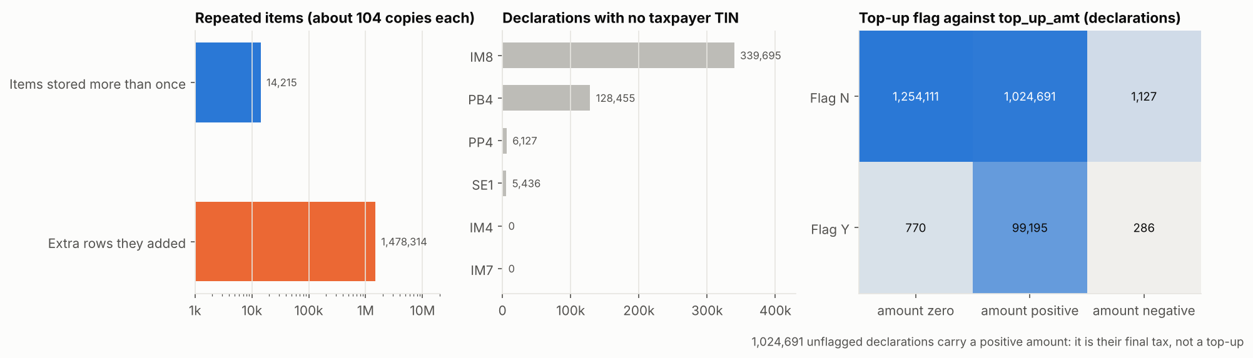
Figure 1: The three data problems: repeated items, missing TINs, and what the top-up column really holds

2.4 Snapshots and Windows: Never Peek at the Future
To test a model honestly, we pretend to stand at a past date, score everyone using only what was known then, and then look at what happened in the next 6 months. That is a back-test. We do it six times, six months apart.
Table 9: The Back-test Timeline
Snapshot (score "as at") | History used for features | Outcomes checked
30 Sep 2023 | Oct 2021 to Sep 2023 | Oct 2023 to Mar 2024
31 Mar 2024 | Apr 2022 to Mar 2024 | Apr 2024 to Sep 2024
30 Sep 2024 | Oct 2022 to Sep 2024 | Oct 2024 to Mar 2025
31 Mar 2025 | Apr 2023 to Mar 2025 | Apr 2025 to Sep 2025
30 Sep 2025 | Oct 2023 to Sep 2025 | Oct 2025 to Mar 2026
31 Mar 2026 | Apr 2024 to Mar 2026 | Apr 2026 to Sep 2026
30 Sep 2026 (live) | Oct 2024 to Sep 2026 | Not yet happened

In plain words
It is like checking a weather forecast: you only believe a forecaster whose predictions, written down BEFORE the day, turned out right. If the model could see the outcome window, it would be copying the answers, and its results would mean nothing.

2.5 Checking Each Download
python main.py check runs simple tests on every CSV before it is used: one row per TIN, TINs are 10 digits, one snapshot date, rates between 0 and 1, no negative amounts, hits never above checks, and the row count is not a round number (a round number like 100,000 usually means Hue cut the download short). Any line marked CHECK must be looked at before modelling.

PART 3: HOW A SCORE IS MADE
Every step from the taxpayer's row to their score, band and reasons, worked through with one made-up taxpayer whose numbers were computed by the real model code.

3.1 The Example Taxpayer
A made-up textile importer, scored as at 31 March 2026 alongside the real population:
Table 10: The Example Taxpayer's History (24 months)
Measure | Value
Declarations | 40
Declarations topped up | 6 (15%)
Severe top-ups (30%+ of final tax) | 3 (7.5%)
Declarations amended | 10 (25%)
Original tax / top-ups | UGX 200M / UGX 16M
Last top-up | 60 days before the snapshot
Share cleared at main station | 80%
Value below benchmark, tax reduced after assessment | none

3.2 Step 1: Work Out the Measures
derive() in src/ctrp/core.py computes the measures the SQL does not give directly:
- PAR_048 = top-ups / (original tax + top-ups) = 16 / 216 = 7.4%. Measured over the final tax so it can never explode (Part 5.2).
- PAR_105 = was there a top-up within 180 days? 60 days, so yes (1).
- PAR_023 = share cleared away from the main station = 1 - 0.80 = 20%.

3.3 Step 2: Protect Against Small Counts
A rate built on very few declarations is mostly luck. Toss a coin twice: getting two heads (100%) does not mean the coin always lands heads. So each rate is blended with the population average:
weighted rate = w x own rate + (1 - w) x population average, w = n / (n + 10)
then keep the LOWER of the weighted rate and the own rate

For our taxpayer, n = 40 declarations, so w = 40 / 50 = 0.8. The population average share topped up is 6.5%:
0.8 x 15.0% + 0.2 x 6.5% = 13.3% (lower than 15%, so 13.3% is used)

Table 11: Small-count Weight for Different Histories
Declarations (n) | Weight on own rate | Meaning
1 | 9% | Almost all population average: one event proves little
2 | 17%
10 | 50% | Half own record, half average
40 | 80% | Our example
100 | 91% | Own record dominates
1,000 | 99% | Practically raw

Why only lower, never raise?
If the blend could raise a rate, a small trader with a perfect record (0 top-ups) would be pulled UP towards the average and get points for other people's behaviour. That is unfair and hard to explain. So the weighting can spare a small trader, but never accuse one.
The officer still sees the RAW rate (15%) in the reason sentence; the weighted rate (13.3%) is only used to compute points.

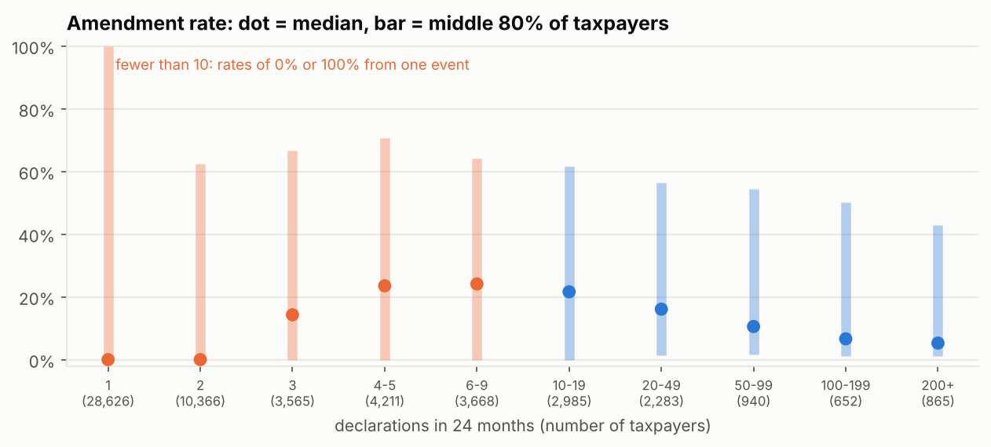
Figure 2: Amendment rate by number of declarations: rates on few declarations are noise

3.4 Step 3: Put Each Measure on a 0 to 1 Ruler
Each parameter has two officer-style thresholds: a minimum risk level (below it, 0) and a maximum (at or above it, 1). In between is a straight line.
scaled = (value - minimum) / (maximum - minimum), held between 0 and 1
PAR_045T: (13.3% - 3%) / (40% - 3%) = 0.278

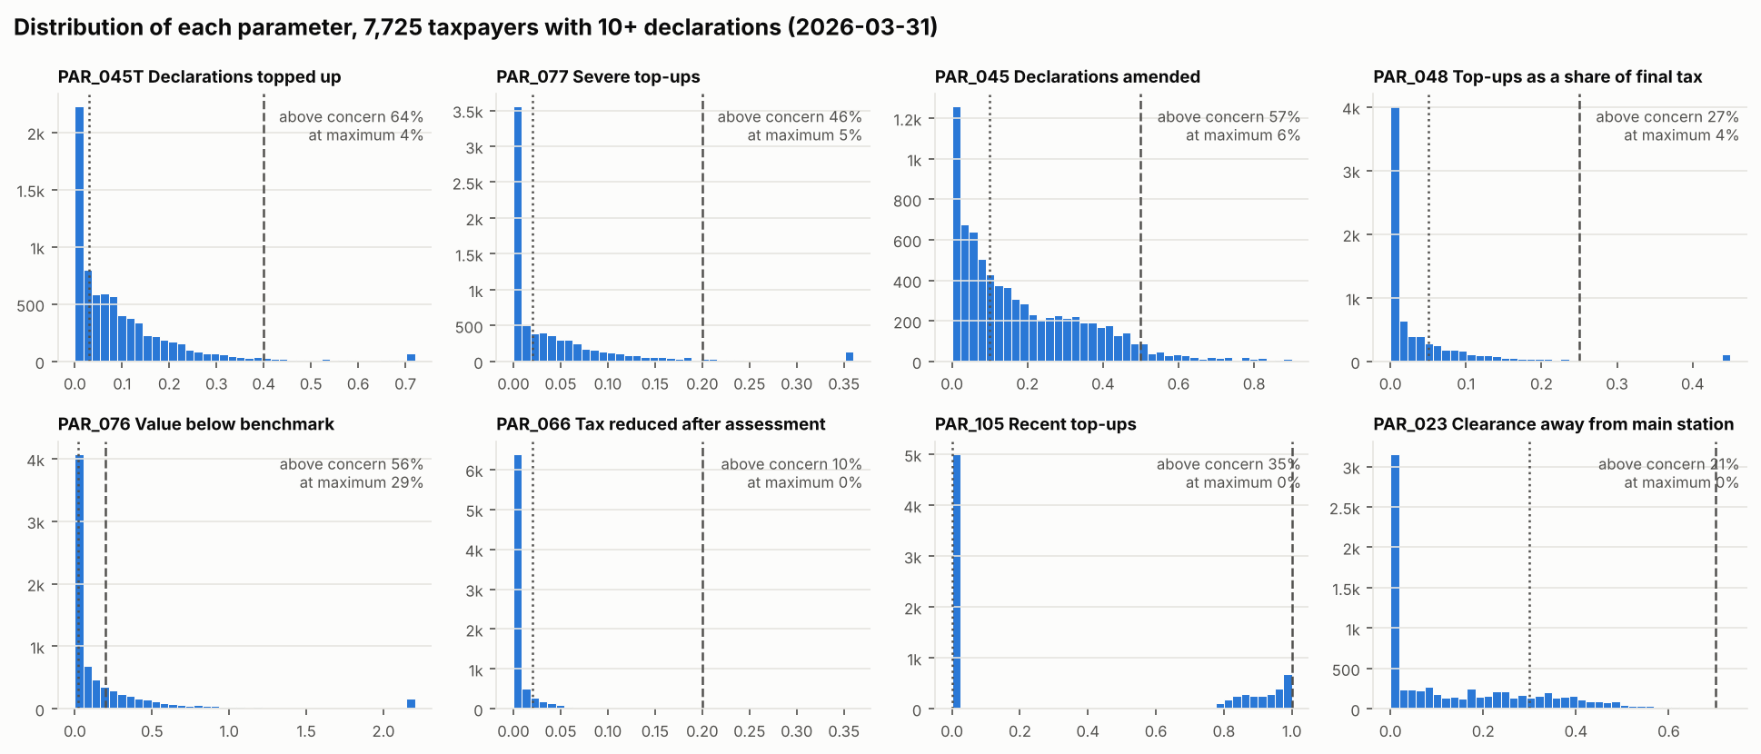
Figure 3: Each parameter for regular taxpayers, with its minimum risk level (dotted) and maximum (dashed)

3.5 Step 4: Weigh the Measures
Each parameter has a likelihood (L) and an impact (I) rating from 1 to 5. Its weight is its L x I divided by the total of all L x I, times 100, so all weights add up to 100 points.
Table 12: Weights
Code | L x I | Weight (points available)
PAR_045T | 5 x 5 = 25 | 25 / 76 x 100 = 32.9
PAR_077 | 4 x 5 = 20 | 26.3
PAR_045 | 4 x 4 = 16 | 21.1
PAR_048, PAR_076, PAR_066, PAR_105, PAR_023 | 3 x 1 = 3 each | 3.9 each
Total | 76 | 100

If a parameter cannot be computed for a taxpayer (for example no items could be benchmarked), it is left out and the others are scaled up so the total available is still 100. The officer sees a MIS note.

3.6 Step 5: Add Up the Points
Table 13: The Example Taxpayer's Points
Code | Raw value | After small-count step | Scaled 0 to 1 | Weight | Points
PAR_045T | 15.0% | 13.3% | 0.278 | 32.9 | 9.16
PAR_077 | 7.5% | 6.6% | 0.254 | 26.3 | 6.68
PAR_045 | 25.0% | 22.5% | 0.311 | 21.1 | 6.55
PAR_048 | 7.4% | 6.7% | 0.087 | 3.9 | 0.34
PAR_076 | 0% | 0% | 0 | 3.9 | 0
PAR_066 | 0% | 0% | 0 | 3.9 | 0
PAR_105 | yes (1) | 0.92 | 0.92 | 3.9 | 3.63
PAR_023 | 20% | 19.3% | 0 (below 30%) | 3.9 | 0
Total |  |  |  | 100 | 26.36, rounded to 26

Score 26 falls in the LOW band (16 to 35). Out of 58,162 taxpayers that day, it ranked 8,608th.

3.7 Step 6: Reasons and Notes
Every parameter that earned points gets a fixed sentence, filled with the taxpayer's raw value. The three largest become Reason 1 to 3; all of them are on the Reasons sheet. Ties are broken by code, so two taxpayers with the same facts always get word-for-word the same reasons.
Table 14: Notes (no points)
Code | When it appears | What it tells the officer
PAT | Trading pattern more unusual than 95% of the peer group | Look at how this taxpayer trades; the score itself is unaffected
LIM | Fewer than 10 declarations in 24 months | The score rests on little history
NPE | Peer group too small, pooled into "Other goods" | The pattern check compared them with a mixed group
LAG | Scorecard and pattern check point opposite ways | Worth a closer look either way
MIS | Some parameters could not be computed | The rest were reweighted

3.8 Step 7: Peer Group and Pattern Note
Regular taxpayers (10 or more declarations) are placed in a peer group: main goods (the HS section where most of their customs value is) x size (bottom, middle or top third by customs value within that section). Our example is "Textiles, medium". Within the group, an Isolation Forest measures how unusual each taxpayer's overall pattern is; the top 5% get the PAT note. Part 5 explains why this adds no points.

3.9 Step 8: The Band
Table 15: Bands (provisional until Stage 7)
Band | Score | Intended handling | Taxpayers, March 2026 | Later hit rate
VERY LOW | 0 to 15 | No routine attention | 44,245 | 2.8%
LOW | 16 to 35 | Visible in monitoring | 9,888 | 5.8%
MEDIUM | 36 to 50 | Reviewed where capacity allows | 1,897 | 10.7%
HIGH | 51 to 80 | Prioritised for review | 1,785 | 43.0%
VERY HIGH | 81 to 100 | Prioritised and escalated | 346 | 38.4%

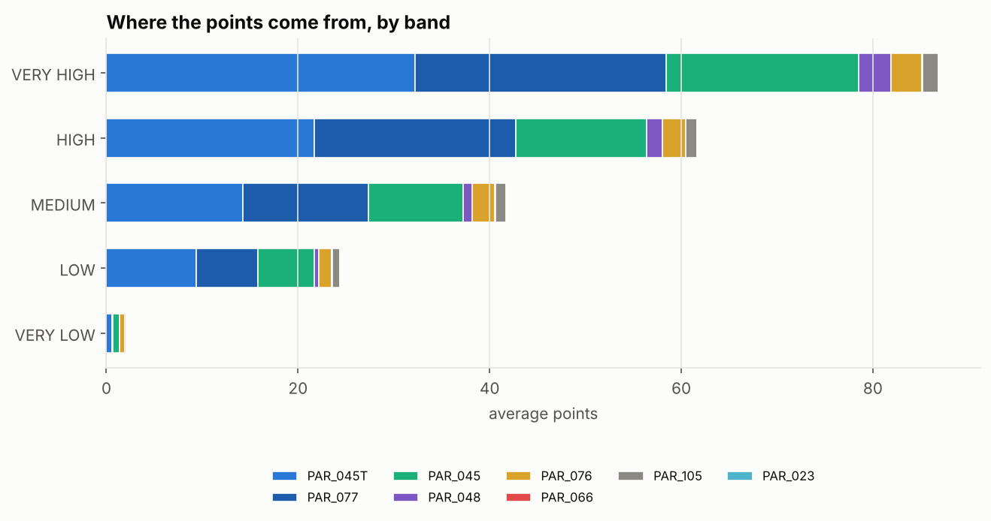
Figure 4: Where the points come from, by band

3.10 The Workbook, Sheet by Sheet
Table 16: The Officers' Workbook
Sheet | What is on it
Read me | What the file is, how to read a score, the bands, the status of the settings
Scores | One row per taxpayer, highest risk first: rank, TIN, score, band, reasons 1 to 3, notes, flags
Reasons | Every reason for every taxpayer, one per row, with the value, thresholds and points (for filtering)
Parameter values | The value and points of every parameter for every taxpayer
Band summary | Taxpayers, declarations and value per band
Reason codes | Every code that can appear, with its fixed wording, thresholds and L x I
Run info | Model version, settings fingerprint, snapshot, run time, input file

PART 4: HOW WE KNOW IT WORKS
How the back-test measures the model, how to read lift, what the results are, and the limits you must state honestly whenever you present them.

4.1 Lift, Step by Step
Lift is the single most important number in this project, so here it is slowly, with the real numbers from the 31 March 2026 snapshot.
- Start with everyone. In the 6 months after the snapshot, customs checked (red or yellow lane) 182,868 declarations from these 58,161 taxpayers. 12,726 of those checks ended in a top-up. So the hit rate for everyone is 12,726 / 182,868 = 7.0%. If officers picked declarations to check at random, about 7 checks in 100 would find a top-up.
- Now take the top of the list. The model's top 5% is 2,908 taxpayers. Their declarations got 19,134 checks, and 7,162 of them ended in a top-up. Their hit rate is 7,162 / 19,134 = 37.4%: about 37 top-ups per 100 checks.
- Divide the two. Lift = 37.4% / 7.0% = 5.4. Checks on the top of the list found top-ups 5.4 times as often as checks picked at random.
- Read it. Lift 1 means the list is no better than chance. Lift 2 means twice as good. Below 1 means worse than chance (the list is pointing at the wrong people).
Table 17: Lift at Three Cut-offs (31 March 2026)
Top of the list | Taxpayers | Checks | Hits | Hit rate | Lift | Share of all hits
Top 1% | 582 | 2,469 | 794 | 32.2% | 4.6 | 6%
Top 5% | 2,908 | 19,134 | 7,162 | 37.4% | 5.4 | 56%
Top 10% | 5,816 | 26,471 | 7,774 | 29.4% | 4.2 | 61%
Everyone | 58,161 | 182,868 | 12,726 | 7.0% | 1.0 | 100%

Why lift matters
Customs can only check a small share of declarations. The question that matters is therefore not "is the model right about everyone?" but "if officers follow the top of the list, how much more do they find per check?" That is exactly what lift measures. In this snapshot, the top 5% of taxpayers produced 56% of all hits: following the list would put officers in front of more than half of the problems while looking at a twentieth of the taxpayers.
Why not "accuracy"?
Only 7% of checks end in a top-up. A lazy model that says "no top-up" for every declaration is 93% accurate, and completely useless. Accuracy rewards being right about the easy majority. Lift only looks at the top of the list, where officers actually spend their time.

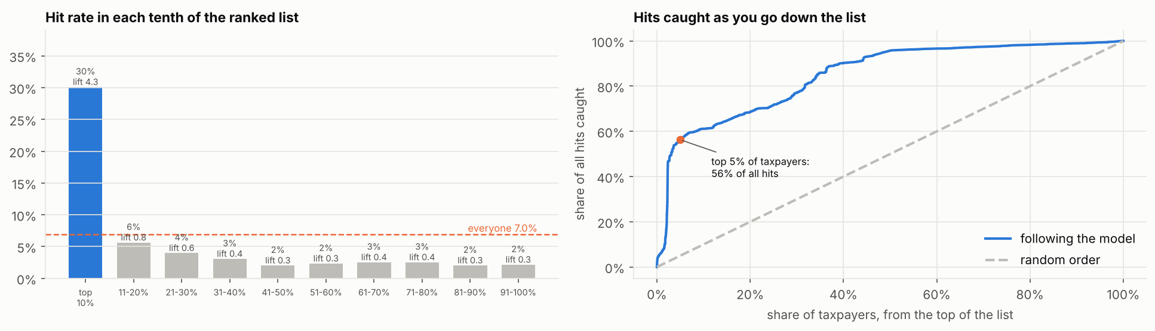
Figure 5: Left: hit rate in each tenth of the ranked list. Right: share of all hits caught as you go down the list
The left chart shows the shape we want: one tall bar at the top (29% hit rate, lift 4.2) and short bars after it, all below average. The right chart shows the same thing as a running total: the blue line shoots up at the start (the top of the list catches most of the hits) while a random order would follow the dashed diagonal.
How to say it in a meeting
If officers had checked only the taxpayers in the top 5% of the list, each check would have been more than five times as likely to find a top-up as a check picked at random, and they would have met more than half of all the top-ups found that half-year.

4.2 Why We Compare With a Baseline
A model is only worth its complexity if it beats the simplest sensible rule. Our baseline ranks taxpayers on their past top-up ratio alone. Averaged over the six snapshots:
Table 18: Release 1 Model Against the Baseline (average of 6 snapshots)
Ranking | Lift top 1% | Lift top 5% | Lift top 10%
Scorecard (release 1) | 4.62 | 4.49 | 4.05
Baseline: past top-up ratio | 2.87 | 3.60 | 3.55

Snapshot by snapshot, the model beats the baseline at the top 1% every time, and at the top 5% and 10% in four of six. It loses in the two earliest snapshots (2023 and early 2024), when past top-ups alone happened to predict unusually well; it wins clearly in the four latest. Say this openly if asked: it is the honest picture.
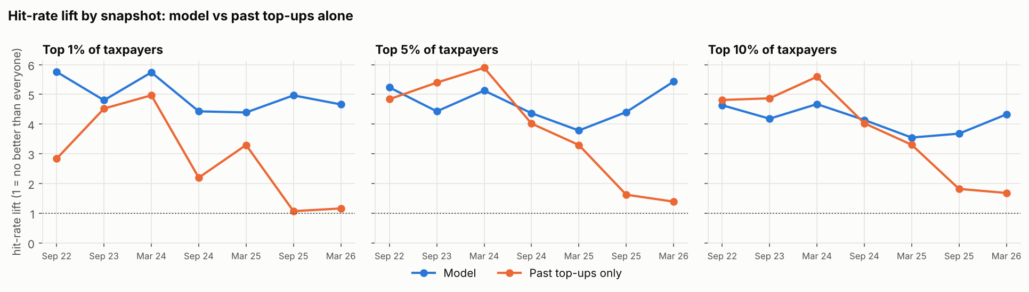
Figure 6: Lift by snapshot: model against past top-ups alone

4.3 Do the Bands Mean Anything?
If the bands work, the hit rate should climb band by band. It does from VERY LOW (2.8%) to HIGH (43%). VERY HIGH is the open problem: in the two latest snapshots it was hit less often than HIGH, with the dip in scores 71 to 90. Stage 7 will look at what those taxpayers have in common before setting the cut-offs.
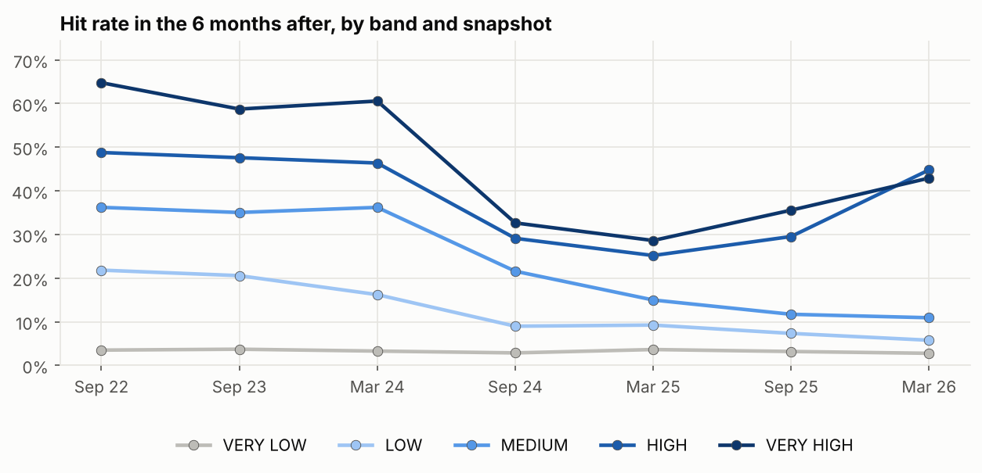
Figure 7: Hit rate by band in every snapshot

4.4 Lift Is Not Everything
Lift is a rate, so it can be raised by putting the "right" kind of small taxpayer at the top: an importer with 2 declarations, both topped up, has a 100% hit rate but contributes 2 hits. A model doing this shows a high lift while catching fewer hits and less revenue. From decision 48, every comparison also shows hits caught, revenue caught and the share of small traders at the top (Part 6 has a real example).

4.5 The Limits You Must State
- Selection bias. We only know the outcome of declarations that were checked, and the selectivity system chose which ones. It is like a teacher who only marks the homework they chose to collect: we never learn about the rest. The model may partly learn what selectivity already picks. The fix, in time, is a small random check share or post-clearance audit results.
- The outcome is narrow. It only sees top-ups on checked declarations. Risk that is never checked, or never found, cannot show up as a hit.
- The base rate fell. The hit rate of all checks dropped from 11-13% to about 7% after March 2024 (4.8 shows nine years). We judge each snapshot against its own rate, so this does not distort the comparison, but the cause is a question for the Risk Officers.
- Flags are as they stand today, not as they stood on the snapshot date. A top-up raised just after the snapshot on a declaration lodged just before it counts in the history. The effect is limited to a few weeks.
- The six snapshots overlap (each history window shares 18 months with the next), so they are not six fully independent tests. Consistency across them is still the best evidence we have.

4.6 Measuring Per Check, Not Per Taxpayer
There are three ways to score a ranking against what happened next. We use the first as the main measure and the third beside it (decisions 84 and 88).
Table 19: Three Ways to Measure
Way | Question it answers | Verdict
A. Per check | Of all red and yellow checks, does the model rank the ones that found a top-up above the ones that did not? | Main measure. Fair to big and small traders; matches how officers judge selectivity (accuracy of checks)
B. Per taxpayer, yes or no | Did the taxpayer get at least one top-up? | Dropped. A trader checked 50 times almost surely gets one; a trader checked twice rarely does. It measures how often customs looked
C. Money | What share of all top-up money came from taxpayers above the line? | Shown beside A. Matches "additional revenue" in the officers' own list; a few big cases can swing it

Why not accuracy?
Only about 7% of checks find a top-up, so a model that says "nothing found" for everything is right about 93% of the time and useless. Accuracy rewards being right about the easy majority.

4.7 Precision and Recall Need a Line
Precision and recall only mean something once a line is drawn: these taxpayers get checked, the rest do not. With every taxpayer above the line, recall is 100% and precision is just the average hit rate, which says nothing about the model. AUC is the measure over all taxpayers; precision and recall are read at the lines officers might use. Averages over the six full snapshots:
Table 20: Precision and Recall at Different Lines (average of 6 snapshots)
Line | Taxpayers above it | Precision (hits per check) | Recall (share of all hits) | Share of top-up money
Top 1% | 1% | 41% | 15% | 26%
Top 5% | 5% | 40% | 42% | 47%
Top 10% | 10% | 36% | 54% | 59%
VERY HIGH | 2% | 41% | 22% | 34%
HIGH and above | 8% | 39% | 52% | 55%
All taxpayers | 100% | 9% | 100% | 100%

The line to quote is HIGH and above, because the bands are what officers act on: the riskiest 8% of taxpayers carry about half of all hits and half of the top-up money, and checks on them find something about four times as often as average. This is not news to officers, who already target repeat offenders. Its value is that the bands mean what they say, that every taxpayer is scored the same way with reasons, and that the other half of the risk sits below HIGH, where history cannot see it: the reason for Track B (Part 10).

4.8 Nine Years of Evidence
A one-pass query (the long run, 7.9) gives every taxpayer's counts for every half-year since October 2014. From it, Track A was scored at 18 dates, every six months from September 2017 to March 2026, each judged on the six months that followed. Checked first against the six dates also pulled in full: the same taxpayers, and 99.5% to 100% of taxpayers matching on every measure. The long run cannot give the price benchmark (PAR_076) or station spread (PAR_023), so it scores on six parameters carrying 92% of the weight; on the six full dates this keeps 95% to 97% of the same top 5%.
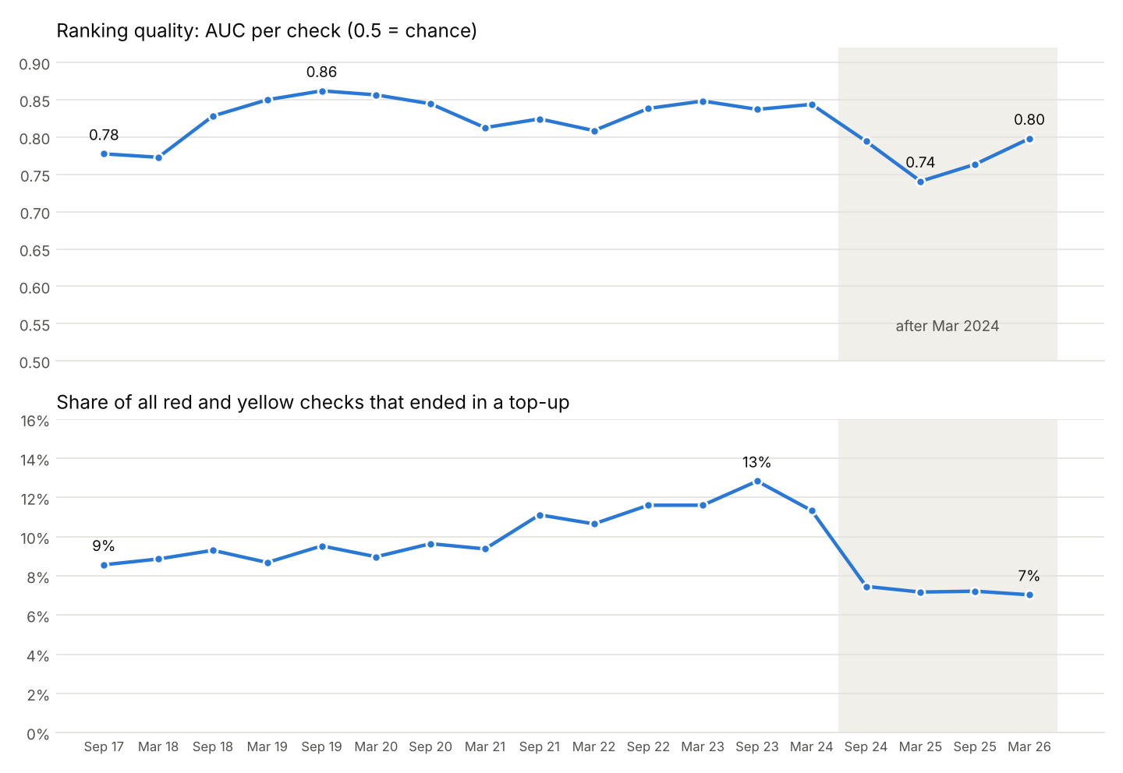
Figure 8: Nine years of validation: AUC per check (top) and the hit rate of all checks (bottom), Sep 2017 to Mar 2026
- Steady over the long run. AUC per check between 0.77 and 0.86, at 0.80 or above on most dates, through pre-COVID, COVID and recovery years.
- One clear dip in nine years, from September 2024 to September 2025 (low point 0.74 in March 2025), recovering to 0.80.
- The dip follows a change in customs, not in the model. The hit rate of all checks fell from 11-13% to 7% after March 2024: checks in general started finding less. The question "what changed in March 2024?" is for the Risk Officers.

4.9 How Many Years of History, and Why Recent Years Count More
The rates behind the three main parameters used to treat the last 24 months equally. Officers look further back but give recent behaviour more weight, so we tested ways of doing the same (decisions 92 to 94).
Table 21: Weighting the Years of History (18 dates; 14 for five years)
Option | AUC per check | Better than the old rule on
Old rule: last 2 years, equal | 0.813 | reference
Last year only | 0.804 | 0 of 18 (worse on 16)
3 years, equal (1, 1, 1) | 0.816 | 14 of 18
3 years, gentle (1, 0.75, 0.5) | 0.817 | 16 of 18
3 years, halving (1, 0.5, 0.25): adopted | 0.817 | 18 of 18
3 years, steep (1, 0.33, 0.11) | 0.816 | 14 of 18
5 years, halving (14 dates) | 0.821 (3 years: 0.820 on the same dates) | 14 of 14

Why halving. Each year back counts half as much as the year after it. It is the only option better than the old rule on every date. Equal or gentle weights let a top-up from three years ago count almost as much as last year's, which flags fewer taxpayers and less accurately; steeper weights forget too quickly. Halving keeps old mistakes visible while letting a trader who has cleaned up recover within about two years. Five years adds nothing measurable over three and needs heavier queries, so the model uses three.
In plain words
A rate is now: (last year's top-ups + half of the year before + a quarter of the year before that) divided by the same mix of declarations. Last year speaks loudest; three years ago still has a say.

PART 5: WHAT WE TRIED, WHAT WE DROPPED, AND WHY
The choices most likely to be questioned. Each section tells the story: what was tried, what the evidence showed, and how to defend the decision in one sentence.

5.1 The Maximum for PAR_045T: 40%, Not 10%
The officers' rule says a taxpayer with more than 10% of declarations topped up is as bad as it gets. With 10% as the maximum, 35% of regular traders scored full points: they were all tied at the top, and the scale could no longer tell a 12% taxpayer from a 60% one. Ranked on this parameter alone, lift fell to 2.6; with a 40% maximum it was 5.3.
Defend it in one sentence
We kept the officers' minimum risk level of 3%, and moved the maximum to 40% because a test that a third of the class passes with full marks cannot rank the class.

5.2 PAR_048 Measured Over Final Tax
Top-ups divided by ORIGINAL tax explodes when the original tax is tiny: one taxpayer declared UGX 29 of tax and got a ratio of 4,399. 2,318 taxpayers were above 1. Dividing by FINAL tax (original plus top-ups) keeps the same order, stays between 0 and 1, and the officers' thresholds convert exactly: 6% becomes 5.7%, 33% becomes 24.8%.
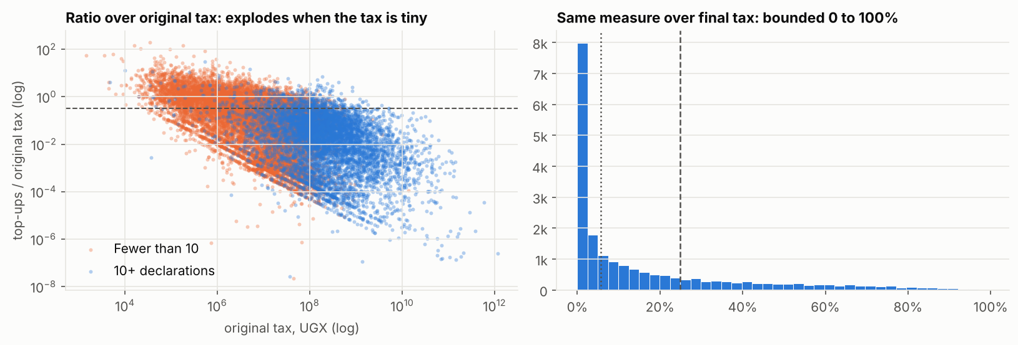
Figure 9: The ratio over original tax explodes; over final tax it is bounded

5.3 One-way Small-count Weighting at K = 10
- No weighting: 5,254 small traders in HIGH or VERY HIGH, many of them one-off vehicle importers with a single top-up.
- K = 10, one-way: 538, with a small cost in lift. Agreed as the fairer balance.
- Two-way (raising clean small traders towards the average): rejected, it accuses people for others' behaviour.
- K estimated from the data (about 3) with two-way shrinkage, tested in the challenger round: it pushed small traders to the top and caught 60% fewer hits.

5.4 HDBSCAN Peer Groups: Dropped
HDBSCAN looks for crowded neighbourhoods of points and calls everything in thin areas "noise". Picture a football field with people standing around: HDBSCAN only forms a group where people stand shoulder to shoulder. Our taxpayers do not stand in clumps; they spread smoothly from tiny to huge. The only crowded spots were piles of taxpayers with identical counts (one HS heading, one origin, one item per declaration). So HDBSCAN made 6 groups of single-product traders and left 77% of regular taxpayers as noise.
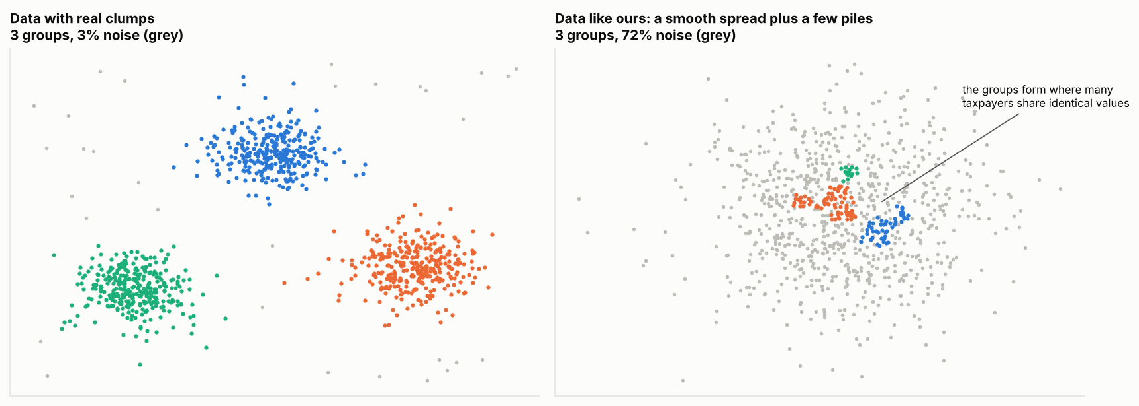
Figure 10: Left: data with real clumps. Right: data like ours, a smooth spread plus a few piles
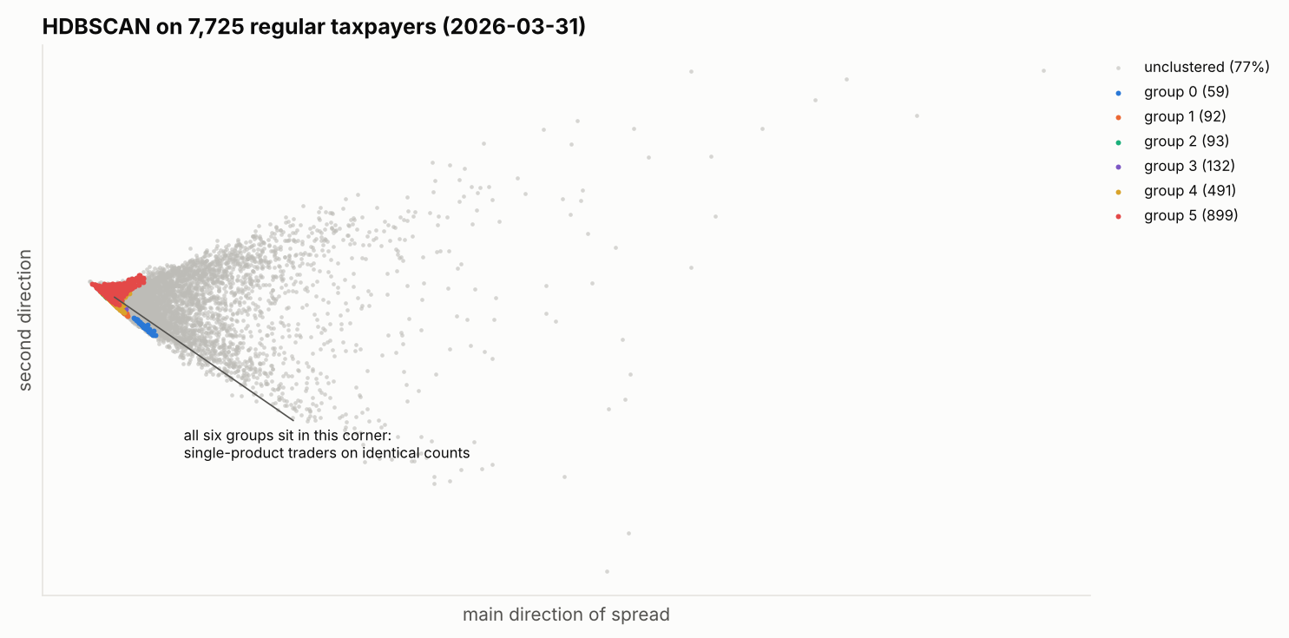
Figure 11: HDBSCAN on our regular taxpayers: the six groups sit in one corner
Defend it in one sentence
HDBSCAN found piles, not peers: it left three quarters of traders without a group, while main goods x size gives every regular trader a group an officer can name.

5.5 Pattern Points: Replaced by a Note
The Isolation Forest plays a game of "20 random questions" to single a taxpayer out from their peer group: "more than 40 HS headings?", "IM7 share above 0.3?". A typical taxpayer needs many questions; an odd one needs few. It never sees outcomes, so it finds what is rare, not what is risky.
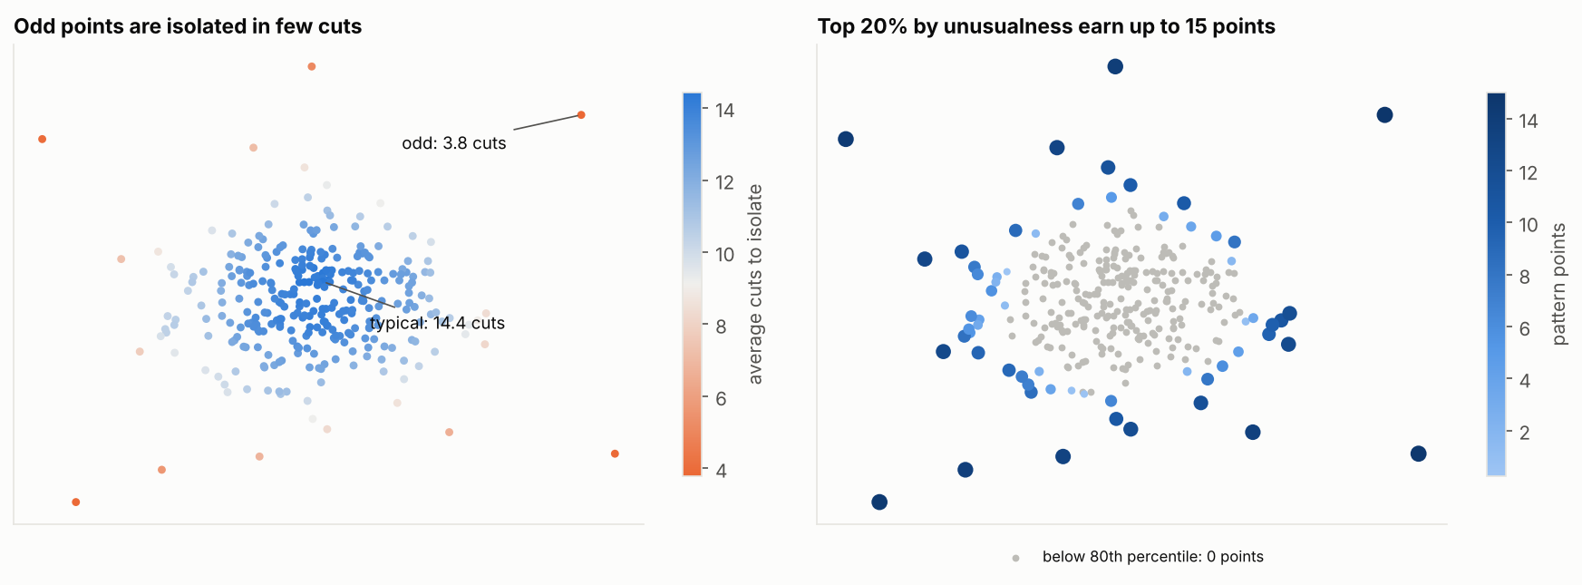
Figure 12: Odd points are isolated in few cuts; the tested rule gave the top 20% up to 15 points
A real example from March 2026, in the "Hides and leather, medium" group: 43 HS headings against a group norm of 1, 5 origins against 1, 4 stations against 1, never topped up, 1% amended against 33%. Scorecard: 0 points. Pattern check: most unusual in the group, 15 points. Next 6 months: 34 declarations, all 34 checked, 0 top-ups.
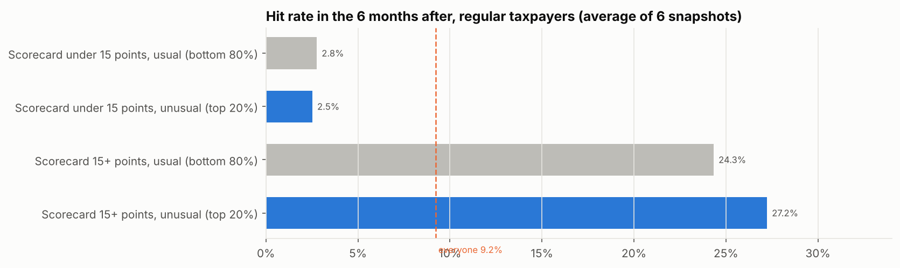
Figure 13: Among low-scoring taxpayers, the unusual ones were hit no more often than the usual ones
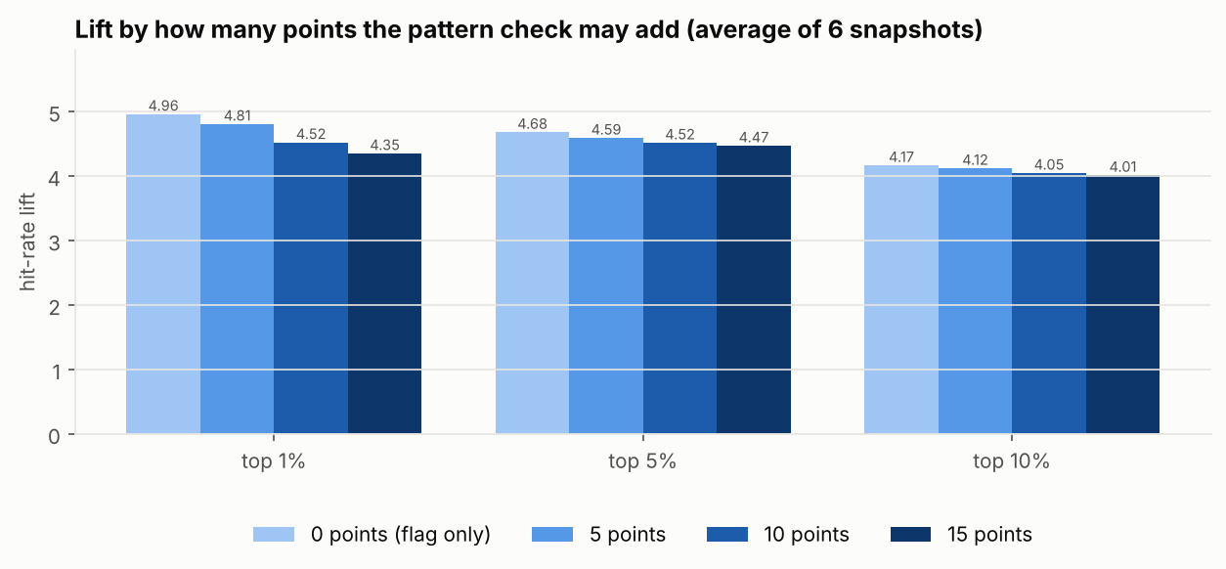
Figure 14: Lift by how many points the pattern check may add: 0 is best at every cut-off
Defend it in one sentence
Unusual is not the same as risky: the pattern points pushed honest general merchants above taxpayers with real top-up records, so we kept the pattern as a note the officer can read.

5.6 Why All Eight Parameters, Not the Best Three
A lean card of the three strongest parameters scored slightly higher at the top 1% (4.87 against 4.62) and slightly lower at 5% (4.26 against 4.49). Keeping all eight costs almost nothing in ranking and keeps every agreed parameter with data in the score and in the reasons officers read. The five weaker ones carry 4% each.

PART 6: THE CHALLENGER MODELS
Other ways of ranking the same taxpayers, what each one is in plain words, how they did against the scorecard, and what happens next.

6.1 Why Test Challengers
You can only call a model good next to its alternatives. The challengers include the candidates of the June 2026 Scope, Architecture and Design document and the strongest ideas from desk research on customs and tax risk models (see the research report "Challenger models for customs risk").

6.2 Each Challenger in Plain Words
Table 22: The Challengers
Challenger | In plain words
Baseline | Rank on past top-up ratio alone.
Learned weights (logistic regression) | Same 8 measures, but instead of officers choosing the weights, the computer finds the weights that best predicted past hits.
Monotone boosting | Hundreds of tiny "if this measure is above X, add a little risk" rules added up. Monotone means a worse value can never lower risk. Additive means each measure's effect can still be read separately.
Monotone boosting with size | The same, also told how big the taxpayer is. Kept as a warning case.
Data-estimated shrinkage | The scorecard, but the small-count weighting strength is learned from the data and works both ways.
Peer percentile | For each measure: how much worse than half of the taxpayers in the same HS section? Added up with the expert weights.
Ensemble (Isolation Forest + PCA) | The design document's anomaly approach, given only "worse than peers" measures.
K-Means distance | Groups taxpayers into 8 clusters; the further from the centre of your cluster, the riskier.
Gaussian mixture | Fits a smooth "typical taxpayer" shape; the less likely you are under it, the riskier.

Fair play rules: models that learn from outcomes only train on earlier snapshots; all are tested on the four latest snapshots; "better" is only claimed when a bootstrap test (re-running the comparison on 300 resampled populations) says the difference is bigger than chance.

6.3 Results
Table 23: Challenger Results (average of 4 test snapshots)
Model | Lift top 5% | Checks in top 5% | Hits in top 5% | Revenue in top 5% | Revenue per check (UGX M)
Scorecard (release 1) | 4.37 | 17,349 | 5,522 | 45% | 1.18
Monotone boosting (same 8 inputs) | 4.75 | 16,916 | 5,809 | 43% | 1.16
Learned weights | 5.00 | 13,809 | 5,070 | 38% | 1.27
Monotone boosting with size | 6.30 | 7,230 | 3,508 | 19% | 1.41
Data-estimated shrinkage | 3.97 | 7,645 | 2,238 | 35% | 1.93
Peer percentile | 3.48 | 16,901 | 4,228 | 45% | 1.16
Ensemble IF + PCA | 2.13 | 44,668 | 6,678 | 50% | 0.51
K-Means distance | 2.49 | 36,635 | 6,424 | 45% | 0.59
Gaussian mixture | 1.20 | 97,543 | 8,414 | 57% | 0.25
Baseline | 2.58 | 4,809 | 807 | 13% | 1.39
Largest importers by value (reference) | 0.52 | 134,580 | 5,099 | 53% | 0.17

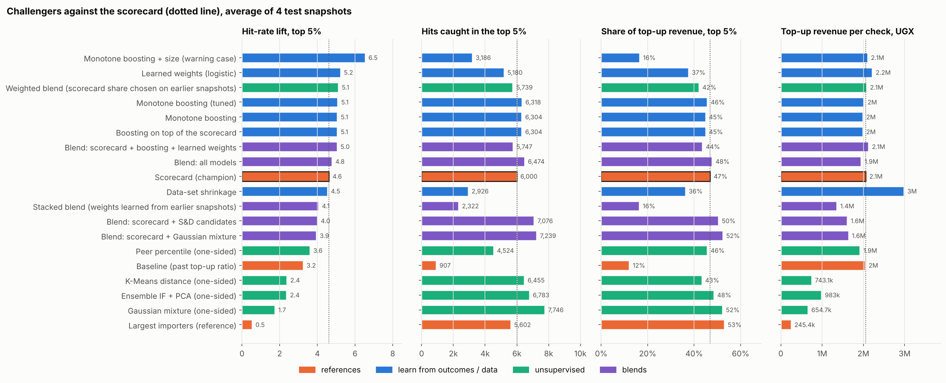
Figure 15: Challengers and blends against the scorecard (dotted line)

6.4 What It Means
- The scorecard holds up. Monotone boosting is a little better (more hits, same revenue, same kind of traders) in 3 of 4 tests and worse in 1. Not enough to replace a model officers can read in their own thresholds, but enough to test further in round 2.
- The warning case shows why lift alone misleads: boosting with size has the highest lift, but it filled the top with one-off importers and caught fewer hits and much less revenue.
- The anomaly and clustering models lose on lift, and their bigger revenue share is an illusion of size (section 6.5): they put big importers at the top, whose top 5% takes far more checks, each finding much less money.
- The learned weights suggest that once the share topped up is known, amendments add little for this outcome. That is evidence for the ratings session, not an automatic change, because learned weights inherit selection bias.
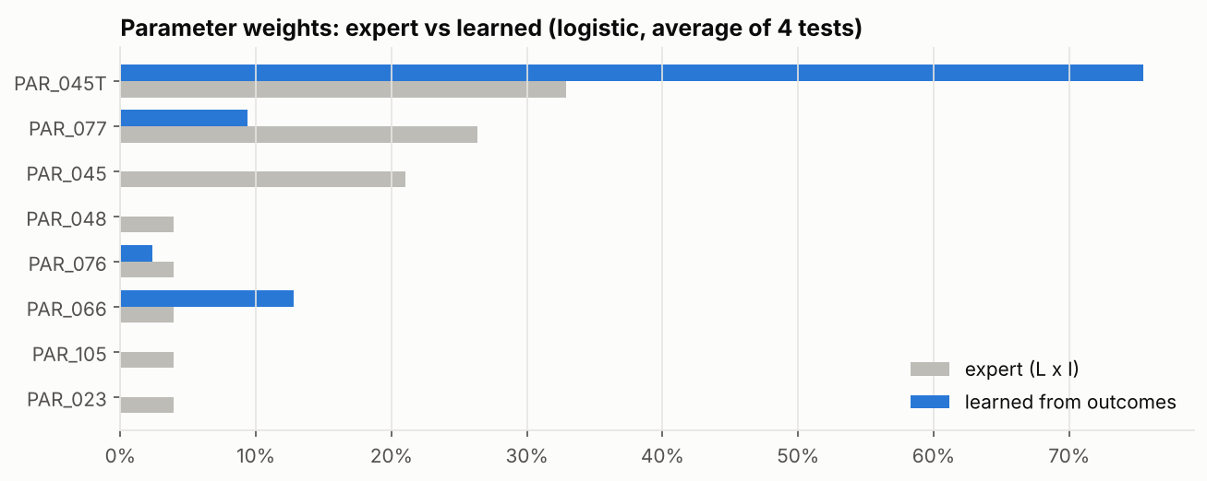
Figure 16: Weights chosen by officers (L x I) against weights learned from outcomes

6.5 What "Revenue Caught" Means, and Why It Can Mislead
Read this before quoting any revenue figure from the comparison.
- Where the money figure comes from. For each taxpayer, the extract records the top-up money (final tax minus original tax) customs actually raised on their declarations in the 6 months after the snapshot. The model does not create or predict this money. It is what the existing checks found.
- What "revenue in the top 5%" is. Add up that money for the taxpayers a model puts in its top 5%, and divide by the total for everyone. In the 6 months after March 2026 the total was UGX 28.2 billion.
- Why it follows size. A big importer with hundreds of declarations is checked thousands of times, so even a low hit rate adds up to a lot of money. Put big importers at the top and the revenue share rises, whether or not the model knows anything about risk.
- The proof. Rank taxpayers on customs value alone, with no risk information at all: the top 5% hold 53% of the top-up revenue, yet their hit rate is half the average (lift 0.52). Revenue share alone would call that a good model.
- The fair measure is revenue per check: money found divided by the checks it took. That is what an officer's time actually buys. The scorecard's top 5% finds UGX 1.18 million per check; the Gaussian mixture's finds UGX 0.25 million, because its top 5% needs 97,543 checks (more than half of all checks) to reach its 57%.
Table 24: Revenue in the Top 5%, 31 March 2026 Snapshot
Ranking | Checks | Hits | Hit rate | Top-up revenue (UGX bn) | Share | Per check (UGX M)
Scorecard | 19,134 | 7,162 | 37.4% | 12.0 | 43% | 0.63
Ensemble IF + PCA | 49,669 | 7,832 | 15.8% | 14.9 | 53% | 0.30
Gaussian mixture | 91,051 | 9,177 | 10.1% | 16.7 | 59% | 0.18
Largest importers by value | 125,743 | 4,178 | 3.3% | 16.0 | 57% | 0.13

Defend it in one sentence
The unsupervised models reach more top-up money only by sending officers to check the biggest importers far more often; per check, the scorecard finds two to five times as much.

6.6 Ensembles: Combining Models
An ensemble combines several models instead of picking one. The simplest kind, used here, is a blend: each taxpayer gets the average of their rank positions in the member models. A taxpayer stays at the top only if several models agree. The idea is that models making different mistakes cover for each other: the Scope and Design candidates find big, high-volume traders, the scorecard finds frequent top-ups. A stacked blend goes one step further and learns from earlier snapshots how much each member should count.
Table 25: Blends Against the Scorecard (average of 4 test snapshots)
Model | Lift top 5% | Hits in top 5% | Revenue in top 5% | Per check (UGX M) | vs scorecard
Scorecard (release 1) | 4.37 | 5,522 | 45% | 1.18
Blend: all models | 4.57 | 6,119 | 46% | 1.11 | 2 better, 0 worse
Blend: scorecard + boosting + learned weights | 4.80 | 5,393 | 42% | 1.25 | 3 better, 0 worse
Blend: scorecard + Scope and Design candidates | 3.90 | 6,680 | 49% | 0.93 | 0 better, 2 worse
Blend: scorecard + Gaussian mixture | 3.92 | 6,673 | 49% | 0.95 | 0 better, 2 worse
Stacked blend (3 tests) | 3.95 | 2,919 | 21% | 1.05 | 1 better, 1 worse

- The blend of all models is the best all-round result: a little more lift, 11% more hits and one more point of revenue share with about the same revenue per check, better in 2 of 4 tests and worse in none. Everyone in its top 5% also has 15 or more scorecard points, so the scorecard's reasons still explain them. It is the leading round 2 challenger (decision 52).
- Why not adopt it now? The gain is real but small and significant in only half the tests; the ranking would no longer follow the points officers see (a taxpayer with 55 points could rank above one with 60); and eight models would have to run and be maintained in production. A shadow run and a blind officer review come first.
- Blends with the Scope and Design candidates catch more hits and revenue share only by pulling in bigger traders with many more checks: lift and revenue per check both fall (decisions 54 and 56).
- The stacked blend is unstable with only three earlier windows to learn from (decision 53).

PART 7: RUNNING EVERYTHING
Every command, in order, for Git Bash on Windows, with what each one produces and what to do when something goes wrong. Every run goes through one entry point: python main.py <command>.

7.1 One-time Setup
Open Git Bash and go to the project folder. Install everything once (and again whenever requirements.txt changes). This also installs the project itself as a package called ctrp, so notebooks and scripts can import ctrp from anywhere. Then run the tests: they should all pass.
cd ~/Desktop/OCTOBER/ctrp
python -m pip install -r requirements.txt
python main.py test

To see every command: python main.py --help.
Table 26: All Commands
Command | What it does | Output
python main.py sql | Writes one Hue query per snapshot | sql/bt_<date>.sql, sql/live_<date>.sql
python main.py check "data/*.csv" | Tests every download | PASS / CHECK report
python main.py score data/live_2026-09-30.csv | Scores one extract (the production run) | results/CTRP_scores_<date>.xlsx and .csv
python main.py backtest | Back-tests every data/bt_*.csv | results/CTRP_backtest.xlsx
python main.py challengers | Compares challengers and blends (about 10 minutes) | results/CTRP_challengers.xlsx
python main.py notebook | Rebuilds and runs the notebook (about 15 minutes) | notebook with outputs; results/charts/*.png
python main.py docs | Rebuilds the decision record and this guide | docs/*.docx
python main.py test | Runs the automatic tests (about 1 minute) | pass or fail

7.2 Make the Queries and Download the Extracts
python main.py sql

This writes sql/bt_2023-09-30.sql ... sql/bt_2026-03-31.sql and sql/live_2026-09-30.sql. For each one: open it, copy everything into a Hue editor, run it (it is one statement), download the result as CSV, and save it in data/ with the SAME name (for example data/bt_2026-03-31.csv). To change the dates, edit BACKTEST_SNAPSHOTS and LIVE_SNAPSHOT at the top of src/ctrp/extract.py and run the command again.

7.3 Check the Downloads
python main.py check "data/*.csv"

Read the SUMMARY at the end: checks_failed should be 0 for every file. Look into any CHECK line before going on.

7.4 Score the Live Snapshot (production run)
python main.py score data/live_2026-09-30.csv

Writes results/CTRP_scores_2026-09-30.xlsx (the officers' workbook) and a CSV copy, and prints the band counts with the model version and settings fingerprint.

7.5 Back-test and Challengers
python main.py backtest
python main.py challengers

The back-test writes the lift of the model and the baseline in every snapshot, and the hit rate by band. The challenger run writes the comparison of every challenger and blend, the learned weights and the stacked-blend weights.

7.6 The Notebook (all the analysis and charts)
In VS Code: open notebooks/CTRP_release1.ipynb, choose the Python kernel (top right), click Run All. It takes about fifteen minutes; section 9 (challengers and blends) takes about ten of them. Every chart is also saved as a PNG in results/charts/ (chart_01.png, chart_02.png, ...) ready for slides. From the command line instead:
python main.py notebook

The notebook is generated from notebooks/build_notebook.py. To change a cell permanently, change it there; python main.py notebook rebuilds the notebook and runs it.

7.7 Rebuild the Documents
python main.py docs

Run it after the notebook has saved the charts. Open the .docx in Word and accept "update the fields" (or press Ctrl+A then F9) to fill in the contents and the lists of tables and figures.

7.8 When Something Goes Wrong
Table 27: Common Problems
Message | Cause and fix
ModuleNotFoundError: No module named ... | A library is missing: run python -m pip install -r requirements.txt.
pip: Read timed out, or Tunnel connection failed: 503 | pip cannot reach the internet through the URA proxy. Try again later, or add --proxy http://<proxy address>:<port> (ask IT for the address), or install one library at a time with a longer wait: python -m pip install pytest --timeout 120.
No module named pytest | Only the tests need it: python -m pip install pytest. Scoring, the notebook and the documents run without it.
ModuleNotFoundError: No module named ctrp (in the notebook) | Run the setup in 7.1, or open the notebook from the notebooks/ folder so it can find ../src.
FileNotFoundError: data/... | The CSV is not in data/ or has a different name. Check the name matches the query file.
ValueError: more than one row for some TINs | The download is wrong (the query was changed or run twice). Re-run the query and download again.
PermissionError when writing an .xlsx | The workbook is open in Excel. Close it and run again.
check shows "rows not a round cut-off" as CHECK | Hue may have cut the download. Download again, making sure you take all rows.
A test fails after you changed something | The change broke a promise the model makes (the test name says which). Fix it before scoring.

7.9 History Since 2017: the Long Run
Hue stops a query after about 30 minutes and a download at 100,000 rows. The full feature query for one date takes about 30 minutes, so the history since 2014 comes from a lighter query: one row per taxpayer per half-year, with counts that add up exactly. It runs as 12 one-year pieces, each well under the row limit.
- Run python main.py sql --long-run. The pieces are written to sql/long_run/if_too_big/ (and half-year pieces to sql/long_run/if_still_too_big/ for any year that still reaches 100,000 rows).
- Run each piece in Hue as one statement, stay on the tab, and save the result as data/long_run/long_run_<year>.csv.
- Run python main.py long-run. It refuses any file that stopped at exactly 100,000 rows, builds a snapshot for every date (data/long_run/lr_<date>.csv) and copies the yearly counts into the full extracts in data/ so the model can weight recent years.
- Run python main.py performance --long-run for the nine-year results (results/CTRP_performance_since_2017.xlsx).

7.10 The Blind Review of Track B
python main.py review results/CTRP_scores_2026-09-30.xlsx --blind 25 # query + key
python main.py blind-pack data/evidence/blind_2026-09-30.csv sql/review/blind_2026-09-30_KEY.csv

The first command picks the top 25 flagged taxpayers and 25 unflagged ones from the same segments, mixes them under codes R01 to R50 and writes the evidence query and the key. Run the query in Hue, then the second command builds the officers' workbook with codes, entries and a verdict column, and nothing that says who was flagged. The key stays with Data Science until the verdicts are in (Part 10).

PART 8: CHANGING THE MODEL SAFELY
Where everything lives, the rules that keep changes safe and traceable, and step-by-step recipes for the changes you are most likely to make.

8.1 Map of the Project
ctrp/
|-- README.md, LICENSE, .gitignore
|-- pyproject.toml project metadata and build configuration
|-- requirements.txt the environment (includes the package itself)
|-- main.py entry point: python main.py <command>
|-- src/ctrp/ the importable package
| |-- __init__.py public API: score_snapshot, load_extract, backtest
| |-- core.py THE MODEL: settings, four layers, reasons, back-test
| |-- utils.py paths, reading an extract, lift and other measures
| |-- report.py the officers' Excel workbook
| |-- extract.py Hue queries and the checks on each download
| |-- pipeline.py score one file, back-test many
| |-- sql/features_outcomes.sql the query, with @@DATE@@ placeholders
| +-- models/challengers.py challengers and blends, compared fairly
|-- tests/ automatic tests on made-up data
|-- notebooks/ CTRP_release1.ipynb and build_notebook.py
|-- docs/ DECISIONS.md, the Word documents, the research report, builders/
|-- sql/ generated queries; sql/analysis/ holds the Stage 1 checks
|-- data/, results/ from Hue and outputs (contain TINs: never committed)
+-- archive/ superseded scripts, kept for reference

Why this layout?
It is the standard layout for Python projects. The model lives in one importable package (src/ctrp), separate from the things that use it (main.py, the notebook, the tests). Anyone who knows Python will know where to look, and nothing can accidentally import a half-finished script.

Table 28: Main Functions in src/ctrp/core.py
Function | Job
derive(df) | Adds computed measures (PAR_048 over final tax, PAR_105, PAR_023, logs) and applies the small-count weighting.
scale(x, zero_at, one_at) | The 0 to 1 ruler.
layer2_scorecard(d) | Points per parameter per taxpayer.
layer1_peers(d, log) | Main goods x size peer groups.
layer3_pattern(d, peers, subtotal) | Isolation Forest percentile within each peer group (for the note).
build_reasons, build_notes | The fixed sentences.
score_snapshot(raw) | Runs everything; returns scores, reasons and parameter values.
backtest(result, raw) | Lift of the model and the baseline against what happened next.
load_extract(path) (in utils.py) | Reads a CSV, keeps TINs as text, refuses duplicate TINs.

8.2 The Golden Rules
- Change settings only in the SETTINGS block of src/ctrp/core.py, never further down.
- Raise MODEL_VERSION (for example 1.0.0-dev4 to 1.0.0-dev5) whenever a change can move a score.
- Run python main.py test. Every test must pass.
- Run python main.py backtest and compare with the previous version on lift, hits caught, revenue caught and small-trader share, in every snapshot.
- Record the decision in docs/DECISIONS.md with its evidence, then python main.py docs.
- Never put TINs, data or results in a shared repository (the .gitignore keeps them out).
The fingerprint
Every output carries a 10-character settings fingerprint. It is computed from every setting, so if anyone changes a threshold, the fingerprint changes. Two workbooks with the same fingerprint were produced by exactly the same settings.

8.3 The Automatic Tests
The tests in tests/ run the model on made-up taxpayers (never real data) and check the promises it makes. If a change breaks one, the test says which.
Table 29: What the Tests Check
File | Promises checked
test_core.py | The ruler is 0 below the minimum risk level and 1 at the maximum; band edges; the small-count weighting only lowers; weights add to 100 and missing parameters are reweighted; scoring is repeatable; the pattern check adds no points; every reason has points; the fingerprint changes with a setting
test_utils.py | Lift of a perfect ranking beats random; lift of everyone is 1; TINs stay text; duplicate TINs are refused
test_report.py | The workbook has the agreed sheets in the agreed order
test_extract.py | Query dates are right and no placeholder is left; a clean download passes every check
test_challengers.py | The comparison runs every model and blend

8.4 Recipe: Change a Threshold
Find the parameter in PARAMS (in src/ctrp/core.py) and change zero_at (minimum risk level) or one_at (maximum). For example, to test a 35% maximum for PAR_045T:
dict(code='PAR_045T', col='top_up_entry_rate', zero_at=0.03, one_at=0.35, L=5, I=5, ...

Then raise MODEL_VERSION, run the tests and the back-test, and compare. The reason sentence updates itself because it reads the thresholds.

8.5 Recipe: Change a Weight
Change L or I for the parameter. Weights are always L x I divided by the total, so changing one parameter changes everyone's share. A parameter with L of 2 or less is not scored at all (context only).

8.6 Recipe: Try the Officers' Thresholds
from ctrp import core as M
M.set_profile('officers_andrew') # or 'officers_judith', 'adopted'
result = M.score_snapshot(M.load_extract("data/bt_2026-03-31.csv"))

8.7 Recipe: Add a New Parameter
- Add the column to the final SELECT in src/ctrp/sql/features_outcomes.sql (build it in a new step if needed). Do not put semicolons in comments.
- Run python main.py sql, re-run the queries in Hue and download the CSVs again.
- If it is a rate between 0 and 1, add its column name to RATES in src/ctrp/extract.py; run python main.py check.
- Add a dict to PARAMS in src/ctrp/core.py: code, col, zero_at, one_at, L, I, fmt ('pct' or 'yesno'), label, and a reason sentence using {v}, {z} and {o}.
- If it is a share of something other than declarations, add it to SHRINK_N with the column holding that count.
- Test it alone and inside the scorecard, as in notebook section 3.8 (lift at the top 5% against the baseline and the scorecard).
- Raise MODEL_VERSION, run the tests and the back-test, record the decision.

8.8 Recipe: Change the Bands
Edit BANDS: each pair is (upper score, name). For example (15, 'VERY LOW') means 0 to 15 is VERY LOW. The workbook colours and band summary follow automatically.

8.9 Recipe: Add a Challenger or a Blend
In src/ctrp/models/challengers.py, write a function score_mymodel(raw, d, train) that returns one number per taxpayer (higher = riskier). train holds earlier snapshots as (raw, derived) pairs; use only those to learn. Add it to the CHALLENGERS dictionary. For a blend, add a line to BLENDS listing its members. Either way it is then measured exactly like the others.

PART 9: DEFENDING THE WORK
The questions you are most likely to be asked, with short answers and where the evidence is.

Table 30: Questions and Answers
Question | Answer
Why not a machine-learning model? | We tested several (Part 6). The best gained a little in 3 of 4 tests and lost in 1, and it learns from outcomes chosen by the selectivity system. The scorecard is explainable in the officers' own thresholds. Boosting goes to round 2.
You promised about 20 parameters; why 8? | 8 have data in the view, 2 more are built and wait for the next extract, and 11 need data that is not in the view (declaration versions, boxes 45 and 46, penalties, agent TIN). None was left out for any other reason.
Why does a taxpayer topped up on 1 of 2 declarations score low? | Two declarations prove little (a coin tossed twice). The weighting spares them, and the LIM note tells the officer the score rests on little history.
Why 40% and not the officers' 10%? | At 10%, a third of regular traders hit full points and the list could not rank them. The minimum risk level stays at their 3%.
Isn't it just repeating the selectivity system? | Partly, possibly; all models trained or judged on checked declarations share this. It is why we want a random check share or audit outcomes, and why the expert scorecard (not fitted to past selections) is the safer release 1 choice.
The design promised clustering and anomaly detection. Where are they? | Tested on real data: HDBSCAN left 77% of traders without a group, and anomaly points lowered lift because unusual is not risky. Both are recorded with evidence; the pattern check stays as a note.
Is a lift of about 4.5 good? | It is well above the baseline (about 3.6 at the top 5%) and above the 3x minimum proposed in the design document for the top 10% (4.05), below its 5x target. Published customs figures score single declarations and are not comparable.
Why is VERY HIGH hit less than HIGH recently? | Known and open. The dip is in scores 71 to 90 in the two latest snapshots. Stage 7 will study it before the bands are set.
Why did the hit rate fall after March 2024? | Unknown; a question for the Risk team. Each snapshot is judged against its own hit rate, so it does not distort the results.
Can importers game it? | The parameters come from customs' own actions (top-ups, amendments, benchmarks), not from what importers report about themselves. Keep the reason codes internal.
Why might a taxpayer change band between two runs? | Their 24-month window moves on, peers change and the population averages change. The fingerprint shows whether the settings changed too.
What does provisional mean? | The thresholds, weights and bands are working values until the Risk Officers confirm them. Every workbook says so on the Read me sheet.
Why not combine models (an ensemble)? | We tested five ways of combining them (Part 6.6). The blend of all models is the best all-round result and is the leading candidate for the next round; it was not adopted yet because the gain is small, significant in only half the tests, and the ranking would no longer follow the points officers see.
Is "the riskiest 8% give half the hits" new? | No, and it should not be sold as new: officers already target repeat offenders. What is new is that every taxpayer is scored the same way, with reasons, over time, that the bands are shown to mean what they say, and that the other half of the risk sits below HIGH, where history cannot see it. That is what Track B is for.
Why measure per check? | Officers judge selectivity by what checks find. Counting taxpayers rewards being checked often; counting checks does not (4.6).
Did the model get worse after 2024? | Over nine years AUC per check stayed between 0.77 and 0.86. The one dip (0.74, March 2025) came when the hit rate of all checks fell from 11-13% to 7%, and it is recovering (4.8).
Why three years, and why halving? | Tested on 18 dates: three years with each year counting half the next is the only weighting better than the old two-year rule on every date. Five years adds nothing measurable (4.9).
How do you know Track B finds anything? | Against top-ups it ranks checks better than chance and better than Track A within the no-history group (AUC 0.62 regular, 0.57 small), but top-ups cannot show undervaluation that was never found. The blind review is the real test (Part 10).
Who decides thresholds and weights? | The Risk Officers, in a ratings session, using the evidence in this guide and the learned weights from Part 6 as input.

PART 10: TWO TRACKS: COMPLIANCE HISTORY AND TRADING BEHAVIOUR
Why one view of risk is not enough, what Track B looks at, how the two tracks combine into the Overall Risk Band, and how Track B is being proven.

10.1 Why a Second Track
Track A (Parts 1 to 4) scores a taxpayer's own compliance record: top-ups, amendments, reductions. It works, but it can only see risk that customs has already found. About 69% of taxpayers have no top-up history at all, and in the back-tests about half of all hits come from taxpayers below HIGH. A trader who undervalues and has never been caught scores zero on Track A.
Track B looks at how a taxpayer trades, compared with similar importers (same main goods, same size), without using anything customs did to them (no top-ups, no lanes). It is built for the taxpayers with no top-up history.

10.2 What Track B Looks At
- Prices below what other importers declare for the same tariff line and origin.
- Amendments, goods spread (many kinds of goods per declaration), station spread, sudden surges in volume, and newness.
- Each measure is turned into a percentile within the peer group, so a trader is compared with traders like them.
- A learned model (monotone boosting, trained only on earlier dates) combines them, separately for regular traders (10 or more declarations) and small traders (fewer).

10.3 How the Two Tracks Combine
Table 31: From Two Tracks to One Band
Column | What it is
History Risk Score and Band | Track A: the compliance record
Risky Behaviour Flag | Track B: Y for the top 5% of regular and the top 1% of small traders with no top-up history
Behaviour risk percentile | How the taxpayer's behaviour ranks against similar importers
Overall Risk Band | The higher of the two; a Risky Behaviour Flag raises a taxpayer to HIGH at most until the flags are proven
Overall band set by | Compliance history or Trading behaviour
Entry evidence | For flagged taxpayers: the entries priced furthest below peers, with entry number, station and year, so an officer can open them

10.4 How Well Track B Does Against Top-ups
Judged with the main measure (AUC per check) within the taxpayers it is for, on the four dates the full extracts allow, each trained only on earlier dates (decision 95):
Table 32: Track B Against Top-ups (AUC per check, no-history taxpayers)
Group | Track B | Track A on the same group | Chance
Regular traders | 0.62 (0.58 to 0.65) | 0.55 | 0.50
Small traders | 0.57 (0.53 to 0.59) | 0.52 | 0.50

A real but modest signal, consistent on every date. Top-ups are the wrong yardstick for most of what Track B looks for: an undervaluation that was never found never became a top-up. So top-ups can only show the part of Track B's value that customs already catches.

10.5 Proving Track B: the Blind Review
- The top 25 flagged taxpayers are mixed with 25 unflagged taxpayers with no top-up history, picked at random from the same segments (decision 86).
- Officers see only codes, TINs and entries priced below peers, with a strength column (how far below) and a mark where the same goods appear on two entries. They do not know who was flagged.
- For each code they write Act, Do not act or Not sure.
- If the flagged group draws clearly more "Act" verdicts than the comparison group, Track B finds real risk.
Why blind
If officers knew who was flagged, they would look harder at those and find more, and the test would prove nothing.

A low price is a reason to look, not proof: the customs value follows the valuation methods in order. Fuel (HS 27) is left out of the evidence, and prices under 5% of peers are marked "Check units" because they are more often a weight or quantity keyed in the wrong unit.

Annex A: Settings Reference
Table 33: Settings in src/ctrp/core.py
Setting | Value | Meaning
MODEL_VERSION | 1.0.0-dev5 | Raised whenever a change can move a score
RECENCY_WEIGHTS | 1, 0.5, 0.25 | How much each of the last 3 years counts in the history rates (4.9)
PARAMS | 8 parameters | Code, column, minimum risk level, maximum, L, I, wording (Part 3)
SHRINK_K | 10 | Small-count weighting strength: w = n / (n + 10)
SHRINK_N | PAR_076 uses items | Which count n each rate is weighted by (default: declarations)
ADEQUATE_ENTRIES | 10 | Below this: limited history, no peer group, no pattern note
HS_SECTIONS | 21 WCO sections | Turns an HS chapter into a section name for peer groups
MIN_GROUP_FOR_PATTERN | 30 | Smaller peer groups are pooled into "Other goods, <size>"
PATTERN_NOTE_PCT | 0.95 | Pattern note for taxpayers more unusual than 95% of their group
LOW_AGREE | see code | When the scorecard and pattern check are said to disagree
BANDS | 15 / 35 / 50 / 80 / 100 | Upper score of each band
SEED | 42 | Fixed randomness, so the same input always gives the same result

