## Appendix A: Crosswalk

To increase the sample size of individuals used in this analysis, the identity-to-GSS crosswalk was revised to encompass more identities. After using the crosswalk from Freeland and Hoey’s (2018) analysis, 136 occupational codes did not have identity match. For the 1996 subsection of the analysis, this resulted in 912 missing cases.

To match occupational codes with identities from the most recent ACT dictionary, 3 general rules were followed:

1. Assign the missing occupational identity to a general identity under which the specific falls. For example, the occupational codes including specific instances of managers (e.g. 1221 - 1229) were all assigned the identity of manager. Another example is assigning the occupational code 2213, indicating “Agronomists and related professionals” the identity of scientist.
2. Assign the missing occupational identity to an analagous identity. For example, occupational code 4122, indicating Statistical and finance clerks was given the identity of accountant.
3. If neither 1 or 2 was possible for an occupational code, no identity was assigned. The occupations that this applied to were typically very specific and had no reasonable analogy within the 303 occupational identities available.

The newly assigned identities are displayed in table 1, which shows the ISCO-88 code, the identity assigned to it, the number of individuals falling into this category, and the description for the ISCO-88 code used to help assign the identity.

Lastly, the occupations without any identity are listed in table 2. In total, the number of excluded cases based on no identity are now reduced to 53.

**Table S1: New Crosswalk Relationships**

|  |  |  |  |
| --- | --- | --- | --- |
| isco88 | term | num | MAJOR, SUB-MAJOR, MINOR AND UNIT GROUPS |
| 110 | legislator | 4 | Legislators and senior officials |
| 1210 | executive | 19 | Directors and chief executives |
| 1220 | manager | 28 | Production and operations managers |
| 1221 | manager | 15 | Production and operations managers in agriculture, hunting, forestry and fishing |
| 1223 | manager | 18 | Production and operations managers in construction |
| 1225 | manager | 37 | Production and operations managers in restaurants and hotels |
| 1226 | manager | 5 | Production and operations managers in transport, storage and communications |
| 1227 | manager | 35 | Production and operations managers in business services enterprises |
| 1229 | manager | 21 | Production and operations managers not elsewhere classified |
| 1234 | manager | 3 | Advertising and public relations managers |
| 1235 | manager | 11 | Supply and distribution managers |
| 1236 | manager | 3 | Computing services managers |
| 1239 | manager | 7 | Other specialist managers not elsewhere classified |
| 1313 | manager_of_branch_store | 15 | Managers of small enterprises in construction |
| 1319 | manager_of_branch_store | 52 | Managers of small enterprises not elsewhere classifie |
| 2110 | physicist | 2 | Physicists, chemists and related professionals |
| 2144 | engineer | 4 | Electronics and telecommunications engineers |
| 2147 | engineer | 1 | Mining engineers, metallurgists and related professionals |
| 2213 | scientist | 1 | Agronomists and related professionals |
| 2229 | doctor | 2 | Health professionals (except nursing) not elsewhere classified |
| 2310 | professor | 15 | College, university and higher education teaching professionals |
| 2320 | teacher | 36 | Secondary education teaching professionals |
| 2332 | elementary_school_teacher | 13 | Pre-primary education teaching professionals |
| 2340 | teacher | 9 | Special education teaching professionals |
| 2412 | professional | 16 | Personnel and careers professionals |
| 2419 | professional | 14 | Business professionals not elsewhere classified |
| 2440 | scientist | 3 | Social science and related professionals |
| 2444 | interpreter | 2 | Philologists, translators and interpreters |
| 2453 | musician | 10 | Composers, musicians and singers |
| 3110 | technician | 3 | Physical and engineering science technicians |
| 3111 | technician | 3 | Chemical and physical science technicians |
| 3112 | technician | 3 | Civil engineering technicians |
| 3118 | technician | 4 | Draughtspersons |
| 3121 | computer_support_specialist | 8 | Computer assistants |
| 3131 | photographer | 4 | Photographers and image and sound recording equipment operators |
| 3142 | ship_captain | 2 | Ships’ deck officers and pilots |
| 3152 | inspector | 21 | Safety, health and quality inspectors |
| 3212 | technician | 1 | Agronomy and forestry technicians |
| 3226 | physician | 14 | Physiotherapists and related associate professionals |
| 3229 | physician | 11 | Health associate professionals (except nursing) not elsewhere classified |
| 3300 | teacher | 17 | Teaching associate professionals |
| 3340 | teacher | 1 | Other teaching associate professionals |
| 3432 | professional | 25 | Legal and related business associate professionals |
| 3442 | civil_servant | 2 | Government tax and excise officials |
| 3443 | civil_servant | 3 | Government social benefits officials |
| 3450 | detective | 4 | Police inspectors and detectives |
| 4110 | clerk | 33 | Secretaries and keyboard-operating clerks |
| 4121 | accountant | 52 | Accounting and book-keeping clerks |
| 4122 | accountant | 6 | Statistical and finance clerks |
| 4221 | travel_agent | 4 | Travel agency and related clerks |
| 5111 | flight_attendant | 3 | Travel attendants and travel stewards |
| 5133 | nursing_assistant | 9 | Home-based personal care workers |
| 5163 | police_officer | 6 | Prison guards |
| 5200 | salesperson | 2 | Models, salespersons and demonstrators |
| 6129 | farmer | 3 | Animal producers and related workers not elsewhere classified |
| 7141 | construction_laborer | 8 | Painters and related workers |
| 7200 | machine_operator_in_a_factory | 38 | Metal, machinery and related trades workers |
| 7213 | sheet_metal_worker | 4 | Sheet-metal workers |
| 7223 | machine_operator_in_a_factory | 5 | Machine-tool setters and setter-operators |
| 7232 | auto_mechanic | 6 | Aircraft engine mechanics and fitters |
| 7240 | electrician | 6 | NA |
| 7324 | craftsman | 5 | Glass, ceramics and related decorative painters |
| 7341 | craftsman | 2 | Compositors, typesetters and related workers |
| 7435 | textile_worker | 4 | Textile, leather and related pattern-makers and cutters |
| 7437 | textile_worker | 6 | Upholsterers and related workers |
| 8100 | machine_operator | 3 | Stationary plant and related operators |
| 8113 | machine_operator | 2 | Well drillers and borers and related workers |
| 8123 | machine_operator | 1 | Metal heat-treating-plant operators |
| 8141 | machine_operator | 3 | Wood-processing-plant operators |
| 8151 | machine_operator | 3 | Crushing-, grinding- and chemical-mixing-machinery operators |
| 8155 | machine_operator | 1 | Petroleum- and natural-gas-refining-plant operators |
| 8161 | machine_operator | 1 | Power-production plant operators |
| 8162 | machine_operator | 4 | Steam-engine and boiler operators |
| 8200 | machine_operator | 35 | Machine operators and assemblers |
| 8221 | machine_operator | 3 | Pharmaceutical-and toiletry-products machine operators |
| 8224 | machine_operator | 2 | Photographic-products machine operators |
| 8230 | machine_operator | 5 | Rubber- and plastic-products machine operators |
| 8231 | machine_operator | 1 | Rubber-products machine operators |
| 8232 | machine_operator | 7 | Plastic-products machine operators |
| 8251 | machine_operator | 9 | Printing-machine operators |
| 8253 | machine_operator | 1 | Paper-products machine operators |
| 8261 | machine_operator | 7 | Fibre-preparing-, spinning- and winding-machine operators |
| 8270 | machine_operator | 3 | Food and related products machine operators |
| 8282 | assembly_line_worker | 16 | Electrical-equipment assemblers |
| 8290 | machine_operator | 9 | Other machine operators not elsewhere classified |
| 8310 | railroad_engineer | 1 | Locomotive engine drivers and related workers |
| 8332 | bulldozer_operator | 4 | Earth-moving and related plant operators |
| 8333 | crane_operator | 2 | Crane, hoist and related plant operators |
| 8334 | bulldozer_operator | 11 | Lifting-truck operators |
| 9110 | salesperson | 4 | Street vendors and related workers |
| 9113 | salesperson | 6 | Door-to-door and telephone salespersons |
| 9152 | security_guard | 4 | Doorkeepers, watchpersons and related workers |
| 9160 | garbage_collector | 1 | Garbage collectors and related labourers |
| 9213 | laborer | 2 | Fishery, hunting and trapping labourers |
| 9312 | construction_laborer | 13 | Construction and maintenance labourers: roads, dams and similar constructions |

**Table S2: OCC codes without identity matches**

|  |  |  |  |
| --- | --- | --- | --- |
| isco88 | term | num | MAJOR, SUB-MAJOR, MINOR AND UNIT GROUPS |
| 1110 | NA | 1 | Legislators and senior government officials |
| 1231 | NA | 9 | Finance and administration managers |
| 1232 | NA | 6 | Personnel and industrial relations managers |
| 1233 | NA | 94 | Sales and marketing managers |
| 1311 | NA | 1 | Managers of small enterprises in agriculture, hunting, forestry and fishing |
| 2113 | NA | 4 | Chemists |
| 2131 | NA | 30 | Computer systems designers, analysts and programmers |
| 2132 | NA | 7 | NA |
| 2141 | NA | 9 | Architects, town and traffic planners |
| 2142 | NA | 9 | Civil engineers |
| 2143 | NA | 10 | Electrical engineers |
| 2145 | NA | 8 | Mechanical engineers |
| 2149 | NA | 27 | Architects, engineers and related professionals not elsewhere classified |
| 2211 | NA | 6 | Biologists, botanists, zoologists and related professionals |
| 2221 | NA | 16 | Medical doctors |
| 2222 | NA | 4 | Dentists |
| 2224 | NA | 5 | Pharmacists |
| 2230 | NA | 42 | Nursing and midwifery professionals |
| 2331 | NA | 50 | Primary education teaching professionals |
| 2359 | NA | 12 | Other teaching professionals not elsewhere classified |
| 2411 | NA | 31 | Accountants |
| 2421 | NA | 9 | Lawyers |
| 2422 | NA | 1 | Judges |
| 2432 | NA | 10 | Librarians and related information professionals |
| 2445 | NA | 3 | Psychologists |
| 2446 | NA | 34 | Social work professionals |
| 2451 | NA | 6 | Authors, journalists and other writers |
| 2452 | NA | 7 | Sculptors, painters and related artists |
| 2455 | NA | 5 | Film, stage and related actors and directors |
| 2460 | NA | 9 | Religious professionals |
| 3122 | NA | 4 | Computer equipment operators |
| 3133 | NA | 6 | Medical equipment operators |
| 3143 | NA | 3 | Aircraft pilots and related associate professionals |
| 3151 | NA | 3 | Building and fire inspectors |
| 3211 | NA | 9 | Life science technicians |
| 3221 | NA | 9 | Medical assistants |
| 3223 | NA | 3 | Dieticians and nutritionists |
| 3225 | NA | 2 | Dental assistants |
| 3231 | NA | 74 | Nursing associate professionals |
| 3410 | NA | 4 | NA |
| 3411 | NA | 4 | Securities and finance dealers and brokers |
| 3412 | NA | 8 | Insurance representatives |
| 3413 | NA | 11 | Estate agents |
| 3415 | NA | 43 | Technical and commercial sales representatives |
| 3416 | NA | 9 | Buyers |
| 3417 | NA | 8 | Appraisers, valuers and auctioneers |
| 3429 | NA | 12 | Business services agents and trade brokers not elsewhere classified |
| 3434 | NA | 3 | Statistical, mathematical and related associate professionals |
| 3471 | NA | 17 | Decorators and commercial designers |
| 3475 | NA | 2 | Athletes, sports persons and related associate professionals |
| 3480 | NA | 1 | Religious associate professionals |
| 4111 | NA | 21 | Stenographers and typists |
| 4113 | NA | 6 | Data entry operators |
| 4114 | NA | 10 | Calculating-machine operators |
| 4115 | NA | 100 | Secretaries |
| 4131 | NA | 48 | Stock clerks |
| 4132 | NA | 1 | Production clerks |
| 4133 | NA | 3 | Transport clerks |
| 4141 | NA | 11 | Library and filing clerks |
| 4142 | NA | 22 | Mail carriers and sorting clerks |
| 4190 | NA | 18 | Other office clerks |
| 4211 | NA | 36 | Cashiers and ticket clerks |
| 4212 | NA | 16 | Tellers and other counter clerks |
| 4213 | NA | 2 | Bookmakers and croupiers |
| 4215 | NA | 5 | Debt-collectors and related workers |
| 4222 | NA | 35 | Receptionists and information clerks |
| 4223 | NA | 8 | Telephone switchboard operators |
| 5100 | NA | 1 | NA |
| 5112 | NA | 1 | Transport conductors |
| 5113 | NA | 2 | Travel guides |
| 5120 | NA | 3 | NA |
| 5122 | NA | 49 | Cooks |
| 5123 | NA | 62 | Waiters, waitresses and bartenders |
| 5131 | NA | 30 | Child-care workers |
| 5132 | NA | 5 | Institution-based personal care workers |
| 5141 | NA | 26 | Hairdressers, barbers, beauticians and related workers |
| 5161 | NA | 5 | Fire-fighters |
| 5162 | NA | 11 | Police officers |
| 5169 | NA | 21 | Protective services workers not elsewhere classified |
| 5220 | NA | 72 | Shop, stall and market salespersons and demonstrators |
| 6113 | NA | 20 | NA |
| 6141 | NA | 2 | Forestry workers and loggers |
| 7122 | NA | 1 | Bricklayers and stonemasons |
| 7123 | NA | 3 | Concrete placers, concrete finishers and related workers |
| 7124 | NA | 27 | Carpenters and joiners |
| 7129 | NA | 8 | Building frame and related trades workers not elsewhere classified |
| 7131 | NA | 1 | Roofers |
| 7132 | NA | 11 | Floor layers and tile setters |
| 7136 | NA | 21 | Plumbers and pipe fitters |
| 7137 | NA | 9 | Building and related electricians |
| 7143 | NA | 2 | Building structure cleaners |
| 7212 | NA | 15 | Welders and flame cutters |
| 7214 | NA | 6 | Structural-metal preparers and erectors |
| 7222 | NA | 15 | Tool-makers and related workers |
| 7230 | NA | 19 | NA |
| 7231 | NA | 37 | Motor vehicle mechanics and fitters |
| 7233 | NA | 3 | Agricultural- or industrial-machinery mechanics and fitters |
| 7241 | NA | 3 | Electrical mechanics fitters and services |
| 7243 | NA | 5 | NA |
| 7245 | NA | 7 | Electrical line installers, repairers and cable jointers |
| 7311 | NA | 2 | Precision-instrument makers and repairers |
| 7411 | NA | 5 | Butchers, fishmongers and related food preparers |
| 7412 | NA | 3 | Bakers, pastry-cooks and confectionery makers |
| 7415 | NA | 2 | Food and beverage tasters and graders |
| 7420 | NA | 1 | NA |
| 7422 | NA | 4 | Cabinetmakers and related workers |
| 7433 | NA | 2 | Tailors, dressmakers and hatters |
| 7510 | NA | 37 | NA |
| 8262 | NA | 3 | Weaving- and knitting-machine operators |
| 8263 | NA | 24 | Sewing-machine operators |
| 8264 | NA | 13 | Bleaching-, dyeing- and cleaning-machine operators |
| 8266 | NA | 1 | Shoemaking- and related machine operators |
| 8269 | NA | 2 | Textile-, fur- and leather-products machine operators not elsewhere classified |
| 8311 | NA | 1 | Locomotive engine drivers |
| 8312 | NA | 1 | Railway brakers, signallers and shunters |
| 8322 | NA | 58 | Car, taxi and van drivers |
| 8323 | NA | 14 | Bus and tram drivers |
| 8340 | NA | 2 | Ships’ deck crews and related workers |
| 9131 | NA | 43 | Domestic helpers and cleaners |
| 9132 | NA | 4 | Helpers and cleaners in offices, hotels and other establishments |
| 9140 | NA | 49 | NA |
| 9141 | NA | 6 | Building caretakers |
| 9142 | NA | 8 | Vehicle, window and related cleaners |
| 9151 | NA | 4 | Messengers, package and luggage porters and deliverers |
| 9153 | NA | 1 | Vending-machine money collectors, meter readers and related workers |
| 9161 | NA | 2 | Garbage collectors |
| 9211 | NA | 11 | Farm-hands and labourers |
| 9311 | NA | 1 | Mining and quarrying labourers |
| 9313 | NA | 1 | Building construction labourers |
| 9320 | NA | 3 | Manufacturing labourers |
| 9322 | NA | 8 | NA |
| 9333 | NA | 27 | NA |
| 9997 | NA | 5 | NA |

## 

## Appendix B: Indicator Normality

**Table S3: Skewness Scores for CFA Indicator Variables**

|  |  |  |  |
| --- | --- | --- | --- |
| Income (Log) | Father SEI | Education | Prestige |
| -0.643 | 0.521 | 0.105 | 0.417 |

|  |  |  |
| --- | --- | --- |
|  |  |  |

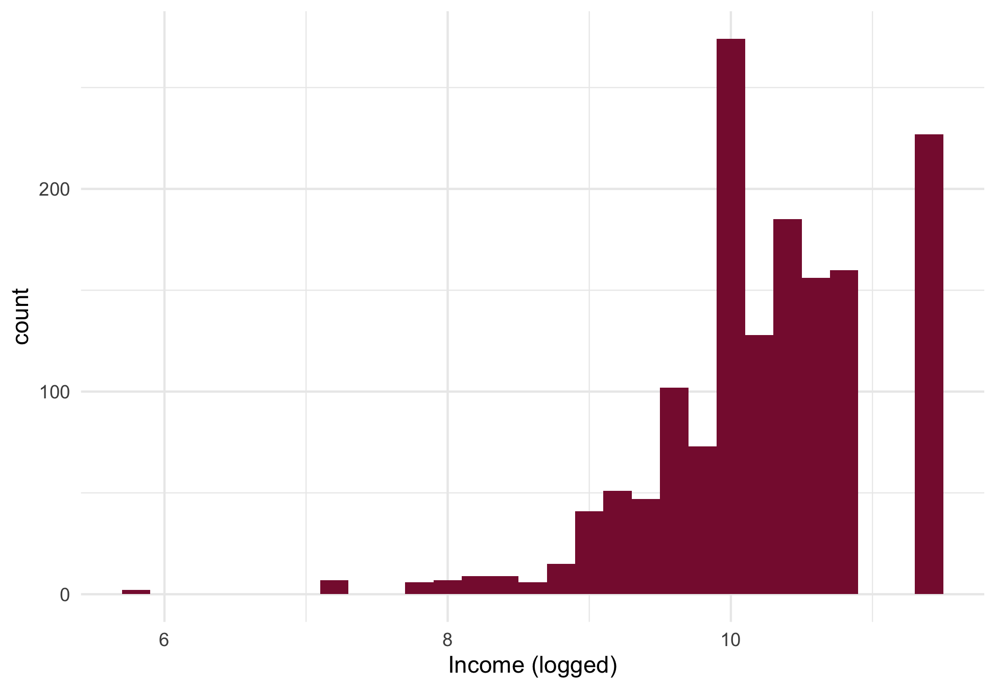

**Figure S1: Income Histogram**

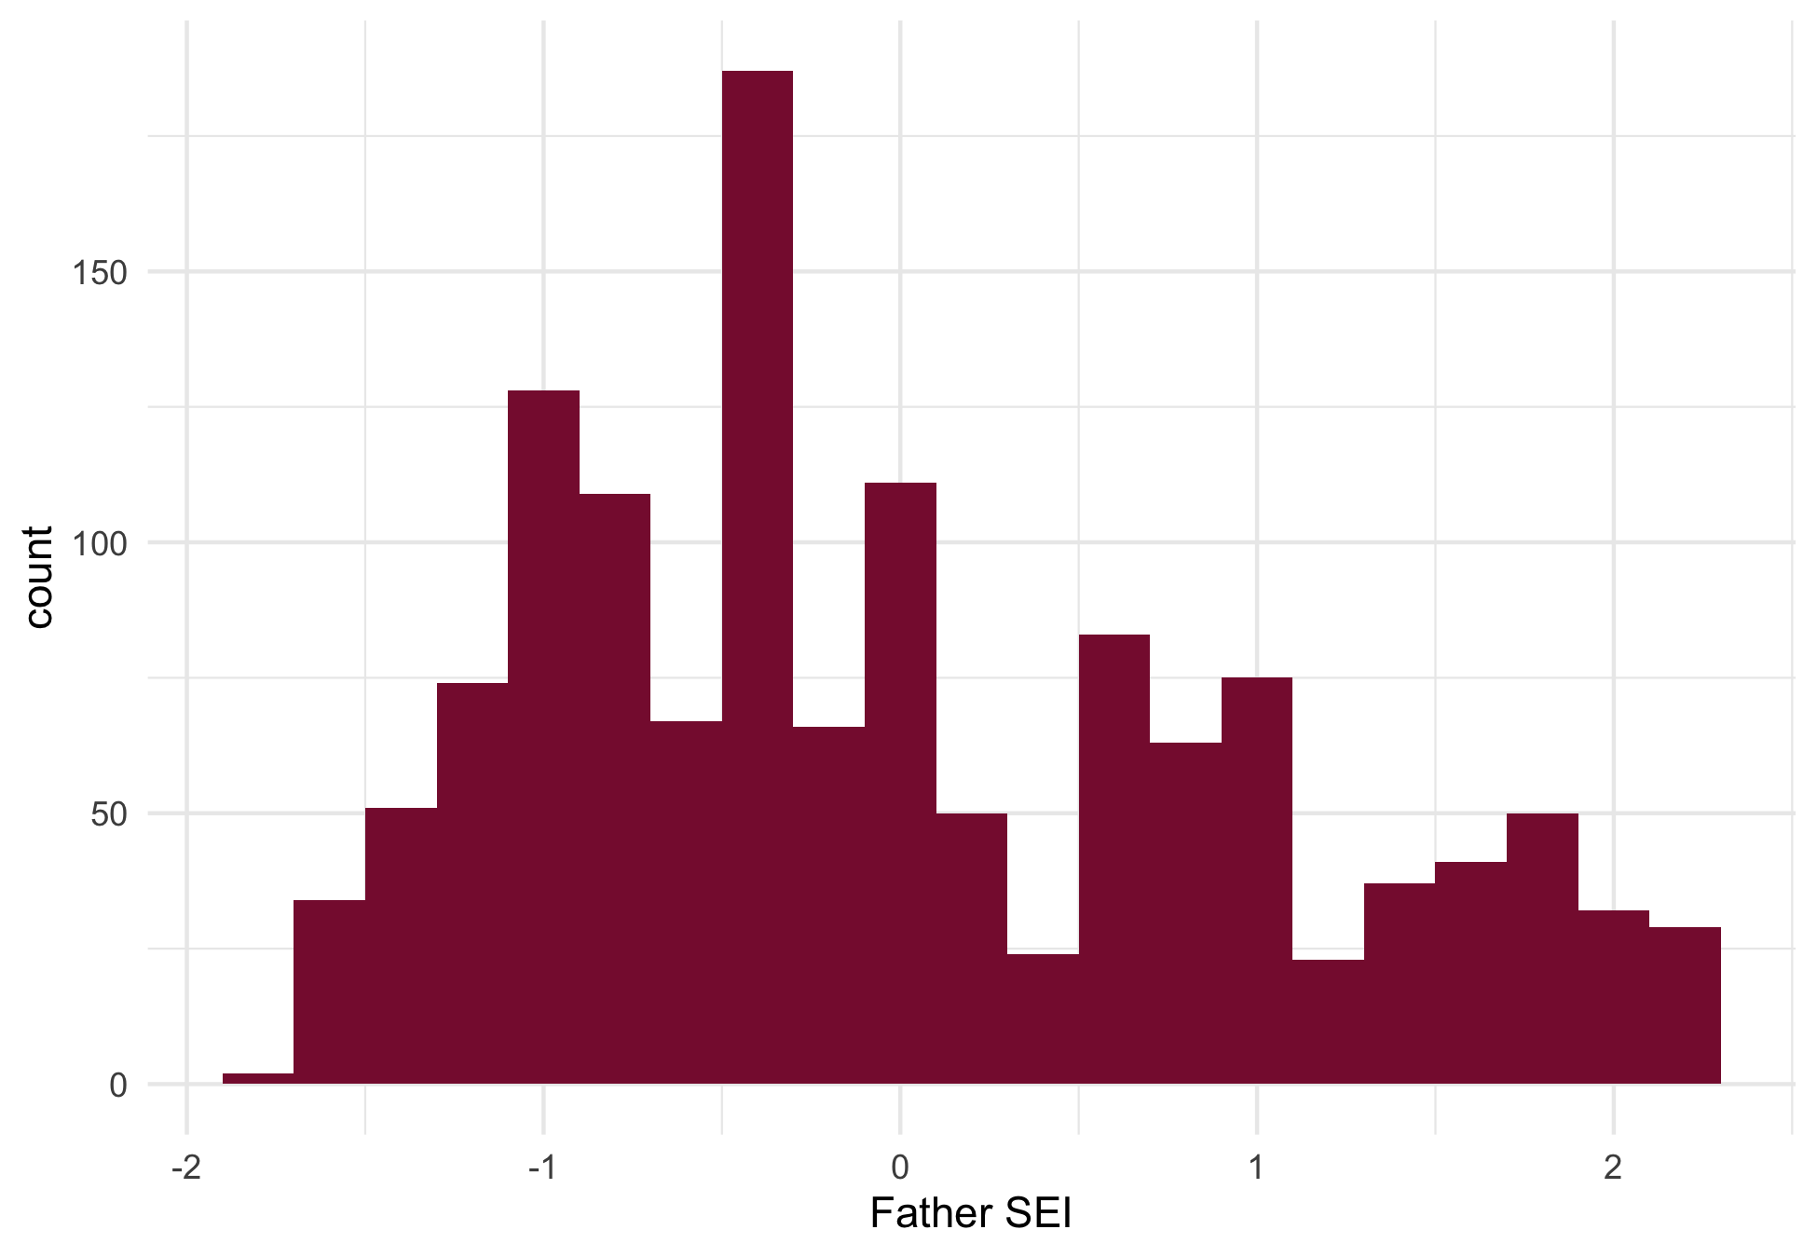

**Figure S2: Father SEI Histogram**

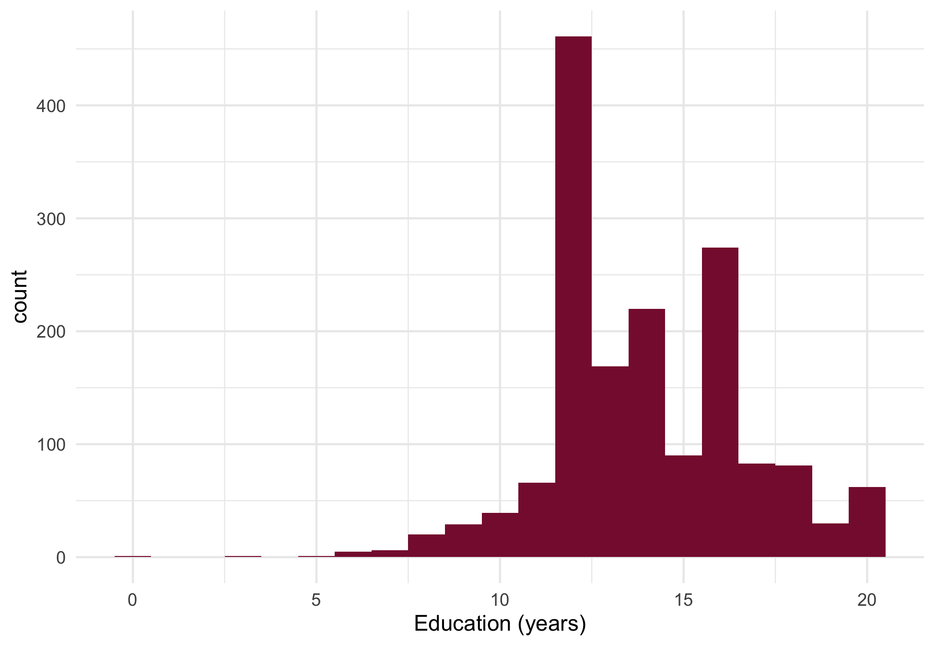

**Figure S3: Education Histogram**

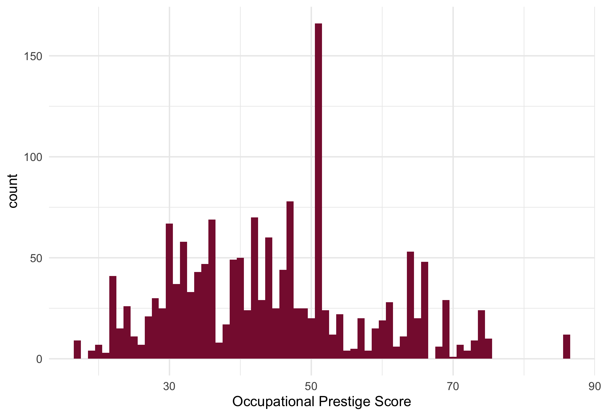

**Figure S4: Occupational Prestige Histogram**