**A morphology-based phylogenetic analysis of the bamboo subtribe Chusqueinae (Poaceae: Bambusoideae)**

Elizabeth McMurchie

April 14, 2020

**ABSTRACT**

A previous phylogenetic analysis of five coding and noncoding chloroplast loci found the genus *Neurolepis* to be paraphyletic, consisting of two separate clades with the larger genus *Chusquea* embedded within it. As a result of this study, *Chusquea* was expanded to include all of the species belonging to the former genus *Chusquea*, as the two clades of *Neurolepis* could not be reliably differentiated morphologically. Existing morphological analyses had previously supported *Chusquea* and *Neurolepis* as separate, monoplyletic sister genera within the monophyletic Chusqueinae. Species belonging to the former genus *Neurolepis* could be distinguished by several morphological characters, including a reed-like habit and complete lack of aerial budding and branching, which differs drastically from the highly branching erect to scandent habits of *Chusquea,* which is notable for having dimorphic multiple buds. *Chusquea* subg. *Rettbergia* and the Euchusquea were previously supported as a monophyletic clades as well based on morphology and chloroplast DNA. In this study, maximum parsimony and Bayesian analyses were conducted on the species of Chusqueinae used in the study that originally determined the paraphyly of *Neuroplepis* using twenty characters tailored to this group. Neither analysis recovered the same species topography as that which was used to support adding former species of *Neurolepis* to *Chusquea*, although Bayesian analysis supported the monophyly of the Chusqueinae and *Chusquea* subg. *Rettbergia.*

**INTRODUCTION**

For much of the past two hundred years, the bamboo subtribe Chusqueinae Soderstrom & Ellis (Poaceae: Bambuseae) was thought to be made up of the genera *Chusquea* Kunth and *Neurolepis* Meissner. The subtribe Chusqueinae appears to be well-supported both morphologically and molecularly based on plastid DNA (Clark et al. 2007). Restricted to the Neotropics, members of Chusqueinae have several synapomorphies, including having at least two papillae on each subsidiary cell around the stomatal apparatus of the foliage leaf and spikelets lacking a rachilla extension, with four glumes and one fertile floret (Fisher et al. 2009). However, *Chusquea* and *Neurolepis* appear vegetatively very dissimilar. *Chusquea*, the larger genus, contained about 200 species, and grew in erect to scandent clumps with aerial branching, the branches often rebranching, with a unique complement of multiple dimorphic buds at each node consisting of a generally larger central bud and two to many smaller subsidiary buds (Judziewicz et al. 1999). Most species of *Chusquea* were montane, though some appeared in the lowlands or at higher elevations, including *páramo* habitats, with the members of the genus ranging from northern Mexico to south-central Chile (Judziewicz et al. 1999). By contrast, *Neurolepis* had a much more limited range, from Costa Rica to Bolivia, and was more restricted to montane forests, cloud forests, and *páramos* (Judziewicz et al. 1999). *Neurolepis* was drastically different from *Chusquea* in appearance, with a reed-like habit resulting from long foliage leaves, a culm as short as a few centimeters long, and a complete lack of any aerial branching (Clark et al. 2007; Fisher et al. 2009).

Despite the clear morphological differences between *Neurolepis* and *Chusquea*, a phylogenetic analysis of 6.6 kb of aligned nucleotide and indel characters belonging to five chloroplast loci, including both coding and noncoding regions, found that the genus *Chusquea* was embedded within the genus *Neurolepis,* with *Neurolepis* itself forming two separate clades(Fisher et al. 2009)*.* This result was surprising given the morphological differences between the species of the two genera and the number of species belonging to each (Fisher et al. 2009). While *Chusquea* was thought to consist of about 200 species, *Neurolepis* contained only 21 (Judziewicz et al. 1999). Although several prior studies of larger sets of bamboos had not suggested this result, one previous study, based on morphology and plastid DNA, had presented weak evidence for the paraphyly of *Neurolepis* (Zhang and Clark 2000; Clark et al. 2007). However, evidence for this paraphyly was limited by inadequate sampling of the genus (Clark et al. 2007).

The placement of *Chuquea* within *Neurolepis* left researchers with two options: split *Neurolepis* into two separate genera, conserving the name *Neurolepis* and creating a new name for one of the two clades, or fold *Neurolepis* into the very morphologically different *Chusquea* (Fisher et al. 2009)*.*. Despite review of the species belonging to *Neurolepis*, no morphological differences were found between the two clades (Fisher et al. 2009). Based on the apparent improbability of morphologically separating species belonging to the two clades of *Neurolepis*, the species belonging to this genus were all moved to the genus *Chusquea* (Fisher et al. 2009).

Other results of the phylogenetic analysis of Chusqueinae based on chloroplastic DNA were more in line with previous studies. A subg. *Rettbergia* (Raddi)L.G.Clark clade within the genus and a Euchusquea clade, which contains all other *Chusquea* not in subg. *Rettbergia*, which had previously been supported by molecular and morphological data, were also supported by this study (Clark et al. 2007; Fisher et al. 2009). *Chusquea* has traditionally been split into three subgenera: subg. *Chusquea*, subg. *Rettbergia*, and subg. *Swallenochloa* (McClure) L.G.Clark, which differ by branching type, habit, and presence of bracts subtending the synflorescence (Judziewicz et al. 1999). As both molecularly supported clades of *Chusquea* fell within the genus as it sits in the paraphyletic *Neurolepis*, the genus *Rettbergia* was not resurrected (Fisher et al. 2009).

This study sought to determine whether a smaller set of morphological characters tailored to *Chusquea,* including the former genus *Neurolepis*, would recover the same cladistics arrangement as found with chloroplast DNA using maximum parsimony and Bayesian likelihood methods used by Fisher et al. (2009). Additionally, this study searched for feasible combinations of morphological features that suggest a way to differentiate between the two clades of former *Neurolepis* and between the three subgenera of *Chusquea*.

**METHODS**

The twenty-seven species of bamboos used by Fisher et al. (2009) in their study of chloroplastic DNA were analyzed morphologically using twenty features tailored to *Neurolepis* and *Chusquea* based on their variability between and within these genera (Table 1). Eighteen of these characters were drawn from Clark et al. 2007, and two additional character states were added. Character states are defined in Table 1, with inapplicable traits marked with “-” and unknown character states marked as “?”. Twelve species of *Neurolepis* as formerly defined and ten species of *Chusquea* were used, as well as five more distantly related species that were used as outgroups. Two species belonged to subtribe Guaduinae Soderstrom & Ellis and one to subtribe Arthrostylidiinae Soderstrom & Ellis, which are woody Neotropical bamboos that are likely sister to the Chusqueinae (Bamboo Phylogeny Group 2012). One species of subtribe Bambusinae Agardh, a Paleotropical woody bamboo, and one species of subtribe Arundinariinae Bentham, a North American temperate woody bamboo, were also used, with Arundinariinae suspected to be the most distantly related to Chusqueinae (Bamboo Phylogeny Group 2012). Species are written using their traditional names to facilitate comparison to Fisher et al. 2009, but updated names based on the taxonomic treatment of Fisher et al. 2009 are provided in Table 3 in the Appendix.

**Table 1.** Morphological character list and character states for the Chusqueinae and related bamboos.

|  |  |
| --- | --- |
| 1. Habit | 0 = erect; 1 = apically arching; 2 = clambering or scandent |
| 1. Culm branching | 0 = no aerial branching; 1 = aerial vegetative branching present |
| 1. Primary buds per midculm node | 0 = 1; 1 = two or more; 2 = none |
| 1. Central bud shape | 0 = triangular; 1 = circular (done-shaped) |
| 1. Branching pattern | 0 = intravaginal; 1 = extravaginal; 2 = infravaginal |
| 1. Culm leaf blade shape | 0 = broadly triangular; 1 = narrowly triangular; 2 = lanceolate (pseudopetiolate) |
| 1. Culm leaf blade midrib abaxially | 0 = indistinguishable; 1 = visible |
| 1. Culm leaf blade-derived appendages on the sheath summit | 0 = no true auricles or fimbriae; 1 = efimbriate auricles present; 2 = fimbriate auricles present; 3 = fimbriae only present |
| 1. Foliage leaf sheath summit extension | 0 = absent; 1 = present |
| 1. Foliage leaf sheath | 0 = rounded on the back; 1 = strongly keeled at least near the apex |
| 1. Foliage leaf midrib placement | 0 = centric; 1 = excentric (wider side of the blade greater than or equal to 1.3 times as wide as the narrower side) |
| 1. Synflorescence form | 0 = open paniculate (at least main axis elongated); 1 = captiate-paniculate; 2 = racemose |
| 1. Spatheate bracts subtending the whole synflorescence | 0 = absent; 1 = one or more present |
| 1. Number of glumes (in female-fertile spikelets or spikelets proper) | 0 = absent; 1 = one; 2 = two; 3 = three; 4 = four; 5 = five or six |
| 1. Awns on the lower two glumes | 0 = absent; 1 = present |
| 1. Rachis extension (internode only, with or without rudimentary spikelet) | 0 = absent; 1 = present |
| 1. Palea apex | 0 = biapiculate (sinus shallow); 1 = tips long-divided (sinus deep); 2 = 1-keeled; 3 = acute, not divided |
| 1. Palea sulcus | 0 = well developed for full length of palea; 1 = well developed only toward the apex; 2 = absent |
| 1. Foliage leaf sheath oral setae/fimbriae | 0 = both oral setae and fimbriae absent; 1 = either oral setae or fimbriae present |
| 1. Foliage leaf outer ligule | 0 = always absent; 1 = present at least some of the time |

Morphological character states were based primarily on Clark et al. 2007, with reference to published species descriptions and specimens from the Ada Hayden Herbarium at Iowa State University when possible. As there is no complete online repository of species descriptions, a number of publications were used to determine applicable morphological character states. For a full list of publications used for each species, see Table 3 in the Appendix.

To determine the most parsimonious tree based on the morphological character states of the bamboo species analyzed, PAUP* was used to construct two 50% majority-rule consensus trees based on 1000 bootstrap replicates. One of the maximum parsimony consensus trees was constructed with all five non-Chusqueinae species set as outgroups and the other with only the most distantly related species, *Arundinaria gigantea* (Walter) Muhl., set as the outgroup. Tree bisection and reconnection (TBR) was used as a branch-swapping algorithm. MrBayes was used to determine a Bayesian estimation of the phylogenetic tree using the Standard Discrete Model. Only the most distantly related species, *Arundinaria gigantea*, was set as the outgroup. The defaults of two independent analyses with four chains each and the Markov chain Monte Carlo parameter (MCMCP) number of generations set to 30000, with sample frequency set to 100. Diagnostic frequency was set to 1000. Diagnostic statistic was set to maximum standard deviation and branch lengths were saved. From these two analyses, the resulting majority-rule consensus tree with bootstrap support values and Bayesian support tree with clade credibility values were compared to the trees produced by Fisher et al. 2009. Clade credibility values represent the Bayesian posterior probabilities of individual clades. Morphological character states and previously supported taxonomic classifications were used to determine which characters might be most valuable to differentiate between different clades. Phylogenetic trees resulting from maximum parsimony analysis and Bayesian inference were visualized with FigTree v1.4.4.

**RESULTS**

Of the 540 possible character states for all 27 species based on the 20 characters observed, 24 character states were inapplicable to species formerly classified as *Neurolepis*, as these species have no aerial branching or central buds along their culms (Table 2). An additional nine character states were unknown due to inadequate species descriptions and herbarium material, resulting in a total of 507 character states on which phylogenetic analyses were based (Table 2).

**Table 2.** Morphological character states used to construct matrix for the Chusqueinae and related bamboos. See Table 1 for explanation of character states.

|  |  |  |  |  |  |  |  |  |  |  |  |  |  |  |  |  |  |  |  |  |
| --- | --- | --- | --- | --- | --- | --- | --- | --- | --- | --- | --- | --- | --- | --- | --- | --- | --- | --- | --- | --- |
| Species | 1. Habit | 2. Culm branching | 3. Primary buds per mid culm node | 4. Central bud shape | 5. Branching pattern | 6. Culm leaf blade shape | 7. Culm leaf blade midrib abaxially | 8. Culm leaf blade-derived appendages | 9. Foliage leaf sheath summit extension | 10. Foliage leaf sheath | 11. Foliage leaf midrib placement | 12. Synflorescence form | 13. Spatheate bracts subtending synflorescence | 14. Number of glumes | 15. Awns on the lower two glumes | 16. Rachis extension | 17. Palea apex | 18. Sulcus | 19. Foliage leaf oral setae/fimbriae | 20. Foliage leaf outer ligule |
| Neurolepis asymmetrica | 0 | 0 | 2 | - | - | 1 | 1 | 0 | 1 | 0 | 1 | 0 | 0 | 4 | 1 | 0 | 0 | 1 | 0 | 1 |
| Neurolepis nana | 0 | 0 | 2 | - | - | 1 | 1 | 0 | 1 | 1 | 1 | 0 | 0 | 4 | 1 | 0 | 0 | 1 | 1 | 1 |
| Neurolepis rigida | 0 | 0 | 2 | - | - | 1 | 0 | 0 | 1 | 1 | 1 | 0 | 0 | 4 | 1 | 0 | 0 | 1 | 1 | 1 |
| Neurolepis villosa | 0 | 0 | 2 | - | - | ? | ? | 0 | 1 | 0 | 0 | 0 | 0 | 4 | 1 | 0 | 0 | 1 | 1 | 1 |
| Neurolepis aristata | 0 | 0 | 2 | - | - | 0 | 0 | 0 | 1 | 0 | 0 | 0 | 0 | 4 | 1 | 0 | 0 | 1 | 0 | 1 |
| Neurolepis elata | 0 | 0 | 2 | - | - | ? | ? | ? | 0 | 1 | 0 | 0 | 0 | 4 | 0 | 0 | 0 | 1 | 0 | 0 |
| Neurolepis nobilis | 0 | 0 | 2 | - | - | 0 | 0 | 0 | 0 | 0 | 1 | 0 | 0 | 4 | 0 | 0 | 0 | 1 | 0 | 0 |
| Neurolepis stuebelii | 0 | 0 | 2 | - | - | 1 | 1 | 0 | 0 | 1 | 1 | 0 | 0 | 4 | 1 | 0 | 0 | 1 | 0 | 0 |
| Arundinaria gigantea | 1 | 1 | 0 | 0 | 0 | 1 | 0 | 2 | 0 | 0 | 0 | 0 | 0 | 2 | 1 | 0 | 0 | 0 | 1 | 1 |
| Bambusa vulgaris | 1 | 1 | 0 | 0 | 1 | 0 | 0 | 2 | 0 | 0 | 0 | 0 | 0 | 2 | 0 | 0 | 0 | 0 | 0 | 1 |
| Rhipidocladum pittieri | 2 | 1 | 0 | 0 | 0 | 1 | 0 | 0 | 1 | 0 | 0 | 2 | 0 | 2 | 0 | 1 | 0 | 2 | 1 | 1 |
| Guadua angustifolia | 0 | 1 | 0 | 0 | 0 | 0 | 0 | 3 | 1 | 1 | 0 | 0 | 0 | 2 | 0 | 0 | 0 | ? | 1 | 1 |
| Otatea acuminata | 1 | 1 | 0 | 0 | 0 | 1 | 0 | 3 | 0 | 0 | 0 | 0 | 0 | 2 | 1 | 1 | 0 | 0 | 1 | 1 |
| Neurolepis virgata | 0 | 0 | 2 | - | - | ? | ? | ? | 1 | 0 | 1 | 0 | 0 | 4 | 0 | 0 | 3 | 0 | 0 | 1 |
| Neurolepis aperta | 0 | 0 | 2 | - | - | 1 | 0 | 2 | 1 | 1 | 1 | 0 | 0 | 4 | 0 | 0 | 0 | 1 | 1 | 0 |
| Neurolepis weberbaueri | 0 | 0 | 2 | - | - | 0 | 0 | 0 | 1 | 0 | 1 | 0 | 0 | 4 | 1 | 0 | 0 | 1 | 0 | 0 |
| Neurolepis pittieri | 0 | 0 | 2 | - | - | 0 | 1 | 2 | 1 | 1 | 1 | 0 | 0 | 4 | 0 | 0 | 0 | 1 | 1 | 1 |
| Chusquea serpens | 2 | 1 | 1 | 0 | 2 | 1 | 0 | 0 | 1 | 1 | 0 | 0 | 0 | 4 | 1 | 0 | 0 | 0 | 0 | 1 |
| Chusquea coronalis | 1 | 1 | 1 | 0 | 1 | 1 | 0 | 0 | 0 | 0 | 0 | 0 | 0 | 4 | 0 | 0 | 0 | 1 | 0 | 1 |
| Chusquea tessellata | 0 | 1 | 1 | 0 | 0 | 1 | 0 | 0 | 0 | 1 | 0 | 0 | 0 | 4 | 0 | 0 | 0 | 1 | 0 | 1 |
| Chusquea scandens | 1 | 1 | 1 | 0 | 1 | 1 | 0 | 0 | 1 | 1 | 0 | 0 | 0 | 4 | 0 | 0 | 0 | 1 | 0 | 1 |
| Chusquea bradei | 2 | 1 | 1 | 1 | 2 | 1 | 1 | 0 | 1 | 1 | 0 | 1 | 1 | 4 | 1 | 0 | 0 | 1 | 0 | 1 |
| Chusquea oligophylla | 2 | 1 | 1 | 1 | 2 | 1 | 1 | 0 | 1 | 1 | 0 | 0 | 0 | 4 | 0 | 0 | 0 | 1 | 0 | 1 |
| Chusquea oxylepis | 2 | 1 | 1 | 1 | 2 | 1 | 1 | 0 | 1 | 1 | 1 | 0 | 1 | 4 | 1 | 0 | 0 | 1 | 0 | 1 |
| Chusquea bambusoides | 2 | 1 | 1 | 1 | 2 | 1 | 1 | 0 | 1 | 1 | 1 | 0 | 1 | 4 | 1 | 0 | 0 | 1 | 0 | 1 |
| Chusquea arachniformis | 2 | 1 | 1 | 1 | 2 | 1 | 1 | 0 | 1 | 1 | 0 | 1 | 1 | 4 | 1 | 0 | 0 | 1 | 0 | 1 |
| Chusquea urelytra | 2 | 1 | 1 | 1 | 2 | 1 | 1 | 0 | 1 | 1 | 1 | 1 | 1 | 4 | 1 | 0 | 0 | 1 | 0 | 1 |

Neithermaximum parsimony analysis of the characters sampled in this study supported the Chusquineae as a monophyletic clade (Figures 1, 2). When all five non-Chusqueinae species were set as an outgroup, three separate clades of *Neurolepis* and *Chusquea* were found, with moderate (65.3%) support for one of the larger clades and high (94.6%) support for the other, with the third clade containing only a single species (Figure 1). With the five non-Chusqueinae set as an outgroup species of *Neurolepis* formed three separate clades, one made up entirely of *Neurolepis* I species, and the other two made up of a mix of *Neurolepis* I and *Neurolepis* II , and *Neurolepis* clades had moderate to high bootstrap support (61-94.6%) (Figure 1). From this phylogenetic tree, due to the polytomy of a *Neurolepis* clade a mixed clade, and one species of *Chusquea*, the origins of *Chusquea* and *Neurolepis* cannot be determined (Figure 1). All species of *Chusquea* subg. *Rettbergia* except *C. oligophylla* Ruprecht fell into a single clade with 100% bootstrap support (Figure 1). Among species used as outgroups, a representative of Guadinae was found to be more closely related to a species of Arundinariinae than another member of Guadinae, with bootstrap support of 100% for this relationship (Figure 1).

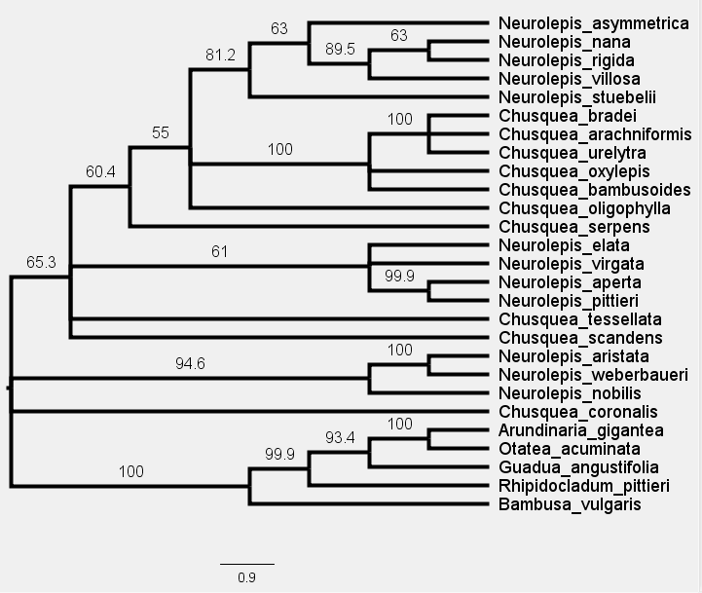

**Figure 1.** Phylogenetic estimation of evolutionary relationships within Chusqueinaebased on maximum parsimony with all five species of the Chusqueinae set as outgroups. Bootstrap values are listed above the branches. Species belonging to *Neurolepis* I are marked with stars, *Neurolepis* II with triangles, *Chusquea* subg. *Rettbergia* with circles, Euchusquea with diamonds, Arundinariinae with a plus, Guadinae with rectangles, Arthrostylidiinae with a pentagon, and Bambusae with an arch.

With only *Arundinaria gigantea* set as an outgroup, the resulting maximum parsimony tree supported *Chusquea* subg. *Rettbergia* as a monophyletic clade, with 100% bootstrap support (Figure 2). All species of *Neurolepis* fall into a single clade with 93% bootstrap support, but this clade also includes the otherwise distantly related species *Guadua angustifolia*, which belongs to subtribe Guadinae (Figure 2). The both *Guadua angustifolia* and *Rhipidocladum pittieri*, a species of subtribe Arthrostylidiinae, fall into a clade with the Chusqueinae, making the Chusqueinae paraphyletic with about 50% bootstrap support (Figure 2). The Euchusquea were not supported as a clade (Figure 2).

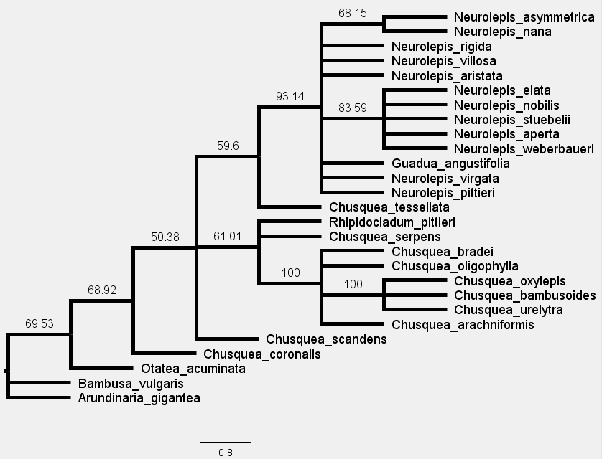

**Figure 2.** Phylogenetic estimation of evolutionary relationships within Chusqueinaebased on maximum parsimony with only *Arundinaria gigantea* set as an outgroup. Bootstrap values are listed above the branches. Species belonging to *Neurolepis* I are marked with stars, *Neurolepis* II with triangles, *Chusquea* subg. *Rettbergia* with circles, Euchusquea with diamonds, Arundinariinae with a plus, Guadinae with rectangles, Arthrostylidiinae with a pentagon, and Bambusae with an arch.

Bayesian analysis of the selected morphological characters with *Arundinaria gigantea* as the outgroup supported Chusqueinae as a clade with a relatively low credibility value of 58%. Notably, the other four outgroup species remained outside the Chusqueinae. *Neurolepis* was placed in a single clade with a clade credibility value of 61% (Figure 3). Within this clade, only *N. aperta* (Muro.) Pilg., and *N. pittieri* McClure form their own clade, with 62% clade credibility (Figure 3). This same small clade was also supported by maximum parsimony, with nearly 100% bootstrap support (Figure 1). *Chusquea* subg. *Rettbergia* was found to be monophyletic in this analysis, with weak clade credibility of 58%, with *C. serpens* L.G. Clark determined to be the sister to subg. *Rettbergia* also with clade credibility of 58% (Figure 3).

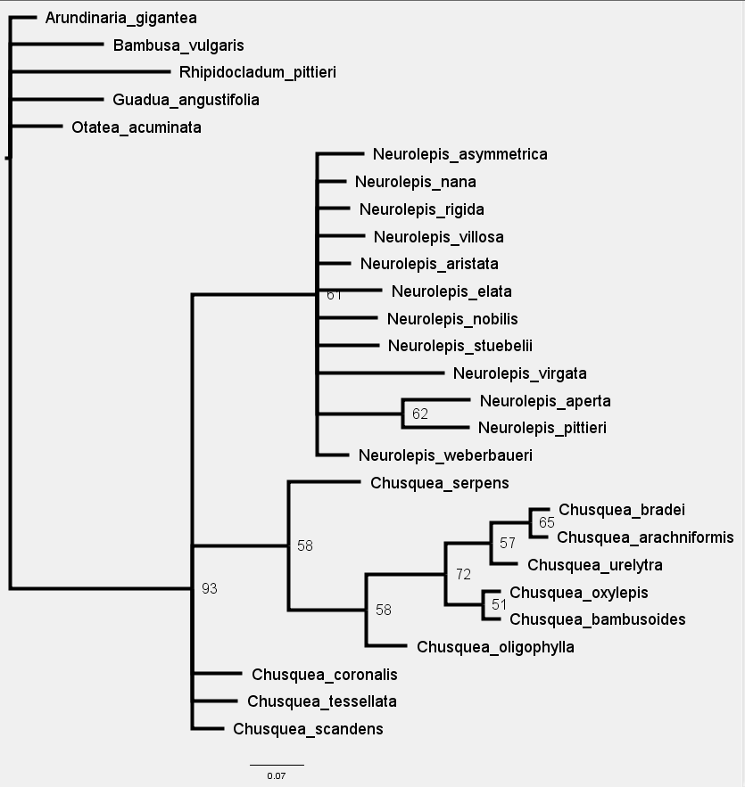

**Figure 3.** Phylogenetic estimation of evolutionary relationships within Chusqueinaebased on Bayesian analysis. Clade credibility values representing the posterior probability of each clade are listed at the nodes. Species belonging to *Neurolepis* I are marked with stars, *Neurolepis* II with triangles, *Chusquea* subg. *Rettbergia* with circles, Euchusquea with diamonds, Arundinariinae with a plus, Guadinae with rectangles, Arthrostylidiinae with a pentagon, and Bambusae with an arch.

**CONCLUSION**

The results of the maximum parsimony and Bayesian analyses conducted using the twenty characters used in this study do not fully agree with those of Fisher et al. (2009), though there are some distinct similarities. Chusqueinae was only fully supported as a clade using Bayesian analysis, despite widespread consensus among researchers based on morphological and molecular data that this clade is monophyletic (Clark et al. 2007; Ruiz-Sanchez 2011; Bamboo Phylogeny Group 2012). Additionally, the placement of *Chusquea* within *Neurolepis* as found by Fisher et al. (2009) was not found in this morphological study. Although the maximum parsimony analysis with all five species of non-Chusqueinae set as outgroups showed multiple clades of *Chusquea* and *Neurolepis* scattered together, *Chusquea* was not monophyletic and *Neurolepis* did not fall into the two clades as seen in Fisher et al. (2009). *Chusquea* was not found to be monophyletic using Bayesian analysis, while *Neurolepis* was, in a reversal of the results of Fisher et al. (2009).

The topology of several clades of species formerly classified as belonging to *Neurolepis* and *Chusquea* scattered together as found in the maximum parsimony tree with all five species of non-Chusqueinae set as outgroups might suggest an evolutionary relationship of these taxa more similar to that inferred by Fisher et al. (2009) than the traditional view of a monophyletic *Neurolepis* and *Chusquea*. Traditionally, *Neurolepis* was thought to have evolved its unusual habit as a response to its montane habitat as a sister genus to the more typical *Chusquea* (Jacobs and Everett 2000). The analysis of Fisher et al. (2009) suggests instead that it’s possible that *Chusquea* may have developed from an ancestor more similar *Neurolepis* or, somewhat less likely, that the unusual habit seen in *Neurolepis* developed twice. While the maximum parsimony analysis here did not give the same results, the analysis using all five of the non-Chusqueinae as outgroups did suggest that either the habit of *Neurolepis* or *Chusquea* emerged multiple times within the same lineage. Species belonging to *Chusquea* with aerial branching have a much wider range of habitats than those formerly belonging to *Neurolepis* and appear to have experienced a much more dramatic species radiation associated with the uplift of the Andes, colonizing a broader range of temperate and lowland tropical habitats in addition to the montane habitats in which they are most common (Clark 1986). Fisher et al. (2009) indicate that *Chusquea* may have developed aerial branching and rebranching from a reed-like ancestral species, with this advantageous morphology promoting a rapid species radiation. However, the fossil record of bamboos in South America is still somewhat poor, making true ancestral characters more difficult to assess (Olivier et al. 2009). Although unlikely under a parsimony analysis, Fisher et al. (2009) show that it is possible that the reed-like habit of *Neurolepis* that is suited to montane habitats evolved at least twice. The maximum parsimony analysis conducted here indicates the potential for multiple developments of both a *Neurolepis*-like habit or one similar to *Chusquea* with aerial rebranching.

*Chusquea* subg. *Rettbergia* was supported by Bayesian and maximum parsimony analysis when only *Arundinaria gigantea* was set as the outgroup, but not fully supported as a monophyletic group by maximum parsimony analysis with all five species of Chusqueinae set as outgroups, which resulted in the exclusion of *C. oligophylla.* The exclusion of *C. oligophylla* from this clade is likely due to several morphological differences that set it apart, including the lack of glume awns and spatheate bract subtending the inflorescence found in all other sampled species of this subgenus (Schiller et al. 2007b). Previous studies of both morphological and genetic data have also supported the monophyly of subg. *Rettbergia* as shown in Bayesian analysis here, despite lack of support for the monophyly of other subgenera of *Chusquea* beyond the presence of the Euchusquea clade (Kelchner and Clark 1997; Clark et al. 2007; Fisher et al. 2009).

Interestingly, phylogenetic relationships among the outgroups to Chusqueinae were also not those expected based on previous analyses. Bayesian analysis did not place the five outgroup species used here into a phylogeny at all, but maximum parsimony analysis produced unusual results. For example, when all five species of non-Chusqueinae were set as outgroups, *Otatea acuminata* (Munro) C.E.Calderón & Soderstr., a member of Guadinae, appears as the sister species to *Arundinaria gigantea* (Walter) Muhl., a member of Arundinariinae, with the improbable relationship of another species of Guadinae, *Guadua angustifolia* Kunth. being sister to both. Arundinariinae is generally thought to be most distantly related subtribe to the rest of the subtribes, while Guadinae and Arthrostylidiinae are thought to be sister to each other, and Chusqueinae sister to both (Ruiz-Sanchez 2011). When only *Arundinaria gigantea* was set as an outgroup, *Guadua angustifolia* unexpectedly fell within *Neurolepis*, far from the other species of Guadinae used in the analysis, and *Rhipidocladum pittieri*, a member of the subtribe Arthrostylidiinae, fell within the greater Chusqueinae. Phylogenetic results completely in line with existing literature were probably not to be expected among the outgroups as the twenty characters chosen were tailored specifically to the Chusqueinae, especially *Neurolepis*. However, the unlikely results of maximum parsimony do cast additional doubt on the utility of maximum likelihood analysis for this type of study.

More characters may be needed to construct a more accurate phylogenetic estimation of the Chusqueinae. Many of the characters used here were selected for ease of nondestructive use with herbarium specimens, but additional characters that require further dissection or destructive imaging are likely of greater utility (Clark et al. 2007). Mircromorphological and anatomical characters are sometimes key to determining differences between even closely-related species within the Chusqueinae (Leandro et al. 2017). No character states were found that could reliably separate species belonging to the two clades of *Neurolepis*. Species belonging to *Neurolepis* I were slightly more likely to have centric foliage leaf midribs, as seen in Table 2, but this was not a universal trait. The characters that most accurately defined the Chusqueinae were similar to those that were observed in previous studies, including zero or more than one buds at midculm modes for the Chusqueinae (Table 2) (Clark et al. 2007). Although *Chusquea* subg. *Rettbergia* was supported by Bayesian analysis and one of the maximum parsimony analyses as a monophyletic clade, supporting character states like infravaginal branching were shared with members of the Euchusquea and character states unique to subg. *Rettbergia*, such as spatheate bracts subtending the entire synflorescence, were not seen in all species of the subgenus. An expanded set of characters, including micromorphological characters, could be more helpful than this limited set of only twenty characters to finding accurate ways of differentiating different clades within the Chusqueinae.

**REFERENCES**

Bamboo Phylogeny Group. 2012. 9th World Bamboo Congress Proceedings. 1–2.

Chen, Shou-liang, Li, De-Zhu, Zhu, Guanghua, Wu, Zhenlan, Lu, Sheng-lian, Liu, Liang, Wang, Zheng-ping, Sun, Bi-xing, Zhu, Zheng-de, Xia, Nianhe, Jia, Liang-zhi, Guo, Zhenhua, Chen, Wenli, Chen, Xiang, Yang, Guangyao, Phillips, Sylvia M., Stapleton, Chris, Soreng, Robert J., Aiken, Susan G., Tzvelev, Nikolai N., Peterson, Paul M., Renvoize, Stephen A., Olonova, Marina V., Ammann, Klaus. 2008. eFloras: Flora of China. St. Louis, Missouri & Harvard University Herbaria, Cambridge, Massachusetts: .

Clark L.G. 1986. Systematics of Chusquea section Chusquea, section Swallenochloa, section Verticillatae, and section Serpentes (Poaceae: Bambusoideae). .

Clark L.G. 1989. Systematics of Chusquea Section Swallenochloa, Section Verticillatae, Section Serpentes, and Section Longifoliae (Poaceae-Bambusoideae). Syst. Bot. Monogr. 27:1.

Clark L.G. 1996a. Six new species of Neurolepis (Poaceae: Bambusoideae: Bambuseae) from Ecuador and Peru. Novon. 6:335.

Clark L.G. 1996b. Four new species of Chusquea (Poaceae: Bambusoideae) from Brazil and Ecuador. Brittonia. 48:250.

Clark L.G., Dransfield S., Triplett J., Sánchez-Ken J.G. 2007a. Phylogenetic relationships among the one-flowered, determinate genera of Bambuseae (Poaceae: Bambusoideae). Aliso J. Syst. Evol. Bot. 23:315–332.

Clark L.G., Dransfield S., Triplett J., Sánchez-Ken J.G. 2007b. Phylogenetic relationships among the one-flowered, determinate genera of Bambuseae (Poaceae: Bambusoideae). Aliso J. Syst. Evol. Bot. 23:315–332.

Emmet J. Judziewicz, Lynn G. Clark, Ximena Londoño, Margaret J. Stern. 1999. American Bamboos. Washington, D.C.: Smithsonian Institution Press.

Fisher A.E., Triplett J.K., Ho C.-S., Schiller A.D., Oltrogge K.A., Schroder E.S., Kelchner S.A., Clark L.G. 2009. Paraphyly in the bamboo subtribe Chusqueinae (Poaceae: Bambusoideae) and a revised infrageneric classification for Chusquea. Syst. Bot. 34:673–683.

Guerreiro C., Alegría Olivera J.J., Vega A.S. 2019. Taxonomic revision of Chusquea subg. Magnifoliae and Chusquea subg. Platonia (Poaceae, Bambusoideae, Chusqueinae) in Peru. Syst. Bot. 44:798–809.

Jacobs S.W.L., Everett J. 2000. Grasses: Systematics and Evolution: Systematics and Evolution. Csiro Publishing.

Kelchner S.A., Clark L.G. 1997. Molecular evolution and phylogenetic utility of the chloroplast rpl 16 intron in Chusquea and the Bambusoideae (Poaceae). Mol. Phylogenet. Evol. 8:385–397.

Leandro T.D., Scatena V.L., Clark L.G. 2017. The contribution of foliar micromorphology and anatomy to the circumscription of species within the Chusquea ramosissima informal group (Poaceae, Bambusoideae, Bambuseae). Plant Syst. Evol. 303:745–756.

Londoño X., Clark L.G. 1998. Eight New Taxa and Two New Reports of Bambuseae (Poaceae: Bambusoideae) from Colombia. Novon. 8:408.

Munro, William. 1870. A monograph of the Bambusaceae, including descriptions of all the species. Trans. Linn. Soc. Lond. 26:1–158.

Olivier J., Otto T., Roddaz M., Antoine P.-O., Londoño X., Clark L.G. 2009. First macrofossil evidence of a pre-Holocene thorny bamboo cf. Guadua (Poaceae: Bambusoideae: Bambuseae: Guaduinae) in south-western Amazonia (Madre de Dios — Peru). Rev. Palaeobot. Palynol. 153:1–7.

Ruiz-Sanchez E. 2011. Biogeography and divergence time estimates of woody bamboos: insights in the evolution of Neotropical bamboos. Bot. Sci. 88:67–75.

Ruiz-Sanchez E., Sosa V., Mejía-Saules M.T., Londoño X., Clark L.G. 2011. A Taxonomic Revision of *Otatea* (Poaceae: Bambusoideae: Bambuseae) Including Four New Species. Syst. Bot. 36:314–336.

Schiller A., Oltrogge K., Triplett J., Clark L.G. 2007a. Chusquea oligophylla Ruprecht. Available from https://www.eeob.iastate.edu/research/bamboo/keys/Rettbergia/C.%20oligophylla/Chusquea%20oligophylla.htm.

Schiller A., Oltrogge K., Triplett J., Clark L.G. 2007b. Chusquea oxylepis. Available from https://www.eeob.iastate.edu/research/bamboo/keys/Rettbergia/C.%20oxylepis/Chusquea%20oxylepis.htm.

Schiller A., Oltrogge K., Triplett J., Clark L.G. 2007c. Chusquea bambusoides. Available from https://www.eeob.iastate.edu/research/bamboo/keys/Rettbergia/C.%20bambusoides/Chusquea%20bambusoides.htm.

Schiller A., Oltrogge K., Triplett J., Clark L.G. 2007d. Chusquea urelytra Hackel. Available from https://www.eeob.iastate.edu/research/bamboo/keys/Rettbergia/C.%20urelytra/Chusquea%20urelytra.htm.

Weakley A.S., Ludwig J.C., Townsend J.F. 2012. Flora of Virginia. Fort Worth: Botanical Research Institute of Texas Press.

Young S.M., Judd W.S. 1992. Systematics of the Guadua angustifolia complex (Poaceae: Bambusoideae). Ann. Mo. Bot. Gard. 79:737.

Zhang W., Clark L.G. 2000. Phylogeny and classification of the Bambusoideae (Poaceae). Monocots: Systematics and Evolution. Csiro Publishing.

**APPENDIX**

Table 3. Resources used in addition to herbarium specimens to describe species used in this study.

|  |  |
| --- | --- |
| Species | References |
| *Neurolepis asymmetrica* L.G. Clark  Current name: *Chusquea asymmetrica* (L.G. Clark) L.G. Clark | (Clark 1996a) |
| *Neurolepis nana* L.G. Clark  Current name: *Chusquea nana* (L.G. Clark) L.G. Clark | (Clark 1996a) |
| *Neurolepis rigida* L.G. Clark  Current name: *Chusquea rigida* (L.G. Clark) L.G. Clark | (Clark 1996a) |
| *Neurolepis villosa* L.G. Clark  Current name: *Chusquea villosa* (L.G. Clark) L.G. Clark | (Clark 1996a) |
| *Neurolepis aristata* (Munro) Hitchc.  Current name: *Chusquea angusta* (Swallen) L.G. Clark | (Guerreiro et al. 2019) |
| *Neurolepis elata* (Kunth) Pilg. in Engler & Prantl  Current name: *Chusquea elata* (Kunth) L.G. Clark | (Guerreiro et al. 2019) |
| *Neurolepis nobilis* (Munro) Pilg. in Engler & Prantl  Current name: *Chusquea nobilis* (Munro) L.G. Clark | (Munro, W. 1870) |
| *Neurolepis stuebelii* (Pilg.) Pilg. in Engler & Prantl  Current name: *Chusquea stuebelii* (Pilg.) L.G. Clark | (Guerreiro et al. 2019) |
| *Arundinaria gigantea* (Walter) Muhl. | (Weakley et al. 2012) |
| *Bambusa vulgaris* Schrad. ex J.C. Wendl. | (Chen, Shou-liang et al. 2008) |
| *Rhipidocladum pittieri* (Hack.) McClure | (Tyrrell 2008) |
| *Guadua angustifolia* Kunth | (Young and Judd 1992) |
| *Otatea acuminata* (Munro) C.E.Calderón & Soderstr. | (Ruiz-Sanchez et al. 2011) |
| *Neurolepis virgata* (Griseb.) Pilg. in Engler & Prantl  Current name: *Chusquea cylindrica* L.G. Clark | (Kew Science 2017) |
| *Neurolepis aperta* (Munro) Pilg. in Engler & Prantl  Current name: *Chusquea spectabilis* L.G. Clark | (Munro, W. 1870) |
| *Neurolepis weberbaueri* Pilg.  Current name: *Chusquea tovari* L.G. Clark | (Munro, W. 1870) |
| *Neurolepis pittieri* McClure  Current name: *Chusquea magnifolia* L.G. Clark | (Clayton, W.D. et al. 2016) |
| *Chusquea serpens* L.G. Clark | (Clark 1989) |
| *Chusquea coronalis* Soderstr. & C.E.Calderón | (Clark 1989) |
| *Chusquea tessellata* Munro | (Clark 1989) |
| *Chusquea scandens* Kunth | (Munro, W. 1870) |
| *Chusquea bradei* L.G. Clark | (Clark 1996b) |
| *Chusquea oligophylla* Rupr. | (Schiller et al. 2007a) |
| *Chusquea oxylepis* Ekman | (Schiller et al. 2007b) |
| *Chusquea bambusoides* Hack. | (Schiller et al. 2007c) |
| *Chusquea arachniformis* L.G.Clark & Londoño  Note: Published as *C. arachniforme* | (Londoño and Clark 1998) |
| *Chusquea urelytra* Hack. | (Schiller et al. 2007d) |