_______________________________________________________________________

CSC251 ADVANCED java programming
_______________________________________________________________________

GROUP PROJECT

Objectives

- Develop a deep understanding of the topics.
- Learn how to work in a group

Instruction

Our department requires every course to have a group project. There are two goals. First, students will develop a deeper understanding of the topics. Second, students will get teamwork experience, which is important in the software industry.

The task is to create a Java application that calculates loans with extra payment.
In the Pearson textbook, loan calculation is covered in chapter 2, chapter 10.
Please don’t add JavaFX, awt, swing, or other technologies in the project.

Input: interest rate, years, loan amount, extra payment
Output: monthly payment and below for each of the 3 conditions:
original interest, current interest, interest saved, total months.
- If there is No extra payment, output total interest needs to be paid
- If there is Extra payment for the first month only, output
  - new total interest
  - interest saved compared to original total interest
  - total months needed to pay off the loan
- If there is Extra payment of $1000 for every month, output
  - new total interest
  - interest saved compared to original total interest
  - total month needed to pay off the loan

Test Cases:
Loan 1 interest rate 5%, 4 years, loan amount $20k, extra payment $1000
Loan 2 interest rate 5%, 30 years, loan amount $300k, extra payment $1000

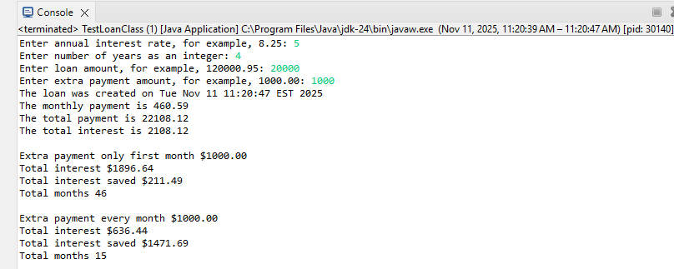
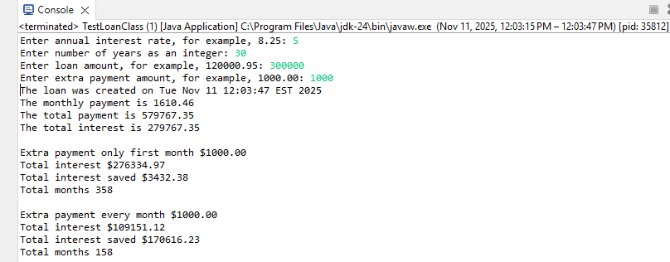

Below examples are copied from Excel file CalculatorWithExtraPayment.xlsx
Loan1
Loan | $ 20,000.00
Interest Rate | 5.00%
Rate (Monthly) | 0.42%
Periods (Years) | 4
Periods (Months) | 48
PMT (Payment) | $460.59
Extra payment: 0
Original Interest | $ 2,108.12
Current Interest | $ 2,108.12
Interest Saved | $ (0.00)
Total months | 48
Extra payment: first month $1000
Original Interest | $ 2,108.12
Current Interest | $ 1,896.64
Interest Saved | $ 211.48
Total months | 46
Extra payment: monthly $1000
Original Interest | $ 2,108.12
Current Interest | $ 636.44
Interest Saved | $ 1,471.68
Total months | 15

Loan2
Loan | $ 300,000.00
Interest Rate | 5.00%
Rate (Monthly) | 0.42%
Periods (Years) | 30
Periods (Months) | 360
PMT (Payment) | $1,610.46
Extra payment: 0
Original Interest | $ 279,767.35
Current Interest | $ 279,767.35
Interest Saved | $ (0.00)
Total months | 360
Extra payment: first month $1000
Original Interest | $ 279,767.35
Current Interest | $ 276,334.97
Interest Saved | $ 3,432.38
Total months | 358
Extra payment: monthly $1000
Original Interest | $ 279,767.35
Current Interest | $ 109,151.12
Interest Saved | $ 170,616.23
Total months | 158

Instructor will assign students to groups with 4 members and provide the names and email addresses.

Students will participate in the following activities:
- Discussion with group members and work on project design and analysis.
- Implementation and testing
- Demo the project and share what is learned, upload the video in MS Team
Each group will have 5 to 10 minutes to do the following:
  - Demo the project (run and display result)
  - Share what’s learned in the experience

Only team leader submits a zip file including the items below.
- Project description and screenshots of result in Microsoft Word file (1 or 2 pages) with file name ends with .docx,
- Java source code files with file name end with .java

Grading rubric

GitHub tasks [10 points]
- GitHub1: Create a GitHub Account: WT email required [5 points]
- GitHub2: Hello, World! GitHub Edition [5 points]

Accuracy and reliability (i.e. if the program work) [60 points]
- getTotalInterest [10 points]
- while (myLoanAmount >= (myMonthlyPayment + extraPay)) [10 points]
- while (myLoanAmount >= myMonthlyPayment) [10 points]
- if (myLoanAmount < myMonthlyPayment) [10 points]
- Test case1 [10 points]
- Test case2 [10 points]

Project description and screenshots of output [10]
- Project description (brief and simple) [5 points]
- screenshots of output [5 points]

Presentation [20 points]
- Demo the project (run and display result) [10 points]
- Share what’s learned in the experience [10 points]

