Vehicle_Theft_Azure_Project_Documentation

- 1. End-to-End Azure Medallion Architecture for Vehicle Theft Analytics
This architecture shows how data flows from external sources to Power BI using Azure Data Factory, ADLS Gen2, Databricks, and Key Vault following Bronze–Silver–Gold Medallion design.
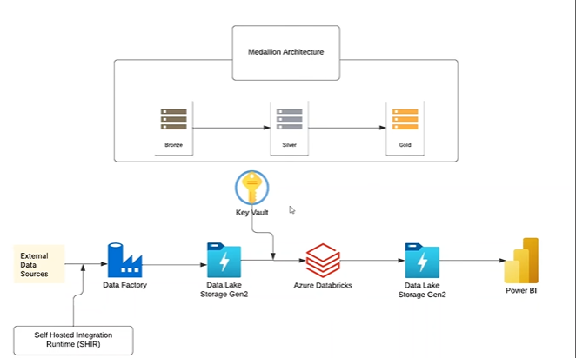

2. Azure Storage Account stvehicle with containers for vehicle data: bronze, silver, gold, and logs, all set to private access.
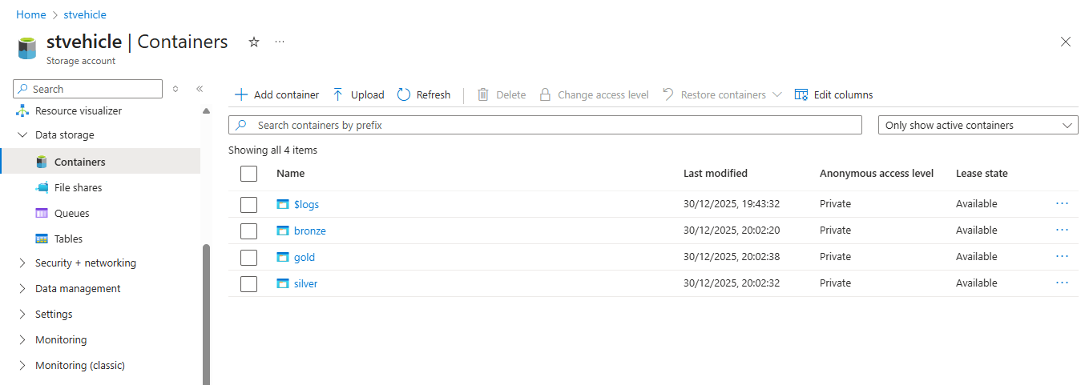
3. Created ADF - Vehiclestudio
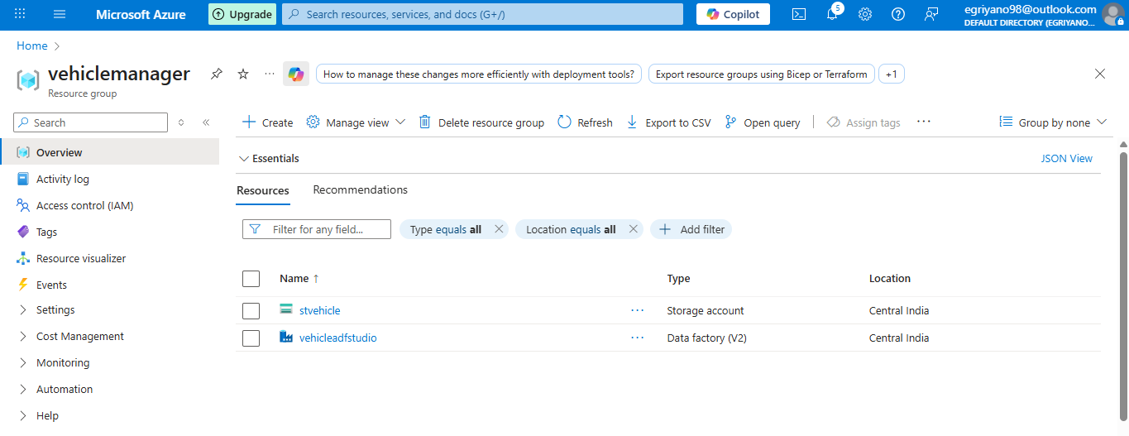
4. Azure Data Factory linked service configuration page, connecting to Blob Storage account 'stvehicle
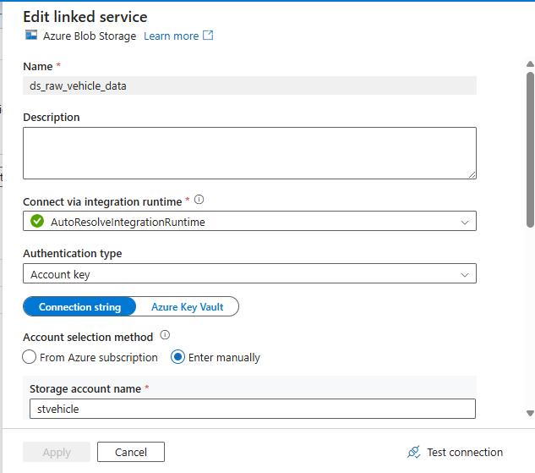

5. Copy activity performance details in Azure Data Factory, showing data transfer from Blob Storage to Data Lake Storage Gen2
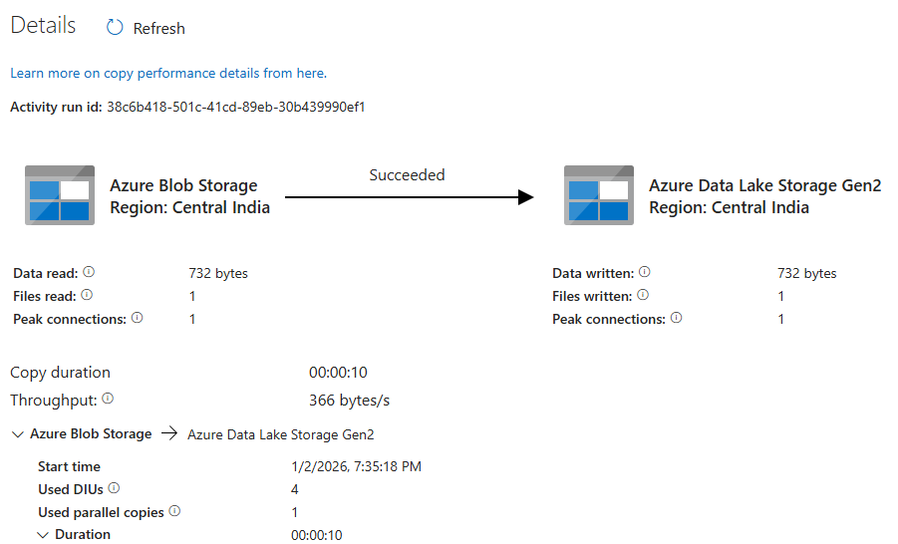
6.Azure Data Factory pipeline successfully executed: Copying data from location - Make details Stolen_vehicle - Database with all activities completed.
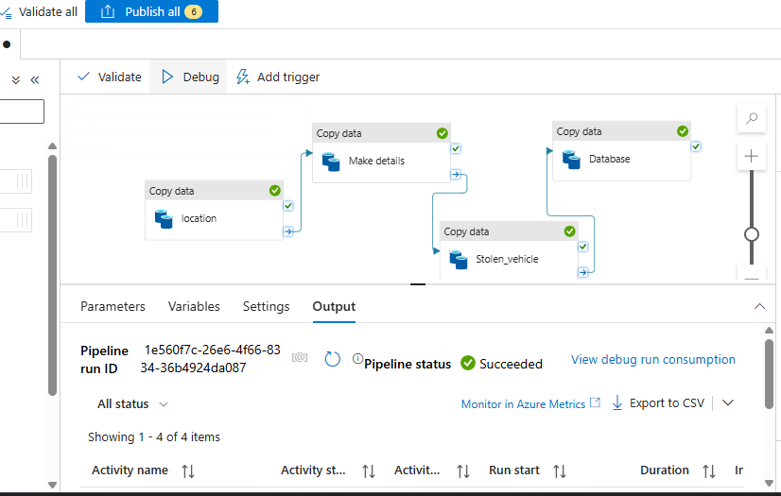

7.1Databricks: Creating a Secret Scope (dbscope) linked to Azure Key Vault to securely manage credentials and secrets.
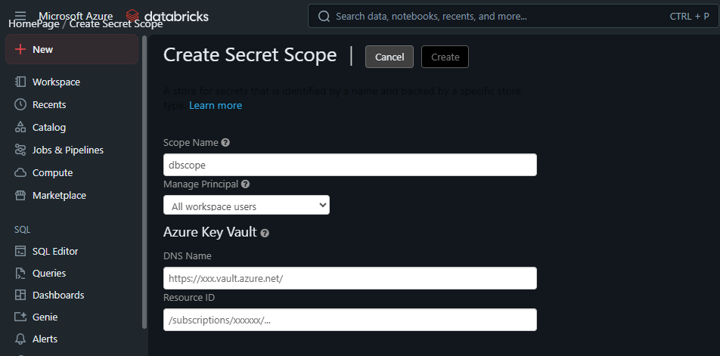
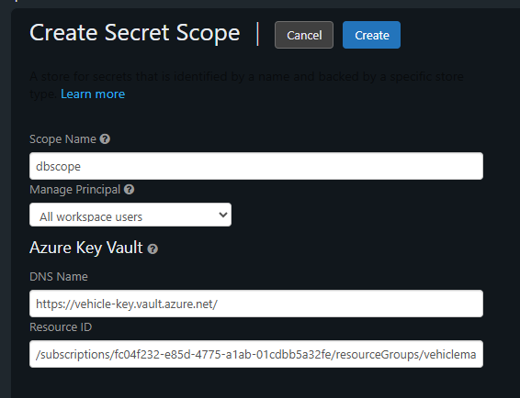
7.2 Creating a secret named 'SAsecret' in Azure Key Vault for secure storage management."
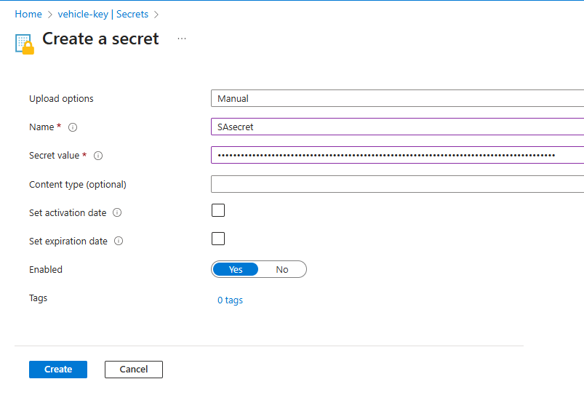

8.1 Loading and displaying a CSV file from Azure Data Lake Storage into a PySpark DataFrame in Databricks
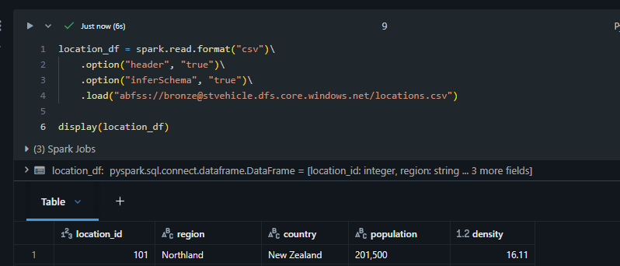
8.2 Checking DataFrame schema in PySpark and identifying the need to transform the 'population' column from string to integer.
Converting the 'population' column from string to integer in PySpark and verifying the updated schema
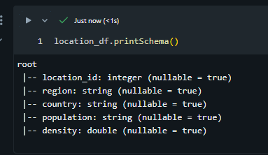
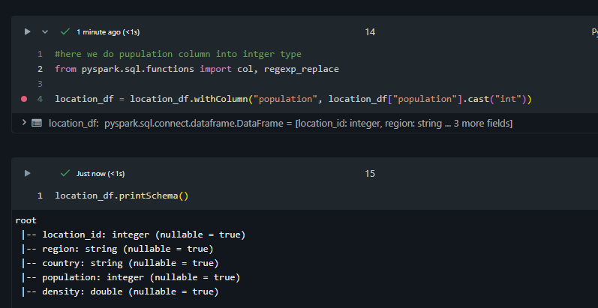
9.1 Data files and metadata stored in the silver container after a successful transformation process
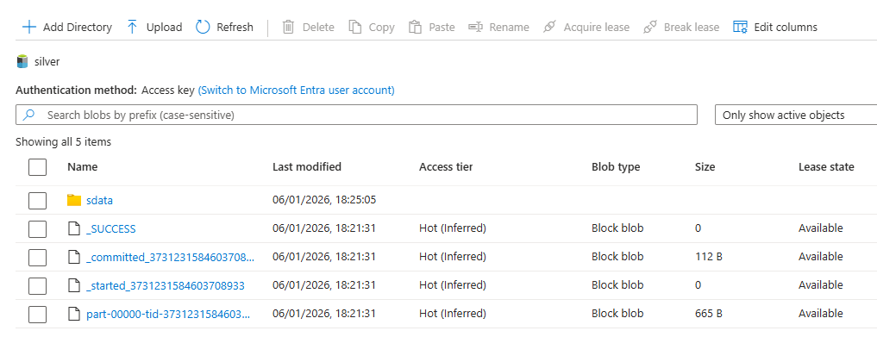
9.2 CSV files stored in the container, including datasets for locations, vehicle details, and stolen vehicle records
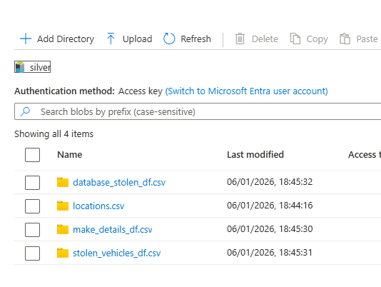
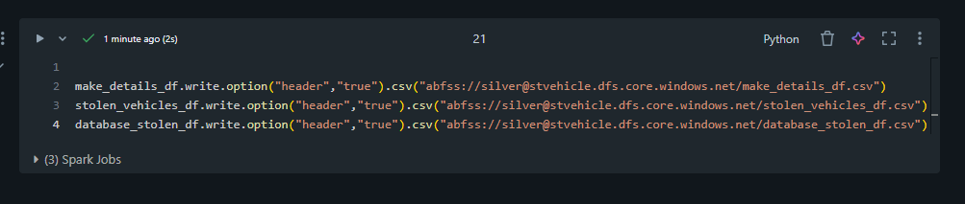
10. Checking for null values in multiple DataFrames to ensure data quality before analysis.
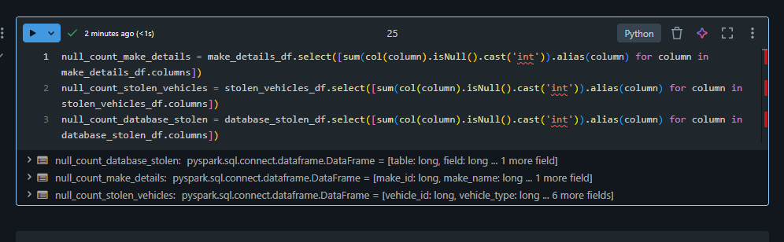
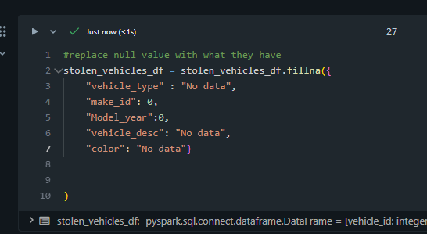
11. Connecting Azure Gold container data to Power BI for transformation and visualization and laoded all data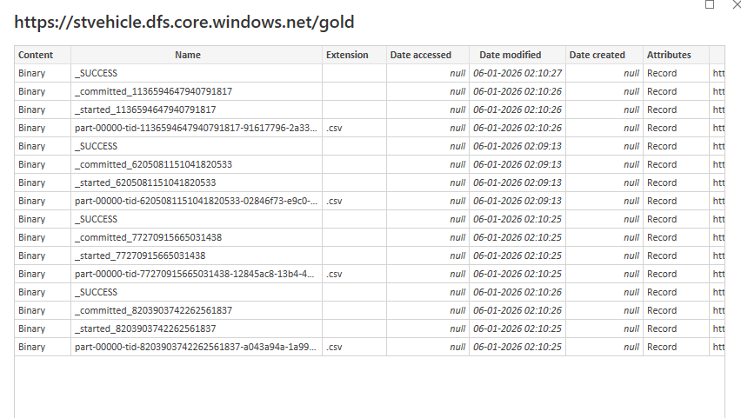
Power BI dashboard showing vehicle theft data analytics with multiple charts including map, bar, candlestick, and line visualizations
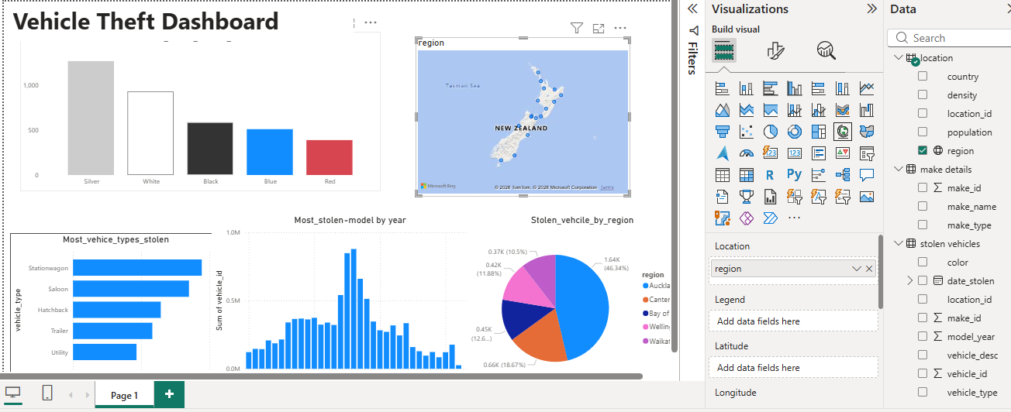

Author-
EKnath Gupta
eknathgupta98@gmail.com
Azure data analyst

Thank You

