**Supporting Information S3**

Bioregions for *Chamaecrista*

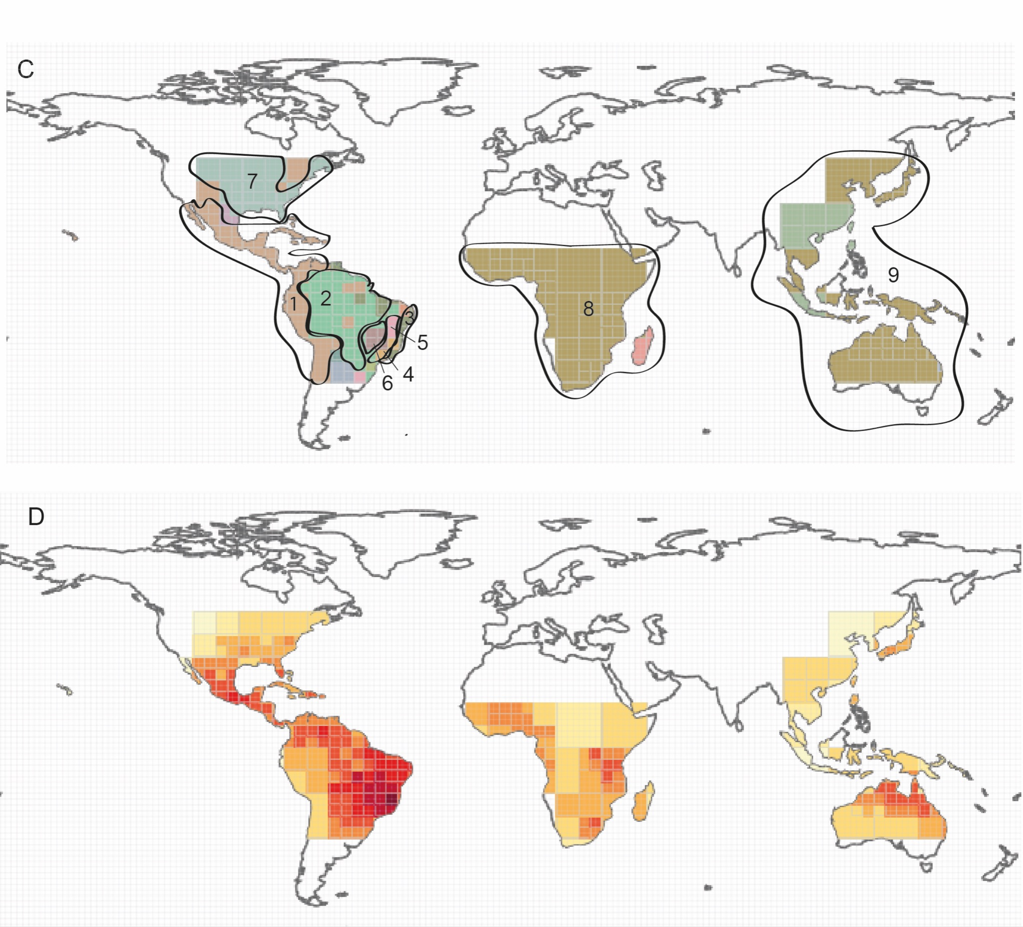

**A.**The bioregions for *Chamaecrista* resulted from Infomap Bioregions (Edler et al. 2016) and which of them were considered here, based on the correspondence of others regionalizations (Morrone 2001, IBGE 2004, Olson et al. 2001) and in our sampling. The bioregionalization was performed with 324 species and 41.899 records (<https://doi.org/10.15468/dl.5gxx8t>). The network analyses were performed in the application with grid cell size ranging between 4o and 16o, with 10 trials, and the remaining parameters were left as the default settings (maximum cell capacity = 100, minimum cell capacity = 10, and cluster cost = 1.0). The region (1=F) corresponds to Caribbean subregion of Morrone (2022); (2=A) corresponds in part to Amazonic subregion of Morrone (2022) and also covers part of the Brazilian Cerrado (IBGE 2004), we did not include the small bioregions that appeared within; (3=E) Paranaense subregion of Morrone (2022); (4 and 5 = D) corresponds to the Campos Rupestres Province (Colli et al. 2019) 10.617 records and 200 species, (5); (6=B) the second richest bioregion with 6.449 records and 151 species, corresponds to Cerrado province, in this last case we adopted the delimitation (shapefile) of IBGE (2004) including also the Chapada dos Veadeiros where occur high level of endemic *Chamaecrista* species. The region 7 (=G), corresponds to North America. In the Paleotropic regions, even the network analyses clustering Afrotropic, Indo-Malay (with a particular area within) and Australasia together, we adopt an ample delimited bioregion (= I). **B**.The richness of *Chamaecrista* obtained from Infomap Bioregions (Edler et al. 2016), grid cell size ranging 4o, maximum cell capacity = 100 species, minimum cell capacity = 10 species. Richness is expressed in hotter colors, light yellow -> dark red.