# GOVERNMENT POLYTECHNIC COLLEGE MATTANNUR-670702

### (Department of Technical Education, Kerala)

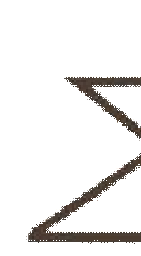

**SEMINAR REPORT ON**

**ULTRASONIC MOTOR**

**SUBMITTED BY RITHURAJ T V**

**(Reg.No:19041675)**

**DEPARTMENT OF ELECTRONICS ENGINEERING**

**2021-22**

**GOVERNMENT POLYTECHNIC COLLEGE MATTANNUR-670702**

**(Department of Technical Education, Kerala)**



**CERTIFICATE**

*Certified that seminar work entitled* “***ULTRASONIC MOTOR*”***is a bonafide work carried out by* **“*RITHURAJ T V* ”** *in partial fulfilment for the award of Diploma in Electronics Engineering from Government Polytechnic College Mattannur during the academic year* 2021-2022.

### Seminar Co-ordinator Head of Section

**Internal Examiner External Examiner**

**DECLARATION**

I hereby declare that the report of *the* ***ULTRASONIC MOTOR*** work entitled which is being submitted to the Govt. Polytechnic College Mattannur, in partial fulfilment of the requirement for the award **of *Diploma in Electronics Engineering*** *i*s a confide report of the work carried out by me. The material in this report has not been submitted to any institute for the award of any degree.

Place:Mattannur **RITHURAJ T V**

Date:

### ACKNOWLEDGEMENT

I would like to take this opportunity to extend my sincere thanks to people who helped me to make this seminar possible. This seminar will be incomplete without mentioning all the people who helped me to make itreal.

Firstly, I would like to thank GOD, almighty, our supreme guide, for bestowing his blessings upon me in my entire endeavor.

I would like to express my deepest gratitude **Mr. M C PRAKASHAN** (Principal GPTC, Mattannur), **Mr. GEORGE KUTTY P P(**Head of Department of Electronics Engg.), for the help rendered by him to prepare and present this Seminar in proper way. Moreover I am very much indebted to **Mr. SREEJITH A** (Lecturer, Electronics Engg, seminar co-ordinator), for their advice.

I am also indebted to all my friends and classmates who have given valuable suggestion and encouragement.

**RITHURAJ T V**

**ABSTRACT**

All of us know that motor is a machine which produces or imparts motion, or in detail it is an arrangement of coils and magnets that converts electric energy into mechanical energy and ultra sonic motors are the next generation motors . in 1980, the world’s first ultrasonic motor was invented which utilizes the piezoelectric effect in the ultrasonic frequency range to provide its motive force resulting in a motor with unusally low speed, hign torque and power toweight characteristics.

Electromagnetism has always been the driving force behind electric motor technology. But these motors suffer from many dwarbacks. The field of ultrasonic seems to be changing that driving forces.

TABLE OF CONTENTS

**CHAPTERNO TOPICS PAGENO**

Chapter1 INTRODUCTION……………………………………...8

Chapter2 GENERAL OVERVIEW……………………………….9

Chapter2.1 PROSTHESIS………………………………………......9

Chapter2.2 MECHATRONICS……………………..………………9

Chapter2.3 BIOMECHATRONICS…………….....……………..…9

Chapter3 WORKING………………………..………………..….10

Chapter3.1 BIOSENSORS………………………………….….…..10

Chapter3.2 MECHANICAL SENSORS…………………………...10

Chapter3.3 KINEMATICS ARCHITECTURES…………………..10

Chapter3.4 CONTROLLER…………………………………….….11

Chapter3.5 ACTUATOR………………………….……………….11

Chapter4 NATURAL HAND AND BIOMECHATRONIC HAND..………….……………………………….……12

Chapter4.1 NATURAL HAND………………….…..…………….12

Chapter4.2 BIOMECHATRONIC HAND………….………….….12

Chapter5 DESGIN AND HAND PROTOTYPE….…………..…14

Chapter5.1 ACTUATOR SYSTEM ARCHITECTURE……….….14

Chapter6 POSTION AND FORCE SENSORS…..……………....16

Chapter6.1 SENSORS……………………………………………...16

Chapter6.2 USE OF SENSORS IN ROBOTICS……………….….16

Chapter6.3 POSITION SENSORS…………………….……….….16

Chapter7 FINGERED TIP FORCE ANALYSIS………………..18

Chapter8 ADAVANTAGES AND DISADVANTAGES……….20

Chapter9 FURTURISTIC ASPECTS…………………………....21

Chapter10 CONCLUSION………………………………………..23

Chapter11 REFERENCE………………………………………….24

|  |  |  |
| --- | --- | --- |
| **FIGURE NO** | **LIST OF FIGURES**  **NAME** | **PAGE NO** |
| Fig 2.1 | A SOLDIER WITH PROSTHETIC ARMS PLAY FOOTBALL....................................... | 9 |
| Fig 4.1  Fig 4.2 | NATURAL HAND……………….......……..  MECHATRONIC HAND……………………. | 12  13 |
| Fig 5.1  Fig 5.2 | FINGER PROTO TYPE……………………..  HIGH PRECISION LINEAR ACTUATOR… | 14  14 |
| Fig 7.1  Fig 7.2  Fig 9.1  Fig 9.2 | POSITIONING OF FINGERPRINT…………  EXPERIMENTAL RESULT…………………  PORTABLE ARM MOVEMNET  TRAINING………………………………….  SENSORY MOTOR PERFORMANCE……. | 18  19  21  22 |

**CHAPTER 1**

**INTRODUCTION**

The objective of the work describe in this paper is to develop an artificial hand aimed  at replicating the appearance and performance of the natural hand  the ultimate goal of this research is to obtain a complete functional substitution of the natural hand. This means that the artificial hand should be felt by the user as the part of his/her own body (extended physiological proprioception(EPP) ) and it should provide the user with the same functions  of natural hand: tactile exploration, grasping , and manipulation (“cybernetic” prothesis). Commercially available prosthetic devices, as well as multifunctional hand designs have good (sometimes excellent) reliability and robustness, but their grasping capabilities can be improved. It has been demonstrated the methodologies and knowledge developed for robotic hands can be apologies and knowledge developed for robotic hands can be applied to the domain of prothestics to augment final performance. The first significant example of an artificial hand designed according to a robotic approach is the Belgrade/USC Hand. Afterwards, several robotic grippers and articulated hands have been developed, for example the Stanford/JPL hand and the Utah/MIT hand  which have achived excellent results. An accurate description and a comparative analysis of state of the art of artificial hands can be found in .

**CHAPTER 2**

**GENERAL OVERVIEW**

**2.1 Prosthesis** In medicine, a prosthesis is an artificial extension that replaces a missing body part. It is part of the field of biomechatronics. Prostheses are typically used to replace parts lost by injury (traumatic) or missing from birth (congenital) or to supplement defective body parts.

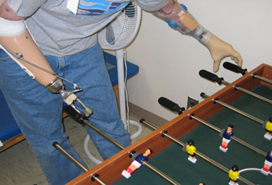

Fig 2.1 A Soldier with prosthetic arms plays foosball.

**2.2 Mechatronics**

Mechatronics is the combination of Mechanical engineering,Electronic engineering,Computer engineering,Control engineering and Systems Design engineering to create useful products. A mechatronics engineer unites the principles of mechanics, electronics, and computing to generate a simpler, more economical and reliable system. An industrial robot is a prime example of a mechatronics system; it includes aspects of electronics, mechanics and computing, so it can carry out its day to day jobs.

**2.3 Biomechatronics**

Biomechatronics is the merging of man with machine -- like the cyborg of science fiction. It is an interdisciplinary field encompassing biology, neurosciences, mechanics, electronics and robotics. Biomechatronic scientists attempt to make devices that interact with human muscle, skeleton, and nervous systems with the goals of assisting or enhancing human motor control that can be lost or impaired by trauma, disease or birth defects.It focuses on the interactivity of the the brain with the electromechanical devices and the systems.

**CHAPTER 3**

**WORKING**

Biomechatronics devices have to be based on how the human body works. For example, four different steps must occur to be able to lift the foot to walk. First, impulses from the motor center of the brain are sent to the foot and leg muscles. Next the nerve cells in the feet send information to the brain telling it to adjust the muscle groups or amount of force required to walk across the ground. Different amounts of force are applied depending on the type of surface being walked across. The leg's muscle spindle nerve cells then sense and send the position of the floor back up to the brain. Finally, when the foot is raised to step, signals are sent to muscles in the leg and foot to set it down.

**3.1 Biosensors**

Biosensors are used to detect what the user wants to do or their intentions. In some devices the information can be relayed by the user's nervous system or muscle system. This information is related by the biosensor to a controller which can be located inside or outside the biomechatronic device. In addition biosensors receive information about the limb position and force from the limb and actuator. Biosensors come in a variety of forms. They can be wires which detect electrical activity, needle electrodes implanted in muscles, and electrode arrays with nerves growing through them.

**3.3 Mechanical Sensors**

The purpose of the mechanical sensors is to measure information about the biomechatronic device and relate that information to the biosensor or controller.

**3.4 Kinematics Architecture**

The kinematics of each finger joint is described in the following subsections.

1. MP joint: the proximal actuator is integrated in the palm and transmits the movement through a slider –crank mechanism to the proximal phalanx, thus, providing flexion/extension movement. The slider is driven by the lead screw transmission mounted directly on the motor shaft.

2. PIP joint: the same mechanism used for MP moves the PIP joint. Only the geometrical features in order that the size of the mechanism fits within the space available according to the strict specification of the biomechatronic hand.

3. DIP joint: a four bars link has been adopted for the DIP joint and its geometrical features have been designed in order to reproduce as closely as possible the natural DIP joint flexion. The mechanism has been synthesized according to the three prescribed position method

To emphasize, altering the graph in ROS simply amounts to starting or stopping a process. In debugging settings, thisis typically done at the command line or in a debugger. The ease of inserting and removing nodes from a running ROS- based system is one of its most power full and fundamental features.

**3.5 Controller**

The controller in a biomechatronic device which relays the user's intentions to the actuators. It also interprets feedback information to the user that comes from the biosensors and mechanical sensors. The other function of the controller is to control the biomechatronic device's movements.

**3.6 Actuator**

The actuator is an artificial muscle. It's job is to produce force and movement. Depending on whether the device is orthotic or prosthetic the actuator can be a motor that assists or replaces the user’s original muscle.

**CHAPTER 4**

**NATURAL HAND AND BIOMECHATRONIC HAND**

**4.1 Natural hand**

Natural Hands are the chief organs for physically manipulating the environment, used for both gross motor skills (such as grasping a large object) and fine motor skills (such as picking up a small pebble). The fingertips contain some of the densest areas of nerve endings on the body, are the richest source of tactile feedback, and have the greatest positioning capability of the body; thus the sense of touch is intimately associated with hands. Like other paired organs (eyes, ears, legs), each hand is dominantly controlled by the opposing brain hemisphere, and thus handedness, or preferred hand choice for single-handed activities such as writing with a pen, reflects a significant individual trait

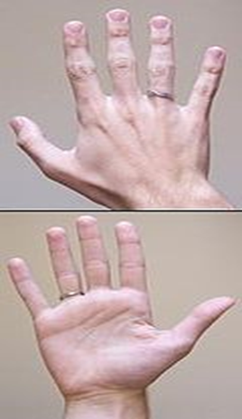

Fig 4.1 Natural ahand

**4.2 Mechatronic hand**

An “ideal” artificial hand should match the requirements of prosthetics and humanoid robotics.It can be wearable by the user which means that it can be perceived as part of the natural body and should replicate sensory-motor capabilities of the natural hand.This means that the artificial hand should be felt by the user as the part of his/her own body (extended physiological proprioception(EPP) ) and it should provide the user with the same functions of natural hand: tactile exploration, grasping , and manipulation ("cybernetic" prosthesis).

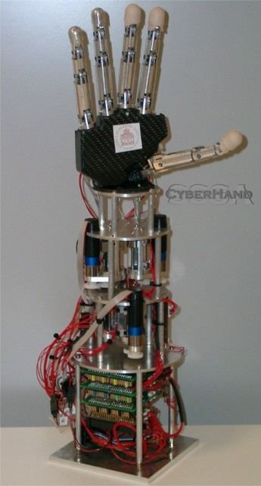

Fig 4.2 Mechatronic hand

**CHAPTER 5**

**DESIGN OF HAND PROTOTYPE**

In order to demonstrate the feasibility of the described biomechatronic approach,we have developed a three fingered hand prototype with two identical fingers (index and middle) and thumb. Actuators, position sensors and a 2-D force sensor are integrated in the hand structure.

The index/middle finger has been designed by reproducing, as closely as possible, the size and kinematics of a human finger. Each finger consists of three phalanges, and a palm needed to house the proximal actuator .

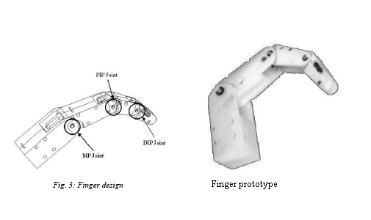

Fig 5.1 Finger prototype

**5.1 Actuator System Architecture**

In order to match the size of a human finger, two micro motors have been integrated within the palm housing and the proximal phalange of each finger. The selected micro motors are Smoovy (RMB, eckweg, CH) micro drivers (5mm diameter) high precision linear motion using lead screw transmission.

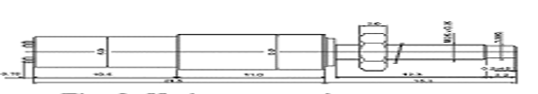

Fig 5.2 High precision linear actuator

The selected actuator fulfills almost all the specifications for application in the prosthetic finger: small size and low weight. The main problem encountered is related to noise which turns out to be relatively high, at least in the current implementation. Despite of this limitation, we decided to proceed with the application of the linear actuator in order to investigate integration problems and global performance. The shell housing provides mechanical resistance of the shaft to both axial and radial loads system. This is very important during grasping task, when the forces generated from the thumb opposition act bon the whole finger structure. Due to the high transmission rate (planetary Gears and lead screw transmission) friction is high and, thus, the joints are not back-drivable. This causes problem in controlling accurately in hand. However the positive side effect of friction is that the grasping forces can be exerted even when power supply is off, a very important function for hand prostheses.

**CHAPTER 6**

**POSITION AND FORCE SENSORS**

**6.1 Sensors**

Sensors are used as peripheral devices in robotics include both simple types such as limit switches and sophisticated type such as machine vision systems. Of course sensors are also used as integral components of the robots position feed back control system. Their function in a robotic work cell is to permit the robotic activities to be co-ordinate with other activities of the cell.

1) TACTILE SENSOR: These are sensors, which respond to contact forces with another object; some of these devices are capable of measuring the level of force involved.

2) PROXIMITY AND RANGE SENSOR: A proximity sensor that indicates when an object is close to another object but before contact has been made. When the distance between the objects can be sensed, the device is called a range sensor.

3) MISCELLANEOUS TYPES: The miscellaneous category includes the remaining kinds of sensors that are used in robotics.

4) MACHINE VISION: A machine vision system is capable of viewing the workspace and interpreting what it sees. These are used in robotics to perform inspection, part recognition and other similar tasks.

**6.2 Use Of Sensors In Robotics**

The major use of sensors in robotics and other automated manufacturing systems can be divided in to four basic categories.

1) Safety monitoring.

2) Inter locks in work cell control.

3) Part inspection for quality control.

4) Determining position and related information about objects in the robot cell.

**6.3 Position Sensors**

A position sensor, based on the Hall Effect sensor is mounted at each active joint of the hand. The main advantages of Hall Effect sensors are there small sizes and their contact less working principle. In each finger, the hall sensors are fixed, respectively, to the palm and to the proximal phalanxes, where as the magnets are mounted directly on the sliders of each joint. In this configuration the sensor measures the linear movement of the slider, which is related to the angular position of the joint. In each MP joint, the linear range of the sensor is 5.2mm, where as in the PIP joint the linear range is 8mm. Using a micrometric translator stage we found optimal configurations for the position sensors. In the first optimal configurations two magnets are used at a distance of 3.5 mm this configuration has a working range of 5.4mm with a linearity of 5.34%. The second optimal configuration (suitable for MP joints) has six magnets and a working range of 8.4mm with a linearity of 3.81%.

**CHAPTER 7**

**FINGERED TIP FORCE ANALYSIS**

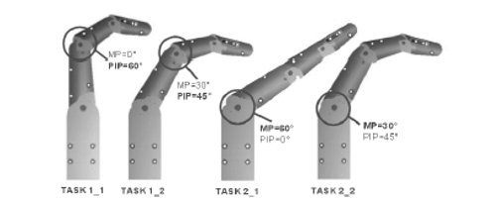

Fig 7.1 positioning of finger joints

A first set of experimental test has been performed in order to evaluate the force that the index /middle finger is able to exert on an external object. To this aim we are measuring the force resulting when the finger is pressing directly on the high accuracy piezo electric load cell corresponding to different configurations of the joints. Two “pressing “task were identified in order to evaluate separately and independently the force generated by actuators of the fingers.

TASK 1: The pushing action is exerted only by the distal actuator.

TASK 2: The pushing action is exerted only by the proximal actuator.

Then ten tests were performed for each subtask . The results obtained are illustrated in the fig.

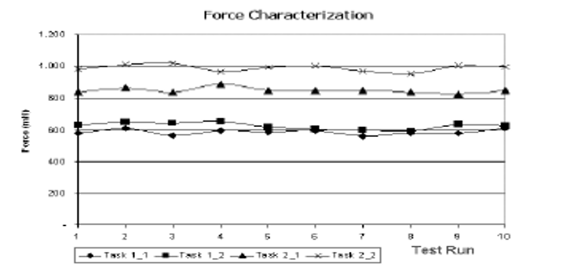

Fig 7.2 Experimental results

**CHAPTER 8**

**ADVANTAGES AND DISADVANATAGES**

**8.1 ADVANTAGES**

Production of parts and products of international standards gives better reputation and return.

It serves effectively for high dimensional accuracy requirements.

It provides high degree of flexibility to modify or redesign the systems.

It provides excellent performance characteristics.

Mechatronic systems provide the increased productivity in manufacturing organization.

Reconfiguration feature by pre supplied programs facilitate the low volume production.

It provides the possibility of remote controlling as well as centralized monitoring and control..

Higher life is expected by proper maintenance and timely diagnosis of the fault.

**8.2 DISADVANTAGES**

The initial cost is high.

Maintenance and repair may workout costly.

Multi-disciplinary engineering background is required to design and implementation.

It needs highly trained workers to operate.

Techno-economic estimation has to be done carefully in the selection of mechatronic system.

It has complexity in identification and correction of problems in the systems.

**CHAPTER 9**

**FUTURISTIC ASPECTS**

• University of Michigan: Human Neuromechanics Laboratory Faculty and students at the Human Neuromechanics Laboratory are building powered lower limb exoskeletons for basic science research and for assisting gait rehabilitation after spinal cord injury

• University of California, Berkeley: Robotics Laboratory In collaboration with a number of other universities and companies, the Berkeley Robotics Laboratory is building a portable lower limb exoskeleton for carrying heavy loads.

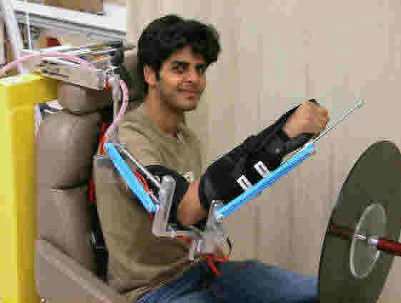

Fig 9.1 portable arm movement training

• University of California, Irvine: Biomechatronics Laboratory This lab, part of the Department of Mechanical and Aerospace Engineering, addresses the needs of persons with movement impairments by incorporating biomechanics, neuro-computation, and human physiology. Some of the current projects involve arm movement training after stroke and robot-assisted locomotor training

• University of Washington: Neurobotics Laboratory The Neurobotics Laboratory builds exoskeletons to rehabilitate, assist, and enhance human motor control and learning capabilities. The lab recently moved from Carnegie Mellon University to University of Washington.

• Rice University: Mechatronics and Haptic Interfaces Laboratory Marcia O'Malley and her lab have developed a force-feedback arm exoskeleton for training and rehabilitation. It was an training algorithm that adjusts to unique needs of each individual

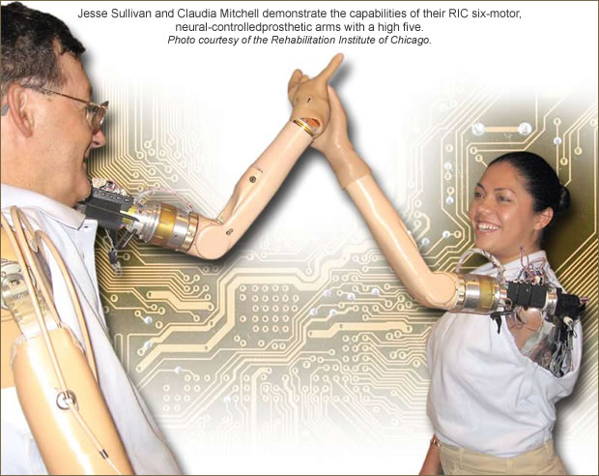

Fig 9.2 sensory motor performance

• Rehabilitation Institute of Chicago (RIC) RIC has many active research projects related to robotics and exoskeletons. Much of research is conducted in the Sensory Motor Performance Program. One important project combined robotics and neural engineering to create “The World’s First Bionic Man”

**CHAPTER 10**

**CONCLUSION**

The biomechatronic design consists of integrating multiple DOF’S finger mechanisms, multisensing capabilities and distributed control inorder to obtain human like appearance, simple and direct controllability and low mass. Implementing a neural of the hand by means of interfaces implanted at peripheral nerves of the amputee is very challenging. This goal could ultimately lead to the development of a truly cybernetic hand, controlled and received by the amputee almost at his/her own lost hand and, therefore, a real potential alternative to hand transplantation

**CHAPTER 11**

**REFERNCE**

1. Brooker, Graham (2012). Introduction to Biomechatronics. University of Sydney, Australia. [*ISBN*](https://en.wikipedia.org/wiki/ISBN_(identifier)) [*978-1-891121-27-2*](https://en.wikipedia.org/wiki/Special:BookSources/978-1-891121-27-2).

2. ^ [Jump up to:*a*](https://en.wikipedia.org/wiki/Biomechatronics#cite_ref-How_Biomechatronics_Works_2-0) [*b*](https://en.wikipedia.org/wiki/Biomechatronics#cite_ref-How_Biomechatronics_Works_2-1) Craig Freudenrich. [*"How Biomechatronics Works"*](http://science.howstuffworks.com/biomechatronics4.htm). HowStuffWorks*. Retrieved July 29, 2016*.

3. [^](https://en.wikipedia.org/wiki/Biomechatronics#cite_ref-3) [*"Touch Bionics"*](http://www.touchbionics.com/about/history)*. Retrieved July 29, 2016*.

4. [^](https://en.wikipedia.org/wiki/Biomechatronics#cite_ref-4) Shaer, Matthew (November 2014). [*"Is This the Future of Robotic Legs?"*](http://www.smithsonianmag.com/innovation/future-robotic-legs-180953040/?no-ist=&preview=&page=1). Smithsonian Magazine.

5. [^](https://en.wikipedia.org/wiki/Biomechatronics#cite_ref-5) [*"Researchers improve efficiency of human walking"*](https://www.nsf.gov/news/news_summ.jsp?cntn_id=134667) (Press Release). NSF*. Retrieved July 29, 2016*.

[6. Biomechatronics – MIT Media Lab](https://biomech.media.mit.edu/)

7. [Biomechatronics Development Lab - Rehabilitation Institute of Chicago (archive.org)](https://web.archive.org/web/20080725091848/http:/www.ric.org/research/centers/smpp/labs/biomechdev/Biomechatronics.aspx)