Embeddings

# 6. Unsupervised learning

Supervised learning

* What is the conditional distribution of $Y|X$?
* How do I build a predictor / classifier?
* Appropriate plots: line plots, box plots, …

Generative (unsupervised( learning

* What is the joint distribution of $(X,Y)$?
* How do I synthesize new datapoints?
* Appropriate plots: scatter / dot plots, histograms, splom, …

# 7. Dimension reduction

## **PCA**

In linear regression (**supervised learning**), we model the data by

$$y_{i}=α x_{i}+β+ε_{i}$$

and choose the parameters $α$ and $β$ to minimize

$$L\left(α,β\right)=\frac{1}{2}\sum_{i=1}^{n}{ε_{i}^{2}}$$

In 1-dimensional PCA (**unsupervised learning**), we model the data by

$$\left(\begin{matrix}x_{i} \\ y_{i}\end{matrix}\right)=\left(\begin{matrix}μ_{x} \\ μ_{y}\end{matrix}\right)+λ_{i}\left(\begin{matrix}δ_{x} \\ δ_{y}\end{matrix}\right)+\left(\begin{matrix}ε_{x,i} \\ ε_{y,i}\end{matrix}\right)$$

and choose the parameters $μ$ and $δ$ to minimize

$$L\left(μ,δ\right)=\frac{1}{2}\sum_{i=1}^{n}{{\left\|\left(\begin{matrix}ε_{x,i} \\ ε_{y,i}\end{matrix}\right)\right\|}^{2}}$$

More generally, we model $N$-dimensional data by picking a $K$-dimensional subspace, and representing each point by its projection onto that subspace,

$${\vec{x}}_{i}=\vec{μ}+\sum_{k=1}^{K}{λ_{k,i} {\vec{δ}}_{k}}+{\vec{ε}}_{i}$$

Magic linear algebra trick:

* the optimal subspaces are nested, $S_{1}⊂S_{2}⊂⋯⊂S_{N}$
* so the sensible choice is to let ${\vec{δ}}_{k}$ be an ordered basis, $S_{1}=\text{span}({\vec{δ}}_{1})$, $S_{2}=\text{span}({\vec{δ}}_{1},{\vec{δ}}_{2})$...

X = countries[features].values

pca = sklearn.decomposition.PCA()

pca_result = pca.fit_transform(X)

μ = pca.mean_

pred = μ + np.zeros_like(pca_result)

for k in range(L): # L = number of PCA components to use

λk = pca_result[:,k]

δk = pca.components_[k]

pred = pred + λk.reshape((-1,1)) * δk.reshape((1,-1))

## **tSNE is more suitable for non-linear dimension reduction**

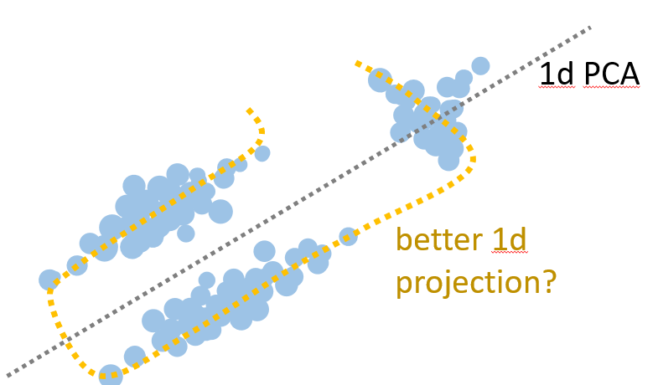 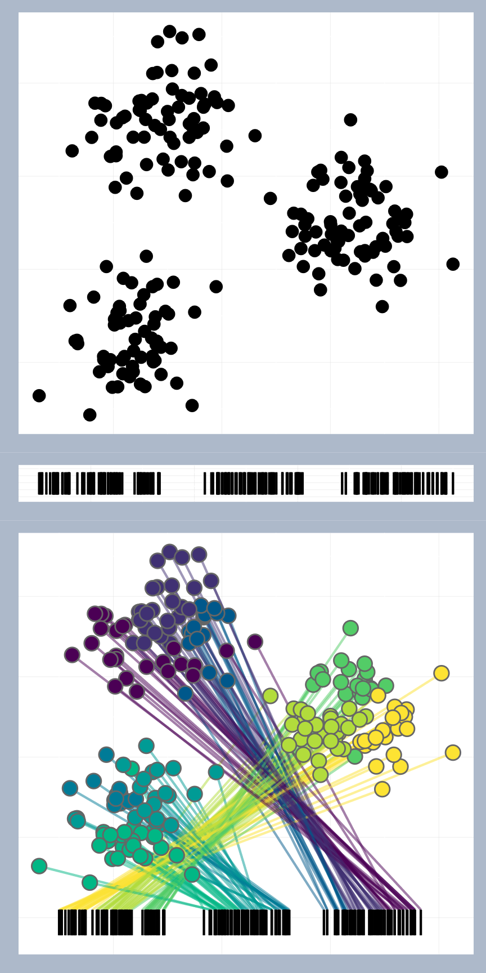

* tSNE finds a low-dimensional representation based on “make it so that the top- $P$ neighbours of a point in the low-dimensional space match its top- $P$ neighbours in the high-dimensional data space”. The hyperparameter $P$ is called *perplexity*.

X = countries[features].values

# scale the columns, so they have the same variance

for k in range(len(features)):

X[:,k] = X[:,k] / np.std(X[:,k])

# K = number of dimensions to reduce to

tsne = sklearn.manifold.TSNE(n_components=K)

tsne_results = tsne.fit_transform(X)

# K=2 is nice for plotting

p1,p2 = tsne_results[:,0], tsne_results[:,1]

plt.scatter(p1, p2, alpha=.2)

## **Uses for dimension reduction**

* Split the data into qualitatively different test and validation subsets, so that validation gives a better test of generalization error
* Take a categorical feature with 100s of values, one-hot encode it to give 100s of features, dimension-reduce to a few features, and perhaps your ML system will run faster

# 8. Self-supervised learning / embedding

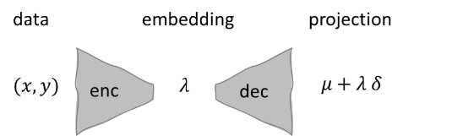

* Don’t think of PCA and tSNE as “tools I can run on a dataset to reduce its dimension”
* Think of them as “learning an encoder (embedding function) and a decoder (reconstruction function), from a training dataset”. The encoder and decoder can be applied to *new unseen* *datapoints*.
* This is useful for semi-supervised learning, and for other interpolation / extrapolation / interpretation questions.

# 9. Content scales

* Any nominal or ordinal scale can (and should) be embedded, based on whatever content we’re interested in.
* We don’t need a formal mathematical embedding – an embedding is really “any order that will help the viewer”.
* Examples
  + Embed a Likert 5-point scale (“strongly agree” … “strongly disagree”) into real numbers in $[0,1]$ based on frequency of responses.
  + Embed students onto a 1d scale based on clustering proximity, to more easily see patterns in turn-it-in similarity scores

# Next steps

* Style… Tufte, The visual display of quantitative information.
* How to tell a story… Berinato, *Good Charts*
* Software libraries… ggplot2 is unrivalled, and it’s not too hard to use it from Python.