Algae on Earth

Team Name: Flamexx
Chosen Theme: Life on Earth
Organisation Name: Action Kids
Country: Romania

Introduction
Our team wanted to investigate the distribution of the algae on the planet and the impact of pollution and other natural and man-made phenomena on them. We expected to find the differences between polluted and natural areas, but we were divided on what would cause more algae growth. We were concerned about how big man’s impact on Earth was, so we decided to investigate.

Method
We used the infrared camera from the Astro-Pi to capture images of the Earth during day time. To analyse the results on Earth we used the NDVI algorithm, we manually enhanced the contrast of the images to improve the visibility of the algae and we made a tool using Godot to easily measure the areas of algae. After this we collected the data, including the area covered by algae, the type of terrain, coordinates, water depth, and the levels of different types of pollution in a spreadsheet. Our team used data from gemstat.org and https://knb.ecoinformatics.org/view/doi:10.5063/F1S180FS . We also used QGIS to visualise the levels of pollution in different areas.
Normal Image | NDVI Image | Contrast Enhanced Image
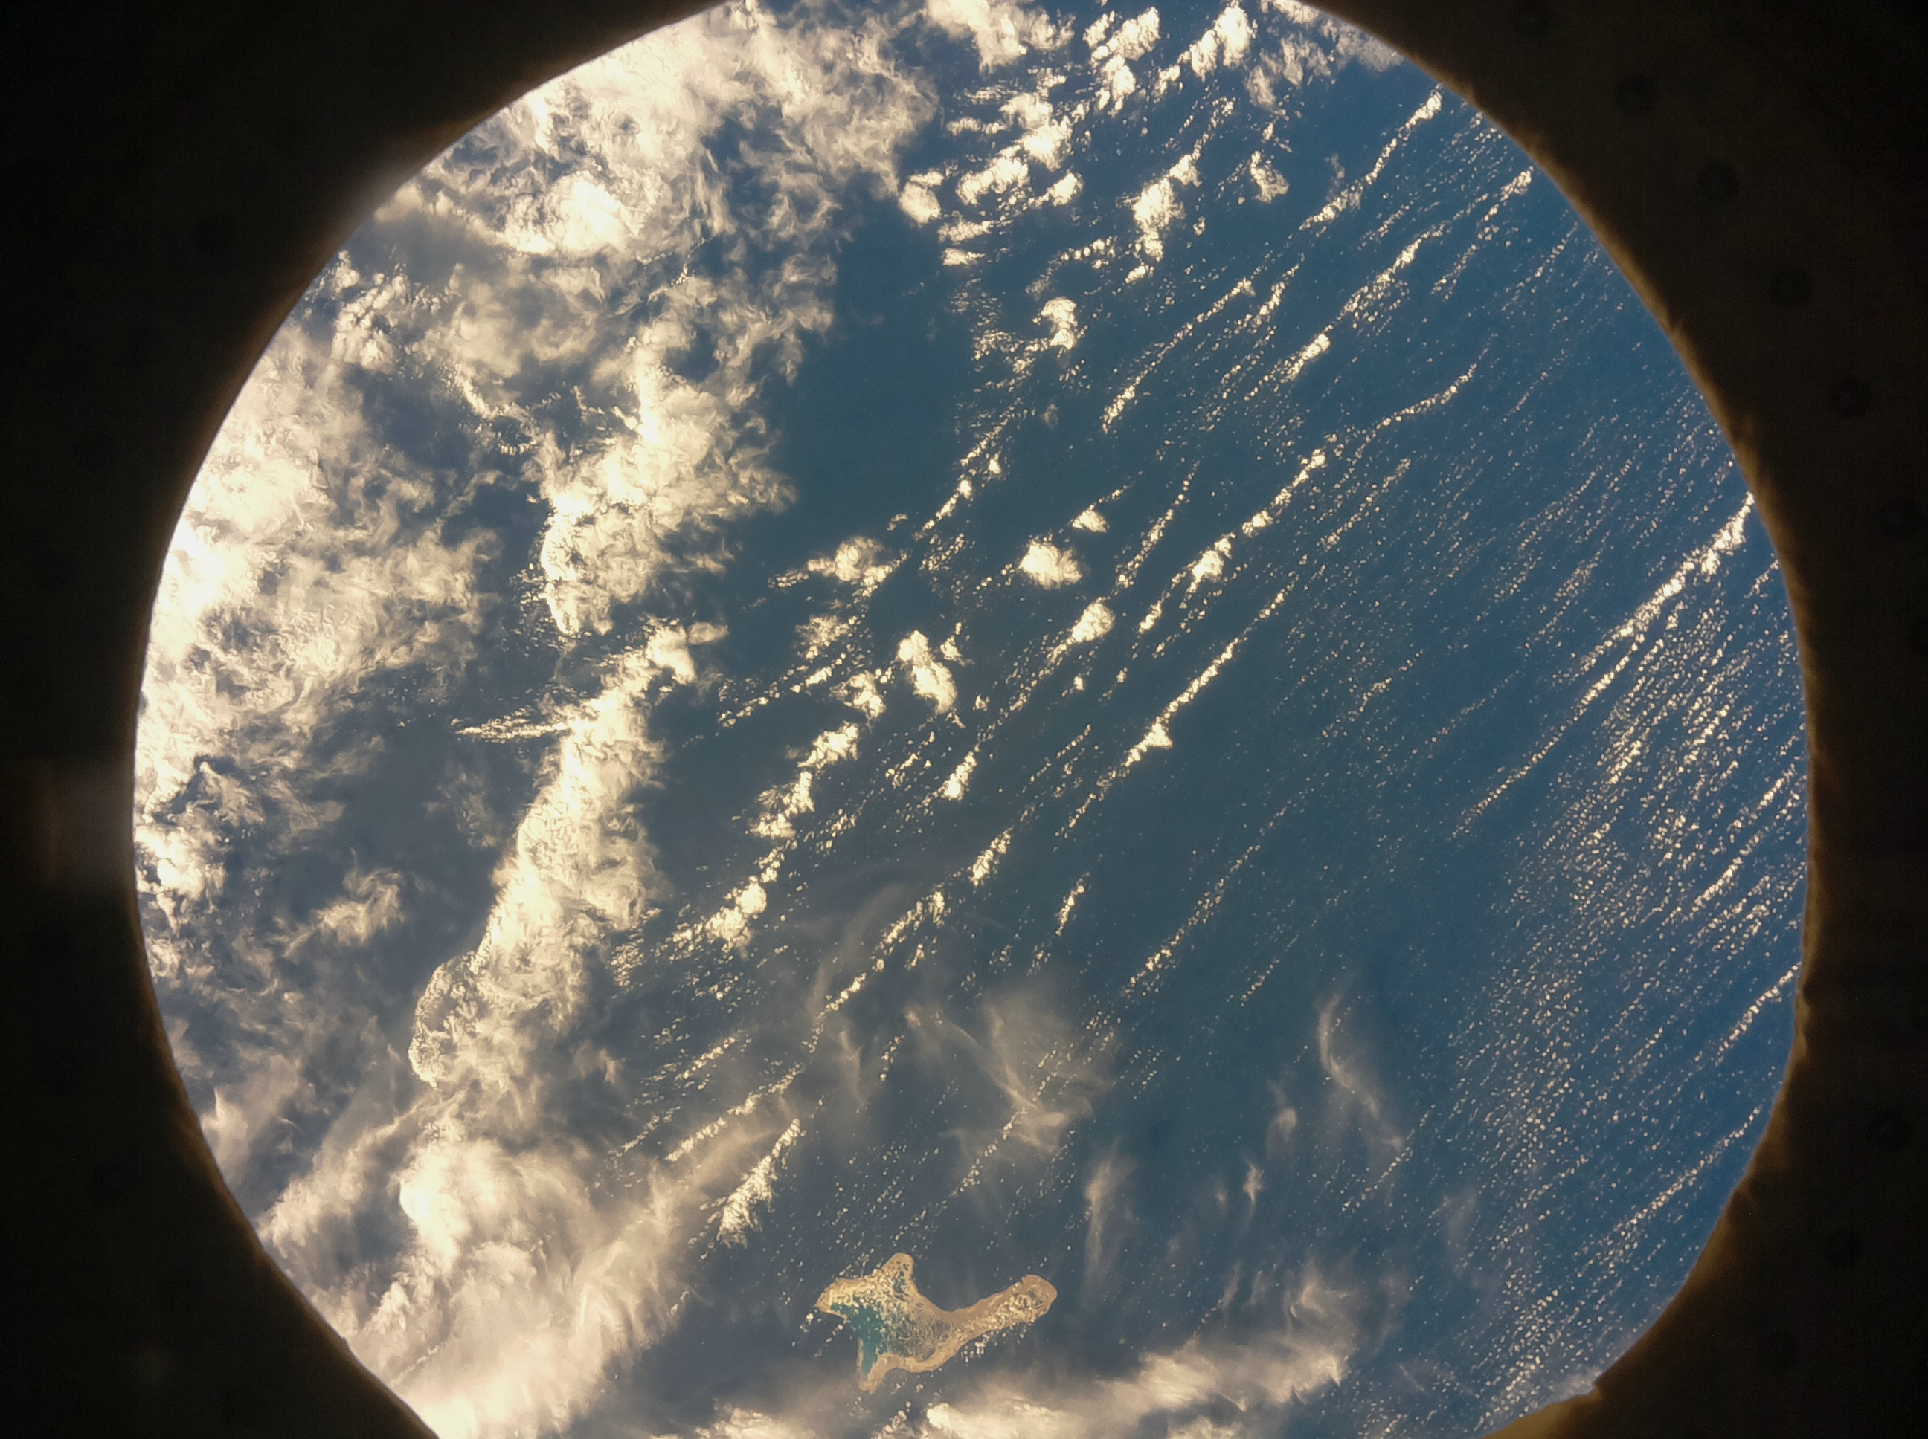 | 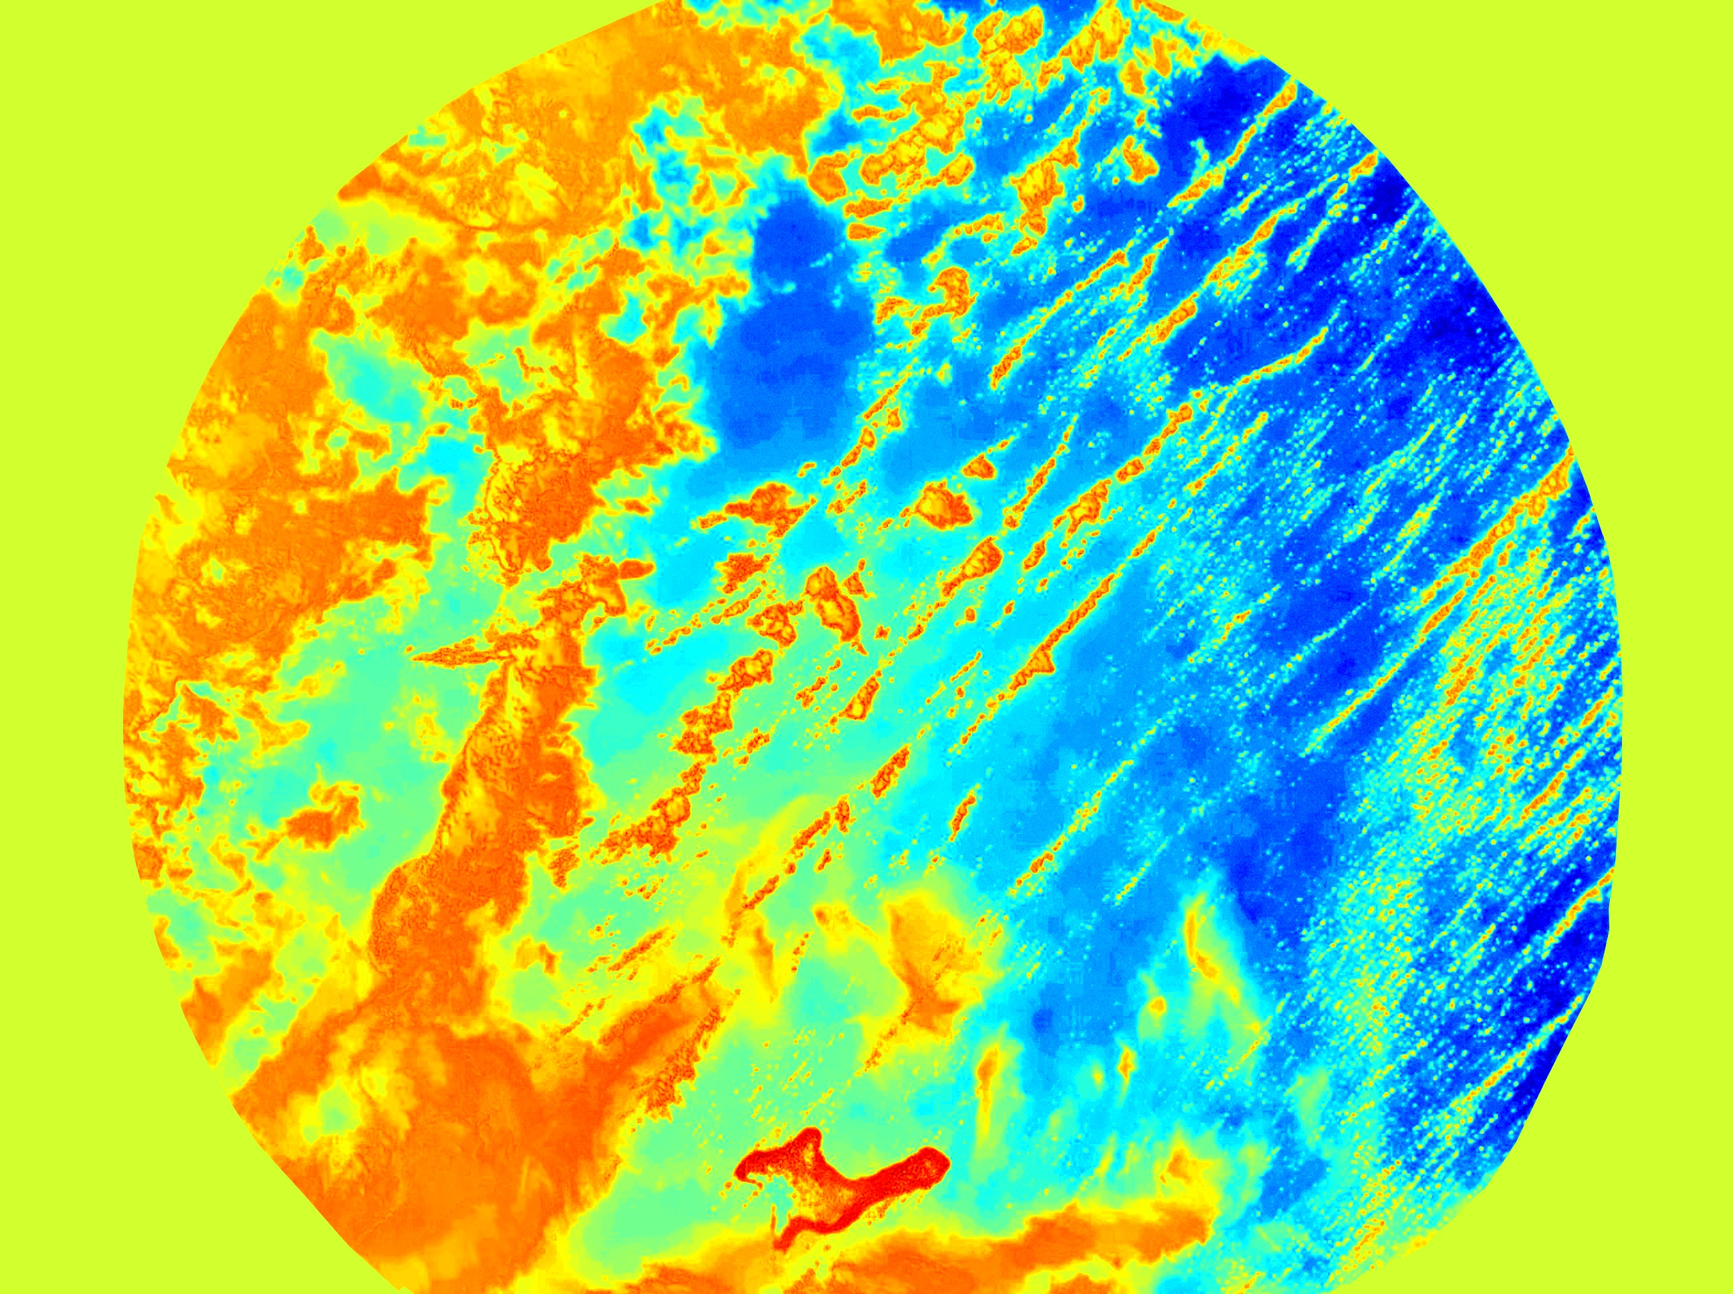 | 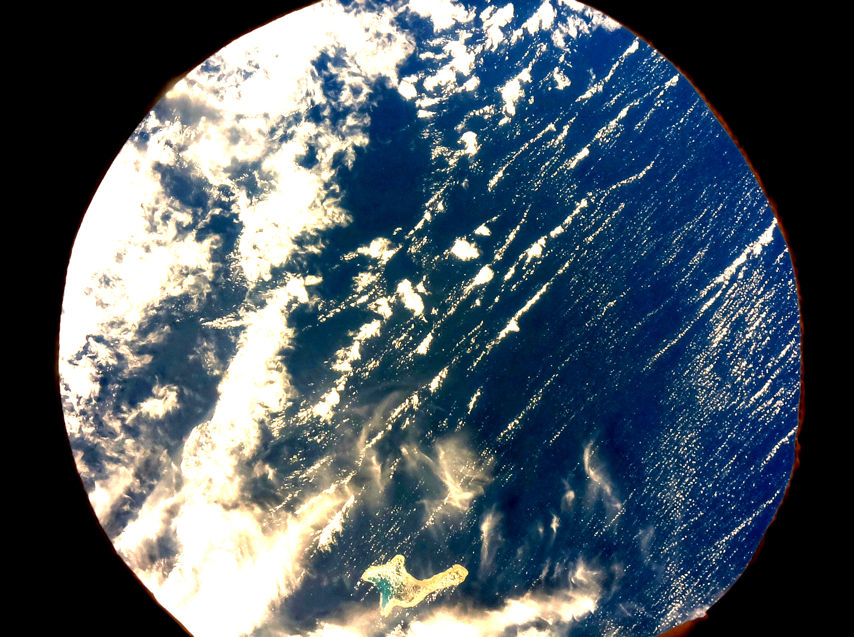

Results
Based on the collected data, we have reached the conclusions that algae are affected by a multitude of natural and man-made factors.
- Polluted areas have more algae than natural areas. Coastal areas have more algae and deep water areas have less. We are not sure why but we suppose it is due to:
  - shallow water
  - river deposits
  - increased pollution near the shore
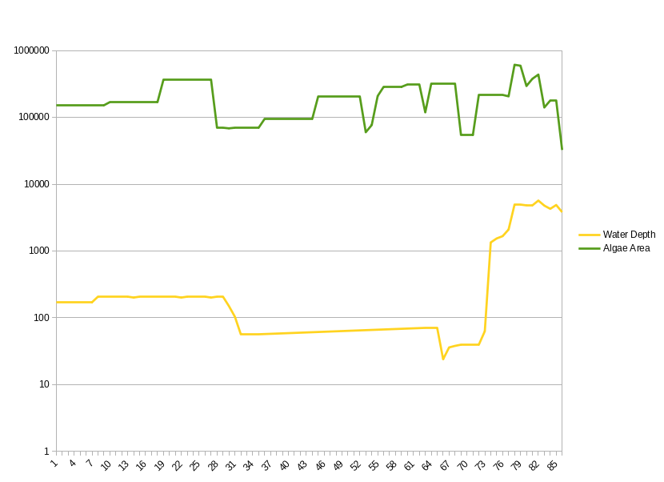 | 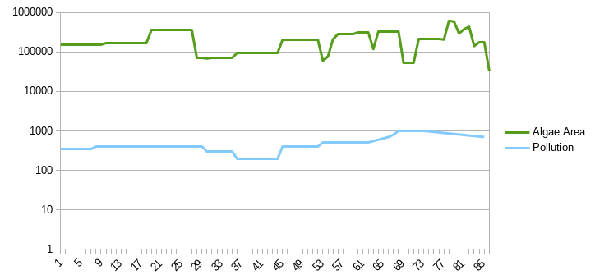
Graph of algae area in picture relative to water depth | Graph of algae area in picture relative to pollution

- Relative to their area, lakes contain more algae than oceans, especially the salt water lakes. Saltwater lakes contain more algae than freshwater lakes.
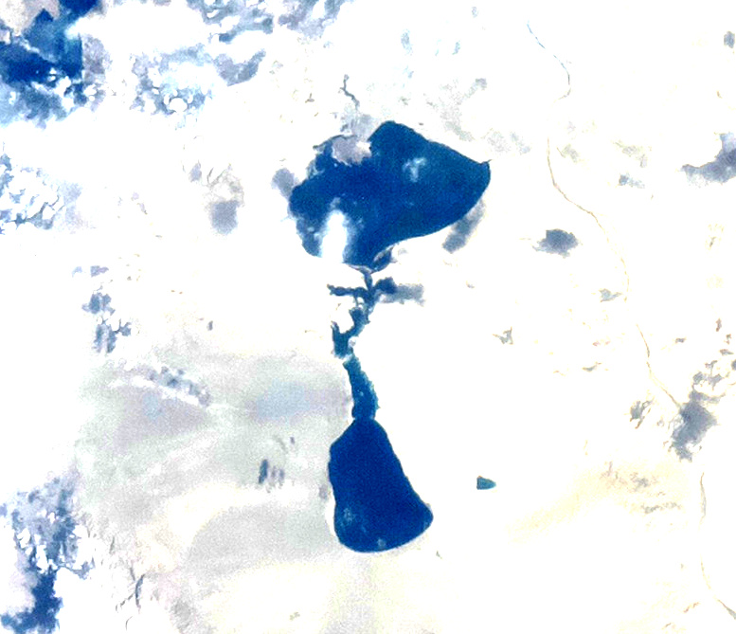
Contrast enhanced image of Lake Khar in Mongolia

- Our team saw that algae are not particularly visible when using the NDVI algorithm because NDVI detects things that reflect infrared and absorb blue; water reflects blue light, so algae can not be detected through NDVI.
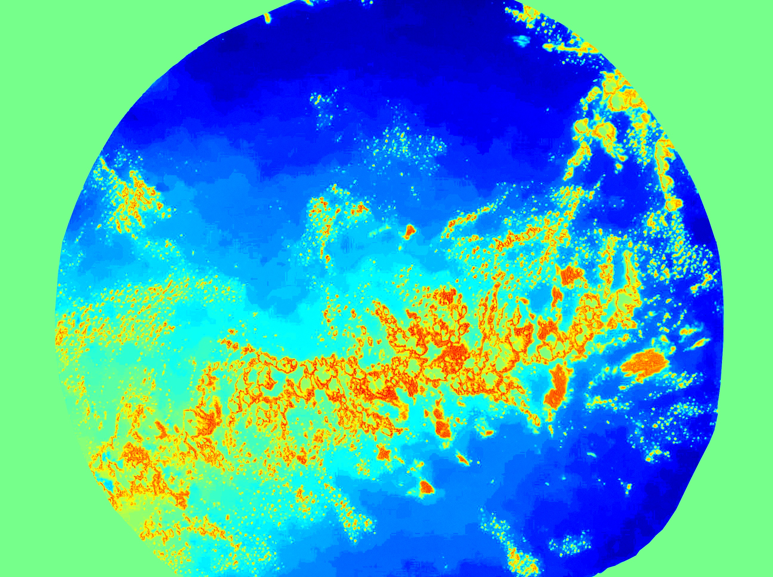 | 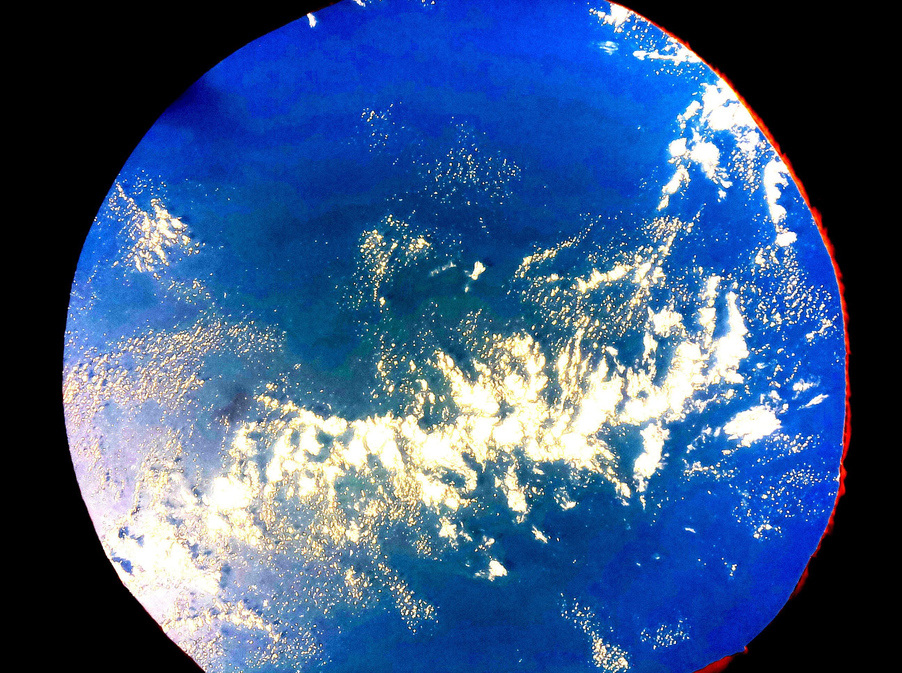
NDVI Image compared to Contrast Enhanced Image

- According to the graph below, we can see the the latitude does not seem to affect algae growth.
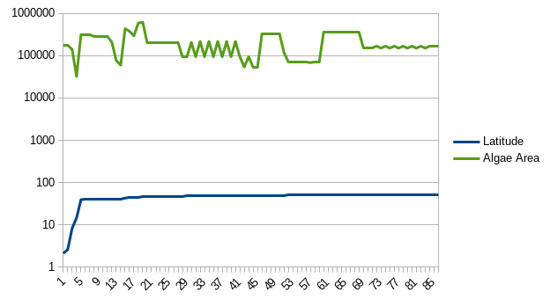
Graph of algae area in picture relative to latitude.

- We were surprised to see, among the last pictures, that we captured images of the Tuamotu Islands. They are not fully visible but the parts we saw were filled with algae.
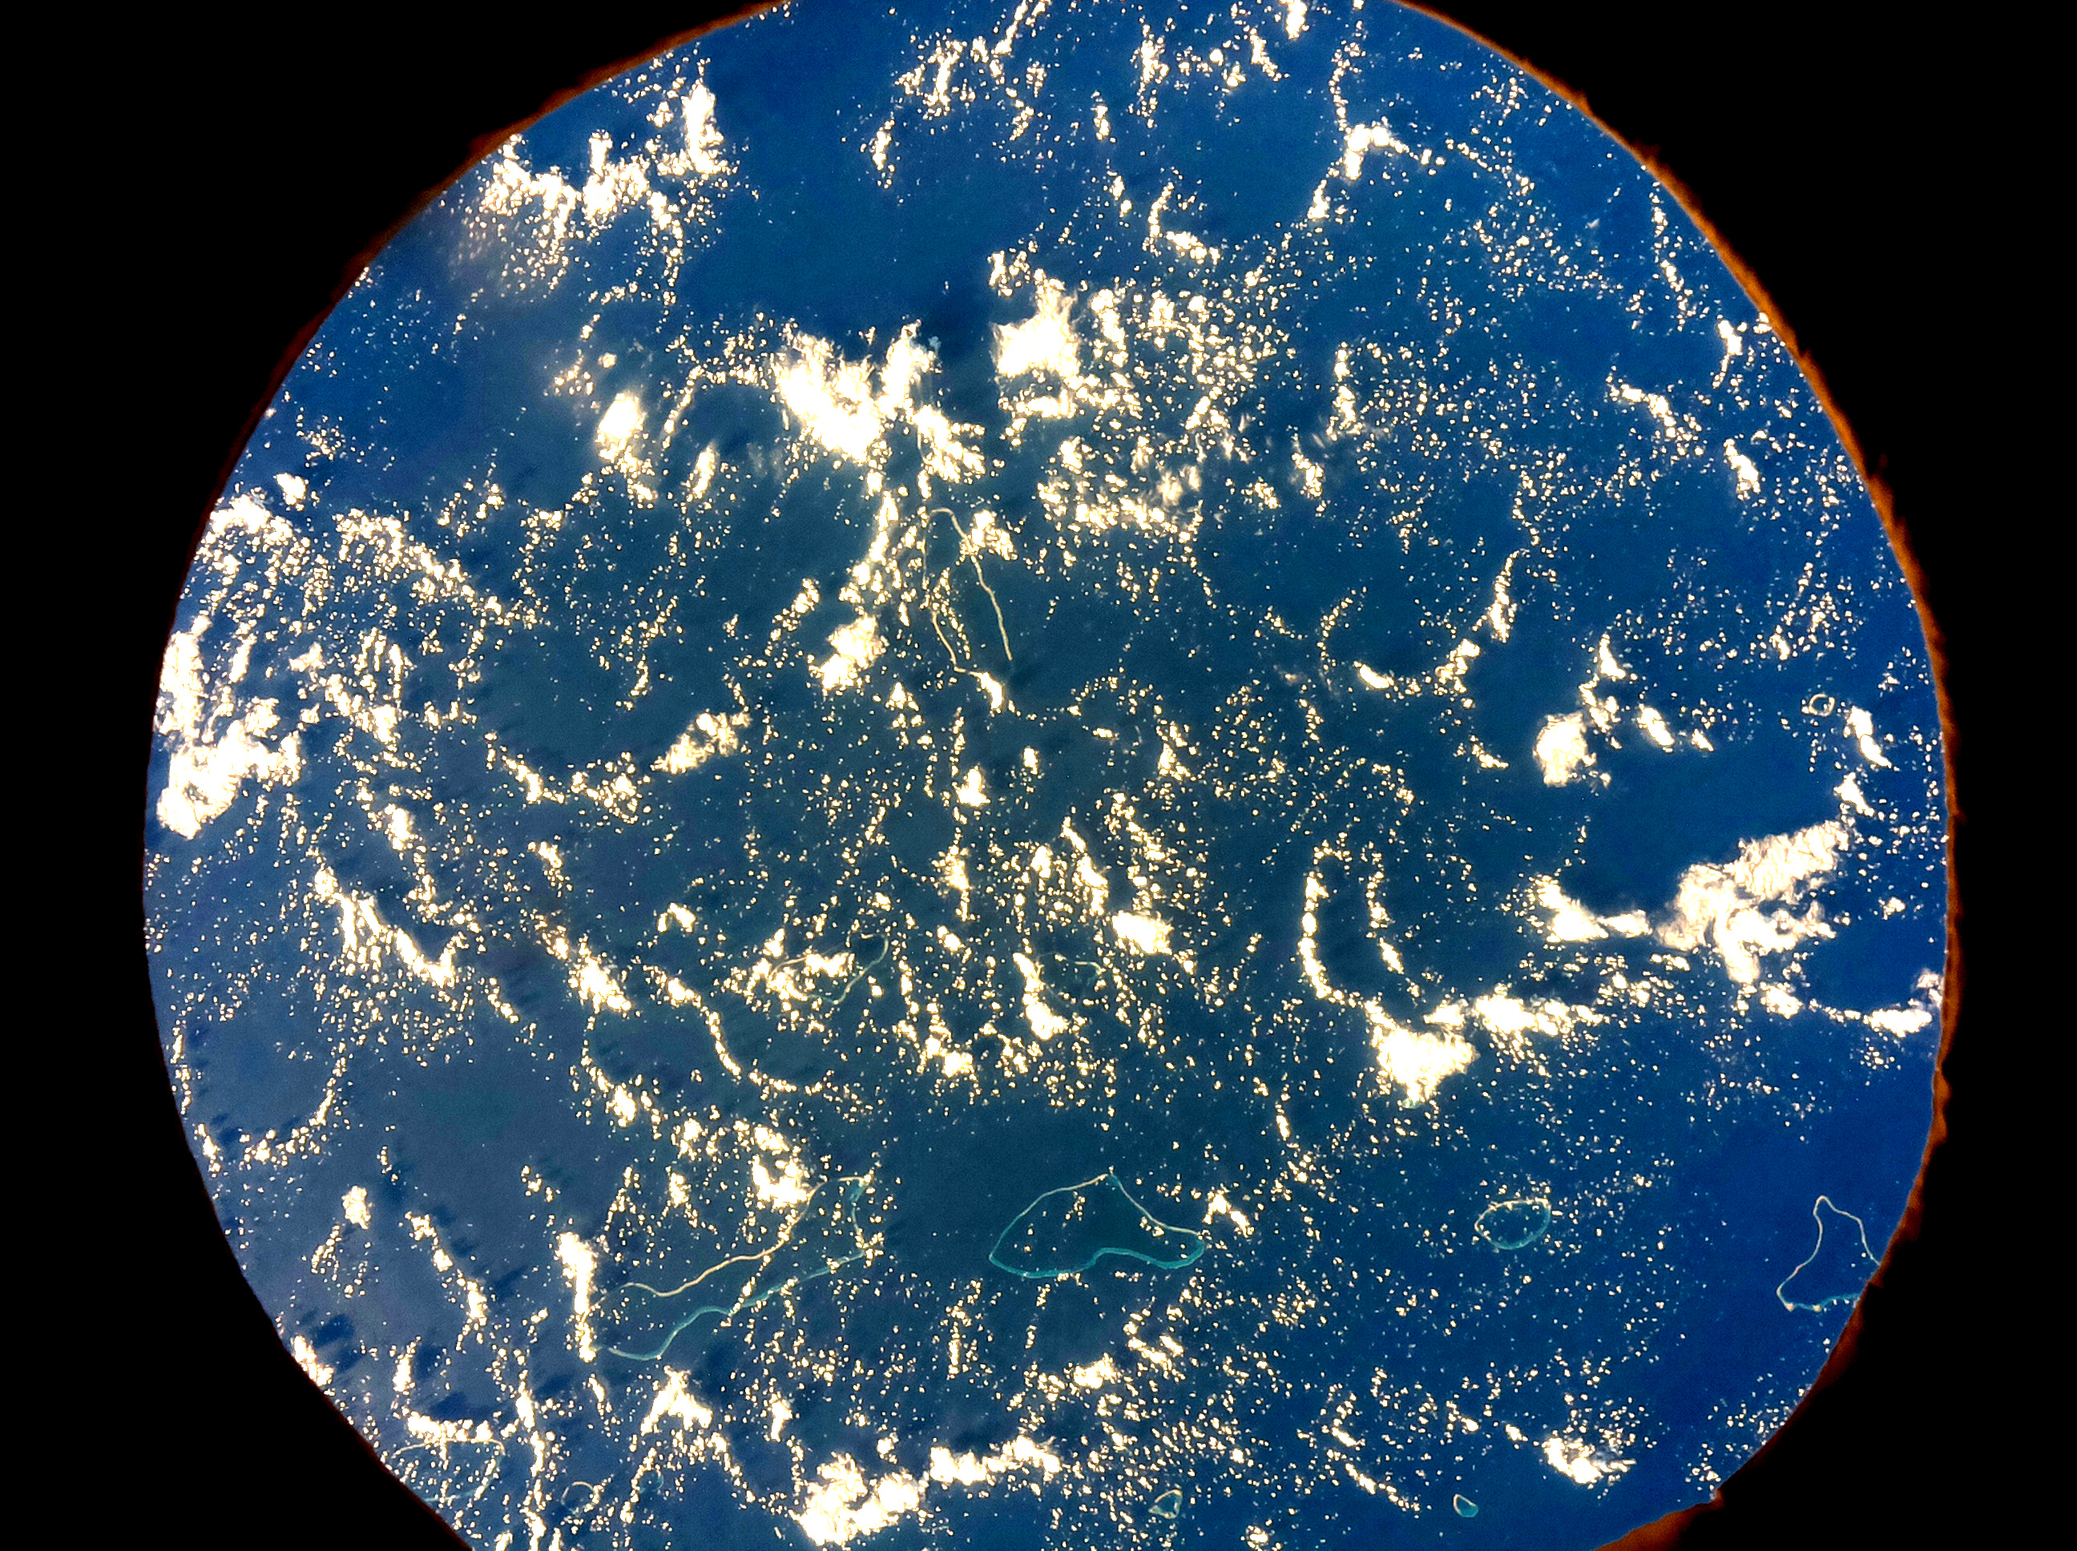
Tuamotu Islands

Conclusion
By analysing the data we received, we managed to answer our main questions about algae. Intrigued by our discovery that saltwater lakes contain more algae than freshwater lakes, our team researched and found out that in the saltwater lakes of China there is little aquatic life so that means that algae is one of the few organisms to grow there. Our discovery that latitude does not affect algae growth suggest the fact that algae are very resilient organisms not easily affected by temperature and other factors.

