RoVino Inventory Management System

Small database-backed web application built to manage wine and bar inventory.
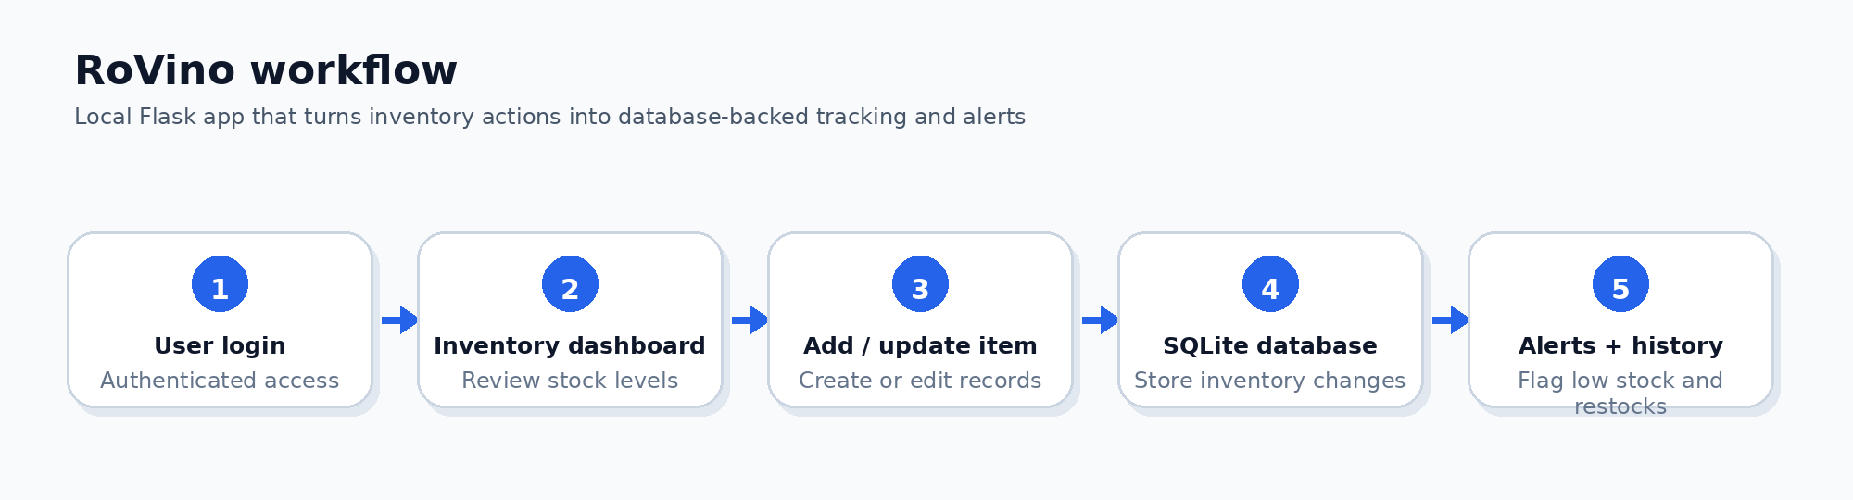

This artifact is meant to show the website itself: the screens, workflow logic, and data organization choices behind the project.
Project Type | Built With | Core Workflows | Portfolio Signal
Independent web-app project | Python, Flask, SQLite, SQL, HTML/CSS, Bootstrap | Login, dashboard, search, item add/update, low-stock alerts, restock history | Structured records, practical database logic, and workflow organization relevant to data-support and lab operations

What the Screens Demonstrate
- A user-facing inventory dashboard with categories, search, item records, low-stock labels, and edit/delete/restock actions.
- A structured add-item workflow that captures category-specific details, initial quantity, price, alert threshold, and storage location.
- An update-item flow for maintaining records over time instead of treating the inventory as a static list.
- A restock-history view that preserves dated activity and supports repeatable restocking actions.

Website Screenshots
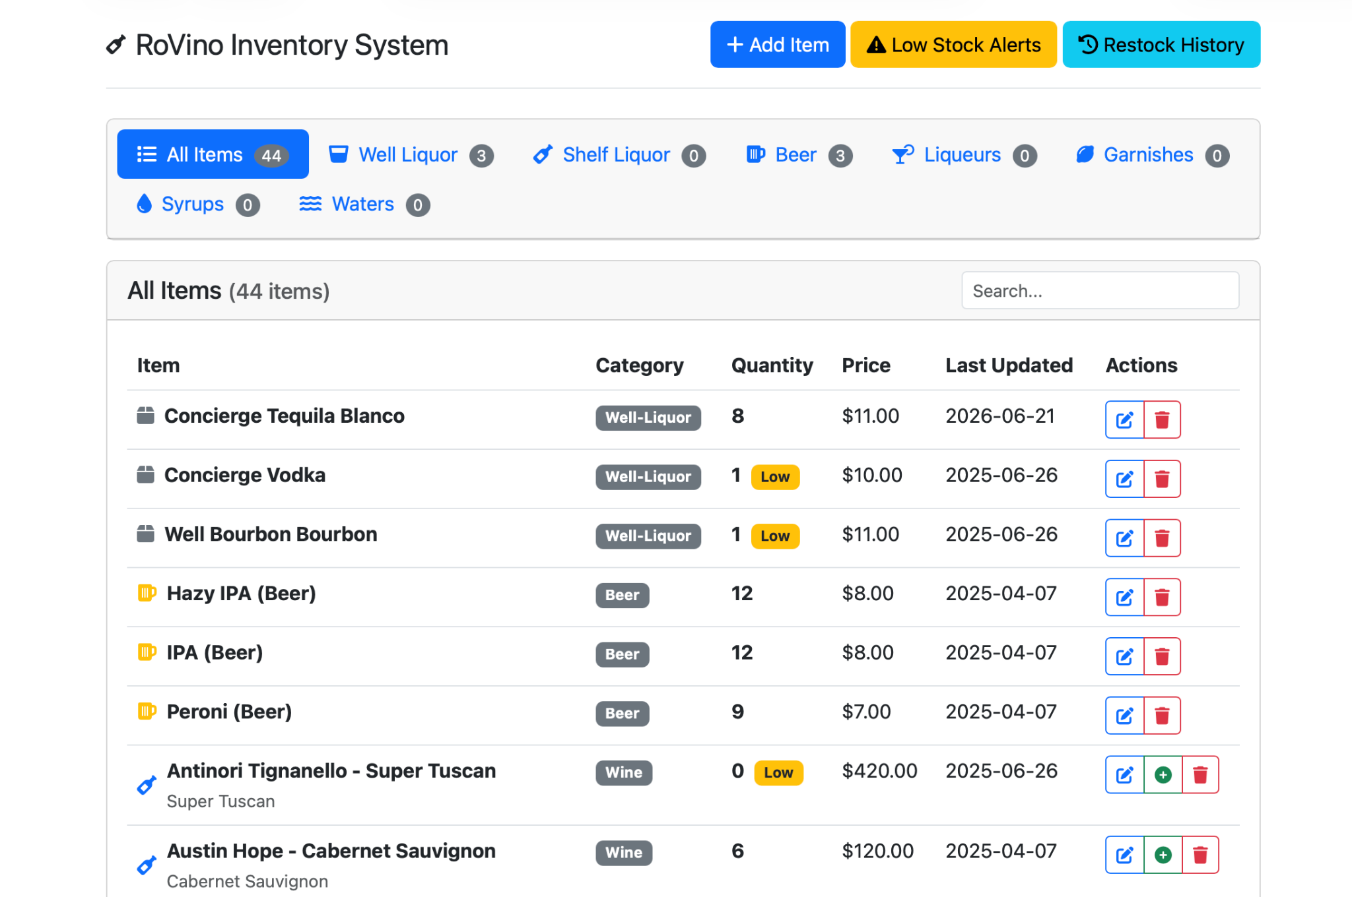
Inventory dashboard: category filtering, searchable records, low-stock labels, and item-level actions.

Login and Access-Control Screen
The login screen shows the project includes an access-control layer rather than exposing the inventory dashboard directly.
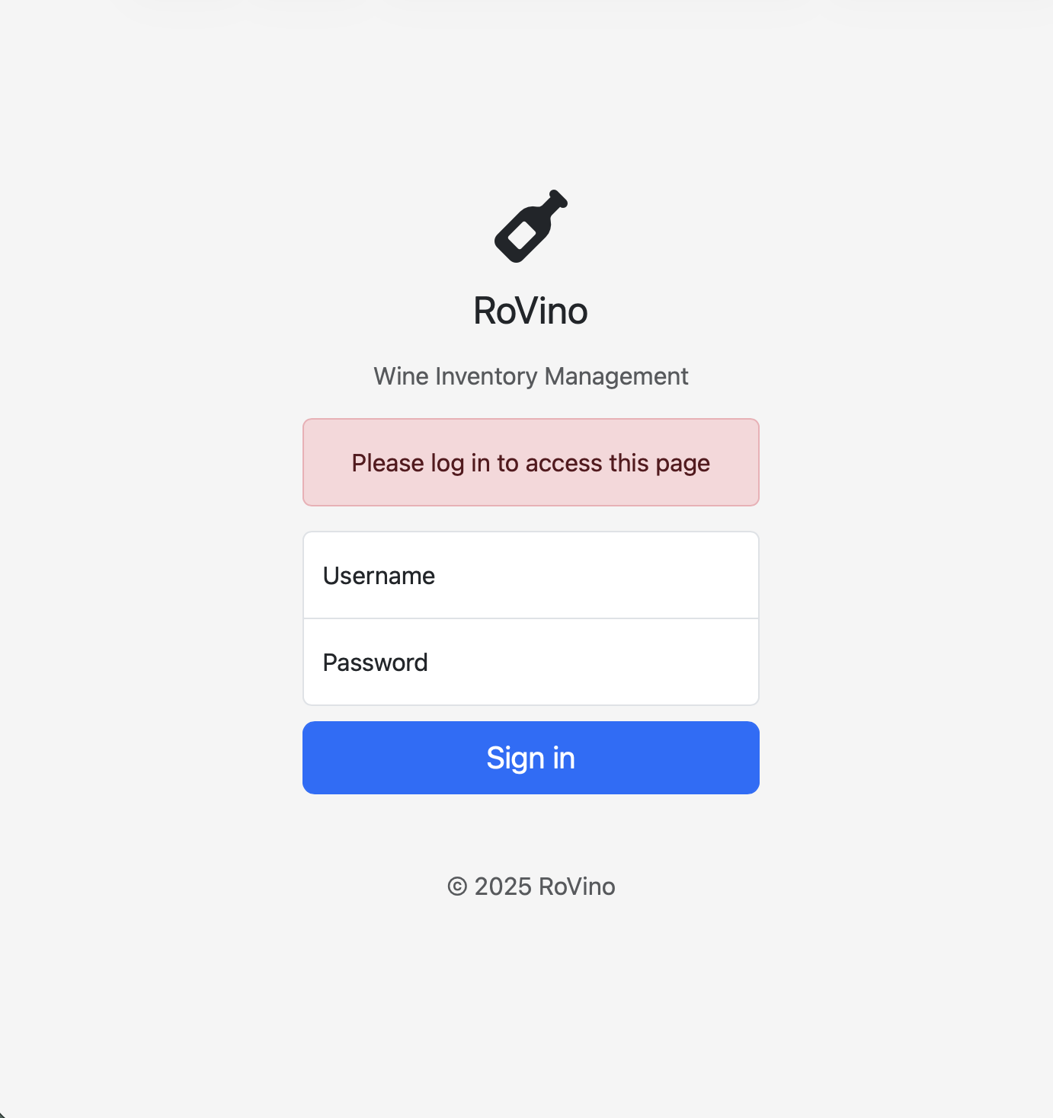
Login screen: basic authentication concept for controlled access to inventory records.

Add-Item Workflow
The add-item screen shows how new inventory records are entered with category selection, required fields, quantity, pricing, and alert thresholds.
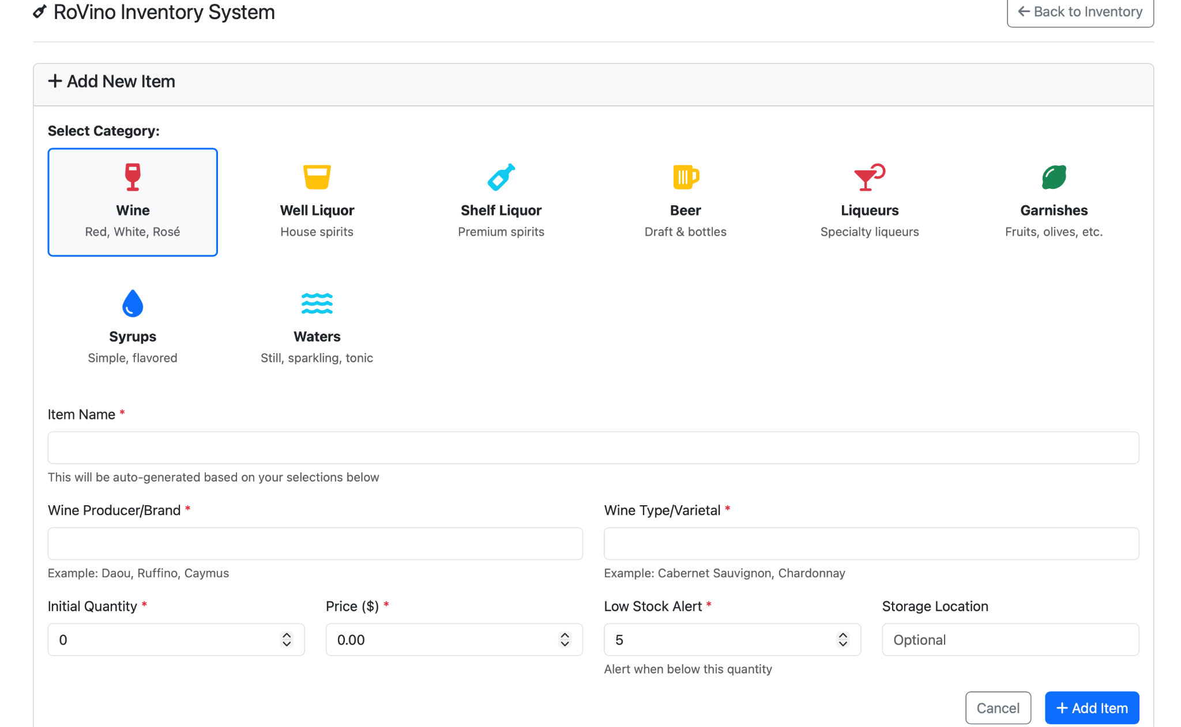
Add-item workflow: structured data entry with category-specific fields and low-stock threshold setup.

Update and Maintenance Workflow
The update screen shows that inventory records can be corrected and maintained after entry, which is essential for any tracking system that changes over time.
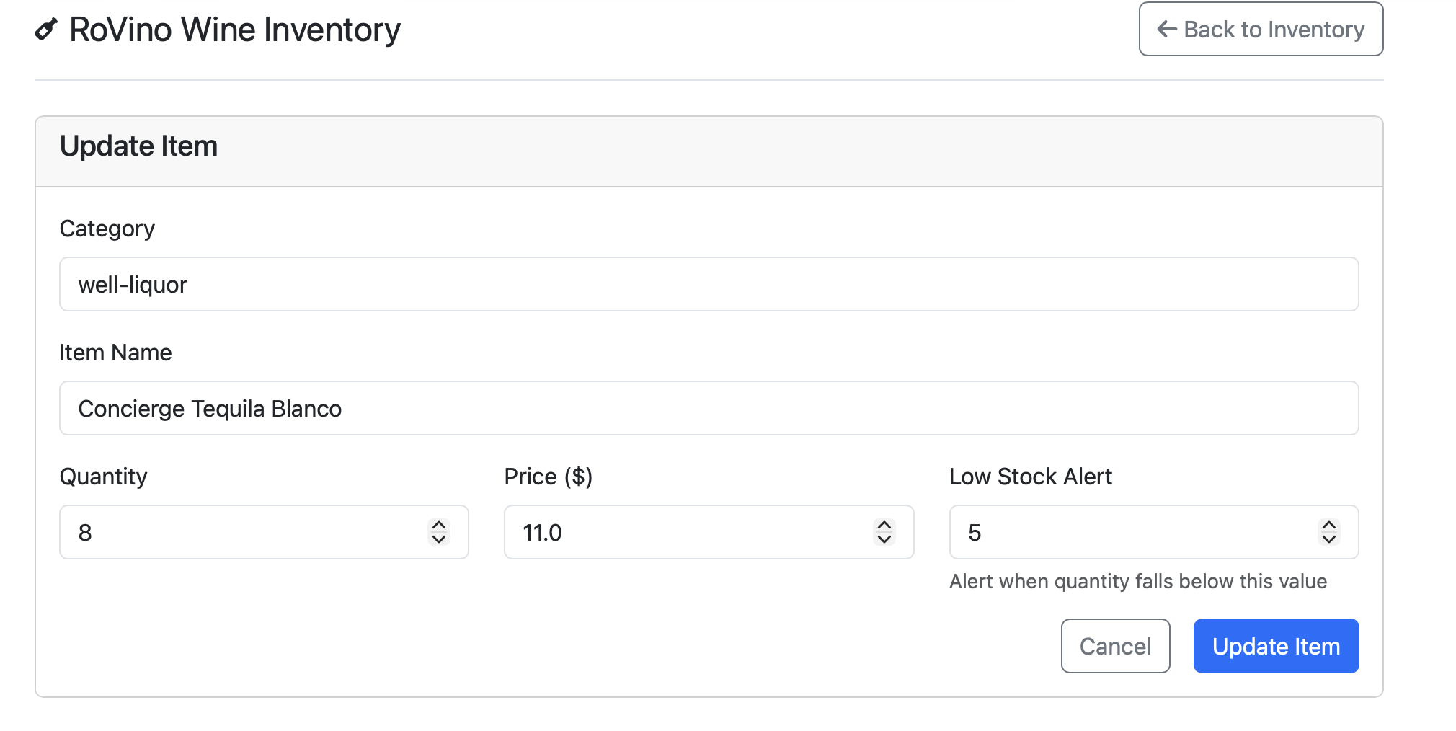
Update-item workflow: edit existing records while preserving the overall inventory structure.

Restock History
The restock-history screen shows a separate activity view for prior restocking events, including date, item, type, quantity, and a repeat-restock action.
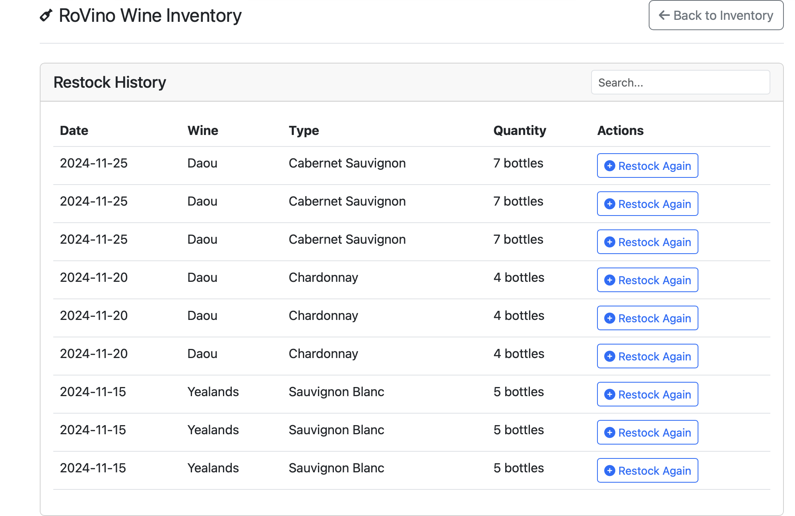
Restock history: dated activity records and repeatable restock actions.

