“TRAILBLAZER”
Project Report

Submitted as partial fulfilment of the project requirements for the degree

of

BACHELOR OF TECHNOLOGY
in
COMPUTER SCIENCE AND ENGINEERING



RGUKT
Rajiv Gandhi University of Knowledge Technologies
R.K.VALLEY

Submitted by

E Jahnavi – R170415

Under the Esteemed guidance of
Ms. Sravani V
RGUKT RK Valley.

1
DECLARATION

We hereby declare that the report of the B.Tech Major Project Work entitled “TRAILBLAZER” which is being submitted to Rajiv Gandhi University of Knowledge Techonologies, RK Valley, in partial fulfillment of the requirements for the award of Degree of Bachelor of Technology in Computer Science and Engineering, is a bonafide report of the work carried out by us. The material contained in this report has not been submitted to any university or institution for award of any degree.

E.Jahnavi – R170415
Dept. Of Computer Science and Engineering

2

RAJIV GANDHI UNIVERSITY OF KNOWLEDGE TECHNOLOGIES

RGUKT

(A.P. Government Act 18 of 2008)
RGUKT, RK VALLEY

Department of Computer Science and Engineering

CERTIFICATE FOR PROJECT COMPLETION

This is to certify that project entitled “TRAILBLAZER” submitted by E.Jahnavi (R170415) under our guidance and supervision for the partial fulfillment for the degree Bachelor of Technology in Computer Science and Engineering during the academic semister-2 2022-2023 at RGUKT, RK VALLEY. To the best of my konwledge, the results embodied in this dissertation work have not been submitted to any University or Institute for the award of any degree or diploma.

Project Internal Guide Head of the Depatment

Ms. Sravani V Mr.N.Satyanandaram

Assistant Professor HOD Of CSE

RGUKT, RK Valley RGUKT, RK Valley

3

ACKNOWLEDGEMENT

I would like to express my gratitude and respect to all those people behind the screen who guided,inspire and helped me crown all our efforts with success.I wish to express my gratitude to my project guide Ms V.Sravani for her valuable guidance at all stages of study,advice,contructive suggestions,supportive attitude and continuous encouragemeny,without which this project could not possible.

I would also like to extend our deepest gratitude to the Head of the Department of Computer Science and Engineering Mr. N Satyanandaram and also Director of RGUKT, RK Valley prof. K Sandhyarani for their constant support and encouragement.

With Sincere Regards
E.Jahnavi

4

Abstract of the Trailblazer

The purpose of Trailblazer is to automate the existing manual system by the help of computerized euipments and full-fledged computer software, fulfilling their requirements, so that their valuable data/information can be stored for a longer period with easy accessing and manipulation of the same. The required software and hardware are easily available and easy to work with.

Trailblazer, as described above, can lead to error free, secure, reliable and fast management system. It can assist the user to concentrate on their other activities rather to concentrate on the record keeping. Thus it will help user in better utilization of resources. The organization can maintain computerized records without redundant entries. That means that one need not be distracted by information that is not relevant, while being able to reach the information.

The aim is to automate its existing manual system by the help of computerized equipments and full-fledged computer software, fufilling their requirements, so that their valuable data/information can be stored for a longer period with easy accessing and manipulation of the same. Basically the project describes how to manage for good performance and better services for the users.

5

Index

1.Introduction 7

2. Objectives 8

3. Intended Audience 8

4. Product Vision 8

5. Scope 8-9

6. Modules 9

7. Technologies 9

7.1 HTML 10
7.2 CSS 10
7.3 DJANGO 10
7.4 MySQL 10-11
8. System in context 12-13

9. Functional Requirements 14-15

10.Starting Project 16

11. Admin Page 17-18

12. Source Code 19-22

13. Web Pages 23-27

14. References 28

6
1.Introduction

The “TRAILBLAZER” demonstrates how to make projects. This application helps the user to create new projects and add existing projects. The user can check the projects according to their requirements like according to the departments or according to their domains. This application gives guidance for the users to prepare projects.
The application is reduced as much as possible to avoid errors while entering the data. It also provides error message while entering invalid data. No formal knowledge is needed for the user to use this system. Thus by this all it proves it is user-friendly. Trailblazer, as described above, can lead to error free, secure, reliable and fast management system. It can assist the user to concentrate on their other activities rather to concentrate on the record keeping. Thus it will help the users in better utilization of resources.

Trailblazer, whether big or small, has challenges to overcome and managing the information of Activity, Projects, Domains. Trailblazer has different modules therefore we design pre-requisites for different departments, project ideas that are adapted to your managerial requirements. This is designed to assist in strategic planning, and will help you ensure that your organization is equipped with the right level of information and details for your future goals. Also, for those busy executive who are always on the go, our systems come with remote access featires, which will allow you to manage your workforce anytime, at all times. These systems will ultimately allow you to better manage resources.

7

2.Objective of Project on Trailblazer:

The main objective of the project on Trailblazer is to provide the project details by using diffierent domains and project ideas. The project is totally built at administrative end and thus only the administrator is guaranteed the access. The purpose of the project is to build an application program to provide the overview of the projects. It contains some inbuilt projects details and stores the project details uploaded by the users.

3.Intended Audience:

The intended audience will be the users who can sign up to access the Trailblazer and also users can check the uploaded projects by the host and the users and the user can upload the project reports which they have done.

4.Product Vision:

Vision Statement:

The product vision is to develop an Trailblazer, which is a user friendly and easily accessible. This Trailblazer helps to provide servies to user which will decrease manual work for the user and make project successfully.
5.Scope of the Trailblazer :
It may help collecting Project details in detail. In a very short time, the collection will be obvious, simple and sensible. It will help a person to know the projects perfectly and vividly. It also helps the user to get an about project and project ideas.
8
- Our project aims to provide the projects in different domains, i.e., we have tried to computerize various various types of projects.
- In computer system, the person has to fill the various forms & number of copies of the forms can be easily generated at a time.
- The system generates types of information that can be used for various purposes.
- It satisfy the user requirement.
- Be easy to understand by the user and operator.
- Be easy to operate.
- Have a good user interface.
- Be expandable.

6.Modules of Trailblazer :

- Prerequisites Module: Used for managing the project details.

- Project ideas : Used for managing the project ideas.

- Project Overview : Used for the source code of the projects.

- Sign Up Module: Used for managing the Sign Up details.

- Login Module: Used for managing the Login details.

- Home Module: Used for managing the Web Page details.

- About Us Module: Used for managing the Managers details.

- Registration Module: Used for managing the Registration details.

7.Technologies:
- Html
- CSS
- Django
- MySQL 9

7.1 Html:

HTML is a Hyper Text Markup Language used to create electronic documents (called pages) that are displayed on the World Wide Web. Each page contains several connections to other pages called hyperlinks. Every web page you see was written using one version of HTML.
7.2 CSS:
Cascading Style Sheets (CSS) is a styleshhet language used to describe the presentation of a document written in HTML or XML. CSS describes how elements should be rendered on screen, on paper, in speech, or on other media.

7.3 Django:
Django is a high-level Python web framework tht enables rapid development of secure and maintainable websites. Built by experienced developers, Django takes care of much of the hassle of web development, so you can focus on writing your app without needing to reinvent the wheel.
7.4 MySQL:
MySQL is a relational database management system.
The database structure is organized into physical files optimized for speed. The logical data model, with objects such as data tables, views, rows, and columns, offers a flexible programming environment.

10
Connection of MySQL in Django:
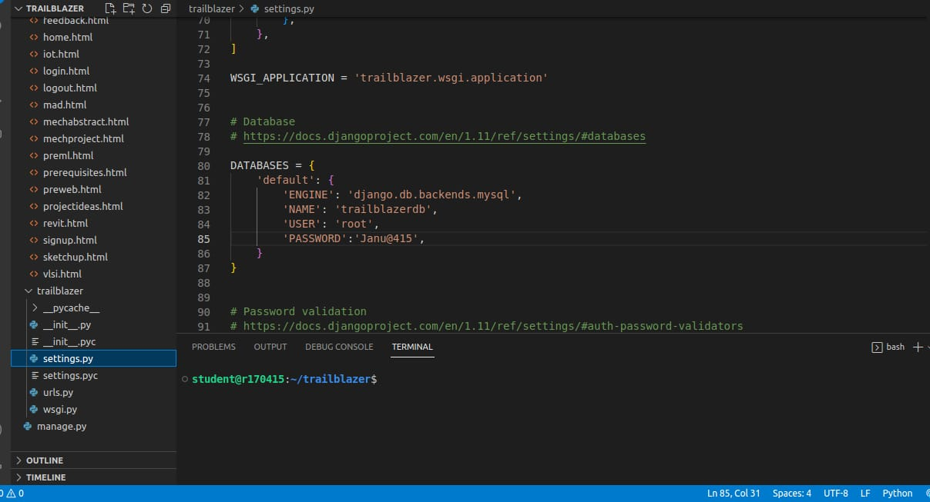
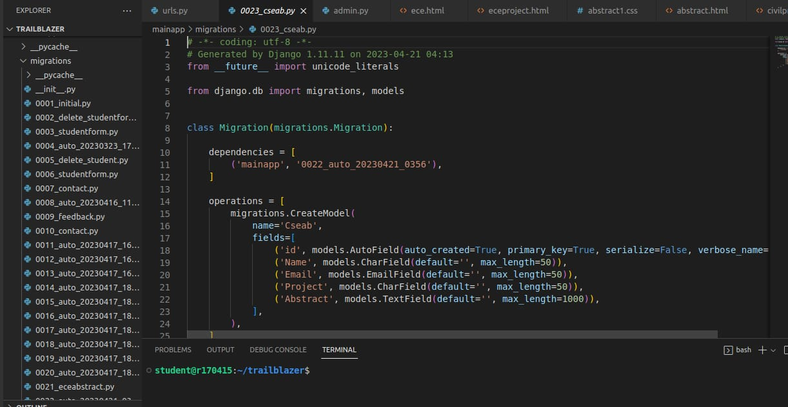
11

8.System in Context:
This Trailblazer provide the list of contents which having the user ,admin,trailblazer and database.

Context Diagram:

User
Admin
Signup,Login,Register in Trailblazer, changepassword.

Home, Prerequisites,
Project ideas, About us.

Accept registrations and project reports.
View,edit,delete the users account,project reports.

Trailblazer

Response to user request
Store user details,project reports.

Database

The below table provides a set of user visible that define the functionalities that are in Trailblazer
12

 | Actor | Action | Object | Frequency | Arrival Pattern | Response
1. | User | onclick | Signup | 1/day | Episodic | It asks username  first name  last name  email  password
2. | User | onclick | Login | 1/day | Episodic | It asks  username  password
3. | User | onclick | Main | 1/day | Episodic | It displays  all modules in the  software
4. | User | onclick | Home | 1/day | Episodic | It displays  information about  software
5. | User | onclick | About us | 1/day | Episodic | It displays information about  managers 13
6. | User | onclick | Prerequisites | 1/day | Episodic | Branch and domain
7. | User | onclick | Project Ideas | 1/day | Episodic | It displays info about projects
8. | User | onclick | Project  Overview  13 | 1/day | Episodic | It displays  the source code of the project
9. | User | onclick | upload | 1/day | Episodic | It displays upload option
9.Functional Requirements:
Use Case Diagram:
Login/Signup

Home

About Us
Prerequisites
Projects
Admin
Project ideas
User
Project Overview

Feedback

Contact

Registration

14
Use Case Overview

 | Use-case ID | Use-case Name | Priority | Stability | Verifiable
1. | UC-TB-PR | Prerequisites | High | Stable | Verifiable
2. | UC-TB-RG | Registrations | High | Not Stable | Verifiable
3. | UC-TB-PI | Project Ideas | High | Stable | Verifiable
4. | UC-TB-UP | Project Overview. | High | Stable | Verifiable

ER Diagram:
Email
Username
Password
Name

User
have
Sign Up
1
N
M

have

Projects
M
1
Prerequsites
Project Ideas
Project Overview

15
10. Starting Project:
Steps:
1.Install mysql in the system
2.Install django by using pip
pip install django
3.Once we installed django in our system,we will get ‘django-admin’ command line tool ,which can be used to create our Django project. Create a project using : django-admin startproject projectName By default some of the python files will be installed and database dbsqlite too. Open the project folder using visual studio code.
4.Create an application in that project folder python3 manage.py startapp appname
5. Add application to the settings.py 6.Define view function inside views.py and define url-pattern to views inside urls.py
7. To Start Server run this following command in terminal python3 manage.py runserver Make sure that run this command in the particular directory where this manage.py is present. This command will generate an url http://127.0.0.1:8000/ use ctrl+click on the url to open in the browser. 8.Send the request.

11. Admin Page:
Django provides a default admin interface which can be used to perform create, read, update and delete operations on the model directly. It reads set of data that explain and gives information about data from the model, to provide an instant interface where the user can adjust contents of the application.
16

Admin Login Page
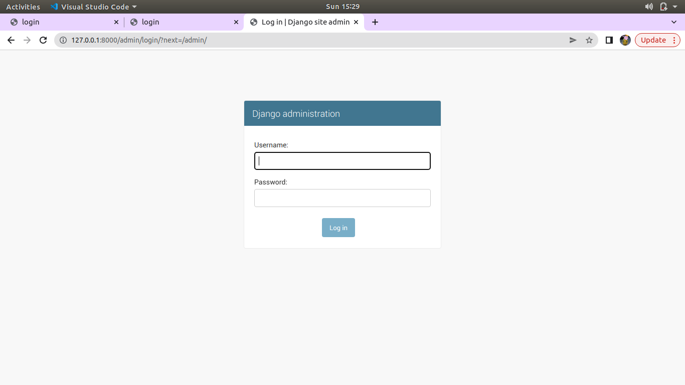
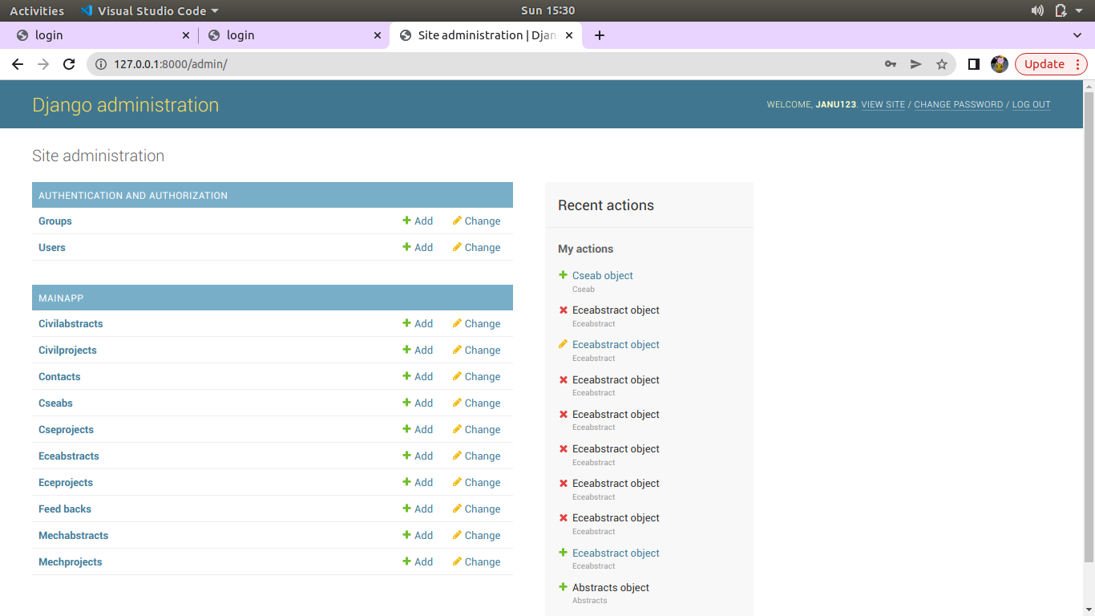

17

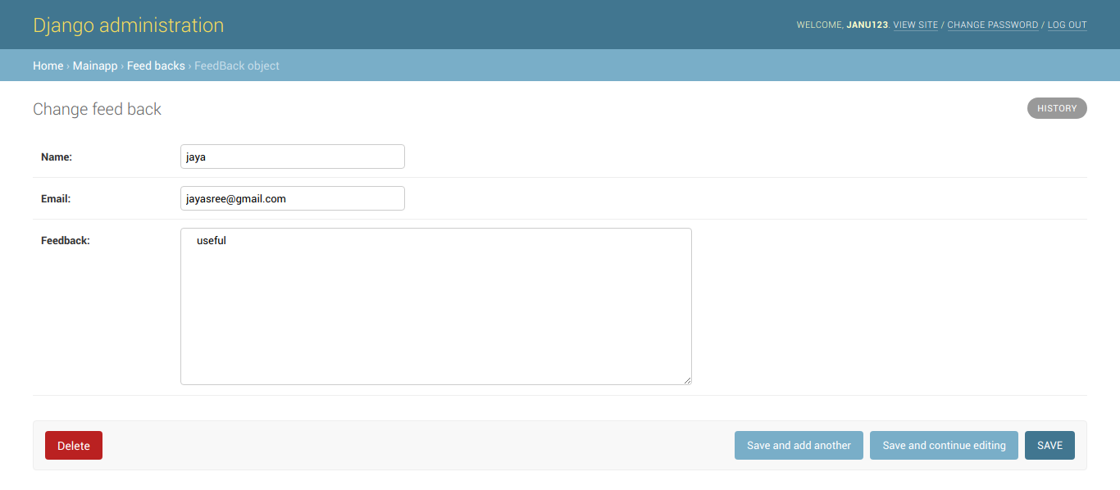

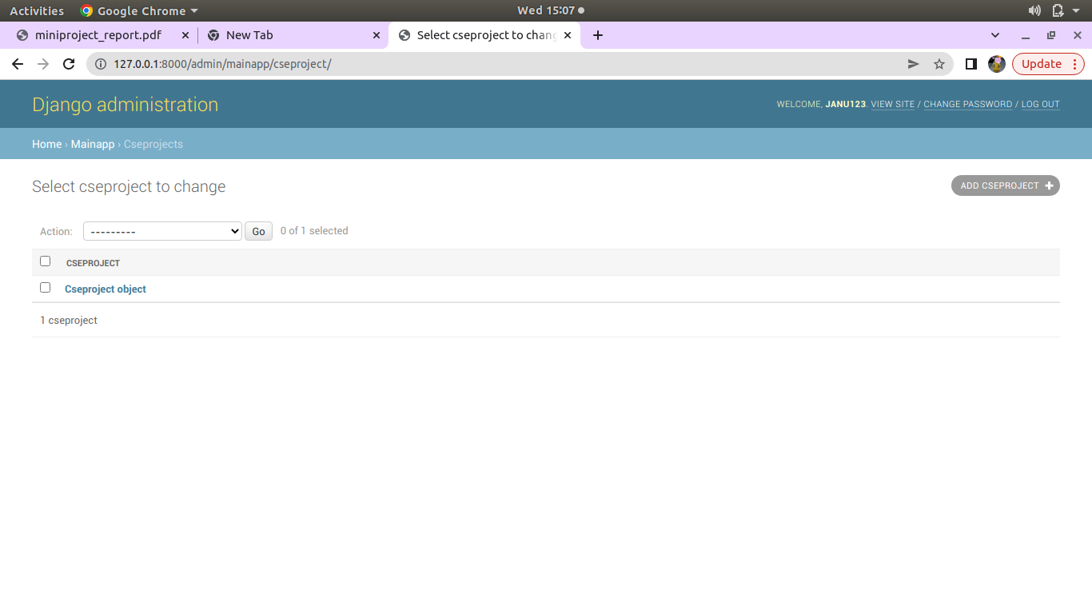
18

12. Source Code:
main.html:
<!DOCTYPE html>
{%load staticfiles%}
<html>
<head>
<title>home page</title>
<link rel="stylesheet" href="{% static 'css/home1.css' %}">
</head>
<body>
<b>
<div class="menu-bar">
<ul>
<div class="logo">
<img src={% static "images/l2.jpg" %} alt="">
</div>
<li class="active"><i class="fa fa-home"></i><a href="{% url 'projectideas' %}">ProjectIdeas</a></li>
<li class="active"><i class="fa fa-home"></i><a href="{% url 'preview' %}">PreRequisites</a></li>
<li class="active"><i class="fa fa-home"></i><a href="#"> ProjectOverview</a>
<div class="sub-menu">
<ul>
<li><a href="{% url 'cseview' %}">CSE</a></li>
<li><a href="{% url 'eceview' %}">ECE</a></li>
<li><a href="#">CIVIL</a></li>
<li><a href="#">MECHANICAL</a></li>
</ul>
</div>
</li>
<li><a href="{% url 'about' %}">About us</a></li>
<li><a href="{% url 'contact' %}">Contact</a></li>
<li><a href="{% url 'feed' %}">Feedback</a></li>
<li><a href="{% url 'loginaction' %}">Logout</a></li>
</ul>
</div>
</b>
<div class="scroll">
19

<marquee scrollamount="15px" direction="right" width="200%">WELCOME TO TRAILBLAZER</marquee>
<marquee scrollamount="15px" id="caption">explore your thoughts</marquee>

</div>
</body>
</html>

views.py (main):
# -*- coding: utf-8 -*-
from __future__ import unicode_literals

from django.shortcuts import render,redirect,HttpResponseRedirect
from django.contrib.auth import authenticate,login
from django.contrib.auth.forms import AuthenticationForm
from django.core import serializers
from django.contrib import messages
from .forms import SignupForm
from django.core.files.storage import FileSystemStorage
from django.http import HttpResponse,HttpResponseNotFound
from .functions import handle_uploaded_file

urls.py(app level)

from .models import FeedBack,Contact,Abstracts,Eceabstract,Cseab,Civilabstract,Mechabstract
from .models import Cseproject,Eceproject,Civilproject,Mechproject
# Create your views here.
def loginaction(request):
if request.method == "POST":
fm = AuthenticationForm(request=request,data=request.POST)
if fm.is_valid():
uname=fm.cleaned_data['username']
passwd=fm.cleaned_data['password']
user= authenticate(username=uname,password=passwd)
if user is not None:
login(request,user)
return HttpResponseRedirect('home')
else:
messages.error(request,'please Enter correct username and password')
20

return HttpResponseRedirect('login')
else:
fm=AuthenticationForm()
return render(request,'login.html',{'form':fm})
def signupaction(request):
if request.method == "POST" :
fm = SignupForm(request.POST)
if fm.is_valid():
messages.success(request,'Account created successfully')
fm.save()
fm=SignupForm()
else:
fm = SignupForm()
return render(request,'signup.html',{'form':fm})
def home(request):
return render(request,"home.html")
def projectideas(request):
return render(request,'projectideas.html')
def abstract(request):
if request.method=='POST':
Name=request.POST['name']
Email=request.POST['email']
Project=request.POST['project']
Abstract=request.POST['abstract']
messages.success(request,'Abstract Submitted successfully')
obj=Eceabstract()
obj.Name=Name
obj.Email=Email
obj.Project=Project
obj.Abstract=Abstract
obj.save()
ab = serializers.serialize("python",Eceabstract.objects.all())
my_dict={
'ab': ab,
}
return render(request,'abstract.html',context=my_dict)

21

urls.py(app level)
from django.conf.urls import url,include
from . import views

urlpatterns = [
url(r'^signup/',views.signupaction,name='signupaction'),
url(r'^projectideas',views.projectideas,name='projectideas'),
url(r'^preview',views.prerequisitesview,name='preview'),
url(r'^preweb',views.preweb,name='preweb'),
url(r'^madview',views.madview,name='madview'),
url(r'^premlview',views.premlview,name='premlview'),
url(r'^cseview',views.cseview,name='cseview'),
url(r'^eceview',views.eceview,name='eceview'),
url(r'^prevlsi',views.prevlsiview,name='prevlsi'),
url(r'^embedded',views.embeddedview,name='embedded'),
url(r'^preiot',views.iotview,name='preiot'),
url(r'^autocad',views.autocadview,name='autocad'),
url(r'^revit',views.revitview,name='revit'),
url(r'^sketchup',views.sketchupview,name='sketchup'),
url(r'^contact',views.contact,name='contact'),
url(r'^feed',views.feedbackview,name='feed'),
url(r'^cseab/',views.cseabstract,name='cseab'),
url(r'^civilab/',views.civilabstract,name='civilab'),
url(r'^mechab/',views.mechabstract,name='mechab'),
url(r'^csepro/',views.cseproject,name='csepro'),
url(r'^ecepro/',views.eceproject,name='ecepro'),
url(r'^civilpro/',views.civilproject,name='civilpro'),
url(r'^mechpro/',views.mechproject,name='mechpro'),
url(r'^about/',views.aboutview,name='about'),
] 22

13. Web Pages:
13.1 Sign Up Page:
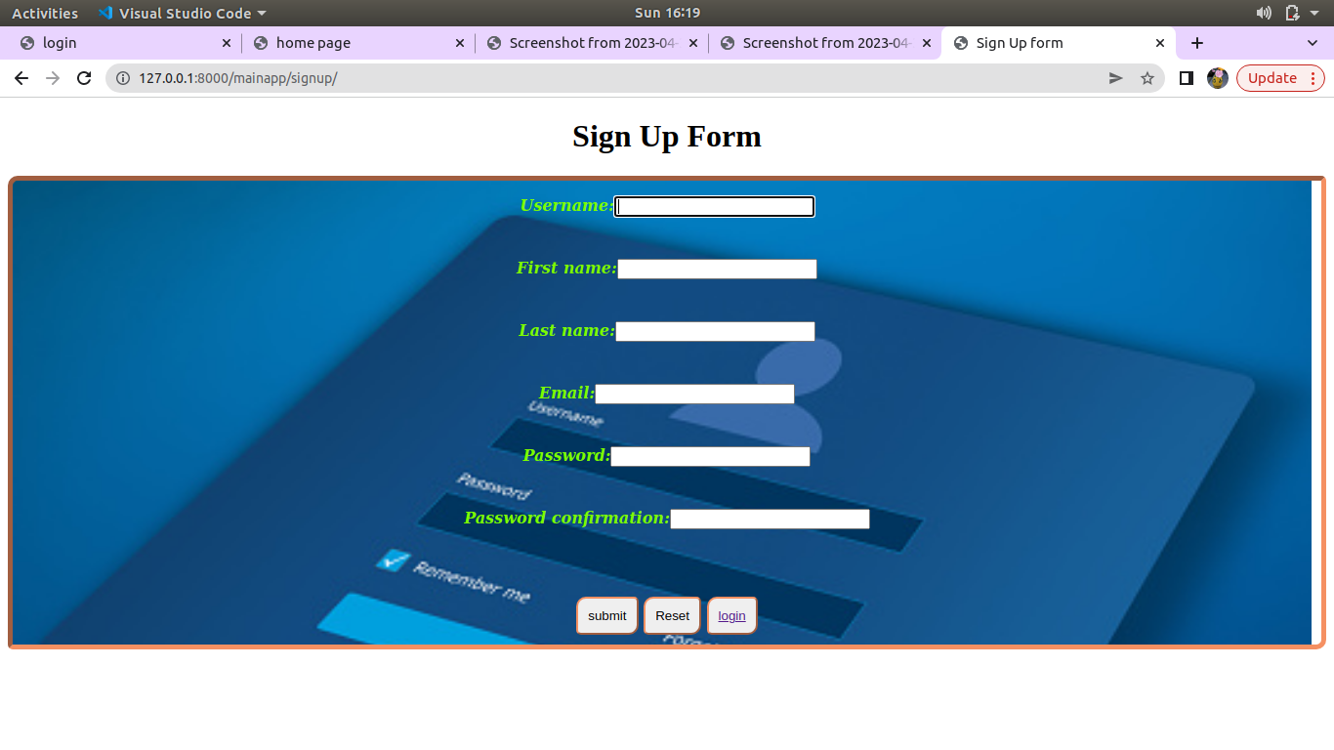
13.2 Login Page:
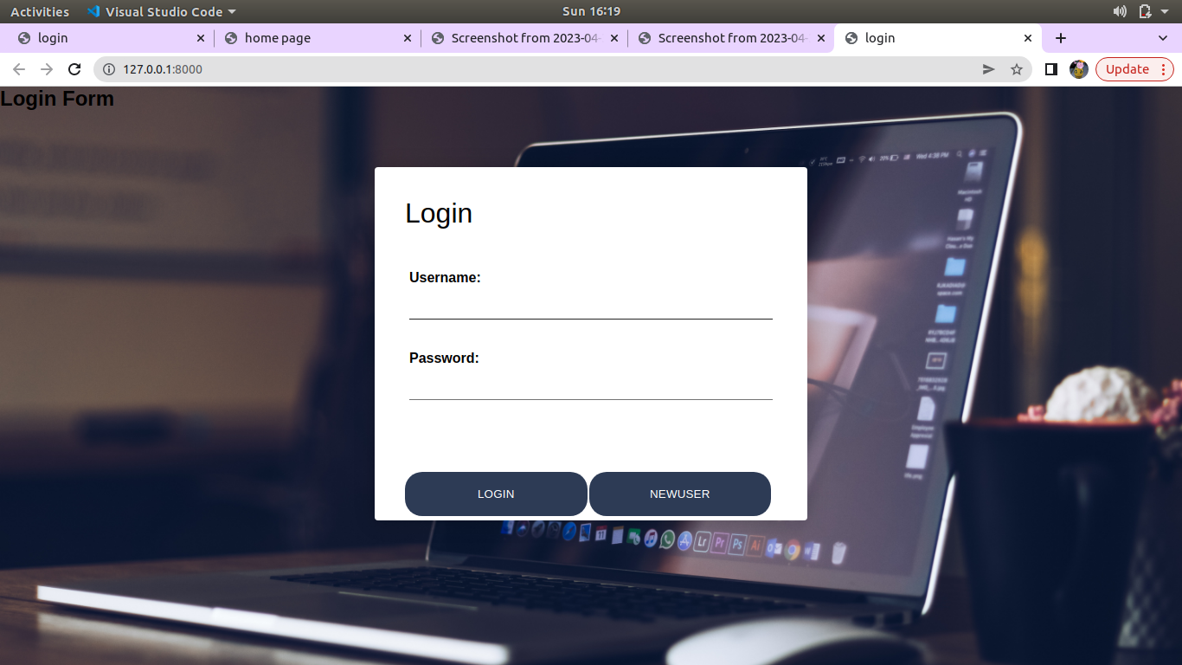
23
13.3 Home Page:
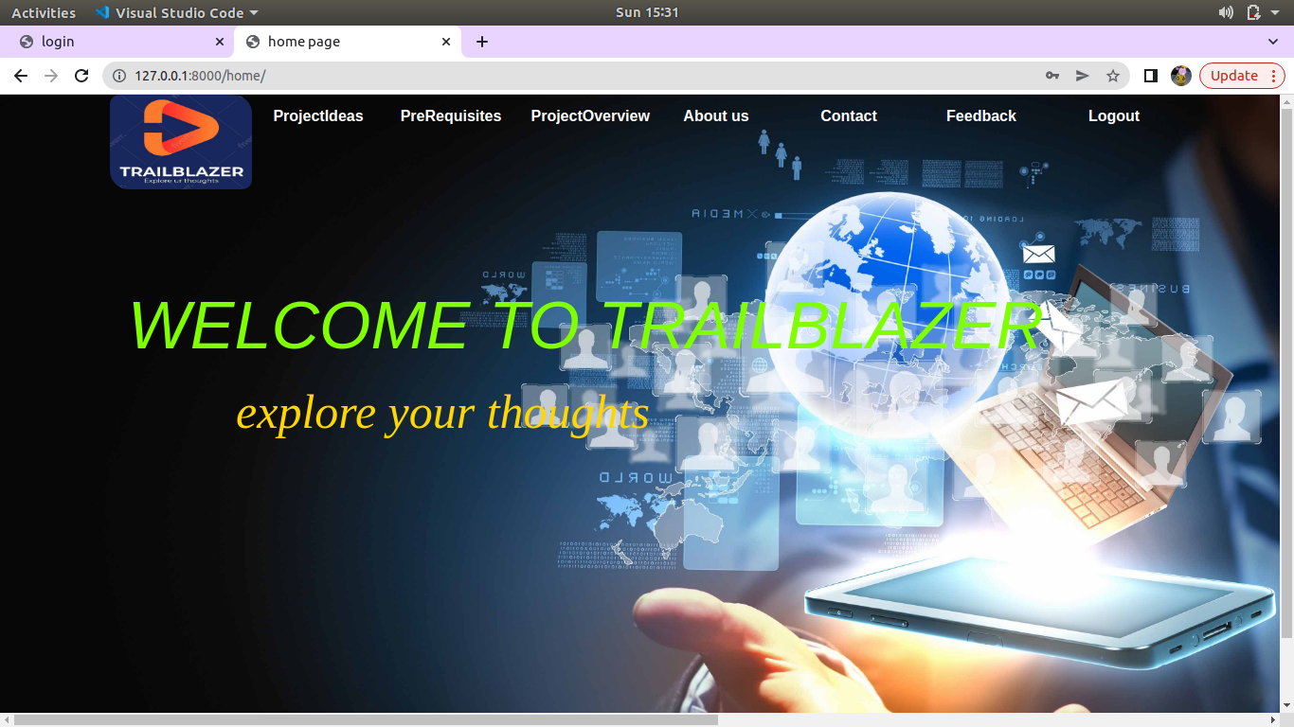
13.4 About Us Page:
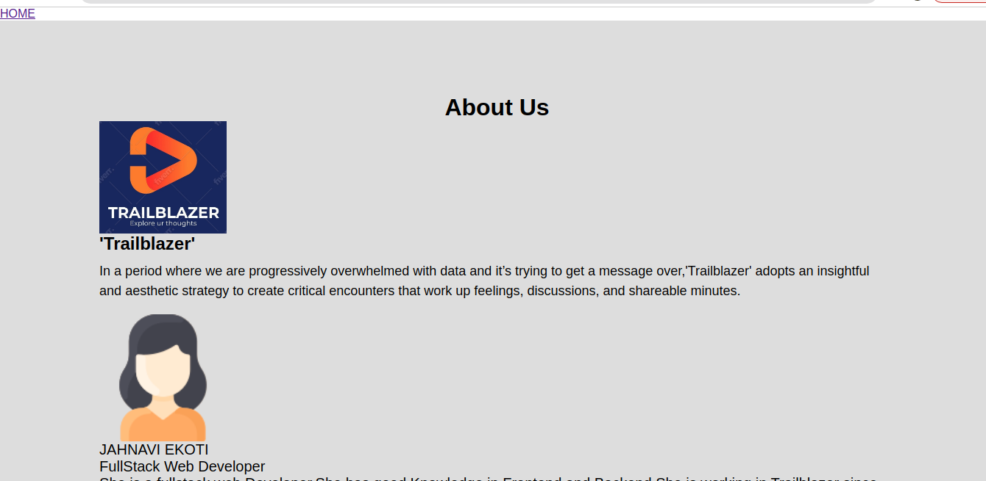
24
13.5 Prerequisites Page:
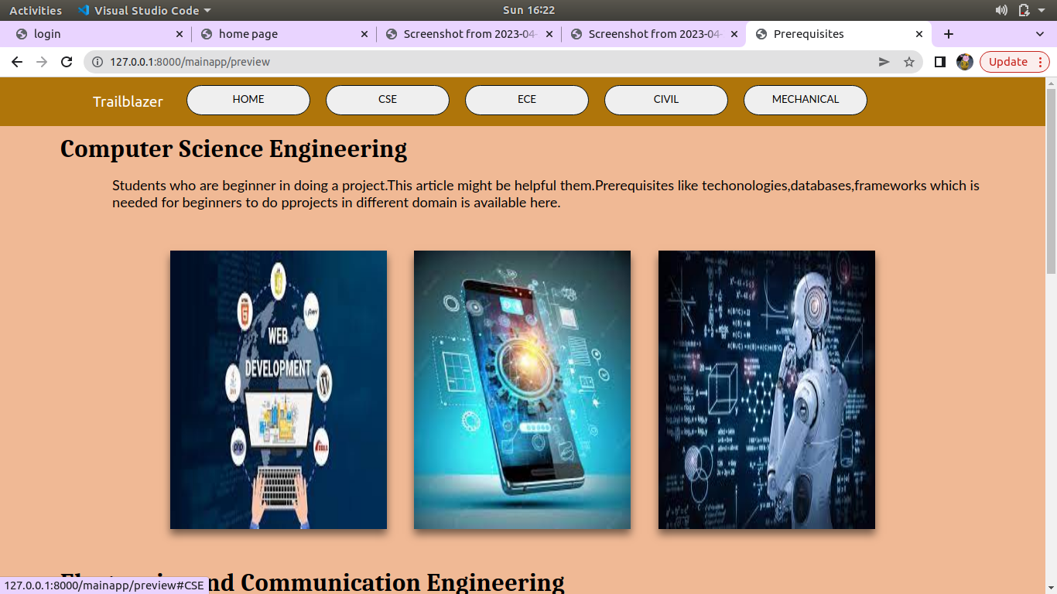
13.6 Project Ideas
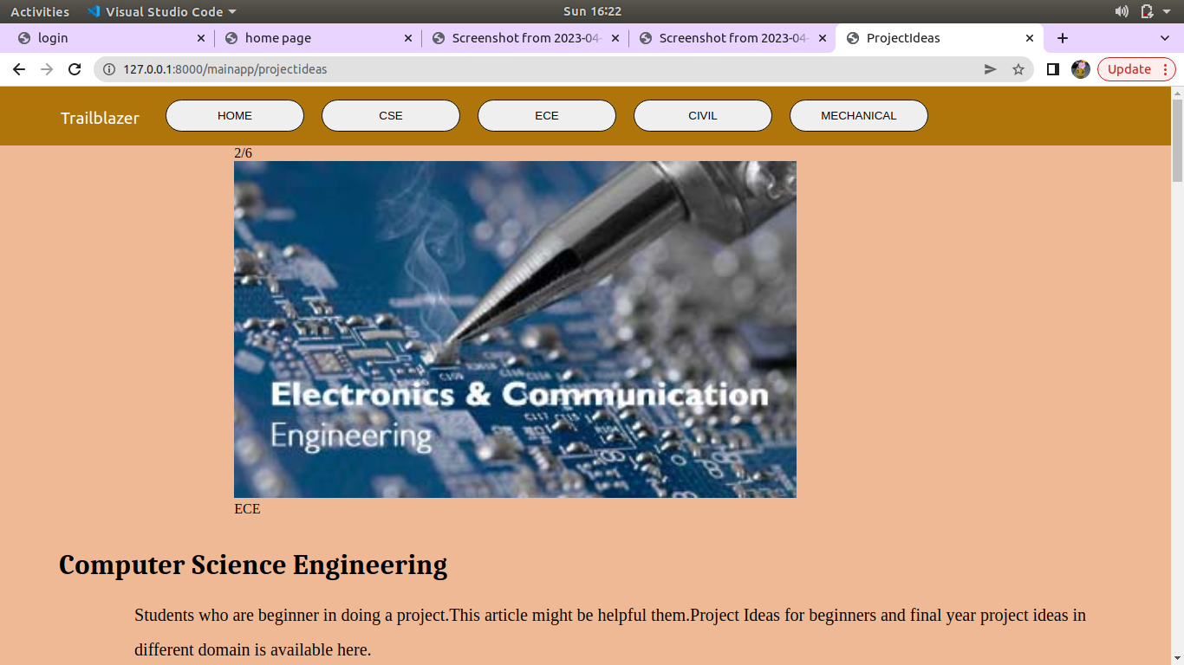
25

13.7 Contact Us
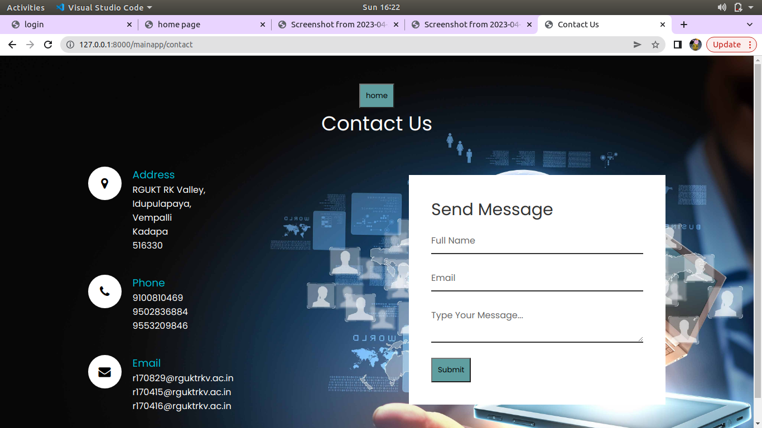
13.8 Feedback
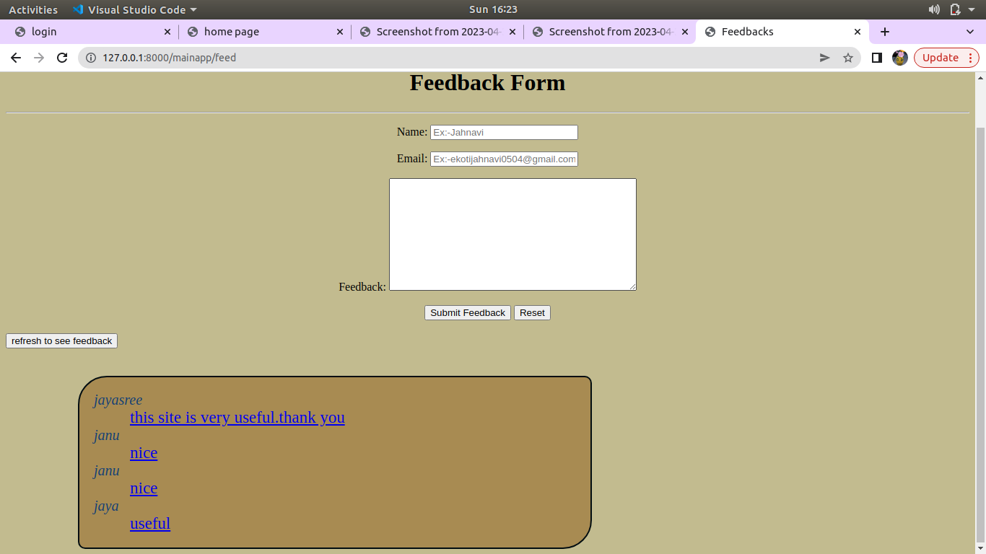
26

13.9 Contact Us Page
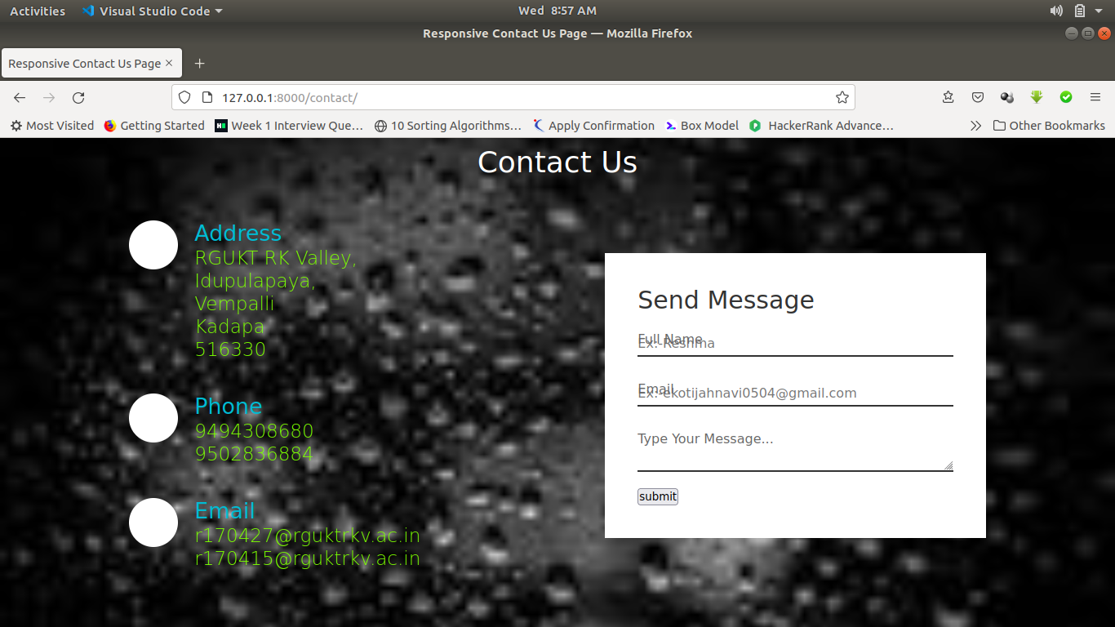

27

14. References:
1.https://www.udemy.comshare101soi3@8EC6KVhGb09rQmorwqy6ID6GET0ufkpd_V64dUG4wYhbyCgileSXluiZoUz1BbBazw==/
2. https://www.w3schools.com/django/django_intro.php
3. https://www.digitalocean.com/community/tutorials/how-to-install-the-django-web-framework-on-ubuntu-18-04
4. Basic Prerequisites of Learning Android App Development - GeeksforGeeks

28

