Ehsan Kourkchi … HW05

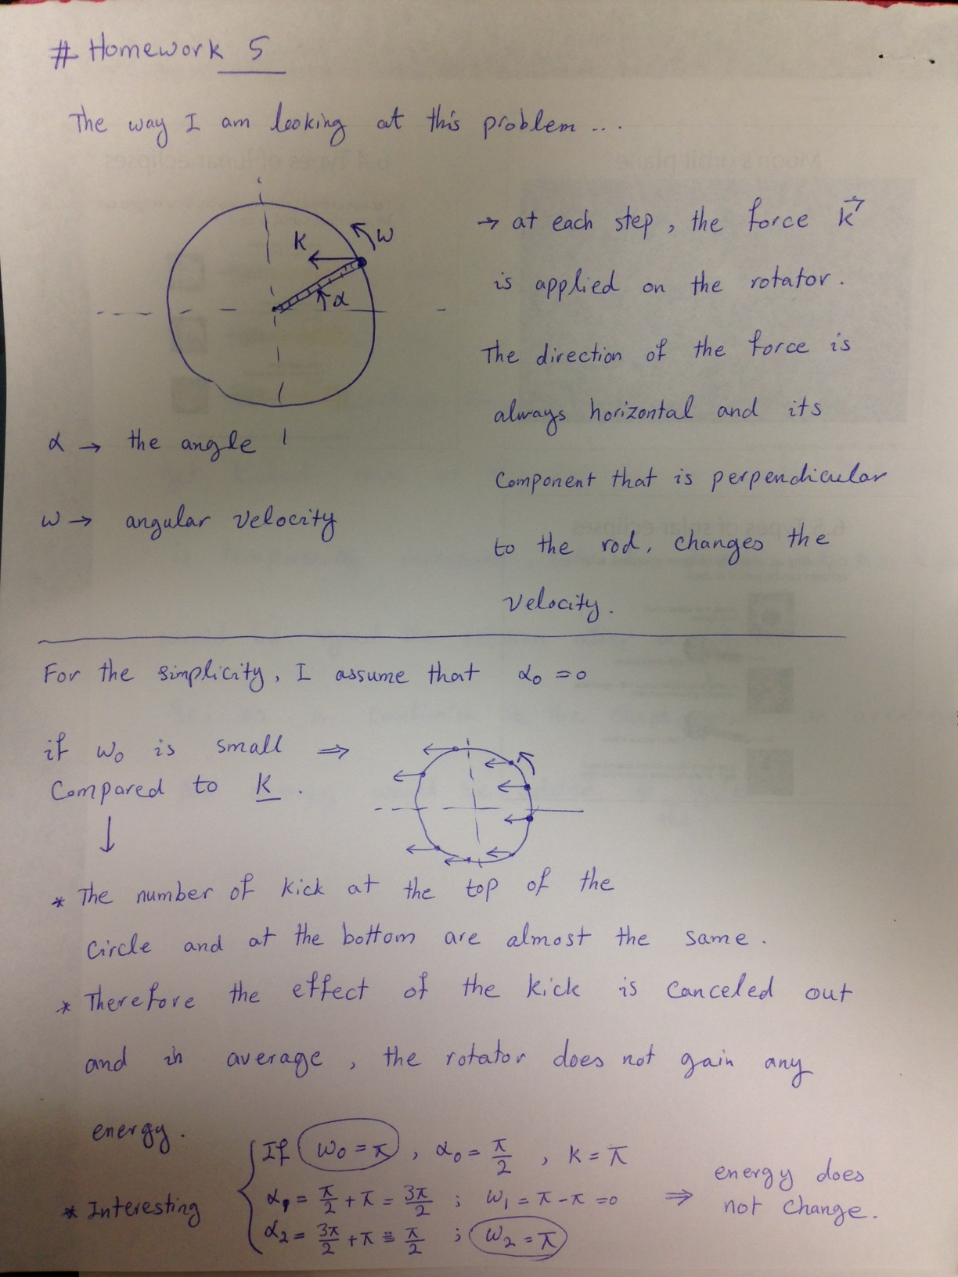

Here is the phase diagrams, and the energy diagram for this particular problem. Energy is constant and the red dashed-line line shows its value.
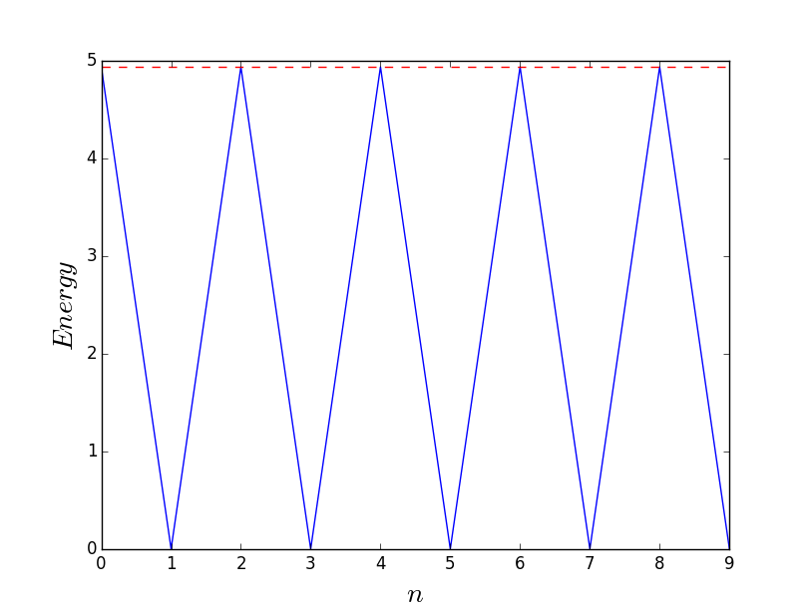

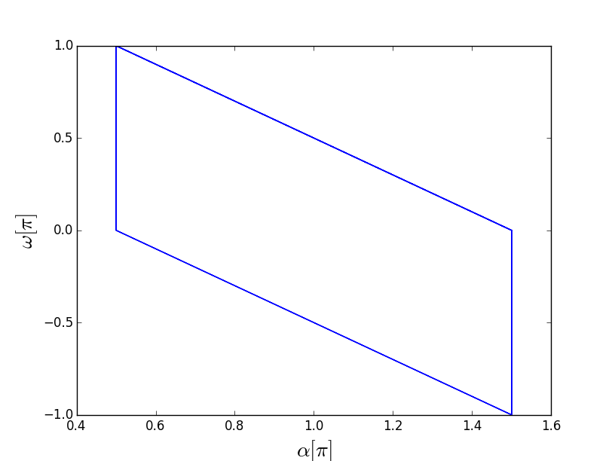

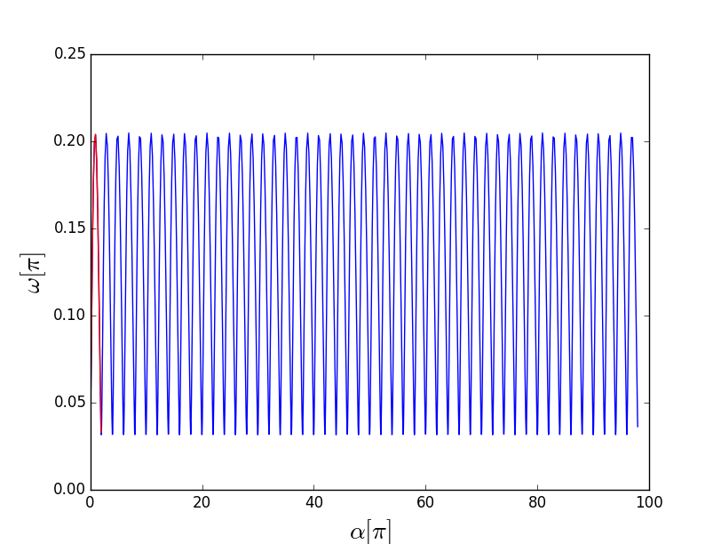
w[0] = 0.1 # velocity
a[0] = 0 # location
K = 0.1

This is the phase diagram. The red part shows the initial condition. As I mentioned earlier, if K is small, the solution is periodic and it is not chaotic.

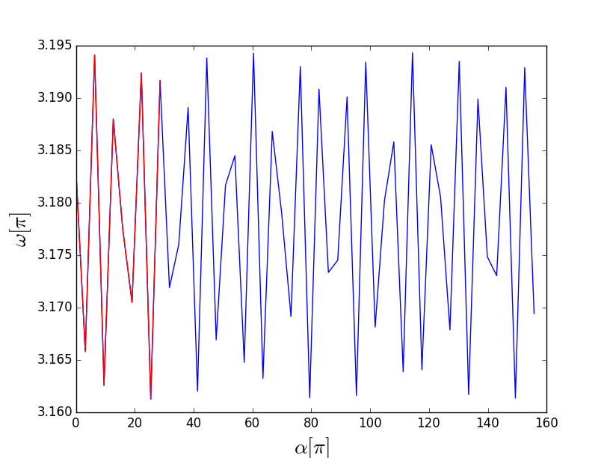
w[0] = 10 # velocity
a[0] = 0 # location
K = 0.1
Even if w[0] is big, the solution is integrable.

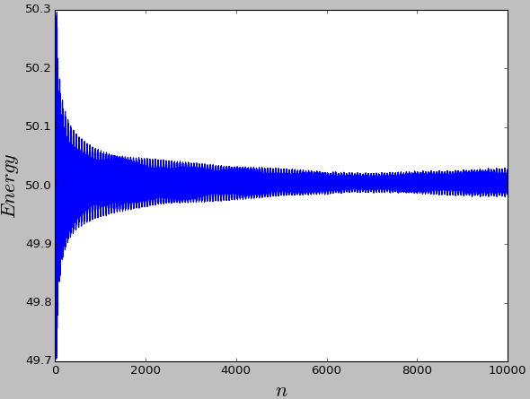

Left plot shows the ensemble average of energy when w0=10 but α0 ∈ [0:2π]. As seen, the energy is fairly constant (~50 = 0.5*10**2), since kicking force is small.


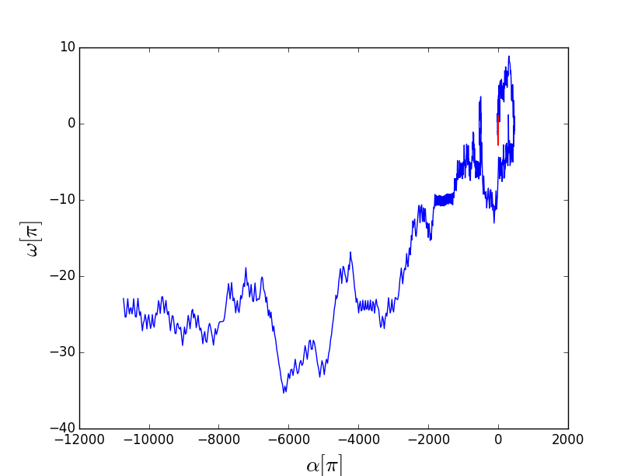Phase space

w[0] = 0.1 # velocity
a[0] = 0 # location
K = 4

When K is increases, chaos starts.

Now, I am trying to find how energy is changing:

w[0] = 0.1 # velocity
a[0] = 0 # location
K = 5
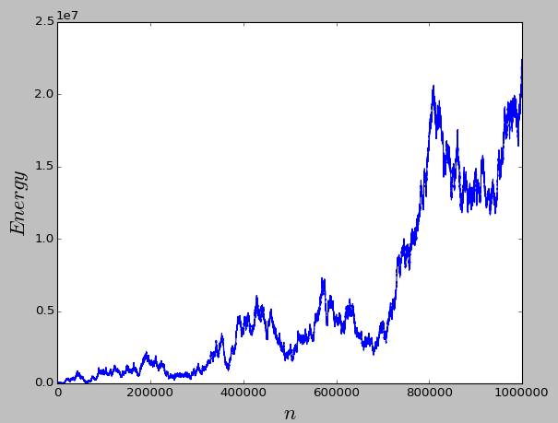

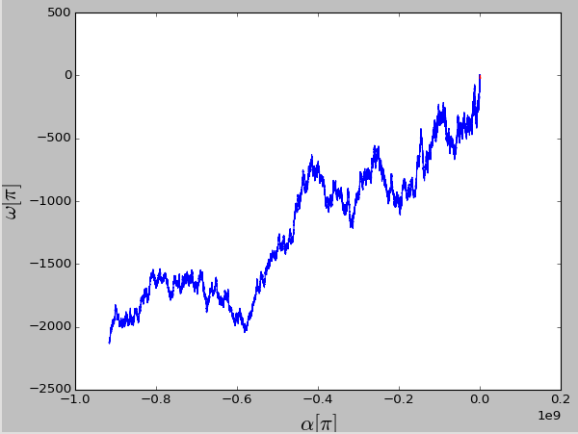Phase diagram: starting from top-right corner

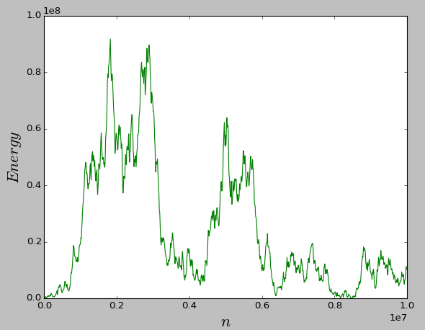
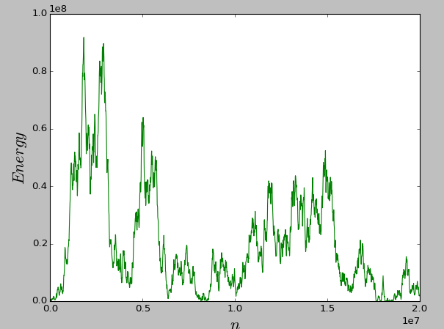

This inset diagram shows my try for twice number of steps (20,000,000 steps), and still everything is chaotic.
And also it's really sensitive to the initial value.

Let's slightly change the initial velocity ….
w[0] = 0.1+1.E-10 # velocity
a[0] = 0 # location
K = 5

This is the results :

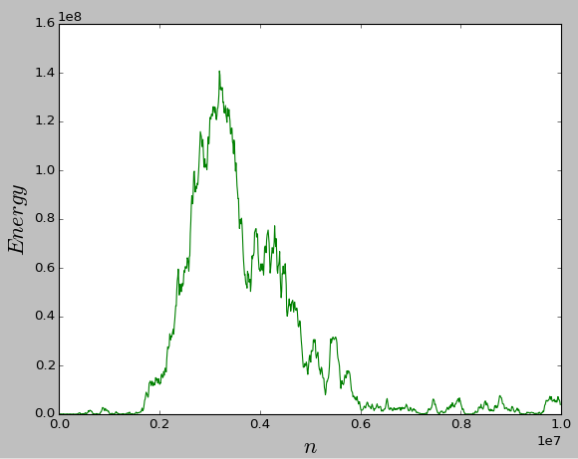

By studying this single state, my conclusion is that, the energy does not reach to infinity. Since K is big, it dramatically changes the velocity of the rotators. The applied change in the velocity is K * sin(alpha), since alpha is rapidly changing at big velocities, sin(alpha) is like a random generator, generating random numbers between K and -K …. Therefore the average effect of this random change in the velocity is almost zero.

How to obtain the ensemble average of the states
Ok, one can linearize these set of equations in order to analyze the system:

let T = 1

1) dα /dt = ω

2) dω/dt = K sin(α + ω)

Then the Jacobin matrix would be:

| 0 1 |
J = | |
| Kcos(α + ω) Kcos(α + ω)|

f(α,ω)= ω
g(α,ω)= K sin(α + ω)

The equilibrium points are f(α0,ω0) and g(α0,ω0) = 0

which happens for (α0=0,ω0=0) and (α0=pi,ω0=0)

Since, the Jacobin is symmetric with respect to α and ω, we can treat both variable in the same way, considering they vary between 0 and 2*pi. The resulting phase space would be like the following diagram.

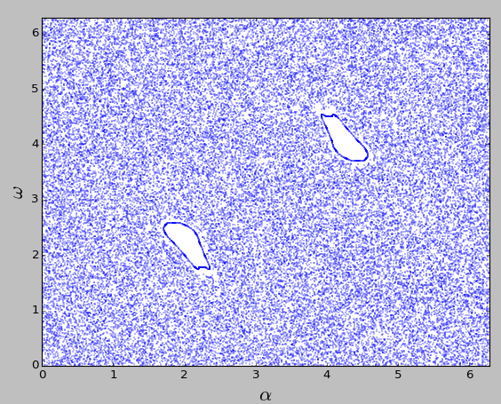

In this diagram, all point show how randomly the phase space is populated.

K = 5

and

α0 = 0, 1, 3, …, 6
ω0 = 0, 1, 3, …, 6

The white regions are the regions where we have stable/periodic solution, that we want to avoid for our ensemble average calculations.

The closer look at the bottom left hole is as following:

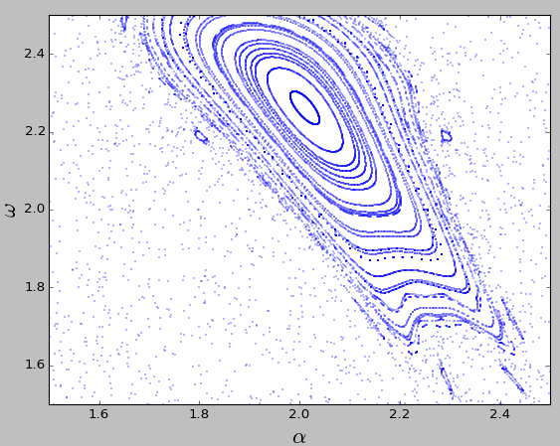

As seen, the solutions inside this hole are periodic.

For the sake of the ensemble average calculations of the energy, we then choose

α0 in [0:1]
ω0 in [0:2π]

This way, we make sure to avoid the hole.

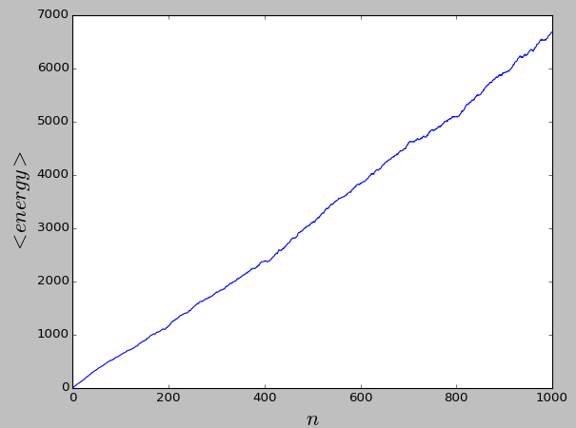
On the right, you see the results of the ensemble average of energy as a function of the kick number.

n: kick number, (or time)

I have used an ensemble of 1,000 set of initial values, taken uniformly

α0 in [0:1]
ω0 in [0:2π]

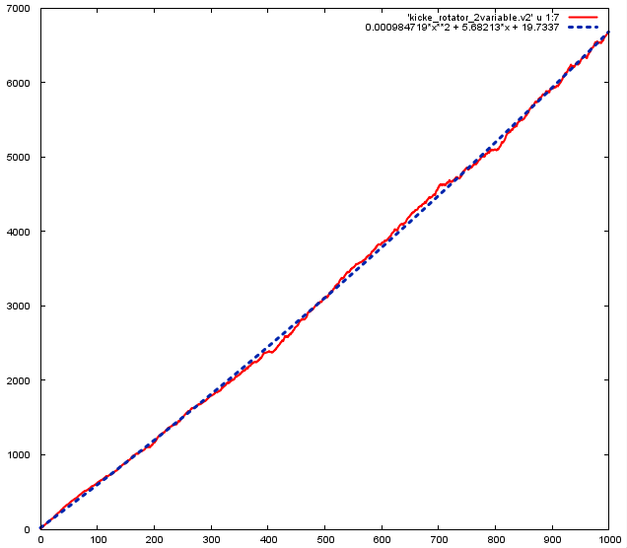This is the same as the previous plot. The dashed line is the best quadratic fitted line, obtained by gnuplot package.
I used a quadratic function, however it look to have a linear fit. In the above diagram, the red curve is the data, and the dashed-line is the fitted line.

gnuplot> f(x) = a*x**2 + b*x + c
gnuplot> fit f(x) 'kicke_rotator_2variable.v2' u 1:7 via a, b, c

---

Iteration 8
WSSR : 2.29483e+06 delta(WSSR)/WSSR : -1.39784e-11
delta(WSSR) : -3.2078e-05 limit for stopping : 1e-05
lambda : 0.00257876

resultant parameter values

a = 0.000984719 > it's small, compared to b and c
b = 5.68213 > therefore, we can ignore it and
c = 19.7337 > just use a linear function.

After 8 iterations the fit converged.
final sum of squares of residuals : 2.29483e+06
rel. change during last iteration : -1.39784e-11

degrees of freedom (FIT_NDF) : 997
rms of residuals (FIT_STDFIT) = sqrt(WSSR/ndf) : 47.9764
variance of residuals (reduced chisquare) = WSSR/ndf : 2301.74

Final set of parameters Asymptotic Standard Error
======================= ==========================

a = 0.000984719 +/- 2.035e-05 (2.067%)
b = 5.68213 +/- 0.021 (0.3696%)
c = 19.7337 +/- 4.542 (23.02%)

correlation matrix of the fit parameters:

a b c
a 1.000
b -0.968 1.000
c 0.745 -0.866 1.000

– the plotting command
gnuplot> plot 'kicke_rotator_2variable.v2' u 1:7 w l lw 2, 0.000984719*x**2 + 5.68213*x + 19.7337 lc rgb '#0025ad' lw 3 lt 0.4

