Ehsan Kourkchi … HW06
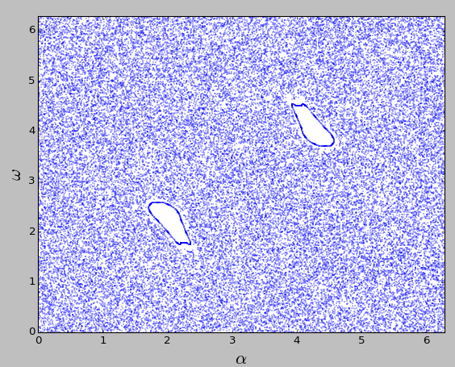
K = 5
α0 in [0:1]
ω0 in [0:2π]

In the previous assignment, we used the above values to avoid the integrable solutions.

Therefore, we use the same domain to do the current assignment.

The number of simulated systems: 100,000
with different initial conditions.

Codes:
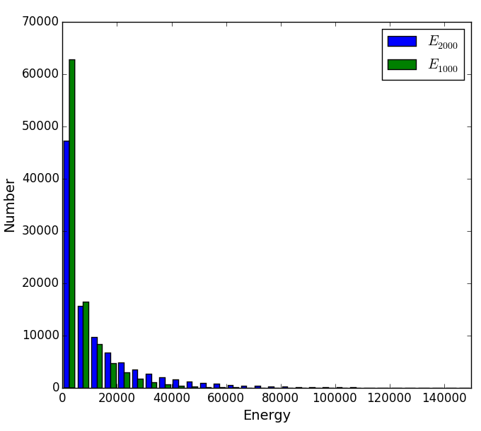Fig 1: The energy distribution. E2000 is the enrgy of the system at step 2,000, and E1000 at step 1,000.
1) ehsan.hw06.py

It calculates the final energy of 100,000 kicked rotators after 2,000 steps, and save in an output file (i.e. energies.v2.txt). This process takes time, that's why having an output file seems to be necessary.

2) ehsan.hist.py
Using the set of energies for different systems, we construct their energy distribution and study how the tail of the distribution goes to zero.

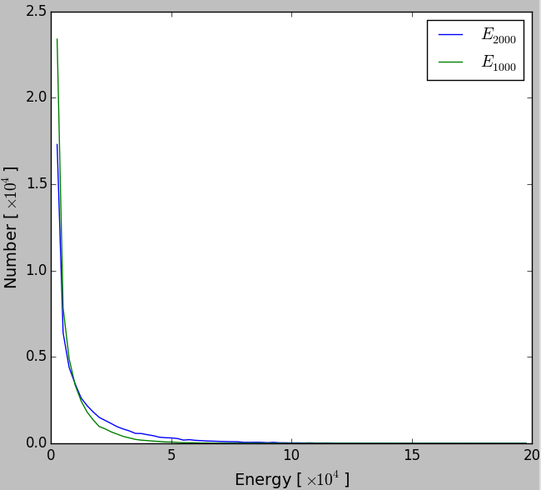Fig 2: Energy distribution, Linear-Linear

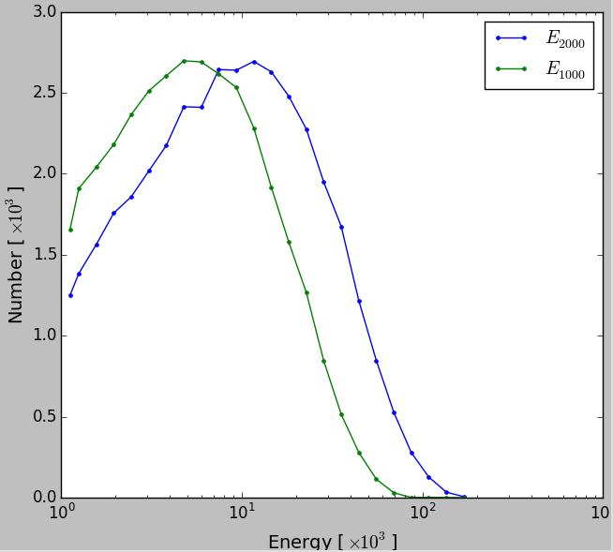Fig 3: Energy distribution, the energy axis is in logarithmic scale (Log-Linear)

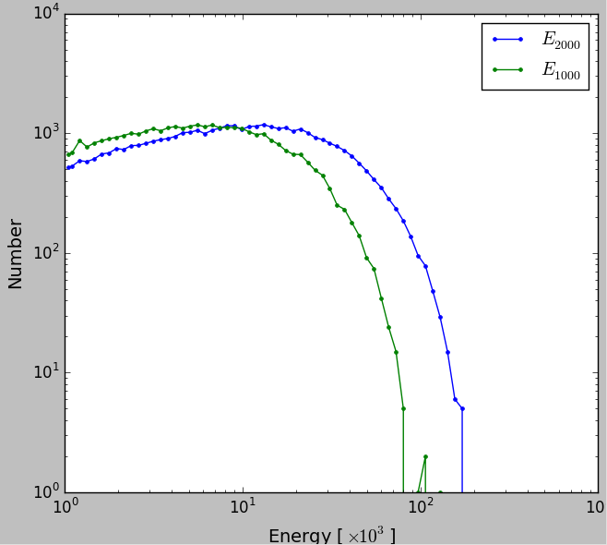Fig 4: Energy distribution, Log-Log scale
So if the tail of the distribution follows a polynomial function, then we should see a linear behavior of tail at log-log plot.

P(E) ∝ E^-α
→ log(P) = (-α) log(E) + cte.

→ if set log(P) = Y and log(E) = X then
Y = -α X + cte.

Since, plot 4 does not show any linear behavior f the tail, w cannot fit a line and find α

Then we look at linear-log plot of P(E):

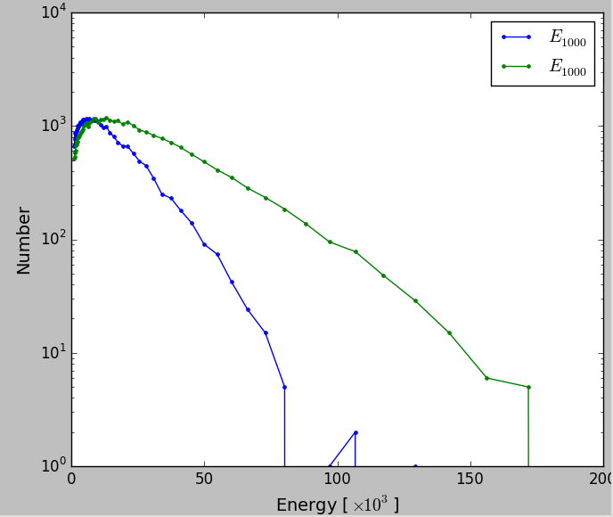Fig 5: Energy Distribution, the number axis (Y-axis) is in logarithmic scale .. Linear-Log
P(E) ∝ exp(-E/Es)
→ log(P) = (-E/Es) log(e) + cte.

→ if set log(P) = Y then
Y = (-E/Es) log(e) + cte.

According to plot 5, Y has a linear relation with E, at the tail of energy distribution. Therefore, we can find the coefficient of the best fitted line, and calculate Es.

The red point in plots 6 and 7, are those point used for the line fitting.
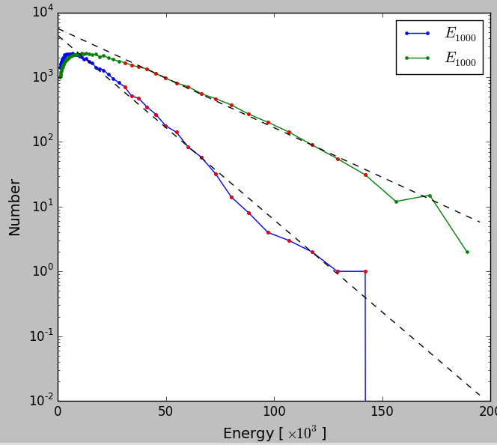Fig 6: Same as Fig 5, fitting straight lines on the tails

Fig 6: 100,000 initial conditions
Green curve:
Es = 28.34
Running the system for 2,000 steps

Blue Curve:
Es = 15.24
Running the system for 1,000 steps

Fig 7: 50,000 initial conditions

Green curve:
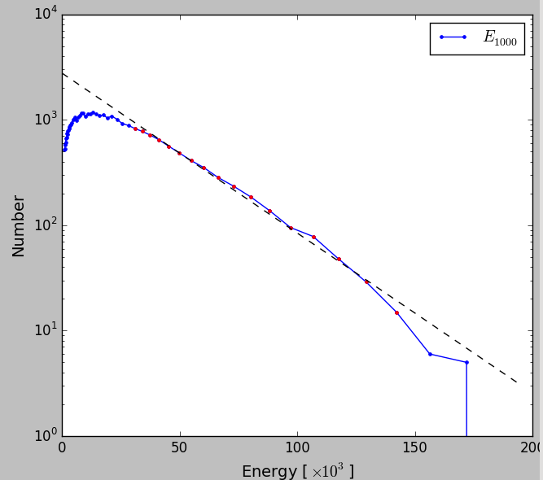Fig 7: energy distribution, for a set with 50,000 members
Es = 28.64
Running the system for 2,000 steps

Comparing plot 6 and 7 shows that changing the sample size does not significantly change the resulting fitted line and therefore the estimated Es.

However, I don't still understand, why the line slope is different when we look at systems at different steps. And the remaining questions is that, how many steps, we need to run the rotators in order to fully constrain Es.

