**1.**

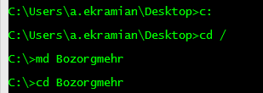

**2.**



**3.**

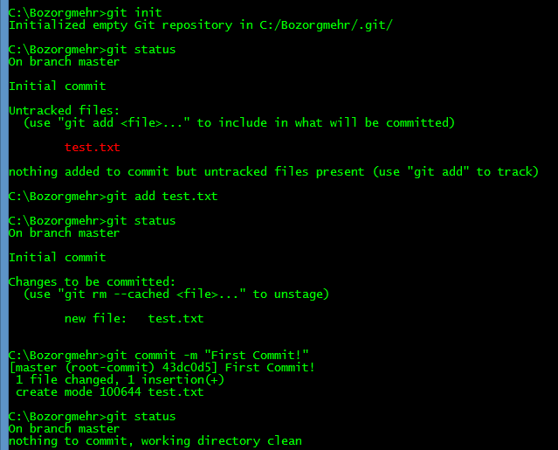

4.

First when we initial an empty repository, the ‘test.txt’ is an untracked file which git doesn’t follow its changes.  
When we run “git add test.txt” then we add ‘test.txt’ to staging area and we tell git that we want to include this file to our repository and git follow its changes.  
After commit the staging area, git add a snapshot of added files to repository history and working directory would be clean of any uncommitted changes.