**5.**



**6.**

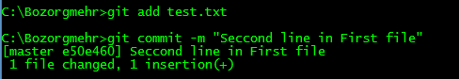

**7.**

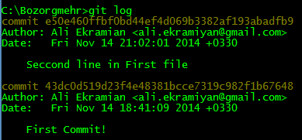

**8.**

We have 4 line for each commit, display commit ID, Author, commit Date and commit message.