**9.**

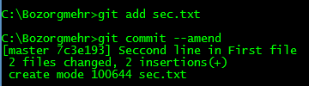

**10.**

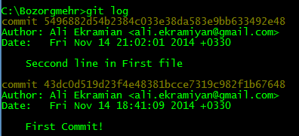

The last commit is replaced with a new commit that have the same snapshot of working directory of removed commit including ‘sec.txt’ file. This new commit have the same author, date and message (we can change message when we run ‘git commit --amend’) but it has a different commit ID (so it’s new commit and the last commit is deleted).