**11.**



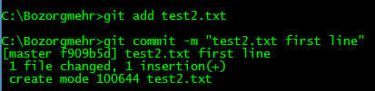

**12.**

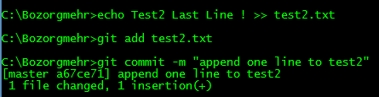

**13.**

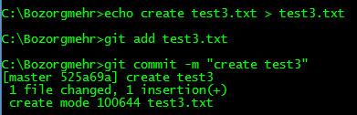

**14.**

We use ‘git log --stat’ or ‘git log -p’ for most detailed view.

