**20.**

git branch Exam  
echo create test4.txt > test4.txt  
git add test4.txt  
git commit –m “create test4.txt on ‘Exam’ branch”

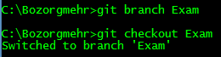  
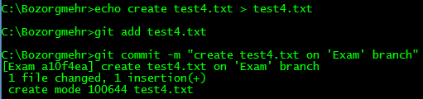

**21.**

  
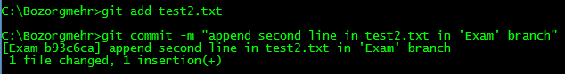

**22.**

git branch

