**23.**

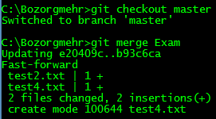

**24.**

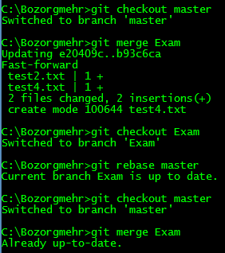

**25.**

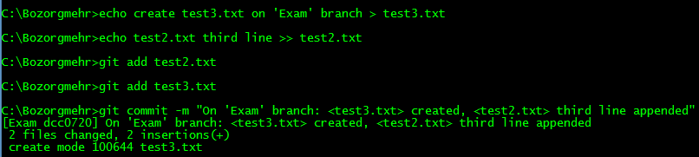

**26.**

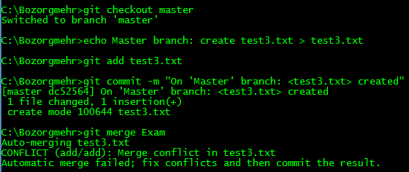

We have merge conflict in test3.txt. For continue merging, we should resolve conflicts: we just open files, edit it, and add it to staging area.

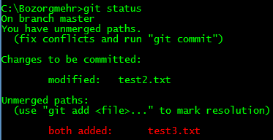

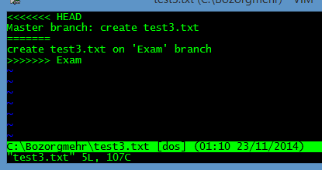

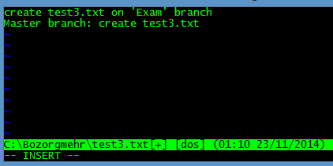

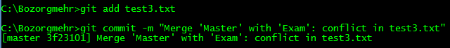

After merging, when we check commits log, we see that last commit is the merge commit:

