**27.**



**28.**

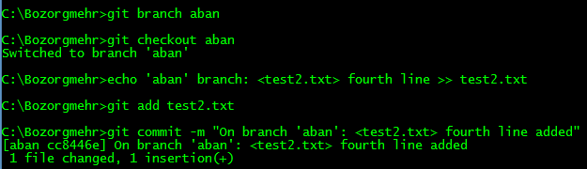

**29.**

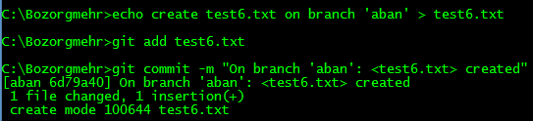

**30.**

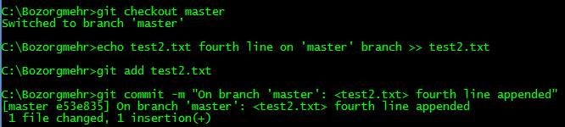

**31.**

We get conflict message: “CONFLICT (content): Merge conflict in test2.txt”. We edit ‘test2.txt’ to resolve conflict, add it to staging area and run ‘git rebase --continue’

