**32.**

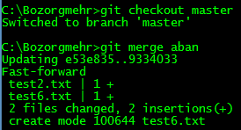

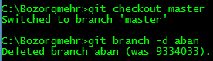

**33.**

We use ‘git remote …’ command to add connection to github repository, and we use ‘git push …’ to save changes on github server.

