**34.**

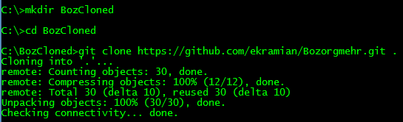

**35.**

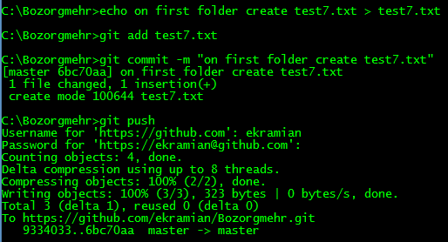

**36.**

After running ‘git pull’, test7.txt will create.

