37.

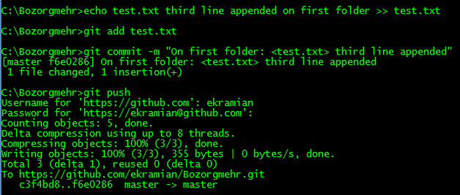

38.

On first run on git pull, git abort pulling because of same change on same file on different repositories.  
After run ‘git stash apply’, again we get merge conflict message in test.txt. we should solve conflicts and commit it.



