**Project Proposal1 : GotoGro-MRM**  
Name : Ekrar Efaz | Student ID : 103494172

Tutor Name : Dr. Naveed Ali  
Product Backlog ID : (Display Data)

1. **Reviewing Estimation Accuracy**

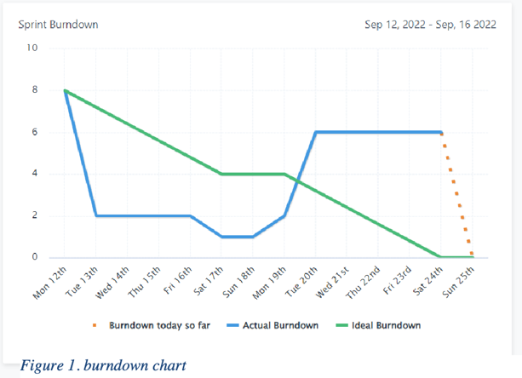

My assigned work was to implement the backlog item to display data to the members. My estimate was around 3 hours. The estimate was very much on point because the work was done with in the timeframe selected with an accuracy of +/- 10 minutes.

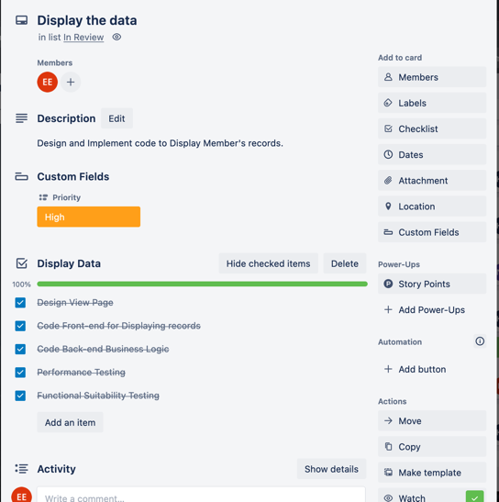

* 1. **Designing Webpage View (Actual Time 18 minutes)**

I had assigned 30 minutes for the design of the webpage. Since We had in our mind what we wanted the users to see when they inspect their records it took us very less time than estimated. The team decided on one of our pre-defined designs in small amount of time. We took inspiration from popular websites, so we didn’t have to come up with a scratch design.

* 1. **Code Front-end for Webpage (Actual time 31 minutes)**

The team was very skilled in Front-end code and more recent frameworks make front-end coding a piece of cake. The estimate was 30 mins and We finished the front-end in one sitting with no remaining errors and later in a team meeting demonstrated the functionality with which everyone was happy. The coding took surprisingly the exact same time as estimated.

* 1. **Code Backend for Business Logic (Actual Time 48 Minutes)**

I did overestimate the time required for backend code to 60 minutes based on my bad experiences in working with backend of a website. But my teammate Trung was very confident with his skills and helped us get through all the syntax and logical errors we came along which speedup the process exceptionally. We saved a lot of time in this part.

* 1. **Functional Suitability Testing (Actual Time 40 minutes)**

I had assigned 30 minutes to Functional Suitability Tests. Testing was the worst part of the project. I procrastinated and didn’t follow test driven code which made the testing part way worse for me. I couldn’t get all the test to pass. It took more time than estimated.

* 1. **Performance Testing (Actual Time 30 minutes)**

The performance testing was simple and easy to do. We matched our requirements within the first few tries and there was no need to refactor our code to enhance performance.

**Conclusion**

In conclusion we managed to implement *Display Data* within the estimated time frame. If I was more acquainted with my team members and knew a lot more about their skills, I would have made a more accurate estimation.