Project Proposal1 : GotoGro-MRM

Name : Ekrar Efaz | Student ID : 103494172

Tutor Name : Dr. Naveed Ali

Product Backlog ID : (Weekly Updates on Grocery Need) Sprint2

1. **Weekly Updates on Grocery Need (120 mintues)**

I have chosen to work with the backlog item which provides the store with weekly updates on the members grocery needs via email and other platforms. I specifically am working with setting up the email system. This item was something I am familiar with and have worked on something similar before.

To completely implement the notification system, we must complete a set of subtasks which are listed below:

1. Performance Testing
2. Functional Testing
3. Coding Back-end for email notification

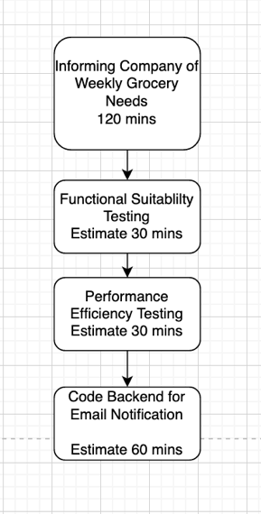

* 1. **Coding Back-end for email notification (60 minutes)**

1. **Estimation by Analogy**

I have previous working with email notifications sent based on a fixed timeframe. The store needs to receive an email every week with details about orders which are made weekly so they can prepare stocks beforehand. Based on the work I have done before with an email notification system this backlog item is very similar. One extra thing I need to do is to query the database for all weekly orders and get all their orders in a list and present them in the email.

**Previous Experience**

Coding backend for a Job portal site

* Email all the listed candidates once a new job post made
* Time required: ~45 minutes

**Current Task**

* Email store with a list item for weekly orders.
* Time estimated: ~60 minutes (Adjusted)
  1. **Functionality testing**

1. **Estimation by Comparison**

We have done functionality testing before in other backlog items and compared to functionality testing for Displaying Member data this is also similar. The effort required for testing is same.

*Comparison Table*

|  |  |
| --- | --- |
| **Display Member Data** | **Email Notification for Weekly Need** |
| Functional Suitability Testing  Time Required: 40 minutes | Functional Suitability Testing  Time Estimate: 30 minutes |

* 1. Performance Testing (30 Minutes)

1. **Estimation by Comparison**

We have done performance testing before in other backlog items and compared to performance testing for Displaying Member data this is also similar. The effort required for testing is same.

*Comparison Table*

|  |  |
| --- | --- |
| **Display Member Data** | **Email Notification for Weekly Need** |
| Performance Testing  Time Required: 30 minutes | Performance Testing  Time Estimate: 30 minutes |