**Project Proposal1 : GotoGro-MRM**

**Assignment 64C**

Name : Ekrar Efaz | Student ID : 103494172

Tutor Name : Dr. Naveed Ali  
Product Backlog ID : Weekly Email Updates

**Reflection Report of Effort Estimation**

I have chosen to work with the backlog item which provides the store with weekly updates on the members grocery needs via email and other platforms. I specifically am working with setting up the email system. This item was something I am familiar with and have worked on something similar before.

To completely implement the notification system, we must complete a set of subtasks which are listed below:

* Performance Testing (30 minutes)
* Functional Testing (30 minutes)
* Coding Back-end for email notification (60 minutes)

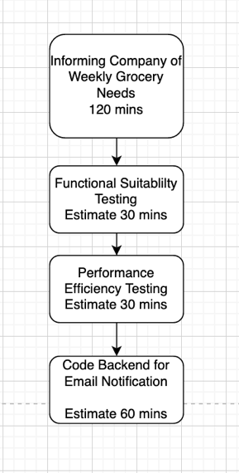

**Reflection on Actual Effort:**

1. *Coding Backend for email Notification (Estimation 60 minutes, Actual 62 minutes)*

I had spent very close to what I estimated for coding the backend of my application. I had kept a little bit of extra time just to be safe because I estimated to finish the task in 45 minutes considering my experience in backend. I had run into a few bugs which I couldn’t fix and, I had to read and figure out code snippets written by the team which dragged my time.

1. *Performance Testing (Estimation 30 minutes, Actual 27 minutes)*

Performance testing was quite a repetitive task which even though I had done performance testing for other backlog items in sprint1 couldn’t go any bit faster. I had to do multiple tests and watch if there the delay between sending and receiving of the email notification was more than the threshold. I spent 27 minutes on this task instead of the estimated 30 minutes which is very close.

1. *Functional Suitability Testing (Estimation 30 minutes, Actual 20 minutes)*

Functional Suitability Testing was the easiest task of all which took me only 20 minutes instead of the estimated 30 minutes. Although I had a bit of bug which made the program do some unintended actions. It took time to figure out what was wrong but everything else was fine. I just had to check whether the email notification and contents were correct after repeating the task a certain number of times.

**Evidence of Effort**

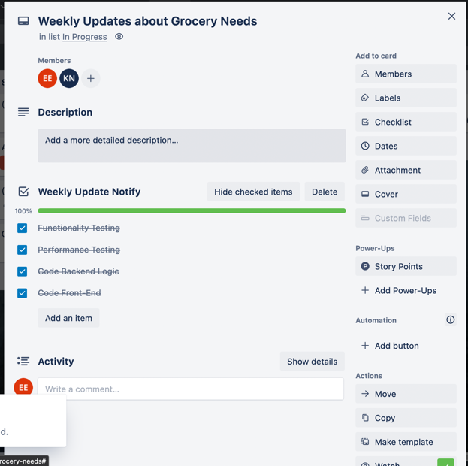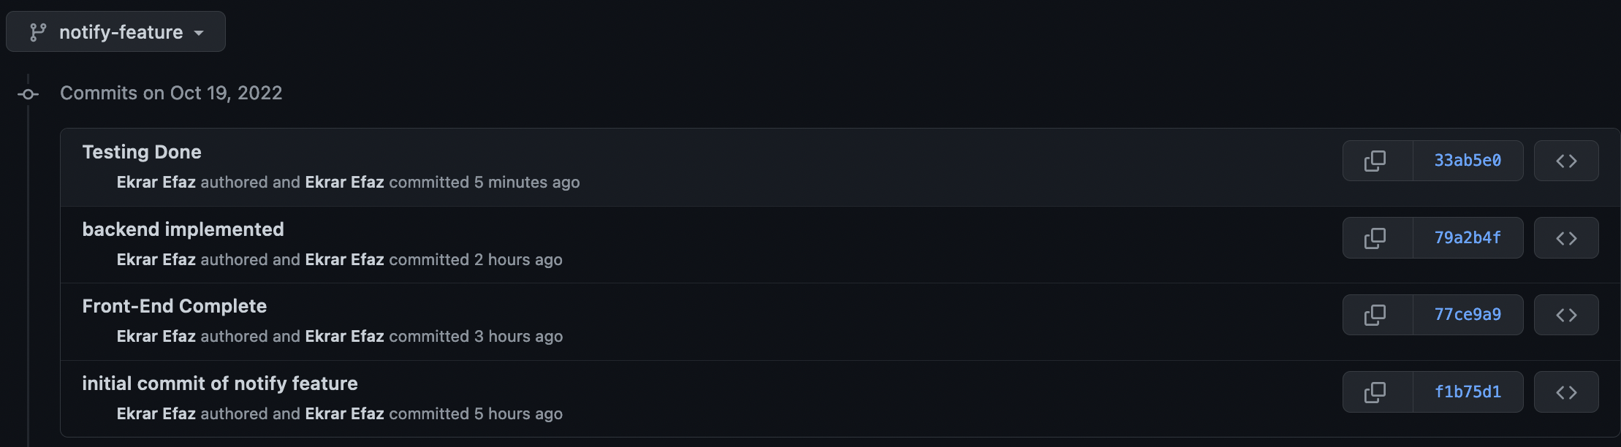

**Time Calculation**: From the GitHub commit time differences it is evident that it took me less than two hours to complete backend implementation and testing. The time the screenshot was taken was at the end of the work. Here we only worked with *backend* *implementation* and *Testing Done* commits.

Conclusion: My estimation was that I needed 120 minutes to complete this backlog item and I used up 109 minutes which is in the margin of +/- 10 %. This indicates that my estimation was close to my actual efforts. In my future sprints I would always keep extra time when estimating code for backend logic because even though I might have experience it doesn’t always work out in the first try.