**Project Proposal1 : GotoGro-MRM**

**Assignment 72D**

Name : Ekrar Efaz | Student ID : 103494172 Tutor Name : Dr. Naveed Ali  
Product Backlog ID : Search Function

**Quality Management**

Our aim in terms of quality is to deliver a software that meets end-user requirements and will perform as expected by the user. We aim to deliver a product that covers testing of each component independently and after it is integrated with the main system, the code review and refactoring and focus on the reliability of the software to deliver necessary information to the client.

***ISO 25010 Model***

**Backlog Item***: Search Function*

* Performance Efficiency
* Sub-characteristic: Time Behaviour
  + Quality Metric: Search results returned without delay
  + Threshold: 4/5 Search Results returned within 1s.

**Quality Checking tasks:**

**Task: 5 search attempts to be performed with time reading. Noted for each attempt.**

I would complete 5 tests with different search parameters. To test the time behaviour of the search function, I would record time from search attempted to result returned and note it as my time efficiency of search result.

The step must be repeated 5 times with no correlation with the other tests, so that I can take 5 independent readings and compare it to my threshold. Out of 5 readings 4 readings must be under 4seconds to pass the Performance Efficiency quality requirement.

This attempt to test is known as manual testing. This testing although prone to human error it gives us the time that a search takes to present results. If the search function takes more time than the threshold, we were to refactor the code for performance.

(search enter time – result return time) = time taken by search function

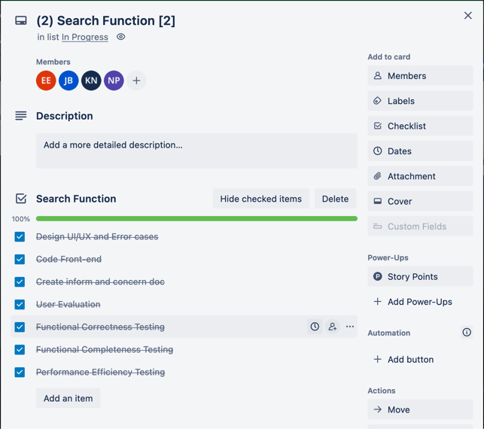

fig: Trello Board

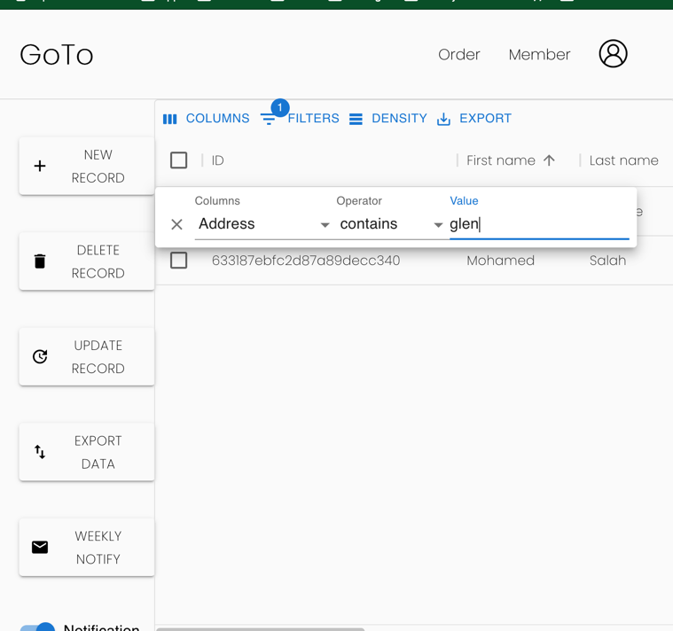

Fig: Search Bar