**Project Proposal1 : GotoGro-MRM**

**Assignment 73D**

Name : Ekrar Efaz | Student ID : 103494172

Tutor Name : Dr. Naveed Ali  
Product Backlog ID : Search Function

***ISO 25010 Model***

**Backlog Item***: Search Function*

* Performance Efficiency
* Sub-characteristic: Time Behaviour
  + Quality Metric: Search results returned without delay
  + Threshold: 4/5 Search Results returned within 1s.

**Task**: 5 search attempts performed with time reading for each attempt to return result.

***Task1****: Search by order (search term: milk)*

**Status**: Task Successful. The result was returned within 1 second.

***Task2****: Search by order (search term: bread)*

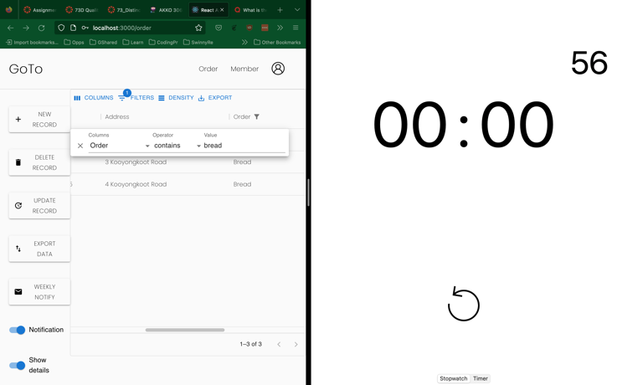

**Task Status**: Correct result returned in .56 seconds < 1 second

***Task3****: Search by Address (search term: Glenferrie)*

**Task Status**: Correct Result returned in .81s < 1 second

***Task4****: Search by First Name (search term: harry)*

***Task5****: Wrong First Name Search (search term: Salah)*

**Task Status**: Correct Result returned in .42s < 1s

***Trello Board***

***Time Record Mechanism***

*I recorded the time manually thus it would include human reaction time error. I had the client program and stopwatch open at the same time. Once I started entering the search term, I started the stopwatch countdown and once I got the result back on display, I stopped the countdown and noted the time accordingly. Although the search times low we must consider the human reaction time error. This task was repeated 5 times for 5 search cases and the recorded result has been present in this document.*

**Reflection Report**

I had conducted 5 tests to ensure the quality requirements of the search function were met. All the tests had passed returning correct results with no error. The threshold for the quality assessment was that 4 out of 5 tests will return correct results within 1 second. In my tests I managed to get 5 out 5 results correctly in < 1s.

Therefore, the backlog item satisfies the quality defined for Time Behaviour, it returns correct results within the defined threshold. I had performance issues with the search function in the beginning but to match the quality requirements I had to refactor my code for better performance and decide on a more efficient algorithm with the help of my teammates.

I would’ve adopted test-driven code mechanism to save more time and avoid all the refactoring. If I had written tests for performance and then code, I would’ve ended up with the final product in one go. For my future sprints I would adopt test driven coding wherever performance testing is required because manual testing takes good amount of time.