**HD Project Proposal: Chronos**  
Name: Ekrar Efaz | Student ID: 103494172

Tutor Name : Dr. Naveed Ali

Tutorial: 10:30 AT325

1. **Problem Description**

Chronos Society is a social organization based in Hawthorn. The organization aims to have serious timepiece enthusiast as its members. Currently, the board of directors has decided to take on a digital approach to their love for timepieces. They want to publish an app that would keep track of a member’s timepieces and his future endeavours in the world of watches along with be-friending other members on the platform to share their interests and collections. The objective of the project is to develop an internal software that allows members to save their collection and digitally interact with other members within the organization. The software is designed with a graphical interface feature and a database to store all data securely.

1. **Scope**

The project aims to digitize a user’s watch collection and present an interface for all users to share their collection and send request for exchanges.

The user can add timepieces to his collection also remove it. The user can add photo of his timepiece and the collection is displayed in the software in a listed format. The data is stored in a database that is connected to the software.

The application doesn’t handle financial transaction in case a trade or exchange has been made nor does it keep track of the exchanges or trades. Trades are solely the user’s responsibility. The application also doesn’t host any pre-loaded database of timepiece models which a user might wish to navigate.

1. **Stakeholders**

The frontline stakeholder is the customer i.e. The Chronos Society. Their interest is what forms the final product. The most important factor is to satisfy the directors of The Chronos Society. They hold the most power and influence in deciding the outcome of the product we are working on. Their requests and requirements for the Interface and Functionality of the software are given the highest priority.

Another important stakeholder for the product is our team. The team translates the companies requests in code lines and they steer the direction of the application’s outcome and have power to influence the clients based on ease of implementation and stronger security. We as stakeholders, are responsible for completing the tasks in assigned time with near perfect functionality.

1. **Deliverables and Schedule**

We plan to provide the client with a working prototype in Sprint 1. They will be provided with a user manual to test the functionalities of the prototype. With their approval of the prototype, we work to implement additional tweaks for the application and address the performance concerns. After completion of the development phase, we will provide the client team with Binaries, Source Code, Software Testing Results and a User Manual as a complete product.

1. **Release Schedule of Product Backlog Items**

|  |  |  |  |  |
| --- | --- | --- | --- | --- |
| *Index* | Item | Dependencies | Business Value  (1 least – 10 most) | Release Schedule (Sprint) |
| F1 | Add New Watch | NA | 8 | Sprint 1 |
| F2 | Add User | NA | 9 | Sprint 1 |
| F3 | Remove User | F2 | 9 | Sprint 1 |
| F4 | Capture Watch Photo | F1 | 5 | Sprint 1 |
| F5 | User Authentication | F2 | 6 | Sprint 1 |
| F6 | Display Watch Collection | F1, F2 | 8 | Sprint 1 |
| F7 | Add Friends | NA | 6 | Sprint 2 |
| F8 | Remove Watch | F1 | 7 | Sprint 2 |
| F9 | Send Messages | F8 | 5 | Sprint 2 |
| F10 | Search in Collection | F1, F7 | 6 | Sprint 2 |
| F11 | Toggle Light/Dark mode | NA | 2 | Sprint 2 |
| F12 | Daily Promotional Mails from Organization | NA | 7 | Sprint 2 |
| F13 | Report Daily user logon | F1 | 8 | Sprint 2 |

1. **Solution Domain**
   1. ***Problem Domain***
      * + Social Organization
        + Personal Collection
        + Luxury Retail Tracker
        + Data Management
   2. ***Solution Domain***
      * + Data Management System
        + Live Online Database
        + Mobile Application
        + Messaging System
   3. ***Knowledge in Related Field***
      * + Have used and Developed applications for personal tracking and data management
        + Not experienced in Luxury Retail Items.
   4. ***Knowledge in Related Programming Skills***
      * + We are team of experienced android developers who worked on various projects developing multifarious applications for different use cases.
        + We also have members with exceptional database management skills.
   5. ***Solution Writeup***

We will be working on an Android Application based on a survey done before the initiation of the project indicated that 93% of the Chronos members use Android device. Our plan to create a web-based application was not taken well by the Client because most of the users of the application will be in a middle age range and they won’t be comfortable using a web application. The client also wanted portability which an android application provides the best solution for.

The application will be used by different members of the Chronos Society and should be on portable device. So, we want to create an android application that the users will install on their preferred android device and use the login credentials provided by the Chronos sysadmins. The data will be hosted on a cloud database (Firebase) to ensure maximum uptime and easier access.

The android application will be divided into several activities starting with a login screen. The login authentication will be conducted by Firebase Authentication services.

The homepage will display two clickable options, one would lead the user to his collections and wish lists and the other would direct him to a social feed that would take data from firebase live-data server and display it to the user.

The collection page would be displayed via Android Recycler View and the list would handle click events to make changes to each item.

1. **Solution Architecture**

The architecture we are going for is the MVVM (Model-View-ViewModel) architecture. It is one of the most popular architectures in mobile development. It is popular because of its modularity. MVVM separates the functionalities of UI/UX, Business Logic and Datastore into 3 parts. View Displays the UI/UX to the user and has no logical backend functionalities. The ViewModel is called when a click action happens on the View and the ViewModel is the middleman between the Database and the View. The ViewModel updates the View after updating the database via the repository.

Every View has a ViewModel which is responsible for handling its updates and click events. The repository is the communicator between a datastore and the ViewModel. In our case Firebase API is the repository that communicates with the ViewModels.

1. **Criteria Formulation**

|  |  |  |
| --- | --- | --- |
| Factors | Justifications | Importance Scale 1 - 5 |
| Business Value | The business value should be highly considered since the business’s stand personally and its worth is important as it bring impacts towards the employee and the client itself. | 5 |
| Feature Dependency | Feature dependency should be considered because some backlog items are dependent on each other. Therefore, the order of the backlog items should be based on their dependencies. | 4 |
| Risk Involved | Risk Involved should be considered because some tasks that have high risks might take a lot of time to finish. If we consider “Risk Involved” as the criteria to evaluate the backlog items, we can ensure that the high-risk tasks always have backup time in case anything goes out of track. | 3 |

***Justification for Backlog Prioritization***

* The business value factor has the highest emphasize because the program must ensure it can provide the required features for the stakeholders. Therefore, these features must be considered as the first item in the ‘To-do list’, so that we can demonstrate to our stakeholders.
* Feature dependency is also one of the important things to do as some of the backlog items are dependent to each other. Dependencies can bring benefit towards the project by creating and managing lead and lag times. Lead time is duration of time which an activity can be accelerated or advanced in relation to the predecessor task, while the lag time is duration of time which a successor task is delayed in relation to the predecessor activity. This functionality is efficient when reschedule a task, all dependent tasks are automatically rescheduled rather than do update schedule for single task manually.
* Risk Involved is high factor as well as we must identify and analyse threats to an organization’s capital. Everyone must manage risk and makes the jobs safer to enables the successful project.

As per the justifications mentioned, the following backlog items were chosen for sprint 1 ordered by their working sequence.

1. *Add User*

This Item is the functioning backbone feature of the application. Since the application is user based the addition of a user holds the highest priority.

1. *Add Watch*

Adding a watch is also a primary feature of the app requested by the client. The applications aim is to display and track watch collections. So, adding a watch is one of the highest priorities we must deliver.

1. *Remove Watch*

Remove watch does exactly what the name suggests. It removes watches from a collection added by the user. Deletion always proves to be a fundamental feature in every situation. The user might not have a watch in his collection anymore and would want to remove it from app database as well. Thus, deletion is on the higher end of the priority scale.

1. *User Authentication*

All the user accounts are determined by the client organization to make sure only the elite members are given the authorization to use the application. So, authentication of users based on password and username is on higher priority

1. *Display Watch Collection*

The user would want to see all his collections in a single page. The display of a user’s collection is one of the key features of the application. That’s why it is put on high priority.

1. *Capture Watch photo*

Capturing and add a watch photo to the collection database is a nice feature of the application agreed upon by the client upon proposal. This item depends on the higher priority items such as add user and add watch.

1. **WBS**

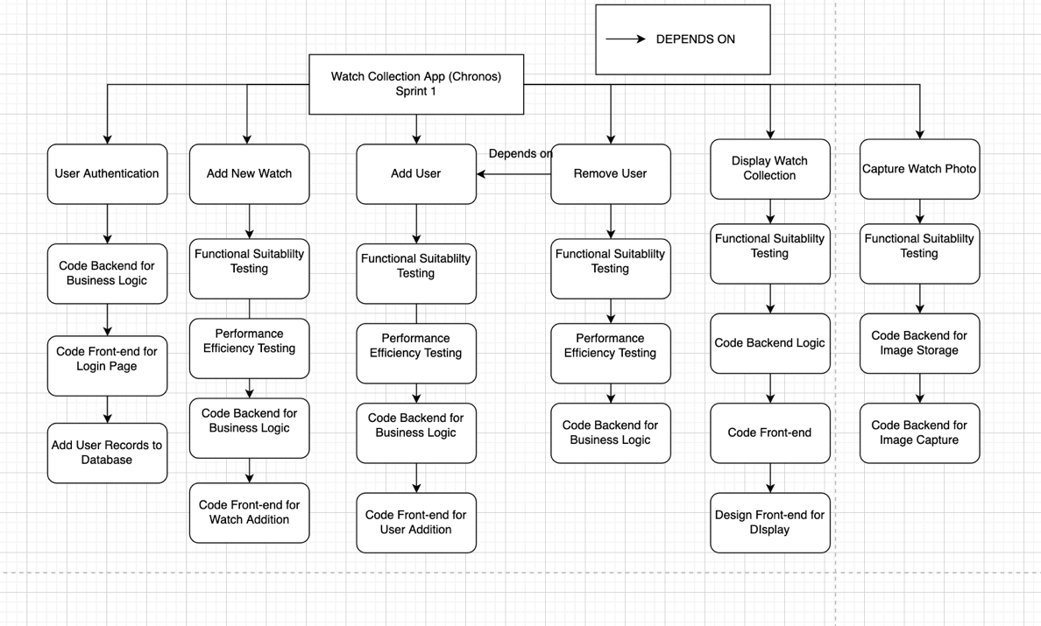

1. **Quality Management**

***Backlog Item: Add New Watch***

* Quality characteristic: Functional suitability
  + Sub-characteristic: Functional completeness
    - Quality metric/ Test condition: Total tests failures
    - Threshold: Less than 8% of total test cases have failed results.
  + Sub-characteristic: Functional correctness
    - Quality metric/ Test condition: Correct tasks done
    - Threshold: 100% of the total tasks are done correctly.
* Quality characteristic: Performance Efficiency
  + Sub-characteristic: Time Behaviour
    - Quality metric/ Test condition: Time for executing one task
    - Threshold: Executing a task takes less than 2 seconds.

***Backlog Item: Add User***

* Quality characteristic: Functional suitability
  + Sub-characteristic: Functional completeness
    - Quality metric/ Test condition: Total tests failures
    - Threshold: Less than 8% of total test cases have failed results.
  + Sub-characteristic: Functional correctness
    - Quality metric/ Test condition: Correct tasks done
    - Threshold: 100% of the total tasks are done correctly.

***Backlog Item: Remove User***

* Quality characteristic: Functional suitability
  + Sub-characteristic: Functional completeness
    - Quality metric/ Test condition: Total tests failures
    - Threshold: Less than 8% of total test cases have failed results.
  + Sub-characteristic: Functional correctness
    - Quality metric/ Test condition: Correct tasks done
    - Threshold: 100% of the total tasks are done correctly.
* Quality characteristic: Security
  + Sub-characteristic: Authenticity
    - Quality Metric: Number of successful delete attempts without authentication
    - Threshold: No. of successful attempts should be < 3%

***Backlog Item: Capture Watch Photo***

* Quality characteristic: Usability
  + Sub-characteristic: Operability
    - Quality metric/ Test condition: Mean score evaluated by the users (on a scale of 10)
    - Threshold: The mean score is greater than 8
* Quality characteristic: Functional suitability
  + Sub-characteristic: Functional completeness
    - Quality metric/ Test condition: Total tests failures
    - Threshold: Less than 8% of total test cases have failed results.
  + Sub-characteristic: Functional correctness
    - Quality metric/ Test condition: Correct tasks done
    - Threshold: 100% of the total tasks are done correctly.

***Backlog Item: User Authentication***

* Quality characteristic: Reliability
  + Sub-characteristic: Fault Tolerance
    - Quality metric: No. of false positives during authentication
    - Threshold: For total number of logins the false positives should be < 2%.
* Quality characteristic: Functional suitability
  + Sub-characteristic: Functional correctness
    - Quality metric/ Test condition: Correct tasks done
    - Threshold: 100% of the total tasks are done correctly.

***Backlog Item: Display Watch Collection***

* Quality characteristic: Functional suitability
  + Sub-characteristic: Functional completeness
    - Quality metric/ Test condition: Total tests failures
    - Threshold: Less than 8% of total test cases have failed results.
  + Sub-characteristic: Functional correctness
    - Quality metric/ Test condition: Correct tasks done
    - Threshold: 100% of the total tasks are done correctly.
* Quality characteristic: Usability
  + Sub-characteristic: Operability
    - Quality metric/ Test condition: Mean score evaluated by the users (on a scale of 10)
    - Threshold: The mean score is greater than 8
* Quality characteristic: Security
  + Sub-characteristic: Confidentiality
    - Quality metric/ Test condition: Number of valid accesses to the data
    - Threshold: No invalid access occurs.
* Quality characteristic: Portability
  + Sub-characteristic: Adaptability
    - Quality metric/ Test condition: The ability to display the data in the mobile’s screen size.
    - Threshold: All data is displayed in the mobile.

1. ***Effort Estimation***

|  |  |  |  |
| --- | --- | --- | --- |
| ***Backlog item*** | ***Estimation*** | ***Estimation Methodology*** | ***Justification*** |
| *User Authentication* | *Overall: 120 mins*  *-Code Backend logic (60 mins)*  *-Code Frontend (30mins)*  *-Add user records to database (30mins)* | *Estimation by Comparison* | *I have previously worked with a much larger scale authentication system with PHP which required layered access control. Compared to that this task is a small-scale authentication system which would take half the time of the previous task which is 120 mins.* |
| *Add Watch* | *Overall: 150 mins*  *-Functionality Testing (30mins)*  *-Performance Testing (30 mins)*  *-Code Backend logic (60 mins)*  *-Code Frontend (30mins)* | *Estimation by Analogy* | *Adding Watch using a form and insert it into database is exactly like adding user orders to the database I worked on earlier. That task had exactly simthe time it will take would be similar as well.* |
| *Add User* | *Overall: 150 mins*  *-Functionality Testing (30mins)*  *-Performance Testing (30 mins)*  *-Code Backend logic (60 mins)*  *-Code Frontend (30mins)* | *Justification by Comparison* | *Just like adding user orders to the database I previously worked on, adding Users via a form, and inserting it corresponds. That task's subtasks were identical to those in Adding a User. Therefore, the amount of time required would be comparable.* |
| *Remove User* | *Overall: 150 mins*  *-Functionality Testing (30mins)*  *-Performance Testing (30 mins)*  *-Code Backend logic (60 mins)* | *Justification by Analogy* | *Removing User required Functionality and Performance testing which has been done for other sprint backlog items, coding the backend for deleting user was like tasks I have done before in other web-based applications.* |
| *Display Watch Collection* | *Overall: 180 mins*  *-Functionality Testing (30mins)*  *-Performance Testing (30 mins)*  *-Code Backend logic (90 mins)*  *-Code Frontend (30mins)*  *-Design Frontend (30mins)* | *Estimation by Analogy* | *Designing the Frontend and coding the frontend was a very simple task like other frontend tasks in the backlog item.*  *I am very familiar with RecyclerView and how they are implemented for performance.*  *I have done several RecyclerView code for different projects and even to help my friends with their android application to achieve better performance.* |
| *Capture Photo* | *Overall: 180 mins*  *- Functionality Testing (30mins)*  *-Code Backend for Image Capture (90mins)*  *-Code Backend for Image storage (60mins)* | *Estimation by Experts* | *I had no experience in capturing photos using an android app and storing the data in a database. I consulted one of my expert Android Dev classmates who interns as an Android developer about the subjective estimation on how long it takes him to do something like this. Based on his estimation I added some extra safety time for myself and ended up with 180 minutes for the task.* |