**Project Proposal[1] :** **“***GotoGro” MRM System*

Ekrar Efaz (103494172)

Tutorial: Tuesday 10:30 ATC325

Tutor: Naveed Ali

**Solution Direction**

*I would be going for a Web-Based application because webpages can be accessed from any kind of device as long as they have a supporting web-browser thus it gets rid of the device constraints that I have to tackle. Device constraints is one of the primary reasons I dropped my idea of developing an android application. If I was developing an android application that would limit the users to android no IOS users or unsupported phones would work. I would be working with the 3 tier Client-Server architecture. Since our problem domain deals with a database-oriented management system with fixed number of client-side PCs are better off using the Client-Server Architecture.*

***Alternatives:***

*Further analysis of the problem suggests that we have a limited number of clients (Management Team) that are going to check and modify the records. We are not working with an e-commerce website that allows the customers to place orders rather it allows the store management team to add/remove new customer members and check their previous purchases. Having a mobile device would limit the number of users based on hardware and desktop application would require the store to put more hardware investments from pocket so they can have enough desktops on location. Therefore, if we have a back-end relational database which will keep all the records required by the store and present them whenever they are requested by the client on a webpage that would be the best proposed solution because the webpage can be accessed from any device if they are on the same network.*

***KoST analysis***

*Knowledge*

*Problem Domain: We are working to help a local member-based grocery store to build a database-oriented record management application that stores and displays the customer information records and their sales records. GotoGro is having problem in manual management of their paper-based member management system, and they request a transition to a digital software-based approach to their member record management.*

*Solution Domain: We can provide a solution for GotoGro by building a web application that handles their Inventory list and members list in a database and displays the necessary information on the front-end of the web application also allowing them to make necessary changes. The web application would also provide downloadable sales and data analysis with outputs in CSV formats that can be used for further learning.*

*Skill: I have the following skills that will aid the development of the application.*

* *Front-end development with HTML, CSS, VanillaJS*
* *Back-end development with PHP and JavaScript*
* *Database management with MySQL and MariaDB*
* *Nginx server management*

*Technology: Client-Server solutions are very popular because of their simplicity and ease of maintenance. It also provides possibility for real-time systems to be built. ATM machines are good example of Client-Server architecture which are also interactive.*

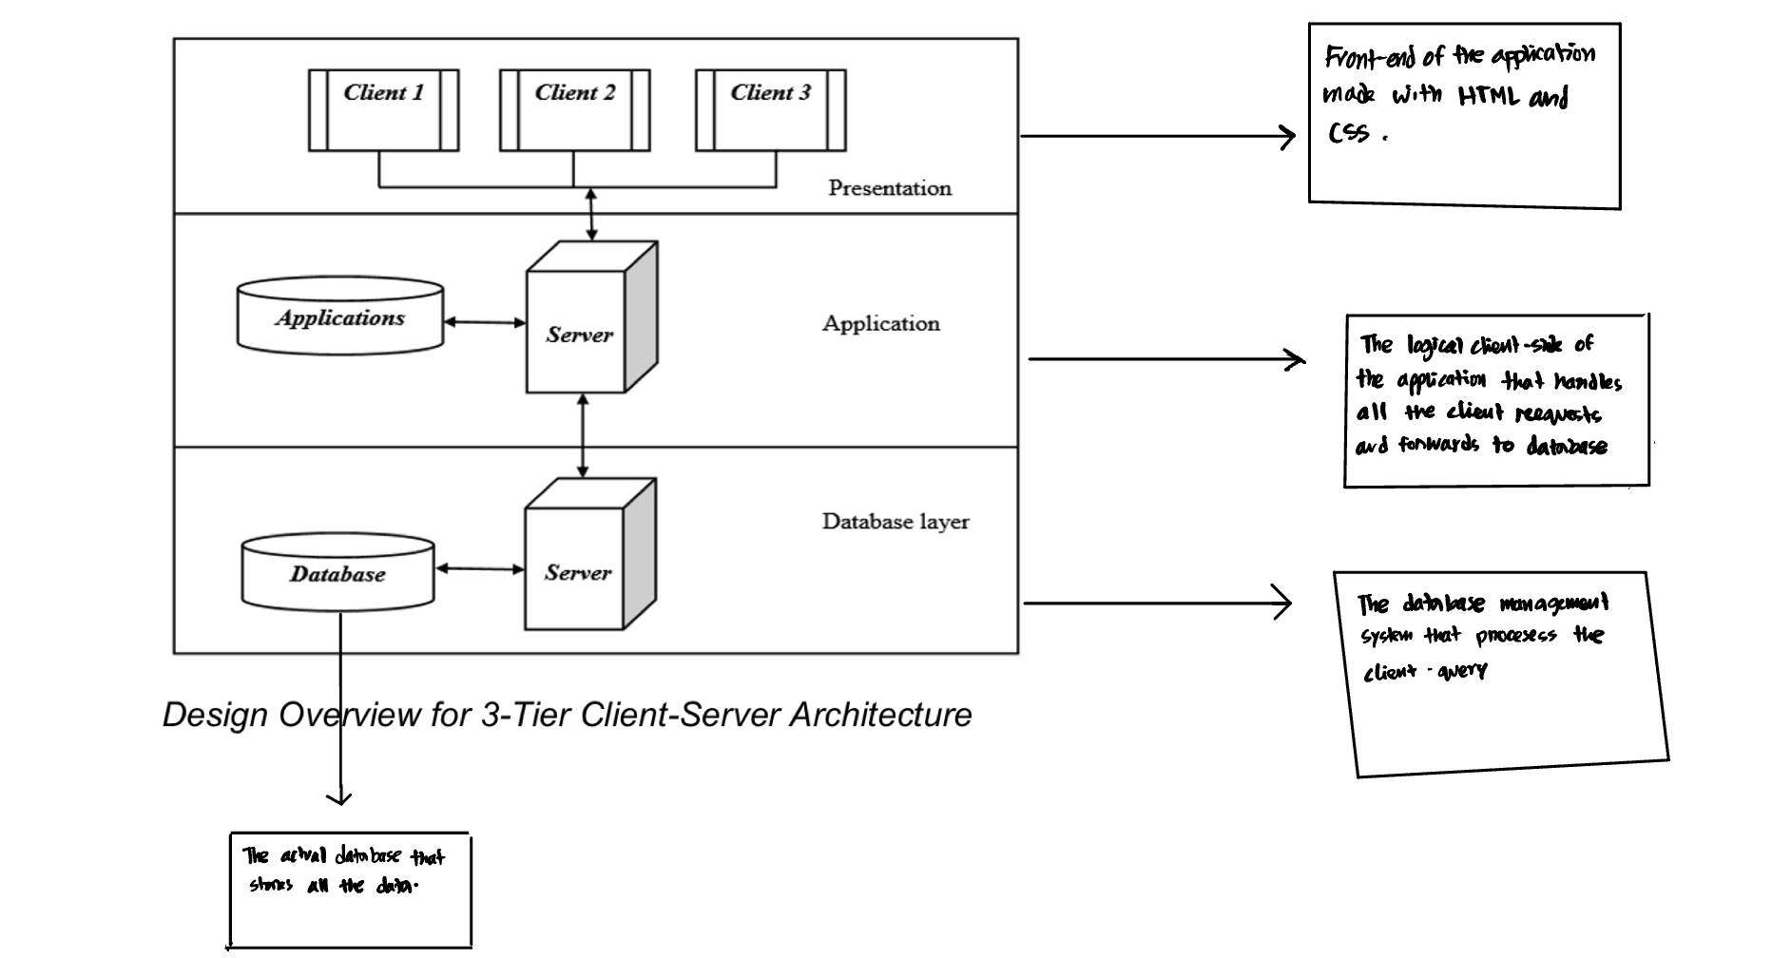

***Design Overview for 3-Tier Client-Server Architecture***

*The Database Layer server is a RDBMS which stores all the data, and the application layer holds the responsibility for business logic. The Presentation Layer only displays data to the user and all the interaction with the data is handled by the Application layer to perform CRUD operations in the database. There might be multiple clients in the Presentation layer, but all the requests are handled by the single application layer server. In this three-tier architecture every pair of layer works as a Client-Server Architecture such as Presentation-Application/Application-Database.*

1. This document is by no means a “full project proposal”. It has been simplified and customized for the purposes of SWE30010 teaching. The full project proposal includes many other sections which have not been discussed during the first few weeks of SWE30010 teaching.