CS 398 Term Project

PL SQL Project management system

Ekrem Çetinkaya – Ömer said bükte

FALL 2016

**INTRODUCTION**

This report is about the project management database which is PL/SQL term project. The report will include information about the database. Report will start with overview of the project which gives information about how database is arranged, business rules that are applied in the project and how they are implemented. Finally, this report will be finalized with last words about the project and our personal opinion about it.

**PROJECT OVERVIEW**

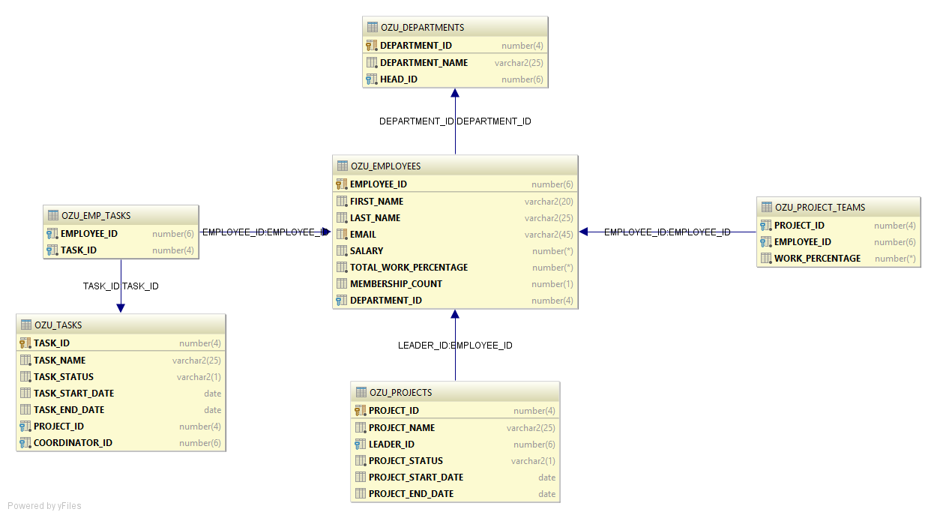

The database of the project management system consists of 6 tables which are the following:

1. **OZU_DEPARTMENTS** : This table stores information about departments.
2. **OZU_EMPLOYEES:** This table stores information about employees along with their total work percentage among projects and total project member count.
3. **OZU_PROJECTS:** This table stores information about projects.
4. **OZU_TASKS:** This table stores information about tasks, which are coordinated by single member but shared among several employees.
5. **OZU_PROJECT_TEAMS:** This table stores information about project teams.

One can find the team of certain project with the following command:

**SELECT** *\** **FROM** OZU_PROJECT_TEAMS **WHERE PROJECT_ID** = <Project ID here>;

Also, all projects of an specific employee can be found with the following command:

**SELECT** *\** **FROM** OZU_PROJECT_TEAMS **WHERE EMPLOYEE_ID** = <Employee ID here>;

1. **OZU_EMP_TASKS:** This table stores information about employee tasks.

One can find the all tasks of an employee with the following command:

**SELECT** *\** **FROM** OZU_TASKS **NATURAL JOIN** OZU_EMP_TASKS

**WHERE EMPLOYEE_ID** = <Employee ID here>;

There are certain business rules in this projects which are implemented with triggers. Those rules and the triggers that are used for these rules are:

1. Status of a project or task can only be changed as following P -> S -> (C or F). If user tries to do any other changes, he/she gets an error. The triggers that are used for this rule are:

* project_status_change_trigger
* task_status_change_trigger

1. A project must have a leader unless its status is P. The trigger that is used for this rule is:

* project_leader_null_trigger

1. An employee cannot be member of more than 5 active projects. The trigger that is used for this rule also updates the member count of the employee accordingly. Trigger is :

* member_count_trigger

1. The total of work percentages of an employee in active projects cannot be more than 1. The trigger that is used for this also updates the total work percentage of the empoloyee accordingly. Trigger is:

* work_percentage_trigger

1. A member of project team cannot be leader of the project if his/her manager is also in the same project team. The trigger that is used for this rule is:

* project_leader_correct_trigger

1. A project team may have only one leader. This business rule is applied in the database table design with the LEADER_ID column in the OZU_PROJECTS table.
2. All changes made in task or project status are logged in an audit table. For this rule, two additional tables are implemented as following:

**CREATE TABLE** OZU_AUDIT_TASKS ( **CREATE TABLE** OZU_AUDIT_PROJECTS (  
 **C_TASK_ID NUMBER**(4), **C_PROJECT_ID NUMBER**(4),  
 **C_DATE DATE**, **C_DATE DATE**,  
 **C_OLD_STATUS VARCHAR2**(1), **C_OLD_STATUS VARCHAR2**(1),  
 **C_NEW_STATUS VARCHAR2**(1) **C_NEW_STATUS VARCHAR2**(1)  
); );

And the triggers that are used for logging are:

* task_audit_trigger
* project_audit_trigger

1. When a Project is finished which means project status of the project becomes ‘C’ or ‘F’ or the project is deleted from OZU_PROJECTS table,
   * The tasks related to this project are deleted from OZU_TASKS table,
   * Records of employees who have tasks of this project are deleted from OZU_EMP_TASKS table,
   * The team of this project is disbanded which means all of the records which contains this project’s id in the OZU_PROJECT_TEAMS table are deleted.

The trigger that is used for this rule is:

* project_complete_trigger

1. When a task is completed which means task status of the task becomes ‘C’ or ‘F’ or the task is deleted from OZU_TASKS table,
   * Records of employees who have this task are deleted from OZU_EMP_TASKS table.

The trigger that is used for this rule is:

* task_complete_trigger

**CONCLUSION**

We created a database for a consulting company which can be used for keeping track on its employees, projects, tasks and departments.

In our case we have created the database according to the our business rules and constraints. These business rules provided to us by our instructor.We have also added some other business rules/constraints in order to create most efficient database.Although we have created this database according to our Instructors business rules/constraints, the model of this database can also be adapted to meet other purposes and thus be used for other projects. We have tried to keep the database structure simple, which makes it easy for also other programmers to understand it.

During our PL/SQL course we have learned about database design. This project gave us the opportunity to try our newly acquired skills in practice and also helped us to understand a lot about how challenging can a database creation be. Furthermore, the challenges we faced during this process made us familiar with common errors and their solutions about PL/SQL. While doing this project we also gained deep understanding on database design and how it can be implemented in real life scenarios. We believe from now on, we can use our database designing skills in other projects.

To wrap it up, this project had strengthen our PL/SQL skills and made them permanent knowledge for us hopefuly. The expreience we earned from this project will definitely assist us in our future life.