PURE ACOUSTIC CASE
Real Part
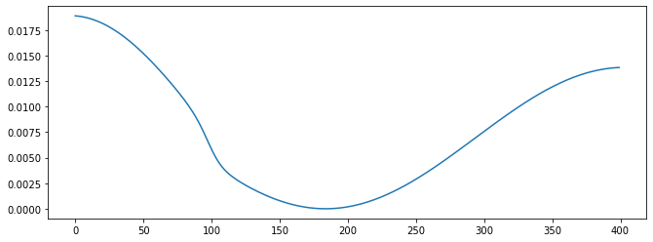

Matthew’s Real Part (IMAG PART IN PRF PAPER)

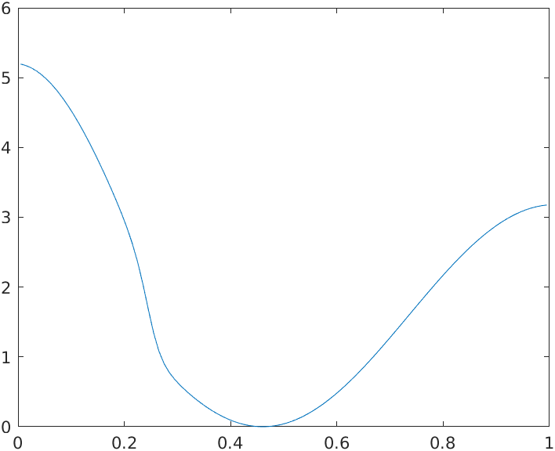

Imag Part

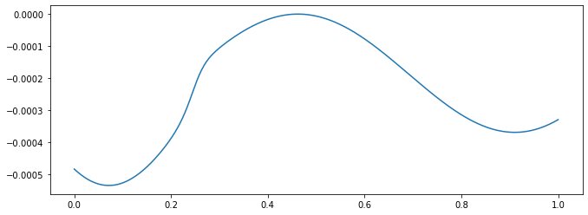

Matthew’s Imag Part(REAL PART IN PRF PAPER)

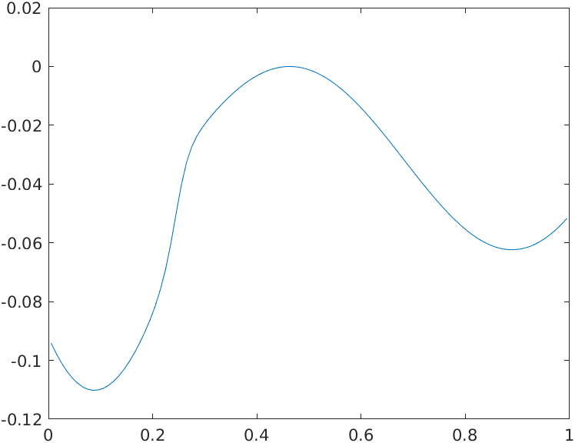

FLAME CASE
Real Part

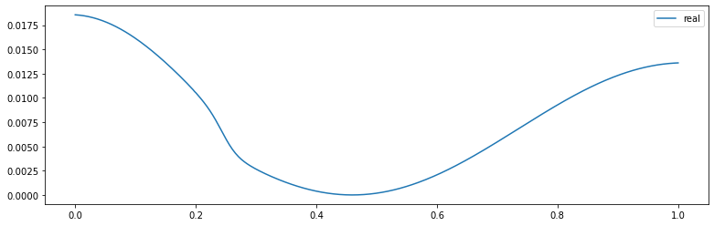

Matthew’s Real Part(IMAG PART IN PRF PAPER)

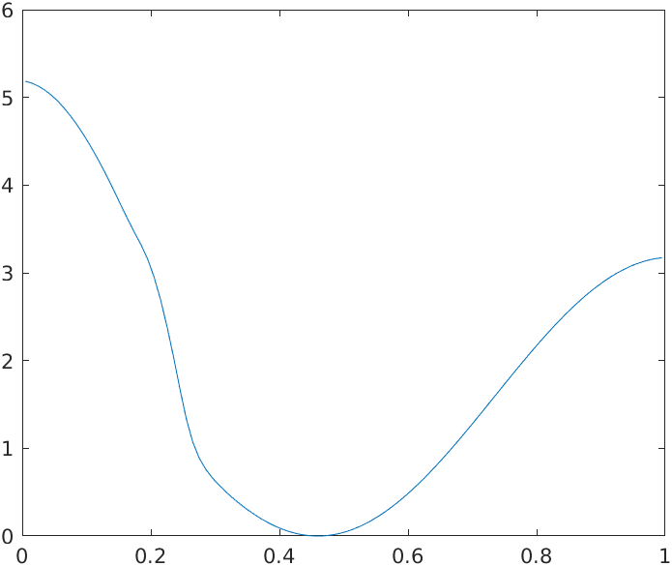

Imag Part

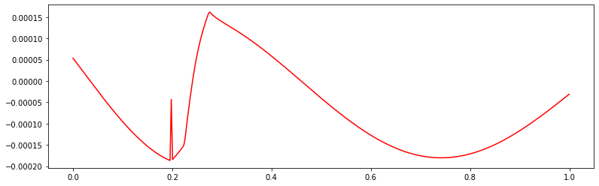

Matthew’s Imag Part(REAL PART IN PRF PAPER)

