**Firecrawl with MCP Architecture and Integration**

Firecrawl is an API service and open-source tool designed to simplify web scraping and crawling, transforming website content into clean, LLM-ready formats like markdown, HTML, or structured data. Built by Mendable.ai, it crawls accessible subpages without requiring a sitemap, handling complex tasks like JavaScript rendering, rate limits, and dynamic content. Key features include:

* **Scrape**: Extracts targeted data from a single URL, supporting formats like markdown, HTML, screenshots, or structured data via AI-powered extraction.
* **Crawl**: Recursively navigates and scrapes entire websites, collecting content from all accessible subpages.
* **Map**: Quickly retrieves all URLs of a website for structural overview.
* **Extract**: Uses AI to convert unstructured data into structured formats, ideal for integration with AI applications.

The Model Context Protocol (MCP) is an open standard that enables secure, standardized communication between AI applications (like LLMs) and external data sources or tools, such as Firecrawl’s web scraping capabilities. Firecrawl’s MCP Server integrates its powerful web scraping, crawling, and data extraction features into AI workflows, allowing tools like Cursor, Claude Desktop, or other LLM clients to access web data seamlessly. Below, I’ll describe the architecture and provide a conceptual diagram for Firecrawl’s MCP integration, as no official diagram is explicitly provided in the sources.

**Conceptual Diagram Description**

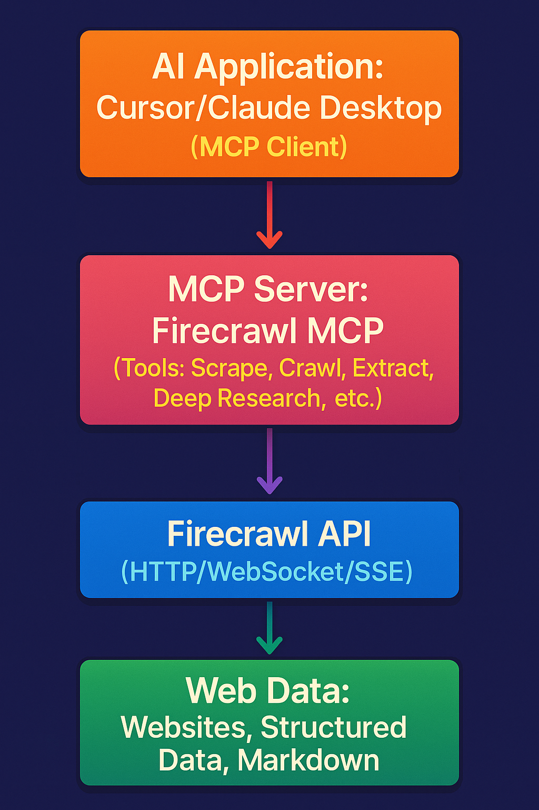

Firecrawl’s Model Context Protocol server integrates scraping capabilities into tools like Cursor or Claude Desktop

Step 1: Register in <https://www.firecrawl.dev/app>

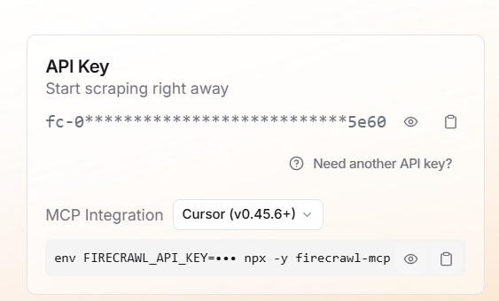

Copy the MCP Integration with Code

{

"mcpServers": {

"mcp-server-firecrawl": {

"command": "npx",

"args": ["-y", "firecrawl-mcp"],

"env": {

"FIRECRAWL_API_KEY": "fc-08144441b2974407a93565c59df35e60"

}

}

}

}

Step 2: Goto Claude Desktop

Goto > File > Settings > Developer >Edit Config

"C:\Users\ekris\AppData\Roaming\Claude\claude_desktop_config.json"

And paste the MCP Integration code of firecrawl and restart the Claude desktop.

Confirm mcp-server-firecrawl is running in Claude desktop.

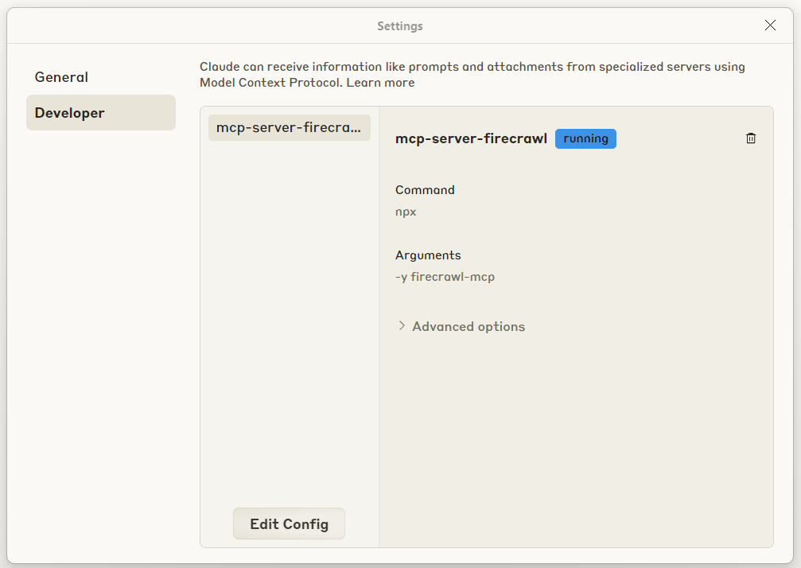

Testing:

Input: give some URL like GitHub <https://github.com/ekrishna10>

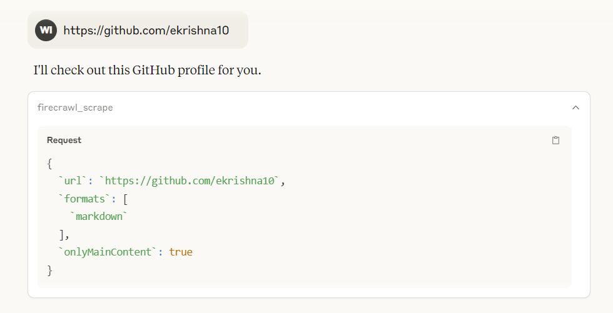

Click on Allow always if any pop up

Output:

