

**A protocol for seamless integration between LLM applications and external data sources**

**The Model Context Protocol (MCP) is an open protocol that enables seamless integration between LLM applications and external data sources and tools. Whether you're building an AI-powered IDE, enhancing a chat interface, or creating custom AI workflows, MCP provides a standardized way to connect LLMs with the context they need.**

**Filesystem MCP Server**

https://github.com/modelcontextprotocol/servers/tree/main/src/filesystem

Node.js server implementing Model Context Protocol (MCP) for filesystem operations.

Features

* Read/write files
* Create/list/delete directories
* Move files/directories
* Search files
* Get file metadata

**Software:**

node-v22.14.0-x64

Claude-Setup-x64

**File system:**

Create folder – mcp in local system

Create few files as you wish

Example:

"D:\fullstackNaresh\mcp\local1.txt"

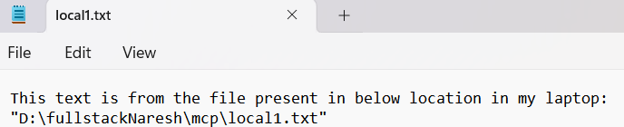

"D:\fullstackNaresh\mcp\local2.txt"

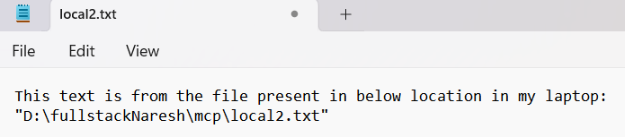

Install the software Claude-Setup-x64.exe and node-v22.14.0-x64.exe

Post installation you will see the Claude icon in the desktop

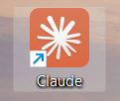

Click on it and open it , Goto File > Settings

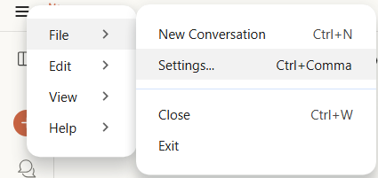

Select Developer on the pop up

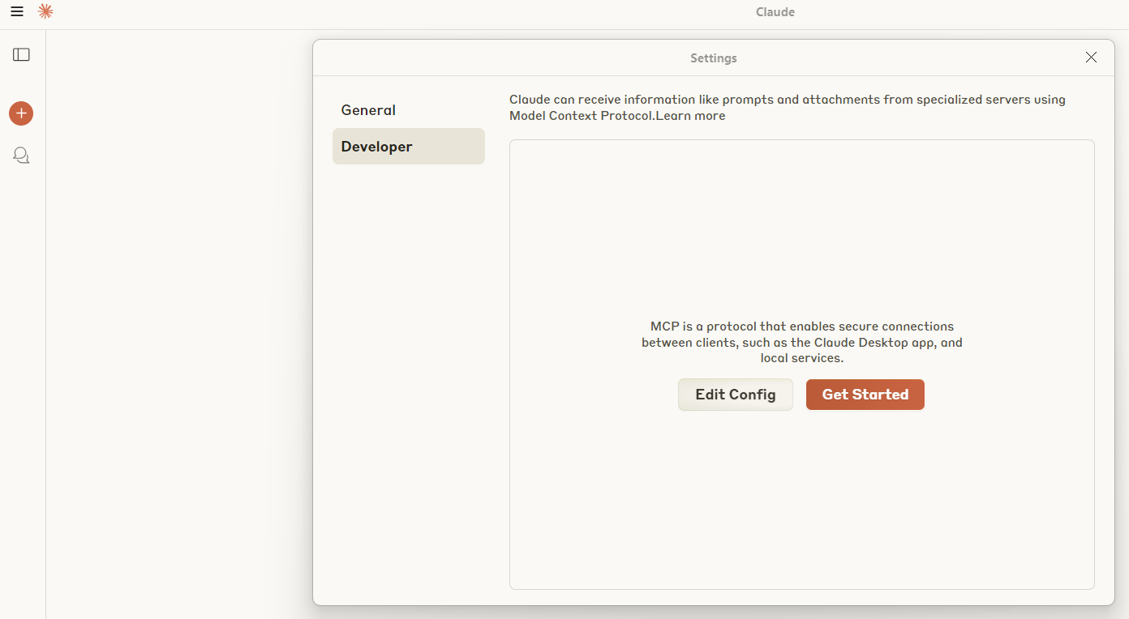

Click on Edit Config

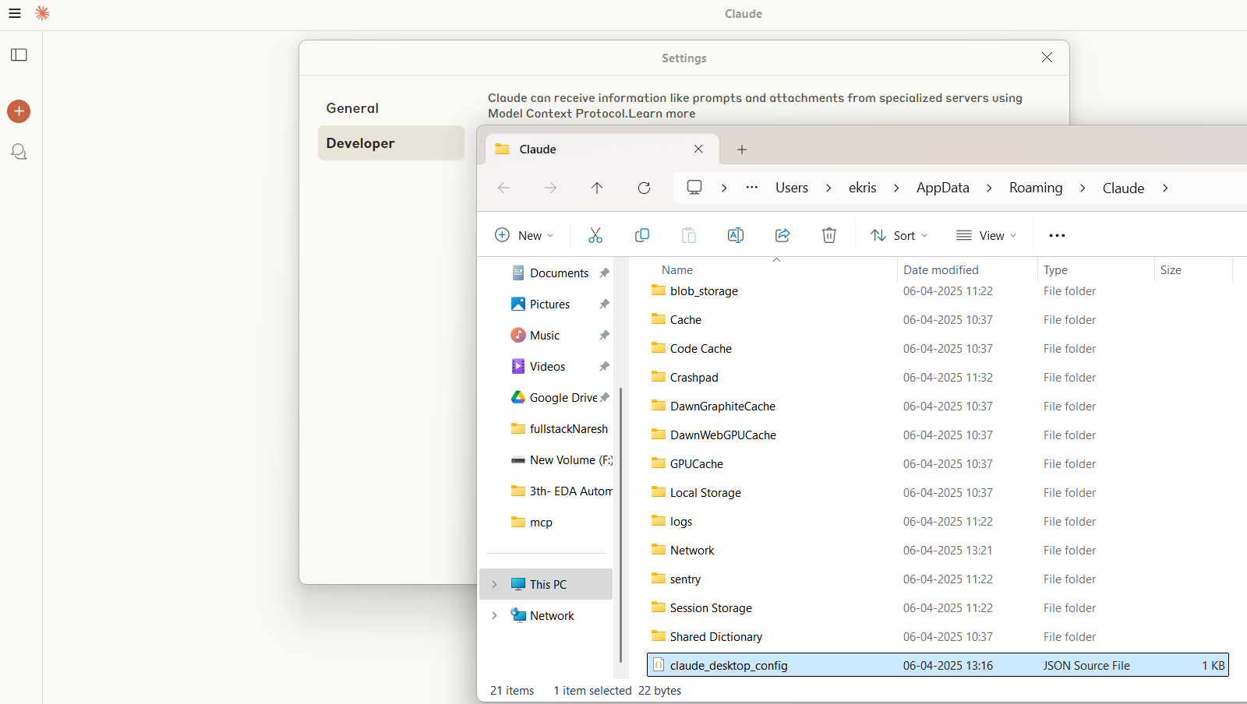

Open the "C:\Users\ekris\AppData\Roaming\Claude\claude_desktop_config.json"

The file will be open in vs code

Goto

<https://github.com/modelcontextprotocol/servers/tree/main/src/filesystem>

<https://github.com/modelcontextprotocol/servers/tree/main/src/filesystem#npx>

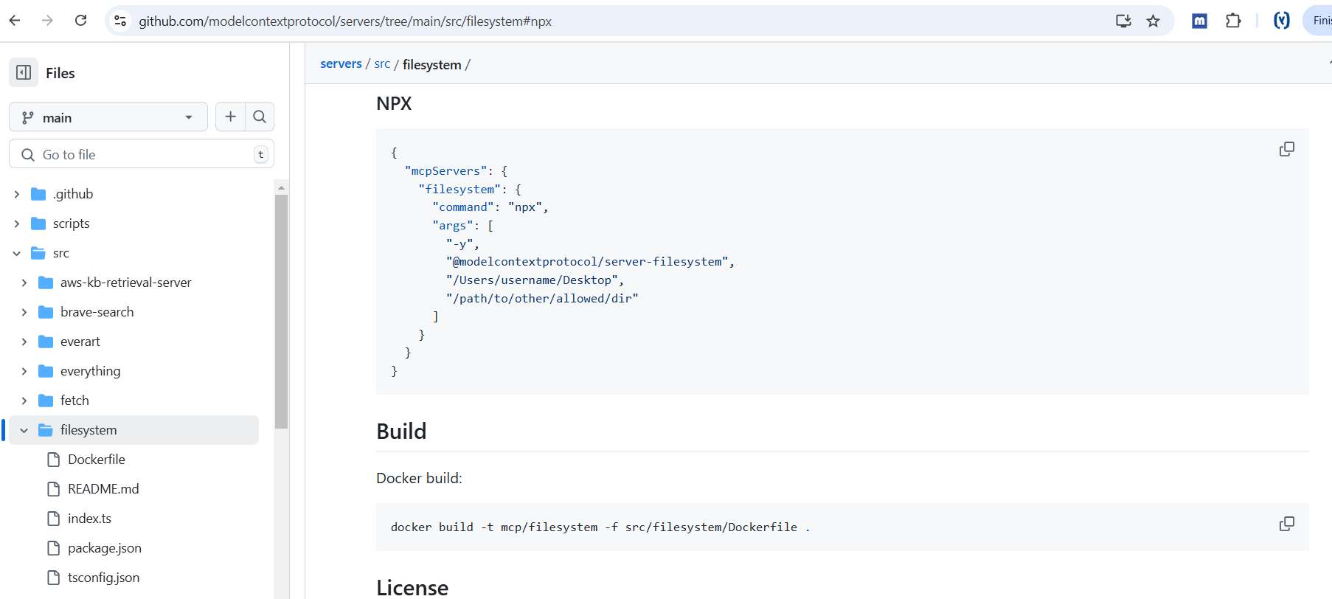

Copy the npx and paste into the claude_desktop_config.json

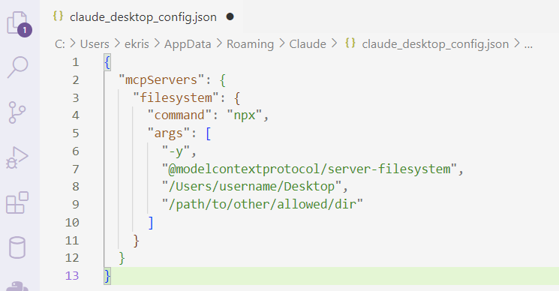

Change the line 8 & 9 number to point to your local file system where files are created

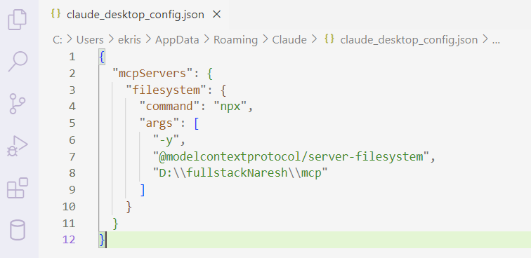

Goto claude > File > Settings > Developer and click on Edit Config and select the claude_desktop_config.json

"C:\Users\ekris\AppData\Roaming\Claude\claude_desktop_config.json"

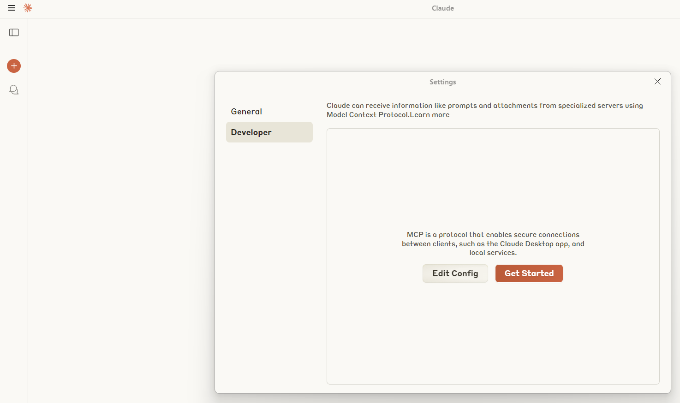

Restart the Claude and go to Claude > File > Settings > Developer to confirm the connection with **Filesystem MCP Server**

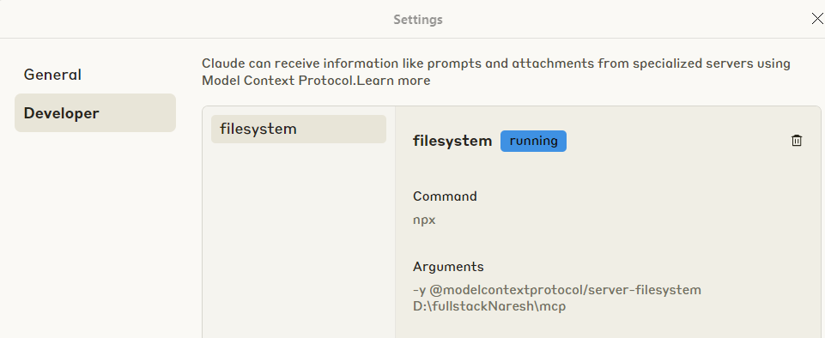

Note: If you get any issue please install the software node-v22.14.0-x64.exe and check again.

So filesystem

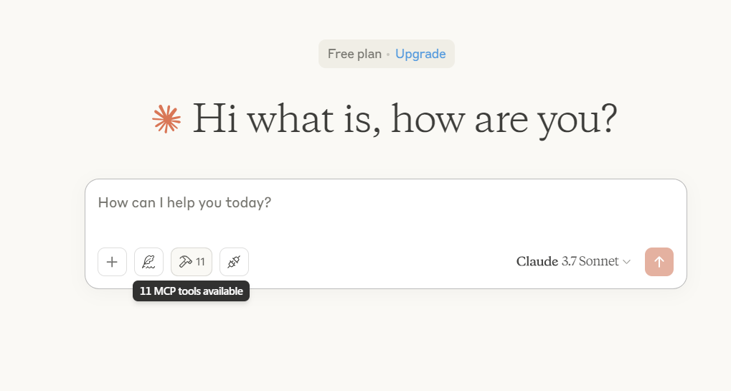

You should see the hammer symbol that all the steps are correct .

Now ask question related to the file created

Input/ouput:

