

**A protocol for seamless integration between LLM applications and external data sources**

**The Model Context Protocol (MCP) is an open protocol that enables seamless integration between LLM applications and external data sources and tools. Whether you're building an AI-powered IDE, enhancing a chat interface, or creating custom AI workflows, MCP provides a standardized way to connect LLMs with the context they need.**

**MCP Server for MySQL based on NodeJS**

A Model Context Protocol server that provides access to MySQL databases. This server enables LLMs to inspect database schemas and execute SQL queries.

**Requirements:**

* Node.js v18 or higher
* MySQL 5.7 or higher (MySQL 8.0+ recommended)
* MySQL user with appropriate permissions for the operations you need
* For write operations: MySQL user with INSERT, UPDATE, and/or DELETE privileges

**Claude Desktop**

To manually configure the MCP server for Claude Desktop App, add the following to your claude_desktop_config.json file (typically located in your user directory)

**Do the necessary changes in claude_desktop_config.json for mysql and node as show below:**

**"C:\Users\ekris\AppData\Roaming\Claude\claude_desktop_config.json"**

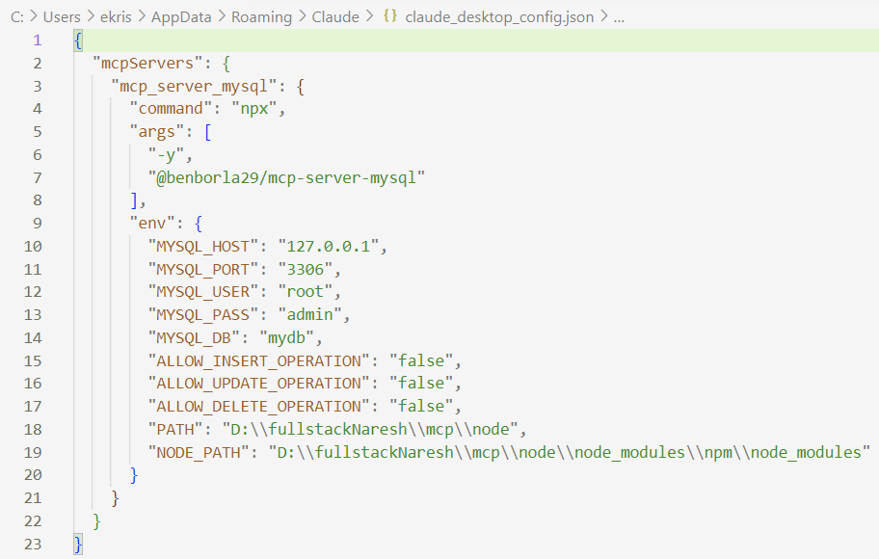

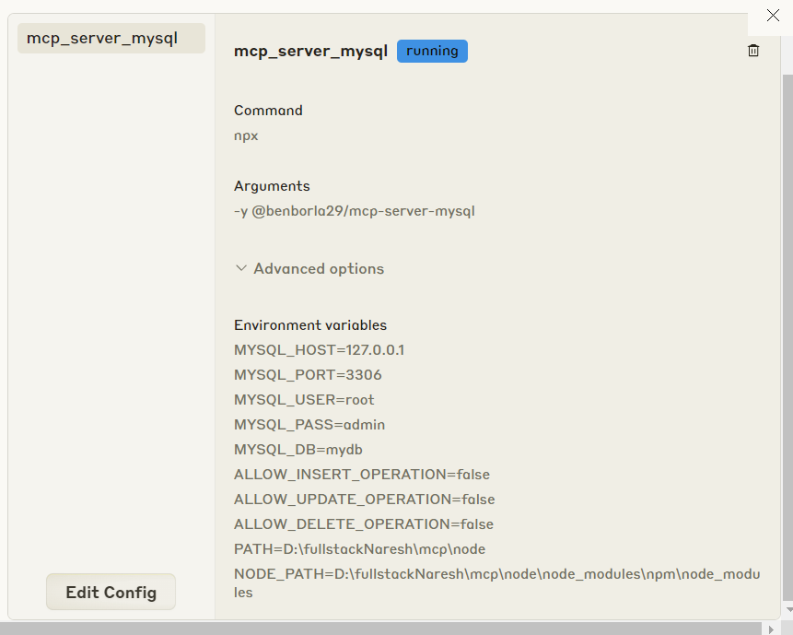

**Logs location:**

**"C:\Users\ekris\AppData\Roaming\Claude\logs\mcp-server-mcp_server_mysql.log"**

**Mysql workbench:**

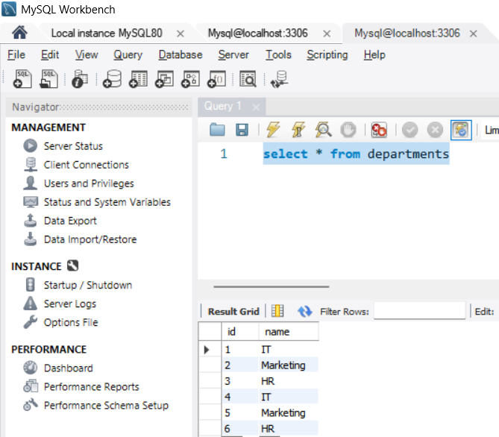

**Goto Claude Desktop and ask question related to database:**

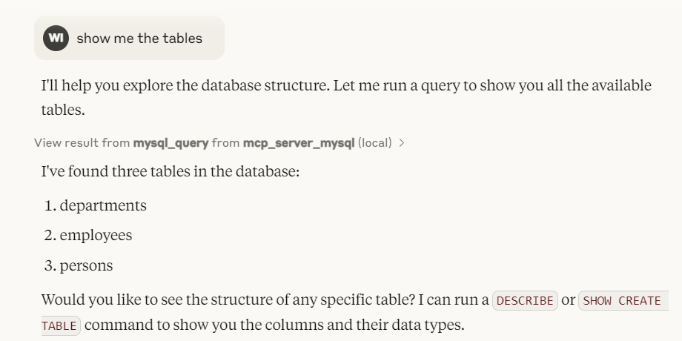

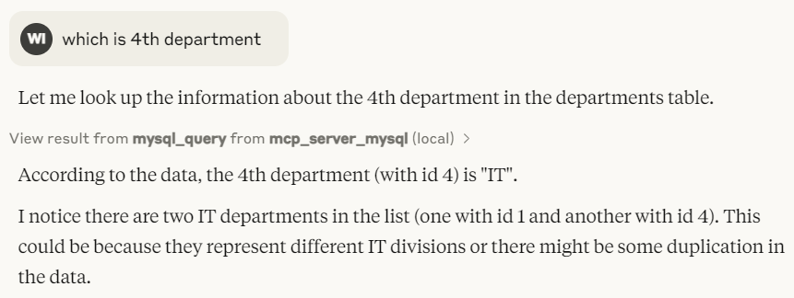

**Reference:**

[**https://github.com/benborla/mcp-server-mysql**](https://github.com/benborla/mcp-server-mysql)

[**https://github.com/designcomputer/mysql_mcp_server**](https://github.com/designcomputer/mysql_mcp_server)