TimeDateCalculator

User's guide

Rev. 1.1

Eigil Krogh Sorensen

Table of contents

TimeDateCalculator in short. 3

Screen shots. 4

How it works. 5

How to use it. 6

# TimeDateCalculator in short.

TimeDateCalculator calculates dates + times from time spans or time spans from dates + times.

# **Screen shots**.

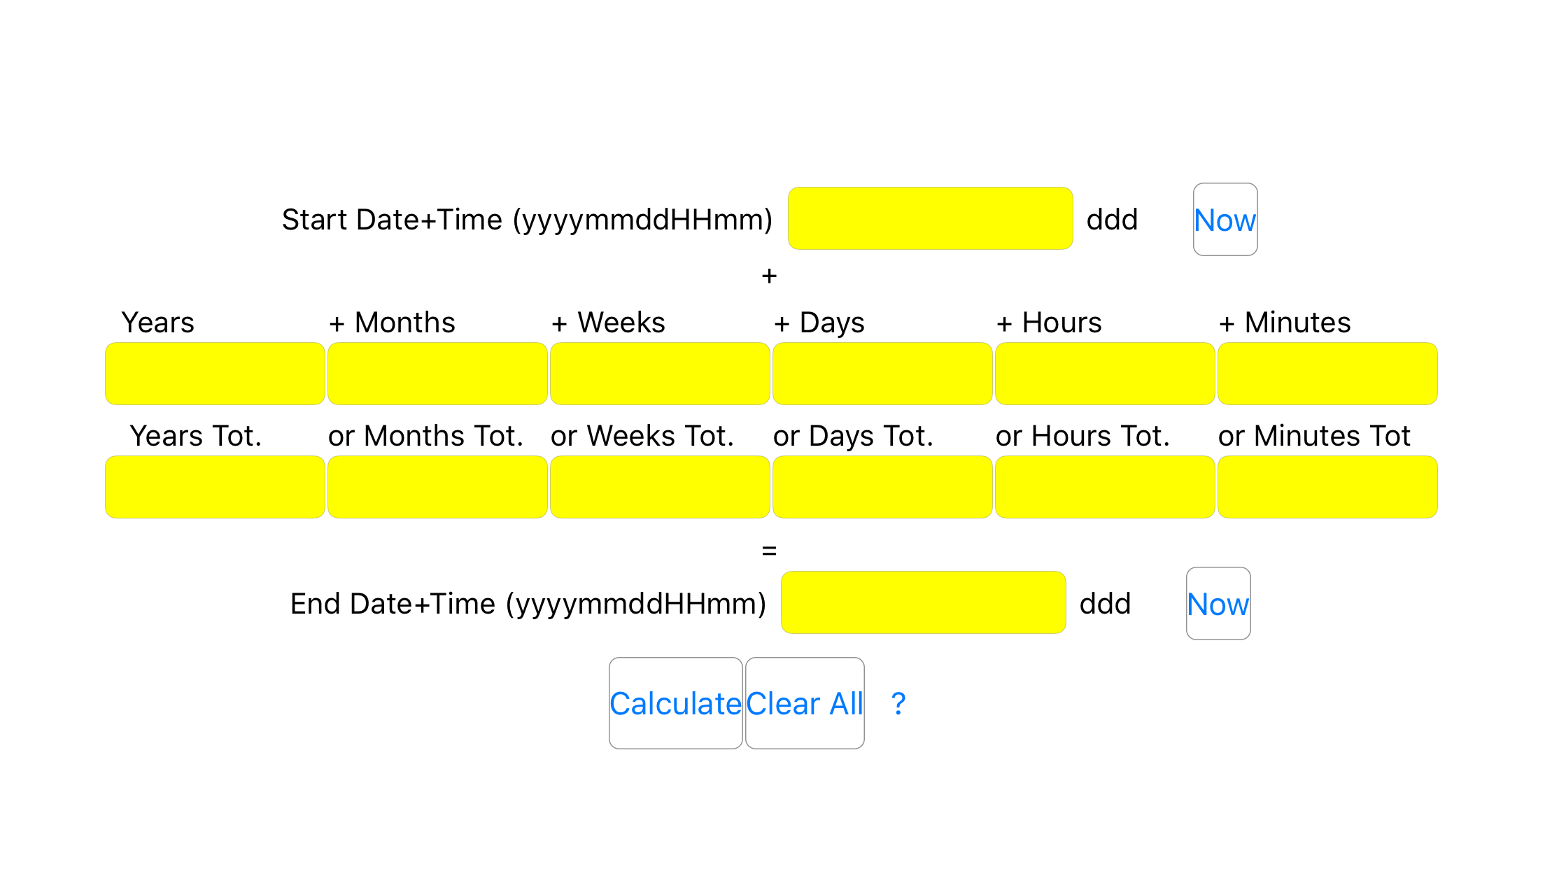

Figure 1 Landscape screen shot

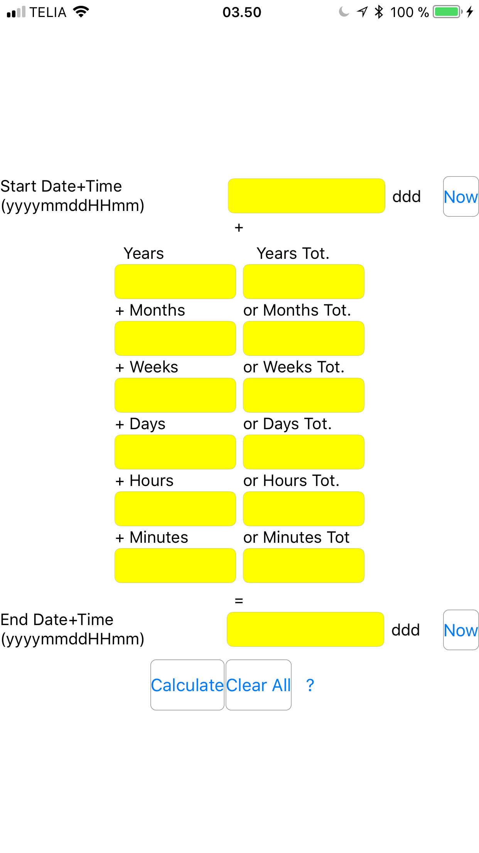

Figure 2 Portrait screen shot.

# How it works.

As you can see from figure 1 and 2

* There is a “Start Date+Time” and an “End Date+Time”.
* There are Time Spans between the “Start Date+Time” and “End Date+Time”:
  + In the row/column with xxx “**Tot**” each box represents the total number of whole Years, Months, Weeks, Days, Hours **OR** Minutes between “Start Date+Time” and “End Date+Time”.
  + In the row/column with **“+”** xxx the values in the boxes are added together to give the full time span between “Start Date+Time” and “End Date+Time”.
* What TimeDateCalculator does is to “solve the equation” so the time spans equals “End Date+Time” – “Start Date+Time”.
* “ddd” will show the three first letters of the name of the day corresponding to the Date+Time.

# How to use it.

You can use it in two ways:

1. Enter the “Start Date+Time” and “End Date+Time” and press calculate:
   * 1. Then the time spans will be calculated.
2. Enter either
   1. the “Start Date+Time” plus a time span and press calculate:
      1. Then the “End Date+Time” will be calculated

**OR**

* 1. the “End Date+Time” plus a time span and press calculate:
     1. Then the “Start Date+Time” will be calculated.

Have a good time!

Kind Regards

Eigil Krogh Sorensen