ChronoWiz

User's Guide

Rev. 2.0

Eigil Krogh Sorensen

Contents
ChronoWiz in short. 3
Screen shots. 4
Landscape screen shots. 4
Portrait screen shots. 9
How it works. 19
How to use it. 21
File 22
Open 22
Correct for time zone 22
Save 22
Settings (Not on phones) 23
Zoom to window. 23
Have a good time! 24

ChronoWiz in short.

- ChronoWiz calculates:
- Dates + Time based on Time Span + Date + Time.
- Time Span between two Dates + Time

- ChronoWiz can read and write .ics files (An ICS file is a calendar file saved in a universal calendar format used by several email and calendar programs).

- ChronoWiz runs on Windows 10 & 11, macOS, iOS & iPadOS and Android.

Screen shots.

Landscape screen shots.
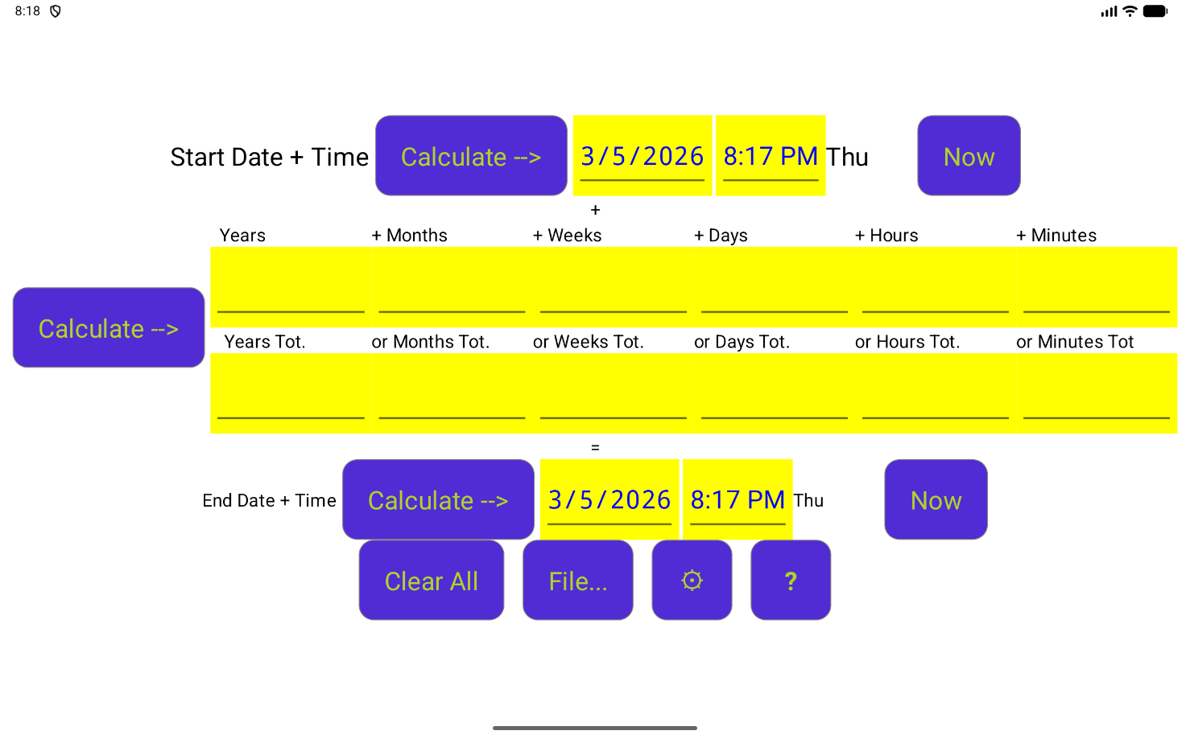
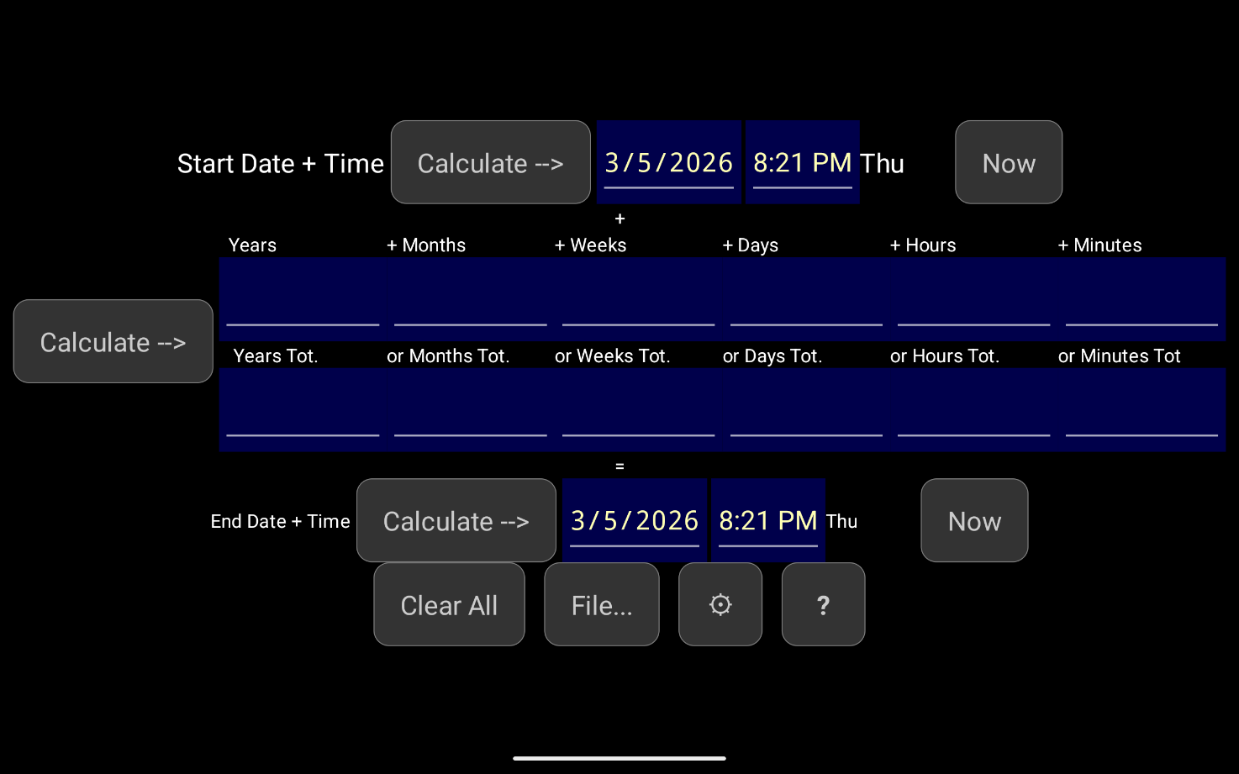
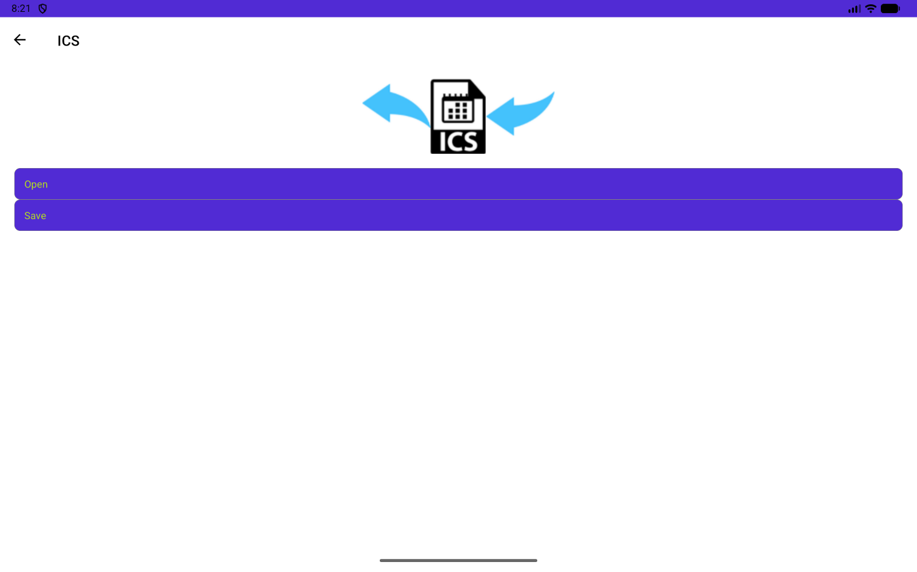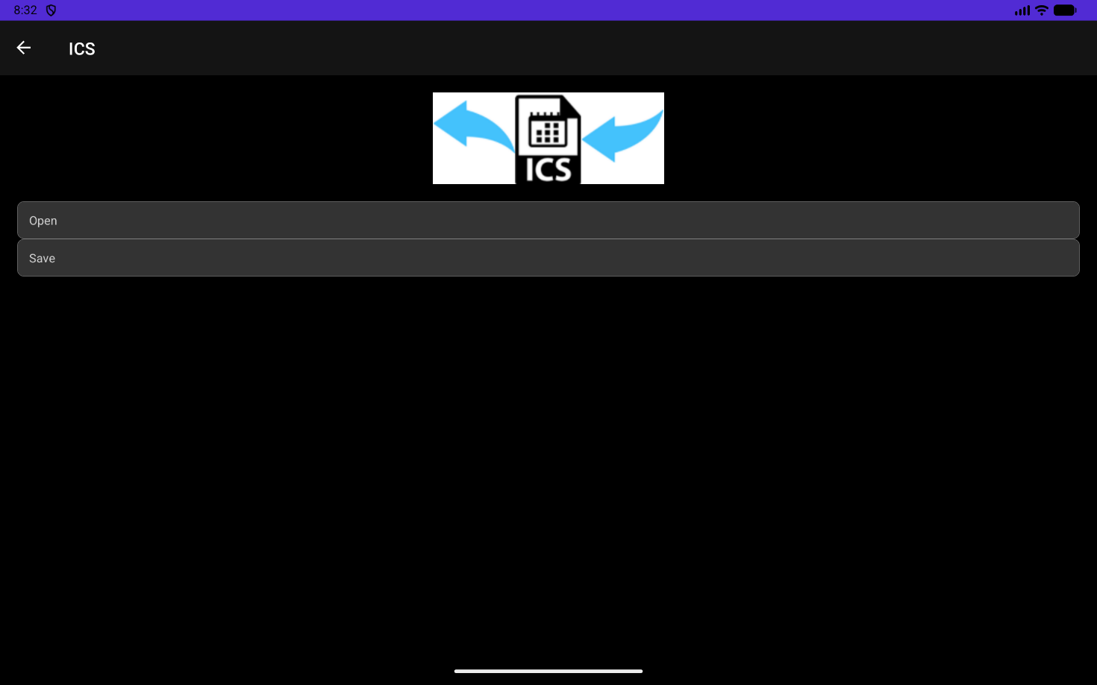
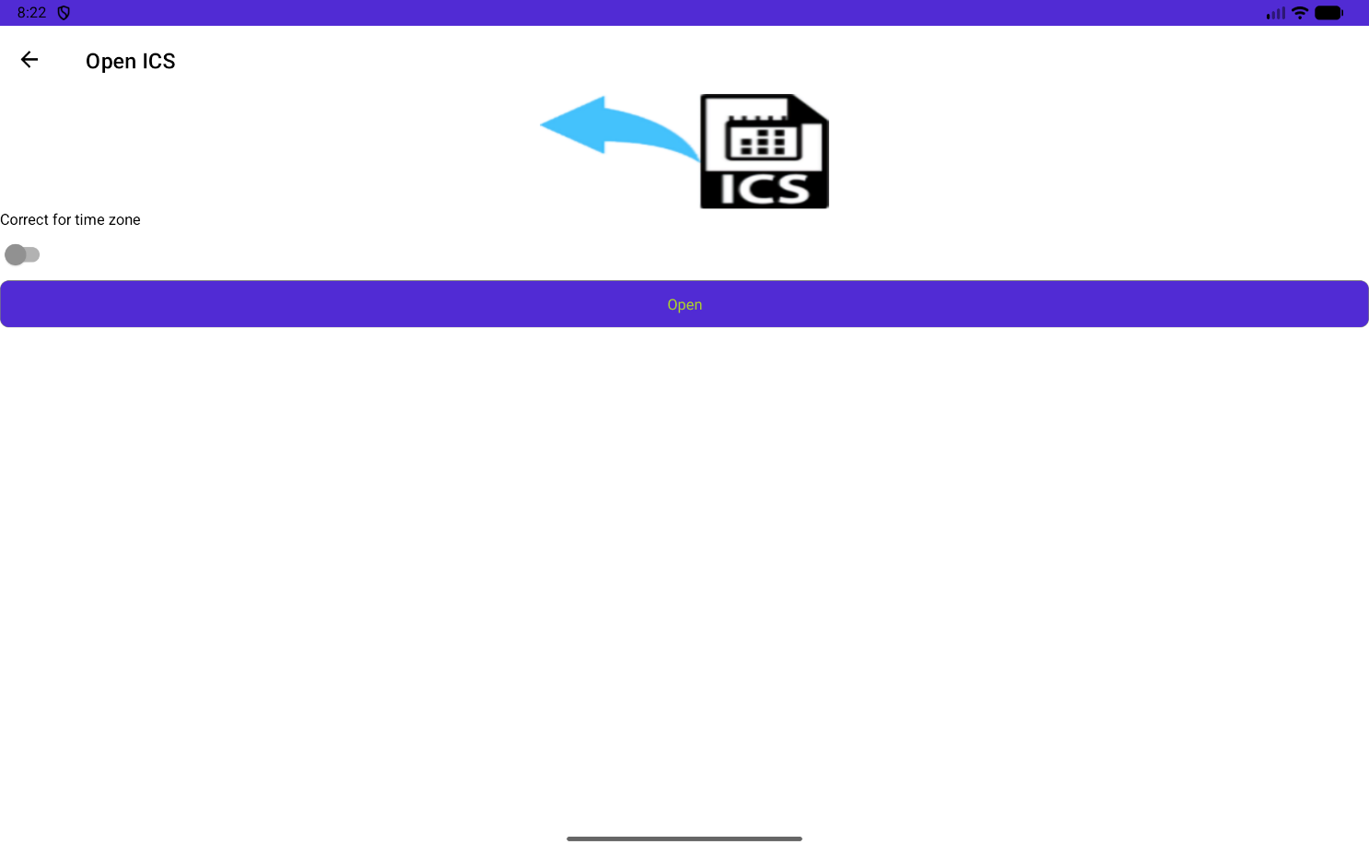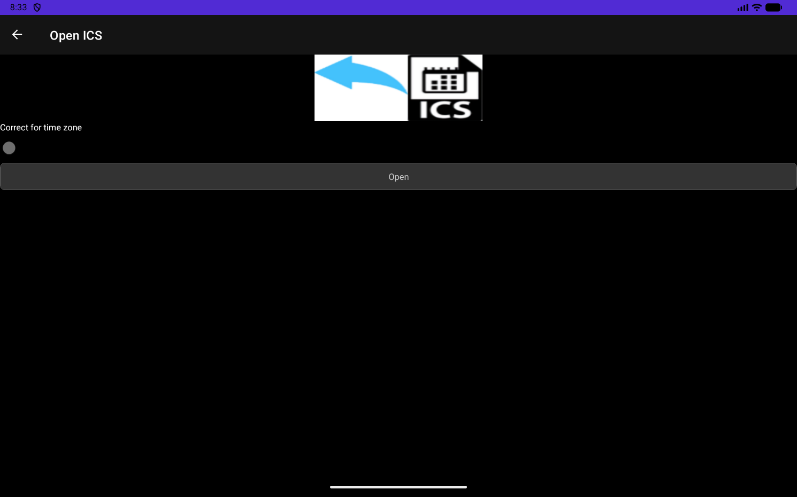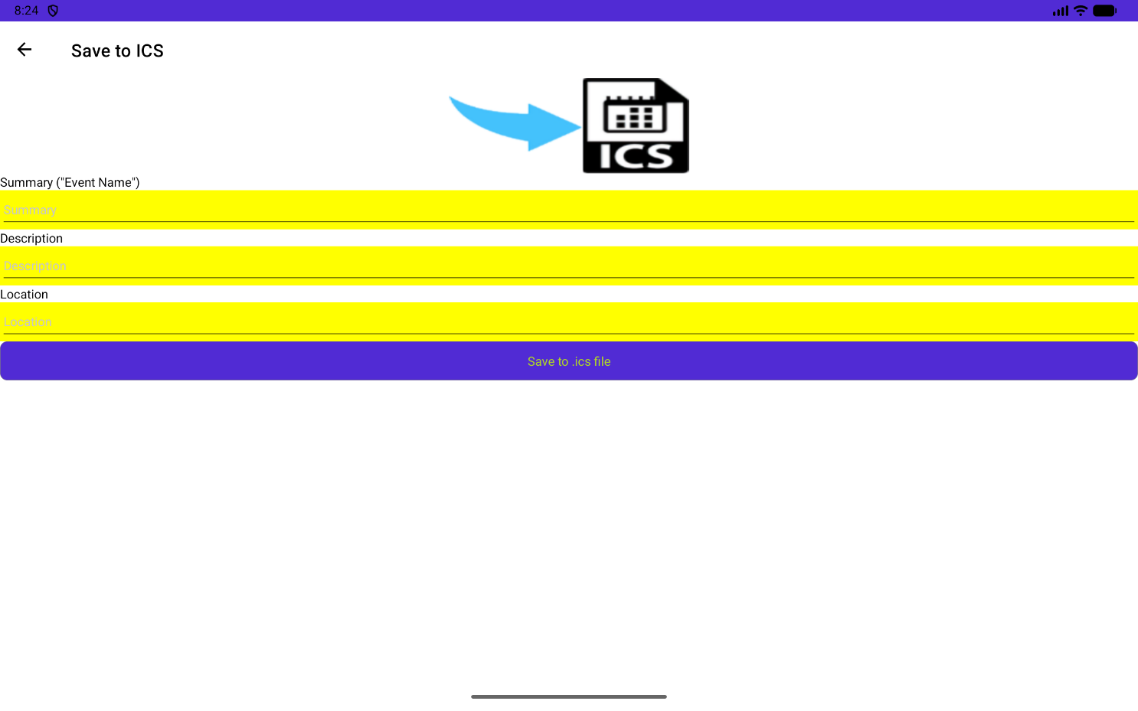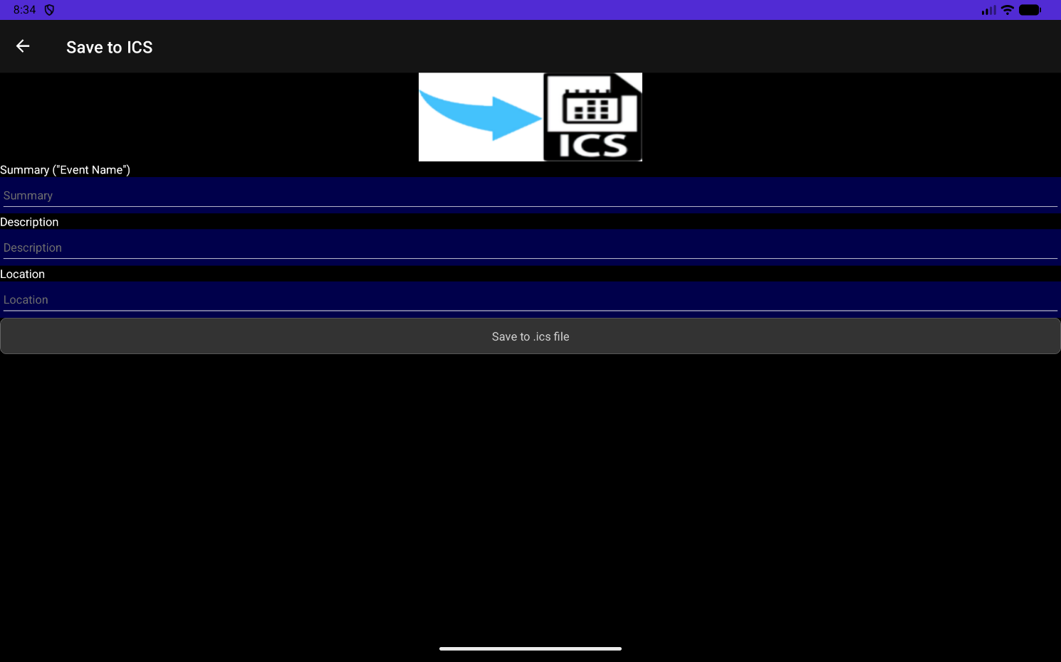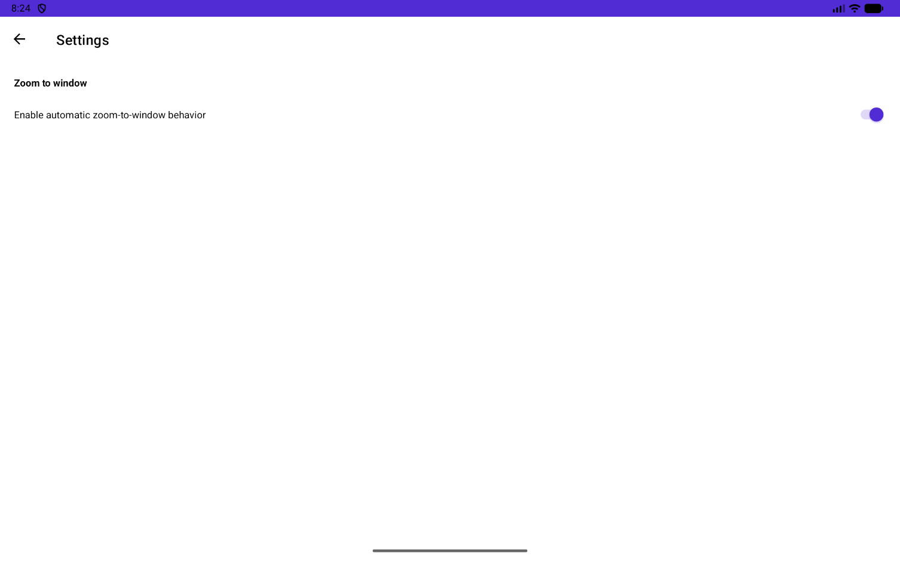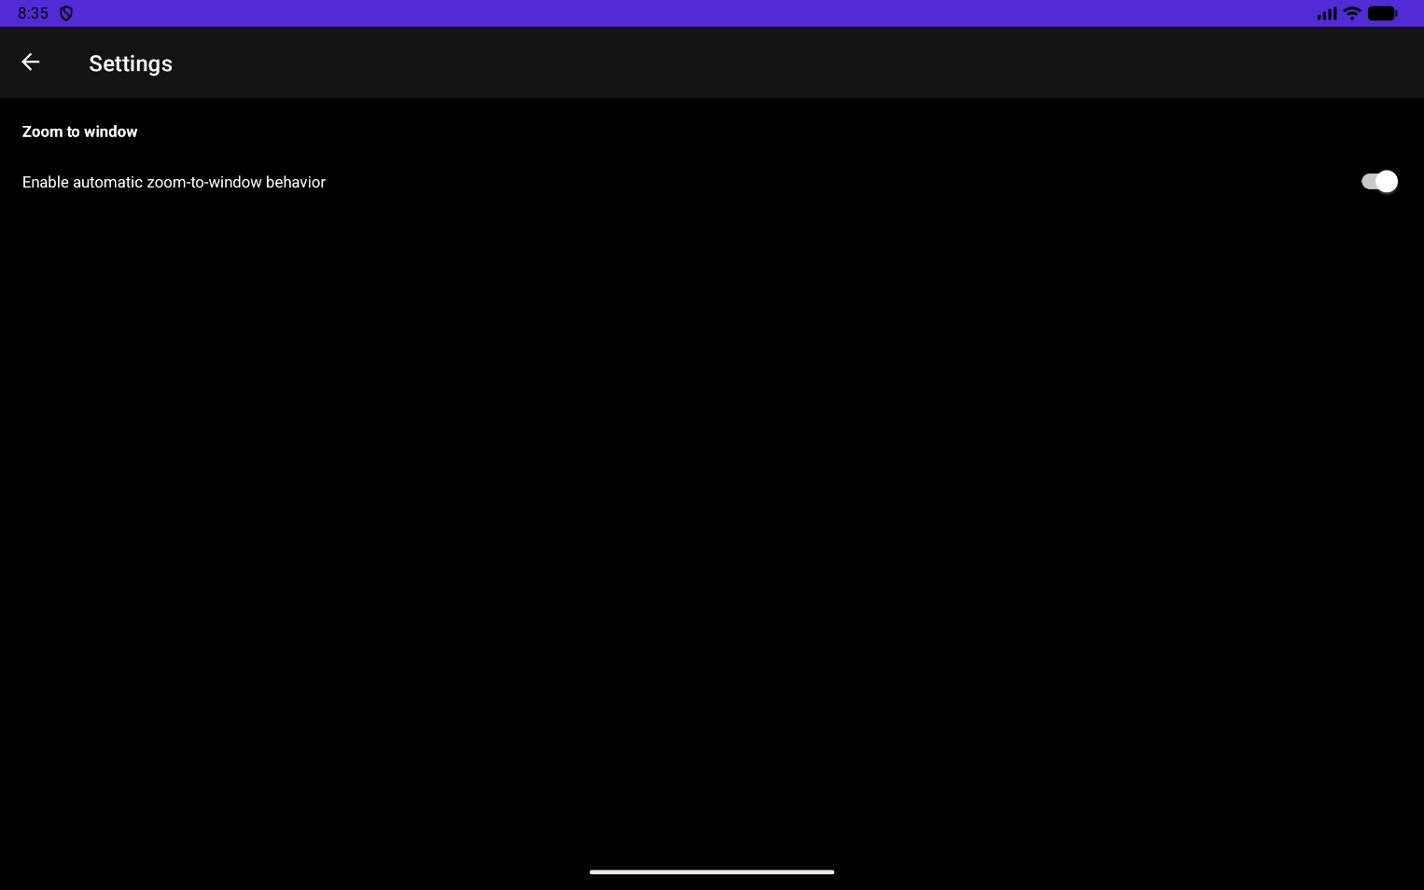

Portrait screen shots.
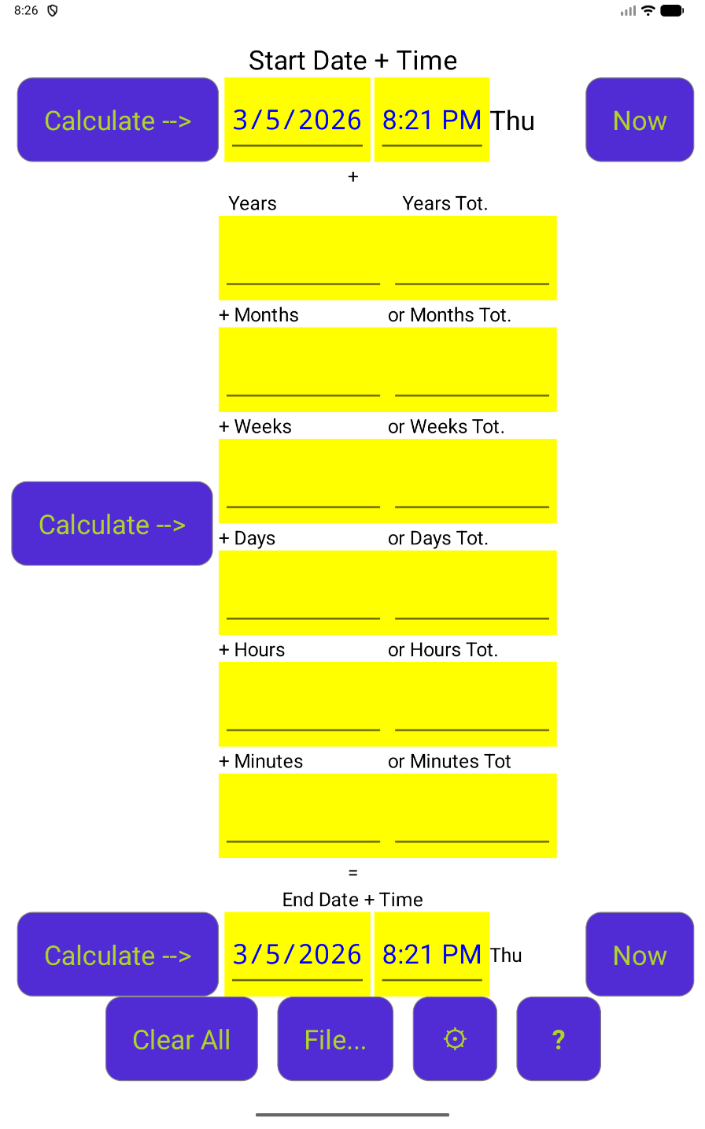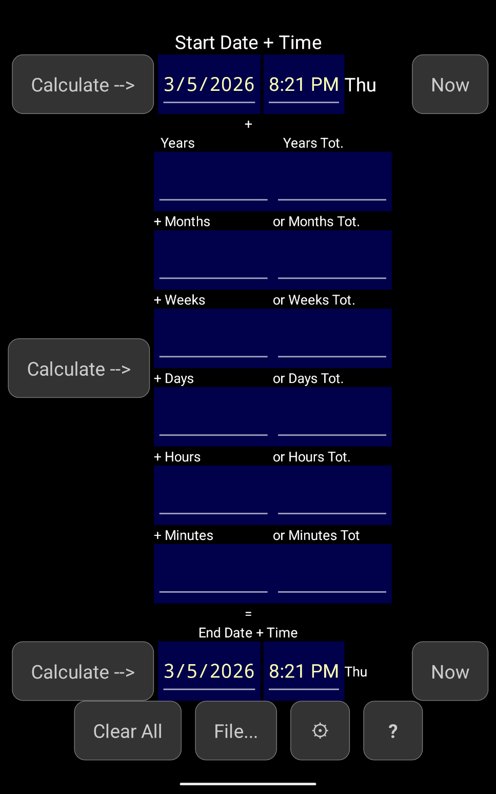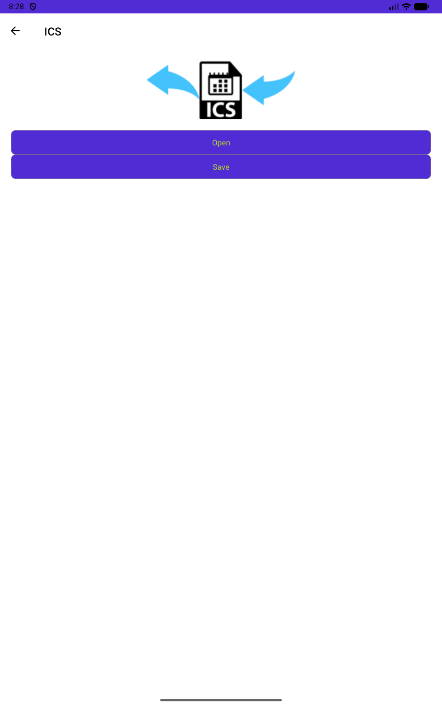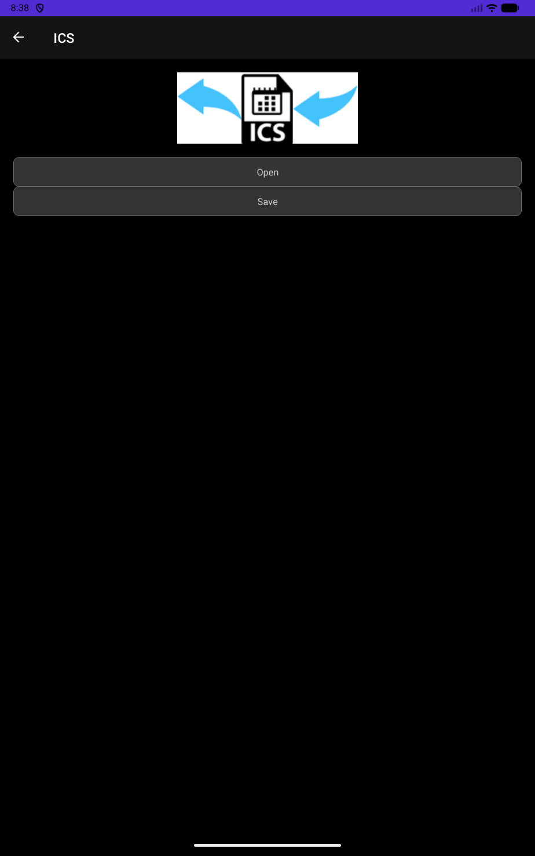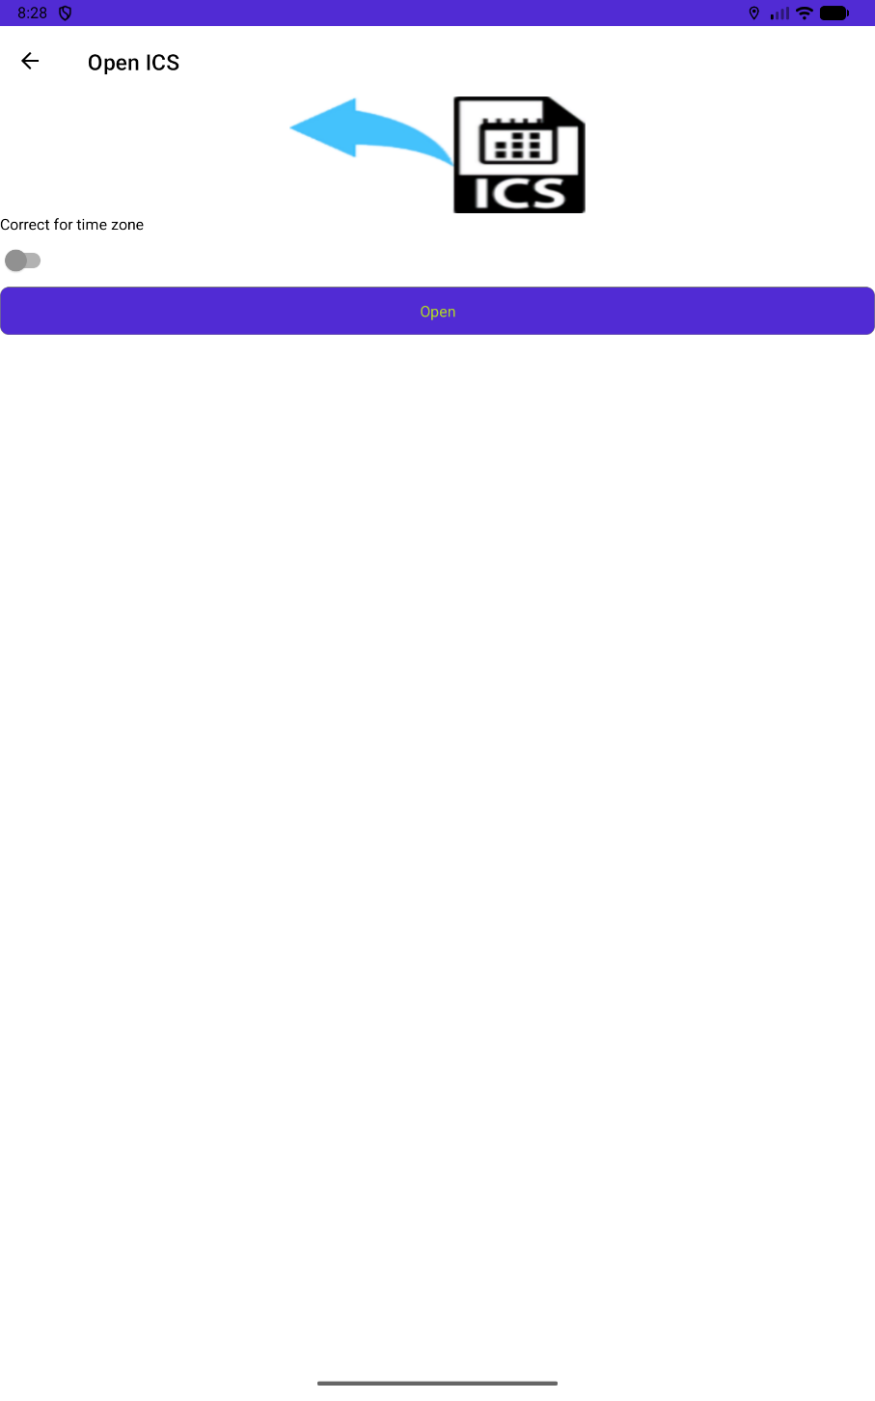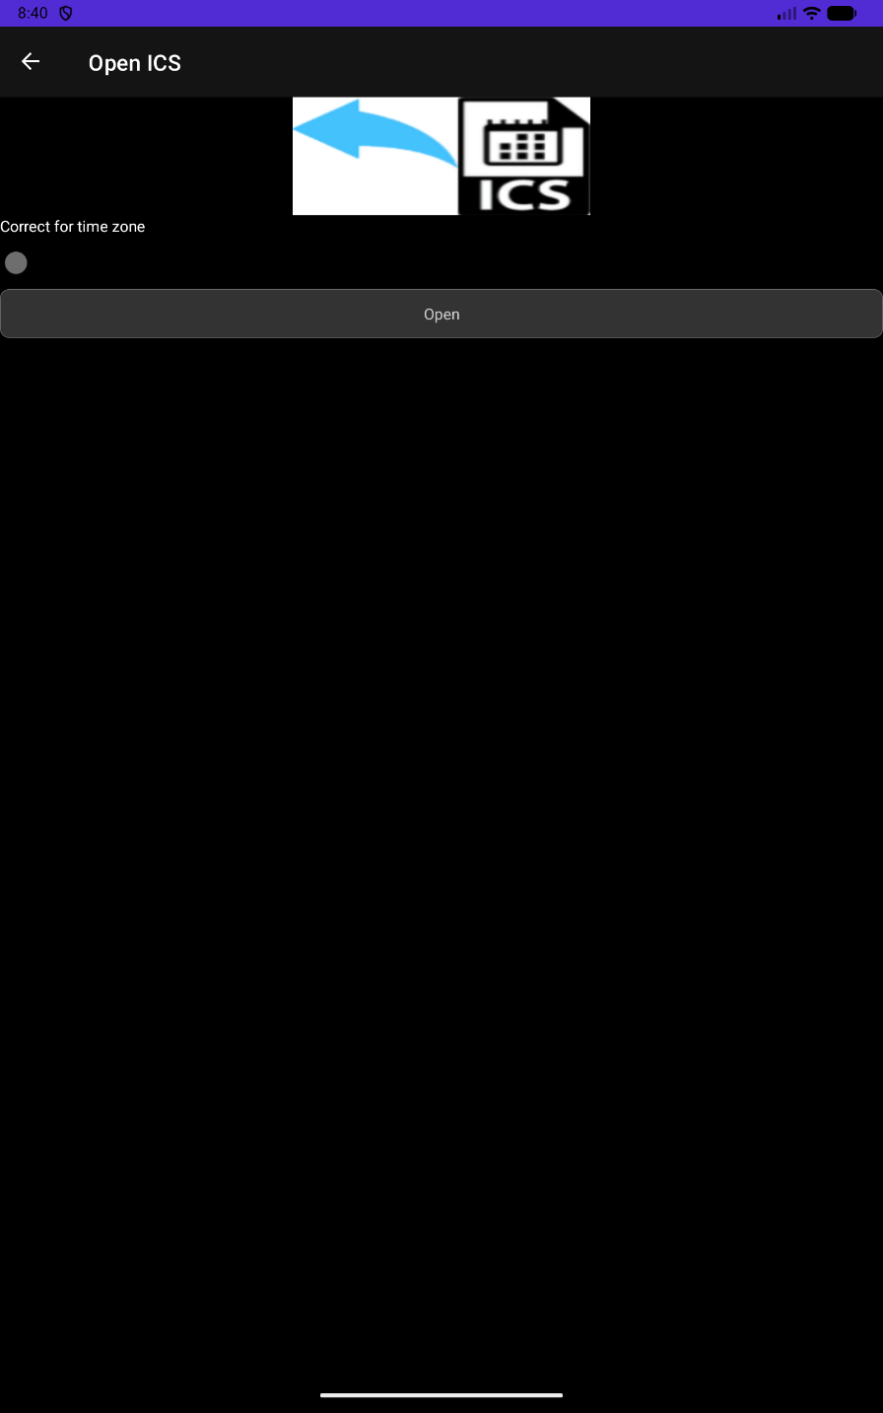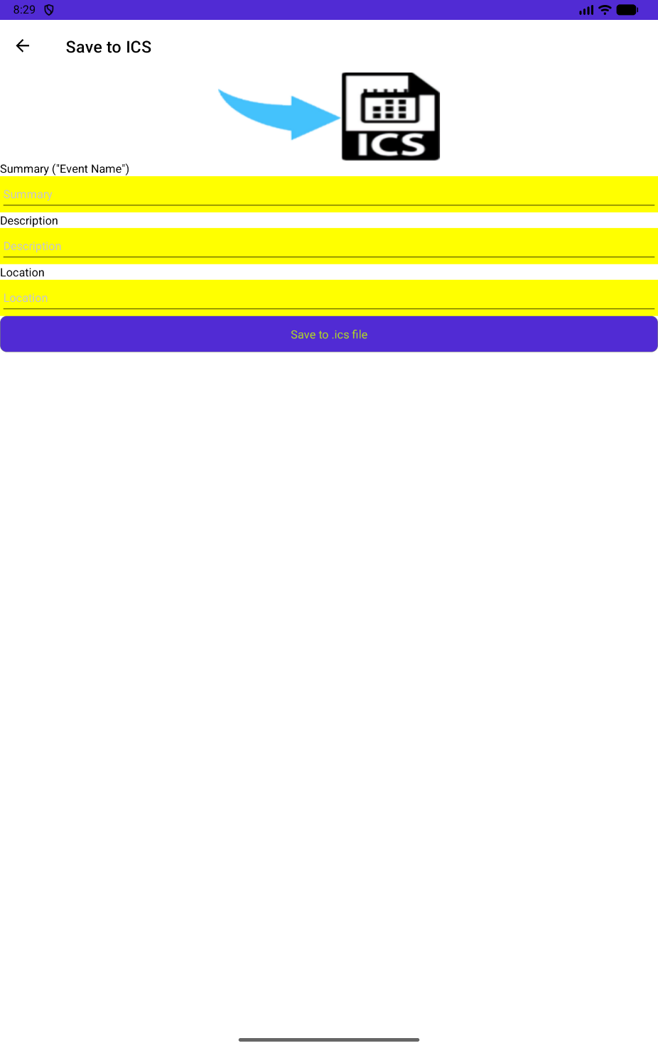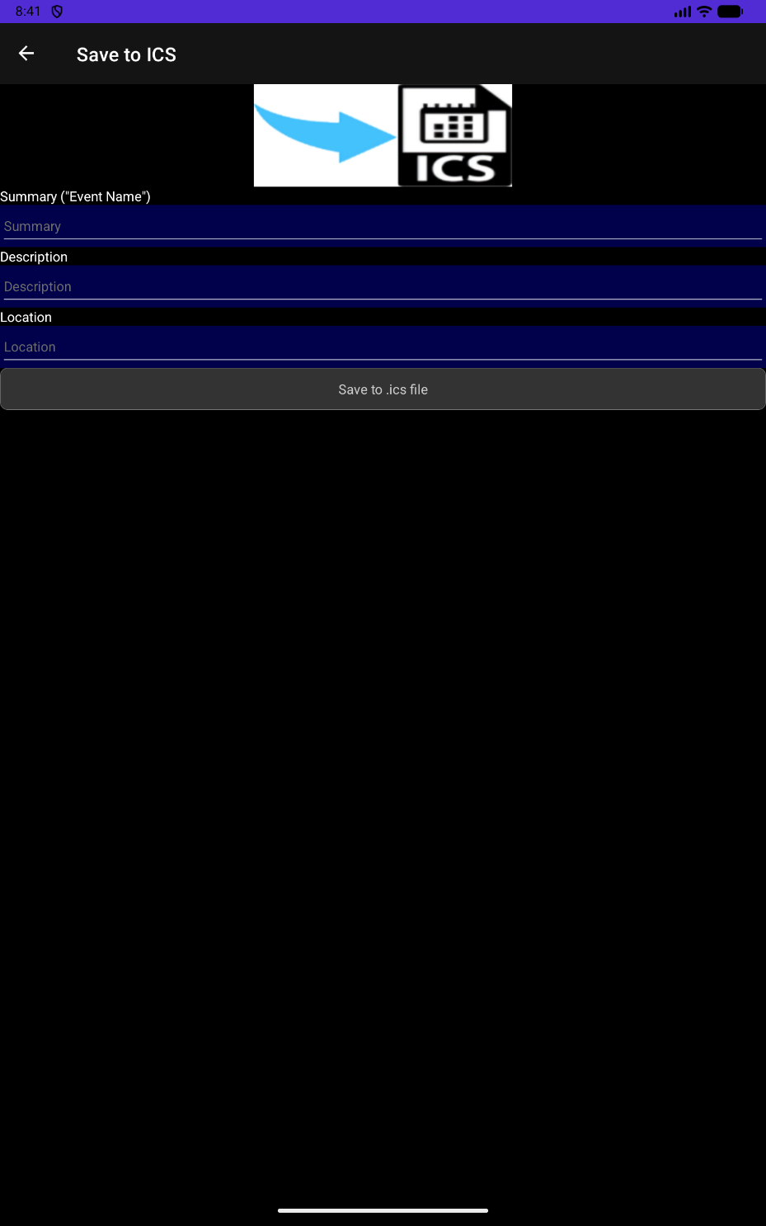
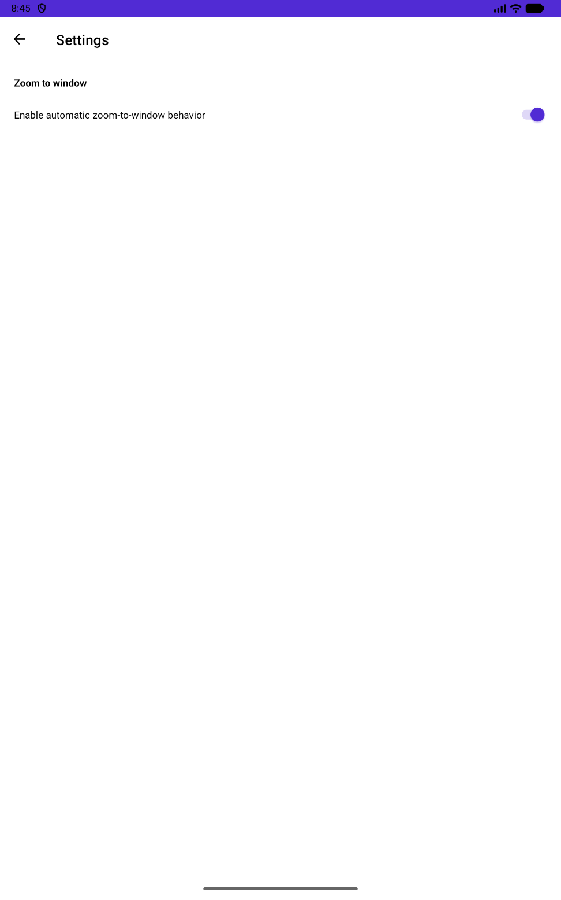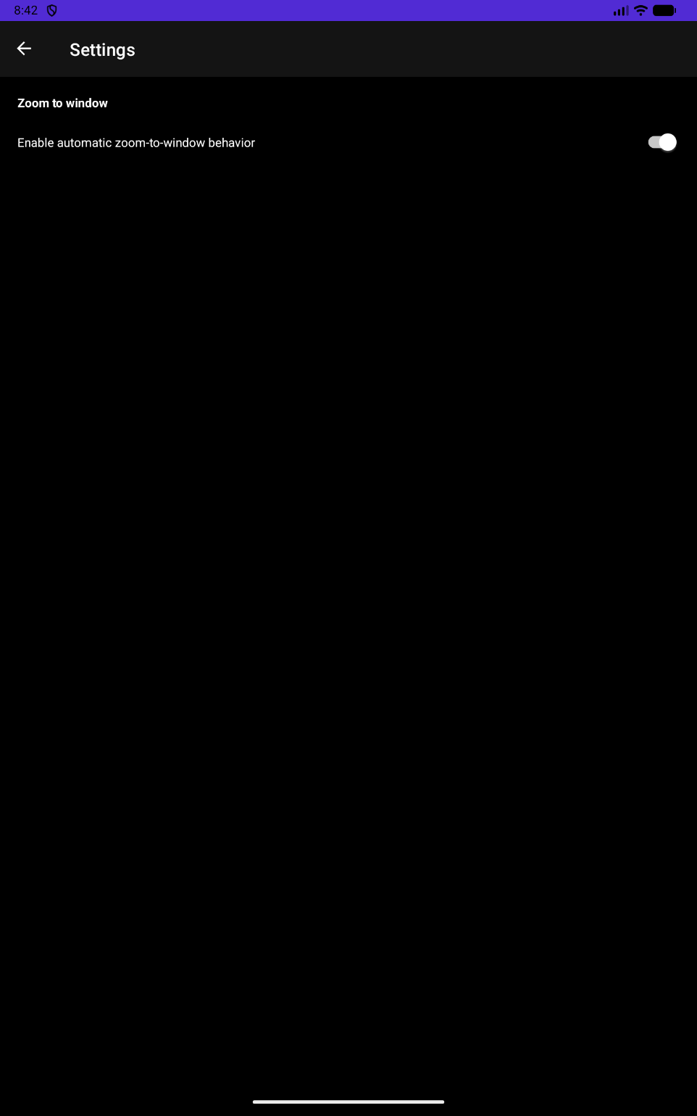

How it works.

As you can see from the screen shots
- There is a “Start Date+Time” and an “End Date+Time”.
- There are Time Spans between the “Start Date+Time” and “End Date+Time”:
  - In the row/column with xxx “Tot” each box represents the total number of whole Years, Months, Weeks, Days, Hours OR Minutes between “Start Date+Time” and “End Date+Time”.
  - In the row/column with “+” xxx the values in the boxes are added together to give the full time span between “Start Date+Time” and “End Date+Time”.
- What ChronoWiz does is to “solve the equation” so the time spans equals “End Date+Time” – “Start Date+Time”.
- “ddd” will show the three first letters of the name of the day corresponding to the Date+Time.

How to use it.

On the first page: Enter “Start Date+Time” or/and “End Date+Time” or/and a “Time Span” and click the arrow next to the time, (“Start Date+Time”, “Time Span” or “End Date+Time”), you want to calculate.

File
Under File you can Open and/or save .ics files.

Open
Here you can Open and Read .ics files.

Correct for time zone
If on the point in time of the event is calculated from time zone for the creator of the event to your time zone so the event simultaneous.

Save
Under Save you can Save/Write to .ics files so others can add the event to their calendars.

Settings (Not on phones)

Zoom to window.
If on, the pages are automatically zoomed to window size.

Have a good time!

Kind Regards
Eigil Krogh Sorensen

