guitarFineTune

User's guide
Rev. 5.1.1
Eigil Krogh Sorensen

Table of contents
guitarFineTune in short. 4
Launch. 5
Permission to use microphone. 6
Pages/Tabs in guitarFineTune. 7
Tune 8
Sound Control 9
Play tone for guitar string 9
E2 9
A2 9
D3 9
G3 9
B3 10
E4 10
All off 10
Output mix 10
Strings 10
Input 10
Output 10
Text boxes 10
Record 10
Raw sound 10
Filtered sound 10
Start 10
Stop 10
Recording Level 11
Level Meter 11
Gain slider 11
Auto 11
Display Control. 13
Background sounds exclusion threshold 13
Text box 13
Auto Calibrate 14
Adaptive 14
Seconds sound in calcs. 14
Average guitar string tone indicators over 14
Calculations 14
Seconds sound per calculation. 14
Show 15
Indicators 15
Strings off tune values (Hz) 15
Spectrum 15
FFT 15
FFT max indicator 15
Threshold 15
Filter 15
Frequency range 15
Lowest frequency (1...69) 15
Highest frequency (343 ... x) 15
Audio Control. 16
Use 50 Hz Filter 17
Use 60 Hz Filter 17
About 50 and 60 Hz filters 17
Disable OS audio preprocessing 17
About 18

guitarFineTune in short.

- guitarFineTune is an app. that aids in tuning electric and acoustic guitars.
- It has a very high resolution. Measurements are in 0.1 Hz resolution.
- All strings can be tuned simultaneously. The measured sound for all 6 strings are all shown at the same time, and compared with the sounds for the strings as they must be, when the guitar is in perfect tune.

Launch.

If you are on iOS the first page shown is the one in figure 1

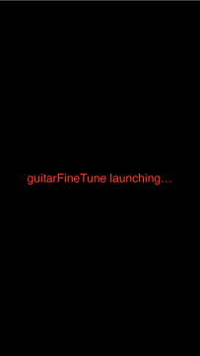
Figure 1 First page on iOS.

If you are on Windows or macOS the splash in figure 2 is shown

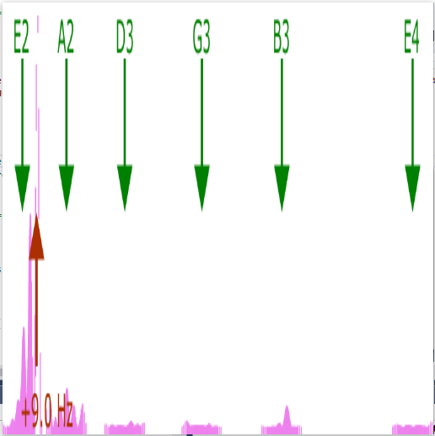
Figure 2 the first page on Windows or macOS.

Permission to use microphone.

If you are using iOS or Android, and guitarFineTune is launched for the first time, then you are asked permission to use the microphone, figure 3.

Figure 3 Permission to use microphone.
Just press OK, if you find it OK.

Pages/Tabs in guitarFineTune.

On top of the screen in guitarFineTune there are 5 tabs that are used to switch between pages, figure 4.

Each tab in guitarFineTune is describes in the following paragraphs.

Figure 4 the tabs.

Tune

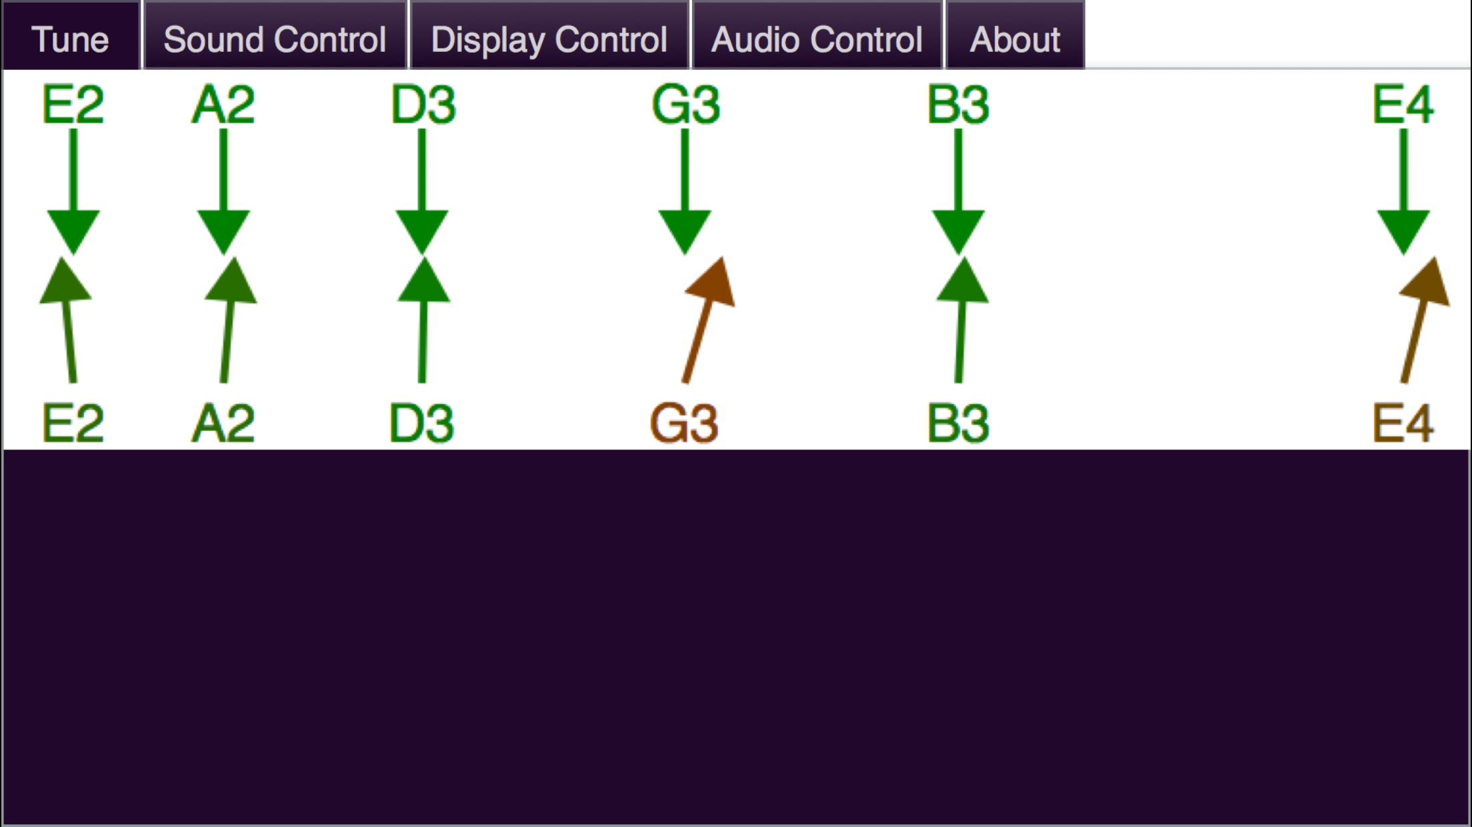
Figure 5 Page used when tuning the guitar.

The Tune page, figure 5, is the main page in guitarFineTune. That is the one used, when tuning the guitar.

E2, A2, D3, G3, B3 and E4 are the guitar strings.

The arrows pointing downwards represent the right guitar string tones.

The upwards pointing arrows show the actual measured string tones. They get more and more red and turned, the more the string is out of tune.

Sound Control
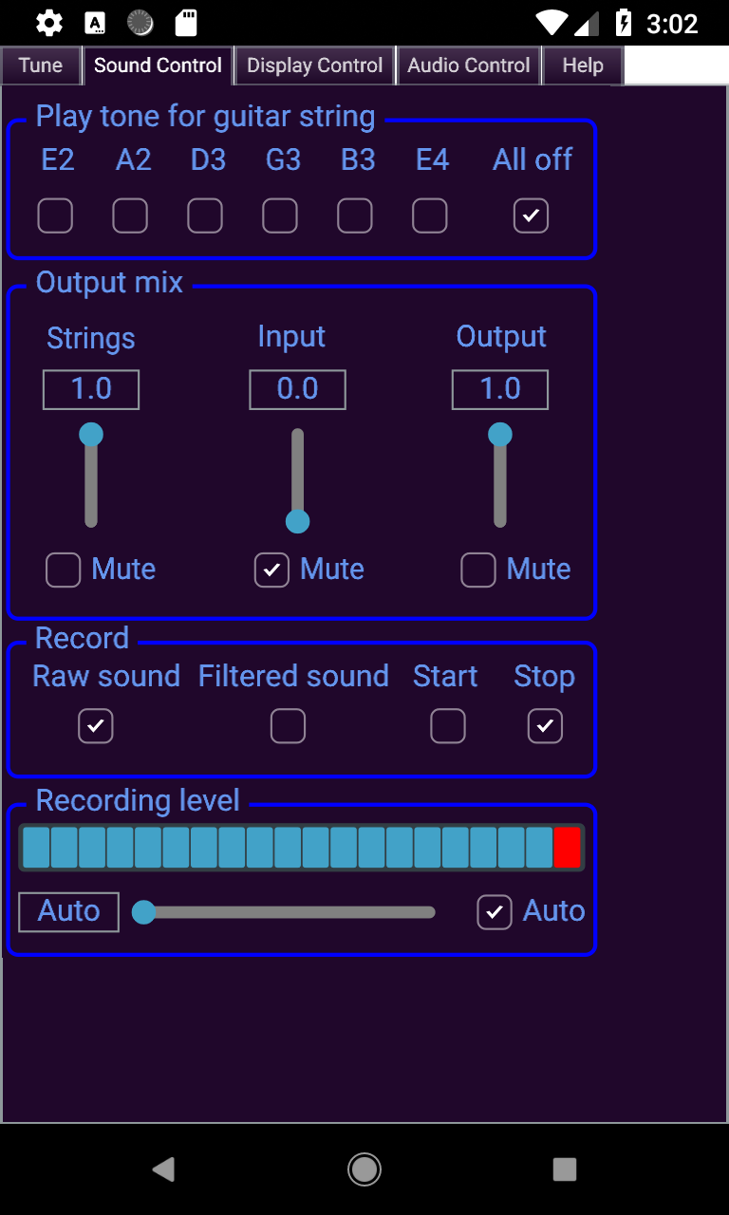

Figure 6 Sound Control page

Play tone for guitar string
Play the sound that the guitar strings should have. A fairly good loud speaker is required.

E2
Play tone for guitar string E2 (82 Hz).

A2
Play tone for guitar string A2 (110 Hz).

D3
Play tone for guitar string D3 (147 Hz).

G3
Play tone for guitar string G3 (196 Hz).

B3
Play tone for guitar string B3 (247 Hz).

E4
Play tone for guitar string E4 (330 Hz).

All off
Turn off all string sounds.
(If you click on a string tone again after having clicked it on the tone will be turned off, but with “All off” you can stop all tones with one click).

Output mix
Mix the input sources and control the output level.

Strings
Control the level for the string sounds.

Input
Route the input source (e.g. microphone or electric guitar) to the output and control the level for the input source.

Output
Control output the level for the mix of guitar string tone and input.

Text boxes
If you click on the text boxes above the sliders you can type in the desired value.

Record
Select the source for audio recording.

Raw sound
Is recorded directly from the sound capture device (internal/external microphone or electric guitar).

Filtered sound
Is recorded after the filters in guitarFineTune (e.g. the 50 Hz filter which you can enable/disable on the Audio Control page).

Start
Start the recording.

Stop
Stop the recording.
When recording is stopped then
- If guitarFineTune is running in Windows or macOS/X then a dialog similar to the one in Figure 7 pops up so you can save the recording if you wish.
      - If uitarFineTune is running in iOS or Android then a dialog similar to the one in Figure 8 pops up so you can share the recording if you wish.

Recording Level
Control the level of the sound that is recorded

Level Meter
Is shown that shows the max peak values of the sound from the selected sound source.

Gain slider
Control the gain that is applied to the sound from the sound source.
    - If the gain is set to 0.00 the gain is calculated automatically. Thus the gain is calculated so the max peak levels are 100%, (thus the level meter will constantly show max).
    - If you click on the text box at the slider you can type in the desired value.

Auto
The gain is calculated automatically (always set to maximum possible).
- If “Auto” is clicked off the latest calculated gain wil continue to work. You can control the gain as you wish.
Figure 7 Save Audio File as ... dialog
Figure 8 Share dialog

Display Control.

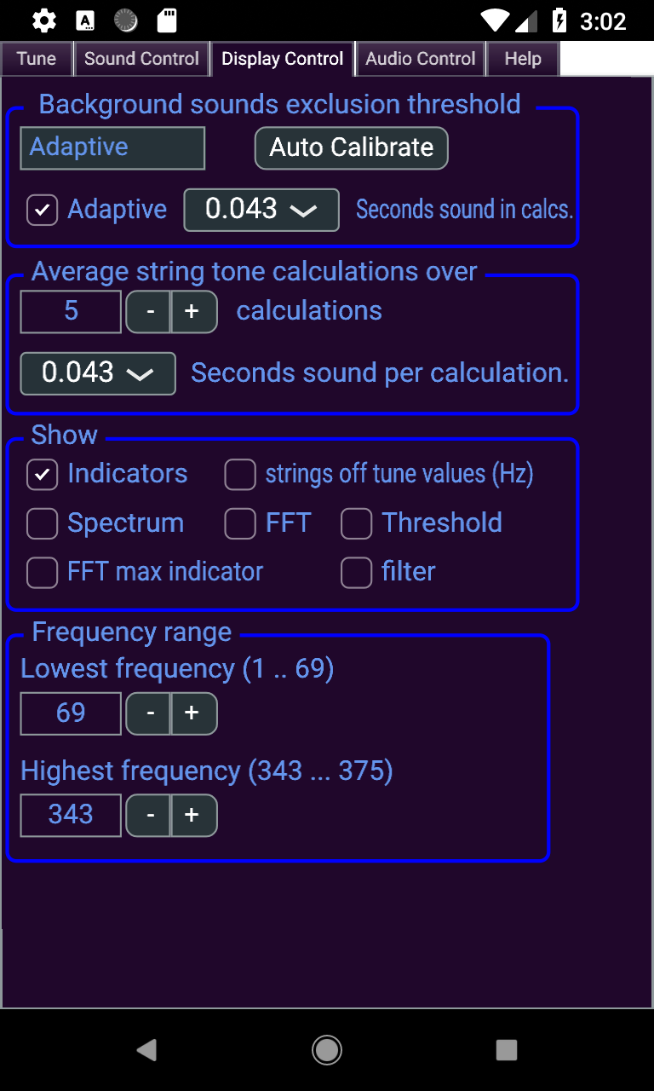
Figure 9 Display Control page

Background sounds exclusion threshold
Is a level that the measured sounds must be above to be included in the calculations. This is done to exclude noise.

Text box
You can either enter one number for all strings in the box with the text Adaptive on figure 9.

Auto Calibrate
If you press “Auto Calibrate” the window in figure 10 pops up. While that window is shown, the sound around is measured, and later regarded as noise and excluded. HINT: While Auto Calibrate is running you should make those noises that can disturb the measurements while tuning. E.g. guitar noises as e.g. picking the strings. So you could make all the noises on the guitar except the string sounds, while Auto Calibrate is running.

Figure 10

Adaptive
The background sound exclusion threshold is calculated automatically and continuously.

Seconds sound in calcs.
Controls how many seconds of measured sound is included in each calculation of the background sound exclusion threshold.

Average guitar string tone indicators over
The number of tone calculations that the actual guitar string tone must be averaged over. This gives more steady indicators but also slows down the display update a bit.

Calculations
The end positions of the indicators for the actual guitar strings sounds (upwards pointing arrows) are averaged over this number of calculations.

Seconds sound per calculation.
The actual tone/frequency for a given string on the guitar is calculated from a sequence of measurements, (samples), of the sound. Here you can chose how many seconds of sound is to be used per calculation.. The higher the number the more accurate is the calculated tone, but it also slows down the update of the display.
This value controls how often the drawings on the Tune page is updated and also how often the “Background sounds exclusion threshold” is calculated, if Adaptive is on. Because of that, changing “Seconds sound per calculation” may also change the value in “Seconds sound in calcs.”

Show
Controls what is shown on the Tune page.

Indicators
Select if the upwards pointing arrows are shown.

Strings off tune values (Hz)
Show (in Hz) how much each guitar string is out of tune (instead of the strings name).

Spectrum
Show frequency spectrum of the sounds.

FFT
Show FFT (Fast Fourier Transformation) spectrum.

FFT max indicator
Place a marker at the max value in the FFT spectrum.

Threshold
If on a short blue horizontal line in shown on the Tune page at each guitar string, indicating the current “Background sounds exclusion threshold”.

Filter
Show a curve showing the characteristics of the filter(s) in use.

Frequency range
The frequency range that is shown on the Tune page.

Lowest frequency (1...69)
The lowest frequency included on the Tune page.

Highest frequency (343 ... x)
The highest frequency included on the Tune page.

Audio Control.

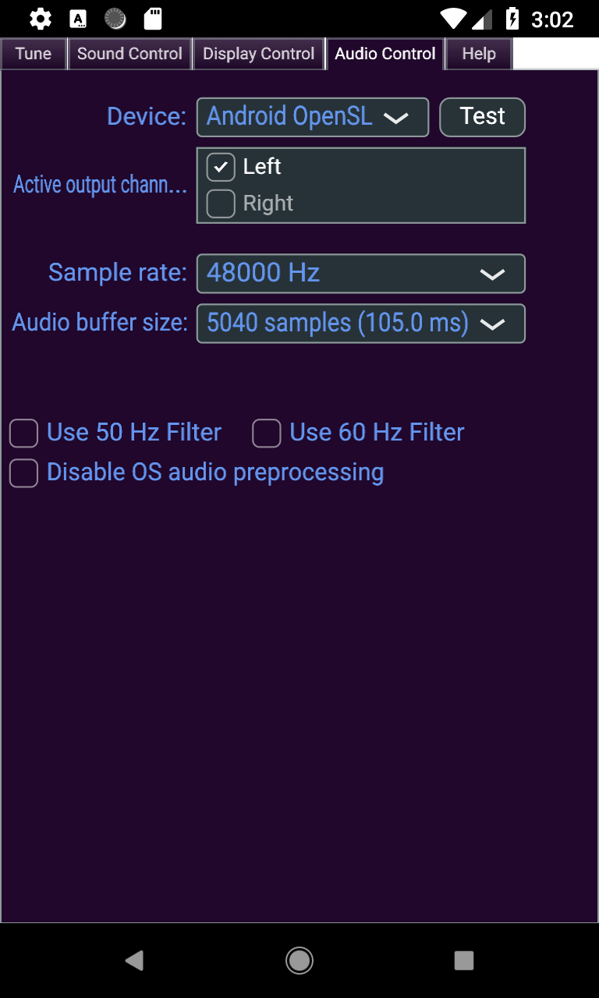
Figure 101 Audio Control

On this page you can control how the audio system in the Operating System is used.

Normally the values are automatically set to reasonable values, but you can change them if necessary.

If you press Test you should hear a 440 Hz sound if the audio system is right configured.

Use 50 Hz Filter
guitarFineTune has a built in 50 Hz filter, that filters out 50 Hz. The filter can be used, if there is 50 Hz noise in the surroundings.

Use 60 Hz Filter
guitarFineTune has a built in 60 Hz filter, that filters out 60 Hz. The filter can be used, if there is 60 Hz noise in the surroundings.

About 50 and 60 Hz filters
50 and 60Hz are the frequencies on the power grid in e.g. Europe (50 Hz) and USA (60 Hz).

You can check if your sound system is infected with the power grid frequencies:

      - On the “Display Control” page
        - In “Show” switch FFT on and switch everything else off.
        - In “Frequency range” set “Lowest frequency” to the lowest possible (1) (and eventually “Highest frequency” to the highest possible).
      - Then on the “Tune” page check if the FFT spectrum has a peak at 50 or 60 Hz.
        - If there is a peak at 50Hz the switch on “Use 50 Hz Filter” on the “Audio Control” page
        - If there is a peak at 60Hz the switch on “Use 60 Hz Filter” on the “Audio Control” page

Disable OS audio preprocessing
iOS and Android have built in preprocessing of sound. This preprocessing can be disabled (might give a greater bandwidth).

About

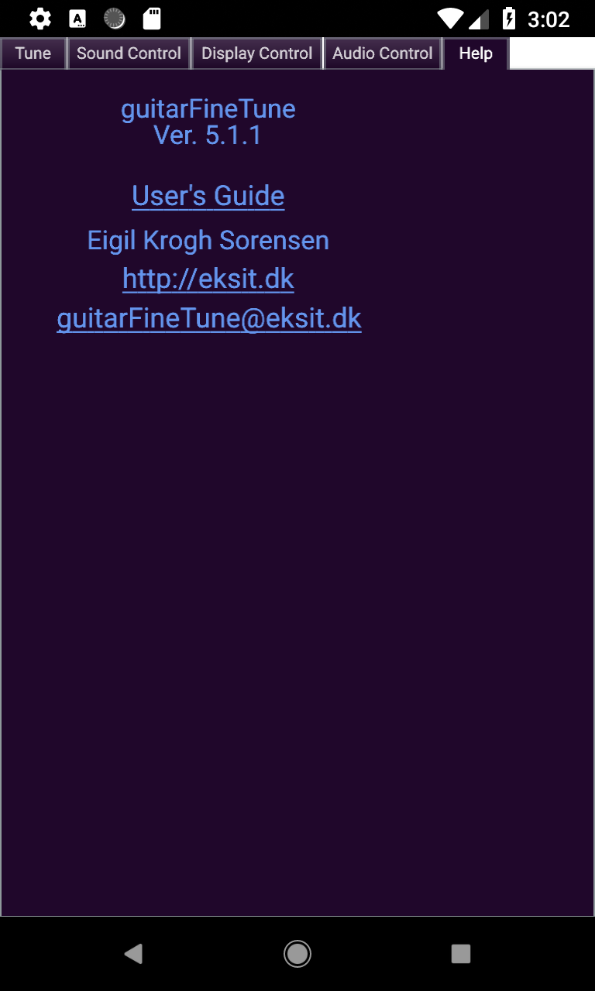
Figure 12 The About page.

Here you find web site and contact info.

Have a good time!

Kind Regards
Eigil Krogh Sorensen

