What is Apache Maven?
Apache Maven is a powerful open-source build automation and project management tool primarily used for Java projects, though it supports other languages like C#, Ruby, and Scala. Developed by the Apache Software Foundation, it simplifies the entire software build process by handling tasks such as compilation, testing, packaging, dependency management, and deployment.
Unlike older tools like Apache Ant (which is procedural and script-based), Maven is declarative and follows the principle of Convention over Configuration. This means it provides sensible defaults for project structure and build processes, so you only need to specify exceptions or customizations.
Maven's name comes from Yiddish, meaning "accumulator of knowledge," reflecting its goal to make project information comprehensible and standardized.

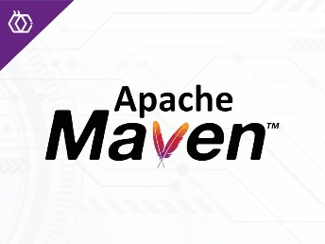
Key Features of Maven
- Dependency Management: Automatically downloads and manages libraries (JARs) from repositories.
- Standard Project Structure: Enforces a consistent directory layout.
- Build Lifecycle: Predefined phases for building projects consistently.
- Plugins: Extensible via thousands of plugins for tasks like testing, reporting, etc.
- Project Object Model (POM): Central configuration in a single XML file.
- Repositories: Uses local, central (Maven Central), and remote repositories.
- Reproducible Builds: Ensures consistent outputs across environments.

Project Object Model (POM) - pom.xml
The heart of every Maven project is the pom.xml file, located in the project's root directory. It describes the project, its dependencies, plugins, build settings, and more.
A minimal pom.xml looks like this:
XML
<project xmlns="http://maven.apache.org/POM/4.0.0"
xmlns:xsi="http://www.w3.org/2001/XMLSchema-instance"
xsi:schemaLocation="http://maven.apache.org/POM/4.0.0
https://maven.apache.org/xsd/maven-4.0.0.xsd">
<modelVersion>4.0.0</modelVersion>

<groupId>com.example</groupId> <!-- Organization or group -->
<artifactId>my-app</artifactId> <!-- Project name -->
<version>1.0-SNAPSHOT</version> <!-- Version -->
<packaging>jar</packaging> <!-- Default: jar; others: war, pom, etc. -->

<name>My Example App</name>
<description>A simple Maven project</description>

<properties>
<java.version>17</java.version> <!-- Custom properties -->
</properties>

<dependencies>
<!-- Example dependency: JUnit for testing -->
<dependency>
<groupId>junit</groupId>
<artifactId>junit</artifactId>
<version>4.13.2</version>
<scope>test</scope>
</dependency>
</dependencies>
</project>
Key elements:
- Coordinates: groupId, artifactId, version uniquely identify the project/artifact.
- Dependencies: List external libraries; Maven resolves transitive dependencies automatically.
- Build Section: Configure plugins, directories, etc.
- Inheritance: Projects can extend a parent POM for shared configurations.
- Super POM: All POMs inherit from Maven's built-in defaults.
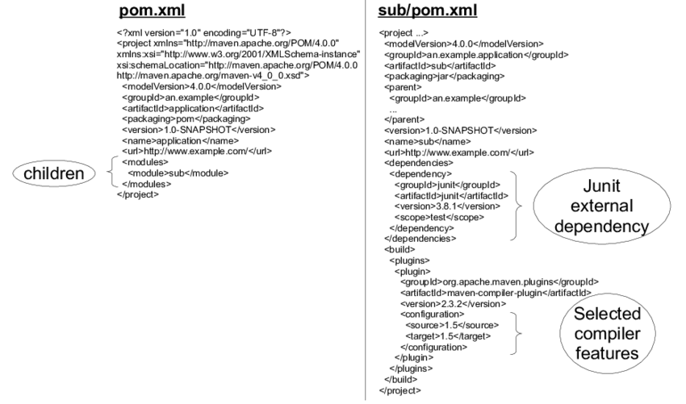

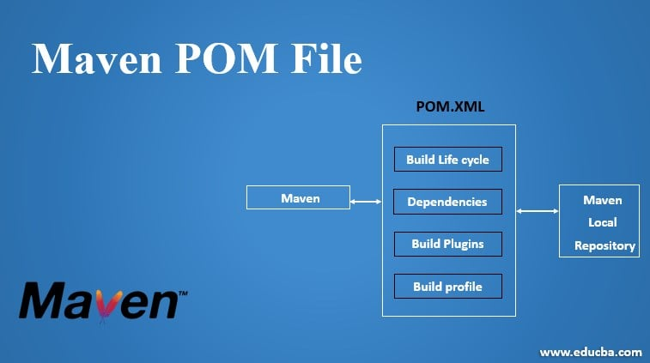

Standard Project Directory Structure
Maven enforces this convention:
text
my-app/
├── pom.xml
├── src
│ ├── main
│ │ ├── java # Production source code
│ │ ├── resources # Config files, properties, etc.
│ │ └── webapp # For web apps (WEB-INF, etc.)
│ └── test
│ ├── java # Test source code
│ └── resources # Test resources
└── target # Generated output (classes, JARs, etc.) - ignored in VCS

Maven Build Lifecycles
Maven has three built-in lifecycles:
- Default (Build) Lifecycle - Handles the main build process (most commonly used).
Phase | Description
validate | Validate the project is correct and all necessary information is available.
compile | Compile the source code.
test | Run unit tests using a suitable framework (e.g., JUnit).
package | Package the compiled code into a distributable format (e.g., JAR/WAR).
verify | Run integration tests and checks.
install | Install the package into the local repository.
deploy | Copy the final package to a remote repository for sharing.
- (There are more phases like process-resources, generate-sources, etc.)
- Clean Lifecycle - Cleans up artifacts.
  - pre-clean, clean (deletes target/), post-clean.
- Site Lifecycle - Generates project documentation/site.
  - site, site-deploy.
When you run mvn <phase>, Maven executes all prior phases in the lifecycle. E.g., mvn package runs validate → compile → test → package.
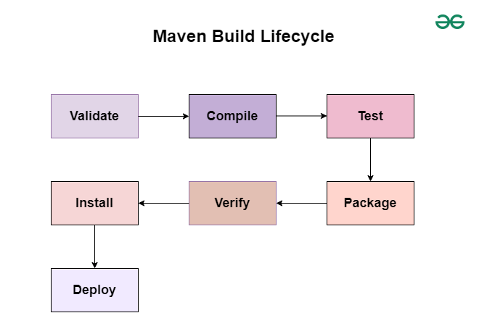
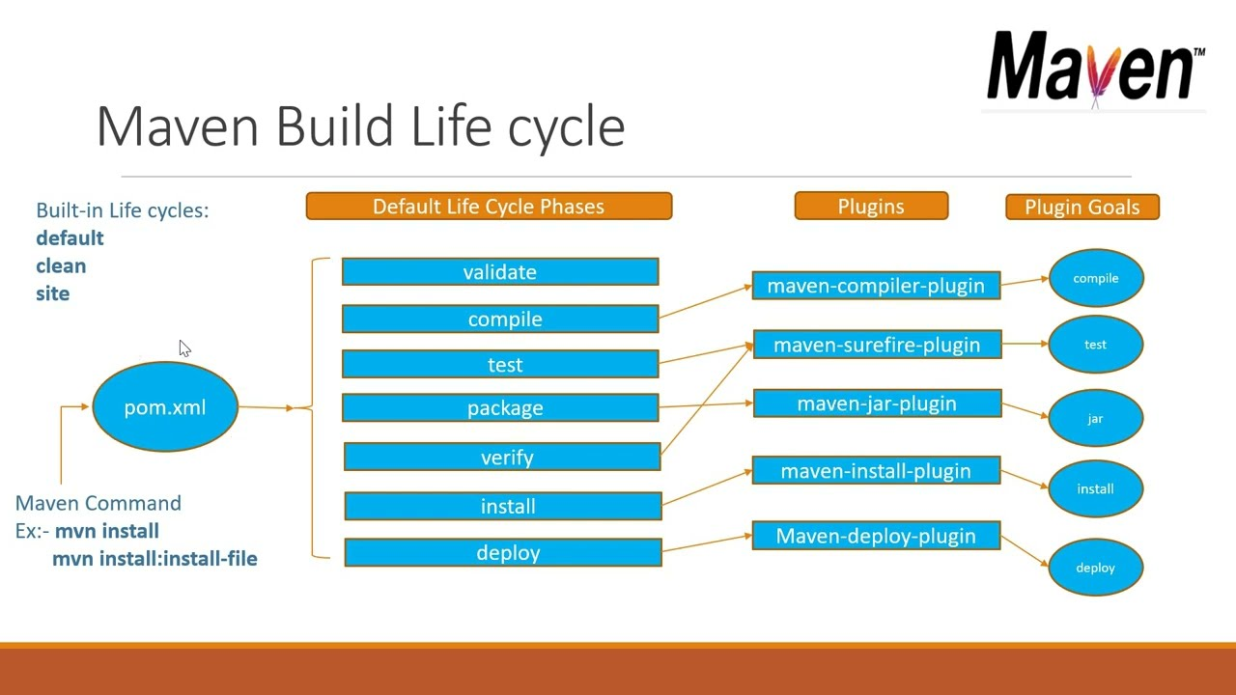

Repositories
- Local: ~/.m2/repository - Cached downloads.
- Central: Default remote (repo.maven.apache.org) - Vast public library collection.
- Remote: Custom (e.g., company Nexus/Artifactory).
Common Commands
- mvn clean - Clean the project.
- mvn compile - Compile code.
- mvn test - Run tests.
- mvn package - Build JAR/WAR.
- mvn install - Install to local repo.
- mvn deploy - Deploy to remote repo.
- mvn archetype:generate - Create a new project from template.

Advantages
- Reduces boilerplate and errors.
- Consistent builds across teams/environments.
- Excellent dependency resolution (handles versions, conflicts).
- Integrates well with IDEs (Eclipse, IntelliJ, VS Code).
Maven remains widely used in enterprise Java development, powering projects at companies like Netflix, Twitter, and many others.

✅ Prerequisite (Very Important)
Maven requires Java (JDK).
Check if Java is installed:
java -version
If not installed, install JDK 8 or above first.

🪟 Install Maven on Windows
1️⃣ Download Maven
- Go to:
👉 https://maven.apache.org/download.cgi
- Download Binary zip archive
(example: apache-maven-3.9.9-bin.zip)

2️⃣ Extract Maven
Extract to a folder, for example:
C:\Program Files\Apache\maven
Inside it you should see:
bin/
conf/
lib/

3️⃣ Set Environment Variables
➤ Add MAVEN_HOME
- Search Environment Variables
- Click New
Variable name: MAVEN_HOME
Variable value: C:\Program Files\Apache\maven
➤ Add Maven to PATH
Edit Path → Add:
%MAVEN_HOME%\bin

4️⃣ Verify Installation
Open Command Prompt:
mvn -version
✅ You should see Maven version details.

🧪 Test Maven (Common Check)
mvn --version
Output should include:
- Apache Maven version
- Java version
- OS details

Guide to create simple a project using Maven (Prime number)
Step1:
F:\JFS_VISEM\Maven_Projects>mvn archetype:generate -DgroupId=com.su2 -DartifactId=PrimeNumberProj -DarchetypeArtifactId=maven-archetype-quickstart -DinteractiveMode=false

Step2:
F:\JFS_VISEM\Maven_Projects>cd PrimeNumberProj

Step3:
F:\JFS_VISEM\Maven_Projects\PrimeNumberProj\src\main\java\com\skillnext>App.java
edit App.java
package com.skillnext;

import java.util.Scanner;

public class App
{
public static boolean check_prime(int n)
{
if (n <= 1)
return false;

for (int i = 2; i <= Math.sqrt(n); i++)
{
if (n % i == 0)
return false;
}
return true;
}

public static void main(String[] args)
{
Scanner sc = new Scanner(System.in);

System.out.println("Enter a number:");
int n = sc.nextInt();

if (check_prime(n))
System.out.println("Num = " + n + " is prime");
else
System.out.println("Num = " + n + " is NOT prime");

sc.close();
}
}
Step4 :
F:\JFS_VISEM\Maven_Projects\PrimeNumberProj>mvn clean package

Step5 :
(to run)
F:\JFS_VISEM\Maven_Projects\PrimeNumberProj>mvn exec:java -Dexec.mainClass=com.su2.App

Building web project using Maven:

Step1:

E:\maven_demo>mvn archetype:generate -DgroupId=in.ac.iare -DartifactId=MyExWeb -DarchetypeArtifactId=maven-archetype-webapp -DinteractiveMode=false

Step2:

E:\maven_demo> dir

Step3:

E:\maven_demo\MyExWeb\src\main\webapp> notepad index.jsp

<html>
<body>
<h2>Welcome to Maven Web World!</h2>
</body>
</html>

Step4 :

cd MyExWeb:>mvn package

MyExWeb\target\MyExWeb.war is generated

Step5 :

Copy
the MyExWeb.war into webapps folder of tomcat server

E:\Softwares\apache-tomcat-9.0.65\webapps and execute it

Step 6:
Start the tomcat server by clicking starupt.bat file of tomcat server

E:\Softwares\apache-tomcat-9.0.65\bin> starupt.bat

Step 7: Run the app using the following url in the browser to get output

http://localhost:8081/MyExWeb

