From Synchronization Physics to Trained Dynamics: A Survey of Oscillator Networks in Machine Learning
Eric Kryski
Independent researcher, Calgary, Alberta, Canada
Corresponding author: Eric Kryski, hello@erickryski.com (ORCID 0009-0005-7751-9059)
2026-09-26
Abstract
Coupled oscillator networks are drawing attention as machine-learning substrates while physics, neuroscience and neuromorphic computing converge on the same oscillatory dynamics from different directions. Physics describes synchronization regimes with computational properties rather than mere order; neuroscience finds functional oscillatory properties in the neuron; and machine learning has produced oscillator architectures that classify, generate images and navigate, with evidence that oscillatory neural networks (ONNs) can be trained, learn, remember and reason. We hypothesize that a substrate whose native operations are resonance and entrainment resembles the neurons evolution refined to sense physical signals, and that a trainable model built from those dynamics would make learning, forgetting and rhythm disruption addressable in simulation. This survey does not test that hypothesis, but uses it for motivation to audit the ONN landscape. We organize eighteen published systems, on two primary questions: whether gradients reach the oscillator dynamics, and whether a conventional encoder or decoder is trained around it. We record the task, data, controls and comparison with conventional networks at comparable budgets; identifying notable findings and methodology gaps. We found the dynamics were rarely isolated; the coupling term has only been removed as a single variable three times, once without a reported number, once on a single dataset, and once only as a retrained model; and no report varies coupling range or boundary conditions as a single variable. We close with eight directions toward shared data, model evaluations and improved controls.
Keywords: coupled oscillators; Kuramoto model; reservoir computing; synchronization; neural architectures; literature survey

1 Introduction and background

1.1 What is an oscillator
An oscillator is a system that keeps a rhythm of its own. Left undisturbed it does not settle at a resting point; it returns to a closed trajectory, a limit cycle, and comes back to that trajectory after being pushed off it. A clock pendulum, drawing on a stored energy source to hold its swing against friction, is the familiar case, and its whole state is one number: how far around the cycle it currently is, its phase. Models that keep only that number are phase-only, and the Kuramoto and Winfree families this survey meets most often are of that kind. Models that track an oscillator’s distance from the centre in addition to its phase carry a second coordinate, the amplitude, so the state lives in a plane rather than on a circle. The Stuart-Landau equation is the canonical form; among the systems surveyed here, the second-order recurrences of the coRNN (Rusch & Mishra, 2021a), UnICORNN (Rusch & Mishra, 2021b) and LinOSS (Rusch & Rus, 2025) lines share that planar state, but as damped or linear oscillators without the amplitude-restoring term that makes a limit cycle self-sustaining: started from rest, as all of them are, they oscillate with whatever amplitude the input gives them rather than returning to a rhythm of their own. Only coRNN among them is damped in the model itself; UnICORNN is undamped by construction and LinOSS has no damping term, a distinction Section 2.3.1 returns to.
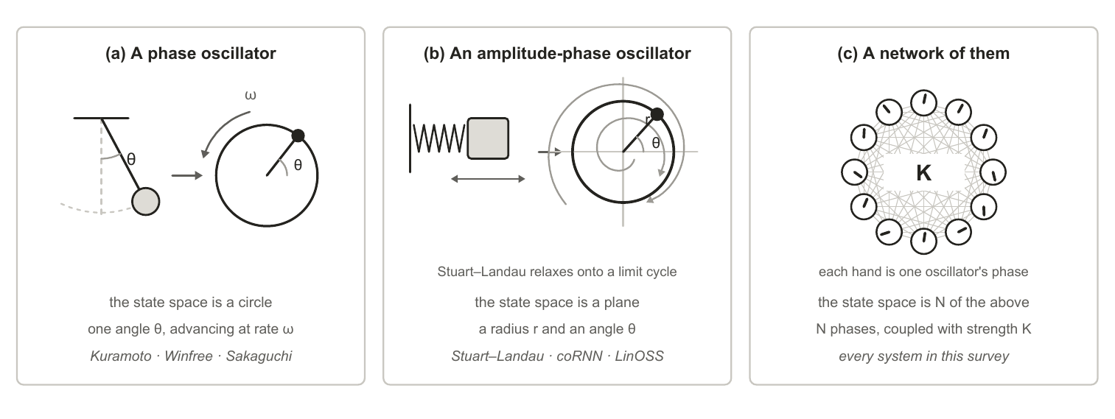
Figure 1. What this survey means by an oscillator, in three widening steps. (a) A phase oscillator keeps a single angle, so its state space is a circle. (b) An amplitude-phase oscillator keeps a radius as well, so its state space is a plane, and trajectories started away from the limit cycle relax onto it. (c) A network keeps N of them and couples each unit to others with strength K. The phases and trajectories drawn are illustrative, not simulated.
Coupling is what makes a population of oscillators one system rather than many: each unit’s rate of change depends on the phases of the units it is connected to, and the strength of that dependence is the coupling constant K. Where a coupled population settles between complete lock and complete disorder is measured by the order parameter R, which runs from 0 to 1. Both extremes are useless for computation. At R near 1 every unit does the same thing, so the population has one degree of freedom left and can carry no signal; at R near 0 nothing is organized for a readout to pick up. The regime that matters is the partial coherence between them, in which some units lock while others drift.
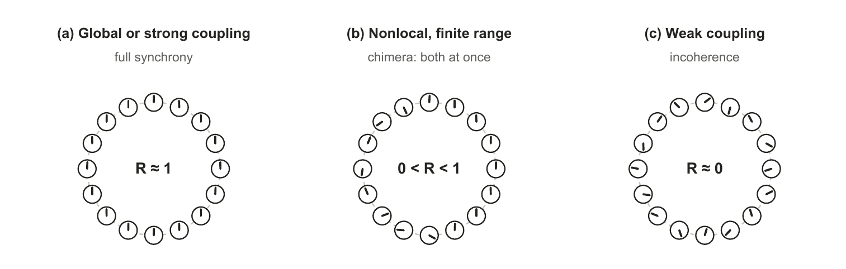
Figure 2. The three coupling regimes reported in the synchronization literature, drawn schematically. Full synchrony leaves no degrees of freedom to carry a signal and incoherence leaves nothing organized; the useful regime is the partial coherence between them, which finite-range nonlocal coupling generically produces. The phases shown are illustrative, not simulated.
That partial regime is also where recurrent computation is reported to peak. Computation in recurrent networks is maximized near the boundary between ordered and chaotic dynamics (Bertschinger & Natschläger, 2004), reservoirs are deliberately parked near that edge, and hierarchical modular structure makes that edge markedly less sensitive to precise tuning (Kuśmierz et al., 2025), a result about autonomous dynamics rather than about trainability. Every design decision surveyed here, whether coupling range, damping, spectral placement or sparsity, is a way of steering the field toward that regime and holding it there, which is also why the same decisions reappear in Section 3.1 as failure modes.

1.2 The evolution of oscillator understanding
Literature from three different fields arrives at similar observations from different directions. Physics and mathematics come first chronologically, describing when a coupled population locks and what its structure does to that. Literature from neuroscience presents findings that cortex runs on rhythms and uses them to route information. Applications within machine learning are much more recent, and almost every system we surveyed aligns with findings from the other two fields.

1.2.1 Within physics and mathematics
The observed coupling of oscillators has been on record since 1665, when Christiaan Huygens found that two pendulum clocks hung from the same wooden beam settled into antiphase within about thirty minutes and resynchronized when disturbed (later published in 1673). Huygens attributed this to motion too small to see, transmitted through the wood beam they shared. The prehistory of the self-sustained oscillator runs from Airy’s first mathematical treatment in 1830 through Poincaré’s limit cycle and Blondel’s naming of the phenomenon, a lineage traced in full by Rivera-Sierra et al. (2026), whose survey of self-oscillatory devices for unconventional computing covers similar background as this paper, but from the materials and neuromorphic hardware angle. Three centuries after Huygens, his observation was given its mathematical form by the Kuramoto coupling function (Kuramoto, 1975), and the same locking is what a row of metronomes started at different times on a shared moving platform demonstrates (Pantaleone, 2002). Huygens’ experiments were later replicated and explained by Bennett et al. (2002). In biology the same synchronization phenomenon was observed at population scale and mathematically modelled, from the patterned flashing of firefly swarms to circadian and cardiac rhythms (Strogatz & Stewart, 1993).
That collective physical dynamics can be computation is much more recent, predating the current oscillatory neural network (ONN) wave by four decades (Figure 6). Hopfield (1982) framed memory as the settling of a dynamic physical system after a stimulus, and argued that such a system has emergent computational properties. Mead (1990) argued that computing using physics directly is the efficiency endgame, also inspired by biological adaptations, and the synchronization canon of Winfree (1967), Kuramoto (1975), the Strogatz (2000) review, and the Pikovsky et al. (2001) textbook set out how coupled oscillator populations self-organize.
Further work on the coupling laws themselves has continued, while the current ONN landscape in machine learning has not yet caught up. The single sinusoid was generalized in several directions: Sakaguchi & Kuramoto (1986) added a phase lag that breaks the symmetry and admits partial coherence rather than forcing all-or-nothing locking; Daido (1992) replaced the sinusoid with an arbitrary periodic function; Schuster & Wagner (1989) put an explicit delay inside the coupling so that interaction depends on history rather than on the instantaneous state. Then it was generalized past pairs entirely. T. Tanaka & Aoyagi (2011) coupled three phases at once and found an infinite number of coexisting synchronized states where pairwise coupling gives one; Ashwin & Rodrigues (2016) showed such terms are not an embellishment but what phase reduction generically produces beyond leading order; Skardal & Arenas (2019) coupled over simplicial complexes and obtained an extensive set of stable partially synchronized states; Mulas et al. (2020) did the same over hypergraphs, where a many-body interaction can exist without its sub-interactions; and Y. Zhang et al. (2023) showed those two representations give qualitatively different synchronization, so higher-order coupling is at least two distinct generalizations rather than one. Multistability on such structures is now characterized directly (Bačić et al., 2026). Separately, the oscillator itself was moved off the circle: Chandra et al. (2019) wrote the units as unit vectors in D dimensions with rotation-matrix natural frequencies, and Aguiar (2023) replaced the scalar coupling constant with a matrix. Appendix B tabulates the full lineage and what each step’s coupling gained over the one before it.
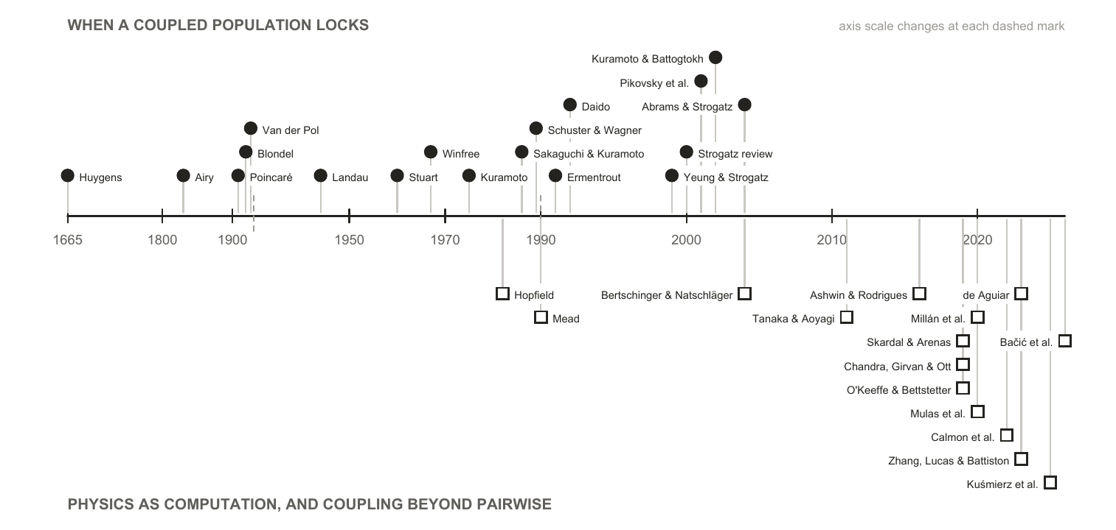
Figure 3. Every physics and mathematics source cited in this survey, in date order. The upper track is the account of when a coupled population locks; the lower track is what structure and operating regime do to it. The axis is piecewise, because four entries predate 1930 and most postdate 1990. Almost every machine-learning system in Section 2 takes its coupling law from the upper track, and from the 1967 to 1992 stretch of it in particular. The exceptions are AKOrN (Miyato et al., 2025) and, through it, HoloGraph (Dan et al., 2025), built on the D-dimensional generalization of Chandra et al. (2019) in the lower track. The rest of the lower track is untouched by the surveyed systems, and its earliest two entries are arguments that physics can compute at all rather than coupling laws to build with.

1.2.2 Within neuroscience
Neuroscience researchers began observing oscillatory coupling directly in cortical tissue: neurons in the feline visual cortex oscillate at 40 to 60 Hz and phase-lock across columns when they respond to the same object, which is why synchrony was proposed as the mechanism binding distributed features into a single percept (Gray et al., 1989). Fries (2015) develops that observation into a “Communication through Coherence” (CTC) hypothesis which essentially states that inter-neuron communication is selective based on gamma-band coherence and synchronization.
Reviewing prior studies of mammalian brains, Fries argues that neuronal groups which need to communicate are tuned to the same gamma band, roughly 30 to 90 Hz, and synchronize in order to do so: sender and receiver lock to a common frequency, and inputs arriving at incoherent phases are effectively ignored. The mechanism he proposes for establishing those phase relations is entrainment with a conduction delay, “both for unidirectional and for bidirectional communication”. Where it succeeds, “gamma entrainment allows to transmit a stimulus representation and to selfishly shut out competing stimuli’s representations”, and it “establishes a cycle-to-cycle memory of the active link that maintains until it is terminated at the end of a theta cycle”. Two features of that account matter here. The gamma rhythm works because it “generates fluctuations in network excitation and inhibition that are sufficiently rapid, such that excitation can essentially temporally escape its ever chasing inhibition”, so the useful window is a narrow phase of each cycle rather than a steady state. And the band itself overlaps the 40 to 60 Hz range at which the feline visual cortex was found to oscillate and phase-lock, which is what ties the binding observation and the communication account together.
Gamma does not act alone. Those bottom-up gamma influences are themselves modulated by top-down alpha-beta activity at 8 to 20 Hz, while attention samples the scene at a 7 to 8 Hz theta rhythm that periodically resets which groups are heard. Communication is therefore selective not because one rhythm gates it but because several rhythms interact, and the theta reset means the gating is repeatedly torn down and rebuilt rather than held.
That last point is what makes the account testable in a network rather than a brain. If a specific phase and amplitude are required before a receiving population responds at all, then coupling between groups is intermittent by construction: groups couple during the excitable window and decouple after it. Whether the coupling and decoupling of a trained oscillator network falls into comparable gamma and theta relationships, and whether it does so on visual tasks in particular, is an open and directly checkable question, and one Section 3.2 returns to.
Beyond the gamma band, Buzsáki (2006) makes the broader claim that self-emerged oscillatory timing is the brain’s fundamental organizer of neuronal information, and that spontaneous activity is the source of cognitive capacity rather than noise to be averaged away. The small-world connectivity of cortex lets these rhythms carry computation on multiple spatial and temporal scales at once, and the perpetual interaction between many network oscillators holds the system in a highly sensitive metastable state, synchronized through weak links at low energetic cost. At the population level the standard reduction is the Kuramoto model (Breakspear et al., 2010), which, recast as a diffusion process under the nonlinear Fokker-Planck equation, accounts for two features of spontaneous large-scale neocortical recordings that a linear treatment does not: the bistability of the human alpha rhythm, and the non-Gaussian fluctuations of the beta rhythm. The family of such reductions, and the mappings between them, has since been set out systematically (Castaldo et al., 2026).
The account is not only about populations. A neuron sitting near its firing threshold is a limit-cycle oscillator, and the phase-response formalism describing how an input shifts its next spike is the same one used for coupled oscillators generally, a correspondence Stiefel & Ermentrout (2016) set out explicitly. The reductions this rests on were built for it: Morris & Lecar (1981) keeps two variables of the Hodgkin & Huxley (1952) conductance dynamics, few enough to analyse and enough to spike. One consequence matters for everything in Section 2: cortex is not quiet when undriven. Resting-state functional connectivity is reproduced by networks of local oscillators running with no stimulus at all (Cabral et al., 2011), which is the biological counterpart of a field that computes before it is trained.
Sensory transduction offers a sharper precedent, because there the frequencies are not learned. The cochlea is modelled as a bank of active oscillators poised near a Hopf bifurcation and tonotopically arranged by design and not by learning (Camalet et al., 2000), an arrangement that yields the sharp, compressive, actively amplified tuning measured in real ears (Kern & Stoop, 2003). The cochlea therefore demonstrates something this survey cares about: a bank of oscillators that performs a hard sensory task well, whose frequencies were fixed by development rather than fitted to data. Where machine learning would train those frequencies, biology specifies them.
Speech is where the account is most fully worked out, and it is the closest thing in neuroscience to a controlled comparison between oscillator models. Reviewing the field, Dogonasheva et al. (2026) set three families of theta-rhythmic segmentation model against each other and separate them by where the flexibility to track a variable speech rate comes from. In the motor-coupled model, auditory and speech-motor cortices are two phase oscillators coupled in both directions rather than one driving the other, and the account reproduces the experimental pattern only once it carries individual differences in the strength of that auditory-motor connection, which is what makes it a model of individual variability in speech-rhythm perception rather than of a population average (Assaneo et al., 2021). In the adaptive-frequency model the oscillator’s own natural frequency moves continuously toward the average period of incoming events, which reproduces human timing judgements on stimulus sequences whose tone positions are jittered by about 20% of the mean period (Doelling et al., 2023). In the single-cell biophysical model, flexibility is intrinsic rather than imposed: the interaction of an m-current with a super-slow potassium current lets a Hodgkin–Huxley cell phase-lock across a broad frequency range, and the resulting segmentation was validated against the TIMIT corpus (Pittman-Polletta et al., 2021). What the review says each model cannot settle is the part relevant here. The two population models are abstracted away from real neuronal biophysics, so neither can say whether a cell-level mechanism produces the flexibility they exhibit. The single-cell model has no network at all and holds its parameters static, so it cannot say whether a population-level mechanism contributes. No model in the review spans both levels, so the flexibility that lets any of them track a variable speech rate cannot presently be attributed to the cell or to the network. That is structurally the problem Section 3.1.1 describes on the machine-learning side, where a system’s result cannot be attributed to its oscillator dynamics because the control that would isolate it has not been run. Two fields arrived at the same impasse without reference to each other.
Disruption of these rhythms is a recognized signature across neurological and psychiatric disorders rather than a correlate of one (Uhlhaas & Singer, 2006), and the relationship has been made interventional: driving gamma-band activity at 40 Hz reduced amyloid load in a mouse model (Iaccarino et al., 2016).
A contested alternative, included because it changes what “oscillator” would mean. The consensus account of the action potential of a neuron is electrical and conductance-based. A minority position models it instead as an electromechanical soliton, a density pulse travelling in the lipid membrane near its melting transition (Heimburg & Jackson, 2005). If something like it held, a neuron would be a mechanical wave medium rather than a circuit, and the oscillator framing would be closer to the underlying physics than to a convenient abstraction. We record it as a live minority hypothesis and take no position on it: it is contested, it is not what the systems in Section 2 assume, and nothing in this survey depends on it. It is an interesting supposition nonetheless, and one we would expect continued work on oscillatory models of cognition to bear on. Were it to hold, the electrical action potential would be a byproduct of an underlying electromechanical oscillation rather than the mechanism itself, which would make the oscillator description of a neuron the literal one rather than the useful one. We flag that as a direction worth watching and not as a claim this survey makes or tests.
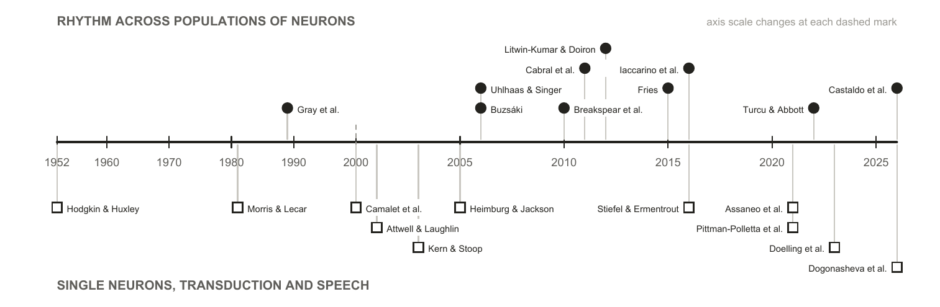
Figure 4. Every neuroscience source cited in this survey, in date order. The upper track is the population account the architectures in Section 2 draw most of their hypotheses from; the lower track is what makes the oscillator description of a neuron literal rather than figurative, together with the transduction and speech work where the frequencies are designed rather than learned.
Two of the neuroscience findings in this section translate directly into testable machine-learning claims, and both reappear in Section 3 as gaps. The binding result (Gray et al., 1989) predicts that removing the synchronization term should hurt grouping tasks specifically. The Hopf-cochlea precedent (Camalet et al., 2000) predicts that designed frequency placement should beat learned placement.

1.2.3 Within machine learning
What an oscillator network is. Section 1.2.1 gives a rule for how coupled units pull on each other, and Section 1.2.2 gives a reason to expect that rule to compute something. An oscillator network is what results when both are pointed at a machine-learning task. An oscillator network, or oscillatory neural network (ONN), is a machine-learning system whose state is a population of oscillators and whose computation is the evolution of that population under a coupling law. Three choices define one. The coupling function is borrowed from the physics. It is the rule that turns the phase difference between two units into a contribution to each one’s rate of change, and choosing Kuramoto rather than Winfree or Sakaguchi fixes which collective states the population can reach at all; Section 2.3.1 sets the forms actually in use side by side. The geometry is which units are coupled to which, and it decides both the parameter cost and the operating regime. The input and readout decide how a task reaches the field and how an answer is taken out of it. Everything else is the same machinery any other neural network uses.
Geometry deserves its own picture because it is treated as an implementation detail in most of the surveyed work and is not one. All-to-all coupling connects every pair through its own learned weight, as in Un-0 (Unconventional AI, 2026a); a ring with a finite coupling range connects each unit only to units near it; a lattice arranges the units in space and couples neighbours through a shared kernel, as in Neural Wave Machines (Keller & Welling, 2023) and the convolutional variant of AKOrN (Miyato et al., 2025); attention connects every pair through weights recomputed from the current state, as in AKOrN’s attentive variant and WONN (Dai & Song, 2026); a modular fabric is dense inside its blocks and sparse between them. All-to-all coupling costs O(N²) parameters and is the bulk of the largest system surveyed here. Finite-range nonlocal coupling is the case in which the physics reports coexisting locked and drifting domains (Kuramoto & Battogtokh, 2002), which is the regime Section 1.1 identified as the useful one. And no published work we found holds a core fixed and varies the geometry, which is why Section 3.1 treats it as an open axis rather than a settled one.
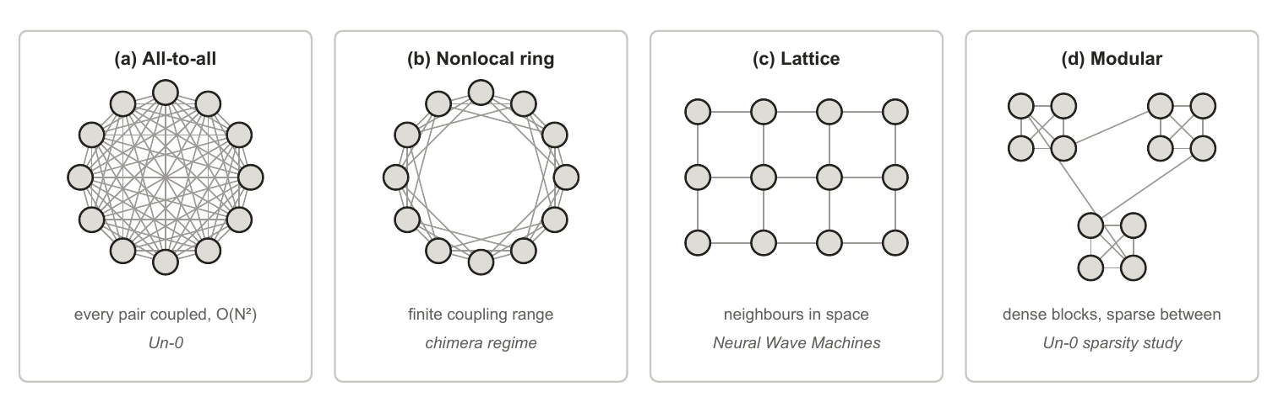
Figure 5. Four coupling geometries over the same twelve oscillators. All-to-all coupling with a free weight per pair is what Un-0 uses, and its O(N²) parameter cost is the bulk of Un-0’s 322M parameters at 16k oscillators; AKOrN and WONN reach every pair through attention weights instead, and AKOrN’s convolutional variant couples a fixed neighbourhood. Finite coupling range is the case the physics canon reports chimera states in. A lattice is the geometry of Neural Wave Machines. The modular fabric is the best performer in the one published sparsity study of a trained oscillator network, which is blog-published and covers one system.
Recent contributions. The systems fall into three groups by where the dynamics sits.
- Oscillatory recurrences replace the recurrence of an RNN with a second-order oscillator ODE. The coRNN (Rusch & Mishra, 2021a) is a network of coupled, damped, nonlinear oscillators: its hidden units interact through full weight matrices inside the nonlinearity, its damping bounds the energy of the hidden state, and its gradient bounds follow from a structure-preserving discretization under a condition that ties the time step to the weight norms, rather than from gating. UnICORNN (Rusch & Mishra, 2021b) keeps the second-order form but drops both the damping and the coupling within a layer: each unit is an independent undamped oscillator, y’’ = −[σ(w y + Vu + b) + αy] with w a vector applied elementwise, the system is Hamiltonian, and a symplectic discretization conserves phase-space volume, which is what its gradient bounds rest on; layers are stacked densely, each unit carries a trainable time step, and the result runs thirty to forty times faster than coRNN. One consequence matters for Section 2.3.2: UnICORNN trains nonlinear dynamics with full backpropagation through the 17,984-step EigenWorms sequences and reaches 90.3% there, a record set in 2021. Their linear descendants trade the nonlinearity for scale: LinOSS (Rusch & Rus, 2025) is a bank of uncoupled forced harmonic oscillators, y’’ = −Ay + Bu + b with A diagonal and no damping term, that is stable for any non-negative A, reaches sequences of roughly fifty thousand steps by parallel scan, and comes in two discretizations, a conservative one and an implicit one whose numerical dissipation the authors read as a forgetting mechanism; D-LinOSS (Boyer et al., 2025) adds an explicit learnable damping term and proves that this enlarges the reachable dynamics from a measure-zero set of eigenvalues, which the earlier discretizations tie to frequency, to the full unit disk. The family has universality theorems, and their construction is a fixed bank of uncoupled forced harmonic oscillators followed by a nonlinear readout (Lanthaler et al., 2023); LinOSS proves its own for its continuous-time model. Two wording notes are worth recording, because they misled an earlier draft of this survey and may mislead a reader. The UnICORNN paper twice calls its parameter α “the damping parameter” in its experiments section, while its model section calls the same α the oscillation frequency and states that the system has no damping or friction term; α multiplies the position, enters the Hamiltonian as the restoring potential, and cannot dissipate energy, so we read the model as the undamped one its name declares. And the LinOSS paper never uses the word damping, while D-LinOSS describes its predecessors as undamped harmonic oscillators whose discretization couples frequency and damping: the dissipation in question belongs to the implicit integrator, not to a term of the model.
- Trained synchronization models put Kuramoto-type dynamics to work directly. AKOrN (Miyato et al., 2025) uses the D-dimensional generalization as a layer inside a conventional network, with the coupling defined by a convolution kernel or by attention rather than by a free all-to-all matrix, and reports its gains on object discovery, adversarial and corruption robustness, calibration and Sudoku rather than on clean classification accuracy, where it trails a ResNet-18. WONN (Dai & Song, 2026) evolves representations on a torus under generalized Winfree dynamics, writing the input into the natural frequencies rather than adding it as a drive. Its authors describe it as the first synchronization architecture to scale competitively to ImageNet-1K, and the qualifier matters, since their own table trains AKOrN on ImageNet-1K at 67.45%; it is also the only system in the survey evaluated on path finding, and one of two on Sudoku. On Maze-hard it reports 76.2% in a single pass and 80.1% when the lowest-energy of 32 sampled trajectories is selected, at 0.396M parameters. The paper frames this as 1% of the parameters of the prior state of the art, but the best result in its own table is TRM-Att at 85.3% with 7M parameters, so the reading we take is a model eighteen times smaller that trails the best result by five points and beats the 27M-parameter HRM by two to six. Un-0 (Unconventional AI, 2026a) trains an all-to-all Kuramoto pool end to end for image generation and publishes a frozen-dynamics control, a decoder-only control and a randomized-structure twin against itself, though only as blog posts with released code. KomplexNet (Muzellec et al., 2025) runs Kuramoto dynamics on the phases of a complex-valued CNN’s first layer, with a coupling kernel trained through a synchrony loss on ground-truth object masks, and reports the most complete set of controls in the survey: a twin trained without the Kuramoto step, a twin whose coupling kernel is held at a fixed Gaussian, and parameter-matched real-valued and Transformer baselines. Its headline margin of 10 to 15% over the real-valued model is measured on overlapping and noisy digits; in distribution the synchronization step is worth two to three points. Kuramoto Attention (Nunley, 2026b) keeps the query-key selection of an attention layer and replaces its value path with a single Kuramoto step, and FSN (Nunley, 2026a) builds that value pathway from static frustration angles, Daido harmonics and an anticipating delay term at once, arguing that consensus records where the attended context is rather than what followed it, so it suits retrieval but not prediction. Kuramoto Orientation Diffusion (Song et al., 2025) makes stochastic Kuramoto the forward process of a diffusion model, which suits generation on periodic domains. HoloGraph (Dan et al., 2025) swaps the diffusion-style message passing of a graph network for synchronization between AKOrN’s vector-valued oscillators with a feedback term, aimed at the over-smoothing repeated diffusion causes; it is the one peer-reviewed system in this group whose ablations concern spectral features and depth rather than the dynamics. Neural Wave Machines (Keller & Welling, 2023) replace coRNN’s dense coupling matrices with a convolution kernel over a lattice, so each oscillator couples only to its neighbours, and report travelling waves along with a parameter saving that follows from the locality by construction.
- Physical substrates run the dynamics in hardware instead of simulating it. A single spin-torque oscillator, time-multiplexed as a frozen reservoir, reaches about 99.6% on spoken digits with one device (Torrejon et al., 2017), on five TI-46 speakers shared between training and test, where its cochlear front end alone reaches 95.8% (Abreu Araujo et al., 2020); four coupled spin-torque oscillators have been trained in hardware to recognize vowels (Romera et al., 2018). Oscillator Ising machines (T. Wang & Roychowdhury, 2019) engineer injection locking so the physics performs a combinatorial search directly, with no training anywhere. Both sit inside the broader physical-reservoir programme (G. Tanaka et al., 2019), and the run-the-physics thesis extends past oscillators into optical (Chen et al., 2025) and thermodynamic (Coles et al., 2023) computing. The same ground has been surveyed from the materials and device side (Rivera-Sierra et al., 2026).
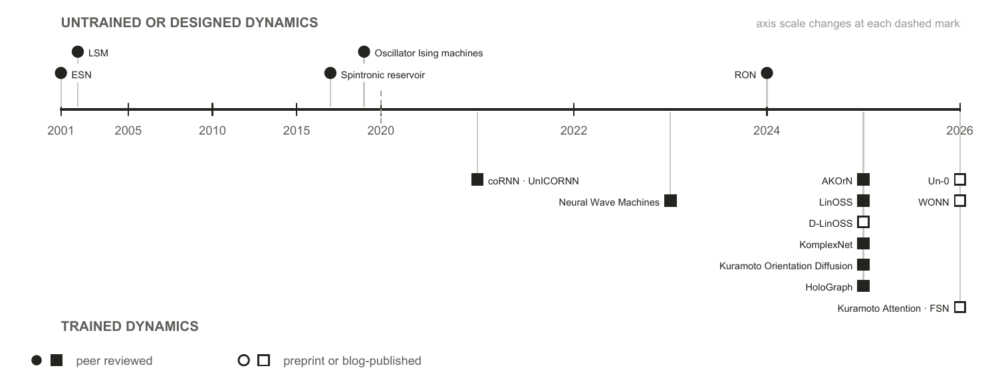
Figure 6. The machine-learning systems this survey covers, by the publication date of the report cited for each. Systems whose dynamics is untrained or designed appear above the axis, systems trained through their dynamics below. A filled marker means the report is peer reviewed. The trained branch is entirely post-2020, and every system whose report is not peer reviewed falls in its last two years.
Set against the physics, the pattern is stark and is one of this survey’s findings. Almost every machine-learning system here uses a coupling law from the 1967 to 1992 window. Kuramoto and Kuramoto–Sakaguchi account for nearly all of the trained systems. Past them the tally is short enough to state exactly. The Stuart-Landau form appears once (K. Zhang et al., 2026). The D-dimensional generalization appears once, as the basis of AKOrN. Higher-order coupling appears once, in a dense associative memory (Nagerl & Berloff, 2025). Delay coupling is the exception, long established in reservoir computing where a single delayed node stands in for a whole network (Appeltant et al., 2011). The inertial, simplicial, hypergraph and Dirac forms appear not at all. Swarmalators, in which phase and spatial position couple to each other, were proposed as a substrate for bio-inspired computing seven years ago (O’Keeffe & Bettstetter, 2019) and we found no machine-learning system built on them. One of the properties those later models offer is asked for directly. FSN argues that consensus records where the attended context is rather than what followed it, and Un-0’s sparsity study reports dense fields collapsing into a globally locked, zero-gradient state, so partial coherence is a stated requirement of the systems themselves rather than an inference of ours. Multistability and coupling beyond pairwise carry no comparable stated demand, and no surveyed system has tested whether either helps. The gap is untested rather than considered.
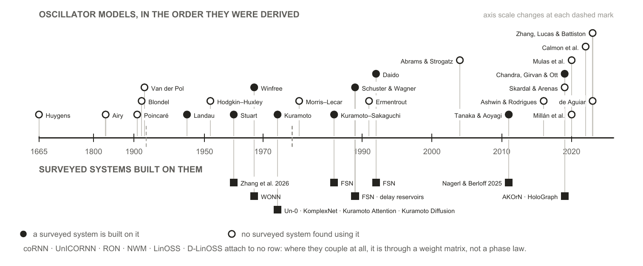
Figure 7. The oscillator models this survey cites, above the surveyed systems built on each one. A filled marker means at least one system in Section 2 uses that coupling form; an open marker means we found none that does. Each system is placed at the year of the model it uses rather than the year it was published, so the lower track measures how far into the lineage the machine-learning literature has reached, not its own chronology.

1.3 Other neural network architectures
Oscillator networks are not the only option, and several of the systems in Section 2 embed one inside a conventional network rather than replacing it. Judging what the oscillator dynamics contributes therefore means knowing what the conventional architectures already do, both as the baselines an oscillator system is measured against and as the components it is often combined with. This section sets out the main families and how each one handles state, which is the property an oscillator field differs on most.
Recurrences carry a state vector forward. The Elman network (Elman, 1990) updates a hidden vector once per input and reuses it, which is the same shape of computation an oscillator field performs, except that the update is a learned weight matrix rather than a differential equation. Its failure mode is what every later design answers: gradients through a long chain of such updates vanish or explode. The LSTM (Hochreiter & Schmidhuber, 1997) answers it with gated paths along which a value passes unchanged, and the gated recurrent unit (Cho et al., 2014) reaches the same effect with two gating units where the LSTM uses four. Oscillator recurrences answer the same question with different machinery, bounding the gradient through the structure of the dynamics rather than with gates, a dissipative energy bound and a structure-preserving discretization in coRNN, conservation of phase-space volume in UnICORNN, which is why both can prove what an LSTM can only demonstrate.
Convolutions carry no state. A convolutional network (Lecun et al., 1998) applies the same local filter across position and lets depth build up the receptive field. Weight sharing over a spatial grid is the assumption an oscillator lattice makes as well; the difference is that a convolution has no dynamics between applications, so nothing persists between one input and the next.
Attention recomputes over the whole window. The Transformer (Vaswani et al., 2017) drops recurrence entirely and lets every position attend to every other, which removes the sequential dependency that made recurrences slow to train. The cost is that it keeps no compressed state: attention is quadratic in sequence length, and at inference the keys and values of every previous token must be held in memory, a footprint that grows linearly with context and dominates serving cost at scale (Kwon et al., 2023). A fixed-size oscillator field is the opposite trade, which is the substance of the efficiency argument made for it.
Diffusion models iterate over noise rather than over time. A diffusion model (Ho et al., 2020; Sohl-Dickstein et al., 2015) carries nothing between inputs; it generates by running a learned denoiser, itself a convolutional or attention network, for a fixed number of steps down a noise schedule, so the computation is a dynamical system over noise level rather than over the time axis of a signal. That makes it the conventional family closest in shape to a trained oscillator field settling from a random initial condition, which is why Un-0 is scored against diffusion baselines and why Kuramoto Orientation Diffusion could replace the Gaussian forward process with stochastic Kuramoto dynamics outright.
State-space models put a linear dynamical system back in. S4 (Gu et al., 2022) recovers a constant-size recurrent state while keeping parallel training, and finds its spectrum’s initialization to be load-bearing rather than incidental (Gu et al., 2023); Mamba (Gu & Dao, 2023) makes the state transition input-dependent and reaches Transformer-quality language modelling. RWKV (Peng et al., 2023) arrives at the same shape from the attention side, rewriting attention as a linear recurrence so that a Transformer-style model trains in parallel and runs with a constant-size state, which makes it the mainstream counterpart of the attention-as-dynamics reading that Kuramoto Attention and FSN give. This is the family the oscillatory recurrences are closest to: LinOSS is a state-space model whose transition is a bank of harmonic oscillators, which is why it is also the oscillator system with the longest gradient horizon in the survey, roughly fifty thousand steps; UnICORNN’s 17,984 is the longest for a nonlinear one. Hybrids interleave the two, keeping a few attention layers for recall over a mostly recurrent stack (Lieber et al., 2024).
Spiking networks are the nearest neighbour. A spiking unit is an oscillator of a restricted kind: it integrates input, crosses a threshold, emits a discrete event, and resets. That discreteness is what makes it efficient on neuromorphic hardware and what makes it hard to train, since the threshold is non-differentiable, so gradient methods need a surrogate and the choice of surrogate is itself a modelling decision (Neftci et al., 2019). Oscillator models keep the state continuous, so coupling is differentiable and no surrogate is needed, and they carry structure a threshold unit discards: a natural frequency, a phase relationship to every other unit, and a graded rather than binary response to input. Recent work narrows the gap from the other side, training networks of Morris–Lecar neurons directly with backpropagation (Akbari et al., 2025, preprint). Whether continuous state makes oscillator networks easier to train is open, and this survey’s own evidence cautions against assuming it. No published work compares a spiking network and an oscillator network on one task under matched conditions, and every nonlinear oscillator system in the record that lacks a proven gradient bound works at a short gradient horizon (Section 2.3).
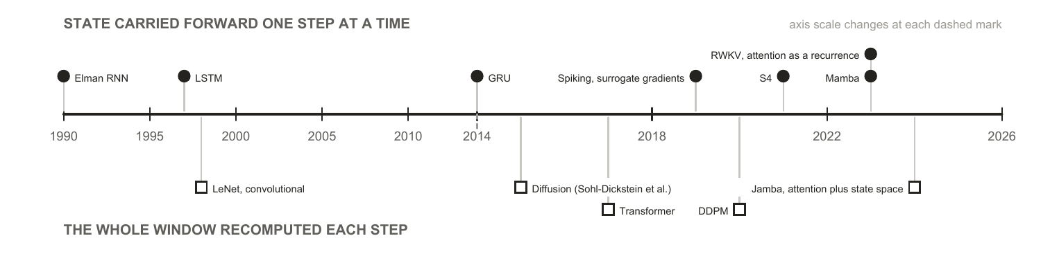
Figure 8. Conventional neural network architectures, by how each one holds the past. Above the axis, a state is carried forward one step at a time; below it, the whole window is recomputed at every step. Diffusion sits below the axis as well: it keeps nothing between inputs and iterates a denoiser over noise levels rather than over time, the iteration Kuramoto Orientation Diffusion makes oscillatory. An oscillator field belongs to the upper track, but its state evolves under a fixed differential equation rather than under a transition learned from scratch, which is the substance of both the efficiency argument made for it and the training difficulty reported against it.

1.4 Motivation for this survey: independent convergence across fields
The case for reviewing oscillator networks is not that any single result is decisive. It is that literatures with different methods and incentives have moved toward the same description of computation, coupling and coherence, and did so largely without citing each other.
From physics, the synchronization canon now describes regimes that look like computation rather than mere order: partial coherence, chimera states with locked and drifting populations coexisting in one field (Abrams & Strogatz, 2004), multistability on higher-order interaction structures, and a computational optimum near the boundary between order and chaos. From neuroscience, the oscillator description of a neuron has hardened from analogy into working model, rhythm has been given specific computational jobs, and disruption of those rhythms is now interventional rather than merely descriptive. In machine learning, oscillator dynamics has begun to appear in architectures that run on mainstream tasks at non-trivial scale: 76.78% top-1 on ImageNet-1K at 12.3M parameters (WONN, preprint), class-conditional generation on ImageNet-64 at FID 6.74 (Un-0, blog-published), regression over fifty-thousand-step windows (LinOSS), object discovery and Sudoku (AKOrN), and character- and byte-level language modelling (Kuramoto Attention, preprint). What these results establish is that the dynamics can be trained at these scales at all; the long-sequence result has a 2021 precedent in UnICORNN’s 17,984-step classification, and the rest were not on the record five years ago. What they do not establish is how the systems stand against tuned conventional baselines, which Section 2.3.4 takes up.
The machine-learning literature has so far built on the simpler end of that physics, and it is already getting results there. The coupling laws in use generally end around the 1992-era physics models (Figure 7), and the geometries in the surveyed machine-learning models are all-to-all, convolutional or attention-defined, with Un-0’s sparsity study the only one to vary connectivity on purpose, while the more recent physics models demonstrate behaviour ONN researchers have reason to want. Partial coherence is the clearest case: two of the surveyed systems name full synchronization as the failure mode they are trying to avoid. Multistability and coupling beyond pairwise are untried here rather than unwanted. That gap reads as headroom rather than deficiency: more expressive coupling laws are sitting unused, and the results already obtained with the simple ones are the reason to think the richer ones are worth trying.
Three motivations sit behind the interest, and they are worth separating from evidence:
- Energy and compute. The brain’s signalling budget is small enough to be a standing reproach to conventional accelerators (Attwell & Laughlin, 2001), and running physics directly has been the efficiency argument since Mead (1990); the concrete modern version is that a fixed-size dynamical state avoids the growing key-value cache that dominates Transformer serving. No trained oscillator network has published a measured energy win (Section 2.3.4), so this is a reason to look, not a result.
- Alignment with the signals. The signals biological sensing evolved to handle are physical waves, and the transducers that receive them are frequency-selective by construction, the cochlea being the clearest case. A substrate whose native operations are resonance, entrainment and phase relationship is therefore not an arbitrary inductive bias for these signals; it is the same class of object as the thing being sensed.
- Explanatory: a trainable model built from the same dynamics as the biological account would make questions about learning, forgetting and rhythm disruption addressable in simulation. All three are hypotheses about what the field could deliver. This survey is about what it has delivered.

1.5 Evidence standard and limitations
Evidence standard. This survey reports no new experiments and cites no unpublished results. Every claim is attributed to a published source. A substantial part of the trained-Kuramoto evidence exists only as technical blog posts, preprints, or community repositories. That material is included, because excluding it would misrepresent the state of the field, and it is marked as non-peer-reviewed everywhere it carries weight. Where a claim rests on such a source, the text says so at the point of use rather than in a footnote.
Five limitations bound every claim that follows.
- Publication-status heterogeneity. The strongest evidence that trained pure-Kuramoto dynamics works at scale, and all of the oscillator-sparsity evidence, is blog-published. Several load-bearing systems are preprints: WONN (Dai & Song, 2026), Kuramoto Attention (Nunley, 2026b), FSN (Nunley, 2026a), and the equilibrium-propagation study (Ahmadi, 2026). KomplexNet (Muzellec et al., 2025) is the one system in this group to have completed peer review since we began this survey, which is itself a reminder of how quickly the status of any row here can change. Independent replications are essentially absent field-wide.
- Protocol heterogeneity. Numbers quoted from different papers cannot be fairly compared across models and protocols. They are therefore set beside each other observationally in this survey and never ranked.
- Coverage bounds. We survey the machine-learning-facing evidence. The synchronization physics, neuroscience and hardware literatures are cited as anchors for background and motivation, and were not reviewed exhaustively.
- A fast-moving field. Every “lacks evidence” claim carries an implicit “that we found”. Several systems surveyed here are months old, and there may be work under review addressing the gaps we identify.
- Interest disclosure. The authors conduct their own experimental work on oscillator substrates. The gaps identified reflect those interests. No unpublished work of ours is used or cited.

2 Oscillator neural networks

2.1 Scope and terms
A “coupled oscillator network” here means a machine-learning system whose state evolves under oscillator dynamics: phase-only models of the Kuramoto and Winfree family, second-order oscillator ODEs, linear oscillatory state-space models, amplitude-phase models, and physical oscillator hardware. Eighteen load-bearing systems meet that definition and are tabulated in Appendix C as fifteen rows, since three pairs share an architecture and a control record: the echo-state network and the liquid state machine, LinOSS (Rusch & Rus, 2025) and D-LinOSS (Boyer et al., 2025), and Kuramoto Attention (Nunley, 2026b) and FSN (Nunley, 2026a). The same words are used differently in physics, neuroscience and machine learning, and several of the comparisons below depend on which sense is meant; Appendix A is a glossary of the terms as this survey uses them.
One adjacent literature is deliberately outside that definition. A substantial body of work uses neural networks to model oscillator dynamics rather than to compute with them, learning the evolution of a coupled system from data, most recently through Koopman operator methods (Sasikumar & Balasubramaniam, 2026). That is the inverse of the question here. This survey asks what oscillator dynamics does for a machine-learning system, not what a machine-learning system can say about oscillator dynamics.

2.2 Taxonomy

2.2.1 Overview
Two independent questions separate the surveyed systems, and crossing them gives four quadrants rather than a tree. The first is whether gradients reach the dynamics: is the oscillator field fitted to the task, or fixed by design or at random before training begins? The second is whether anything else is trained: does a conventional encoder, decoder or readout sit around the field and do part of the work? The first question is where the field’s claims differ most. The second is where its attribution problems live, because a trained scaffold can carry a result that is then reported as the dynamics’.
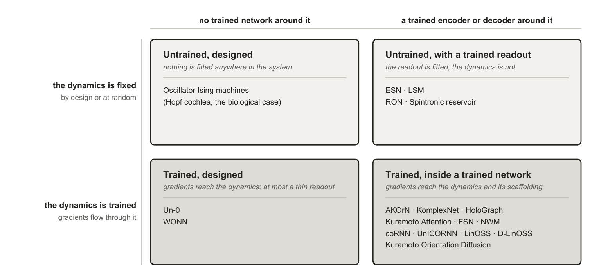
Figure 9. The taxonomy used in this survey. Systems split on two independent questions: whether gradients reach the dynamics, and whether a trained conventional network wraps it. Coupling law, geometry and substrate cut across all four quadrants and are carried as columns in Section 2.3 rather than as further branches, because nesting them produces a tree no system occupies uniquely.

2.2.2 Untrained designed dynamics
Nothing is fitted anywhere. Every parameter is chosen, and the physics performs the computation directly. Oscillator Ising machines (T. Wang & Roychowdhury, 2019) are the clear case: injection locking is engineered so that the equilibrium the hardware falls into is the answer to a combinatorial problem, and there is no training step of any kind. This is the strongest form of the run-the-physics argument: if a system’s parameters can be chosen so that its natural dynamics settles on the answer, the computation costs whatever the physics costs and no more. It is also why designing a substrate around a specific task, rather than training a general one to perform it, should be further studied by the field.
The biological precedent sits in the same quadrant and is worth keeping in view because it is the one place where designed beats learned on the record. The cochlea is a tonotopically arranged bank of active oscillators whose frequencies are set by construction, not fitted, and it delivers sharp, compressive, actively amplified tuning that no learned filterbank has bettered.

2.2.3 Trained designed dynamics
Gradients reach the dynamics, and the dynamics is essentially the whole model rather than a component of one; a thin conventional encoder or decoder may remain, and in Un-0 it is under 13% of the parameters. Un-0 (Unconventional AI, 2026a) is a pure Kuramoto pool with learned all-to-all coupling and learned natural frequencies, read out by a convolutional decoder and trained end to end for image generation; WONN (Dai & Song, 2026) uses generalized Winfree coupling, writes the input into the natural frequencies through a learned embedding rather than adding it as a drive, and updates those frequencies once per layer. Both are the field’s scale demonstrations, and both are also where the attribution question is cleanest, because there is comparatively little conventional machinery to which a result could be misattributed, which is also what makes a decoder-only control meaningful for Un-0. Un-0 publishes the controls this quadrant makes possible: a frozen-reservoir control, against which its trained dynamics wins clearly, with single-step learned dynamics performing near the untrained level on CIFAR-10, and a decoder-only control that does worse than either (blog-published). WONN publishes neither.

2.2.4 Untrained dynamics with a trained encoder or decoder
The dynamics is fixed, randomly or by design, and a readout is fitted to it. This is the oldest branch and the best evidenced, because a field was built on it: echo-state networks and liquid state machines fix random recurrent dynamics and train only a linear readout (Jaeger, 2001; Maass et al., 2002), a construction whose scope and limits were consolidated a decade later (Lukoševičius & Jaeger, 2009).
The oscillator-specific evidence here is the strongest in the survey. A single physical spin-torque oscillator, time-multiplexed as a frozen reservoir, reaches roughly 99.6% spoken-digit recognition with one device rather than a network of them (Torrejon et al., 2017), 3.8 points above what its cochlear front end reaches alone, with the same speakers in training and test (Abreu Araujo et al., 2020). Untrained networks of randomly coupled damped oscillators, RON (Ceni et al., 2024), are reported to beat a leaky echo-state network on every benchmark they run, and to beat fully trained recurrent models, including a trained version of themselves, on chaotic forecasting and on small-parameter classification, while losing to the trained models on the long-memory classification tasks; the trainable parameters are matched, which the paper enforces, and the random reservoir then carries about fifty times more units than the trained networks. That is a trained-versus-untrained comparison in the untrained direction, and the paper’s trained twin is the frozen-twin control of Section 2.3.3 run in reverse. And designed dynamics can replace random dynamics at no cost: deterministic minimum-complexity reservoirs match classical random echo-state networks (Rodan & Tino, 2011).
The distinguishing feature within this quadrant is where the fixed dynamics comes from, and it matters because Section 3.1 shows designed structure repeatedly failing to beat randomized twins elsewhere. Random initialization is the reservoir default, deterministic construction is a documented alternative at equal accuracy, and the tonotopic cochlea is the limiting case in which every parameter is chosen. This is the one branch where that comparison has been run and design holds up.

2.2.5 Trained dynamics with a trained encoder or decoder
Gradients flow through the oscillator dynamics and through conventional layers around it. This quadrant drives the current wave and carries the heaviest attribution burden, since a conventional scaffold surrounds the part under test.
Within it, the useful sub-division is architectural role, because it predicts both the training horizon and the controls the system needs. As a recurrent core, the dynamics replaces the recurrence of an RNN: coRNN (Rusch & Mishra, 2021a) and UnICORNN (Rusch & Mishra, 2021b), LinOSS (Rusch & Rus, 2025) and D-LinOSS (Boyer et al., 2025), and Neural Wave Machines (Keller & Welling, 2023). This is where the theory is strongest and the horizons longest. As a layer inside a conventional network, Kuramoto dynamics sits as one block among ordinary ones: AKOrN (Miyato et al., 2025)’s D-dimensional layers, KomplexNet (Muzellec et al., 2025)’s phase dynamics inside a complex-valued CNN, the synchronization message passing of HoloGraph (Dan et al., 2025) inside a graph network. As an attention mechanism, a Kuramoto or Kuramoto–Sakaguchi step stands in for an attention layer, typically one dynamics step per layer: Kuramoto Attention (Nunley, 2026b) and FSN (Nunley, 2026a). As a generative process, stochastic Kuramoto becomes the forward process of a diffusion model trained through per-step score objectives rather than through a long chain: Kuramoto Orientation Diffusion (Song et al., 2025).
The theory underwriting this quadrant is real and worth stating, because it establishes that the function class is there to be learned even where the evidence that it is learned is thin. The family is universal, with quantitative approximation and generalization bounds (Huang et al., 2026b, 2026a) and an infinite-horizon extension (Sagodi & Park, 2026); input-to-state stability has been established for coupled oscillator networks (Stölzle & Della Santina, 2024); and contraction conditions are known for composing stable recurrent modules (Kozachkov et al., 2022). One result cuts the other way, and it is the sharpest thing theory says here: within-layer coupling may not be required for the family’s universality, because a diagonal, uncoupled bank could suffice (Lanthaler et al., 2023). That is proved for a fixed bank of forced harmonic oscillators with a nonlinear readout, in continuous time, rather than for the Kuramoto-family models most of the surveyed systems use, and a discretization inherits it only for small time steps, so it bounds what synchronization can be claimed to add rather than settling it. If it carries, whatever synchronization contributes is inductive bias, and only a controlled ablation can measure it.

2.3 Comparison of the current landscape

2.3.1 What the systems are built from
Appendix C records what each system is: its oscillator family, the part of a model the dynamics constitutes, what gradients reach, and whether the work is peer reviewed. Appendix D records what each system reports: task, data, headline result, parameter count and training horizon. Both are inventory. The three things worth reading across them are the coupling law, the geometry, and where the input enters, because those are the choices the physics says are consequential and the papers make in passing.
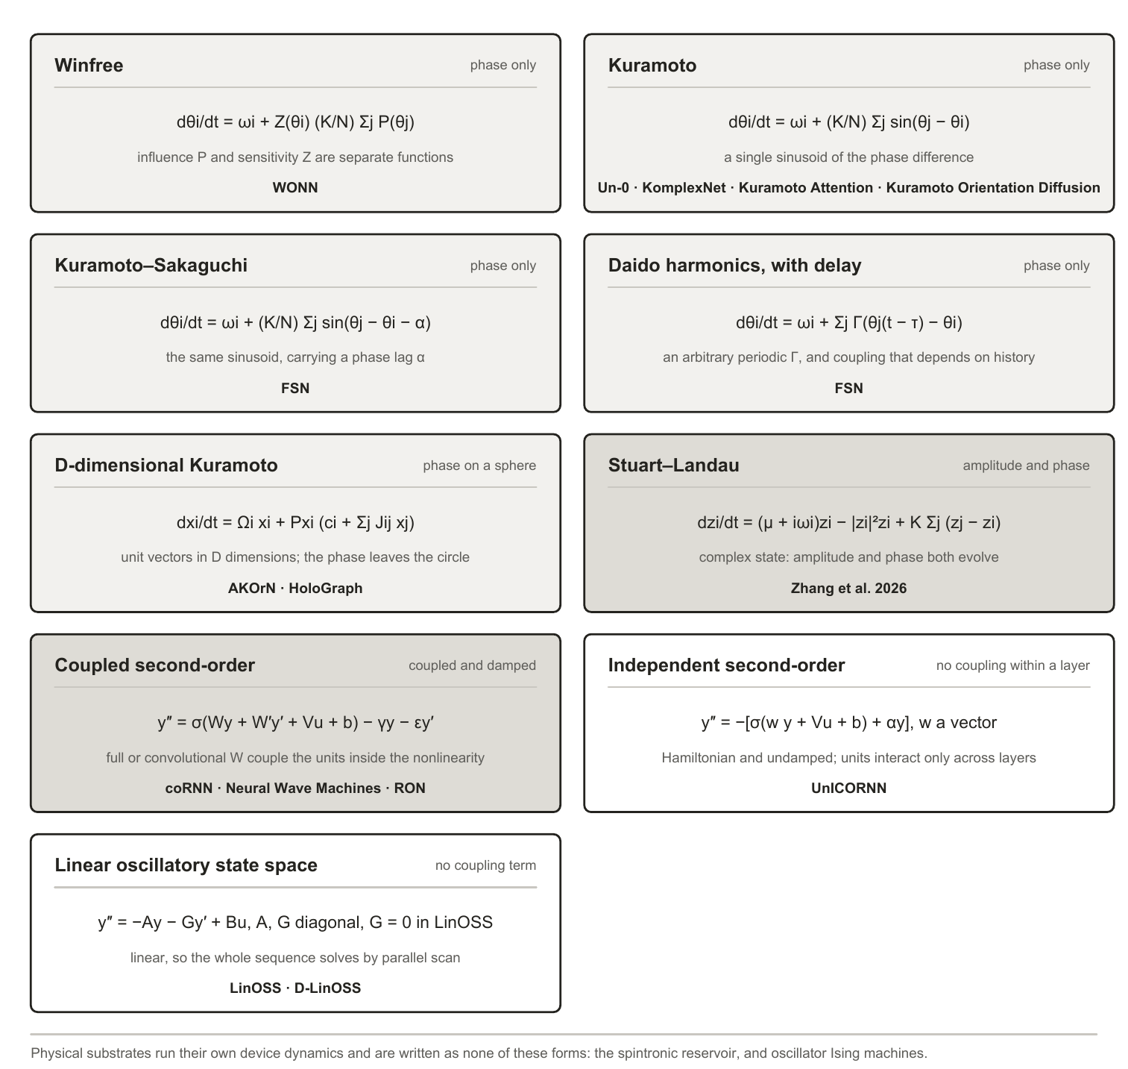
Figure 10. The oscillator dynamics each surveyed system is built on, grouped by how the dynamics is written rather than by when it was published. The first seven forms carry a coupling term between units, whether as a phase difference, a projected vector sum, or, in the coupled second-order recurrences, full or convolutional weight matrices inside the nonlinearity. The last two do not: UnICORNN’s units are independent within a layer and LinOSS’s state matrices are diagonal, which is why Section 2.3.3 records a coupling ablation for those rows as not applicable rather than as missing. Appendix B places all of them in the wider lineage.
Where the input enters looks like an implementation detail and is not one. Classical theory is unambiguous that input can only pull the phases into step if it acts on the phase, so an additive drive and a value written into the natural frequency do different things (Adler (1946); the phase-response formalism in Pikovsky et al. (2001)), and drive competes with mutual order in forced populations (Childs & Strogatz, 2008). Hardware treats injection locking as the computation itself. The surveyed systems scatter across the four available forms silently: additive drive (LinOSS; coRNN, inside its nonlinearity), phase-coupled conditioning (AKOrN’s projected conditioning, Un-0’s conditioning oscillators sin-coupled into the field), input written into natural frequencies (WONN), and input-gated coupling strength (KomplexNet). No paper in this set contrasts two injection forms under controls or discusses the choice as a choice.
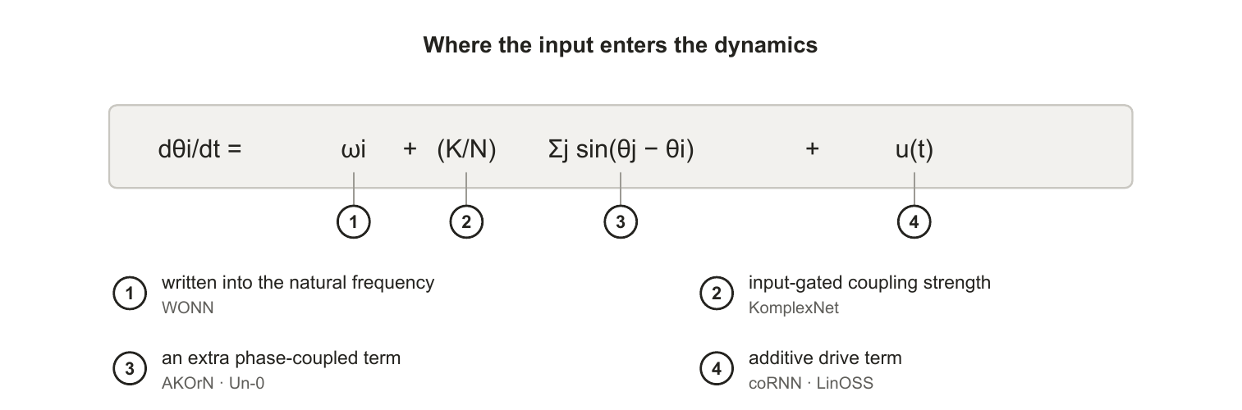
Figure 11. The four ways input enters the dynamics across the surveyed systems, each marked against the term it modifies. Classical theory makes this consequential rather than incidental: entrainment requires a phase-dependent term, so writing input into the natural frequency (1) and adding it as a drive (4) are not interchangeable. No paper in this survey contrasts two injection forms under controls.
Geometry and capacity are separable design choices in principle, and whether they can be set separately in practice is not something the record answers: one surveyed system has varied them together; none has varied either alone. Un-0’s sparsity study (Unconventional AI, 2026b) reports that static masks fixed before training remove 50 to 98.4% of couplings and maintain or improve generation; that at the smallest ImageNet-64 size the best result is a modular variant at reduced parameter count; that optimal sparsity scales with system size; and that above a critical sparsity performance degrades, the extreme failure being input-output disconnection. Its own summary is that connectivity acts as a control knob, not a monotonic regularizer. Two attributions carry independent interest: improvements track generative recall, meaning diversity, rather than precision, under the established decomposition (Kynkäänniemi et al., 2019; Sajjadi et al., 2018), and sparse systems tolerate higher learning rates, with dense failures blamed on collapse into global lock. All of this is blog-published, one system, one modality. The physics is consistent with it: chimera coexistence is generic for nonlocal finite-range coupling, modular fabrics natively produce chimera-like states and metastable timescale hierarchies (Hizanidis et al., 2016; Litwin-Kumar & Doiron, 2012), sparse recurrent fabrics classify at high capacity through resonant amplification (Turcu & Abbott, 2022), and in conventional networks near-independent recurrent modules generalize better out of distribution (Goyal et al., 2021) while spatial wiring costs make modularity emerge (Achterberg et al., 2023).
Damping and frequency placement are the two physics parameters the surveyed papers do report, and each turns out to be doing two jobs at once. The spectral radius of an echo-state network is simultaneously its stability condition and its memory-nonlinearity operating point; coRNN’s damping bounds the energy of its hidden state, which its gradient analysis then rests on, while its authors offer only heuristics and a robustness sweep on what damping does for expressivity; D-LinOSS learns its damping to widen the reachable spectrum, and keeps its eigenvalues inside the unit disk by constraining the frequency given the damping and time step rather than by the damping itself; and a speech-oscillator study built on coRNN sweeps its frequency and damping ranges together and finds the low-frequency band decisive (Chandravadia & Imam, 2026). Frequency placement shows the design-beats-training pattern repeatedly: state-space models find their spectrum’s initialization load-bearing, D-LinOSS initializes in spectrum space by design, envelope-band initialization decides success on raw-waveform speech, and the cochlea literature designs the bank outright.

2.3.2 What the systems are evaluated on
A survey of this shape would normally open its comparison with a shared benchmark. The field has not established one yet, and that absence is itself one of the gaps this survey identifies. Some convergence has started: Sudoku is now reported by two independent groups, AKOrN and WONN, and CIFAR and ImageNet recur across several systems, though at different tasks. The spread is still the point, though. Read down the task column of Appendix D: class-conditional image generation scored by FID, ImageNet-1K top-1 classification, maze path finding and Sudoku, object discovery, multi-object binding robustness at small scale, character-level language modelling, generation on periodic domains, extreme-length sequence classification, general time-series benchmarks, spoken-digit recognition, and combinatorial optimization. Almost no two rows share a task, and where two rows do, they rarely share a protocol.
Shared cross-disciplinary benchmarks largely do not exist here for three reasons. The field is genuinely multidisciplinary: results arrive from nonlinear dynamics, neuromorphic hardware, computational neuroscience and mainstream deep learning, and each of those communities brought its own evaluation habits with it. A physics group reporting a locking diagram and a deep-learning group reporting top-1 accuracy are not being careless with each other’s conventions; they are answering different questions. The field is also young. Most of the trained-dynamics systems here postdate 2023, and a subfield converges on shared benchmarks once its methods stabilize, not before. And the substrates are not commensurable: a time-multiplexed physical oscillator and a 322M-parameter simulated Kuramoto pool cannot be run on one task suite even in principle.
As a result, cross-system accuracy comparisons are unsafe, because the tasks differ and so does the effort spent tuning each baseline. A general claim of the form “oscillator networks are better at X” cannot be supported by this record, because no two systems have been run on X under one protocol. Narrower claims can be made, and two papers make them: Kuramoto Attention reports beating a parameter-matched Transformer at the 5M scale on byte-level code, and RON reports beating echo-state and fully trained recurrent baselines on chaotic forecasting. Each of those stands for its own task at its own scale against its own baseline. What does not follow from either is that the result carries to another task, another parameter budget, or another oscillator system. And an absent result is not a demonstrated limitation: generative speech, streaming inference and measured energy on hardware contain no oscillator system at all, so nothing has been shown to fail there.
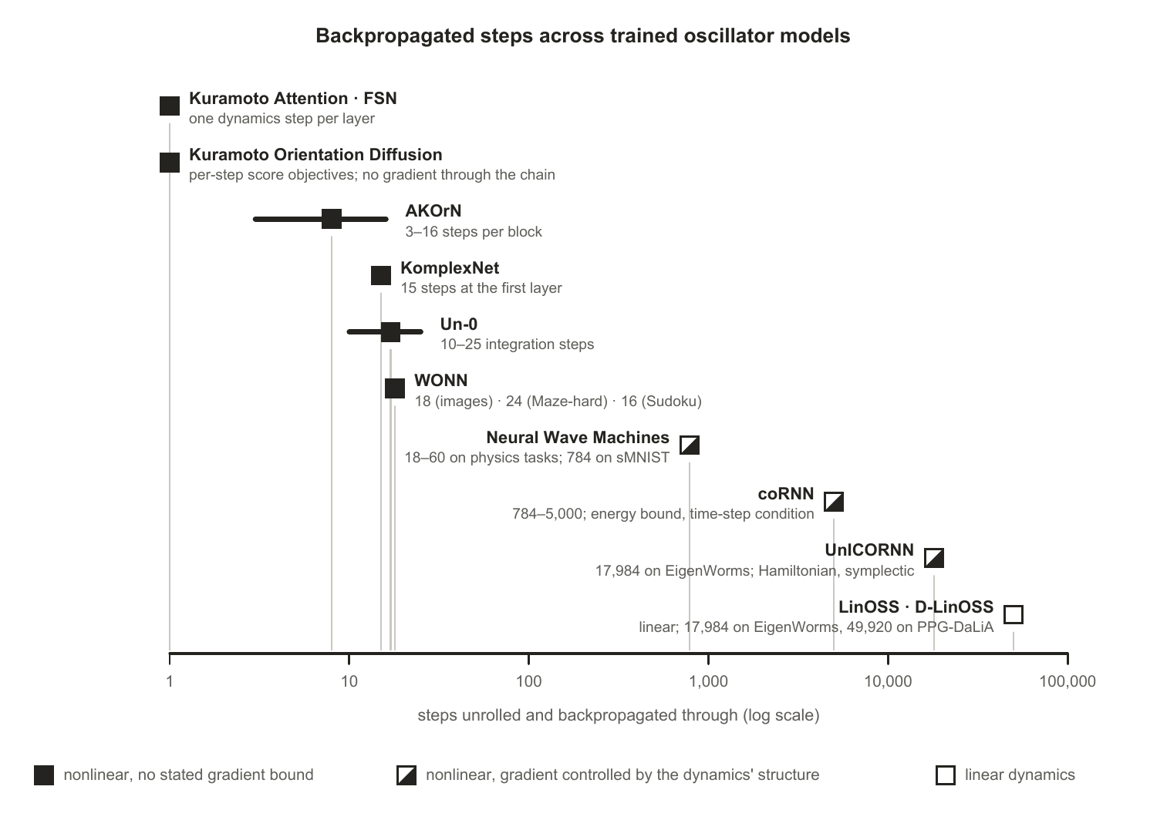
Figure 12. Steps unrolled and backpropagated through, by system. Filled markers are nonlinear dynamics with no stated gradient bound; half-filled markers are nonlinear dynamics whose gradients are controlled by the structure of the dynamics, a dissipative energy bound with a time-step condition in coRNN and Neural Wave Machines, and Hamiltonian conservation in UnICORNN; the open marker is linear dynamics. Every nonlinear system without a stated bound trains at twenty-five steps or fewer; the two nonlinear systems that reach thousands of steps carry a proof, and the only system beyond twenty thousand is linear.
What is comparable. Two kinds of comparison survive those limits. A paper’s own ablations are protocol-matched by construction, so the controls table below compares like with like even where nothing else in the record does. And parameter budget carries across papers wherever it is reported, which is what makes the matched-budget external baselines, rare but present, worth reading closely.
Training horizon is comparable in the same way and shows a conspicuous pattern. Un-0 trains with 10 to 25 integration steps and reports no stability machinery of any kind; WONN unrolls 18 steps for images, six layers of three, and a single layer of 24 or 16 steps for Maze-hard and Sudoku; AKOrN settles for 3 to 16 steps per block; KomplexNet runs 15; Kuramoto Attention takes one dynamics step per layer; Kuramoto Orientation Diffusion never trains a long chain at all. The oscillator systems that do handle long horizons each brought a guarantee with them rather than a recipe: coRNN bounds its hidden-state energy through damping and its gradients through a structure-preserving discretization with a time-step condition, and trains to five thousand steps; UnICORNN removes the damping, integrates a Hamiltonian system symplectically so that phase-space volume is conserved, and trains with full backpropagation through 17,984-step sequences, made affordable by inverting the recurrence instead of storing it; LinOSS makes the dynamics linear and stable for any non-negative frequency, and reaches fifty thousand; D-LinOSS constrains its eigenvalues to the unit disk. Two of those four are nonlinear, so the wall is not nonlinearity as such; it is nonlinear dynamics without a proof. Theory tracks the same line, with generalization bounds growing linearly in horizon and approximation rates requiring incremental stability. Meanwhile a parallel literature develops training rules that avoid backpropagation through the dynamics entirely: equilibrium propagation for Kuramoto frequencies (Ahmadi, 2026) and local force-measurement rules for driven nonlinear oscillators (Bösch et al., 2025).

2.3.3 What the systems report as controls
The controls table is where this survey’s argument is decided. The five controls below are not a standard anyone has adopted; they are assembled in Section 3.1 from cases where each control’s absence is documented to have misled. A mark means the surveyed work reports running that control. A dash means we did not find it reported in the work we surveyed, not that it was not run, and not that the result would change if it were. The pattern, rather than any single mark, is the observation.
Table 1. Controls reported by each system. A tick means the surveyed work reports running that control; ≈ marks the nearest published instance rather than the control itself; a dash means we did not find it reported, which is not evidence it was not run. Damping is not one of the five, but the record holds two ablations of it that span a pair of papers (Section 2.3.3).
System | Frozen twin | Decoder-only | Randomized twin | Matched-budget baseline | Single-term ablation of coupling
Un-0 | ✓ | ✓ | ✓ (modular vs random masks) | — (an external reimplementation exists but is not matched; Section 2.3.4) | —
AKOrN | — | ✓ (ItrConv and ItrSA: the same iterated layers without the Kuramoto update) | — | ≈ (those baselines at matched FLOPs and memory and “roughly the same number of parameters”; counts not printed) | ✓ (a J = 0 bar in a robustness figure; no number in the text, protocol unstated)
WONN | — | — | — | ≈ (ResNet-18 at 11.7M against 12.3M on ImageNet-1K, an off-the-shelf baseline under a different training recipe) | —
Kuramoto Attention / FSN | — | — | — | ✓ (parameter-matched Transformers at 1M and 5M) | ≈ (a learned value projection in place of the Kuramoto step, +0.25 BPC; the matched Transformer is the no-synchronization model)
KomplexNet | ✓ (coupling kernel held at a fixed Gaussian) | ✓ (real-valued twin; complex twin without the Kuramoto step) | — | ✓ (parameter-matched real-valued model, and a ViT of comparable size) | ✓ (retrained without the Kuramoto step, “random phases at the first layer”; not also zeroed at evaluation)
Kuramoto Orientation Diffusion | — | ✓ (Gaussian score model with the same U-Net) | — | ✓ (the same U-Net; the same experiment as the previous cell) | ✓ (K(t) = 0 in the forward process, reported numerically on one dataset)
HoloGraph | — | — | — | — | —
Neural Wave Machines | — | — | — | — (the globally coupled coRNN it is compared with shares hyperparameters, not a parameter count) | —
coRNN | — | — | — | ✓ (a 9k-parameter LSTM on Lorenz-96, in the supplement, where coRNN loses) | —
UnICORNN | — | — | — | ✓ (the same 9k-parameter Lorenz-96 comparison, where UnICORNN loses) | n/a (no coupling within a layer)
LinOSS / D-LinOSS | — | — | — | — (counts reported and unmatched) | n/a (diagonal state matrices; D-LinOSS against LinOSS-IMEX ablates damping, not coupling)
RON | n/a (untrained by construction; its trained twin hcoRNN is the same comparison run in reverse) | — | — | ✓ (ESN and trained RNN baselines at matched trainable parameters) | —
Spintronic reservoir | n/a | — | — | — | —
Oscillator Ising machines | n/a (no training) | — | — | — | —
Three systems remove the coupling term as a single variable, and the way each does it is itself a finding. Kuramoto Orientation Diffusion sets K(t) = 0 in its forward process and reports the result in a table: on Brodatz textures the hundred-step FID rises from 18.5 to 33.8, though the reference-only process still beats the Gaussian baseline at 38.3, so part of the gain belongs to the periodic design rather than to the coupling, and the ablation is one dataset with single runs. KomplexNet trains a copy of its network without the Kuramoto step, “random phases at the first layer”; because the phase update has no other term, deleting the coupling and freezing the phases are the same operation, and the retrained model loses two to three points in distribution, five to six under overlap and about thirty under Gaussian noise. AKOrN ablates its learned coupling matrix as a J = 0 bar inside a robustness figure, with no number in the text and no statement of whether that variant was retrained without coupling or had its coupling zeroed at evaluation, which is the difference between measuring what coupling contributes and measuring a readout meeting unfamiliar dynamics. None of the three is what a shared protocol would ask for: a retrained and a zeroed-at-test variant side by side, on more than one dataset, with seeds. Damping, which is not among the five controls, has been ablated twice, each time across a pair of papers by the same group. UnICORNN is coRNN with the damping and the within-layer coupling removed and a layer stack added, and D-LinOSS with its damping set to zero recovers LinOSS’s conservative discretization exactly, so the two papers of each pair publish both sides of a comparison that neither runs alone. That the authors published both sides at all is to their credit, and the second pair is the cleaner instance, since only one term moves, though its LinOSS numbers are carried over from the earlier paper rather than re-run; we would still prefer the two sides in one paper under one protocol, which is what Section 3.2 asks for. Of the sixty-five applicable control comparisons these five give across the fourteen rows, sixteen have been run, ten of them by three systems, plus three near-instances; Appendix E itemizes them.

2.3.4 How the systems compare with conventional architectures
Each system’s own reported numbers, set against the architectures of Section 2.3, read as follows. Un-0’s ImageNet-64 FID of 6.74 is competitive with first-generation diffusion baselines and far from the modern frontier, where one-step models reach FID around 1.5 on harder benchmarks (Deng et al., 2026), as its authors acknowledge; a community reimplementation on MNIST, 512 oscillators trained for 800 epochs against a class-conditional DCGAN that its own write-up puts at roughly ten times the parameters, judges the DCGAN the visibly stronger generator without reporting a metric (Kuramoto-MNIST (hcm444, 2026), community repository); it is not a matched-budget comparison, and it agrees with rather than overturns the authors’ own statement that conventional generators remain stronger. Its authors also report an observation about scale that no one has yet tested independently: quality keeps improving as the model grows, but more slowly than for the conventional diffusion models they compare against, EDM (Karras et al., 2022) and GDD (Zheng & Yang, 2024), so the gap to the frontier widens rather than closes with size. That is a single blog-published observation from the system’s own authors rather than a scaling study, and it is the clearest reason the field needs one: whether trained oscillator networks scale competitively is the question a prospective adopter will ask first, and nothing peer reviewed currently answers it. WONN’s 76.78% ImageNet-1K at 12.3M parameters makes it the first synchronization architecture competitive at that scale: it beats a ResNet-18 of similar size by seven points and trails a ResNet-50 of twice the size by a tenth of a point, under training recipes the paper does not match and with baseline ViTs well below their published best. Its reasoning results are the sharper claim, and they need the same care: 76.2% on Maze-hard in one pass, 80.1% with best-of-32 energy voting, at 0.396M parameters, against 85.3% for the 7M-parameter TRM-Att and 74.5% for the 27M-parameter HRM. That is a parameter-efficiency margin rather than an accuracy win, and not a matched-budget comparison in the sense of Section 2.3.3. AKOrN’s reported advantages are adversarial and corruption robustness, calibration and Sudoku rather than clean-accuracy dominance, where it trails a ResNet-18 by three to five points.
The wins that exist are niche-shaped, and the niches are real. LinOSS beats state-space baselines on extreme-length sequences: 95.0% on the 17,984-step EigenWorms task against 70.9% for Mamba, the weakest baseline, and 87.8% for LRU, the strongest, and half of Mamba’s error on fifty-thousand-step heart-rate windows. It is the clearest protocol-matched oscillator win in the survey and sits exactly where a fixed-size dynamical state should have the advantage over attention, with three caveats the paper itself supplies: the win belongs to the dissipative implicit variant, since the conservative variant scores 80.0% on EigenWorms and loses to five baselines there; the parameter budgets are not matched, with LinOSS at five to nine times the parameters of Mamba and S6 on that task; and the baseline numbers are carried over from prior work rather than re-run. The first of those is evidence for this survey’s own reading in Section 3.1.4 that dissipation, rather than oscillation, is doing the work. Kuramoto Attention beats a parameter-matched Transformer at the 5M scale on byte-level code, by median only on enwik8, and trails it at 1M (preprint). Untrained oscillator reservoirs beat trained RNNs on some time-series benchmarks. KomplexNet wins on multi-object binding robustness at small scale. A single physical oscillator does spoken digits at roughly 99.6% with one device, 3.8 points above its front end alone. Neural Wave Machines report a parameter saving that follows from their convolutional coupling, with 45k of their 50k parameters in the encoder and decoder.
The energy argument, often the headline motivation, currently rests on adjacent substrates rather than on oscillator networks. A spiking-network text-to-speech system reports ANN-comparable quality at about 10.5% of the energy (K. Wang et al., 2024); neuromorphic keyword spotting has an established measured energy-per-inference methodology (Blouw et al., 2019); continuous-time ODE neurons make the small-trained-dynamical-system case (Hasani et al., 2021; Hasani et al., 2022). No trained oscillator network has published a measured energy win.
Comparative numbers across these papers are not protocol-matched: baselines differ in tuning effort, parameter budgets are rarely matched, seeds are rarely reported, and the strongest trained-Kuramoto evidence is not peer reviewed. Each niche is supported by one or two papers. We also note lanes where no oscillator system exists at all: to our knowledge none performs generative or streaming speech, and streaming time-series work generally is thin, so absence of dominance there is absence of peer-reviewed attempts rather than a claim on capability thus far.

3 Discussion

3.1 Research challenges
Where the evidence stops. Each subsection states a bound the literature itself establishes, drawn from the same sources that make the positive case above. These are not objections from outside the field.

3.1.1 Attribution, and the controls that are missing
Each of the five controls in Section 2.3.3 exists because a published result shows what happens when it is absent. Frozen twins: untrained oscillator dynamics can carry a task unaided (Section 2.2.4), so a trained gain must be measured against one, and Un-0 (Unconventional AI, 2026a) and KomplexNet (Muzellec et al., 2025), whose fixed-Gaussian-kernel twin comes within a point of its trained kernel in distribution, are the two trained-synchronization systems we found reporting it. Decoder-only controls: wherever a conventional encoder or decoder wraps the dynamics, the compute may live there. Initialization sensitivity: learnable front-ends that end where they started (Anderson et al., 2023) show apparent learning can be initialization in disguise, and visible parameter motion without recovery of a known-good solution (Milling et al., 2026) shows motion is not value. Randomized twins: designed structure can reduce to generic sparsity, and across fifteen biological-pathway-informed models randomized sparse masks matched or beat the biology-informed ones (Caranzano et al., 2026). Matched-budget baselines: where the budget is actually matched the result can reverse. At 9k parameters on the chaotic Lorenz-96 system, both coRNN (Rusch & Mishra, 2021a) and UnICORNN (Rusch & Mishra, 2021b) lose to an LSTM in their own supplements, which their authors attribute to a design that rules out chaos by construction. A community reimplementation of Un-0’s recipe on MNIST is often read as the same kind of test; it is not, since its class-conditional DCGAN carries roughly ten times the parameters and its verdict is visual (Kuramoto-MNIST (hcm444, 2026), community repository). It is the only external comparison of a trained-synchronization system we found, and it should be read as a reimplementation rather than as a budget-matched control.
Single-term ablations are the gap that matters most, because the term in question names the family, and the gap is now one of reporting rather than of absence. Kuramoto Orientation Diffusion (Song et al., 2025) sets K(t) = 0 and keeps only the phase-reference drift, reporting a rise of fifteen FID points at a hundred steps relative to its locally coupled model on Brodatz textures: the clearest single-variable removal in the record, though it ablates a forward diffusion process rather than a trained coupling, on one dataset, without seeds. AKOrN (Miyato et al., 2025) does the same to a coupling that is learned. Its update carries a natural-frequency rotation Ω, a sum over neighbours weighted by a learned coupling J, a conditioning stimulus computed from the input and held fixed over the steps, and a learned step size with renormalization onto the sphere, with Ω and J optimized against the task objective. Figure 8 of that paper reports a J = 0 bar beside a separate Ω = 0 bar in a random-noise robustness test on CIFAR-10, so the two physics terms were treated as independent axes rather than swapped wholesale, and with J = 0 each layer’s population decouples completely: each oscillator turns under its own frequency and its stimulus alone. What the paper does not say is whether that variant was retrained without coupling or had a learned J zeroed at evaluation, and the difference decides what the number means. A retrained variant measures what the coupling contributes; zeroing a learned J at test time largely measures a readout meeting dynamics it was never fitted to. The value itself appears in no table and no sentence, only as a bar, so a reader cannot tell which was done; the paper’s own ablation table instead finds that the projection and renormalization, not J or Ω, carry the largest effect. KomplexNet (Muzellec et al., 2025) reports the retrained half of that pair. Its complex-valued twin trained “without the Kuramoto synchrony (random phases at the first layer)” is the coupling ablation, since the phase update contains nothing but the coupling, and it costs two to three points in distribution, five to six on overlapping digits and about thirty under Gaussian noise; the same paper’s twin with a fixed Gaussian kernel shows that training the kernel adds under a point in distribution, and its parameter-matched real-valued and Transformer baselines complete the set. What it cannot say is what a trained KomplexNet does with its coupling switched off. Kuramoto Attention (Nunley, 2026b) reports twelve single-axis ablations and one value-transport comparison, of which one replaces the on-manifold circular mean, the Kuramoto step by the paper’s own account, with a dense linear value projection at a cost of +0.25 BPC; the parameter-matched Transformer it is scored against is the no-synchronization model at the same size, so the pair is a coupling ablation in all but name. FSN (Nunley, 2026a) reports three mechanism ablations, removing the static frustration angles, the feed-forward block and the delay term, and flags its own delay result as screen-level rather than converged. KoPE (Xiao et al., 2026) removes its whole phase dynamics rather than the coupling term.
Where the controls were run, they changed conclusions: Un-0’s frozen-reservoir control, KomplexNet’s random-phase and fixed-kernel controls, Kuramoto Orientation Diffusion’s reference-only process, and the matched-parameter Lorenz-96 comparison in the coRNN and UnICORNN supplements. In each of those cases the control changed what could be concluded from the paper, which is the argument for running them: they are not a procedural formality but the step that decides whether a reported gain is attributable to the dynamics. The binding results are also a reason not to assume the missing ablations would come back empty. If synchronization is the mechanism that groups distributed features, as the neuroscience in Section 1.2.2 reports, then removing it should cost accuracy on grouping tasks specifically, and be harmless on tasks that do not require grouping. An ablation that finds nothing on one task family is therefore not evidence that the coupling does nothing.
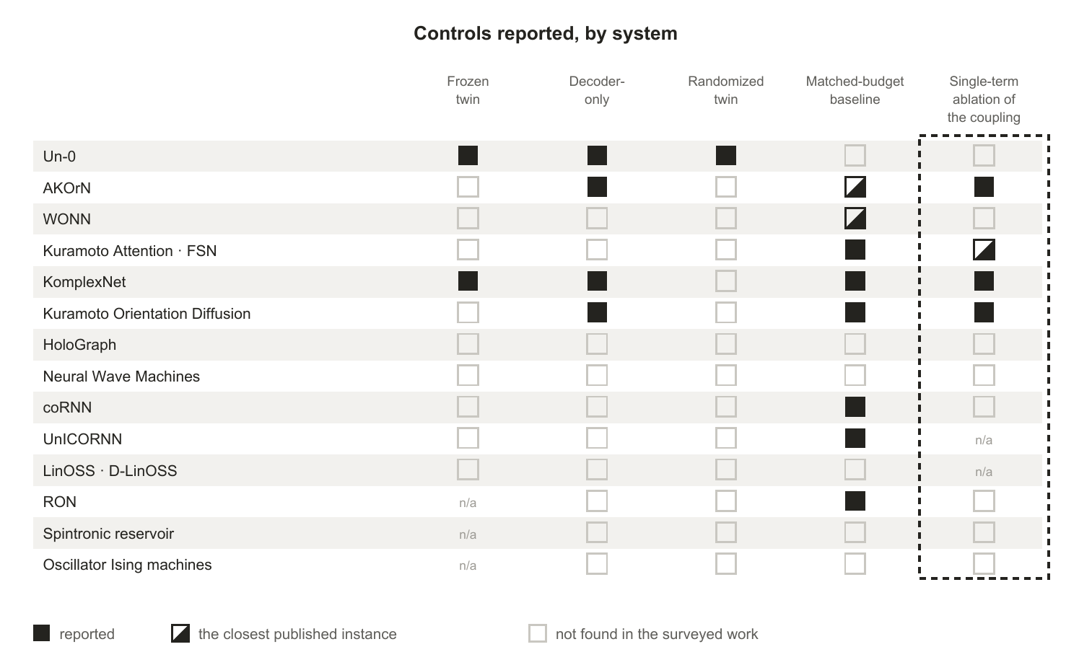
Figure 13. Controls reported by each system. A filled square means the surveyed work reports running that control; an open square means we did not find it reported, which is not evidence that it was not run. Three systems remove the coupling term as a single variable, the mechanism the Kuramoto family is named after; one reports no number, one reports a single dataset, and one, KomplexNet (Muzellec et al., 2025), reports only a retrained model. Half-filled squares mark the nearest published instance rather than the control itself.

3.1.2 What training moves, and what it does not
Universality says nothing about trainability, and the adjacent literature is pointed about one parameter group. Learnable audio front-ends move little from initialization; mel-initialized filters barely train at all even when distilled toward a fully specified designed teacher (Lostanlen et al., 2023); a state-space model’s frequency bias is set at initialization and conventional training does not move it (Yu et al., 2025); and where front-ends are compared head to head, gradient-learned placement wins neither contest: front-ends that keep adapting at inference beat both the hand-designed and the gradient-learned kind (Meng et al., 2026; Q. Zhang et al., 2025). In Kuramoto networks specifically, the one study to train natural frequencies as a parameter in their own right rather than jointly with coupling (Ahmadi, 2026) reports roughly half of randomly initialized runs failing through loss-landscape multistability, rescued by seeding the frequencies from the eigenvectors of the coupling Laplacian, on a nine-oscillator network with seven learnable frequencies separating two vowels (preprint). And where oscillator systems succeed with fixed frequencies chosen by design, as when envelope-band initialization makes a coRNN (Rusch & Mishra, 2021a) trainable on raw waveform where a vanilla RNN fails (Chandravadia & Imam, 2026), design rather than learning determined the frequency structure. “Oscillator networks learn” is therefore well supported for coupling and readout-adjacent parameters and specifically doubtful for frequency placement.
Parameter sensitivity is reported within a paper and almost never across tasks. WONN (Dai & Song, 2026) and AKOrN (Miyato et al., 2025) each report results on more than one task family, and both configure their model separately for each, but neither reports whether a setting tuned for one task carries to another; the remaining systems fix a single family. The literature therefore cannot say whether an optimum is task-dependent, which is the natural expectation if some tasks want the dynamics for transduction and others want it for memory.

3.1.3 Structure and geometry
Geometry is varied in four of the surveyed systems, and in none of them as a single variable. Neural Wave Machines (Keller & Welling, 2023) comes closest, running a one-dimensional core of twenty-three disjoint rings and a two-dimensional torus core against a globally coupled coRNN with the same hyperparameters and hidden size, explicitly to isolate the effect of the imposed structure; but the parameter counts of that comparison are neither matched nor reported, and its two cores differ in convolution kernel as well as in topology. Kuramoto Orientation Diffusion contrasts global with 5x5 local coupling while retuning the coupling strength between the two. WONN (Dai & Song, 2026) contrasts convolutional with attentive coupling, and reports that the convolutional variant “introduces substantially more parameters”, so the comparison is not budget-matched either. Un-0’s sparsity study contrasts dense, random-sparse and modular fabrics, the only one of the four to do so with learned couplings. What no published work we found does is vary coupling range or boundary conditions as a single variable at a matched budget, so the question of what geometry buys is answered nowhere by a controlled sweep. And designed structure must beat its randomized twin before design gets credit, a caution Un-0’s random-versus-modular comparison only partially addresses. Two scope limits apply to the sparsity evidence as well. Sparsity of interactions and sparsity of parameters coincide in all-to-all coupling matrices but come apart in tied parameterizations, where a convolutional or spectral kernel keeps every interaction while holding few parameters, and no sparsity study covers that regime. The oscillator-side evidence is also a non-peer-reviewed study of one system whose authors themselves flag protocol drift between posts.

3.1.4 The dynamics as both resource and hazard
Three lines of work, none of them aimed at the others, point the same way. Operating-regime theory puts computation near the order-chaos boundary and reservoirs are deliberately parked there. Failure modes named in the trained-oscillator literature: Un-0’s sparsity study reports dense all-to-all fields easily falling into catastrophic synchronization, a globally locked, zero-gradient state, and FSN’s case against consensus runs the same way. The useful regime is partial coherence, exactly what the physics says finite-range nonlocal coupling generically produces. Optimization landscape: frequency-parameter loss surfaces are highly non-convex with narrow basins, established for sinusoidal-frequency estimation by gradient descent (Hayes et al., 2023; Turian & Henry, 2020), known since Rife and Boorstyn in 1974, observed as spectral-gap gradient suppression in quantum circuits (Poppel et al., 2026), and reported as multistability seed-failures in Kuramoto frequency learning.
The hazard is manageable, since the successes exist. But the published management strategies are themselves evidence for the diagnosis, and they are less uniform than a first reading suggests: coRNN bounds its hidden-state energy through damping and its gradients through a time-step condition, UnICORNN removes the damping and relies on conservation instead, LinOSS (Rusch & Rus, 2025) is stable for any non-negative frequency and its implicit variant, the one that wins on long sequences, carries numerical dissipation, D-LinOSS (Boyer et al., 2025) learns an explicit damping term to widen its spectrum, and Un-0’s remedy is topological. The theory arrives at a related requirement from the other direction, and the coincidence is worth naming. Three of the five fixes above dissipate energy, and the one linear model that does not, the conservative LinOSS variant, loses to the dissipative one on the longest task. Independently, the approximation rates proved for these models hold only if the system is incrementally stable, which is the property dissipation provides. Dissipation is therefore not a workaround sitting beside the theory; it is what both the trainability results and the approximation-rate guarantees lean on, with UnICORNN the standing exception that trains long sequences on conservation alone. One caveat on the inference itself: papers do not report failed horizon scaling, so publication bias could manufacture the pattern, and no published study we found isolates horizon length as the single variable on a fixed nonlinear oscillator substrate.

3.1.5 The physics the field has not used
Section 1.2.3 counted how many of the surveyed systems use each coupling form and found the count concentrated between 1967 and 1992. What follows is what that leaves unexplored. No surveyed system uses inertial, simplicial, hypergraph or Dirac coupling. Swarmalators, in which phase and spatial position couple to each other, were proposed as a substrate for bio-inspired computing in 2019 (O’Keeffe & Bettstetter, 2019), and we found no machine-learning system built on them, trained or untrained. The bounds of the physics parameters are unmapped: no published work sweeps coupling strength, frequency spread or delay to the point where the system leaves its useful regime, so the operating envelope is known only anecdotally. One paper compares coupling functions on a single task under controls, and its result is a null. FSN removes its static frustration angles and reports the no-phase model indistinguishable from the full one at a thirty-epoch budget, three seeds against five, with the angles buying early-training speed rather than final quality; because the delay term it keeps is itself a frustrated coupling with a data-determined angle, the comparison does not reach plain Kuramoto, which the same paper reports as a clearly worse model. That is one comparison, within one coupling family, on one task, and not yet at convergence. We found none that compares across families, so the choice of a Kuramoto-type coupling over a Winfree or Stuart-Landau one remains a convention rather than a finding.

3.1.6 The missing shared protocol
The field has no shared benchmark, no shared reporting convention, and no agreed set of controls, which is why Section 2.3 can compare within papers but not across them easily. This is more of a coordination and standards-setting concern than a scientific error, and it is one of the first things that could benefit the community.

3.2 Future directions
These are directions for the field rather than protocols for a paper. Each follows from a specific gap above, and each would be worth doing whichever way it came out.
- A shared benchmark suite for oscillator substrates. The most valuable single contribution available is an open, versioned task suite that runs an oscillator system and a tuned conventional baseline under one harness at matched parameter budgets, spanning static classification, long-horizon temporal tasks and generation. The suite need not be invented: the surveyed work has already begun to converge on candidates, and consolidating on them would cost less than agreeing new ones. Static classification is already CIFAR-10 and CIFAR-100 and ImageNet-1K, used by Un-0 for generation and WONN for recognition. Reasoning is already Sudoku, reported independently by AKOrN and WONN, with WONN’s Maze-hard a candidate for path finding. Long-horizon sequence work already runs on the UEA archive and EigenWorms, where UnICORNN, LinOSS and D-LinOSS report. Character-level language modelling already runs on enwik8, and byte-level code on CodeParrot, where Kuramoto Attention and FSN report. Spoken-digit recognition on TI-46 is a standard benchmark for oscillator reservoirs in hardware, and vowel recognition has been run on coupled oscillators in hardware (Romera et al., 2018). What is missing from each is not the dataset but the protocol around it: a tuned conventional baseline at a matched parameter budget, seeds reported, and the five controls of Section 2.3.3 run alongside. Nothing in Section 2.3 can be turned into a ranking until this exists, and its absence is currently mistaken for parity in both directions.
- A reporting standard for controls. The five controls of Section 2.3.3 should become a norm rather than an exception: frozen twins, decoder-only controls, randomized-structure twins, matched-budget baselines and single-term ablations, with multi-seed variance reported alongside. Sixteen of sixty-five possible control comparisons, ten of them from three systems, is what a field looks like before its reporting habits have settled, and settling them costs less now than it will once the literature is large. Concretely, a paper introducing a trained oscillator system would say for each of the five controls (frozen twin, decoder-only, randomized twin, matched-budget baseline, single-term ablation of the coupling) whether it was run, and give the resulting number rather than only the headline result. Where a control does not apply it is worth saying so and saying why: a frozen twin means nothing for a system whose dynamics is never trained, and a coupling ablation means nothing for a model that has no coupling term. An unreported control and an inapplicable one look identical to a reader, and distinguishing them took us a close reading of every paper in Table 1; an earlier draft of this survey still got several of them wrong, which is the argument for a standard rather than for close reading. Where two papers from one group publish the two sides of an ablation, as coRNN and UnICORNN do for damping and coupling and LinOSS and D-LinOSS do for damping, the standard would ask for the comparison to be run once more, under one protocol, in the later paper.
- Treat the coupling law as a variable. The field should establish what its namesake mechanism contributes, by comparing coupling functions on one task under one harness, and by reaching past the 1967 to 1992 window into the higher-order, delayed and D-dimensional forms the physics has characterized. The specific value of the later physics is that each form makes a different capability available, and none has been tried. Higher-order coupling produces many coexisting stable states where pairwise coupling produces one, which is what an associative memory needs. Simplicial and hypergraph coupling attach the dynamics to structure that is not reducible to pairs, which is what relational data has. Swarmalators couple phase to spatial position, so position becomes part of the computation rather than an index into it, which is what a system processing spatially structured input would want. Each of these is a testable substitution into an existing architecture rather than a new one, and each would establish whether the field’s concentration on 1967-to-1992 coupling reflects a considered choice or an inherited default.
- Treat geometry as a reported design decision. Papers should state their coupling geometry as a choice, report a randomized twin whenever a designed structure is claimed to matter, and vary topology and boundary conditions at matched parameters. This is the axis on which the record is currently thinnest.
- Report where the input enters. Injection form is currently chosen silently across four incompatible options that classical theory says are not interchangeable. Two things would help, and they are separable. Stating which of the four a system uses, and why, would make the choice visible where it is currently invisible. Running two of them in one substrate on one task would establish whether the choice changes the result at all, which no surveyed paper reports and classical theory predicts it should.
- Measure energy on hardware. The efficiency argument is the field’s most-cited motivation and its least-evidenced claim. The neuromorphic literature already has a protocol for this: report dynamic power draw and inference rate for one task, derive energy cost per inference, and compare the same workload across substrates at equal accuracy, as Blouw et al. do for keyword spotting across a neuromorphic chip, a CPU, a GPU and two embedded accelerators (Blouw et al., 2019). Running an oscillator system through the same procedure would either substantiate the efficiency motivation or retire it, and either outcome would be more useful than the current position, where the claim is cited more often than it is measured.
- Replicate the blog-published results. The strongest evidence that trained Kuramoto dynamics works at scale, and all of the sparsity evidence, currently rests on non-peer-reviewed posts by one group. Independent replication would move the field’s central claim onto the record.
- Establish whether scaling laws exist. No published scaling study exists for trained oscillator networks along parameters, oscillator count or data, against a conventional reference. Without one, no claim about where these systems are headed can be assessed.
Appendix F collects the questions these directions leave open.

4 Conclusion
The current wave of oscillator architectures has produced real systems. The oscillatory recurrences and their linear state-space descendants hold strong long-sequence records, one of them nonlinear, with approximation results behind them; trained synchronization models generate images and classify at ImageNet scale; frozen physical oscillators rival trained networks on narrow tasks at a fraction of the parameter count. Read against tuned conventional baselines, though, the record is parity and niches rather than dominance, and the surveyed authors mostly say so: the strongest generative result is competitive with first-generation diffusion and far from the current frontier, the largest classification result is the first of its kind at that scale rather than the best, and the clearest wins are shaped like LinOSS (Rusch & Rus, 2025) on eighteen- to fifty-thousand-step sequences, which is a real advantage on a specific axis.
Our central finding is that the evidence rarely isolates the dynamics, so it is not yet clear what the oscillator physics itself contributes. Five controls would separate a trained system’s result from the alternative explanations for it, and applied across the fourteen rows of Table 1 they give seventy possible comparisons. Five do not apply, since a frozen twin means nothing for a system that never trains its dynamics and a coupling ablation means nothing for a model whose units do not couple within a layer, which leaves sixty-five. Sixteen have been run, and ten of those belong to three systems: Un-0 (Unconventional AI, 2026a) reports a frozen twin, a decoder-only comparison and a randomized twin; KomplexNet (Muzellec et al., 2025) reports a frozen kernel, a no-dynamics twin, parameter-matched baselines and a model retrained without its coupling; Kuramoto Orientation Diffusion (Song et al., 2025) reports a same-network Gaussian baseline and a K(t) = 0 forward process. The remaining six are a no-dynamics baseline and a coupling ablation from AKOrN (Miyato et al., 2025), and matched-budget baselines from Kuramoto Attention (Nunley, 2026b) and FSN (Nunley, 2026a), from RON (Ceni et al., 2024), and from coRNN (Rusch & Mishra, 2021a) and UnICORNN (Rusch & Mishra, 2021b) on one supplementary task. Appendix E itemizes them. Where a control has been run it has changed what the paper could conclude, and in two cases it reversed a headline: at matched parameters on a chaotic system both oscillatory recurrences lose to an LSTM, and a fixed coupling kernel comes within a point of KomplexNet’s learned one in distribution.
Three further gaps sit alongside that one, and Section 3.1 sets out the evidence for each. We found no scaling study for trained oscillator networks, so how these systems behave as they grow is unknown. No surveyed system has published a measured energy win, which leaves the field’s most-cited motivation resting on adjacent substrates. And the physics in use stops short of the forms that would test the properties these papers say they want: partial coherence on structured supports, the many coexisting stable states that higher-order and simplicial coupling produce, and the phase-position coupling of swarmalators. The neuroscience shows the same attribution problem from the other side, and the review that sets three theta-rhythmic segmentation models against each other (Dogonasheva et al., 2026) reaches it independently.
None of that is a verdict on the approach, and none of it requires new theory to address. Section 3.2 sets out eight directions: a shared benchmark suite, a reporting standard for controls, treating the coupling law as a variable, treating geometry as a reported design decision, reporting where the input enters, measuring energy on hardware, replicating the blog-published results, and establishing whether scaling laws exist. The first three would do most of the work: consolidating on the benchmarks the field has already begun to share rather than inventing new ones, reporting which of the five controls a paper ran and which it did not, and treating the coupling law as a variable rather than an inherited default. Each is achievable within a single paper’s effort, and each would convert a question this survey had to leave open into a result.
The convergence that makes oscillator networks interesting, across physics, neuroscience and machine learning, is a reason to run those experiments rather than evidence of what they will show. The physics is fairly well established; the machine-learning literature built on it is still novel and rapidly evolving, and as a result its evidentiary conventions have not yet settled. Whether the alignment between resonant substrates and the signals biology evolved to sense buys anything measurable is, on the present record, still open.

Appendix

A Glossary
Table 2. Terms as this survey uses them. Where physics, neuroscience and machine learning use a word differently, the sense given here is the one intended throughout.
Term | As used in this survey
ANN | Artificial neural network. Used here for the conventional architectures of Section 1.3: convolutions, recurrences, attention and state-space models.
ONN | Oscillatory neural network. A machine-learning system whose state is a population of oscillators and whose computation is their evolution under a coupling law.
Phase | Where a single oscillator is around its cycle. One angle, written θ.
Amplitude | How far the state sits from the centre of the cycle. Present in Stuart-Landau and second-order models, absent from phase-only ones.
Natural frequency | The rate ω at which one oscillator would advance if uncoupled. Where the input enters in some systems, and a learnable parameter in others.
Coupling | The dependence of each unit’s rate of change on the state of the units it is connected to. Its strength is the constant K.
Coupling function | The specific form that dependence takes, for example a single sinusoid (Kuramoto), a sinusoid with a phase lag (Kuramoto–Sakaguchi), or an arbitrary periodic function (Daido).
Geometry | Which units are coupled to which: all-to-all, finite-range on a ring, neighbours on a lattice, or dense blocks sparsely joined.
Order parameter (R) | How far a population has locked, from 0 for incoherence to 1 for full synchrony.
Entrainment | An external drive pulling oscillators onto its own rhythm. Requires a phase-dependent input term; an added constant will not do it.
Chimera state | Locked and drifting regions coexisting in one field of identical, symmetrically coupled units.
Reservoir | Dynamics left fixed, random or designed, with only a readout fitted to the task.
Frozen | Held at initialization while the rest of the system trains.
Readout | The trained map from the state of the dynamics to a task output, usually linear.
Frozen twin | The same system, same task, same parameter budget, with the dynamics frozen and only the readout fitted. Separates a trained system’s score from what its untrained dynamics would reach alone.
Randomized twin | The same system with its designed structure replaced by a random one of matching parameter count and coupling count. Separates a claim about a geometry from a claim about sparsity.
Decoder-only control | The scaffolding without the dynamics, which locates any gain in the dynamics rather than in the conventional layers around it.
Matched-budget baseline | A conventional architecture at the same parameter count on the same task.
Single-term ablation | Removing one term of the dynamics, holding everything else fixed. For a Kuramoto-family model that means the coupling term. A variant retrained without the term and a trained model with the term zeroed at evaluation answer different questions, and a report should say which it ran.
Gradient horizon | How many dynamics steps are unrolled and backpropagated through during training.

B Oscillator physics models
Table 3. Oscillator physics models, in the order they were derived, and what each one’s coupling gained over the one before it. Huygens’ observation heads the table as the first record of the coupling rather than as a model of it. Airy, Poincaré and Blondel are the prehistory of the self-sustained oscillator, dated as in Rivera-Sierra et al. (2026). Almost every machine-learning system surveyed in this paper uses one of the entries from Landau and Stuart, Winfree, Kuramoto, Kuramoto–Sakaguchi, Schuster and Wagner, Daido, or Chandra, Girvan & Ott; the model timeline in Section 1.2.3 marks which rows those are, and no surveyed system is built on any of the others.
Model | What the coupling gained
Huygens (1665) (observation, not a model) | Two pendulum clocks on a shared beam settle into antiphase within half an hour and resynchronize when disturbed. The first recorded instance of the coupling this table is about, replicated and explained by Bennett et al. (2002).
Airy (1830) | The first mathematical treatment of self-oscillation: a system that draws on a steady energy source to sustain a rhythm of its own period.
Poincaré (1908) | The limit cycle: a closed orbit that neighbouring trajectories approach, which is the object every entry below describes and the reason they can be reduced to a phase at all.
Blondel (1919) | The term self-sustained oscillation, separating a system that maintains its own rhythm from one driven periodically from outside.
Van der Pol oscillator (Van der Pol, 1926) | The first model of relaxation oscillation, written to describe vacuum-tube circuits. A limit cycle that is stable against perturbation, the object every later model reduces.
Landau (1944) | An amplitude equation for the onset of turbulence, in which a cubic saturation term bounds a growing mode instead of letting it diverge.
Hodgkin–Huxley (Hodgkin & Huxley, 1952) | Conductance-based dynamics of the action potential, and the reason a neuron is treatable as an oscillator at all.
Stuart (1960) | The same amplitude equation derived from the Navier-Stokes equations for parallel flow. Amplitude now evolves alongside phase, and the phase-only models below are its reduction.
Winfree (1967) | Collective synchronization as a mathematical problem, with each oscillator’s influence on the field separated from its sensitivity to the field.
Kuramoto (1975) | Phase-only reduction under weak, all-to-all sinusoidal coupling, and with it an exactly solvable transition from incoherence to collective locking.
Morris–Lecar (Morris & Lecar, 1981) | A two-variable conductance model of the barnacle giant muscle fibre: enough biophysics to spike, few enough variables to analyse.
Kuramoto–Sakaguchi (Sakaguchi & Kuramoto, 1986) | A phase-lag parameter α inside the coupling, representing propagation delay or frustration, which breaks the symmetry and admits partial coherence.
Schuster & Wagner (1989) | An explicit propagation delay inside the coupling argument, making the interaction depend on history rather than on the instantaneous state, which supports coexisting in-phase and anti-phase branches. Lifted to a whole population by Yeung & Strogatz (1999).
Ermentrout (1991) | Inertia in the phase dynamics, giving the population mass-like behaviour and a hysteretic rather than smooth approach to synchrony, the form used for power grids and Josephson junctions.
Daido (1992) | Coupling generalized from a sine to an arbitrary periodic function, described by an order function rather than a single order parameter.
Abrams & Strogatz (2004) | Chimera states: identical, symmetrically coupled oscillators splitting into coexisting domains of synchrony and incoherence, following Kuramoto & Battogtokh (2002).
T. Tanaka & Aoyagi (2011) | The first explicit non-pairwise phase term, coupling three phases at once, which produces an exponentially large number of coexisting cluster attractors where pairwise coupling gives one.
Ashwin & Rodrigues (2016) | The demonstration that non-pairwise terms are not an embellishment: they are what the phase reduction of a symmetric Hopf system generically produces beyond leading order.
Skardal & Arenas (2019) | Coupling over the triangles of a simplicial complex, giving a discontinuous desynchronization transition and an extensive set of stable partially synchronized states.
Chandra et al. (2019) | Oscillators as unit vectors in D dimensions with rotation-matrix natural frequencies, so the phase is no longer confined to a circle. This is the coupling AKOrN uses, and HoloGraph through it.
Millán et al. (2020) | Phases carried by edges and triangles rather than only by nodes, coupled through the boundary operators, so the topology of the complex drives the dynamics directly.
Mulas et al. (2020) | Coupling over hyperedges of arbitrary size with no downward closure, so a many-body interaction can exist without all of its sub-interactions, which a simplicial complex cannot represent.
Calmon et al. (2022) | Node and link signals locked together through the topological Dirac operator, producing a collective rhythm that emerges with no external drive.
Aguiar (2023) | The scalar coupling constant replaced by a coupling matrix, generalizing the Sakaguchi phase lag to a full rotation of the interaction in D dimensions.
Y. Zhang et al. (2023) | The finding that hypergraph and simplicial representations give qualitatively different synchronization, so higher-order coupling is not one generalization but at least two.

C Oscillator systems: design and classification
Table 4. Design and classification of each surveyed system: its oscillator family, the part of a model the dynamics constitutes, what gradients reach, and whether the work is peer reviewed. Fifteen rows cover eighteen systems.
System | Oscillator family | Architectural role | What is trained | Substrate | Status
ESN (Jaeger, 2001) / LSM (Maass et al., 2002) | random recurrent | reservoir core | readout only | simulated | peer-reviewed
Spintronic reservoir (Torrejon et al., 2017) | spin-torque oscillator | physical reservoir | readout only | hardware, one device time-multiplexed | Nature 2017
RON (Ceni et al., 2024) | randomly coupled damped oscillators | reservoir core | readout only | simulated | AISTATS 2024
Oscillator Ising machines (T. Wang & Roychowdhury, 2019) | engineered injection locking | solver substrate | nothing; designed | hardware | peer-reviewed
coRNN (Rusch & Mishra, 2021a) | coupled damped second-order: full weight matrices inside the nonlinearity | recurrent core | dynamics, including the coupling | simulated | ICLR 2021
UnICORNN (Rusch & Mishra, 2021b) | independent undamped second-order: Hamiltonian, no coupling within a layer | recurrent core | dynamics, and a per-unit time step | simulated | ICML 2021
LinOSS (Rusch & Rus, 2025) / D-LinOSS (Boyer et al., 2025) | linear oscillatory SSM: uncoupled forced harmonic oscillators, undamped in LinOSS, learnable damping in D-LinOSS | recurrent core | linear dynamics | simulated | ICLR 2025 oral (LinOSS); preprint (D-LinOSS)
Neural Wave Machines (Keller & Welling, 2023) | coRNN with convolutional coupling over a lattice | recurrent core | dynamics, including the coupling kernel | simulated | ICML 2023
Un-0 (Unconventional AI, 2026a) | Kuramoto, all-to-all | whole model, with a convolutional decoder under 13% of the parameters | coupling K, frequencies ω and the decoder | simulated | blogs + MIT-licensed code (Unconventional AI, 2026c); not peer reviewed
WONN (Dai & Song, 2026) | generalized Winfree, trigonometric or MLP-parameterized, with attention-defined coupling | whole model, with a learned input embedding and per-layer update networks | dynamics; input written as the initial frequencies | simulated | preprint
AKOrN (Miyato et al., 2025) | D-dimensional Kuramoto, convolutional or attentive coupling | layer in a conventional net | dynamics, including Ω, J and the step size | simulated | ICLR 2025 oral
KomplexNet (Muzellec et al., 2025) | Kuramoto on the phases of a complex-valued CNN’s first layer | layer in a conventional net | coupling kernel, through a mask-supervised synchrony loss, and the network | simulated | TMLR 2025
Kuramoto Attention (Nunley, 2026b) / FSN (Nunley, 2026a) | Kuramoto (Kuramoto Attention); Kuramoto–Sakaguchi–Daido with delay (FSN) | attention mechanism | dynamics | simulated | preprints
Kuramoto Orientation Diffusion (Song et al., 2025) | stochastic Kuramoto; coupling and noise schedules fixed | generative forward process | score network | simulated | NeurIPS 2025
HoloGraph (Dan et al., 2025) | D-dimensional Kuramoto with a feedback term, over graph adjacency | layer in a conventional net | dynamics; a learnable scaling of the adjacency | simulated | Nature Communications 2025

D Oscillator systems: reported results
Numbers are as published and are not comparable across rows: different tasks, different baselines, different tuning effort (Section 2.3.2). They are recorded so that claims can be checked against their sources, not so that systems can be ranked.
Table 5. Reported results for the same systems, in the same order as Appendix C. These are as published and are not comparable across rows: different tasks, different baselines, different tuning effort (Section 2.3.2).
System | Task and data | Reported result | Parameters | Training horizon
ESN / LSM | time series | the frozen-dynamics paradigm (survey (Lukoševičius & Jaeger, 2009)) | — | —
Spintronic reservoir | spoken digits (TI-46, five speakers, shared between training and test) | ~99.6% recognition; the cochlear front end alone 95.8% | one device | —
RON | time-series classification and chaotic forecasting | above a leaky ESN on every task; above trained RNNs on chaotic forecasting and small-parameter classification; below coRNN and its trained twin on sMNIST, psMNIST, noise-padded CIFAR-10 and FordA | matched trainable parameters, 0.1k to 134k, with 13,000 oscillators against 256 trained units | —
Oscillator Ising machines | combinatorial optimization | physics performs the search | — | —
coRNN | psMNIST (784 steps), noise-padded CIFAR-10 (1,000), the adding problem (to 5,000) | comparable to the state of the art; best single-layer RNN on sMNIST and psMNIST at publication | 34k to 134k | full BPTT; energy bounded by damping, gradients bounded under a time-step condition on the weights
UnICORNN | psMNIST, noise-padded CIFAR-10, EigenWorms (17,984 steps), IMDB, vital signs | 98.4% on psMNIST; 90.3% on EigenWorms with full BPTT, against 57.9% for a truncated-BPTT LSTM | 35k to 135k; a few thousand on EigenWorms | full BPTT through 17,984 steps, made invertible; gradients bounded by Hamiltonian conservation
LinOSS / D-LinOSS | UEA archive including EigenWorms (17,984 steps), PPG-DaLiA (49,920-step windows), weather forecasting | EigenWorms 95.0% (LinOSS-IM), 80.0% (LinOSS-IMEX), 93.9% (D-LinOSS), against 70.9% for Mamba (Gu & Dao, 2023) and 87.8% for LRU; PPG-DaLiA error 6.4 against 10.65 for Mamba (MSE × 10⁻²) | 134k on EigenWorms, against 27k for Mamba and 15k for S6 | parallel scan; implicit (dissipative) or symplectic (conservative) discretization
Neural Wave Machines | sMNIST and psMNIST; rotating MNIST; a Hamiltonian physics suite | 98.6% and 94.8% at 50k parameters against 99.1% and 95.0% for coRNN at 134k; travelling waves and emergent topography | 50k, of which 45k are the encoder and decoder | 18 to 60 steps on the physics tasks; 784 on sMNIST
Un-0 | class-conditional images, CIFAR-10 and ImageNet-64 | FID ~8.8 (CIFAR-10); FID 6.74 (ImageNet-64) | 19.4M; 322M | 10–25 integration steps
WONN | ImageNet-1K, ImageNet-100 and CIFAR classification; Maze-hard; Sudoku | 76.78% top-1 on ImageNet-1K (ResNet-18 69.73%, ResNet-50 76.89%); 76.2% on Maze-hard, 80.1% with best-of-32 energy voting (TRM-Att 85.3%, HRM 74.5%); 100% on Sudoku | 12.3M (ImageNet-1K); 0.396M (Maze-hard); 1.58M (Sudoku) | 18 steps for images (6 layers × 3); 24 (Maze-hard); 16 (Sudoku)
AKOrN | object discovery, Sudoku, CIFAR-10 robustness and calibration | robustness and calibration advantages; 100% on Sudoku in distribution and 89.5% out of distribution with voting; clean CIFAR-10 accuracy below ResNet-18 | not printed; baselines matched in FLOPs and memory | 8 steps per block for object discovery, 16 for Sudoku, 3 to 6 for CIFAR-10
KomplexNet | multi-object recognition on Multi-MNIST variants: 2 to 9 digits, overlap, noise, CIFAR backgrounds | 10 to 15% over a real-valued model under overlap and noise; 2 to 3 points in distribution | small; matched to the real-valued baseline in its appendix | 15 Kuramoto steps at the first layer, backpropagated through
Kuramoto Attention / FSN | character-level language modelling (enwik8) and byte-level code (CodeParrot) | above a parameter-matched Transformer at 5M on code and by median on enwik8; below it at 1M (preprints) | 1M; 5M | one dynamics step per layer
Kuramoto Orientation Diffusion | generation on periodic domains: fingerprints, textures, terrain, CIFAR-10 | Brodatz FID 18.5 at 100 steps and 14.2 at 1,000, against 38.3 and 20.4 for the same-network Gaussian baseline; CIFAR-10 28.2 against 38.0 at 100 steps, but 10.8 against 3.2 at 1,000 | same U-Net as the baseline; count not reported | forward chain of 100 to 1,000 steps simulated; per-step score objectives, no gradient through the chain
HoloGraph | node and graph classification on ten citation, web and molecule graphs; fMRI task decoding | best or near-best against eight GNN baselines including KuramotoGNN and GraphCON; accuracy stable to 128 layers | not reported in the main text | unrolled forward-difference stack, to 128 layers

E How the control counts are derived
The counts quoted in Sections 2.3.3 and 4 are derived from Table 1 as follows. Fourteen rows times five controls gives seventy possible control comparisons. Five are marked not applicable: the single-term coupling ablation for UnICORNN (Rusch & Mishra, 2021b), whose units do not couple within a layer, and for LinOSS (Rusch & Rus, 2025) / D-LinOSS (Boyer et al., 2025), whose state matrices are diagonal, and the frozen twin for RON (Ceni et al., 2024), the spintronic reservoir and oscillator Ising machines, none of which trains its dynamics in the first place. coRNN (Rusch & Mishra, 2021a) is coupled through its full weight matrices, so its coupling cell is applicable and empty. That leaves sixty-five applicable comparisons, of which sixteen are reported:
- Un-0 (Unconventional AI, 2026a), frozen twin.
- Un-0, decoder-only.
- Un-0, randomized twin (modular against random masks).
- AKOrN (Miyato et al., 2025), decoder-only (ItrConv and ItrSA, the same iterated layers without the Kuramoto update).
- AKOrN, single-term ablation of the coupling (a J = 0 bar in a robustness figure).
- Kuramoto Attention (Nunley, 2026b) / FSN (Nunley, 2026a), matched-budget baseline (parameter-matched Transformers at 1M and 5M).
- KomplexNet (Muzellec et al., 2025), frozen twin (coupling kernel held at a fixed Gaussian).
- KomplexNet, decoder-only (the real-valued twin, and the complex twin without the Kuramoto step).
- KomplexNet, matched-budget baseline (a parameter-matched real-valued model, and a ViT of comparable size).
- KomplexNet, single-term ablation of the coupling (retrained without the Kuramoto step).
- Kuramoto Orientation Diffusion (Song et al., 2025), decoder-only (the Gaussian score model with the same U-Net).
- Kuramoto Orientation Diffusion, matched-budget baseline (the same experiment as item 11, counted once per column as the table does).
- Kuramoto Orientation Diffusion, single-term ablation of the coupling (K(t) = 0).
- coRNN, matched-budget baseline (a 9k-parameter LSTM on Lorenz-96, in the supplement).
- UnICORNN, matched-budget baseline (the same Lorenz-96 comparison).
- RON, matched-budget baseline (echo-state and trained recurrent baselines at matched trainable parameters).
Three further cells are marked as the nearest published instance rather than the control itself, and are not counted among the sixteen: AKOrN’s matched-budget cell, since its baselines are matched in FLOPs and memory and described as roughly matched in parameters but the counts are not printed; WONN (Dai & Song, 2026)’s matched-budget cell, since the ResNet-18 it is compared with is an off-the-shelf model of similar size under a different training recipe; and the coupling cell of Kuramoto Attention / FSN, whose learned-value-projection ablation replaces the Kuramoto step rather than removing it.
Two comparisons the five controls do not capture are recorded in Section 2.3.3 because they come close to a sixth: UnICORNN is coRNN with the damping and the within-layer coupling removed and a layer stack added, and D-LinOSS with its damping set to zero recovers LinOSS’s conservative discretization, so each pair of papers publishes both sides of a damping ablation that neither paper runs alone.
An earlier draft of this survey counted seven of fifty-five. The difference is entirely controls that the papers report and that draft had missed, together with one cell it had marked not applicable in error. We record the correction here because it is itself evidence for the argument of Section 3.2 that reported controls need a reporting standard to be legible.
Table 1 covers fourteen of the fifteen rows in Appendix C. ESN (Jaeger, 2001) and LSM (Maass et al., 2002) are omitted from it because they are the reservoir-computing precedent this survey measures oscillator systems against rather than oscillator systems whose dynamics is itself under test.

F Questions the record leaves open
Ten questions no published work settles, each following from a gap in Section 3.1 and each with a note on what evidence would close it.
- Is the synchronization term load-bearing? Removed as a single variable three times, in a diffusion forward process on one dataset, in one bar of a robustness figure, and in a model retrained without the term, never with a retrained and a zeroed-at-test variant side by side; theory says expressivity survives without it; the binding literature says something is lost on grouping tasks. A single-term ablation across task classes would say what synchronization is for.
- Which physics parameters repay training? Frozen-vs-trained at matched parameters, per parameter group, with decoder-only and designed-untrained controls, across families. The frequency group carries a specific published warning and deserves the sharpest test.
- Is oscillator persistence usable memory? Delayed-input decodability, interference, and contraction tests, which port reservoir memory-capacity methodology to trained oscillator substrates, against the null that ring-down is mere afterglow.
- Do geometry and boundary conditions matter? Topology and boundary varied at matched parameters on fixed tasks, with randomized-structure twins. Currently supported only by adjacent fields and emergence results.
- Is the horizon wall landscape or recipe? Horizon swept as the only variable on one substrate, crossed with optimizer, truncation, and non-BPTT training rules.
- How do capacity, state, and connectivity trade? Iso-parameter and iso-state grids beyond one system and modality, including tied-parameter kernels where interactions and parameters separate, and module-count trades at matched budget.
- What does injection form decide? Additive drive, parameter writing, and phase-coupled conditioning compared in one substrate under one scaffold: the choice every system currently makes silently.
- Are parameter optima task-dependent? The same sweeps repeated across task families; we found no physics parameter swept on two task families under one protocol.
- Are there scaling laws? No published scaling study exists for trained oscillator networks: parameters, oscillator count, and data scaled against a conventional reference.
- Does the energy story survive measurement? Energy per inference measured on hardware under the established neuromorphic methodology, for a trained oscillator system doing a real task, against a conventional baseline at matched accuracy.

Declaration of generative AI and AI-assisted technologies in the manuscript preparation process
During the preparation of this work the author used Claude (Anthropic) in order to search for and surface candidate prior art, to write the tooling that produces the manuscript’s distributable formats and checks its bibliography, and to write the code that draws the figures from data and layouts the author specified. After using this tool, the author reviewed and edited the content as needed and takes full responsibility for the content of the published article. The author wrote the manuscript and independently verified every reference and every claim attributed to a source.

CRediT authorship contribution statement
Eric Kryski: Conceptualization, Methodology, Investigation, Software, Data curation, Visualization, Writing – original draft, Writing – review & editing.

Declaration of competing interest
The author declares no known competing financial interests or personal relationships that could have appeared to influence the work reported in this paper.

Funding
This research did not receive any specific grant from funding agencies in the public, commercial, or not-for-profit sectors.

Data availability
No new data were generated. The manuscript source, its bibliography and the tooling that builds and checks it are available at https://github.com/ekryski/oscillator-research. A preprint of this article is available at https://doi.org/10.2139/ssrn.7445198.
References
Abrams, D. M., & Strogatz, S. H. (2004). Chimera states for coupled oscillators. Physical Review Letters, 93, 174102. https://doi.org/10.1103/PhysRevLett.93.174102
Abreu Araujo, F., Riou, M., Torrejon, J., Tsunegi, S., Querlioz, D., Yakushiji, K., Fukushima, A., Kubota, H., Yuasa, S., Stiles, M. D., & Grollier, J. (2020). Role of non-linear data processing on speech recognition task in the framework of reservoir computing. Scientific Reports, 10, 328. https://doi.org/10.1038/s41598-019-56991-x
Achterberg, J., Akarca, D., Strouse, D. J., Duncan, J., & Astle, D. E. (2023). Spatially embedded recurrent neural networks reveal widespread links between structural and functional neuroscience findings. Nature Machine Intelligence, 5(12). https://doi.org/10.1038/s42256-023-00748-9
Adler, R. (1946). A study of locking phenomena in oscillators. Proceedings of the IRE, 34(6), 351–357. https://doi.org/10.1109/JRPROC.1946.229930
Aguiar, M. A. M. de. (2023). Generalized frustration in the multidimensional kuramoto model. Physical Review E, 107(4). https://doi.org/10.1103/PhysRevE.107.044205
Ahmadi, M. R. (2026). The phase is the gradient: Equilibrium propagation for frequency learning in kuramoto networks. https://arxiv.org/abs/2604.10272
Akbari, N., Mason, K., Gruber, A., & Nicola, W. (2025). Direct training of networks of morris-lecar neurons with backprop. bioRxiv. https://doi.org/10.1101/2025.11.23.690009
Anderson, M., Kinnunen, T., & Harte, N. (2023). Learnable frontends that do not learn: Quantifying sensitivity to filterbank initialisation. IEEE International Conference on Acoustics, Speech and Signal Processing ICASSP 2023, Rhodes Island, Greece, June 4-10, 2023, 1–5. https://doi.org/10.1109/ICASSP49357.2023.10095474
Appeltant, L., Soriano, M. C., Van der Sande, G., Danckaert, J., Massar, S., Dambre, J., Schrauwen, B., Mirasso, C. R., & Fischer, I. (2011). Information processing using a single dynamical node as complex system. Nature Communications, 2(1). https://doi.org/10.1038/ncomms1476
Ashwin, P., & Rodrigues, A. (2016). Hopf normal form with $S_{N}$ symmetry and reduction to systems of nonlinearly coupled phase oscillators. Physica D: Nonlinear Phenomena, 325. https://doi.org/10.1016/j.physd.2016.02.009
Assaneo, M. F., Rimmele, J. M., Sanz Perl, Y., & Poeppel, D. (2021). Speaking rhythmically can shape hearing. Nature Human Behaviour, 5(1). https://doi.org/10.1038/s41562-020-00962-0
Attwell, D., & Laughlin, S. B. (2001). An energy budget for signaling in the grey matter of the brain. Journal of Cerebral Blood Flow & Metabolism, 21(10), 1133–1145. https://doi.org/10.1097/00004647-200110000-00001
Bačić, I., Schaub, M. T., Kurths, J., & Witthaut, D. (2026). Phase locking and multistability in the topological kuramoto model on cell complexes. Nature Communications, 17(1). https://doi.org/10.1038/s41467-026-75565-w
Bennett, M., Schatz, M. F., Rockwood, H., & Wiesenfeld, K. (2002). Huygens’s clocks. Proceedings of the Royal Society of London. Series A: Mathematical, Physical and Engineering Sciences, 458(2019). https://doi.org/10.1098/rspa.2001.0888
Bertschinger, N., & Natschläger, T. (2004). Real-time computation at the edge of chaos in recurrent neural networks. Neural Computation, 16(7). https://doi.org/10.1162/089976604323057443
Blouw, P., Choo, X., Hunsberger, E., & Eliasmith, C. (2019). Benchmarking keyword spotting efficiency on neuromorphic hardware. Proceedings of the 7th Annual Neuro-Inspired Computational Elements Workshop (NICE 2019), 1–8. https://doi.org/10.1145/3320288.3320304
Bösch, C., Roeder, G., Serra-Garcia, M., & Adams, R. P. (2025). Local learning rules for out-of-equilibrium physical generative models. https://arxiv.org/abs/2506.19136
Boyer, J., Rusch, T. K., & Rus, D. (2025). Learning to dissipate energy in oscillatory state-space models. https://arxiv.org/abs/2505.12171
Breakspear, M., Heitmann, S., & Daffertshofer, A. (2010). Generative models of cortical oscillations: Neurobiological implications of the kuramoto model. Frontiers in Human Neuroscience, 4. https://doi.org/10.3389/fnhum.2010.00190
Buzsáki, G. (2006). Rhythms of the brain. OUP. https://doi.org/10.1093/acprof:oso/9780195301069.001.0001
Cabral, J., Hugues, E., Sporns, O., & Deco, G. (2011). Role of local network oscillations in resting-state functional connectivity. NeuroImage, 57(1). https://doi.org/10.1016/j.neuroimage.2011.04.010
Calmon, L., Restrepo, J. G., Torres, J. J., & Bianconi, G. (2022). Dirac synchronization is rhythmic and explosive. Communications Physics, 5(1). https://doi.org/10.1038/s42005-022-01024-9
Camalet, S., Duke, T., Jülicher, F., & Prost, J. (2000). Auditory sensitivity provided by self-tuned critical oscillations of hair cells. Proceedings of the National Academy of Sciences, 97(7). https://doi.org/10.1073/pnas.97.7.3183
Caranzano, I., Pancotti, C., Rollo, C., Sartori, F., Liò, P., Fariselli, P., & Sanavia, T. (2026). Sparsity is all you need: Rethinking biologically informed neural networks. Briefings in Bioinformatics, 27(4), bbag425. https://doi.org/10.1093/bib/bbag425
Castaldo, F., Aristides, R. de P., Clusella, P., Garcia-Ojalvo, J., & Ruffini, G. (2026). Rosetta stone of neural mass models. Physics Reports, 1189. https://doi.org/10.1016/j.physrep.2026.05.004
Ceni, A., Cossu, A., Stölzle, M. W., Liu, J., Santina, C. D., Bacciu, D., & Gallicchio, C. (2024). Random oscillators network for time series processing. In S. Dasgupta, S. Mandt, & Y. Li (Eds), International conference on artificial intelligence and statistics, 2-4 may 2024, palau de congressos, valencia, spain (Vol. 238, pp. 4807–4815). PMLR. https://proceedings.mlr.press/v238/ceni24a.html
Chandra, S., Girvan, M., & Ott, E. (2019). Continuous versus discontinuous transitions in the d-dimensional generalized kuramoto model: Odd d is different. Physical Review X, 9(1). https://doi.org/10.1103/PhysRevX.9.011002
Chandravadia, N., & Imam, N. (2026). Neural rhythms as priors of speech computations. Patterns, 7(8). https://doi.org/10.1016/j.patter.2026.101563
Chen, S., Li, Y., Wang, Y., Chen, H., & Ozcan, A. (2025). Optical generative models. Nature, 644(8078). https://doi.org/10.1038/s41586-025-09446-5
Childs, L. M., & Strogatz, S. H. (2008). Stability diagram for the forced kuramoto model. Chaos: An Interdisciplinary Journal of Nonlinear Science, 18(4), 043128. https://doi.org/10.1063/1.3049136
Cho, K., Merriënboer, B. van, Gulcehre, C., Bahdanau, D., Bougares, F., Schwenk, H., & Bengio, Y. (2014). Learning phrase representations using RNN encoder-decoder for statistical machine translation. Proceedings of the 2014 Conference on Empirical Methods in Natural Language Processing (EMNLP), 1724–1734. https://doi.org/10.3115/v1/D14-1179
Coles, P. J., Szczepanski, C., Melanson, D., Donatella, K., Martinez, A. J., & Sbahi, F. (2023). Thermodynamic AI and the fluctuation frontier. 2023 IEEE International Conference on Rebooting Computing (ICRC), 1–10. https://doi.org/10.1109/ICRC60800.2023.10386858
Dai, J., & Song, Y. (2026). Winfree oscillatory neural network. https://arxiv.org/abs/2605.20922
Daido, H. (1992). Order function and macroscopic mutual entrainment in uniformly coupled limit-cycle oscillators. Progress of Theoretical Physics, 88(6), 1213–1218. https://doi.org/10.1143/ptp/88.6.1213
Dan, T., Ding, J., & Wu, G. (2025). Explore brain-inspired machine intelligence for connecting dots on graphs through holographic blueprint of oscillatory synchronization. Nature Communications, 16(1). https://doi.org/10.1038/s41467-025-64471-2
Deng, M., Li, H., Li, T., Du, Y., & He, K. (2026). Generative modeling via drifting. https://arxiv.org/abs/2602.04770
Doelling, K. B., Arnal, L. H., & Assaneo, M. F. (2023). Adaptive oscillators support bayesian prediction in temporal processing. PLOS Computational Biology, 19(11). https://doi.org/10.1371/journal.pcbi.1011669
Dogonasheva, O., Giraud, A.-L., Zakharov, D., & Gutkin, B. (2026). Neuro-oscillatory models of cortical speech processing. Neural Networks, 195. https://doi.org/10.1016/j.neunet.2025.108194
Elman, J. L. (1990). Finding structure in time. Cognitive Science, 14(2). https://doi.org/10.1207/s15516709cog1402_1
Ermentrout, G. B. (1991). An adaptive model for synchrony in the firefly pteroptyx malaccae. Journal of Mathematical Biology, 29(6), 571–585. https://doi.org/10.1007/BF00164052
Fries, P. (2015). Rhythms for cognition: Communication through coherence. Neuron, 88(1). https://doi.org/10.1016/j.neuron.2015.09.034
Goyal, A., Lamb, A., Hoffmann, J., Sodhani, S., Levine, S., Bengio, Y., & Schölkopf, B. (2021). Recurrent independent mechanisms. 9th International Conference on Learning Representations, ICLR 2021, Virtual Event, Austria, May 3-7, 2021. https://openreview.net/forum?id=mLcmdlEUxy-
Gray, C. M., König, P., Engel, A. K., & Singer, W. (1989). Oscillatory responses in cat visual cortex exhibit inter-columnar synchronization which reflects global stimulus properties. Nature, 338(6213). https://doi.org/10.1038/338334a0
Gu, A., & Dao, T. (2023). Mamba: Linear-time sequence modeling with selective state spaces. https://arxiv.org/abs/2312.00752
Gu, A., Goel, K., & Ré, C. (2022). Efficiently modeling long sequences with structured state spaces. The Tenth International Conference on Learning Representations, ICLR 2022, Virtual Event, April 25-29, 2022. https://openreview.net/forum?id=uYLFoz1vlAC
Gu, A., Johnson, I., Timalsina, A., Rudra, A., & Ré, C. (2023). How to train your HiPPO: State space models with generalized orthogonal basis projections. The Eleventh International Conference on Learning Representations, ICLR 2023, Kigali, Rwanda, May 1-5, 2023. https://openreview.net/forum?id=klK17OQ3KB
Hasani, R., Lechner, M., Amini, A., Liebenwein, L., Ray, A., Tschaikowski, M., Teschl, G., & Rus, D. (2022). Closed-form continuous-time neural networks. Nature Machine Intelligence, 4(11). https://doi.org/10.1038/s42256-022-00556-7
Hasani, R., Lechner, M., Amini, A., Rus, D., & Grosu, R. (2021). Liquid time-constant networks. Proceedings of the Thirty-Fifth AAAI Conference on Artificial Intelligence, AAAI-21, 35, 7657–7666. https://doi.org/10.1609/aaai.v35i9.16936
Hayes, B., Saitis, C., & Fazekas, G. (2023). Sinusoidal frequency estimation by gradient descent. IEEE International Conference on Acoustics, Speech and Signal Processing ICASSP 2023, Rhodes Island, Greece, June 4-10, 2023, 1–5. https://doi.org/10.1109/ICASSP49357.2023.10095188
hcm444. (2026). Kuramoto-MNIST. GitHub repository. https://github.com/hcm444/Kuramoto-MNIST
Heimburg, T., & Jackson, A. D. (2005). On soliton propagation in biomembranes and nerves. Proceedings of the National Academy of Sciences, 102(28), 9790–9795. https://doi.org/10.1073/pnas.0503823102
Hizanidis, J., Kouvaris, N. E., Zamora-López, G., Díaz-Guilera, A., & Antonopoulos, C. G. (2016). Chimera-like states in modular neural networks. Scientific Reports, 6(1). https://doi.org/10.1038/srep19845
Ho, J., Jain, A., & Abbeel, P. (2020). Denoising diffusion probabilistic models. Advances in Neural Information Processing Systems 33: Annual Conference on Neural Information Processing Systems 2020, NeurIPS 2020, December 6-12, 2020, Virtual. https://proceedings.neurips.cc/paper/2020/hash/4c5bcfec8584af0d967f1ab10179ca4b-Abstract.html
Hochreiter, S., & Schmidhuber, J. (1997). Long short-term memory. Neural Computation, 9(8). https://doi.org/10.1162/neco.1997.9.8.1735
Hodgkin, A. L., & Huxley, A. F. (1952). A quantitative description of membrane current and its application to conduction and excitation in nerve. The Journal of Physiology, 117(4), 500–544. https://doi.org/10.1113/jphysiol.1952.sp004764
Hopfield, J. J. (1982). Neural networks and physical systems with emergent collective computational abilities. Proceedings of the National Academy of Sciences, 79(8). https://doi.org/10.1073/pnas.79.8.2554
Huang, Z., Zuev, K. M., Xia, Y., & Beer, M. (2026a). Upper approximation bounds for neural oscillators. Mechanical Systems and Signal Processing, 256, 114485. https://doi.org/10.1016/j.ymssp.2026.114485
Huang, Z., Zuev, K. M., Xia, Y., & Beer, M. (2026b). Upper generalization bounds for neural oscillators. https://arxiv.org/abs/2603.09742
Iaccarino, H. F., Singer, A. C., Martorell, A. J., Rudenko, A., Gao, F., Gillingham, T. Z., Mathys, H., Seo, J., Kritskiy, O., Abdurrob, F., Adaikkan, C., Canter, R. G., Rueda, R., Brown, E. N., Boyden, E. S., & Tsai, L.-H. (2016). Gamma frequency entrainment attenuates amyloid load and modifies microglia. Nature, 540(7632), 230–235. https://doi.org/10.1038/nature20587
Jaeger, H. (2001). The ‘echo state’ approach to analysing and training recurrent neural networks (GMD Report 148). German National Research Center for Information Technology. https://www.ai.rug.nl/minds/uploads/EchoStatesTechRep.pdf
Karras, T., Aittala, M., Aila, T., & Laine, S. (2022). Elucidating the design space of diffusion-based generative models. Advances in Neural Information Processing Systems 35: Annual Conference on Neural Information Processing Systems 2022, NeurIPS 2022. https://arxiv.org/abs/2206.00364
Keller, T. A., & Welling, M. (2023). Neural wave machines: Learning spatiotemporally structured representations with locally coupled oscillatory recurrent neural networks. In A. Krause, E. Brunskill, K. Cho, B. Engelhardt, S. Sabato, & J. Scarlett (Eds), International conference on machine learning, ICML 2023, 23-29 july 2023, honolulu, hawaii, USA (Vol. 202, pp. 16168–16189). PMLR. https://proceedings.mlr.press/v202/keller23a.html
Kern, A., & Stoop, R. (2003). Essential role of couplings between hearing nonlinearities. Physical Review Letters, 91(12). https://doi.org/10.1103/PhysRevLett.91.128101
Kozachkov, L., Ennis, M., & Slotine, J.-J. (2022). RNNs of RNNs: Recursive construction of stable assemblies of recurrent neural networks. In S. Koyejo, S. Mohamed, A. Agarwal, D. Belgrave, K. Cho, & A. Oh (Eds), Advances in neural information processing systems 35: Annual conference on neural information processing systems 2022, NeurIPS 2022, new orleans, LA, USA, november 28 - december 9, 2022. http://papers.nips.cc/paper\_files/paper/2022/hash/c4d5e998372e2b8742c6dc806e38bc0e-Abstract-Conference.html
Kuramoto, Y. (1975). Self-entrainment of a population of coupled non-linear oscillators. In Lecture notes in physics. https://doi.org/10.1007/BFb0013365
Kuramoto, Y., & Battogtokh, D. (2002). Coexistence of coherence and incoherence in nonlocally coupled phase oscillators. Nonlinear Phenomena in Complex Systems, 5(4), 380–385. http://www.j-npcs.org/abstracts/vol2002/v5no4/v5no4p380.html
Kuśmierz, Ł., Pereira-Obilinovic, U., Lu, Z., Mastrovito, D., & Mihalas, S. (2025). Hierarchy of chaotic dynamics in random modular networks. Physical Review Letters, 134(14). https://doi.org/10.1103/PhysRevLett.134.148402
Kwon, W., Li, Z., Zhuang, S., Sheng, Y., Zheng, L., Yu, C. H., Gonzalez, J. E., Zhang, H., & Stoica, I. (2023). Efficient memory management for large language model serving with PagedAttention. Proceedings of the 29th Symposium on Operating Systems Principles, SOSP 2023, Koblenz, Germany, October 23-26, 2023, 611–626. https://doi.org/10.1145/3600006.3613165
Kynkäänniemi, T., Karras, T., Laine, S., Lehtinen, J., & Aila, T. (2019). Improved precision and recall metric for assessing generative models. Advances in Neural Information Processing Systems 32: Annual Conference on Neural Information Processing Systems 2019, NeurIPS 2019, Vancouver, BC, Canada, December 8-14, 2019. https://papers.nips.cc/paper_files/paper/2019/hash/0234c510bc6d908b28c70ff313743079-Abstract.html
Landau, L. D. (1944). On the problem of turbulence. In Collected papers of l. D. landau (pp. 387–391). https://doi.org/10.1016/b978-0-08-010586-4.50057-2
Lanthaler, S., Rusch, T. K., & Mishra, S. (2023). Neural oscillators are universal. Advances in Neural Information Processing Systems 36: Annual Conference on Neural Information Processing Systems 2023, NeurIPS 2023, New Orleans, LA, USA, December 10-16, 2023, 46786–46806. https://doi.org/10.52202/075280-2027
Lecun, Y., Bottou, L., Bengio, Y., & Haffner, P. (1998). Gradient-based learning applied to document recognition. Proceedings of the IEEE, 86(11). https://doi.org/10.1109/5.726791
Lieber, O., Lenz, B., Bata, H., Cohen, G., Osin, J., Dalmedigos, I., Safahi, E., Meirom, S., Belinkov, Y., Shalev-Shwartz, S., Abend, O., Alon, R., Asida, T., Bergman, A., Glozman, R., Gokhman, M., Manevich, A., Ratner, N., Rozen, N., … Shoham, Y. (2024). Jamba: A hybrid transformer-mamba language model. https://arxiv.org/abs/2403.19887
Litwin-Kumar, A., & Doiron, B. (2012). Slow dynamics and high variability in balanced cortical networks with clustered connections. Nature Neuroscience, 15(11). https://doi.org/10.1038/nn.3220
Lostanlen, V., Haider, D., Han, H., Lagrange, M., Balazs, P., & Ehler, M. (2023). Fitting auditory filterbanks with multiresolution neural networks. 2023 IEEE Workshop on Applications of Signal Processing to Audio and Acoustics (WASPAA), 1–5. https://doi.org/10.1109/WASPAA58266.2023.10248131
Lukoševičius, M., & Jaeger, H. (2009). Reservoir computing approaches to recurrent neural network training. Computer Science Review, 3(3). https://doi.org/10.1016/j.cosrev.2009.03.005
Maass, W., Natschläger, T., & Markram, H. (2002). Real-time computing without stable states: A new framework for neural computation based on perturbations. Neural Computation, 14(11). https://doi.org/10.1162/089976602760407955
Mead, C. (1990). Neuromorphic electronic systems. Proceedings of the IEEE, 78(10). https://doi.org/10.1109/5.58356
Meng, H., Sethu, V., Ambikairajah, E., Zhang, Q., & Li, H. (2026). Adaptive per-channel energy normalization front-end for robust audio signal processing. IEEE International Conference on Acoustics, Speech and Signal Processing ICASSP 2026. https://arxiv.org/abs/2510.18206
Millán, A. P., Torres, J. J., & Bianconi, G. (2020). Explosive higher-order kuramoto dynamics on simplicial complexes. Physical Review Letters, 124(21). https://doi.org/10.1103/PhysRevLett.124.218301
Milling, M., Triantafyllopoulos, A., Rampp, S. D. N., & Schuller, B. W. (2026). A frequency analysis of filterbank initialisation and noise augmentation for LEAF. Scientific Reports, 16(1). https://doi.org/10.1038/s41598-026-49403-4
Miyato, T., Löwe, S., Geiger, A., & Welling, M. (2025). Artificial kuramoto oscillatory neurons. The Thirteenth International Conference on Learning Representations, ICLR 2025, Singapore, April 24-28, 2025. https://openreview.net/forum?id=nwDRD4AMoN
Morris, C., & Lecar, H. (1981). Voltage oscillations in the barnacle giant muscle fiber. Biophysical Journal, 35(1), 193–213. https://doi.org/10.1016/S0006-3495(81)84782-0
Mulas, R., Kuehn, C., & Jost, J. (2020). Coupled dynamics on hypergraphs: Master stability of steady states and synchronization. Physical Review E, 101(6). https://doi.org/10.1103/PhysRevE.101.062313
Muzellec, S., Alamia, A., Serre, T., & VanRullen, R. (2025). Enhancing deep neural networks through complex-valued representations and kuramoto synchronization dynamics. https://arxiv.org/abs/2502.21077
Nagerl, J., & Berloff, N. G. (2025). Higher-order kuramoto oscillator network for dense associative memory. https://arxiv.org/abs/2507.21984
Neftci, E. O., Mostafa, H., & Zenke, F. (2019). Surrogate gradient learning in spiking neural networks: Bringing the power of gradient-based optimization to spiking neural networks. IEEE Signal Processing Magazine, 36(6), 51–63. https://doi.org/10.1109/MSP.2019.2931595
Nunley, J. (2026a). Attention as frustrated synchronization. https://arxiv.org/abs/2606.18694
Nunley, J. (2026b). Kuramoto attention: Synchronizing self-attention on the torus. https://arxiv.org/abs/2606.11585
O’Keeffe, K., & Bettstetter, C. (2019). A review of swarmalators and their potential in bio-inspired computing. Micro- and Nanotechnology Sensors, Systems, and Applications XI. https://doi.org/10.1117/12.2518682
Pantaleone, J. (2002). Synchronization of metronomes. American Journal of Physics, 70(10), 992–1000. https://doi.org/10.1119/1.1501118
Peng, B., Alcaide, E., Anthony, Q., Albalak, A., Arcadinho, S., Biderman, S., Cao, H., Cheng, X., Chung, M., Derczynski, L., Du, X., Grella, M., Gv, K., He, X., Hou, H., Kazienko, P., Kocon, J., Kong, J., Koptyra, B., … Zhu, R.-J. (2023). RWKV: Reinventing RNNs for the transformer era. Findings of the Association for Computational Linguistics: EMNLP 2023, Singapore, December 6-10, 2023, 14048–14077. https://doi.org/10.18653/v1/2023.findings-emnlp.936
Pikovsky, A., Rosenblum, M., & Kurths, J. (2001). Synchronization: A universal concept in nonlinear sciences. Rosenblum & Kurths, CUP. https://doi.org/10.1017/CBO9780511755743
Pittman-Polletta, B. R., Wang, Y., Stanley, D. A., Schroeder, C. E., Whittington, M. A., & Kopell, N. J. (2021). Differential contributions of synaptic and intrinsic inhibitory currents to speech segmentation via flexible phase-locking in neural oscillators. PLOS Computational Biology, 17(4). https://doi.org/10.1371/journal.pcbi.1008783
Poppel, M., Baumann, M., Wölckert, S., Linnhoff-Popien, C., & Stein, J. (2026). Long range frequency tuning for QML. https://arxiv.org/abs/2602.23409
Rivera-Sierra, G., Bisquert, J., & Fenollosa, R. (2026). Self-oscillatory neuron-like devices for unconventional computing applications. Chemical Reviews, 126(10). https://doi.org/10.1021/acs.chemrev.5c00878
Rodan, A., & Tino, P. (2011). Minimum complexity echo state network. IEEE Transactions on Neural Networks, 22(1). https://doi.org/10.1109/TNN.2010.2089641
Romera, M., Talatchian, P., Tsunegi, S., Abreu Araujo, F., Cros, V., Bortolotti, P., Trastoy, J., Yakushiji, K., Fukushima, A., Kubota, H., Yuasa, S., Ernoult, M., Vodenicarevic, D., Hirtzlin, T., Locatelli, N., Querlioz, D., & Grollier, J. (2018). Vowel recognition with four coupled spin-torque nano-oscillators. Nature, 563(7730), 230–234. https://doi.org/10.1038/s41586-018-0632-y
Rusch, T. K., & Mishra, S. (2021a). Coupled oscillatory recurrent neural network (coRNN): An accurate and (gradient) stable architecture for learning long time dependencies. 9th International Conference on Learning Representations, ICLR 2021, Virtual Event, Austria, May 3-7, 2021. https://openreview.net/forum?id=F3s69XzWOia
Rusch, T. K., & Mishra, S. (2021b). UnICORNN: A recurrent model for learning very long time dependencies. Proceedings of the 38th International Conference on Machine Learning, ICML 2021, 18-24 July 2021, Virtual Event, Proceedings of Machine Learning Research, 139, 9168–9178. https://proceedings.mlr.press/v139/rusch21a.html
Rusch, T. K., & Rus, D. (2025). Oscillatory state-space models. The Thirteenth International Conference on Learning Representations, ICLR 2025, Singapore, April 24-28, 2025. https://openreview.net/forum?id=GRMfXcAAFh
Sagodi, A., & Park, I. M. (2026). Universal approximation theorems for dynamical systems with infinite-time horizon guarantees. https://arxiv.org/abs/2602.08640
Sajjadi, M. S. M., Bachem, O., Lucic, M., Bousquet, O., & Gelly, S. (2018). Assessing generative models via precision and recall. Advances in Neural Information Processing Systems 31: Annual Conference on Neural Information Processing Systems 2018, NeurIPS 2018, Montréal, Canada, December 3-8, 2018. https://papers.nips.cc/paper_files/paper/2018/hash/f7696a9b362ac5a51c3dc8f098b73923-Abstract.html
Sakaguchi, H., & Kuramoto, Y. (1986). A soluble active rotator model showing phase transitions via mutual entrainment. Progress of Theoretical Physics, 76(3), 576–581. https://doi.org/10.1143/PTP.76.576
Sasikumar, N. P., & Balasubramaniam, P. (2026). Modeling chaotic synchronization dynamics using koopman physics-informed neural networks. Chaos, Solitons &Amp; Fractals, 206. https://doi.org/10.1016/j.chaos.2026.117944
Schuster, H. G., & Wagner, P. (1989). Mutual entrainment of two limit cycle oscillators with time delayed coupling. Progress of Theoretical Physics, 81(5). https://doi.org/10.1143/PTP.81.939
Skardal, P. S., & Arenas, A. (2019). Abrupt desynchronization and extensive multistability in globally coupled oscillator simplexes. Physical Review Letters, 122(24). https://doi.org/10.1103/PhysRevLett.122.248301
Sohl-Dickstein, J., Weiss, E. A., Maheswaranathan, N., & Ganguli, S. (2015). Deep unsupervised learning using nonequilibrium thermodynamics. Proceedings of the 32nd International Conference on Machine Learning, ICML 2015, Lille, France, 6-11 July 2015, Proceedings of Machine Learning Research, 37, 2256–2265. https://proceedings.mlr.press/v37/sohl-dickstein15.html
Song, Y., Keller, T. A., Brodjian, S., Miyato, T., Yue, Y., Perona, P., & Welling, M. (2025). Kuramoto orientation diffusion models. Advances in Neural Information Processing Systems 38: Annual Conference on Neural Information Processing Systems 2025, NeurIPS 2025, 4587–4616. https://doi.org/10.52202/085713-0143
Stiefel, K. M., & Ermentrout, G. B. (2016). Neurons as oscillators. Journal of Neurophysiology, 116(6), 2950–2960. https://doi.org/10.1152/jn.00525.2015
Stölzle, M., & Della Santina, C. (2024). Input-to-state stable coupled oscillator networks for closed-form model-based control in latent space. Advances in Neural Information Processing Systems 37: Annual Conference on Neural Information Processing Systems 2024, NeurIPS 2024, Vancouver, BC, Canada, December 10-15, 2024, 82010–82059. https://doi.org/10.52202/079017-2607
Strogatz, S. H. (2000). From kuramoto to crawford: Exploring the onset of synchronization in populations of coupled oscillators. Physica D: Nonlinear Phenomena, 143(1-4). https://doi.org/10.1016/S0167-2789(00)00094-4
Strogatz, S. H., & Stewart, I. (1993). Coupled oscillators and biological synchronization. Scientific American, 269(6). https://doi.org/10.1038/scientificamerican1293-102
Stuart, J. T. (1960). On the non-linear mechanics of wave disturbances in stable and unstable parallel flows. Part 1. The basic behaviour in plane poiseuille flow. Journal of Fluid Mechanics, 9(3), 353–370. https://doi.org/10.1017/S002211206000116X
Tanaka, G., Yamane, T., Héroux, J. B., Nakane, R., Kanazawa, N., Takeda, S., Numata, H., Nakano, D., & Hirose, A. (2019). Recent advances in physical reservoir computing: A review. Neural Networks, 115. https://doi.org/10.1016/j.neunet.2019.03.005
Tanaka, T., & Aoyagi, T. (2011). Multistable attractors in a network of phase oscillators with three-body interactions. Physical Review Letters, 106(22). https://doi.org/10.1103/PhysRevLett.106.224101
Torrejon, J., Riou, M., Araujo, F. A., Tsunegi, S., Khalsa, G., Querlioz, D., Bortolotti, P., Cros, V., Yakushiji, K., Fukushima, A., Kubota, H., Yuasa, S., Stiles, M. D., & Grollier, J. (2017). Neuromorphic computing with nanoscale spintronic oscillators. Nature, 547(7664). https://doi.org/10.1038/nature23011
Turcu, D., & Abbott, L. F. (2022). Sparse RNNs can support high-capacity classification. PLOS Computational Biology, 18(12). https://doi.org/10.1371/journal.pcbi.1010759
Turian, J., & Henry, M. (2020). I’m sorry for your loss: Spectrally-based audio distances are bad at pitch. ‘I Can’t Believe It’s Not Better!’ Workshop at NeurIPS 2020 (ICBINB@NeurIPS 2020). https://openreview.net/forum?id=Z4UwGkTRTes
Uhlhaas, P. J., & Singer, W. (2006). Neural synchrony in brain disorders: Relevance for cognitive dysfunctions and pathophysiology. Neuron, 52(1), 155–168. https://doi.org/10.1016/j.neuron.2006.09.020
Unconventional AI. (2026a). Introducing Un-0: Generating images with coupled oscillators. Unconventional AI blog. https://unconv.ai/blog/introducing-un-0-generating-images-with-coupled-oscillators/
Unconventional AI. (2026b). Less is more: Scaling dynamics with sparsity. Unconventional AI blog. https://unconv.ai/blog/less-is-more-scaling-dynamics-with-sparsity/
Unconventional AI. (2026c). Un-0: Image generation with coupled oscillators (source code). GitHub repository. https://github.com/unconv-ai/Un-0
Van der Pol, Balth. (1926). On relaxation-oscillations. The London, Edinburgh, and Dublin Philosophical Magazine and Journal of Science, 2(11), 978–992. https://doi.org/10.1080/14786442608564127
Vaswani, A., Shazeer, N., Parmar, N., Uszkoreit, J., Jones, L., Gomez, A. N., Kaiser, L., & Polosukhin, I. (2017). Attention is all you need. Advances in Neural Information Processing Systems 30: Annual Conference on Neural Information Processing Systems 2017, NIPS 2017, Long Beach, CA, USA, December 4-9, 2017. https://papers.nips.cc/paper_files/paper/2017/hash/3f5ee243547dee91fbd053c1c4a845aa-Abstract.html
Wang, K., Zhang, J., Ren, Y., Yao, M., Shang, D., Xu, B., & Li, G. (2024). SpikeVoice: High-quality text-to-speech via efficient spiking neural network. https://arxiv.org/abs/2408.00788
Wang, T., & Roychowdhury, J. (2019). OIM: Oscillator-based ising machines for solving combinatorial optimisation problems. In Lecture notes in computer science. https://doi.org/10.1007/978-3-030-19311-9_19
Winfree, A. T. (1967). Biological rhythms and the behavior of populations of coupled oscillators. Journal of Theoretical Biology, 16(1). https://doi.org/10.1016/0022-5193(67)90051-3
Xiao, M., Wang, Y., Han, D., Shan, C., & Li, D. (2026). Kuramoto oscillatory phase encoding: Neuro-inspired synchronization for improved learning efficiency. International Conference on Machine Learning, ICML 2026. https://openreview.net/forum?id=1rSqVUl7l3
Yeung, M. K. S., & Strogatz, S. H. (1999). Time delay in the kuramoto model of coupled oscillators. Physical Review Letters, 82(3). https://doi.org/10.1103/PhysRevLett.82.648
Yu, A., Lyu, D., Lim, S. H., Mahoney, M. W., & Erichson, N. B. (2025). Tuning frequency bias of state space models. The Thirteenth International Conference on Learning Representations, ICLR 2025, Singapore, April 24-28, 2025. https://openreview.net/forum?id=wkHcXDv7cv
Zhang, K., Reynolds, D. N., Deidda, P., & Tudisco, F. (2026). Stuart-landau oscillatory graph neural network. In H. Hacid, Y. Maarek, F. Bonchi, I. Guy, & E. Yilmaz (Eds), Proceedings of the ACM web conference 2026, WWW 2026, dubai, united arab emirates, originally scheduled for april 13-17, 2026, rescheduled for june 29 - july 3, 2026 (pp. 1469–1480). ACM. https://dl.acm.org/doi/10.1145/3774904.3792675
Zhang, Q., Wickramasinghe, B., Ambikairajah, E., Sethu, V., & Li, H. (2025). Should audio front-ends be adaptive? Comparing learnable and adaptive front-ends. https://arxiv.org/abs/2502.03260
Zhang, Y., Lucas, M., & Battiston, F. (2023). Higher-order interactions shape collective dynamics differently in hypergraphs and simplicial complexes. Nature Communications, 14. https://doi.org/10.1038/s41467-023-37190-9
Zheng, B., & Yang, T. (2024). Diffusion models are innate one-step generators. https://arxiv.org/abs/2405.20750

