From Synchronization Physics to Trained Dynamics: A Survey of Oscillator Networks in Machine Learning
2026-09-01
Abstract
Coupled oscillator networks are drawing increased attention as machine-learning substrates, while at the same time literature from physics, neuroscience and neuromorphic computing appear to be converging on the same oscillatory dynamics from different directions. Physics now describes oscillatory synchronization regimes that exhibit computation properties rather than mere order. Neuroscience research has identified the neuron as a complex chemical and physical system with functional oscillatory properties. The machine learning field has recently produced oscillator architectures that demonstrate computational effectiveness on certain tasks such as classification, image generation and path navigation, even providing evidence to suggest that oscillatory neural networks (ONNs) can be trained, learn, remember and reason. Such observations across multiple scientific disciplines are the motivation for this paper and our overarching hypothesis that an oscillatory substrate whose native operations are resonance and entrainment more closely resemble the biological neurons refined through evolutionary “training” to sense and learn from signals in our physical world, and that a trainable model built from those dynamics would make questions about learning, forgetting and rhythm disruption addressable in simulation. We do not aim to test this hypothesis in this paper, but use it as motivation to provide a critical survey of the current landscape of ONNs. We organise thirteen published systems on two questions: whether gradients reach the oscillator dynamics and whether a conventional encoder or decoder is trained around it, which separates designed dynamics that are never learned, apparent learning via untrained dynamics with a trained readout, and trained dynamics with and without a conventional network wrapped around them. For each model classification we record the task, the data used, the controls, and how it compares against conventional artificial neural network (ANN) baselines at comparable parameter budgets, tasks and training. The comparative picture is an analysis of parity and niches rather than a particular architecture’s dominance, as the current body of work on ONNs is, in our opinion, too immature to assert such a comparison. The evidence surveyed rarely isolates the dynamics: of the fifty-five applicable control comparisons the five give across the surveyed systems, seven have been run, the coupling term has been removed as a single variable just twice and never at a matched budget on a paper’s headline task, and no report varies coupling range or boundary conditions as a single variable. We identify these gaps in greater detail and close with eight concrete directions for the field that we believe would help the field establish more cross- referential data, tasks, training and model architecture parity from which to baseline future ONN research efforts with more precise controls.

1 Introduction and background

1.1 What is an oscillator
An oscillator is a system that keeps a rhythm of its own. Left undisturbed it does not settle at a resting point; it returns to a closed trajectory, a limit cycle, and comes back to that trajectory after being pushed off it. A clock pendulum, drawing on a stored energy source to hold its swing against friction, is the familiar case, and its whole state is one number: how far around the cycle it currently is, its phase. Models that keep only that number are phase-only, and the Kuramoto and Winfree families this survey meets most often are of that kind. Models that keep the distance from the centre as well, the amplitude, describe a state living in a plane rather than on a circle: the Stuart-Landau equation is the canonical form, and the damped second-order recurrences of the coRNN [1] and LinOSS [2] lines are the machine-learning case.
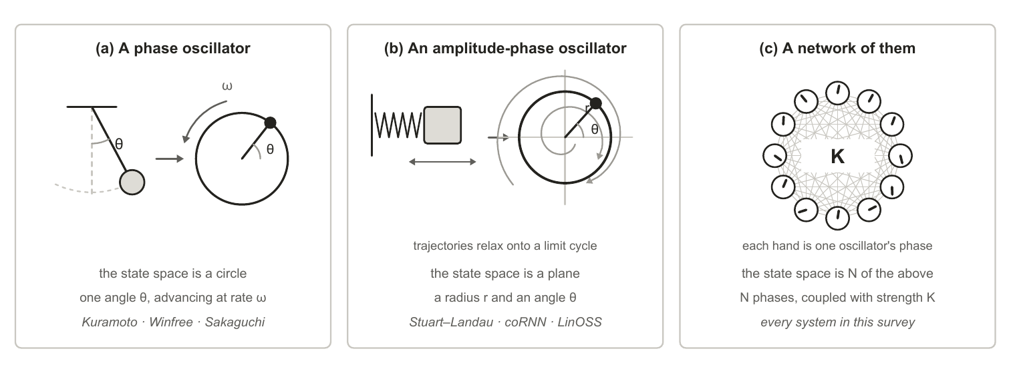
Figure 1. What this survey means by an oscillator, in three widening steps. (a) A phase oscillator keeps a single angle, so its state space is a circle. (b) An amplitude-phase oscillator keeps a radius as well, so its state space is a plane, and trajectories started away from the limit cycle relax onto it. (c) A network keeps N of them and couples each unit to others with strength K. The phases and trajectories drawn are illustrative, not simulated.
Coupling is what makes a population of oscillators one system rather than many: each unit’s rate of change depends on the phases of the units it is connected to, and the strength of that dependence is the coupling constant K. Where a coupled population settles between complete lock and complete disorder is measured by the order parameter R, which runs from 0 to 1. Both extremes are useless for computation. At R near 1 every unit does the same thing, so the population has one degree of freedom left and can carry no signal; at R near 0 nothing is organised for a readout to pick up. The regime that matters is the partial coherence between them, in which some units lock while others drift.
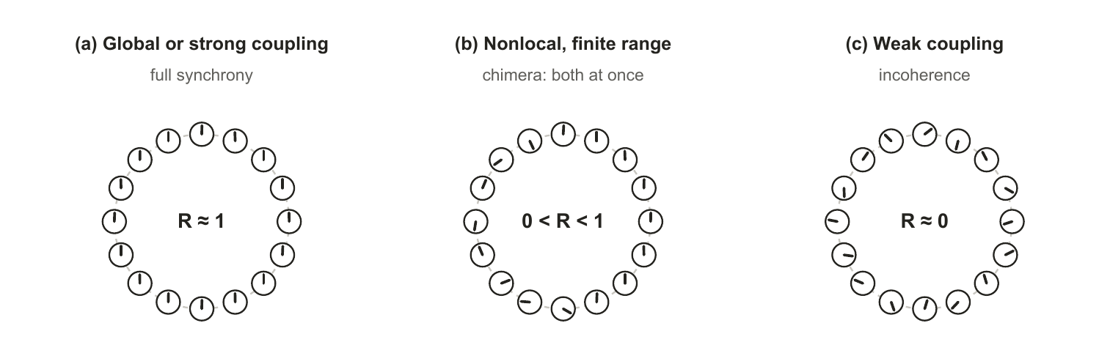
Figure 2. The three coupling regimes reported in the synchronization literature, drawn schematically. Full synchrony leaves no degrees of freedom to carry a signal and incoherence leaves nothing organised; the useful regime is the partial coherence between them, which finite-range nonlocal coupling generically produces. The phases shown are illustrative, not simulated.
That partial regime is also where recurrent computation is reported to peak. Computation in recurrent networks is maximised near the boundary between ordered and chaotic dynamics [3], reservoirs are deliberately parked near that edge, and and hierarchical modular structure makes that edge markedly less sensitive to precise tuning [4], a result about autonomous dynamics rather than about trainability. Every design decision surveyed here, whether coupling range, damping, spectral placement or sparsity, is a way of steering the field toward that regime and holding it there, which is also why the same decisions reappear in Section 3.1 as failure modes.

1.2 The evolution of oscillator understanding
Literature from three different fields arrive at the similar observations from different directions. Physics and mathematics come first chronologically, describing when a coupled population locks and what its structure does to that. Literature from neuroscience presents findings that cortex runs on rhythms and uses them to route information. Applications within machine learning are much more recent, and almost every system we surveyed aligns with findings from the other two fields.

1.2.1 Within physics and mathematics
The observed coupling of oscillators has been on record since 1665, when Christiaan Huygens, found that two pendulum clocks hung from the same wooden beam settled into antiphase within about thirty minutes and resynchronized when disturbed (later published in 1673). Huygens attributed this to motion too small to see, transmitted through the wood beam they shared. The prehistory of the self-sustained oscillator runs from Airy’s first mathematical treatment in 1830 through Poincaré’s limit cycle and Blondel’s naming of the phenomenon, a lineage traced in full by [5], whose survey of self-oscillatory devices for unconventional computing covers similar background as this paper, but from the materials and neuromorphic hardware angle. Fast forward a few hundred years: Huygens’ observation was mathematically explained by the Kuramoto coupling function [6] and the famous experiment demonstrating multiple metronomes on a moving surface, started at different times, synchronizing. Huygens’ experiments were later replicated and explained by [7]. In biology the same synchronization phenomenon was observed at population scale and mathematically modelled, from the patterned flashing of firefly swarms to circadian and cardiac rhythms [8].
That collective physical dynamics can be computation is much more recent, predating the current Oscillatory Neural Network (ONN) wave by four decades (Figure 6). [9] framed memory as the settling of a dynamic physical system after a stimulus and that such a system has emergent computational properties. [10] argued that computing using physics directly is the efficiency endgame, also inspired by biological adaptations, and the synchronization canon of [11], [6], the [12] review, and the [13] textbook set out how coupled oscillator populations self-organize.
Further work on the coupling laws themselves has continued, while the current ONN landscape in machine learning has not yet caught up. The single sinusoid was generalised in several directions: [14] added a phase lag that breaks the symmetry and admits partial coherence rather than forcing all-or-nothing locking; [15] replaced the sinusoid with an arbitrary periodic function; [16] put an explicit delay inside the coupling so that interaction depends on history rather than on the instantaneous state. Then it was generalised past pairs entirely. [17] coupled three phases at once and found an infinite number of coexisting synchronized states where pairwise coupling gives one; [18] showed such terms are not an embellishment but what phase reduction generically produces beyond leading order; [19] coupled over simplicial complexes and obtained an extensive set of stable partially synchronized states; [20] did the same over hypergraphs, where a many-body interaction can exist without its sub-interactions; and [21] showed those two representations give qualitatively different synchronization, so higher-order coupling is at least two distinct generalisations rather than one. Multistability on such structures is now characterised directly [22]. Separately, the oscillator itself was moved off the circle: [23] wrote the units as unit vectors in D dimensions with rotation-matrix natural frequencies, and [24] replaced the scalar coupling constant with a matrix. Appendix C tabulates the full lineage and what each step’s coupling gained over the one before it.
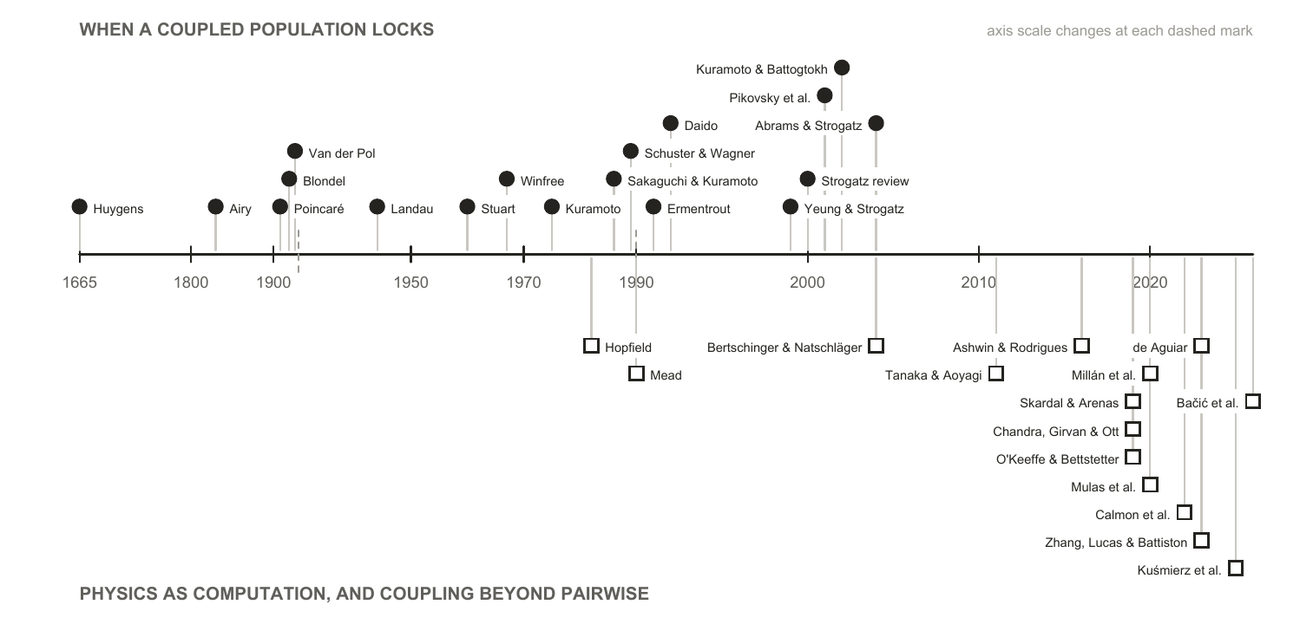
Figure 3. Every physics and mathematics source cited in this survey, in date order. The upper track is the account of when a coupled population locks; the lower track is what structure and operating regime do to it. The axis is piecewise, because four entries predate 1930 and most postdate 1990. Almost every machine-learning system in Section 2 takes its coupling law from the upper track, and from the 1967 to 1992 stretch of it in particular. The single exception is AKOrN [25], built on the D-dimensional generalisation of [23] in the lower track. The rest of the lower track is untouched by the surveyed systems, and its earliest two entries are arguments that physics can compute at all rather than coupling laws to build with.

1.2.2 Within neuroscience
Neuroscience researchers began observing oscillatory coupling directly in cortical tissue: neurons in the feline visual cortex oscillate at 40 to 60 Hz and phase-lock across columns when they respond to the same object, which is why synchrony was proposed as the mechanism binding distributed features into a single percept [26]. [27] develops that observation into a “Communication through Coherence” (CTC) hypothesis which essentially states that: inter-neuron communication is selective based on gamma-band coherence and synchronization.
Reviewing prior studies of mammalian brains, Fries argues that neuronal groups which need to communicate are tuned to the same gamma band, roughly 30 to 90 Hz, and synchronize in order to do so: sender and receiver lock to a common frequency, and inputs arriving at incoherent phases are effectively ignored. The mechanism he proposes for establishing those phase relations is entrainment with a conduction delay, “both for unidirectional and for bidirectional communication”. Where it succeeds, “gamma entrainment allows to transmit a stimulus representation and to selfishly shut out competing stimuli’s representations”, and it “establishes a cycle-to-cycle memory of the active link that maintains until it is terminated at the end of a theta cycle”. Two features of that account matter here. The gamma rhythm works because it “generates fluctuations in network excitation and inhibition that are sufficiently rapid, such that excitation can essentially temporally escape its ever chasing inhibition”, so the useful window is a narrow phase of each cycle rather than a steady state. And the band itself overlaps the 40 to 60 Hz range at which the feline visual cortex was found to oscillate and phase-lock, which is what ties the binding observation and the communication account together.
Gamma does not act alone. Those bottom-up gamma influences are themselves modulated by top-down alpha-beta activity at 8 to 20 Hz, while attention samples the scene at a 7 to 8 Hz theta rhythm that periodically resets which groups are heard. Communication is therefore selective not because one rhythm gates it but because several rhythms interact, and the theta reset means the gating is repeatedly torn down and rebuilt rather than held.
That last point is what makes the account testable in a network rather than a brain. If a specific phase and amplitude are required before a receiving population responds at all, then coupling between groups is intermittent by construction: groups couple during the excitable window and decouple after it. Whether the coupling and decoupling of a trained oscillator network falls into comparable gamma and theta relationships, and whether it does so on visual tasks in particular, is an open and directly checkable question, and one Section 3.2 returns to.
Beyond the gamma band, [28] makes the broader claim that self-emerged oscillatory timing is the brain’s fundamental organizer of neuronal information, and that spontaneous activity is the source of cognitive capacity rather than noise to be averaged away. The small-world connectivity of cortex lets these rhythms carry computation on multiple spatial and temporal scales at once, and the perpetual interaction between many network oscillators holds the system in a highly sensitive metastable state, synchronized through weak links at low energetic cost. At the population level the standard reduction is the Kuramoto model [29], which recast as a diffusion process under the nonlinear Fokker-Planck equation accounts for two features of spontaneous large-scale neocortical recordings that a linear treatment does not: the bistability of the human alpha rhythm, and the non-Gaussian fluctuations of the beta rhythm. The family of such reductions, and the mappings between them, has since been set out systematically [30].
The account is not only about populations. A neuron sitting near its firing threshold is a limit-cycle oscillator, and the phase-response formalism describing how an input shifts its next spike is the same one used for coupled oscillators generally, a correspondence [31] set out explicitly. The reductions this rests on were built for it: [32] keeps two variables of the [33] conductance dynamics, few enough to analyse and enough to spike. One consequence matters for everything in Section 2: cortex is not quiet when undriven. Resting-state functional connectivity is reproduced by networks of local oscillators running with no stimulus at all [34], which is the biological counterpart of a field that computes before it is trained.
Sensory transduction offers a sharper precedent, because there the frequencies are not learned. The cochlea is modelled as a bank of active oscillators poised near a Hopf bifurcation and tonotopically arranged by design and not by learning [35], an arrangement that yields the sharp, compressive, actively amplified tuning measured in real ears [36]. The cochlea therefore demonstrates something this survey cares about: a bank of oscillators that performs a hard sensory task well, whose frequencies were fixed by development rather than fitted to data. Where machine learning would train those frequencies, biology specifies them.
Speech is where the account is most fully worked out, and it is the closest thing in neuroscience to a controlled comparison between oscillator models. Reviewing the field, [37] set three families of theta-rhythmic segmentation model against each other and separate them by where the flexibility to track a variable speech rate comes from. In the motor-coupled model, auditory and speech-motor cortices are two phase oscillators coupled in both directions rather than one driving the other, and the account reproduces the experimental pattern only once it carries individual differences in the strength of that auditory-motor connection, which is what makes it a model of individual variability in speech-rhythm perception rather than of a population average [38]. In the adaptive-frequency model the oscillator’s own natural frequency moves continuously toward the average period of incoming events, which reproduces human timing judgements on stimulus sequences whose tone positions are jittered by about 20% of the mean period [39]. In the single-cell biophysical model, flexibility is intrinsic rather than imposed: the interaction of an m-current with a super-slow potassium current lets a Hodgkin-Huxley cell phase-lock across a broad frequency range, and the resulting segmentation was validated against the TIMIT corpus [40]. What the review says each model cannot settle is the part relevant here. The two population models are abstracted away from real neuronal biophysics, so neither can say whether a cell-level mechanism produces the flexibility they exhibit. The single-cell model has no network at all and holds its parameters static, so it cannot say whether a population-level mechanism contributes. No model in the review spans both levels, so the flexibility that lets any of them track a variable speech rate cannot presently be attributed to the cell or to the network. That is structurally the problem Section 3.1.1 describes on the machine-learning side, where a system’s result cannot be attributed to its oscillator dynamics because the control that would isolate it has not been run. Two fields arrived at the same impasse without reference to each other.
Disruption of these rhythms is a recognised signature across neurological and psychiatric disorders rather than a correlate of one [41], and the relationship has been made interventional: driving gamma-band activity at 40 Hz reduced amyloid load in a mouse model [42].
A contested alternative, included because it changes what “oscillator” would mean. The consensus account of the action potential of a neuron is electrical and conductance-based. A minority position models it instead as an electromechanical soliton, a density pulse travelling in the lipid membrane near its melting transition [43]. If something like it held, a neuron would be a mechanical wave medium rather than a circuit, and the oscillator framing would be closer to the underlying physics than to a convenient abstraction. We record it as a live minority hypothesis and take no position on it: it is contested, it is not what the systems in Section 2 assume, and nothing in this survey depends on it. It is an interesting supposition nonetheless, and one we would expect continued work on oscillatory models of cognition to bear on. Were it to hold, the electrical action potential would be a byproduct of an underlying electromechanical oscillation rather than the mechanism itself, which would make the oscillator description of a neuron the literal one rather than the useful one. We flag that as a direction worth watching and not as a claim this survey makes or tests.
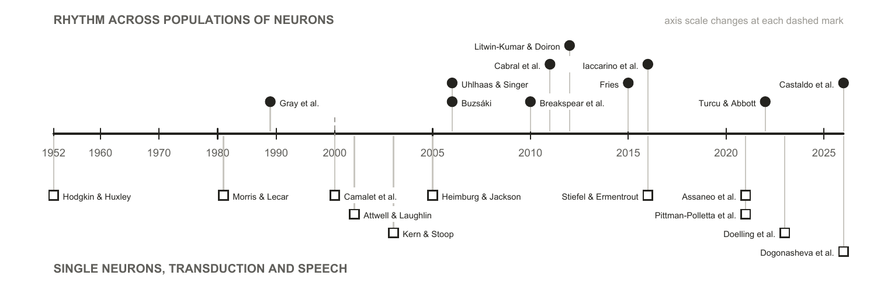
Figure 4. Every neuroscience source cited in this survey, in date order. The upper track is the population account the architectures in Section 2 draw most of their hypotheses from; the lower track is what makes the oscillator description of a neuron literal rather than figurative, together with the transduction and speech work where the frequencies are designed rather than learned.
Two of the neuroscience findings in this section translate directly into testable machine-learning claims, and both reappear in Section 3 as gaps. The binding result [26] predicts that removing the synchronization term should hurt grouping tasks specifically. The Hopf-cochlea precedent [35] predicts that designed frequency placement should beat learned placement.

1.2.3 Within machine learning
What an oscillator network is. Section 1.2.1 gives a rule for how coupled units pull on each other, and Section 1.2.2 gives a reason to expect that rule to compute something. An oscillator network is what results when both are pointed at a machine-learning task. An oscillator network, or oscillatory neural network (ONN), is a machine-learning system whose state is a population of oscillators and whose computation is the evolution of that population under a coupling law. Three choices define one. The coupling function is borrowed from the physics. It is the rule that turns the phase difference between two units into a contribution to each one’s rate of change, and choosing Kuramoto rather than Winfree or Sakaguchi fixes which collective states the population can reach at all; Section 2.3.1 sets the forms actually in use side by side. The geometry is which units are coupled to which, and it decides both the parameter cost and the operating regime. The input and readout decide how a task reaches the field and how an answer is taken out of it. Everything else is the same machinery any other neural network uses.
Geometry deserves its own picture because it is treated as an implementation detail in most of the surveyed work and is not one. All-to-all coupling connects every pair, as in Un-0 [44] and AKOrN [25]; a ring with a finite coupling range connects each unit only to units near it; a lattice arranges the units in space and couples neighbours, as in Neural Wave Machines [45]; a modular fabric is dense inside its blocks and sparse between them. All-to-all coupling costs O(N²) parameters and is the bulk of the largest system surveyed here. Finite-range nonlocal coupling is the case in which the physics reports coexisting locked and drifting domains [46], which is the regime Section 1.1 identified as the useful one. And no published work we found holds a core fixed and varies the geometry, which is why Section 3.1 treats it as an open axis rather than a settled one.
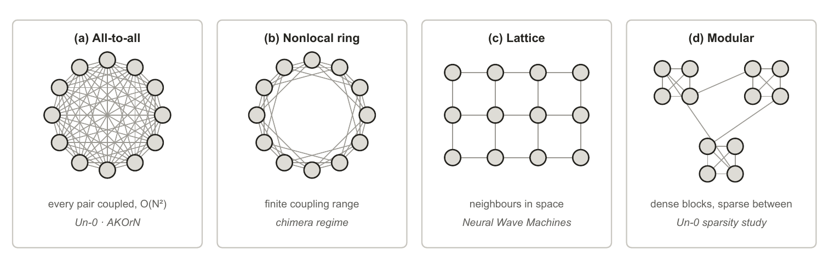
Figure 5. Four coupling geometries over the same twelve oscillators. All-to-all coupling is what Un-0 and AKOrN use, and its O(N²) parameter cost is the bulk of Un-0’s 322M parameters at 16k oscillators. Finite coupling range is the case the physics canon reports chimera states in. A lattice is the geometry of Neural Wave Machines. The modular fabric is the best performer in the one published sparsity study of a trained oscillator network, which is blog-published and covers one system.
Recent contributions. The systems fall into three groups by where the dynamics sits.
- Oscillatory recurrences replace the recurrence of an RNN with a damped second-order ODE. The coRNN [1] proves gradient bounds directly from its damping terms rather than relying on gating, and UnICORNN [47] makes the same construction fast by keeping the units independent. Their linear descendants trade the nonlinearity for scale: LinOSS [2] obtains unconditional stability from an implicit discretization and reaches roughly eighteen-thousand-step sequences by parallel scan, and D-LinOSS [48] makes the damping itself learnable and proves this strictly enlarges the reachable dynamics, since fixed damping covers only a measure-zero set of eigenvalue configurations. The family has a universality theorem, and it is reservoir-shaped: a bank of forced harmonic oscillators plus a readout suffices [49].
- Trained synchronization models put Kuramoto-type dynamics to work directly. AKOrN [25] uses the D-dimensional generalisation as a layer inside a conventional network and reports its gains on object discovery, calibration and reasoning-style tasks rather than on raw accuracy. WONN [50] evolves representations on a torus under generalised Winfree dynamics, writing the input into the natural frequencies rather than adding it as a drive. It is the first synchronization architecture to reach ImageNet-1K scale at all, and it is also the only one in the survey evaluated on logical reasoning and path finding as well as recognition: on Maze-hard it reports 80.1% at 1% of the parameters of the prior state of the art, which is the largest parameter-efficiency margin any system here claims. Un-0 [44] trains an all-to-all Kuramoto pool end to end for image generation and is the only system in the survey to publish a frozen-dynamics control against itself, though only as blog posts with released code. KomplexNet [51] carries phase dynamics inside a complex-valued CNN and reports the field’s most direct evidence for the binding hypothesis, a random-phase control that costs roughly 10 to 15% on multi-object grouping. Kuramoto Attention [52] replaces attention layers with a single Kuramoto-Sakaguchi step, and FSN [53] builds a value pathway from frustration angles, repulsive harmonics and a delay term at once, arguing explicitly that a fully synchronized network computes nothing further. Kuramoto Orientation Diffusion [54] makes stochastic Kuramoto the forward process of a diffusion model, which suits generation on periodic domains. HoloGraph [55] swaps the diffusion-style message passing of a graph network for synchronization between coupled oscillators, aimed at the over-smoothing repeated diffusion causes. Neural Wave Machines [45] couple oscillators locally on a lattice and report parameter-efficiency advantages from the travelling waves that result.
- Physical substrates run the dynamics in hardware instead of simulating it. A single spin-torque oscillator, time-multiplexed as a frozen reservoir, reaches about 99.6% on spoken digits with one device [56]. Oscillator Ising machines [57] engineer injection locking so the physics performs a combinatorial search directly, with no training anywhere. Both sit inside the broader physical-reservoir programme [58], and the run-the-physics thesis extends past oscillators into optical [59] and thermodynamic [60] computing. The same ground has been surveyed from the materials and device side [5].
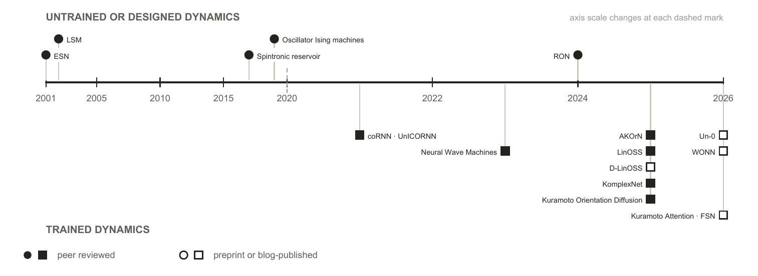
Figure 6. The machine-learning systems this survey covers, by the publication date of the report cited for each. Systems whose dynamics is untrained or designed appear above the axis, systems trained through their dynamics below. A filled marker means the report is peer reviewed. The trained branch is entirely post-2020, and every system whose report is not peer reviewed falls in its last two years.
Set against the physics, the pattern is stark and is one of this survey’s findings. Almost every machine-learning system here uses a coupling law from the 1967 to 1992 window. Kuramoto and Kuramoto-Sakaguchi account for nearly all of the trained systems. Past them the tally is short enough to state exactly. The Stuart-Landau form appears once [61]. The D-dimensional generalisation appears once, as the basis of AKOrN. Higher-order coupling appears once, in a dense associative memory [62]. Delay coupling is the exception, long established in reservoir computing where a single delayed node stands in for a whole network [63]. The inertial, simplicial, hypergraph and Dirac forms appear not at all. Swarmalators, in which phase and spatial position couple to each other, were proposed as a substrate for bio-inspired computing seven years ago [64] and we found no machine-learning system built on them. One of the properties those later models offer is asked for directly. FSN argues that a fully synchronized network computes nothing further, and Un-0’s sparsity study reports dense fields collapsing into a globally locked, zero-gradient state, so partial coherence is a stated requirement of the systems themselves rather than an inference of ours. Multistability and coupling beyond pairwise carry no comparable stated demand, and no surveyed system has tested whether either helps. The gap is untested rather than considered.
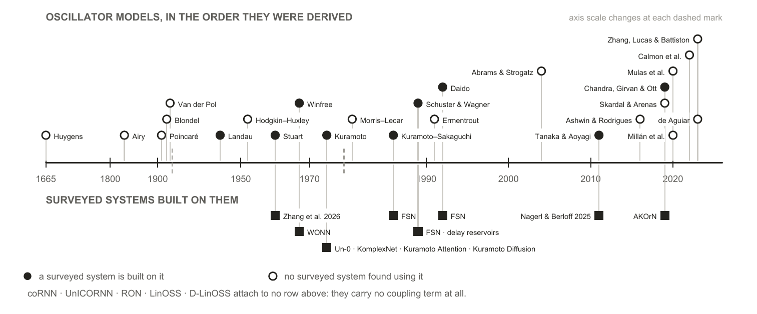
Figure 7. The oscillator models this survey cites, above the surveyed systems built on each one. A filled marker means at least one system in Section 2 uses that coupling form; an open marker means we found none that does. Each system is placed at the year of the model it uses rather than the year it was published, so the lower track measures how far into the lineage the machine-learning literature has reached, not its own chronology.

1.3 Other neural network architectures
Oscillator networks are not the only option, and several of the systems in Section 2 embed one inside a conventional network rather than replacing it. Judging what the oscillator dynamics contributes therefore means knowing what the conventional architectures already do, both as the baselines an oscillator system is measured against and as the components it is often combined with. This section sets out the main families and how each one handles state, which is the property an oscillator field differs on most.
Recurrences carry a state vector forward. The Elman network [65] updates a hidden vector once per input and reuses it, which is the same shape of computation an oscillator field performs, except that the update is a learned weight matrix rather than a differential equation. Its failure mode is what every later design answers: gradients through a long chain of such updates vanish or explode. The LSTM [66] answers it with gated paths along which a value passes unchanged, and the gated recurrent unit [67] reaches the same effect with two gating units where the LSTM uses four. Oscillator recurrences answer the same question with different machinery, bounding the gradient with damping rather than with gates, which is why coRNN can prove what an LSTM can only demonstrate.
Convolutions carry no state. A convolutional network [68] applies the same local filter across position and lets depth build up the receptive field. Weight sharing over a spatial grid is the assumption an oscillator lattice makes as well; the difference is that a convolution has no dynamics between applications, so nothing persists between one input and the next.
Attention recomputes over the whole window. The Transformer [69] drops recurrence entirely and lets every position attend to every other, which removes the sequential dependency that made recurrences slow to train. The cost is that it keeps no compressed state: attention is quadratic in sequence length, and at inference the keys and values of every previous token must be held in memory, a footprint that grows linearly with context and dominates serving cost at scale [70]. A fixed-size oscillator field is the opposite trade, which is the substance of the efficiency argument made for it.
State-space models put a linear dynamical system back in. S4 [71] recovers a constant-size recurrent state while keeping parallel training, and finds its spectrum’s initialization to be load-bearing rather than incidental [72]; Mamba [73] makes the state transition input-dependent and reaches Transformer-quality language modelling. This is the family the oscillatory recurrences are closest to: LinOSS is a state-space model whose transition is a bank of harmonic oscillators, which is why it is also the oscillator system with the longest gradient horizon in the survey. Hybrids interleave the two, keeping a few attention layers for recall over a mostly recurrent stack [74].
Spiking networks are the nearest neighbour. A spiking unit is an oscillator of a restricted kind: it integrates input, crosses a threshold, emits a discrete event, and resets. That discreteness is what makes it efficient on neuromorphic hardware and what makes it hard to train, since the threshold is non-differentiable, so gradient methods need a surrogate and the choice of surrogate is itself a modelling decision [75]. Oscillator models keep the state continuous, so coupling is differentiable and no surrogate is needed, and they carry structure a threshold unit discards: a natural frequency, a phase relationship to every other unit, and a graded rather than binary response to input. Recent work narrows the gap from the other side, training networks of Morris-Lecar neurons directly with backpropagation ([76], preprint). Whether continuous state makes oscillator networks easier to train is open, and this survey’s own evidence cautions against assuming it. No published work compares a spiking network and an oscillator network on one task under matched conditions, and every nonlinear oscillator system in the record works at a short gradient horizon (Section 2.3).
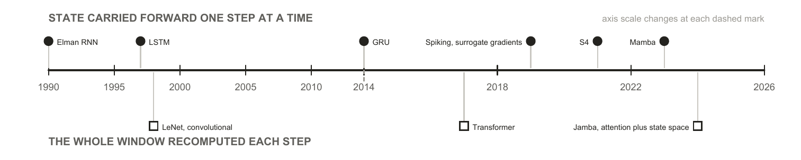
Figure 8. Conventional neural network architectures, by how each one holds the past. Above the axis, a state is carried forward one step at a time; below it, the whole window is recomputed at every step. An oscillator field belongs to the upper track, but its state evolves under a fixed differential equation rather than under a transition learned from scratch, which is the substance of both the efficiency argument made for it and the training difficulty reported against it.

1.4 Motivation for this survey: independent convergence across fields
The case for reviewing oscillator networks is not that any single result is decisive. It is that literatures with different methods and incentives have moved toward the same description of computation, coupling and coherence, and did so largely without citing each other.
From physics, the synchronization canon now describes regimes that look like computation rather than mere order: partial coherence, chimera states with locked and drifting populations coexisting in one field [77], multistability on higher-order interaction structures, and a computational optimum near the boundary between order and chaos. From neuroscience, the oscillator description of a neuron has hardened from analogy into working model, rhythm has been given specific computational jobs, and disruption of those rhythms is now interventional rather than merely descriptive. In machine learning, oscillator dynamics has begun to appear in architectures that run on mainstream tasks at non-trivial scale: 76.78% top-1 on ImageNet-1K at 12.3M parameters (WONN, preprint), class-conditional generation on ImageNet-64 at FID 6.74 (Un-0, blog-published), sequence classification at roughly eighteen thousand steps (LinOSS), object discovery and Sudoku (AKOrN), and character-level language modelling (Kuramoto Attention, preprint). What these results establish is that the dynamics can be trained at these scales at all, which was not on the record five years ago. What they do not establish is how the systems stand against tuned conventional baselines, which Section 2.3.4 takes up.
The machine-learning literature has so far built on the simpler end of that physics, and it is already getting results there. The coupling laws in use generally end around the 1992-era physics models (Figure 7), and the geometries in the surveyed machine-learning models are all-to-all or nothing, with Un-0 only recently demonstrating a sparse geometry, while the more recent physics models demonstrate behaviour ONN researchers have reason to want. Partial coherence is the clearest case: two of the surveyed systems name full synchronization as the failure mode they are trying to avoid. Multistability and coupling beyond pairwise are untried here rather than unwanted. That gap reads as headroom rather than deficiency: more expressive coupling laws are sitting unused, and the results already obtained with the simple ones are the reason to think the richer ones are worth trying.
Three motivations sit behind the interest, and they are worth separating from evidence:
- Energy and compute. The brain’s signalling budget is small enough to be a standing reproach to conventional accelerators [78], and running physics directly has been the efficiency argument since [10]; the concrete modern version is that a fixed-size dynamical state avoids the growing key-value cache that dominates Transformer serving. No trained oscillator network has published a measured energy win (Section 2.3.4), so this is a reason to look, not a result.
- Alignment with the signals. The signals biological sensing evolved to handle are physical waves, and the transducers that receive them are frequency-selective by construction, the cochlea being the clearest case. A substrate whose native operations are resonance, entrainment and phase relationship is therefore not an arbitrary inductive bias for these signals; it is the same class of object as the thing being sensed.
- Explanatory: a trainable model built from the same dynamics as the biological account would make questions about learning, forgetting and rhythm disruption addressable in simulation. All three are hypotheses about what the field could deliver. This survey is about what it has delivered.

1.5 Evidence standard and limitations
Evidence standard. This survey reports no new experiments and cites no unpublished results. Every claim is attributed to a published source. A substantial part of the trained-Kuramoto evidence exists only as technical blog posts, preprints, or community repositories. That material is included, because excluding it would misrepresent the state of the field, and it is marked as non-peer-reviewed everywhere it carries weight. Where a claim rests on such a source, the text says so at the point of use rather than in a footnote.
Five limitations bound every claim that follows.
- Publication-status heterogeneity. The strongest evidence that trained pure-Kuramoto dynamics works at scale, and all of the oscillator-sparsity evidence, is blog-published. Several load-bearing systems are preprints: WONN [50], Kuramoto Attention [52], FSN [53], and the equilibrium-propagation study [79]. KomplexNet [51] is the one system in this group to have completed peer review since we began this survey, which is itself a reminder of how quickly the status of any row here can change. Independent replications are essentially absent field-wide.
- Protocol heterogeneity. Numbers quoted from different papers cannot be fairly compared across models and protocols. They are therefore set beside each other observationally in this survey and never ranked.
- Coverage bounds. We survey the machine-learning-facing evidence. The synchronization physics, neuroscience and hardware literatures are cited as anchors for background and motivation, and were not reviewed exhaustively.
- A fast-moving field. Every “lacks evidence” claim carries an implicit “that we found”. Several systems surveyed here are months old, and there may be work under review addressing the gaps we identify.
- Interest disclosure. The authors conduct their own experimental work on oscillator substrates. The gaps identified reflect those interests. No unpublished work of ours is used or cited.

2 Oscillator neural networks

2.1 Scope and terms
A “coupled oscillator network” here means a machine-learning system whose state evolves under oscillator dynamics: phase-only models of the Kuramoto and Winfree family, second-order oscillator ODEs, linear oscillatory state-space models, amplitude-phase models, and physical oscillator hardware. Thirteen load-bearing systems meet that definition and are tabulated in Appendix D. The same words are used differently in physics, neuroscience and machine learning, and several of the comparisons below depend on which sense is meant; Appendix B is a glossary of the terms as this survey uses them.
One adjacent literature is deliberately outside that definition. A substantial body of work uses neural networks to model oscillator dynamics rather than to compute with them, learning the evolution of a coupled system from data, most recently through Koopman operator methods [80]. That is the inverse of the question here. This survey asks what oscillator dynamics does for a machine-learning system, not what a machine-learning system can say about oscillator dynamics.

2.2 Taxonomy

2.2.1 Overview
Two independent questions separate the surveyed systems, and crossing them gives four quadrants rather than a tree. The first is whether gradients reach the dynamics: is the oscillator field fitted to the task, or fixed by design or at random before training begins. The second is whether anything else is trained: does a conventional encoder, decoder or readout sit around the field and do part of the work. The first question is where the field’s claims differ most. The second is where its attribution problems live, because a trained scaffold can carry a result that is then reported as the dynamics’.
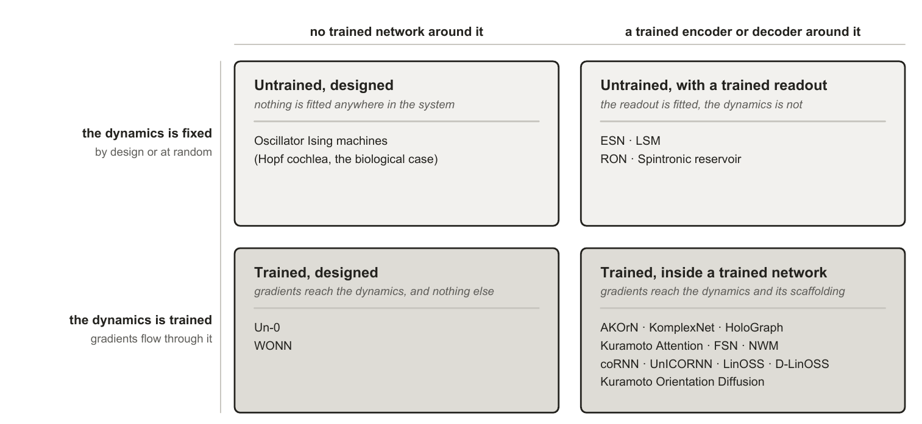
Figure 9. The taxonomy used in this survey. Systems split on two independent questions: whether gradients reach the dynamics, and whether a trained conventional network wraps it. Coupling law, geometry and substrate cut across all four quadrants and are carried as columns in Section 2.3 rather than as further branches, because nesting them produces a tree no system occupies uniquely.

2.2.2 Untrained designed dynamics
Nothing is fitted anywhere. Every parameter is chosen, and the physics performs the computation directly. Oscillator Ising machines [57] are the clear case: injection locking is engineered so that the equilibrium the hardware falls into is the answer to a combinatorial problem, and there is no training step of any kind. This is the strongest form of the run-the-physics argument: if a system’s parameters can be chosen so that its natural dynamics settles on the answer, the computation costs whatever the physics costs and no more. It is also why designing a substrate around a specific task, rather than training a general one to perform it, should be further studied by the field.
The biological precedent sits in the same quadrant and is worth keeping in view because it is the one place where designed beats learned on the record. The cochlea is a tonotopically arranged bank of active oscillators whose frequencies are set by construction, not fitted, and it delivers sharp, compressive, actively amplified tuning that no learned filterbank has bettered.

2.2.3 Trained designed dynamics
Gradients reach the dynamics, and the dynamics is essentially the whole model rather than a component of one. Un-0 [44] is a pure Kuramoto pool with learned all-to-all coupling and learned natural frequencies, trained end to end for image generation; WONN [50] uses Winfree coupling and writes the input into the natural frequencies rather than adding it as a drive. Both are the field’s scale demonstrations, and both are also where the attribution question is cleanest, because there is comparatively little conventional machinery to which a result could be misattributed. Un-0 is the only system in the survey that publishes the control this quadrant makes possible: a frozen-reservoir control, against which its trained dynamics wins clearly, with single-step and linearized dynamics performing near the untrained level (blog-published).

2.2.4 Untrained dynamics with a trained encoder or decoder
The dynamics is fixed, randomly or by design, and a readout is fitted to it. This is the oldest branch and the best evidenced, because a field was built on it: echo-state networks and liquid state machines fix random recurrent dynamics and train only a linear readout ([81]; [82]), a construction whose scope and limits were consolidated a decade later [83].
The oscillator-specific evidence here is the strongest in the survey. A single physical spin-torque oscillator, time-multiplexed as a frozen reservoir, reaches roughly 99.6% spoken-digit recognition with one device rather than a network of them [56]. Untrained networks of randomly coupled damped oscillators, RON [84], are reported to outperform both echo-state and fully trained recurrent baselines on time-series benchmarks, which is a trained-versus-untrained comparison in the untrained direction. And designed dynamics can replace random dynamics at no cost: deterministic minimum-complexity reservoirs match classical random echo-state networks [85].
The distinguishing feature within this quadrant is where the fixed dynamics comes from, and it matters because Section 3.1 shows designed structure repeatedly failing to beat randomized twins elsewhere. Random initialization is the reservoir default, deterministic construction is a documented alternative at equal accuracy, and the tonotopic cochlea is the limiting case in which every parameter is chosen. This is the one branch where that comparison has been run and design holds up.

2.2.5 Trained dynamics with a trained encoder or decoder
Gradients flow through the oscillator dynamics and through conventional layers around it. This quadrant drives the current wave and carries the heaviest attribution burden, since a conventional scaffold surrounds the part under test.
Within it, the useful sub-division is architectural role, because it predicts both the training horizon and the controls the system needs. As a recurrent core, the dynamics replaces the recurrence of an RNN: coRNN [1] and UnICORNN [47], LinOSS [2] and D-LinOSS [48], and Neural Wave Machines [45]. This is where the theory is strongest and the horizons longest. As a layer inside a conventional network, Kuramoto dynamics sits as one block among ordinary ones: AKOrN [25]’s D-dimensional layers, KomplexNet [51]’s phase dynamics inside a complex-valued CNN, the synchronization message passing of HoloGraph [55] inside a graph network. As an attention mechanism, a Kuramoto or Kuramoto-Sakaguchi step stands in for an attention layer, typically one dynamics step per layer: Kuramoto Attention [52] and FSN [53]. As a generative process, stochastic Kuramoto becomes the forward process of a diffusion model trained through per-step score objectives rather than through a long chain: Kuramoto Orientation Diffusion [54].
The theory underwriting this quadrant is real and worth stating, because it establishes that the function class is there to be learned even where the evidence that it is learned is thin. The family is universal, with quantitative approximation and generalization bounds ([86]; [87]) and an infinite-horizon extension [88]; input-to-state stability has been established for coupled oscillator networks [89]; and contraction conditions are known for composing stable recurrent modules [90]. One result cuts the other way, and it is the sharpest thing theory says here: within-layer coupling may not be required for the family’s universality, because a diagonal, uncoupled bank could suffice [49]. That is proved for a bank of forced harmonic oscillators with a nonlinear readout rather than for the Kuramoto-family models most of the surveyed systems use, so it bounds what synchronization can be claimed to add rather than settling it. If it carries, whatever synchronization contributes is inductive bias, and only a controlled ablation can measure it.

2.3 Comparison of the current landscape

2.3.1 What the systems are built from
Appendix D records what each system is: its oscillator family, the part of a model the dynamics constitutes, what gradients reach, and whether the work is peer reviewed. Appendix E records what each system reports: task, data, headline result, parameter count and training horizon. Both are inventory. The three things worth reading across them are the coupling law, the geometry, and where the input enters, because those are the choices the physics says are consequential and the papers make in passing.
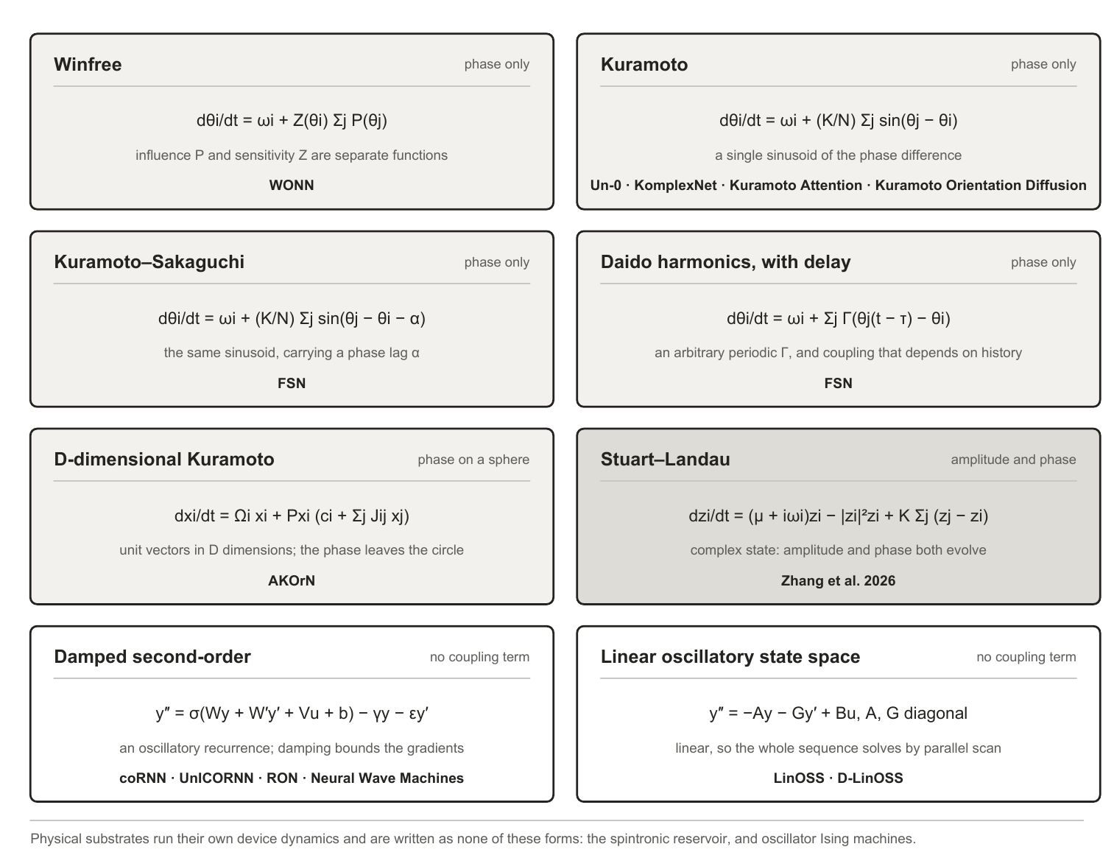
Figure 10. The oscillator dynamics each surveyed system is built on, grouped by how the dynamics is written rather than by when it was published. The first six forms carry an explicit coupling term between units. The last two do not, which is why Section 2.3.3 records a coupling ablation for those rows as not applicable rather than as missing. Appendix C places all of them in the wider lineage.
Where the input enters looks like an implementation detail and is not one. Classical theory is unambiguous that input can only pull the phases into step if it acts on the phase, so an additive drive and a value written into the natural frequency do different things (Adler 1946; the phase-response formalism in [13]), and drive competes with mutual order in forced populations [91]. Hardware treats injection locking as the computation itself. The surveyed systems scatter across the four available forms silently: additive drive (coRNN, LinOSS), phase-coupled conditioning (AKOrN’s projected conditioning, Un-0’s conditioning oscillators sin-coupled into the field), input written into natural frequencies (WONN), and input-gated coupling strength (KomplexNet). No paper in this set contrasts two injection forms under controls or discusses the choice as a choice.
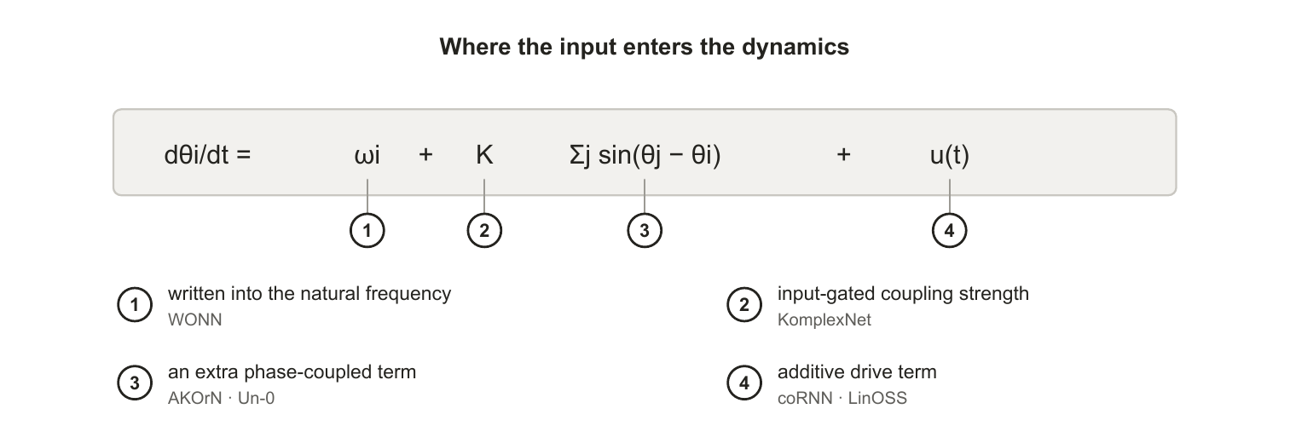
Figure 11. The four ways input enters the dynamics across the surveyed systems, each marked against the term it modifies. Classical theory makes this consequential rather than incidental: entrainment requires a phase-dependent term, so writing input into the natural frequency (1) and adding it as a drive (4) are not interchangeable. No paper in this survey contrasts two injection forms under controls.
Geometry and capacity are separable design choices in principle, and whether they can be set separately in practice is not something the record answers: one surveyed system has varied them together, none has varied either alone. Un-0’s sparsity study [92] reports that static masks fixed before training remove 50 to 98.4% of couplings and maintain or improve generation; that the best ImageNet-64 result is a modular variant at reduced parameter count; that optimal sparsity scales with system size; and that above a critical sparsity performance degrades, the extreme failure being input-output disconnection. Its own summary is that connectivity acts as a control knob, not a monotonic regularizer. Two attributions carry independent interest: improvements track generative recall, meaning diversity, rather than precision, under the established decomposition ([93]; [94]), and sparse systems tolerate higher learning rates, with dense failures blamed on collapse into global lock. All of this is blog-published, one system, one modality. The physics is consistent with it: chimera coexistence is generic for nonlocal finite-range coupling, modular fabrics natively produce chimera-like states and metastable timescale hierarchies ([95]; [96]), sparse recurrent fabrics classify at high capacity through resonant amplification [97], and in conventional networks near-independent recurrent modules generalize better out of distribution [98] while spatial wiring costs make modularity emerge [99].
Damping and frequency placement are the two physics parameters the surveyed papers do report, and each turns out to be doing two jobs at once. The spectral radius of an echo-state network is simultaneously its stability condition and its memory-nonlinearity operating point; coRNN’s damping guarantees its gradient bounds and shapes its expressivity; D-LinOSS uses learnable damping as its stability mechanism and proves it strictly enlarges the reachable dynamics; and per-unit damping has a unimodal sweet spot in a speech-oscillator study [100]. Frequency placement shows the design-beats-training pattern repeatedly: state-space models find their spectrum’s initialization load-bearing, D-LinOSS initializes in spectrum space by design, envelope-band initialization decides success on raw-waveform speech, and the cochlea literature designs the bank outright.

2.3.2 What the systems are evaluated on
A survey of this shape would normally open its comparison with a shared benchmark. The field has not established one yet, and that absence is itself one of the gaps this survey identifies. Some convergence has started: Sudoku is now reported by two independent groups, AKOrN and WONN, and CIFAR and ImageNet recur across several systems, though at different tasks. The spread is still the point, though. Read down the task column of Appendix E: class-conditional image generation scored by FID, ImageNet-1K top-1 classification, maze path finding and Sudoku, object discovery, multi-object binding robustness at small scale, character-level language modelling, generation on periodic domains, extreme-length sequence classification, general time-series benchmarks, spoken-digit recognition, and combinatorial optimisation. Almost no two rows share a task, and where two rows do, they rarely share a protocol.
Shared cross-disciplinary benchmarks largely do not exist here for three reasons. The field is genuinely multidisciplinary: results arrive from nonlinear dynamics, neuromorphic hardware, computational neuroscience and mainstream deep learning, and each of those communities brought its own evaluation habits with it. A physics group reporting a locking diagram and a deep-learning group reporting top-1 accuracy are not being careless with each other’s conventions; they are answering different questions. The field is also young. Most of the trained-dynamics systems here postdate 2023, and a subfield converges on shared benchmarks once its methods stabilise, not before. And the substrates are not commensurable: a time-multiplexed physical oscillator and a 322M-parameter simulated Kuramoto pool cannot be run on one task suite even in principle.
As a result, cross-system accuracy comparisons are unsafe, because the tasks differ and so does the effort spent tuning each baseline. A general claim of the form “oscillator networks are better at X” cannot be supported by this record, because no two systems have been run on X under one protocol. Narrower claims can be made, and two papers make them: Kuramoto Attention reports beating a parameter-matched transformer at the 5M scale, and RON reports beating echo-state and fully trained recurrent baselines on time-series benchmarks. Each of those stands for its own task at its own scale against its own baseline. What does not follow from either is that the result carries to another task, another parameter budget, or another oscillator system. And an absent result is not a demonstrated limitation: generative speech, streaming inference and measured energy on hardware contain no oscillator system at all, so nothing has been shown to fail there.
What is comparable. Two kinds of comparison survive those limits. A paper’s own ablations are protocol-matched by construction, so the controls table below compares like with like even where nothing else in the record does. And parameter budget carries across papers wherever it is reported, which is what makes the matched-budget external baselines, rare but present, worth reading closely.
Training horizon is comparable in the same way and shows a conspicuous pattern. Un-0 trains with 10 to 25 integration steps and reports no stability machinery of any kind; WONN unrolls 18 steps, six layers of three; Kuramoto Attention takes one dynamics step per layer; Kuramoto Orientation Diffusion never trains a long chain at all. The oscillator systems that do handle long horizons changed the problem rather than solving it: coRNN and UnICORNN prove gradient bounds from damping first, LinOSS makes the dynamics linear, D-LinOSS keeps every mode contractive by construction. Theory tracks the same line, with generalization bounds growing linearly in horizon and approximation rates requiring incremental stability. Meanwhile a parallel literature develops training rules that avoid backpropagation through the dynamics entirely: equilibrium propagation for Kuramoto frequencies [79] and local force-measurement rules for driven nonlinear oscillators [101].
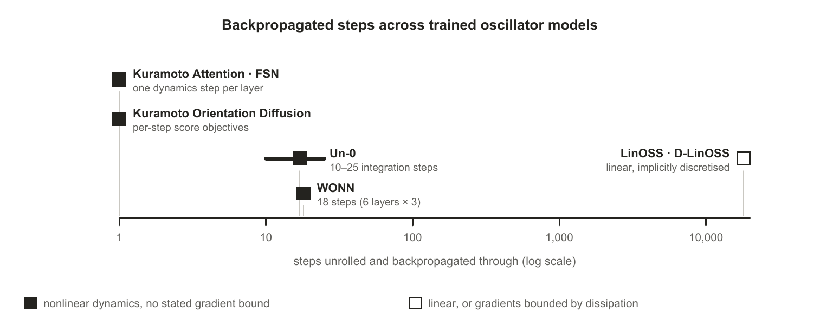
Figure 12. Steps unrolled and backpropagated through, by system. Filled markers are nonlinear dynamics with no stated gradient bound; open markers are linear dynamics, or gradients bounded by dissipation. coRNN and UnICORNN are not plotted: they train long sequences, but prove gradient bounds from damping before doing so. Every nonlinear system sits at the short end, and the one system three orders of magnitude out is linear.

2.3.3 What the systems report as controls
The controls table is where this survey’s argument is decided. The five controls below are not a standard anyone has adopted; they are assembled in Section 3.1 from cases where each control’s absence is documented to have misled. A mark means the surveyed work reports running that control. A dash means we did not find it reported in the work we surveyed, not that it was not run, and not that the result would change if it were. The pattern, rather than any single mark, is the observation.
Controls reported by each system. A tick means the surveyed work reports running that control; ≈ marks the nearest published instance rather than the control itself; a dash means we did not find it reported, which is not evidence it was not run.
System | Frozen twin | Decoder-only | Randomized twin | Matched-budget baseline | Single-term ablation of coupling
Un-0 | ✓ | ✓ | ✓ (modular vs random masks) | not reported (external replication only) | —
AKOrN | — | — | — | — | ✓ (a J = 0 bar in a robustness figure; no number in the text, protocol unstated)
WONN | — | — | — | — | —
Kuramoto Attention / FSN | — | — | — | ✓ (param-matched transformer, 5M) | not reported (thirteen ablations, none removed the synchronization step)
KomplexNet | — | — | — | — | ≈ (random-phase control: the nearest published instance, not the ablation itself)
Kuramoto Orientation Diffusion | — | — | — | — | ✓ (K(t) = 0 in the forward process, reported numerically)
Neural Wave Machines | — | — | — | — | —
coRNN / UnICORNN | — | — | — | — | n/a (no coupling term)
LinOSS / D-LinOSS | — | — | — | — | n/a (no coupling term)
RON | n/a (untrained by construction) | — | — | ✓ (ESN and trained RNN baselines) | —
Spintronic reservoir | n/a | — | — | — | —
Oscillator Ising machines | n/a (no training) | — | — | — | —
Two systems remove the coupling term as a single variable, and the way they do it is an important finding. Kuramoto Orientation Diffusion sets K(t) = 0 in its forward process and reports the result in a table, which is the one unambiguous instance in the record. AKOrN ablates its learned coupling matrix as a J = 0 bar inside a robustness figure, with no number in the text and no statement of whether that variant was retrained without coupling or had its coupling zeroed at evaluation, which is the difference between measuring what coupling contributes and measuring a readout meeting unfamiliar dynamics. KomplexNet’s random-phase control is a third near-instance that freezes phases rather than deleting the coupling. Neither of the two is run at a matched parameter budget against the full model on a task the paper leads with, so the term that names the family has been isolated twice, once legibly. Of the fifty-five applicable control comparisons these five give across the twelve systems, seven have been run, plus this one near-instance; Appendix G itemises them.

2.3.4 How the systems compare with conventional architectures
Each system’s own reported numbers, set against the architectures of Section 2.3, read as follows. Un-0’s ImageNet-64 FID of 6.74 is competitive with first-generation diffusion baselines and far from the modern frontier, where one-step models reach FID around 1.5 on harder benchmarks [102], as its authors acknowledge; a community matched-budget replication found a DCGAN clearly stronger on MNIST (Kuramoto-MNIST [103], community repository). Its authors also report an observation about scale that no one has yet tested independently: quality keeps improving as the model grows, but more slowly than for the conventional diffusion models they compare against, EDM [104] and GDD [105], so the gap to the frontier widens rather than closes with size. That is a single blog-published observation from the system’s own authors rather than a scaling study, and it is the clearest reason the field needs one: whether trained oscillator networks scale competitively is the question a prospective adopter will ask first, and nothing peer reviewed currently answers it. WONN’s 76.78% ImageNet-1K at 12.3M parameters makes it the first synchronization architecture competitive at that scale, not better than modern baselines. Its reasoning results are the sharper claim: 80.1% on Maze-hard at 1% of the parameters of the prior state of the art, which is a parameter-efficiency margin rather than an accuracy win, and is not a matched-budget comparison in the sense of Section 2.3.3, since the budgets differ by two orders of magnitude in the oscillator system’s favour. AKOrN’s reported advantages are robustness, calibration and reasoning-style tasks rather than accuracy dominance.
The wins that exist are niche-shaped, and the niches are real. LinOSS beats Mamba-class baselines on extreme-length sequences, 95.0% against 70.9% on roughly eighteen-thousand-step EigenWorms, which is the clearest protocol-matched oscillator win in the survey and sits exactly where a fixed-size dynamical state should have the advantage over attention. Kuramoto Attention reports beating a parameter-matched Transformer at the 5M scale only (preprint). Untrained oscillator reservoirs beat trained RNNs on some time-series benchmarks. KomplexNet wins on multi-object binding robustness at small scale. A single physical oscillator does spoken digits at roughly 99.6% with one device. Neural Wave Machines report parameter-efficiency advantages.
The energy argument, often the headline motivation, currently rests on adjacent substrates rather than on oscillator networks. A spiking-network text-to-speech system reports ANN-comparable quality at about 10.5% of the energy [106]; neuromorphic keyword spotting has an established measured energy-per-inference methodology [107]; continuous-time ODE neurons make the small-trained-dynamical-system case ([108]; [109]). No trained oscillator network has published a measured energy win.
Comparative numbers across these papers are not protocol-matched: baselines differ in tuning effort, parameter budgets are rarely matched, seeds are rarely reported, and the strongest trained-Kuramoto evidence is not peer reviewed. Each niche is supported by one or two papers. We also note lanes where no oscillator system exists at all: to our knowledge none performs generative or streaming speech, and streaming time-series work generally is thin, so absence of dominance there is absence of peer-reviewed attempts rather than a claim on capability thus far.

3 Discussion

3.1 Research challenges
Where the evidence stops. Each subsection states a bound the literature itself establishes, drawn from the same sources that make the positive case above. These are not objections from outside the field.

3.1.1 Attribution, and the controls that are missing
Each of the five controls in Section 2.3.3 exists because a published result shows what happens when it is absent. Frozen twins: untrained oscillator dynamics can carry a task unaided (Section 2.2.4), so a trained gain must be measured against one, and Un-0 [44] is the only trained-synchronization system we found reporting that control. Decoder-only controls: wherever a conventional encoder or decoder wraps the dynamics, the compute may live there. Initialization sensitivity: learnable front-ends that end where they started [110] show apparent learning can be initialization in disguise, and visible parameter motion without recovery of a known-good solution [111] shows motion is not value. Randomized twins: designed structure can reduce to generic sparsity, and across fifteen biological-pathway-informed models randomized sparse masks matched or beat the biology-informed ones [112]. Matched-budget baselines: a community replication of Un-0’s recipe on MNIST, matched to a DCGAN on parameter count, batch size, training length and best-of-32 selection, reports the DCGAN as the stronger generator on that benchmark (Kuramoto-MNIST [103], community repository). It is the only external matched-budget comparison of a trained-synchronization system we found, and it runs against the system’s own headline.
Single-term ablations are the gap that matters most, because the term in question names the family, and the gap is now one of reporting rather than of absence. Kuramoto Orientation Diffusion [54] sets K(t) = 0 and keeps only the phase-reference drift, reporting a rise of more than fifteen FID points at a hundred steps: the clearest single-variable removal in the record, though it ablates a forward diffusion process rather than a trained coupling. AKOrN [25] does the same to a coupling that is learned. Its update carries three terms: a natural-frequency rotation Ω, a sum over neighbours weighted by a learned coupling matrix J, and the input, with both Ω and J optimised against the task objective. Figure 8 of that paper reports a J = 0 bar beside a separate Ω = 0 bar, so the two physics terms were treated as independent axes rather than swapped wholesale, and with J = 0 the population decouples completely: each oscillator turns under its own frequency and the input alone. What the paper does not say is whether that variant was retrained without coupling or had a learned J zeroed at evaluation, and the difference decides what the number means. A retrained variant measures what the coupling contributes; zeroing a learned J at test time largely measures a readout meeting dynamics it was never fitted to. The value itself appears in no table and no sentence, only as a bar, so a reader cannot tell which was done. Kuramoto Attention [52] reports twelve single-axis ablations and a value-transport comparison, of which one replaces the on-manifold circular mean with a dense linear value projection at a cost of +0.25 BPC, which is the nearest anything in the trained line comes to isolating the synchronization step, though it swaps the value path rather than removing the coupling. FSN [53] reports three mechanism ablations, removing the frustration phases, the feed-forward block and the delay term, and flags its own delay result as screen-level rather than converged. KomplexNet [51]’s random-phase control is the closest published instance and reports its complex-valued model beating a real-valued baseline by roughly 10 to 15% under distribution shift, while KoPE [113] removes its whole phase dynamics rather than the coupling term.
Where the controls were run, they changed conclusions: Un-0’s frozen-reservoir control, KomplexNet’s random-phase control, and the matched-budget DCGAN. In each of those three cases the control changed what could be concluded from the paper, which is the argument for running them: they are not a procedural formality but the step that decides whether a reported gain is attributable to the dynamics. The binding results are also a reason not to assume the missing ablations would come back empty. If synchronization is the mechanism that groups distributed features, as the neuroscience in Section 1.2.2 reports, then removing it should cost accuracy on grouping tasks specifically, and be harmless on tasks that do not require grouping. An ablation that finds nothing on one task family is therefore not evidence that the coupling does nothing.
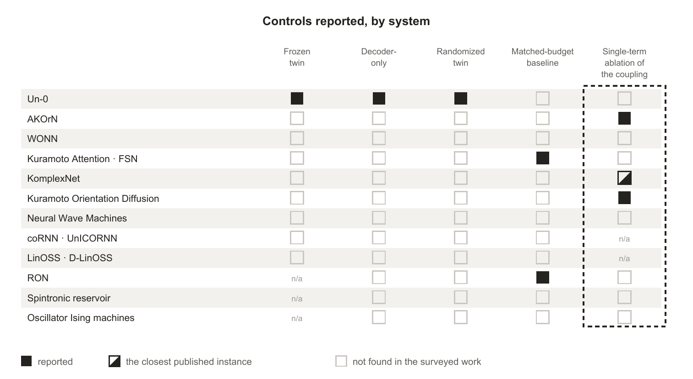
Figure 13. Controls reported by each system. A filled square means the surveyed work reports running that control; an open square means we did not find it reported, which is not evidence that it was not run. Two systems remove the coupling term as a single variable, the mechanism the Kuramoto family is named after, and neither does so at a matched budget on the task its paper leads with. KomplexNet [51]’s random-phase control, marked as the nearest published instance, freezes phases rather than deleting the coupling.

3.1.2 What training moves, and what it does not
Universality says nothing about trainability, and the adjacent literature is pointed about one parameter group. Learnable audio front-ends move little from initialization; mel-initialized filters barely train at all even when distilled toward a fully specified designed teacher [114]; a state-space model’s frequency bias is set at initialization and conventional training does not move it [115]; and where front-ends are compared head to head, gradient-learned placement wins neither contest: front-ends that keep adapting at inference beat both the hand-designed and the gradient-learned kind ([116]; [117]). In Kuramoto networks specifically, the one study making natural frequencies first-class learnable parameters reports roughly half of randomly initialized runs failing through landscape multistability, rescued by designed spectral seeding (toy scale, preprint). And where oscillator systems succeed with fixed frequencies chosen by design, as when envelope-band initialization makes a coRNN [1] trainable on raw waveform where a vanilla RNN fails [100], design rather than learning determined the frequency structure. “Oscillator networks learn” is therefore well supported for coupling and readout-adjacent parameters and specifically doubtful for frequency placement.
Parameter sensitivity is reported within a paper and almost never across tasks. WONN [50] and AKOrN [25] each report results on more than one task family, and both configure their model separately for each, but neither reports whether a setting tuned for one task carries to another; the remaining systems fix a single family. The literature therefore cannot say whether an optimum is task-dependent, which is the natural expectation if some tasks want the dynamics for transduction and others want it for memory.

3.1.3 Structure and geometry
Geometry is varied in four of the surveyed systems, and in none of them as a single variable. Neural Wave Machines [45] comes closest, running a one-dimensional ring core and a two-dimensional torus core against a globally coupled coRNN at equivalent parameters and explicitly to isolate the effect of the imposed structure, but its two cores differ in convolution kernel as well as in topology. Kuramoto Orientation Diffusion contrasts global with 5x5 local coupling while retuning the coupling strength between the two. WONN [50] contrasts convolutional with attentive coupling, and reports that the convolutional variant “introduces substantially more parameters”, so the comparison is not budget-matched either. Un-0’s sparsity study contrasts dense, random-sparse and modular fabrics, the only one of the four to do so with learned couplings. What no published work we found does is vary coupling range or boundary conditions as a single variable at a matched budget, so the question of what geometry buys is answered nowhere by a controlled sweep. And designed structure must beat its randomized twin before design gets credit, a caution Un-0’s random-versus-modular comparison only partially addresses. Two scope limits apply to the sparsity evidence as well. Sparsity of interactions and sparsity of parameters coincide in all-to-all coupling matrices but come apart in tied parameterizations, where a convolutional or spectral kernel keeps every interaction while holding few parameters, and no sparsity study covers that regime. The oscillator-side evidence is also a non-peer-reviewed study of one system whose authors themselves flag protocol drift between posts.

3.1.4 The dynamics as both resource and hazard
Three lines of work, none of them aimed at the others, point the same way. Operating-regime theory puts computation near the order-chaos boundary and reservoirs are deliberately parked there. Failure modes named in the trained-oscillator literature: Un-0’s sparsity study reports dense all-to-all fields easily falling into catastrophic synchronization, a globally locked, zero-gradient state, and FSN opens from the same thesis. The useful regime is partial coherence, exactly what the physics says finite-range nonlocal coupling generically produces. Optimization landscape: frequency-parameter loss surfaces are highly non-convex with narrow basins, established for sinusoidal-frequency estimation by gradient descent ([118]; [119]), known since Rife and Boorstyn in 1974, observed as spectral-gap gradient suppression in quantum circuits [120], and reported as multistability seed-failures in Kuramoto frequency learning.
The hazard is manageable, since the successes exist. But the published management strategies are themselves evidence for the diagnosis: coRNN proves its gradient bounds from its damping, LinOSS [2] obtains stability from implicit discretization, D-LinOSS [48] parameterizes damping so every mode stays contractive, and Un-0’s remedy is topological. The theory arrives at the same requirement from the other direction, and the coincidence is worth naming. Each fix above adds damping to make training work. Independently, the approximation rates proved for these models hold only if the system is incrementally stable, which is the property damping provides. Damping is therefore not a workaround sitting beside the theory; it is what both the trainability and the approximation-rate guarantees depend on. One caveat on the inference itself: papers do not report failed horizon scaling, so publication bias could manufacture the pattern, and no published study we found isolates horizon length as the single variable on a fixed nonlinear oscillator substrate.

3.1.5 The physics the field has not used
Section 1.2.3 counted how many of the surveyed systems use each coupling form and found the count concentrated between 1967 and 1992. What follows is what that leaves unexplored. No surveyed system uses inertial, simplicial, hypergraph or Dirac coupling. Swarmalators, in which phase and spatial position couple to each other, were proposed as a substrate for bio-inspired computing in 2019 [64], and we found no machine-learning system built on them, trained or untrained. The bounds of the physics parameters are unmapped: no published work sweeps coupling strength, frequency spread or delay to the point where the system leaves its useful regime, so the operating envelope is known only anecdotally. One paper compares coupling functions on a single task under controls, and its result is a null. FSN removes the static frustration phases, which reduces its Kuramoto-Sakaguchi coupling to plain Kuramoto, and reports the two statistically indistinguishable at convergence over matched seeds, with the frustration buying early-training speed rather than final quality. That is one comparison, within one coupling family, on one task. We found none that compares across families, so the choice of a Kuramoto-type coupling over a Winfree or Stuart-Landau one remains a convention rather than a finding.

3.1.6 The missing shared protocol
The field has no shared benchmark, no shared reporting convention, and no agreed set of controls, which is why Section 2.3 can compare within papers but not across them easily. This is more of a coordination and standards-setting concern than a scientific error, and it is one of the first things that could benefit the community.

3.2 Future directions
These are directions for the field rather than protocols for a paper. Each follows from a specific gap above, and each would be worth doing whichever way it came out.
- A shared benchmark suite for oscillator substrates. The most valuable single contribution available is an open, versioned task suite that runs an oscillator system and a tuned conventional baseline under one harness at matched parameter budgets, spanning static classification, long-horizon temporal tasks and generation. The suite need not be invented: the surveyed work has already begun to converge on candidates, and consolidating on them would cost less than agreeing new ones. Static classification is already CIFAR-10 and CIFAR-100 and ImageNet-1K, used by Un-0 for generation and WONN for recognition. Reasoning is already Sudoku, reported independently by AKOrN and WONN, with WONN’s Maze-hard a candidate for path finding. Long-horizon sequence work already runs on the UEA archive and EigenWorms, where LinOSS and D-LinOSS report. Character-level language modelling already runs on enwik8, where Kuramoto Attention and FSN report. Spoken-digit recognition on TI-46 is the one task an oscillator has run in hardware. What is missing from each is not the dataset but the protocol around it: a tuned conventional baseline at a matched parameter budget, seeds reported, and the five controls of Section 2.3.3 run alongside. Nothing in Section 2.3 can be turned into a ranking until this exists, and its absence is currently mistaken for parity in both directions.
- A reporting standard for controls. The five controls of Section 2.3.3 should become a norm rather than an exception: frozen twins, decoder-only controls, randomized-structure twins, matched-budget baselines and single-term ablations, with multi-seed variance reported alongside. Seven of fifty-five possible control comparisons is what a field looks like before its reporting habits have settled, and settling them costs less now than it will once the literature is large. Concretely, a paper introducing a trained oscillator system would say for each of the five controls (frozen twin, decoder-only, randomized twin, matched-budget baseline, single-term ablation of the coupling) whether it was run, and give the resulting number rather than only the headline result. Where a control does not apply it is worth saying so and saying why: a frozen twin means nothing for a system whose dynamics is never trained, and a coupling ablation means nothing for a model that has no coupling term. An unreported control and an inapplicable one look identical to a reader, and distinguishing them took us a close reading of every paper in Table 1.
- Treat the coupling law as a variable. The field should establish what its namesake mechanism contributes, by comparing coupling functions on one task under one harness, and by reaching past the 1967 to 1992 window into the higher-order, delayed and D-dimensional forms the physics has characterised. The specific value of the later physics is that each form makes a different capability available, and none has been tried. Higher-order coupling produces many coexisting stable states where pairwise coupling produces one, which is what an associative memory needs. Simplicial and hypergraph coupling attach the dynamics to structure that is not reducible to pairs, which is what relational data has. Swarmalators couple phase to spatial position, so position becomes part of the computation rather than an index into it, which is what a system processing spatially structured input would want. Each of these is a testable substitution into an existing architecture rather than a new one, and each would establish whether the field’s concentration on 1967-to-1992 coupling reflects a considered choice or an inherited default.
- Treat geometry as a reported design decision. Papers should state their coupling geometry as a choice, report a randomized twin whenever a designed structure is claimed to matter, and vary topology and boundary conditions at matched parameters. This is the axis on which the record is currently thinnest.
- Report where the input enters. Injection form is currently chosen silently across four incompatible options that classical theory says are not interchangeable. Two things would help, and they are separable. Stating which of the four a system uses, and why, would make the choice visible where it is currently invisible. Running two of them in one substrate on one task would establish whether the choice changes the result at all, which no surveyed paper reports and classical theory predicts it should.
- Measure energy on hardware. The efficiency argument is the field’s most-cited motivation and its least-evidenced claim. The neuromorphic literature already has a protocol for this: report dynamic power draw and inference rate for one task, derive energy cost per inference, and compare the same workload across substrates at equal accuracy, as Blouw et al. do for keyword spotting across a neuromorphic chip, a CPU, a GPU and two embedded accelerators [107]. Running an oscillator system through the same procedure would either substantiate the efficiency motivation or retire it, and either outcome would be more useful than the current position, where the claim is cited more often than it is measured.
- Replicate the blog-published results. The strongest evidence that trained Kuramoto dynamics works at scale, and all of the sparsity evidence, currently rests on non-peer-reviewed posts by one group. Independent replication would move the field’s central claim onto the record.
- Establish whether scaling laws exist. No published scaling study exists for trained oscillator networks along parameters, oscillator count or data, against a conventional reference. Without one, no claim about where these systems are headed can be assessed.
Appendix G collects the questions these directions leave open.

4 Conclusion
The current wave of oscillator architectures has produced real systems. The oscillatory recurrences and their linear state-space descendants hold strong long-sequence records, with approximation results behind them for a related construction; trained synchronization models generate images and classify at ImageNet scale; frozen physical oscillators rival trained networks on narrow tasks at a fraction of the parameter count. Read against tuned conventional baselines, though, the record is parity and niches rather than dominance, and the surveyed authors mostly say so: the strongest generative result is competitive with first-generation diffusion and far from the current frontier, the largest classification result is the first of its kind at that scale rather than the best, and the clearest wins are shaped like LinOSS [2] on eighteen-thousand-step sequences, which is a real advantage on a specific axis.
Our central finding is that the evidence rarely isolates the dynamics, so it is not yet clear what the oscillator physics itself contributes. Five controls would separate a trained system’s result from the alternative explanations for it, and applied across the twelve systems in Table 1 they give sixty possible comparisons. Five do not apply, since a frozen twin means nothing for a system that never trains its dynamics and a coupling ablation means nothing for a model with no coupling term, which leaves fifty-five. Seven have been run, and three of those seven belong to one system: Un-0 [44] reports a frozen twin, a decoder-only comparison and a randomized twin. The remaining four are matched-budget baselines from Kuramoto Attention [52] and FSN [53] and from RON [84], and single-term coupling ablations from Kuramoto Orientation Diffusion [54] and AKOrN [25]. Appendix G itemises them. Where a control has been run it has changed what the paper could conclude, and in one case it reversed the headline: a matched-budget community replication found a conventional baseline clearly stronger than the oscillator system it reimplemented.
Three further gaps sit alongside that one, and Section 3.1 sets out the evidence for each. We found no scaling study for trained oscillator networks, so how these systems behave as they grow is unknown. No surveyed system has published a measured energy win, which leaves the field’s most-cited motivation resting on adjacent substrates. And the physics in use stops short of the forms that would test the properties these papers say they want: partial coherence on structured supports, the many coexisting stable states that higher-order and simplicial coupling produce, and the phase-position coupling of swarmalators. The neuroscience shows the same attribution problem from the other side, and the review that sets three speech models against each other reaches it independently.
None of that is a verdict on the approach, and none of it requires new theory to address. Section 3.2 sets out eight directions: a shared benchmark suite, a reporting standard for controls, treating the coupling law as a variable, treating geometry as a reported design decision, reporting where the input enters, measuring energy on hardware, replicating the blog-published results, and establishing whether scaling laws exist. The first three would do most of the work: consolidating on the benchmarks the field has already begun to share rather than inventing new ones, reporting which of the five controls a paper ran and which it did not, and treating the coupling law as a variable rather than an inherited default. Each is achievable within a single paper’s effort, and each would convert a question this survey had to leave open into a result.
The convergence that makes oscillator networks interesting, across physics, neuroscience and machine learning, is a reason to run those experiments rather than evidence of what they will show. The physics is fairly well established; the machine-learning literature built on it is still novel and rapidly evolving, and as a result its evidentiary conventions have not yet settled. Whether the alignment between resonant substrates and the signals biology evolved to sense buys anything measurable is, on the present record, still open.

Appendix

5 Use of AI assistance
Generative AI tools were used in preparing this survey to search for and surface candidate prior art, to write the tooling that produces the manuscript’s distributable formats and checks its bibliography, and to generate figures. The author wrote the manuscript and independently verified every reference and every claim attributed to a source. Responsibility for the content, including any error of attribution, rests with the author.

6 Glossary
Terms as this survey uses them. Where physics, neuroscience and machine learning use a word differently, the sense given here is the one intended throughout.
Term | As used in this survey
ANN | Artificial neural network. Used here for the conventional architectures of Section 1.3: convolutions, recurrences, attention and state-space models.
ONN | Oscillatory neural network. A machine-learning system whose state is a population of oscillators and whose computation is their evolution under a coupling law.
Phase | Where a single oscillator is around its cycle. One angle, written θ.
Amplitude | How far the state sits from the centre of the cycle. Present in Stuart-Landau and second-order models, absent from phase-only ones.
Natural frequency | The rate ω at which one oscillator would advance if uncoupled. Where the input enters in some systems, and a learnable parameter in others.
Coupling | The dependence of each unit’s rate of change on the state of the units it is connected to. Its strength is the constant K.
Coupling function | The specific form that dependence takes, for example a single sinusoid (Kuramoto), a sinusoid with a phase lag (Kuramoto-Sakaguchi), or an arbitrary periodic function (Daido).
Geometry | Which units are coupled to which: all-to-all, finite-range on a ring, neighbours on a lattice, or dense blocks sparsely joined.
Order parameter (R) | How far a population has locked, from 0 for incoherence to 1 for full synchrony.
Entrainment | An external drive pulling oscillators onto its own rhythm. Requires a phase-dependent input term; an added constant will not do it.
Chimera state | Locked and drifting regions coexisting in one field of identical, symmetrically coupled units.
Reservoir | Dynamics left fixed, random or designed, with only a readout fitted to the task.
Frozen | Held at initialization while the rest of the system trains.
Readout | The trained map from the state of the dynamics to a task output, usually linear.
Frozen twin | The same system, same task, same parameter budget, with the dynamics frozen and only the readout fitted. Separates a trained system’s score from what its untrained dynamics would reach alone.
Randomized twin | The same system with its designed structure replaced by a random one of matching parameter count and coupling count. Separates a claim about a geometry from a claim about sparsity.
Decoder-only control | The scaffolding without the dynamics, which locates any gain in the dynamics rather than in the conventional layers around it.
Matched-budget baseline | A conventional architecture at the same parameter count on the same task.
Single-term ablation | Removing one term of the dynamics, holding everything else fixed. For a Kuramoto-family model that means the coupling term.
Gradient horizon | How many dynamics steps are unrolled and backpropagated through during training.

7 Oscillator physics models
Oscillator physics models, in the order they were derived, and what each one’s coupling gained over the one before it. Huygens’s observation heads the table as the first record of the coupling rather than as a model of it. Airy, Poincaré and Blondel are the prehistory of the self-sustained oscillator, dated as in [5]. Almost every machine-learning system surveyed in this paper uses one of the entries from Landau and Stuart, Winfree, Kuramoto, Kuramoto–Sakaguchi, Schuster and Wagner, Daido, or Chandra, Girvan & Ott; the model timeline in Section 1.2.3 marks which rows those are, and no surveyed system is built on any of the others.
Model | What the coupling gained
Huygens (1665) (observation, not a model) | Two pendulum clocks on a shared beam settle into antiphase within half an hour and resynchronize when disturbed. The first recorded instance of the coupling this table is about, replicated and explained by [7].
Airy (1830) | The first mathematical treatment of self-oscillation: a system that draws on a steady energy source to sustain a rhythm of its own period.
Poincaré (1908) | The limit cycle: a closed orbit that neighbouring trajectories approach, which is the object every entry below describes and the reason they can be reduced to a phase at all.
Blondel (1919) | The term self-sustained oscillation, separating a system that maintains its own rhythm from one driven periodically from outside.
Van der Pol oscillator [121] | The first model of relaxation oscillation, written to describe vacuum-tube circuits. A limit cycle that is stable against perturbation, the object every later model reduces.
[122] | An amplitude equation for the onset of turbulence, in which a cubic saturation term bounds a growing mode instead of letting it diverge.
Hodgkin–Huxley [33] | Conductance-based dynamics of the action potential, and the reason a neuron is treatable as an oscillator at all.
[123] | The same amplitude equation derived from the Navier-Stokes equations for parallel flow. Amplitude now evolves alongside phase, and the phase-only models below are its reduction.
[11] | Collective synchronization as a mathematical problem, with each oscillator’s influence on the field separated from its sensitivity to the field.
[6] | Phase-only reduction under weak, all-to-all sinusoidal coupling, and with it an exactly solvable transition from incoherence to collective locking.
Morris–Lecar [32] | A two-variable conductance model of the barnacle giant muscle fibre: enough biophysics to spike, few enough variables to analyse.
Kuramoto–Sakaguchi [14] | A phase-lag parameter α inside the coupling, representing propagation delay or frustration, which breaks the symmetry and admits partial coherence.
[124] | Inertia in the phase dynamics, giving the population mass-like behaviour and a hysteretic rather than smooth approach to synchrony, the form used for power grids and Josephson junctions.
[16] | An explicit propagation delay inside the coupling argument, making the interaction depend on history rather than on the instantaneous state, which supports coexisting in-phase and anti-phase branches. Lifted to a whole population by [125].
[15] | Coupling generalised from a sine to an arbitrary periodic function, described by an order function rather than a single order parameter.
[77] | Chimera states: identical, symmetrically coupled oscillators splitting into coexisting domains of synchrony and incoherence, following [46].
[17] | The first explicit non-pairwise phase term, coupling three phases at once, which produces an exponentially large number of coexisting cluster attractors where pairwise coupling gives one.
[18] | The demonstration that non-pairwise terms are not an embellishment: they are what the phase reduction of a symmetric Hopf system generically produces beyond leading order.
[19] | Coupling over the triangles of a simplicial complex, giving a discontinuous desynchronization transition and an extensive set of stable partially synchronized states.
[23] | Oscillators as unit vectors in D dimensions with rotation-matrix natural frequencies, so the phase is no longer confined to a circle. This is the coupling AKOrN uses.
[126] | Phases carried by edges and triangles rather than only by nodes, coupled through the boundary operators, so the topology of the complex drives the dynamics directly.
[20] | Coupling over hyperedges of arbitrary size with no downward closure, so a many-body interaction can exist without all of its sub-interactions, which a simplicial complex cannot represent.
[127] | Node and link signals locked together through the topological Dirac operator, producing a collective rhythm that emerges with no external drive.
[24] | The scalar coupling constant replaced by a coupling matrix, generalising the Sakaguchi phase lag to a full rotation of the interaction in D dimensions.
[21] | The finding that hypergraph and simplicial representations give qualitatively different synchronization, so higher-order coupling is not one generalisation but at least two.

8 Oscillator systems: design and classification
Design and classification of each surveyed system: its oscillator family, the part of a model the dynamics constitutes, what gradients reach, and whether the work is peer reviewed.
System | Oscillator family | Architectural role | What is trained | Substrate | Status
ESN [81] / LSM [82] | random recurrent | reservoir core | readout only | simulated | peer-reviewed
Spintronic reservoir [56] | spin-torque oscillator | physical reservoir | readout only | hardware, one device time-multiplexed | Nature 2017
RON [84] | randomly coupled damped oscillators | reservoir core | readout only | simulated | AISTATS 2024
Oscillator Ising machines [57] | engineered injection locking | solver substrate | nothing; designed | hardware | peer-reviewed
coRNN [1] / UnICORNN [1] | damped second-order | recurrent core | dynamics, no phase coupling | simulated | ICLR/ICML 2021
LinOSS [2] / D-LinOSS [48] | linear oscillatory SSM | recurrent core | linear dynamics, learnable damping | simulated | ICLR 2025 (LinOSS); preprint (D-LinOSS)
Neural Wave Machines [45] | locally coupled oscillatory RNN | recurrent core | dynamics | simulated | ICML 2023
Un-0 [44] | Kuramoto, all-to-all | whole model | coupling K and frequencies ω | simulated | blogs + MIT code [128]; not peer-reviewed
WONN [50] | Winfree | whole model | dynamics; input written as frequencies | simulated | preprint
AKOrN [25] | N-dimensional Kuramoto | layer in a conventional net | dynamics | simulated | ICLR 2025
KomplexNet [51] | Kuramoto in a complex-valued CNN | layer in a conventional net | dynamics | simulated | TMLR 2025
Kuramoto Attention [52] / FSN [53] | Kuramoto; Kuramoto–Sakaguchi (FSN) | attention mechanism | dynamics | simulated | preprints
Kuramoto Orientation Diffusion [54] | stochastic Kuramoto | generative forward process | score network | simulated | NeurIPS 2025

9 Oscillator systems: reported results
Numbers are as published and are not comparable across rows: different tasks, different baselines, different tuning effort (Section 2.3.2). They are recorded so that claims can be checked against their sources, not so that systems can be ranked.
Reported results for the same systems, in the same order as Appendix D. These are as published and are not comparable across rows: different tasks, different baselines, different tuning effort (Section 2.3.2).
System | Task and data | Reported result | Parameters | Training horizon
ESN / LSM | time series | the frozen-dynamics paradigm (survey [83]) | — | —
Spintronic reservoir | spoken digits | ~99.6% recognition | one device | —
RON | time-series benchmarks | reported above ESN and trained RNN baselines | — | —
Oscillator Ising machines | combinatorial optimisation | physics performs the search | — | —
coRNN / UnICORNN | long-sequence classification | state of the art at publication | — | long BPTT, damping-bounded gradients
LinOSS / D-LinOSS | sequences to ~18k steps; EigenWorms | 95.0% vs 70.9% for Mamba [73]-class baselines | — | parallel scan, implicit discretisation
Neural Wave Machines | sequence and physics tasks | travelling waves, emergent topography, parameter efficiency | — | —
Un-0 | class-conditional images, CIFAR-10 and ImageNet-64 | FID ~8.8 (CIFAR-10); FID 6.74 (ImageNet-64) | 19.4M; 322M | 10–25 integration steps
WONN | ImageNet-1K and CIFAR classification; Maze-hard; Sudoku | 76.78% top-1 on ImageNet-1K; 80.1% on Maze-hard at 1% of prior state-of-the-art parameters | 12.3M | 18 unrolled steps (6 layers × 3)
AKOrN | object discovery, Sudoku | robustness and calibration advantages, not accuracy dominance | — | short iterative settles
KomplexNet | multi-object binding, small scale | synchronization helps ~10–15% | — | —
Kuramoto Attention / FSN | character-level language modelling | above a parameter-matched transformer at 5M (preprint) | 5M | one dynamics step per layer
Kuramoto Orientation Diffusion | generation on periodic domains | — | — | per-step score objectives

10 How the control counts are derived
The counts quoted in Sections 2.3.3 and 4 are derived from Table 1 as follows. Twelve rows times five controls gives sixty possible control comparisons. Five are marked not applicable: the single-term coupling ablation for coRNN [1] / UnICORNN [47] and for LinOSS [2] / D-LinOSS [48], neither of which has a coupling term to remove, and the frozen twin for RON [84], the spintronic reservoir and oscillator Ising machines, none of which trains its dynamics in the first place. That leaves fifty-five applicable comparisons, of which seven are reported:
- Un-0 [44], frozen twin.
- Un-0, decoder-only.
- Un-0, randomized twin (modular against random masks).
- Kuramoto Attention [52] / FSN [53], matched-budget baseline (parameter-matched transformer at 5M).
- RON, matched-budget baseline (echo-state and trained recurrent baselines).
- Kuramoto Orientation Diffusion [54], single-term ablation of the coupling (K(t) = 0).
- AKOrN [25], single-term ablation of the coupling (a J = 0 bar in a robustness figure).
An eighth cell, KomplexNet [51]’s random-phase control, is marked as the nearest published instance rather than the control itself, and is not counted among the seven.
Table 1 covers twelve of the thirteen systems in Appendix D. ESN [81] and LSM [82] are omitted from it because they are the reservoir-computing precedent this survey measures oscillator systems against rather than oscillator systems whose dynamics is itself under test.

11 Questions the record leaves open
Ten questions no published work settles, each following from a gap in Section 3.1 and each with a note on what evidence would close it.
- Is the synchronization term load-bearing? Removed as a single variable twice, in a diffusion forward process and in one bar of a robustness figure, and never at a matched budget on a headline task; theory says expressivity survives without it, the binding literature says something is lost on grouping tasks. A single-term ablation across task classes would say what synchronization is for.
- Which physics parameters repay training? Frozen-vs-trained at matched parameters, per parameter group, with decoder-only and designed-untrained controls, across families. The frequency group carries a specific published warning and deserves the sharpest test.
- Is oscillator persistence usable memory? Delayed-input decodability, interference, and contraction tests, which port reservoir memory-capacity methodology to trained oscillator substrates, against the null that ring-down is mere afterglow.
- Do geometry and boundary conditions matter? Topology and boundary varied at matched parameters on fixed tasks, with randomized-structure twins. Currently supported only by adjacent fields and emergence results.
- Is the horizon wall landscape or recipe? Horizon swept as the only variable on one substrate, crossed with optimizer, truncation, and non-BPTT training rules.
- How do capacity, state, and connectivity trade? Iso-parameter and iso-state grids beyond one system and modality, including tied-parameter kernels where interactions and parameters separate, and module-count trades at matched budget.
- What does injection form decide? Additive drive, parameter writing, and phase-coupled conditioning compared in one substrate under one scaffold: the choice every system currently makes silently.
- Are parameter optima task-dependent? The same sweeps repeated across task families; we found no physics parameter swept on two task families under one protocol.
- Are there scaling laws? No published scaling study exists for trained oscillator networks: parameters, oscillator count, and data scaled against a conventional reference.
- Does the energy story survive measurement? Energy per inference measured on hardware under the established neuromorphic methodology, for a trained oscillator system doing a real
References
[1] T. K. Rusch and S. Mishra, ‘Coupled oscillatory recurrent neural network (coRNN): An accurate and (gradient) stable architecture for learning long time dependencies’, in 9th international conference on learning representations, ICLR 2021, virtual event, austria, may 3-7, 2021, OpenReview.net, 2021. Available: https://openreview.net/forum?id=F3s69XzWOia
[2] T. K. Rusch and D. Rus, ‘Oscillatory state-space models’, in The thirteenth international conference on learning representations, ICLR 2025, singapore, april 24-28, 2025, OpenReview.net, 2025. Available: https://openreview.net/forum?id=GRMfXcAAFh
[3] N. Bertschinger and T. Natschläger, ‘Real-time computation at the edge of chaos in recurrent neural networks’, Neural Computation, vol. 16, no. 7, 2004, doi: 10.1162/089976604323057443.
[4] Ł. Kuśmierz, U. Pereira-Obilinovic, Z. Lu, D. Mastrovito, and S. Mihalas, ‘Hierarchy of chaotic dynamics in random modular networks’, Physical Review Letters, vol. 134, no. 14, 2025, doi: 10.1103/PhysRevLett.134.148402.
[5] G. Rivera-Sierra, J. Bisquert, and R. Fenollosa, ‘Self-oscillatory neuron-like devices for unconventional computing applications’, Chemical Reviews, vol. 126, no. 10, 2026, doi: 10.1021/acs.chemrev.5c00878.
[6] Y. Kuramoto, ‘Self-entrainment of a population of coupled non-linear oscillators’, in Lecture notes in physics, 1975. doi: 10.1007/BFb0013365.
[7] M. Bennett, M. F. Schatz, H. Rockwood, and K. Wiesenfeld, ‘Huygens’s clocks’, Proceedings of the Royal Society of London. Series A: Mathematical, Physical and Engineering Sciences, vol. 458, no. 2019, 2002, doi: 10.1098/rspa.2001.0888.
[8] S. H. Strogatz and I. Stewart, ‘Coupled oscillators and biological synchronization’, Scientific American, vol. 269, no. 6, 1993, doi: 10.1038/scientificamerican1293-102.
[9] J. J. Hopfield, ‘Neural networks and physical systems with emergent collective computational abilities’, Proceedings of the National Academy of Sciences, vol. 79, no. 8, 1982, doi: 10.1073/pnas.79.8.2554.
[10] C. Mead, ‘Neuromorphic electronic systems’, Proceedings of the IEEE, vol. 78, no. 10, 1990, doi: 10.1109/5.58356.
[11] A. T. Winfree, ‘Biological rhythms and the behavior of populations of coupled oscillators’, Journal of Theoretical Biology, vol. 16, no. 1, 1967, doi: 10.1016/0022-5193(67)90051-3.
[12] S. H. Strogatz, ‘From kuramoto to crawford: Exploring the onset of synchronization in populations of coupled oscillators’, Physica D: Nonlinear Phenomena, vol. 143, no. 1–4, 2000, doi: 10.1016/S0167-2789(00)00094-4.
[13] A. Pikovsky, M. Rosenblum, and J. Kurths, Synchronization: A universal concept in nonlinear sciences. Rosenblum & Kurths, CUP, 2001. doi: 10.1017/CBO9780511755743.
[14] H. Sakaguchi and Y. Kuramoto, ‘A soluble active rotater model showing phase transitions via mutual entrainment’, Progress of Theoretical Physics, vol. 76, no. 3, pp. 576–581, 1986, doi: 10.1143/PTP.76.576.
[15] H. Daido, ‘Order function and macroscopic mutual entrainment in uniformly coupled limit-cycle oscillators’, Progress of Theoretical Physics, vol. 88, no. 6, pp. 1213–1218, 1992, doi: 10.1143/ptp/88.6.1213.
[16] H. G. Schuster and P. Wagner, ‘Mutual entrainment of two limit cycle oscillators with time delayed coupling’, Progress of Theoretical Physics, vol. 81, no. 5, 1989, doi: 10.1143/PTP.81.939.
[17] T. Tanaka and T. Aoyagi, ‘Multistable attractors in a network of phase oscillators with three-body interactions’, Physical Review Letters, vol. 106, no. 22, 2011, doi: 10.1103/PhysRevLett.106.224101.
[18] P. Ashwin and A. Rodrigues, ‘Hopf normal form with $S_{N}$ symmetry and reduction to systems of nonlinearly coupled phase oscillators’, Physica D: Nonlinear Phenomena, vol. 325, 2016, doi: 10.1016/j.physd.2016.02.009.
[19] P. S. Skardal and A. Arenas, ‘Abrupt desynchronization and extensive multistability in globally coupled oscillator simplexes’, Physical Review Letters, vol. 122, no. 24, 2019, doi: 10.1103/PhysRevLett.122.248301.
[20] R. Mulas, C. Kuehn, and J. Jost, ‘Coupled dynamics on hypergraphs: Master stability of steady states and synchronization’, Physical Review E, vol. 101, no. 6, 2020, doi: 10.1103/PhysRevE.101.062313.
[21] X.-J. Zhang, J. M. Moore, G. Yan, and X. Li, ‘Universal structural patterns in sparse recurrent neural networks’, Communications Physics, vol. 6, no. 1, 2023, doi: 10.1038/s42005-023-01364-0.
[22] I. Bačić, M. T. Schaub, J. Kurths, and D. Witthaut, ‘Phase locking and multistability in the topological kuramoto model on cell complexes’, Nature Communications, vol. 17, no. 1, 2026, doi: 10.1038/s41467-026-75565-w.
[23] S. Chandra, M. Girvan, and E. Ott, ‘Continuous versus discontinuous transitions in the d-dimensional generalized kuramoto model: Odd d is different’, Physical Review X, vol. 9, no. 1, 2019, doi: 10.1103/PhysRevX.9.011002.
[24] M. A. M. de Aguiar, ‘Generalized frustration in the multidimensional kuramoto model’, Physical Review E, vol. 107, no. 4, 2023, doi: 10.1103/PhysRevE.107.044205.
[25] T. Miyato, S. Löwe, A. Geiger, and M. Welling, ‘Artificial kuramoto oscillatory neurons’, in The thirteenth international conference on learning representations, ICLR 2025, singapore, april 24-28, 2025, OpenReview.net, 2025. Available: https://openreview.net/forum?id=nwDRD4AMoN
[26] C. M. Gray, P. König, A. K. Engel, and W. Singer, ‘Oscillatory responses in cat visual cortex exhibit inter-columnar synchronization which reflects global stimulus properties’, Nature, vol. 338, no. 6213, 1989, doi: 10.1038/338334a0.
[27] P. Fries, ‘Rhythms for cognition: Communication through coherence’, Neuron, vol. 88, no. 1, 2015, doi: 10.1016/j.neuron.2015.09.034.
[28] G. Buzsáki, Rhythms of the brain. OUP, 2006. doi: 10.1093/acprof:oso/9780195301069.001.0001.
[29] M. Breakspear, S. Heitmann, and A. Daffertshofer, ‘Generative models of cortical oscillations: Neurobiological implications of the kuramoto model’, Frontiers in Human Neuroscience, vol. 4, 2010, doi: 10.3389/fnhum.2010.00190.
[30] F. Castaldo, R. de P. Aristides, P. Clusella, J. Garcia-Ojalvo, and G. Ruffini, ‘Rosetta stone of neural mass models’, Physics Reports, vol. 1189, 2026, doi: 10.1016/j.physrep.2026.05.004.
[31] K. M. Stiefel and G. B. Ermentrout, ‘Neurons as oscillators’, Journal of Neurophysiology, vol. 116, no. 6, pp. 2950–2960, 2016, doi: 10.1152/jn.00525.2015.
[32] C. Morris and H. Lecar, ‘Voltage oscillations in the barnacle giant muscle fiber’, Biophysical Journal, vol. 35, no. 1, pp. 193–213, 1981, doi: 10.1016/S0006-3495(81)84782-0.
[33] A. L. Hodgkin and A. F. Huxley, ‘A quantitative description of membrane current and its application to conduction and excitation in nerve’, The Journal of Physiology, vol. 117, no. 4, pp. 500–544, 1952, doi: 10.1113/jphysiol.1952.sp004764.
[34] J. Cabral, E. Hugues, O. Sporns, and G. Deco, ‘Role of local network oscillations in resting-state functional connectivity’, NeuroImage, vol. 57, no. 1, 2011, doi: 10.1016/j.neuroimage.2011.04.010.
[35] S. Camalet, T. Duke, F. Jülicher, and J. Prost, ‘Auditory sensitivity provided by self-tuned critical oscillations of hair cells’, Proceedings of the National Academy of Sciences, vol. 97, no. 7, 2000, doi: 10.1073/pnas.97.7.3183.
[36] A. Kern and R. Stoop, ‘Essential role of couplings between hearing nonlinearities’, Physical Review Letters, vol. 91, no. 12, 2003, doi: 10.1103/PhysRevLett.91.128101.
[37] O. Dogonasheva, A.-L. Giraud, D. Zakharov, and B. Gutkin, ‘Neuro-oscillatory models of cortical speech processing’, Neural Networks, vol. 195, 2026, doi: 10.1016/j.neunet.2025.108194.
[38] M. F. Assaneo, J. M. Rimmele, Y. Sanz Perl, and D. Poeppel, ‘Speaking rhythmically can shape hearing’, Nature Human Behaviour, vol. 5, no. 1, 2021, doi: 10.1038/s41562-020-00962-0.
[39] K. B. Doelling, L. H. Arnal, and M. F. Assaneo, ‘Adaptive oscillators support bayesian prediction in temporal processing’, PLOS Computational Biology, vol. 19, no. 11, 2023, doi: 10.1371/journal.pcbi.1011669.
[40] B. R. Pittman-Polletta, Y. Wang, D. A. Stanley, C. E. Schroeder, M. A. Whittington, and N. J. Kopell, ‘Differential contributions of synaptic and intrinsic inhibitory currents to speech segmentation via flexible phase-locking in neural oscillators’, PLOS Computational Biology, vol. 17, no. 4, 2021, doi: 10.1371/journal.pcbi.1008783.
[41] P. J. Uhlhaas and W. Singer, ‘Neural synchrony in brain disorders: Relevance for cognitive dysfunctions and pathophysiology’, Neuron, vol. 52, no. 1, pp. 155–168, 2006, doi: 10.1016/j.neuron.2006.09.020.
[42] H. F. Iaccarino et al., ‘Gamma frequency entrainment attenuates amyloid load and modifies microglia’, Nature, vol. 540, no. 7632, pp. 230–235, 2016, doi: 10.1038/nature20587.
[43] T. Heimburg and A. D. Jackson, ‘On soliton propagation in biomembranes and nerves’, Proceedings of the National Academy of Sciences, vol. 102, no. 28, pp. 9790–9795, 2005, doi: 10.1073/pnas.0503823102.
[44] Unconventional AI, ‘Introducing Un-0: Generating images with coupled oscillators’. Accessed: Aug. 16, 2026. [Online]. Available: https://unconv.ai/blog/introducing-un-0-generating-images-with-coupled-oscillators/
[45] T. A. Keller and M. Welling, ‘Neural wave machines: Learning spatiotemporally structured representations with locally coupled oscillatory recurrent neural networks’, in International conference on machine learning, ICML 2023, 23-29 july 2023, honolulu, hawaii, USA, A. Krause, E. Brunskill, K. Cho, B. Engelhardt, S. Sabato, and J. Scarlett, Eds, in Proceedings of machine learning research, vol. 202. PMLR, 2023, pp. 16168–16189. Available: https://proceedings.mlr.press/v202/keller23a.html
[46] Y. Kuramoto and D. Battogtokh, ‘Coexistence of coherence and incoherence in nonlocally coupled phase oscillators’, Nonlinear Phenomena in Complex Systems, vol. 5, no. 4, pp. 380–385, 2002, Available: http://www.j-npcs.org/abstracts/vol2002/v5no4/v5no4p380.html
[47] T. K. Rusch and S. Mishra, ‘UnICORNN: A recurrent model for learning very long time dependencies’, in Proceedings of the 38th international conference on machine learning, ICML 2021, 18-24 july 2021, virtual event, in Proceedings of machine learning research, vol. 139. PMLR, 2021, pp. 9168–9178. Available: https://proceedings.mlr.press/v139/rusch21a.html
[48] J. Boyer, T. K. Rusch, and D. Rus, ‘Learning to dissipate energy in oscillatory state-space models’. 2025. Available: https://arxiv.org/abs/2505.12171
[49] S. Lanthaler, T. K. Rusch, and S. Mishra, ‘Neural oscillators are universal’, in Advances in neural information processing systems 36: Annual conference on neural information processing systems 2023, NeurIPS 2023, new orleans, LA, USA, december 10-16, 2023, 2023, pp. 46786–46806. doi: 10.52202/075280-2027.
[50] J. Dai and Y. Song, ‘Winfree oscillatory neural network’. 2026. Available: https://arxiv.org/abs/2605.20922
[51] S. Muzellec, A. Alamia, T. Serre, and R. VanRullen, ‘Enhancing deep neural networks through complex-valued representations and kuramoto synchronization dynamics’. 2025. Available: https://arxiv.org/abs/2502.21077
[52] J. Nunley, ‘Kuramoto attention: Synchronizing self-attention on the torus’. 2026. Available: https://arxiv.org/abs/2606.11585
[53] J. Nunley, ‘Attention as frustrated synchronization’. 2026. Available: https://arxiv.org/abs/2606.18694
[54] Y. Song et al., ‘Kuramoto orientation diffusion models’, in Advances in neural information processing systems 38: Annual conference on neural information processing systems 2025, NeurIPS 2025, 2025, pp. 4587–4616. doi: 10.52202/085713-0143.
[55] T. Dan, J. Ding, and G. Wu, ‘Explore brain-inspired machine intelligence for connecting dots on graphs through holographic blueprint of oscillatory synchronization’, Nature Communications, vol. 16, no. 1, 2025, doi: 10.1038/s41467-025-64471-2.
[56] J. Torrejon et al., ‘Neuromorphic computing with nanoscale spintronic oscillators’, Nature, vol. 547, no. 7664, 2017, doi: 10.1038/nature23011.
[57] T. Wang and J. Roychowdhury, ‘OIM: Oscillator-based ising machines for solving combinatorial optimisation problems’, in Lecture notes in computer science, 2019. doi: 10.1007/978-3-030-19311-9_19.
[58] G. Tanaka et al., ‘Recent advances in physical reservoir computing: A review’, Neural Networks, vol. 115, 2019, doi: 10.1016/j.neunet.2019.03.005.
[59] S. Chen, Y. Li, Y. Wang, H. Chen, and A. Ozcan, ‘Optical generative models’, Nature, vol. 644, no. 8078, 2025, doi: 10.1038/s41586-025-09446-5.
[60] P. J. Coles, C. Szczepanski, D. Melanson, K. Donatella, A. J. Martinez, and F. Sbahi, ‘Thermodynamic AI and the fluctuation frontier’, in 2023 IEEE international conference on rebooting computing (ICRC), 2023, pp. 1–10. doi: 10.1109/ICRC60800.2023.10386858.
[61] K. Zhang, D. N. Reynolds, P. Deidda, and F. Tudisco, ‘Stuart-landau oscillatory graph neural network’, in Proceedings of the ACM web conference 2026, WWW 2026, dubai, united arab emirates, originally scheduled for april 13-17, 2026, rescheduled for june 29 - july 3, 2026, H. Hacid, Y. Maarek, F. Bonchi, I. Guy, and E. Yilmaz, Eds, ACM, 2026, pp. 1469–1480. doi: 10.1145/3774904.3792675.
[62] J. Nagerl and N. G. Berloff, ‘Higher-order kuramoto oscillator network for dense associative memory’. 2025. Available: https://arxiv.org/abs/2507.21984
[63] L. Appeltant et al., ‘Information processing using a single dynamical node as complex system’, Nature Communications, vol. 2, no. 1, 2011, doi: 10.1038/ncomms1476.
[64] K. O’Keeffe and C. Bettstetter, ‘A review of swarmalators and their potential in bio-inspired computing’, in Micro- and nanotechnology sensors, systems, and applications XI, SPIE, 2019. doi: 10.1117/12.2518682.
[65] J. L. Elman, ‘Finding structure in time’, Cognitive Science, vol. 14, no. 2, 1990, doi: 10.1207/s15516709cog1402_1.
[66] S. Hochreiter and J. Schmidhuber, ‘Long short-term memory’, Neural Computation, vol. 9, no. 8, 1997, doi: 10.1162/neco.1997.9.8.1735.
[67] K. Cho et al., ‘Learning phrase representations using RNN encoder-decoder for statistical machine translation’, in Proceedings of the 2014 conference on empirical methods in natural language processing (EMNLP), Association for Computational Linguistics, 2014, pp. 1724–1734. doi: 10.3115/v1/D14-1179.
[68] Y. Lecun, L. Bottou, Y. Bengio, and P. Haffner, ‘Gradient-based learning applied to document recognition’, Proceedings of the IEEE, vol. 86, no. 11, 1998, doi: 10.1109/5.726791.
[69] A. Vaswani et al., ‘Attention is all you need’, in Advances in neural information processing systems 30: Annual conference on neural information processing systems 2017, NIPS 2017, long beach, CA, USA, december 4-9, 2017, 2017. Available: https://papers.nips.cc/paper_files/paper/2017/hash/3f5ee243547dee91fbd053c1c4a845aa-Abstract.html
[70] W. Kwon et al., ‘Efficient memory management for large language model serving with PagedAttention’, in Proceedings of the 29th symposium on operating systems principles, SOSP 2023, koblenz, germany, october 23-26, 2023, ACM, 2023, pp. 611–626. doi: 10.1145/3600006.3613165.
[71] A. Gu, K. Goel, and C. Ré, ‘Efficiently modeling long sequences with structured state spaces’, in The tenth international conference on learning representations, ICLR 2022, virtual event, april 25-29, 2022, OpenReview.net, 2022. Available: https://openreview.net/forum?id=uYLFoz1vlAC
[72] A. Gu, I. Johnson, A. Timalsina, A. Rudra, and C. Ré, ‘How to train your HiPPO: State space models with generalized orthogonal basis projections’, in The eleventh international conference on learning representations, ICLR 2023, kigali, rwanda, may 1-5, 2023, OpenReview.net, 2023. Available: https://openreview.net/forum?id=klK17OQ3KB
[73] A. Gu and T. Dao, ‘Mamba: Linear-time sequence modeling with selective state spaces’. 2023. Available: https://arxiv.org/abs/2312.00752
[74] O. Lieber et al., ‘Jamba: A hybrid transformer-mamba language model’. 2024. Available: https://arxiv.org/abs/2403.19887
[75] E. O. Neftci, H. Mostafa, and F. Zenke, ‘Surrogate gradient learning in spiking neural networks: Bringing the power of gradient-based optimization to spiking neural networks’, IEEE Signal Processing Magazine, vol. 36, no. 6, pp. 51–63, 2019, doi: 10.1109/MSP.2019.2931595.
[76] N. Akbari, K. Mason, A. Gruber, and W. Nicola, ‘Direct training of networks of morris-lecar neurons with backprop’. bioRxiv, 2025. doi: 10.1101/2025.11.23.690009.
[77] D. M. Abrams and S. H. Strogatz, ‘Chimera states for coupled oscillators’, Physical Review Letters, vol. 93, p. 174102, 2004, doi: 10.1103/PhysRevLett.93.174102.
[78] D. Attwell and S. B. Laughlin, ‘An energy budget for signaling in the grey matter of the brain’, Journal of Cerebral Blood Flow & Metabolism, vol. 21, no. 10, pp. 1133–1145, 2001, doi: 10.1097/00004647-200110000-00001.
[79] M. R. Ahmadi, ‘The phase is the gradient: Equilibrium propagation for frequency learning in kuramoto networks’. 2026. Available: https://arxiv.org/abs/2604.10272
[80] N. P. Sasikumar and P. Balasubramaniam, ‘Modeling chaotic synchronization dynamics using koopman physics-informed neural networks’, Chaos, Solitons &amp; Fractals, vol. 206, 2026, doi: 10.1016/j.chaos.2026.117944.
[81] H. Jaeger, ‘The “echo state” approach to analysing and training recurrent neural networks’, German National Research Center for Information Technology, GMD Report 148, 2001. Available: https://www.ai.rug.nl/minds/uploads/EchoStatesTechRep.pdf
[82] W. Maass, T. Natschläger, and H. Markram, ‘Real-time computing without stable states: A new framework for neural computation based on perturbations’, Neural Computation, vol. 14, no. 11, 2002, doi: 10.1162/089976602760407955.
[83] M. Lukoševičius and H. Jaeger, ‘Reservoir computing approaches to recurrent neural network training’, Computer Science Review, vol. 3, no. 3, 2009, doi: 10.1016/j.cosrev.2009.03.005.
[84] A. Ceni et al., ‘Random oscillators network for time series processing’, in International conference on artificial intelligence and statistics, 2-4 may 2024, palau de congressos, valencia, spain, S. Dasgupta, S. Mandt, and Y. Li, Eds, in Proceedings of machine learning research, vol. 238. PMLR, 2024, pp. 4807–4815. Available: https://proceedings.mlr.press/v238/ceni24a.html
[85] A. Rodan and P. Tino, ‘Minimum complexity echo state network’, IEEE Transactions on Neural Networks, vol. 22, no. 1, 2011, doi: 10.1109/TNN.2010.2089641.
[86] Z. Huang, K. M. Zuev, Y. Xia, and M. Beer, ‘Upper approximation bounds for neural oscillators’, Mechanical Systems and Signal Processing, vol. 256, p. 114485, 2026, doi: 10.1016/j.ymssp.2026.114485.
[87] Z. Huang, K. M. Zuev, Y. Xia, and M. Beer, ‘Upper generalization bounds for neural oscillators’. 2026. Available: https://arxiv.org/abs/2603.09742
[88] A. Sagodi and I. M. Park, ‘Universal approximation theorems for dynamical systems with infinite-time horizon guarantees’. 2026. Available: https://arxiv.org/abs/2602.08640
[89] M. Stölzle and C. Della Santina, ‘Input-to-state stable coupled oscillator networks for closed-form model-based control in latent space’, in Advances in neural information processing systems 37: Annual conference on neural information processing systems 2024, NeurIPS 2024, vancouver, BC, canada, december 10-15, 2024, 2024, pp. 82010–82059. doi: 10.52202/079017-2607.
[90] L. Kozachkov, M. Ennis, and J.-J. Slotine, ‘RNNs of RNNs: Recursive construction of stable assemblies of recurrent neural networks’, in Advances in neural information processing systems 35: Annual conference on neural information processing systems 2022, NeurIPS 2022, new orleans, LA, USA, november 28 - december 9, 2022, S. Koyejo, S. Mohamed, A. Agarwal, D. Belgrave, K. Cho, and A. Oh, Eds, 2022. Available: http://papers.nips.cc/paper\_files/paper/2022/hash/c4d5e998372e2b8742c6dc806e38bc0e-Abstract-Conference.html
[91] L. M. Childs and S. H. Strogatz, ‘Stability diagram for the forced kuramoto model’, Chaos: An Interdisciplinary Journal of Nonlinear Science, vol. 18, no. 4, p. 043128, 2008, doi: 10.1063/1.3049136.
[92] Unconventional AI, ‘Less is more: Scaling dynamics with sparsity’. Accessed: Aug. 16, 2026. [Online]. Available: https://unconv.ai/blog/less-is-more-scaling-dynamics-with-sparsity/
[93] M. S. M. Sajjadi, O. Bachem, M. Lucic, O. Bousquet, and S. Gelly, ‘Assessing generative models via precision and recall’, in Advances in neural information processing systems 31: Annual conference on neural information processing systems 2018, NeurIPS 2018, montréal, canada, december 3-8, 2018, 2018. Available: https://papers.nips.cc/paper_files/paper/2018/hash/f7696a9b362ac5a51c3dc8f098b73923-Abstract.html
[94] T. Kynkäänniemi, T. Karras, S. Laine, J. Lehtinen, and T. Aila, ‘Improved precision and recall metric for assessing generative models’, in Advances in neural information processing systems 32: Annual conference on neural information processing systems 2019, NeurIPS 2019, vancouver, BC, canada, december 8-14, 2019, 2019. Available: https://papers.nips.cc/paper_files/paper/2019/hash/0234c510bc6d908b28c70ff313743079-Abstract.html
[95] J. Hizanidis, N. E. Kouvaris, G. Zamora-López, A. Díaz-Guilera, and C. G. Antonopoulos, ‘Chimera-like states in modular neural networks’, Scientific Reports, vol. 6, no. 1, 2016, doi: 10.1038/srep19845.
[96] A. Litwin-Kumar and B. Doiron, ‘Slow dynamics and high variability in balanced cortical networks with clustered connections’, Nature Neuroscience, vol. 15, no. 11, 2012, doi: 10.1038/nn.3220.
[97] D. Turcu and L. F. Abbott, ‘Sparse RNNs can support high-capacity classification’, PLOS Computational Biology, vol. 18, no. 12, 2022, doi: 10.1371/journal.pcbi.1010759.
[98] A. Goyal et al., ‘Recurrent independent mechanisms’, in 9th international conference on learning representations, ICLR 2021, virtual event, austria, may 3-7, 2021, OpenReview.net, 2021. Available: https://openreview.net/forum?id=mLcmdlEUxy-
[99] J. Achterberg, D. Akarca, D. J. Strouse, J. Duncan, and D. E. Astle, ‘Spatially embedded recurrent neural networks reveal widespread links between structural and functional neuroscience findings’, Nature Machine Intelligence, vol. 5, no. 12, 2023, doi: 10.1038/s42256-023-00748-9.
[100] N. Chandravadia and N. Imam, ‘Neural rhythms as priors of speech computations’, Patterns, vol. 7, no. 8, 2026, doi: 10.1016/j.patter.2026.101563.
[101] C. Bösch, G. Roeder, M. Serra-Garcia, and R. P. Adams, ‘Local learning rules for out-of-equilibrium physical generative models’. 2025. Available: https://arxiv.org/abs/2506.19136
[102] M. Deng, H. Li, T. Li, Y. Du, and K. He, ‘Generative modeling via drifting’. 2026. Available: https://arxiv.org/abs/2602.04770
[103] hcm444, ‘Kuramoto-MNIST’. Accessed: Aug. 16, 2026. [Online]. Available: https://github.com/hcm444/Kuramoto-MNIST
[104] T. Karras, M. Aittala, T. Aila, and S. Laine, ‘Elucidating the design space of diffusion-based generative models’, in Advances in neural information processing systems 35: Annual conference on neural information processing systems 2022, NeurIPS 2022, 2022. Available: https://arxiv.org/abs/2206.00364
[105] B. Zheng and T. Yang, ‘Diffusion models are innate one-step generators’. 2024. Available: https://arxiv.org/abs/2405.20750
[106] K. Wang et al., ‘SpikeVoice: High-quality text-to-speech via efficient spiking neural network’. 2024. Available: https://arxiv.org/abs/2408.00788
[107] P. Blouw, X. Choo, E. Hunsberger, and C. Eliasmith, ‘Benchmarking keyword spotting efficiency on neuromorphic hardware’, in Proceedings of the 7th annual neuro-inspired computational elements workshop (NICE 2019), ACM, 2019, pp. 1–8. doi: 10.1145/3320288.3320304.
[108] R. Hasani, M. Lechner, A. Amini, D. Rus, and R. Grosu, ‘Liquid time-constant networks’, in Proceedings of the thirty-fifth AAAI conference on artificial intelligence, AAAI-21, 2021, pp. 7657–7666. doi: 10.1609/aaai.v35i9.16936.
[109] R. Hasani et al., ‘Closed-form continuous-time neural networks’, Nature Machine Intelligence, vol. 4, no. 11, 2022, doi: 10.1038/s42256-022-00556-7.
[110] M. Anderson, T. Kinnunen, and N. Harte, ‘Learnable frontends that do not learn: Quantifying sensitivity to filterbank initialisation’, in IEEE international conference on acoustics, speech and signal processing ICASSP 2023, rhodes island, greece, june 4-10, 2023, 2023, pp. 1–5. doi: 10.1109/ICASSP49357.2023.10095474.
[111] M. Milling, A. Triantafyllopoulos, S. D. N. Rampp, and B. W. Schuller, ‘A frequency analysis of filterbank initialisation and noise augmentation for LEAF’, Scientific Reports, vol. 16, no. 1, 2026, doi: 10.1038/s41598-026-49403-4.
[112] I. Caranzano et al., ‘Sparsity is all you need: Rethinking biologically informed neural networks’, Briefings in Bioinformatics, vol. 27, no. 4, p. bbag425, 2026, doi: 10.1093/bib/bbag425.
[113] M. Xiao, Y. Wang, D. Han, C. Shan, and D. Li, ‘Kuramoto oscillatory phase encoding: Neuro-inspired synchronization for improved learning efficiency’, in International conference on machine learning, ICML 2026, OpenReview.net, 2026. Available: https://openreview.net/forum?id=1rSqVUl7l3
[114] V. Lostanlen, D. Haider, H. Han, M. Lagrange, P. Balazs, and M. Ehler, ‘Fitting auditory filterbanks with multiresolution neural networks’, in 2023 IEEE workshop on applications of signal processing to audio and acoustics (WASPAA), 2023, pp. 1–5. doi: 10.1109/WASPAA58266.2023.10248131.
[115] A. Yu, D. Lyu, S. H. Lim, M. W. Mahoney, and N. B. Erichson, ‘Tuning frequency bias of state space models’, in The thirteenth international conference on learning representations, ICLR 2025, singapore, april 24-28, 2025, OpenReview.net, 2025. Available: https://openreview.net/forum?id=wkHcXDv7cv
[116] Q. Zhang, B. Wickramasinghe, E. Ambikairajah, V. Sethu, and H. Li, ‘Should audio front-ends be adaptive? Comparing learnable and adaptive front-ends’. 2025. Available: https://arxiv.org/abs/2502.03260
[117] H. Meng, V. Sethu, E. Ambikairajah, Q. Zhang, and H. Li, ‘Adaptive per-channel energy normalization front-end for robust audio signal processing’, in IEEE international conference on acoustics, speech and signal processing ICASSP 2026, 2026. Available: https://arxiv.org/abs/2510.18206
[118] B. Hayes, C. Saitis, and G. Fazekas, ‘Sinusoidal frequency estimation by gradient descent’, in IEEE international conference on acoustics, speech and signal processing ICASSP 2023, rhodes island, greece, june 4-10, 2023, 2023, pp. 1–5. doi: 10.1109/ICASSP49357.2023.10095188.
[119] J. Turian and M. Henry, ‘I’m sorry for your loss: Spectrally-based audio distances are bad at pitch’, in ‘I can’t believe it’s not better!’ Workshop at NeurIPS 2020 (ICBINB@NeurIPS 2020), 2020. Available: https://openreview.net/forum?id=Z4UwGkTRTes
[120] M. Poppel, M. Baumann, S. Wölckert, C. Linnhoff-Popien, and J. Stein, ‘Long range frequency tuning for QML’. 2026. Available: https://arxiv.org/abs/2602.23409
[121] Balth. Van der Pol, ‘On relaxation-oscillations’, The London, Edinburgh, and Dublin Philosophical Magazine and Journal of Science, vol. 2, no. 11, pp. 978–992, 1926, doi: 10.1080/14786442608564127.
[122] L. D. Landau, ‘On the problem of turbulence’, in Collected papers of l. D. landau, 1944, pp. 387–391. doi: 10.1016/b978-0-08-010586-4.50057-2.
[123] J. T. Stuart, ‘On the non-linear mechanics of wave disturbances in stable and unstable parallel flows. Part 1. The basic behaviour in plane poiseuille flow’, Journal of Fluid Mechanics, vol. 9, no. 3, pp. 353–370, 1960, doi: 10.1017/S002211206000116X.
[124] G. B. Ermentrout, ‘An adaptive model for synchrony in the firefly pteroptyx malaccae’, Journal of Mathematical Biology, vol. 29, no. 6, pp. 571–585, 1991, doi: 10.1007/BF00164052.
[125] M. K. S. Yeung and S. H. Strogatz, ‘Time delay in the kuramoto model of coupled oscillators’, Physical Review Letters, vol. 82, no. 3, 1999, doi: 10.1103/PhysRevLett.82.648.
[126] A. P. Millán, J. J. Torres, and G. Bianconi, ‘Explosive higher-order kuramoto dynamics on simplicial complexes’, Physical Review Letters, vol. 124, no. 21, 2020, doi: 10.1103/PhysRevLett.124.218301.
[127] L. Calmon, J. G. Restrepo, J. J. Torres, and G. Bianconi, ‘Dirac synchronization is rhythmic and explosive’, Communications Physics, vol. 5, no. 1, 2022, doi: 10.1038/s42005-022-01024-9.
[128] Unconventional AI, ‘Un-0: Image generation with coupled oscillators (source code)’. Accessed: Aug. 16, 2026. [Online]. Available: https://github.com/unconv-ai/Un-0

