Spoken-Digit Recognition Without Training: Geometry, Coupling, and Drive Effects in Frozen Oscillator Fields
2026-08-22
Abstract
Recent work has revived coupled-oscillator networks as a computational substrate, with several lines reporting that oscillator dynamics carry useful task structure even without training. We test that proposition for speech at a deliberately small, fully controlled scale. We freeze every physics parameter of a 1,024-oscillator field (~2k parameters) and measure spoken-digit recognition (AudioMNIST, speaker- disjoint) across a full factorial of six coupling laws, six lattice geometries, three natural-frequency structures, pinning, spectral clamp, and three drive pathways, at three noise and gain conditions, against five trained conventional baselines at exact parameter parity, a no-dynamics linear floor, and published oscillator-reservoir anchors. Untrained fields sit at a statics plateau roughly three points above a linear ridge on band statistics at every condition tested, above every trained conventional baseline at the same parameter budget, yet never far above what their own input representation supports linearly, and no design axis we varied moved that margin. On an order-discrimination task built so that order- free readouts provably cannot answer it, the same frozen fields read temporal order at 0.97 to 1.00, and a severed-coupling control attributes that memory predominantly to per-oscillator phase integration.

1 Introduction
Coupled oscillators are having a revival as a machine-learning substrate. Hardware reservoirs classify spoken digits with a handful of spintronic oscillators [1]; oscillator-inspired recurrent networks post competitive accuracy on speech-adjacent benchmarks [2]; trained Kuramoto dynamics generate images [3] and function as computational primitives for vision and reasoning [4]. Much of this literature carries, implicitly or explicitly, a reservoir premise: that oscillator physics by itself, before any training, transduces signals into computationally useful structure.
This paper tests that premise for speech, under controls, at small scale. Our overarching hypothesis, stated so it can fail: untrained oscillator fields possess reservoir properties useful for speech recognition. We commit to both outcomes. If the hypothesis holds, the experiments say which geometries and coupling laws carry the effect and why the data suggests so. If it does not, the experiments say what bounds it, which design limitations could mask a real effect (readout capacity, readout data size, field size, frontend conditioning), each with a measured control or a named future test, and what would refute or rescue the claim.
We evaluate spoken digits 0–9 (AudioMNIST [5], speaker-disjoint split), the standard task of the oscillator-reservoir literature, which makes our numbers placeable against published anchors without head-to-head claims. The design principles throughout:
- One change at a time. Every comparison differs from its twin by exactly one factor; every scaffold is shared verbatim across arms.
- Pre-registration. Decision bars were recorded before each launch; verdicts are scored per the criteria as written. Two registered predictions were refuted by their own tests; both refutations are reported.
- Attribution by construction. The only fitted object anywhere in the primary protocol is a closed-form linear probe; a no-dynamics floor (the identical probe on the raw frontend features) decomposes every accuracy into what the representation carries plus what the dynamics add.
- The full matrix is the result. Dead regions are reported as data; no runs were pruned.
Contributions:
- The first controlled comparison of lattice geometry in an oscillator network (six shapes at identical parameter budget and coupling stencil); measured effects fell well below the pre-registered threshold at this scale.
- A three-rung transduction ladder (envelope, phase-referenced, carrier) that isolates how audio enters the field as an experimental factor, with a drive-unit calibration protocol and an integrator-validity bound that any cross-frontend comparison needs.
- A measured account of the phase-referenced collapse: untrained fields cannot read Adler-form drive at any gain, while the same pathway trains healthily, with the locking-range analysis that explains both regimes of the failure.
- A readout-sufficiency control showing the linear probe is near-complete for these features, and quantifying the one regime where it is not.
- Direct evidence against tonotopic frequency design under every drive form tested, including the case where the designed rows demonstrably lock to their carriers.
- A suggested, evidence-bounded non-monotone relation between field coherence and readability.
- A statics-proof order-discrimination task, floored at chance by construction, on which untrained oscillator state reads temporal order at 0.97–1.00, with a severed-coupling control that attributes the memory predominantly to per-oscillator integration.

2 Background: the physics under test

2.1 Coupling laws
All six families share the update θ̇ᵢ = ωᵢ + couplingᵢ(θ; K) + driveᵢ − λ·sin θᵢ, where K is a per-channel spatial coupling kernel applied convolutionally over the lattice, ω the natural frequencies, λ a pinning toward rest, and the drive enters per the pathway (§4.3). The families differ only in the coupling term, a controlled deviation series from the Kuramoto base:
family | coupling (essence) | primary source | why it is in the matrix
kuramoto | Σⱼ Kᵢⱼ sin(θⱼ−θᵢ) | [6], [7] | the minimal, exactly analyzed synchronization law; every other family is a controlled deviation from it
sakaguchi | sin(θⱼ−θᵢ−α) | [8] | frustration shifts the synchronization transition and admits travelling/partially coherent regimes [9]
harmonic2 | + β·sin 2(θⱼ−θᵢ) | [10], [11] | higher harmonics create multi-cluster attractors; cluster states as candidate feature diversity
winfree | sensitivity × influence product | [6]; ML neighbor [12] | the ancestral population model, a genuinely different signal pathway
stuart–landau (sl) | complex ż = (μ+iω)z − |z|²z + coupling | [13], [14] | adds the amplitude channel: extra state per oscillator
sl-fixedamp | SL coupling, amplitude clamped | this work | isolates coupling-form credit from amplitude-channel credit
Untrained sakaguchi/harmonic2 runs run at canonical nonzero parameters (α = π/4, β = 0.5) because their zero values are exactly the Kuramoto reference (zero is the correct training initialization, where the deviation is learned; it is not a distinct untrained physics). Both canonical values are sensitivity-tested in §5.5.

2.2 Lattice geometries
Six shapes share the identical local coupling stencil and parameter budget; only the wrap rule at the lattice edge differs: sheet (both axes open), cylinder (one periodic axis), torus (both periodic), helix (a 1-D circulant winding with octave-per-turn tonotopy), cube (a 3-torus), and a latitude–longitude sphere lattice. Why shape could plausibly matter for audio, each hypothesis falsifiable in the matrix: (i) tonotopy × topology: geometry decides which frequency bands are dynamical neighbors (the torus wraps the top band back to the bottom; the helix makes octave-related bands adjacent across turns; open edges make band order strictly linear, like the cochlea’s); (ii) travelling-wave recirculation: periodic axes sustain circulating waves (a memory mechanism), open edges terminate them, and sheet/cylinder/torus form a 0/1/2-periodic-axis series; (iii) dimensionality and path length: the cube shortens interaction paths at matched oscillator count; the sphere adds curvature and poles. (iv) To our knowledge no published oscillator-network work varies lattice topology under controls, so either a positive effect or its absence is a new datum.

2.3 Why oscillator physics might matter for audio at all
Speech is oscillation at every scale: prosody (~1 Hz), syllable rhythm (4–8 Hz), phone transitions (10–40 Hz), pitch and formants (100–3,000 Hz). An oscillator field is a frequency-selective medium: intrinsic timescales, locking behavior, and spatial wave modes are its native representational resources.
The premise is not ours and is best established in neuroscience, where oscillator models of cortical speech processing are a developed literature rather than a proposal. Reviewing it, [15] set three families of theta-rhythmic segmentation model against each other and separate them by where the flexibility to track a variable speech rate comes from, which is precisely the question a frozen field has to answer without training. In the motor-coupled model, top-down motor onsets force a phase reset in auditory cortex and the auditory oscillation tracks the short interval to the next reset, reproducing individual variability in speech-rhythm perception [16]. In the adaptive-frequency model the oscillator’s own natural frequency moves continuously toward the average period of incoming events, reproducing human timing judgements and tolerating temporal jitter up to about 20% [17]. In the biophysical model the flexibility is intrinsic: an m-current interacting with a super-slow potassium current lets a Hodgkin-Huxley cell phase-lock across a broad frequency range, and the resulting segmentation was validated against the TIMIT corpus [18]. Two points carry over to this paper. First, all three achieve their flexibility by adapting something, whether phase, frequency or intrinsic current, which is exactly what the frozen field tested here is not allowed to do, so their success is a reason to expect a fixed field to have a ceiling. Second, the review’s own criticism of the field is that the first two models are abstracted away from real biophysics and the third has static parameters and no network dynamics, which is the same attribution problem this paper addresses by measurement rather than by argument. The hypothesis space is that frequency matching (tonotopic design), interaction topology (geometry), and state richness (amplitude) tune which acoustic structure a frozen field transduces. The matrix turns each supposition into a measured factor rather than an architectural assumption.

3 The system under test
Everything upstream and downstream of the field is fixed and parameter-free (or frozen-random); the only fitted object in the primary protocol is a linear ridge probe.
Field. 1,024 phase (or Stuart–Landau) oscillators: 4 channels × a 16×16 lattice. Per-channel coupling kernel K [4×16×16] plus natural frequencies ω [4×16×16] ≈ 2k parameters, all drawn at seed-pinned random initialization and never trained. Coupling is evaluated spectrally, with K̂ = FFT(K) under the boundary geometry’s wrap, so the geometry factor lives in the wrap rule and nowhere else. A spectral clamp caps |K̂|; integration is explicit Euler at dt = 0.1.
Drive. Band r of the frontend drives every oscillator of lattice row r, in all channels, scaled by a gain g (tonotopic broadcast; per-shape mappings pre-declared).
Probe (the attribution logic). Each clip’s trajectory (sin θ, cos θ for every oscillator, valid frames only) is compressed to a fixed-width feature vector Φ(x) of masked pooled statistics (mean, spread, frame-delta) over the full span and per quarter-window. The probe asks one question: are the ten digits’ feature vectors linearly separable? The reader is ridge regression, W = (ΦᵀΦ + λI)⁻¹ΦᵀY: one closed-form hyperplane per class, chosen as the weakest reader precisely so attribution is unambiguous: a linear scorer cannot compute, so any separation it finds must pre-exist in the features; the dynamics wrote it. The probe measures the outcome (class-separable response), not mechanism; locking and coherence are measured separately by instrumentation (§4.6). The weakest-reader choice is itself tested, not assumed (§5.4).
Floor. The identical ridge on the frontend features directly, field bypassed, per condition and per representation. Every accuracy decomposes into representation (floor) + dynamics (run − floor).
Parity. Fields and conventional baselines expose features to the identical masked featurization, ridge, and best-validation selection protocol at a matched ~2k parameter budget.
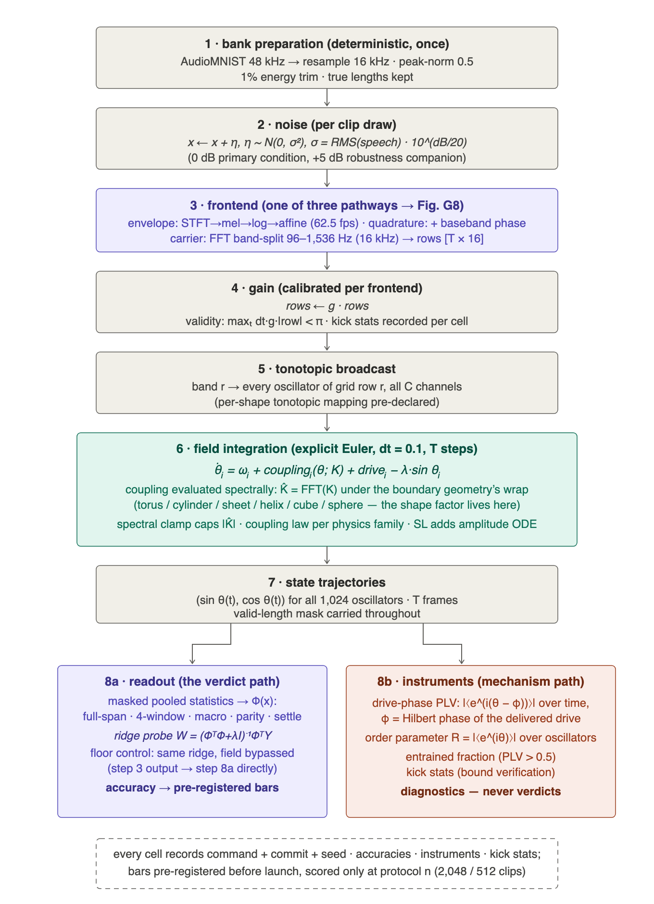
Figure 1. Order of operations, from audio to verdict. Every arm of the study passes through the same stages in the same order; only the boxed stage differs between an oscillator arm and its floor.
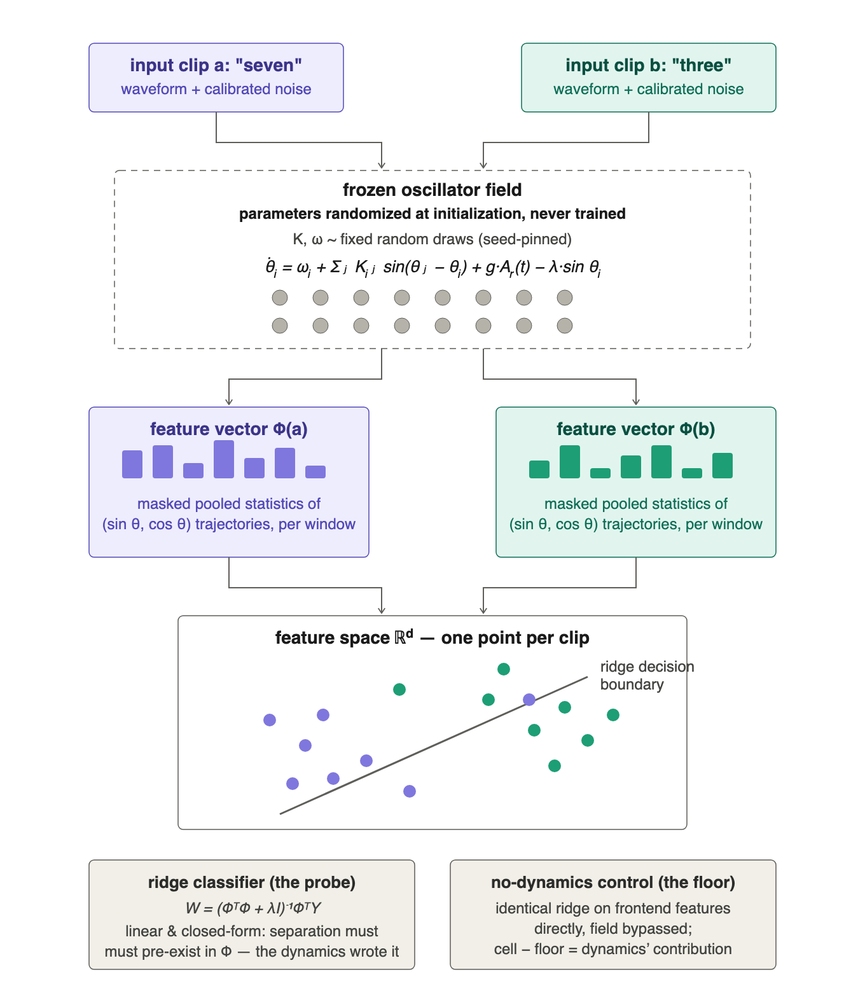
Figure 2. The linear-probe attribution protocol. The probe is deliberately the weakest available reader, so that any separation it finds must already exist in the features rather than being computed by the readout.

4 Methods

4.1 Task and data
AudioMNIST [5]: 30,000 recordings, 60 speakers × 10 digits × 50 repetitions at 48 kHz. Bank: repetitions 0–19 per speaker×digit, resampled to 16 kHz, peak-normalized to 0.5, energy-trimmed at 1% of peak, ≤1 s, true lengths stored; speaker-disjoint split (speakers 1–48 train / 49–60 test; overlap verified zero). Median digit 0.62 s = 38 hop frames. Training/evaluation sets are drawn from the bank with replacement (repeated clips receive fresh noise draws); the protocol size is 2,048 training / 512 test clips per run, and all decision bars are scored only at this size.

4.2 Primary frontend (mel envelope)
512-sample/256-hop Hann STFT → 16 mel bands → log → fixed affine (v+10)/10 clamped at 0 → rows [T×16] at 62.5 fps. Zero trainable parameters and no per-utterance statistics (streaming honesty); deliberately lightweight so bookend projections cannot dominate attribution. Constants calibrated on the digit bank (1,024 clips, valid frames only): raw log-mel first percentile −7.74 (the −10 offset sits below it); post-affine mean 0.84 / p95 1.52 / max 1.80; clamped fraction 0.02%. Disclosures: 50% window overlap ⇒ adjacent-frame correlation, identical for every arm; no overlap across clips. A lens-cost control runs one conventional baseline at 40 mel bands so the 16-band bottleneck’s cost is a measured number in anchor comparisons.

4.3 The transduction ladder (drive pathways)
Three pathways are chosen so each adds exactly one kind of information or mechanism over the last, making result differences attributable to that addition:
- Envelope (mel). Loudness only: the frontend above; drive θ̇ᵢ += g·Aᵣ(t), additive and state-independent. The base rung: literature-standard representation, comparable to the baselines and anchors.
- Quadrature. Adds reference-relative phase at the same rate and bands: the per-band analytic signal demodulated at band center yields a baseband phase φᵣ(t) (±31 Hz by the hop Nyquist, never raw carrier cycles); drive θ̇ᵢ += g·Aᵣ·sin(φᵣ − θᵢ), the canonical Adler injection form [19].
- Carrier (direct). Removes the transcoder: a full-clip FFT band-split (16 bands, 96–1,536 Hz) delivers the band waveforms themselves at 16 kHz; drive θ̇ᵢ += g·xᵣ(t), additive and oscillatory, so genuine injection locking becomes possible. Its band limit trades the >1.5 kHz envelope information the mel path keeps for in-band carrier phase, priced by computing every floor on the carrier representation itself (§5.3).
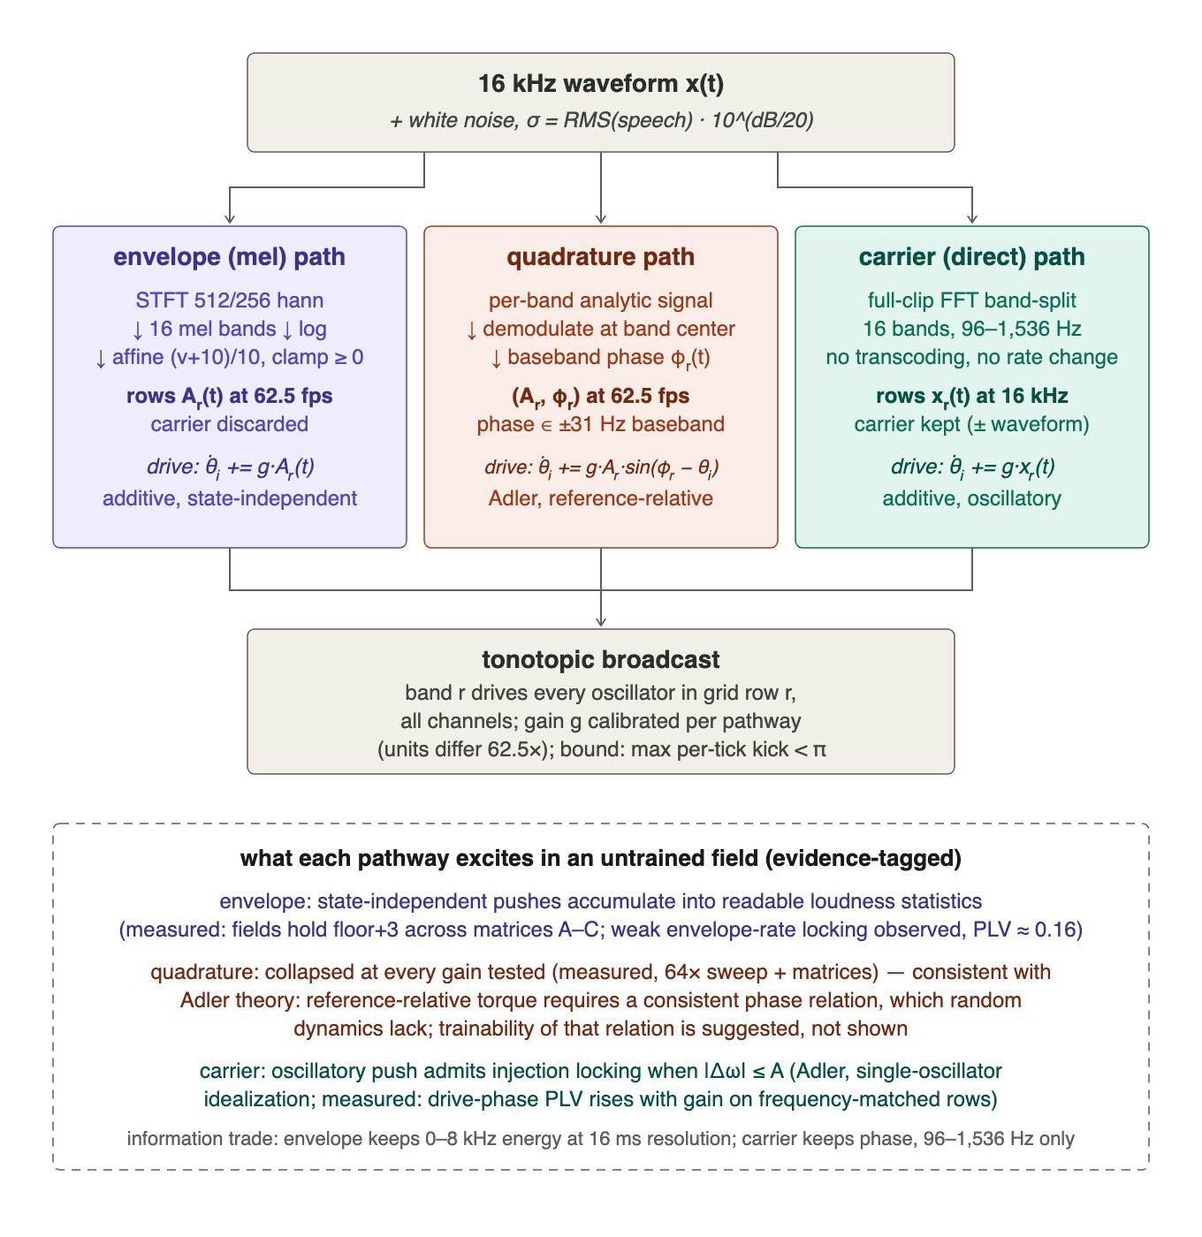
Figure 3. The three drive pathways. Each rung adds exactly one kind of information or mechanism over the one below it, so a difference in result is attributable to that addition.
Evidence notes carried with the ladder: envelope pushes accumulate into readable loudness statistics (measured throughout §5.2), and the measured weak envelope-rate locking (drive-phase PLV ≈ 0.16 at the calibrated operating point, decaying with gain) suggests additive drive can weakly phase-lock through the pinning nonlinearity, the Shapiro-step mechanism [20], while carrying no claim that it must. Quadrature collapsed at every gain tested (§5.2, §6), consistent with Adler theory; trainability of the required phase relation is suggested, not shown. Carrier drive admits injection locking when |Δω| ≤ A (single-oscillator idealization; measured in §5.3).

4.4 Noise protocol
Added white noise with σ = RMS(speech) · 10^(dB/20), drawn i.i.d. per sample over the full padded window; 0 dB means noise at speech-equal power (not clean audio), −10 dB means 0.32×, +5 dB means 1.78×. Why noise at all: the unmodified samples saturate the models under test (untrained arms reach 0.939 already at −10 dB, brushing our 0.95 kill line), and a near-ceiling task cannot discriminate design points. Calibration: a {−10…+10 dB} grid over four untrained arms; pick the level whose strongest untrained arm lands in [0.70, 0.90]. Conditions of record: 0 dB primary, +5 dB as the harsher-noise robustness companion, both fully run under both baseline protocols, both reported. Listenable examples (the same clip at every level, one seeded noise draw rescaled per level) ship with the paper, regenerable by a committed script.

4.5 Drive scale, gain, and the integrator-validity bound
The gain dial multiplies frontend-relative units, so cross-frontend gain equality is meaningless: measured row scales at 0 dB are mel-affine RMS 1.32 versus carrier RMS 0.021, a 62.5× units gap. Each frontend therefore runs at its own gate-calibrated gain, with effective drive (g × row RMS) reported at every operating point. Gains of record: mel g = 1.0 (the calibrated units unamplified; its gate read flat ±0.6 across {0.5, 1, 2}); carrier g = 32 by its own gate. Every sweep obeys an integrator-validity bound: a point is valid iff every per-tick drive phase increment stays below π (max-criterion; standard explicit-integrator discipline [21]), with rms increment ≤ 0.5 rad as an accuracy annotation. Measured bounds: carrier valid to g ≈ 75, mel to g ≈ 17 at dt = 0.1. Per-run increment statistics are recorded by instrumentation in every run. Higher physical drive, when a question needs it, is reached by increasing substeps, never by gain past the bound. Prior art for the response shape: input scaling is a canonical reservoir hyperparameter with an interior optimum [22].

4.6 Instrumentation (mechanism, never verdicts)
Drive-phase PLV per band: each oscillator’s phase is compared against the analytic (Hilbert) phase of its own row’s delivered drive; entrained fraction is the share above a 0.5 lock threshold. Rationale: natural stimuli have no single analytic stimulus phase, but the delivered drive is fully known, and locking to it is the physically meaningful question and is well-defined for every stimulus class here. On pure tones, where a stimulus phase is analytic, the drive-phase reader agrees with the stimulus-phase reader (committed test). The global order parameter $R=|⟨e^{iθ}⟩|$ (no reference; the field against itself) and the per-tick drive-increment statistics complete the instrument set. Instruments are diagnostics; verdicts come only from the pre-registered accuracy bars.

4.7 Evidential standard
Scope and evidence. Speech recognition from frozen oscillator fields. Every number reported here comes from a pre-registered, protocol-complete run; decision criteria were written before each run and verdicts scored per the criteria as written. All code, per-run results, and audio and figure assets accompany the paper (§9).
Pre-registration with bars written before launch; frozen controls through identical scaffolding; replication (screens at one seed; claims need three seeds plus same-seed replicates, seeds matched across arms); cross-run and same-seed determinism checks (bit-identical replication verified); best-validation selection under one rule for all arms. Every run records command + commit + seed, accuracies per feature family, instruments, and drive-increment statistics.

5 Results
Throughout: “windowed” is the primary metric (the ridge on per-quarter-window pooled statistics); floors are per-condition and per-representation; chance is 0.100.

5.1 Conventional references at exact parameter parity
Five trained baselines (GRU, TCN, small CNN, tiny transformer, minimal S4D-style SSM) at the matched ~2k budget, identical frontend, featurization, ridge, and selection protocol, under two protocols: the frozen-probe protocol (training against a fixed random readout direction, the physics-symmetric objective used by field arms) and the trained-head protocol (a learned classifier head, conventional practice), three seeds each, at both noise conditions.
Trained-head windowed means (per-seed tables in the supplementary results):
arm | +5 dB | 0 dB
GRU | 0.737 | 0.772
CNN | 0.703 | 0.741
Transformer | 0.697 | 0.776
TCN | 0.693 | 0.767
S4D | 0.685 | 0.746
Two findings frame everything downstream. First, at the 2k budget, trained conventional networks approximately equal a linear ridge on band statistics: at +5 dB only one trained run of thirty (GRU seed 2, 0.762) exceeds the windowed floor (0.750), and at 0 dB zero trained-head runs clear the floor (0.805; closest 0.801). Second, a scaffold finding: the frozen-probe objective is hostile to ReLU feed-forward architectures (CNN/TCN collapse under it while training fine conventionally at the same size), measured by a scaffold-versus-size control with learned heads at the identical budget. Both protocols are therefore reported for every conventional arm. Literature anchors, with protocol caveats and never as head-to-head claims: spintronic hardware reservoirs ~99.6% on TI-46 [1]; coRNN on AudioMNIST 78–91% under different frontends [2].

5.2 The untrained matrix: a statics plateau, with design effects bounded below threshold
The full factorial (six physics × six geometries × three ω levels × two λ × two clamp × two frontends) ran at three conditions: A (+5 dB, g=2), B (0 dB, g=2), C (+5 dB, g=1): 600 supported runs each (documented implementation scopes exclude SL × non-torus and SL × quadrature), with the sakaguchi/harmonic2 columns measured at their canonical nonzero parameters. Verdicts per the pre-registered bars:
The plateau. Envelope-driven untrained fields hold ≈ floor+3 at every condition. Means (vs windowed floors): A 0.774 (0.750), B 0.836 (0.805), C 0.783 (0.750); maxima 0.79–0.87, topping every trained conventional mean at the 2k budget under both protocols at both noise levels, while never exceeding their own representation’s linear content by more than a few points. At this scale, digit identity is statics-dominated, and everything reaches it.
Geometry: little impact beyond the control, replicated. Every shape is compared against its torus twin, the run identical to it in physics family, ω structure, pinning, clamp, and operating condition, differing only in the lattice wrap rule. Under envelope drive each shape has 48 such twins per condition (four phase families × three ω × two λ × two clamp; the amplitude cores are torus-only and so contribute none), and 144 pooled across the three conditions.
No shape came close to the pre-registered +3 threshold. Pooled over the three conditions, the per-shape mean deltas run from −0.13 (sphere) to +0.39 (helix); helix, the best shape, is positive in 61% of its 144 twins. Read one condition at a time, the extremes widen only to −0.63 (sphere, +5 dB g=1) and +0.58 (helix, +5 dB g=2), still under a fifth of the threshold, and not consistent in sign across conditions for any shape but helix. The quadrature pathway agrees despite sitting near chance: −0.53 to +0.29 over the same 144 twins per shape. To our knowledge this is the first controlled geometry comparison in an oscillator network; at this scale, the measured effect of lattice shape is bounded well below our decision threshold.
Tonotopic design: no measured benefit over its randomized control, replicated. The pre-registered criterion required designed ω to exceed randomized ω (the randomized-twin discipline of [23]) by +5. It was not met on any read, at any scope.
Per physics family, pooled over the three conditions under envelope drive (72 twins per phase family, 12 per amplitude family), designed − random runs from +0.28 (kuramoto) down to −1.21 (harmonic2), with no family reaching a tenth of the bar, and harmonic2 and winfree negative in all three conditions. Pooling families within a condition (104 twins), the envelope deltas are −0.31, −0.42 and −0.56; on the widest read available, all families and both drive pathways at one condition (200 twins), they are −0.12, +0.52 and −0.60. Under envelope drive the carrier is absent at hop rate, so ω structure can act only as a timescale prior, and we measured no untrained benefit from it.
Gain: near-dead, with one named interaction. Full-matrix C−A deltas: +0.9 mean (73% positive), a small real tilt toward g=1, with every factor summary below the ±3 yardstick except one: fixed-amplitude SL recovers +3.3 at g=1, erasing its Matrix-A deficit. The physics-family spread is therefore operating-point-conditioned (3.3 points at g=2 compressing to ~1.2 at g=1), and amplitude freedom reads as the absorber of drive-scale mismatch: full SL was gain-insensitive; only the amplitude-clamped variant moved.
Coupling law barely matters untrained. With genuinely distinct physics (α = π/4, β = 0.5), per-twin deviations from kuramoto are +0.1 to +0.9 points (≈ half positive; 72 twins per family per condition): sl 0.783 > kuramoto ≈ sakaguchi ≈ harmonic2 (≈0.776) > winfree 0.773 > sl-fixedamp 0.750 at g=2. Within phase cores, the coupling law is worth under a point untrained; the amplitude channel is the only physics lever above one.
Phase-referenced drive: collapsed at every gain. Quadrature runs sit at 0.24–0.33 absolute (chance 0.10), −0.53 below their magnitude twins at 100% of 288 twin pairs, and a diagnostic sweep at g ∈ {8, 32, 128} plus the matrix’s g ∈ {1, 2} never recovers half the magnitude read (non-monotone, ≤0.324 throughout). The identical quadrature pathway trains healthily (+39.8% loss drop in harness verification). Section 6 gives the model analysis; the scoped claim is that phase-referenced input is trainable-but-not-reservoir.
Settle-versus-stream. Every frozen run was read both ways: from the driven streaming trajectory, and from a 32-frame drive-free ring-down. Settle loses everywhere: −10 points mean, 0% positive across 600 runs. For untrained envelope-driven fields, the driven trajectory carries the information.

5.3 The transduction test: carrier drive does not rescue the plateau
If the mel transcoder were compressing a dynamical margin, driving the field with the band-split waveform itself (the carrier pathway) should restore it. We measured carrier floors first (0 dB: standard 0.533, windowed 0.680; the ≈12-point gap to the mel floors is the band-limit’s measured cost), gate-calibrated the carrier gain (g=32), and ran a 14-run diagonal (six physics × torus × {random, designed} ω + a helix pair) at protocol size, with three pre-registered bars. All three came back negative:
- Transduction: best run 0.701 = carrier floor +2.1 (bar: +5 to claim restoration; ≤+3 ⇒ statics-bound is frontend-invariant). Thirteen of fourteen runs sit at or below the carrier floor. The statics-bound picture holds under both transduction modes.
- Tonotopic design under carrier drive: designed − random averaged −2.0 across the diagonal’s seven designed/random twins, and the same to one decimal over the six torus families alone (criterion: +5). The no-benefit finding extends to the drive form the design was meant for. The instrument sharpens the point: designed rows demonstrably lock to their carriers (drive-phase PLV 0.17 vs 0.03 for random rows, 5–6×) and score lower. Our results showed that entrainment occurs; it did not improve accuracy on this task at this scale.
- Helix octave-per-turn: +1.0 / −1.0 vs torus (criterion: +3). The geometry finding extends unchanged to carrier drive.
Drive-pathway mechanism, summarized from the measurements above. Our results showed the envelope representation’s floor at 0.805 against the carrier’s 0.680: the representation itself carries ~12.5 points more linearly readable content, because the band-split path discards all envelope information above 1.5 kHz, while the field added a similar small margin above each floor. The instruments showed weak envelope-rate locking on the winning pathway (drive-phase PLV ≈ 0.16) and strong carrier locking on the losing designed rows (5–6× the random arm’s PLV). Together these measurements support a representation-content account of the pathway ordering and count against a resonance-matching account: the pathway with the least locking won, and the pathway with the most locking gained nothing from it. We therefore attribute the envelope path’s advantage to what its representation carries, not to how its drive engages the physics; we hypothesize that locking becomes valuable only when the task requires the temporal structure it encodes, a hypothesis §5.7 begins to test and that direct per-band transduction instrumentation would settle.
The gain-response curves behind the operating points were re-verified at three seeds with the drive-phase reader and the increment instrument (quotable table in supplementary): designed-ω holds a seed-robust +3–4 point edge over random at gate size in the mid-gain band, an edge that vanishes at protocol size, which is why the scored Caranzano verdict is negative. Locking is a mechanism; the probe scores outcomes.

5.4 Readout sufficiency: the linear probe, tested
The weakest-reader design choice is a measured control, not an assumption. On one scored-condition run and its floor twin, an MLP head (2×128) and a small window-token transformer ran on the identical features, identical splits and selection, three head seeds, across training sizes 512→16,384 (with-replacement caveat: the pool holds 9,600 unique clips; the largest size is an augmentation regime and labeled as such).
At protocol size (2,048): the transformer reads +2.6 over ridge on run features (all three seeds above) while reading −10 on the floor twin: a real, seed-robust, run-side-only nonlinear margin, and the honest caveat to linear-completeness. It is a small-data phenomenon: by 4,096 the ridge saturates the run read (0.871), by 16,384 the ridge leads everything (0.881), and the floor’s own nonlinear readers close most of the remaining gap (floor MLP +2.3 over floor ridge at 8,192; generic band-statistic nonlinearity, not field structure). Across the whole curve, the field’s best-reader edge over its floor’s best reader is stable at +1.7 to +2.9 points. Overfitting is reported, not assumed: every nonlinear head shows train–test gaps of +0.09 to +0.20, and the floor MLP memorizes its training set outright. All heads carry more parameters than the entire oscillator field.

5.5 Sensitivity of the canonical physics values
harmonic2 β: deviations from kuramoto are identical (−0.98) at β ∈ {0.25, 0.5, 1.0}, insensitive across the literature range [10], [11] (verified to be a genuine accuracy plateau, not a plumbing artifact: the trajectories differ substantially between β values). β > 1 is excluded by design: the second-harmonic weight multiplies its term unnormalized, confounding coupling shape with total strength; a future extension would use normalized mixing (1, β)/(1+β).
sakaguchi α: the five-point response {π/8, π/4, 3π/8, 1.39, π/2} traces a non-monotone curve: +0.2 / −2.7 / −3.9 / −0.4 / +1.2 versus kuramoto (each point ≤1.7σ individually; the trough ≈2.4σ). A registered mechanistic prediction, that the deviation tracks frustration energy ∝ sin 2α and is therefore symmetric about π/4, was refuted by the 3π/8 point. The instruments show the lag desynchronizing the field monotonically (R 0.095 → 0.066 across the range; textbook Sakaguchi behavior) while envelope locking stays flat, so readability does not track coherence, and the least synchronized field (α = π/2, the zero-attraction boundary) reads best, slightly above kuramoto. α therefore enters the record as a measured factor level with its response curve (π/4 = mid-range lag; 1.39 = π/2 − 0.18, the canonical chimera value [9]; π/2 = the boundary), not an assumed constant. Matrix-wide, the family deviation at α = π/4 is +0.1–0.2 (§5.2): the crown-configuration trough did not generalize.

5.6 Coherence and readability: an inverted-U, suggested
A registered scatter over the corrected protocol-size matrices (936 envelope runs: 312 at each of the three conditions) tested whether readability anti-correlates with global coherence. The anti-correlation bar (Spearman ρ ≤ −0.3 in ≥2 of 3 conditions) came back 0/3: the across-run trend at low coherence is mildly positive and consistent (ρ = +0.256, +0.254, +0.227; winfree +0.51 to +0.62 per condition). Meanwhile every high-coherence state we measured reads worse than its less-coherent twin: the reference-slaved quadrature regime; the most coherent carrier run (R 0.65) losing to its incoherent twin (R 0.32); the α-curve’s locked extremes. The recorded suggestion, which is a suggestion and not a mechanism, is non-monotone: mild coherence helps, locking hurts (an inverted-U in R). Across-run correlations are confounded (R co-varies with pinning, clamp, and family), so the named discriminating experiment is a causal within-family R-response curve, driving R from ~0.05 to ~0.6 with everything else fixed. This reading is consistent with the over-synchronization concerns raised independently in the trained-oscillator literature [3], [24].
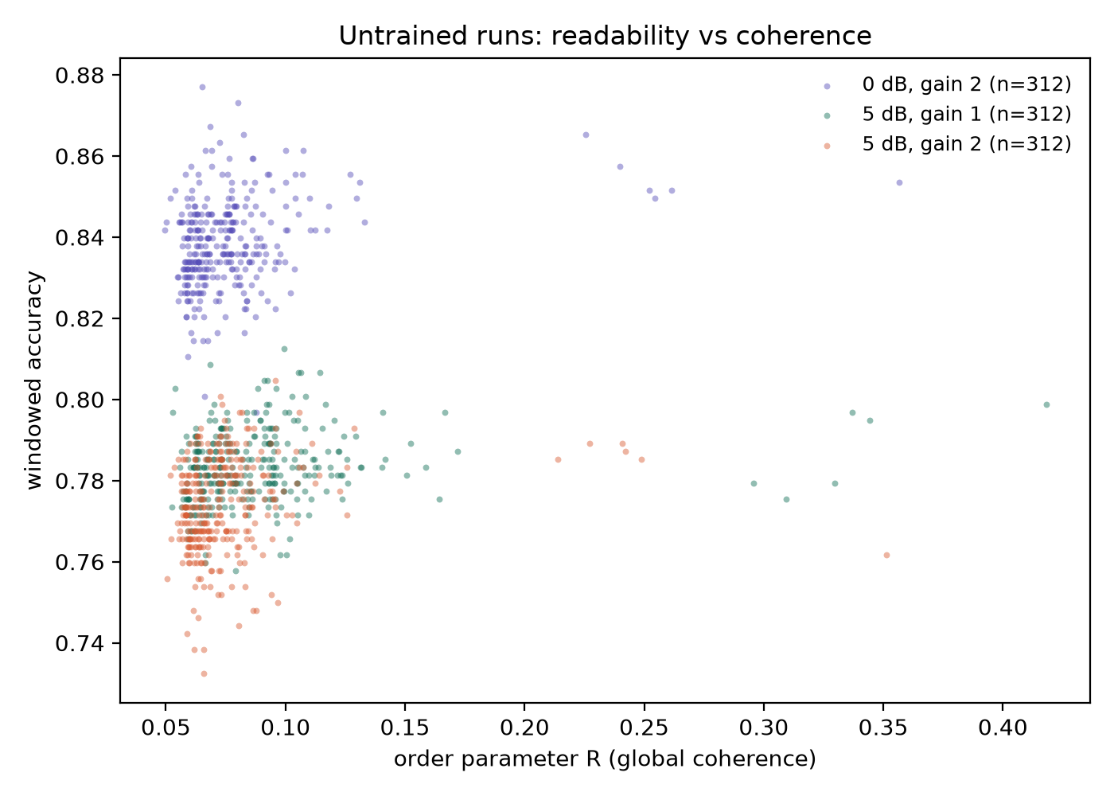
Figure 4. Readability against coherence across the swept conditions. The relation is not monotone: mild coherence accompanies the best reads, and the most strongly locked fields read worse than their less coherent twins.

5.7 The task axis: untrained state carries temporal order near-perfectly
Every task above is statics-dominated, so the field’s dynamics are barely interrogated. We therefore built a task that statics provably cannot answer: classify two-digit sequences whose unordered content is identical (digit a then b, versus b then a; independent recordings joined by a 100 ms gap; a 272 ms silent leader absorbs the featurization warmup so the readout window is order-symmetric by design). The primary read is the full-span pooled protocol, which is order-free by construction: any permutation-invariant statistic of the frame multiset is identical for both classes regardless of its richness: the defense is mathematical, not empirical, though the empirical check agrees (matched floors 0.465–0.518 across all five pairs; chance 0.500; the |Δ| feature’s single-junction sensitivity is the stated exception and is measurably negligible). Any accuracy above chance through this readout must come from state that persists across time.
Results (five digit pairs, three seeds, protocol size; full-span accuracy):
pair | matched floor | kuramoto (frozen) | SL (frozen) | GRU (trained)
3,7 | 0.486 | 0.970 ±0.003 | 0.990 ±0.004 | 0.977 ±0.015
1,8 | 0.496 | 0.997 ±0.003 | 1.000 ±0.000 | 0.995 ±0.001
2,5 | 0.490 | 0.997 ±0.002 | 0.996 ±0.004 | 0.992 ±0.005
4,9 | 0.518 | 0.988 ±0.005 | 0.995 ±0.001 | 0.990 ±0.004
0,6 | 0.465 | 0.988 ±0.003 | 0.996 ±0.002 | 0.995 ±0.003
(± = half-range over three seeds; audio examples of the stimuli, both orders of two pairs at the experimental condition, ship with the paper in resources/audio/order/, regenerable by committed script.)
The pre-registered bar (≥0.60 on ≥3 of 5 valid pairs) passes 5/5 with ~40 points to spare: untrained oscillator state reads temporal order at 0.97–1.00 through readouts that are blind to it without the dynamics. Frozen Stuart–Landau is the best arm everywhere (amplitude as memory; one perfect score), and the frozen fields match the trained GRU, a comparison scoped strictly to the shared order-free readout protocol (a recurrent network with a sequence head would answer this task trivially; the point is that under identical readout constraints, training the recurrence added nothing beyond what the frozen physics provides).
A severed-coupling control (spectral cap → 0, same runs) attributes the mechanism: uncoupled oscillators alone read 0.947–0.980, with coupling adding +1.7–2.3, closely matching the coupling term’s measured contribution on the statics task. The order memory is predominantly per-oscillator phase integration: each oscillator’s phase is an integral of its own drive history, with collective dynamics contributing a small consistent margin. Scope notes: this is synthetic sequencing of natural units (no co-articulation), one gap length, near ceiling, a single demonstration with a registered hardness ladder (longer sequences, variable gaps, memory-horizon curves), not a characterized capability. It is also consistent with the settle result (§5.2): the memory lives in the driven evolution of the state, not in autonomous ring-down persistence.

6 The phase-referenced collapse: model and mechanism
The magnitude push is oscillator-state-independent; the Adler torque g·Aᵣ·sin(φᵣ − θᵢ) depends on each oscillator’s phase relative to a shared reference. The Adler equation θ̇ = Δω + A·sin(φ−θ) locks iff |Δω_eff| ≤ A [19]; locking is the only mechanism by which a reference-relative torque produces a persistent readable phase relation.
The untrained field sits outside the readable regime at every gain, for two reasons that meet in the middle. At low gain, the baseband reference rotates at up to ±π rad/frame (the ±31 Hz Nyquist edge) while intrinsic rates are ~0.1 rad/frame and per-frame torque ≲0.2 rad: far outside the locking range, sin(φ−θ) time-averages toward zero, and residual torques across a population with random initial phases and dispersed ω are mutually incoherent. At high gain, the torque dominates any detuning and the population is dragged onto the shared reference, θᵢ → φᵣ(t): a reference-slaved state is nearly input-invariant in the informative dimensions: within a row all oscillators carry the same φᵣ, and the amplitude pattern Aᵣ(t), which carries most digit identity (the magnitude path’s 0.77+ demonstrates it), is projected out of the phase state. The measured non-monotone middle (0.168/0.275/0.314 at g = 8/32/128) is consistent with the crossover between the two failure regimes. This account is labeled consistent-with-data; the per-gain drive-phase instrumentation that would test it directly is left to future work.
What training changes is neither the drive nor the phases but the coupling kernel: reshaping the field’s autonomous dynamics until the population maintains a consistent phase relation to the reference, at which point reference-relative torques sum constructively, the identical pathway trains healthily. Hence the scoped claim: phase-referenced input is trainable-but-not-reservoir: it requires co-organization with the reference, which trained dynamics can supply and random dynamics cannot. Because of this phenomenon, the carrier pathway removes the transcoder and drives the field with the band-filtered waveform itself: an additive oscillatory drive engages entrainment, creating phase organization through the locking dynamics with no pre-organization required, turning the untrained-phase question into one about locking range rather than co-organization. Section 5.3 reports the outcome: locking occurs, and the plateau stands.

7 Discussion
The hypothesis, scored. As tested, at ~2k parameters, on spoken digits, under three drive forms and three conditions, the reservoir premise splits along the task axis. On statics-dominated recognition, it survives only in a bounded form: untrained fields carry digit information consistently above every trained conventional baseline at the same budget, yet only +2–3 points above their own representation’s linear content, and that margin was indifferent to every design axis we varied: geometry and tonotopic design each showed little impact beyond their controls (the latter even with measured locking), the coupling law was worth under a point, gain was nearly inert, and phase-referenced input was unreadable. On the order task, the one task whose answer requires memory, the premise holds emphatically: near-ceiling accuracy over chance-blind floors, carried predominantly by per-oscillator integration. The synthesis: the input representation determines what the field can encode (measured by floors, not by resonance-matching); the task determines whether the dynamics are interrogated at all; the readout determines how much of the whole stack is harvested; and the field’s untrained design, whether shape, frequency structure or coupling law, determines almost nothing. The strong version of the design premise is refuted at this scale by the bars as written; the state-memory premise is confirmed. The amplitude channel is the one design element that mattered on both axes (family lead on statics; best arm on order), and since α/β are precisely the parameters training can adjust, amplitude trainability is the sharpest hypothesis a trained-dynamics study should test next.
What bounds the conclusion. Four limitations, each with its measured control or named test: readout capacity (controlled in §5.4, near-complete, with a quantified small-data exception); readout data size (measured to the bank’s ceiling; an expanded bank is the named next test); field size (2k parameters is one point on the size axis, and the size-scaling curve is unmeasured here); and frontend conditioning (two of three pathways here are lossy in different ways, so transduction itself wants direct instrumentation). The statics-dominance of digit identity is itself a scope condition: tasks with heavier temporal structure may separate dynamics from statics where digits cannot.
What the no-effect findings are worth. The geometry result answers an open question no controlled experiment had touched; the design results (tonotopy, coupling law) bound how much of the oscillator revival’s promise can come for free; the phase-collapse analysis converts a failed factor into a mechanism with a testable training-side prediction; and the coherence–readability inverted-U, if it survives its causal test, connects the untrained record to the over-synchronization failure mode reported in trained oscillator systems. The evaluation frame, comprising floors, parity, drive-unit calibration with a validity bound, drive-phase instrumentation and pre-registered bars, is reusable as-is for trained-dynamics studies, and ships with this paper for exactly that purpose.

8 Related work
Hardware oscillator reservoirs establish the premise’s strongest published support [1]; reservoir computing supplies the frame and its cautions [22], [25], [26], [27]. Oscillator-inspired trained networks (coRNN [2]; Neural Wave Machines [28]; WONN [12]; AKOrN [4]) and Kuramoto-based generation [3] motivate the frozen-versus-trained distinction this paper measures from the frozen side. Synchronization theory supplies the analytical spine [6], [7], [8], [19], [20], [29]; chimera states [Kuramoto & Battogtokh 2002; Abrams & Strogatz 2004] ground the partial-coherence readings. The randomized-twin discipline for designed structure follows [23]; frequency- learning front-ends [30], [31] are the trained counterpoint to our fixed tonotopy. The closest body of work to this paper’s premise is the neuro-oscillatory speech literature reviewed by [15], whose three model families [16], [17], [18] all obtain their rate flexibility from adaptation of some parameter, and none of which is evaluated against a parameter-matched conventional baseline on a recognition task. To our knowledge, no prior work varies oscillator-network lattice topology under controls, runs a pre-registered factorial of coupling laws untrained, or instruments drive-phase locking against delivered drive in a speech setting.

9 Reproducibility
Everything the paper rests on is published alongside it. The record holds 1,940 runs: the 1,800-run two-pathway factorial, the 14-run carrier diagonal, and 126 gates, controls, sweeps, and conventional references.
what | where
experiment harness (field cores, the nine geometries, frontends, probes, instruments, baselines) | harness/
the sweep driver and the launch, scoring, figure, and audio scripts | harness/sweep.py, scripts/
harness test suite (contracts for every mechanism the paper claims) | tests/
the complete record: 1,940 runs, grouped one file per drive variant and coupling law, each carrying its full configuration and every metric | results/
authored figures and the generated coherence scatter | resources/figures/
noise-calibration and order-task audio examples | resources/audio/
Every run records its full configuration and seed in its own results.json; all matrices, gates, floors, and controls are regenerable from the committed scripts. Same-seed replication is bit-identical (verified cross-run and cross-run); cross-seed spreads are reported wherever claims rest on them. Both registered predictions that their own tests refuted (§5.5, §5.6) are reported in full above rather than dropped.
References
[1] J. Torrejon et al., ‘Neuromorphic computing with nanoscale spintronic oscillators’, Nature, vol. 547, no. 7664, 2017, doi: 10.1038/nature23011.
[2] T. K. Rusch and S. Mishra, ‘Coupled oscillatory recurrent neural network (coRNN): An accurate and (gradient) stable architecture for learning long time dependencies’, in 9th international conference on learning representations, ICLR 2021, virtual event, austria, may 3-7, 2021, OpenReview.net, 2021. Available: https://openreview.net/forum?id=F3s69XzWOia
[3] Unconventional AI, ‘Introducing Un-0: Generating images with coupled oscillators’. Accessed: Aug. 16, 2026. [Online]. Available: https://unconv.ai/blog/introducing-un-0-generating-images-with-coupled-oscillators/
[4] T. Miyato, S. Löwe, A. Geiger, and M. Welling, ‘Artificial kuramoto oscillatory neurons’, in The thirteenth international conference on learning representations, ICLR 2025, singapore, april 24-28, 2025, OpenReview.net, 2025. Available: https://openreview.net/forum?id=nwDRD4AMoN
[5] S. Becker, J. Vielhaben, M. Ackermann, K.-R. Müller, S. Lapuschkin, and W. Samek, ‘AudioMNIST: Exploring explainable artificial intelligence for audio analysis on a simple benchmark’, Journal of the Franklin Institute, vol. 361, no. 1, pp. 418–428, 2024, doi: 10.1016/j.jfranklin.2023.11.038.
[6] A. T. Winfree, ‘Biological rhythms and the behavior of populations of coupled oscillators’, Journal of Theoretical Biology, vol. 16, no. 1, 1967, doi: 10.1016/0022-5193(67)90051-3.
[7] Y. Kuramoto, ‘Self-entrainment of a population of coupled non-linear oscillators’, in Lecture notes in physics, 1975. doi: 10.1007/BFb0013365.
[8] H. Sakaguchi and Y. Kuramoto, ‘A soluble active rotator model showing phase transitions via mutual entrainment’, Progress of Theoretical Physics, vol. 76, no. 3, 1986, doi: 10.1143/PTP.76.576.
[9] D. M. Abrams and S. H. Strogatz, ‘Chimera states for coupled oscillators’. 2004. Available: https://arxiv.org/abs/nlin/0407045
[10] H. Daido, ‘Order function and macroscopic mutual entrainment in uniformly coupled limit-cycle oscillators’, Progress of Theoretical Physics, vol. 88, no. 6, 1992, doi: 10.1143/ptp/88.6.1213.
[11] D. Hansel, G. Mato, and C. Meunier, ‘Clustering and slow switching in globally coupled phase oscillators’, Physical Review E, vol. 48, no. 5, 1993, doi: 10.1103/PhysRevE.48.3470.
[12] J. Dai and Y. Song, ‘Winfree oscillatory neural network’. 2026. Available: https://arxiv.org/abs/2605.20922
[13] J. T. Stuart, ‘On the non-linear mechanics of wave disturbances in stable and unstable parallel flows part 1. The basic behaviour in plane poiseuille flow’, Journal of Fluid Mechanics, vol. 9, no. 3, 1960, doi: 10.1017/S002211206000116X.
[14] I. S. Aranson and L. Kramer, ‘The world of the complex ginzburg-landau equation’, Reviews of Modern Physics, vol. 74, no. 1, 2002, doi: 10.1103/RevModPhys.74.99.
[15] O. Dogonasheva, A.-L. Giraud, D. Zakharov, and B. Gutkin, ‘Neuro-oscillatory models of cortical speech processing’, Neural Networks, vol. 195, 2026, doi: 10.1016/j.neunet.2025.108194.
[16] M. F. Assaneo, J. M. Rimmele, Y. Sanz Perl, and D. Poeppel, ‘Speaking rhythmically can shape hearing’, Nature Human Behaviour, vol. 5, no. 1, 2020, doi: 10.1038/s41562-020-00962-0.
[17] K. B. Doelling, L. H. Arnal, and M. F. Assaneo, ‘Adaptive oscillators support bayesian prediction in temporal processing’, PLOS Computational Biology, vol. 19, no. 11, 2023, doi: 10.1371/journal.pcbi.1011669.
[18] B. R. Pittman-Polletta, Y. Wang, D. A. Stanley, C. E. Schroeder, M. A. Whittington, and N. J. Kopell, ‘Differential contributions of synaptic and intrinsic inhibitory currents to speech segmentation via flexible phase-locking in neural oscillators’, PLOS Computational Biology, vol. 17, no. 4, 2021, doi: 10.1371/journal.pcbi.1008783.
[19] R. Adler, ‘A study of locking phenomena in oscillators’, Proceedings of the IRE, vol. 34, no. 6, 1946, doi: 10.1109/JRPROC.1946.229930.
[20] A. Pikovsky, M. Rosenblum, and J. Kurths, Synchronization: A universal concept in nonlinear sciences. Rosenblum & Kurths, CUP, 2001. doi: 10.1017/CBO9780511755743.
[21] Hairer, Solving ordinary differential equations i: Nonstiff problems. Springer Series in Computational Mathematics, 1993. doi: 10.1007/978-3-540-78862-1.
[22] M. Lukoševičius, ‘A practical guide to applying echo state networks’, in Lecture notes in computer science, 2012. doi: 10.1007/978-3-642-35289-8_36.
[23] I. Caranzano et al., ‘Sparsity is all you need: Rethinking biological pathway-informed approaches in deep learning’. 2025. Available: https://arxiv.org/abs/2505.04300
[24] J. Nunley, ‘Attention as frustrated synchronization’. 2026. Available: https://arxiv.org/abs/2606.18694
[25] H. Jaeger, ‘The “echo state” approach to analysing and training recurrent neural networks’, German National Research Center for Information Technology, GMD Report 148, 2001. Available: https://www.ai.rug.nl/minds/uploads/EchoStatesTechRep.pdf
[26] W. Maass, T. Natschläger, and H. Markram, ‘Real-time computing without stable states: A new framework for neural computation based on perturbations’, Neural Computation, vol. 14, no. 11, 2002, doi: 10.1162/089976602760407955.
[27] G. Tanaka et al., ‘Recent advances in physical reservoir computing: A review’, Neural Networks, vol. 115, 2019, doi: 10.1016/j.neunet.2019.03.005.
[28] T. A. Keller and M. Welling, ‘Neural wave machines: Learning spatiotemporally structured representations with locally coupled oscillatory recurrent neural networks’, in Proceedings of the 40th international conference on machine learning, in Proceedings of machine learning research, vol. 202. PMLR, 2023, pp. 16168–16189. Available: https://proceedings.mlr.press/v202/keller23a.html
[29] S. H. Strogatz, ‘From kuramoto to crawford: Exploring the onset of synchronization in populations of coupled oscillators’, Physica D: Nonlinear Phenomena, vol. 143, no. 1–4, 2000, doi: 10.1016/S0167-2789(00)00094-4.
[30] V. Lostanlen, D. Haider, H. Han, M. Lagrange, P. Balazs, and M. Ehler, ‘Fitting auditory filterbanks with multiresolution neural networks’. 2023. Available: https://arxiv.org/abs/2307.13821
[31] N. Zeghidour, O. Teboul, F. de Chaumont Quitry, and M. Tagliasacchi, ‘LEAF: A learnable frontend for audio classification’, in 9th international conference on learning representations, ICLR 2021, virtual event, austria, may 3-7, 2021, OpenReview.net, 2021. Available: https://openreview.net/forum?id=jM76BCb6F9m

